BCA Cyber Security
Project Based Learning — Phase 2 Proposal
Fire Guard: “A Rule-Based Firewall Simulation System using Data Structures.”

Student / Team Information
Team Name: | Firewall Squad
Team member 1 (Team Lead)  Shivansh Chand: 2510320287: sshivanshchand@gmail.com | 
Team member 2  Muhammad Saad Hasan Fouzan: 2512370025: muhammadsaad9927689287@gmail.com | 
Team member 3  Arsh Abu Bakar: 2512370024: arshbbkr@gmail.com | 
Team member 4  Dherya Negi: 2511120049: dheryaff14@gmail.com | 

Proposal Description

Motivation
Firewalls decide whether to let network traffic pass or not, based on some rules that are already set. Being cyber security students, we thought this would be a good topic for our first PBL project, so that we actually understand this idea ourselves instead of just reading it in books.
So our motivation is to build a simple Firewall Rule Simulator which shows how a firewall allows or blocks packets, using the basic data structures we are learning in our DSA subject. This way we are connecting our DSA subject with our cyber security branch in one project, and all 4 of us can build and explain it easily.

State of the Art / Current Solution
This problem is already solved in real life by tools like iptables/netfilter on Linux and Windows Defender Firewall. These keep a table of rules and check every packet that comes in against those rules, one by one, in a particular order.
These real firewalls are very advanced and made to handle huge traffic, which is too much for a semester project. So we are not trying to copy them fully — we are just making a small version that shows the same basic idea: storing rules, checking packets against them, and deciding allow or block, using simple data structures so we can explain the working properly.

Project Goals and Milestones
Our main goal is to build a working Firewall Rule Simulator which stores some rules and checks sample/simulated packets against them, and shows the result through a simple GUI. The whole project will be made in Python.
- Phase 1: Make the rule structure, store some rules directly in the code, and check a sample packet against them using linear search, shown through the command line.
- Phase 2: Let the user add, view and edit rules while the program is running, keep a log of the packets checked, and sort the rules by priority.
- Phase 3: Build the Tkinter GUI — rule table, a box to enter a test packet, and a live result showing allow or block; final testing and fixing issues.

Project Approach
We are building the whole project in Python only, both the logic part and the GUI part, so we don't have to mix two different languages. The rules and the log entries are stored as a list of dictionaries, which works like an array of records — each one holding fields like source IP, port number and the action (allow/block).
When a packet comes in, our Rule Engine checks the rule list one by one using linear search, and as soon as it finds the first matching rule, it gives the final decision. We are also adding a basic sort so the rules can be arranged by priority before matching. For the interface we are using Python's own Tkinter library, since it is already built into Python and we don't need any extra setup or bridge between languages.
Technologies used: Python 3, Tkinter for the GUI, and normal Python lists/dictionaries. We are not using any outside DSA library, since writing the logic ourselves is the whole point of this project.

System Architecture
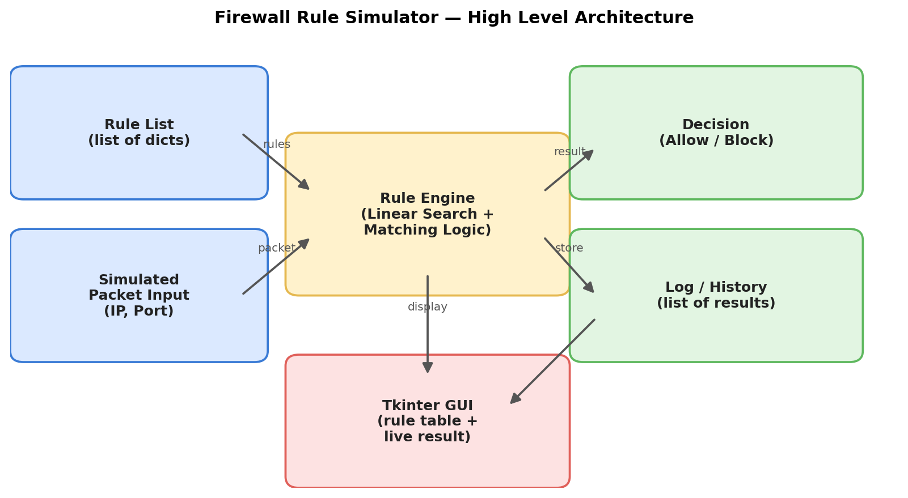

Project Outcome / Deliverables
- A Python program that checks a batch of mock packets against our firewall rules using lists and linear search.
- A simple Tkinter GUI showing the rule table and the live result (allowed/blocked) for test packets.
- A small log/history that keeps track of the packets already checked.
- Full source code, our phase-wise reports and a final presentation of the project.

Assumptions
We are assuming that the packets used are only sample/mock data (fake IP and port numbers) and not real live network traffic, since working with real traffic is outside what we can do in a semester. We are also keeping the number of rules small, around 10 to 20, which should be enough to clearly show the logic.

References
- Python official documentation — docs.python.org
- Tkinter official documentation — docs.python.org/3/library/tkinter.html
- GeeksforGeeks — Data Structures and Algorithms basics (geeksforgeeks.org)
- Basic concepts of firewall rule matching — general networking/cybersecurity coursework

