Jupyter Notebook Export

In [9]:
import os
print("Checking /kaggle/input ...\n")
base_path = "/kaggle/input"
if not os.path.exists(base_path):
print("This does not look like Kaggle notebook environment.")
else:
level1 = sorted(os.listdir(base_path))
if len(level1) == 0:
print("No dataset attached yet.")
print("Go to the right side panel in Kaggle -> Add Input -> search tiny-imagenet and attach the dataset.")
else:
print("Datasets/folders found in /kaggle/input:\n")
for folder in level1:
print(" -", folder)
folder_path = os.path.join(base_path, folder)
if os.path.isdir(folder_path):
try:
subfolders = sorted(os.listdir(folder_path))[:15]
for sub in subfolders:
print(" ->", sub)
except:
pass
print()

Output:
Checking /kaggle/input ...
Datasets/folders found in /kaggle/input:
- datasets
-> akash2sharma
- notebooks
-> hareeshpeddamaru

In [10]:
import os
path = "/kaggle/input/datasets/akash2sharma"
print("Checking:", path, "\n")
if os.path.exists(path):
items = sorted(os.listdir(path))
print("Items found:\n")
for item in items:
print("-", item)
full_path = os.path.join(path, item)
if os.path.isdir(full_path):
try:
subitems = sorted(os.listdir(full_path))[:20]
for sub in subitems:
print(" ->", sub)
except:
pass
print()
else:
print("Path does not exist")

Output:
Checking: /kaggle/input/datasets/akash2sharma
Items found:
- tiny-imagenet
-> tiny-imagenet-200

In [11]:
import os
dataset_path = "/kaggle/input/datasets/akash2sharma/tiny-imagenet/tiny-imagenet-200"
print("Dataset path:", dataset_path)
print()
if os.path.exists(dataset_path):
items = sorted(os.listdir(dataset_path))
print("Main folders/files inside dataset:\n")
for item in items:
print("-", item)
else:
print("Dataset path not found")

Output:
Dataset path: /kaggle/input/datasets/akash2sharma/tiny-imagenet/tiny-imagenet-200
Main folders/files inside dataset:
- test
- tiny-imagenet-200
- train
- val
- wnids.txt
- words.txt

In [12]:
import os
import torch
from torchvision import datasets, transforms
from torch.utils.data import DataLoader
# fixed dataset path
DATASET_PATH = "/kaggle/input/datasets/akash2sharma/tiny-imagenet/tiny-imagenet-200"
TRAIN_DIR = os.path.join(DATASET_PATH, "train")
VAL_DIR = os.path.join(DATASET_PATH, "val")
TEST_DIR = os.path.join(DATASET_PATH, "test")
print("Train path exists:", os.path.exists(TRAIN_DIR))
print("Val path exists:", os.path.exists(VAL_DIR))
print("Test path exists:", os.path.exists(TEST_DIR))
# basic transform
transform = transforms.Compose([
transforms.Resize((224, 224)),
transforms.ToTensor()
])
# load only training dataset for now
train_dataset = datasets.ImageFolder(TRAIN_DIR, transform=transform)
print("\nTrain dataset loaded successfully")
print("Total training images:", len(train_dataset))
print("Total classes:", len(train_dataset.classes))
print("First 5 class names:", train_dataset.classes[:5])

Output:
Train path exists: True
Val path exists: True
Test path exists: True
Train dataset loaded successfully
Total training images: 100000
Total classes: 200
First 5 class names: ['n01443537', 'n01629819', 'n01641577', 'n01644900', 'n01698640']

In [13]:
from torchvision import datasets, transforms
transform = transforms.Compose([
transforms.Resize((224, 224)),
transforms.ToTensor()
])
train_dataset = datasets.ImageFolder(TRAIN_DIR, transform=transform)
print("Train dataset loaded successfully")
print("Total training images:", len(train_dataset))
print("Total classes:", len(train_dataset.classes))
print("First 5 class names:", train_dataset.classes[:5])

Output:
Train dataset loaded successfully
Total training images: 100000
Total classes: 200
First 5 class names: ['n01443537', 'n01629819', 'n01641577', 'n01644900', 'n01698640']

In [14]:
import torch
from torch.utils.data import DataLoader
import matplotlib.pyplot as plt
# -------------------------------
# STEP 1: DataLoader
# -------------------------------
BATCH_SIZE = 32
train_loader = DataLoader(
train_dataset,
batch_size=BATCH_SIZE,
shuffle=True,
num_workers=2,
pin_memory=True
)
print("DataLoader created successfully")
print("Batch size:", BATCH_SIZE)
# -------------------------------
# STEP 2: Check one batch
# -------------------------------
images, labels = next(iter(train_loader))
print("\nOne batch loaded successfully")
print("Images shape:", images.shape) # expected: [32, 3, 224, 224]
print("Labels shape:", labels.shape) # expected: [32]
# -------------------------------
# STEP 3: Show sample images
# -------------------------------
fig, axes = plt.subplots(2, 3, figsize=(10, 7))
axes = axes.flatten()
for i in range(6):
img = images[i].permute(1, 2, 0).numpy() # CHW -> HWC
axes[i].imshow(img)
axes[i].set_title(f"Class: {labels[i].item()}")
axes[i].axis("off")
plt.tight_layout()
plt.show()

Output:
DataLoader created successfully
Batch size: 32
One batch loaded successfully
Images shape: torch.Size([32, 3, 224, 224])
Labels shape: torch.Size([32])
<Figure size 1000x700 with 6 Axes>
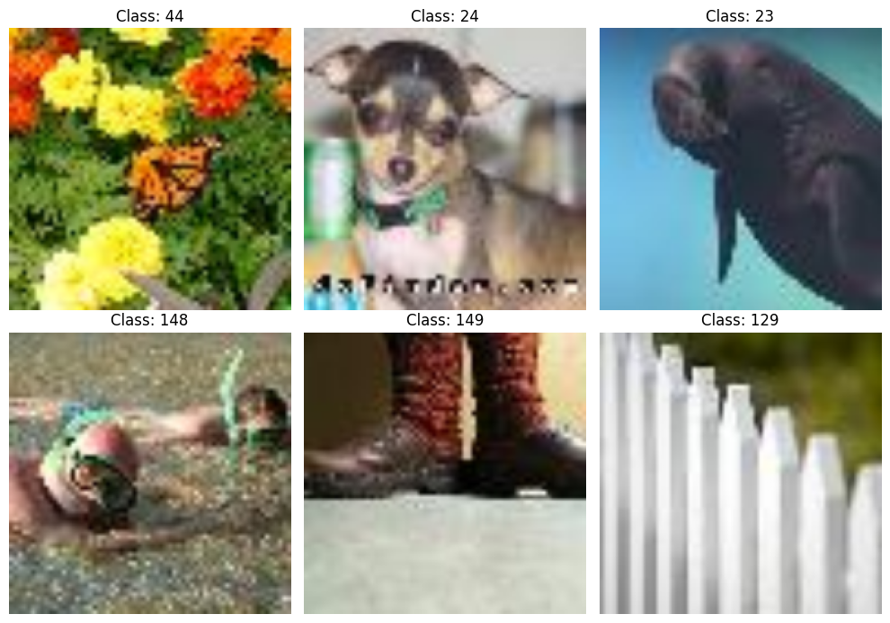

In [15]:
import torch
import matplotlib.pyplot as plt
# =========================================================
# STEP 1: CONFIG
# =========================================================
IMG_SIZE = 224
PATCH_SIZE = 16
IN_CHANS = 3
NUM_PATCHES = (IMG_SIZE // PATCH_SIZE) ** 2 # 14 x 14 = 196
PATCH_DIM = PATCH_SIZE * PATCH_SIZE * IN_CHANS # 16*16*3 = 768
MASK_RATIO = 0.75
VISIBLE_PATCHES = int(NUM_PATCHES * (1 - MASK_RATIO)) # 49
MASKED_PATCHES = NUM_PATCHES - VISIBLE_PATCHES # 147
print("IMG_SIZE:", IMG_SIZE)
print("PATCH_SIZE:", PATCH_SIZE)
print("NUM_PATCHES:", NUM_PATCHES)
print("PATCH_DIM:", PATCH_DIM)
print("VISIBLE_PATCHES:", VISIBLE_PATCHES)
print("MASKED_PATCHES:", MASKED_PATCHES)
# =========================================================
# STEP 2: PATCHIFY
# Input: (B, 3, 224, 224)
# Output: (B, 196, 768)
# =========================================================
def patchify(imgs, patch_size=16):
B, C, H, W = imgs.shape
assert H == W, "Image must be square"
assert H % patch_size == 0, "Image size must be divisible by patch size"
h = H // patch_size
w = W // patch_size
# reshape into patches
x = imgs.reshape(B, C, h, patch_size, w, patch_size)
x = x.permute(0, 2, 4, 3, 5, 1) # (B, h, w, p, p, C)
x = x.reshape(B, h * w, patch_size * patch_size * C)
return x
# =========================================================
# STEP 3: UNPATCHIFY
# Input: (B, 196, 768)
# Output: (B, 3, 224, 224)
# =========================================================
def unpatchify(x, patch_size=16, img_size=224):
B = x.shape[0]
h = img_size // patch_size
w = img_size // patch_size
C = 3
x = x.reshape(B, h, w, patch_size, patch_size, C)
x = x.permute(0, 5, 1, 3, 2, 4) # (B, C, h, p, w, p)
imgs = x.reshape(B, C, img_size, img_size)
return imgs
# =========================================================
# STEP 4: TEST PATCHIFY + UNPATCHIFY
# =========================================================
sample_images, sample_labels = next(iter(train_loader))
sample_images = sample_images[:2] # test only 2 images
patches = patchify(sample_images, PATCH_SIZE)
reconstructed = unpatchify(patches, PATCH_SIZE, IMG_SIZE)
print("\nOriginal image batch shape:", sample_images.shape)
print("Patchified shape:", patches.shape)
print("Reconstructed shape:", reconstructed.shape)
# =========================================================
# STEP 5: VISUAL CHECK
# original vs reconstructed
# =========================================================
fig, axes = plt.subplots(2, 2, figsize=(8, 8))
for i in range(2):
orig = sample_images[i].permute(1, 2, 0).numpy()
recon = reconstructed[i].permute(1, 2, 0).numpy()
axes[i, 0].imshow(orig)
axes[i, 0].set_title(f"Original {i+1}")
axes[i, 0].axis("off")
axes[i, 1].imshow(recon)
axes[i, 1].set_title(f"Unpatchified {i+1}")
axes[i, 1].axis("off")
plt.tight_layout()
plt.show()

Output:
IMG_SIZE: 224
PATCH_SIZE: 16
NUM_PATCHES: 196
PATCH_DIM: 768
VISIBLE_PATCHES: 49
MASKED_PATCHES: 147
Original image batch shape: torch.Size([2, 3, 224, 224])
Patchified shape: torch.Size([2, 196, 768])
Reconstructed shape: torch.Size([2, 3, 224, 224])
<Figure size 800x800 with 4 Axes>
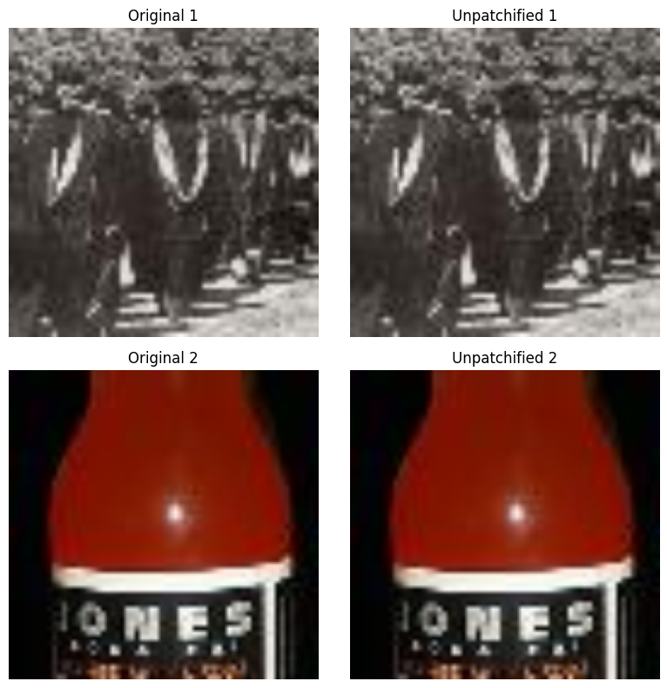

In [16]:
import torch
import matplotlib.pyplot as plt
# =========================================================
# STEP 1: RANDOM MASKING
# x shape: (B, N, D)
# returns:
# x_visible -> only visible patches
# mask -> (B, N), 0=visible, 1=masked
# ids_restore -> for restoring original order later
# ids_keep -> visible patch indices
# =========================================================
def random_masking(x, num_keep=49):
B, N, D = x.shape
# random noise for each patch
noise = torch.rand(B, N, device=x.device)
# sort noise to shuffle patch indices
ids_shuffle = torch.argsort(noise, dim=1)
# inverse index to restore original order later
ids_restore = torch.argsort(ids_shuffle, dim=1)
# keep first num_keep patches
ids_keep = ids_shuffle[:, :num_keep]
# visible patches only
x_visible = torch.gather(
x,
dim=1,
index=ids_keep.unsqueeze(-1).repeat(1, 1, D)
)
# create binary mask: first visible=0, remaining masked=1
mask = torch.ones(B, N, device=x.device)
mask[:, :num_keep] = 0
# restore mask to original patch order
mask = torch.gather(mask, dim=1, index=ids_restore)
return x_visible, mask, ids_restore, ids_keep
# =========================================================
# STEP 2: MAKE MASKED IMAGE FROM PATCH MASK
# =========================================================
def make_masked_image(imgs, mask, patch_size=16, img_size=224):
patches = patchify(imgs, patch_size) # (B, 196, 768)
# expand mask over patch pixels
mask_expanded = mask.unsqueeze(-1).repeat(1, 1, patches.shape[-1])
masked_patches = patches.clone()
masked_patches[mask_expanded.bool()] = 0 # black out masked patches
masked_imgs = unpatchify(masked_patches, patch_size, img_size)
return masked_imgs
# =========================================================
# STEP 3: TEST RANDOM MASKING
# =========================================================
sample_images, _ = next(iter(train_loader))
sample_images = sample_images[:2] # test on 2 images
patches = patchify(sample_images, PATCH_SIZE)
x_visible, mask, ids_restore, ids_keep = random_masking(patches, num_keep=VISIBLE_PATCHES)
masked_imgs = make_masked_image(sample_images, mask, PATCH_SIZE, IMG_SIZE)
print("Original patches shape:", patches.shape) # (B, 196, 768)
print("Visible patches shape:", x_visible.shape) # (B, 49, 768)
print("Mask shape:", mask.shape) # (B, 196)
print("ids_restore shape:", ids_restore.shape) # (B, 196)
print("ids_keep shape:", ids_keep.shape) # (B, 49)
print("\nFor first image:")
print("Visible patches count:", int((mask[0] == 0).sum().item()))
print("Masked patches count :", int((mask[0] == 1).sum().item()))
# =========================================================
# STEP 4: VISUAL CHECK
# =========================================================
fig, axes = plt.subplots(2, 2, figsize=(8, 8))
for i in range(2):
orig = sample_images[i].permute(1, 2, 0).numpy()
masked = masked_imgs[i].permute(1, 2, 0).numpy()
axes[i, 0].imshow(orig)
axes[i, 0].set_title(f"Original {i+1}")
axes[i, 0].axis("off")
axes[i, 1].imshow(masked)
axes[i, 1].set_title(f"Masked {i+1}")
axes[i, 1].axis("off")
plt.tight_layout()
plt.show()

Output:
Original patches shape: torch.Size([2, 196, 768])
Visible patches shape: torch.Size([2, 49, 768])
Mask shape: torch.Size([2, 196])
ids_restore shape: torch.Size([2, 196])
ids_keep shape: torch.Size([2, 49])
For first image:
Visible patches count: 49
Masked patches count : 147
<Figure size 800x800 with 4 Axes>
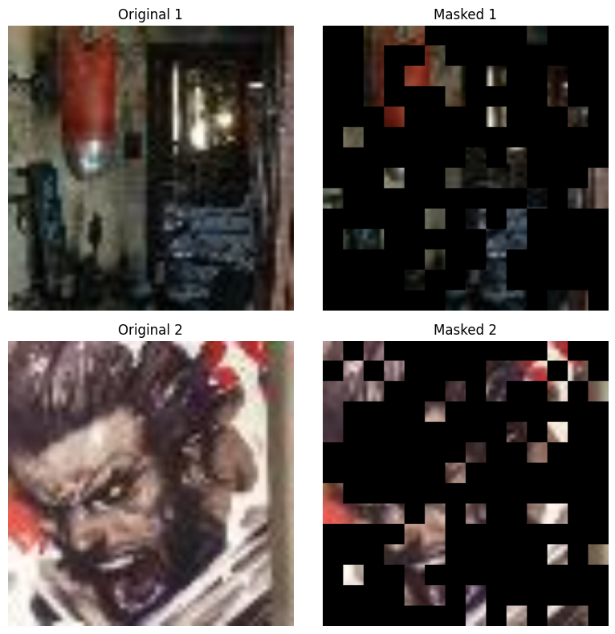

In [17]:
import torch
import torch.nn as nn
# =========================================================
# STEP 1: MLP BLOCK
# =========================================================
class MLP(nn.Module):
def __init__(self, dim, mlp_ratio=4.0):
super().__init__()
hidden_dim = int(dim * mlp_ratio)
self.fc1 = nn.Linear(dim, hidden_dim)
self.act = nn.GELU()
self.fc2 = nn.Linear(hidden_dim, dim)
def forward(self, x):
x = self.fc1(x)
x = self.act(x)
x = self.fc2(x)
return x
# =========================================================
# STEP 2: TRANSFORMER BLOCK
# =========================================================
class TransformerBlock(nn.Module):
def __init__(self, dim, num_heads):
super().__init__()
self.norm1 = nn.LayerNorm(dim)
self.attn = nn.MultiheadAttention(
embed_dim=dim,
num_heads=num_heads,
batch_first=True
)
self.norm2 = nn.LayerNorm(dim)
self.mlp = MLP(dim)
def forward(self, x):
# attention part
x_norm = self.norm1(x)
attn_out, _ = self.attn(x_norm, x_norm, x_norm)
x = x + attn_out
# mlp part
x = x + self.mlp(self.norm2(x))
return x
# =========================================================
# STEP 3: QUICK TEST
# =========================================================
# dummy visible patch tokens similar to encoder input
dummy_x = torch.randn(2, 49, 768) # (B, visible_patches, embed_dim)
block = TransformerBlock(dim=768, num_heads=12)
out = block(dummy_x)
print("Input shape :", dummy_x.shape)
print("Output shape:", out.shape)
# extra sanity checks
print("\nSame shape maintained:", dummy_x.shape == out.shape)
print("Any NaN in output:", torch.isnan(out).any().item())

Output:
Input shape : torch.Size([2, 49, 768])
Output shape: torch.Size([2, 49, 768])
Same shape maintained: True
Any NaN in output: False

In [18]:
import torch
import torch.nn as nn
# =========================================================
# MAE CONFIG
# =========================================================
ENC_DIM = 768
ENC_LAYERS = 12
ENC_HEADS = 12
DEC_DIM = 384
DEC_LAYERS = 12
DEC_HEADS = 6
# =========================================================
# FULL MAE MODEL
# =========================================================
class MAE(nn.Module):
def __init__(self):
super().__init__()
# patch embedding: 768 -> 768
self.patch_embed = nn.Linear(PATCH_DIM, ENC_DIM)
# encoder positional embeddings
self.enc_pos_embed = nn.Parameter(torch.randn(1, NUM_PATCHES, ENC_DIM) * 0.02)
# encoder blocks
self.encoder_blocks = nn.ModuleList([
TransformerBlock(dim=ENC_DIM, num_heads=ENC_HEADS)
for _ in range(ENC_LAYERS)
])
self.enc_norm = nn.LayerNorm(ENC_DIM)
# encoder to decoder projection
self.enc_to_dec = nn.Linear(ENC_DIM, DEC_DIM)
# mask token for decoder
self.mask_token = nn.Parameter(torch.randn(1, 1, DEC_DIM) * 0.02)
# decoder positional embeddings
self.dec_pos_embed = nn.Parameter(torch.randn(1, NUM_PATCHES, DEC_DIM) * 0.02)
# decoder blocks
self.decoder_blocks = nn.ModuleList([
TransformerBlock(dim=DEC_DIM, num_heads=DEC_HEADS)
for _ in range(DEC_LAYERS)
])
self.dec_norm = nn.LayerNorm(DEC_DIM)
# final prediction head: decoder dim -> patch pixels
self.decoder_pred = nn.Linear(DEC_DIM, PATCH_DIM)
def forward(self, imgs):
# -----------------------------------------
# 1. patchify images
# imgs: (B, 3, 224, 224)
# patches: (B, 196, 768)
# -----------------------------------------
patches = patchify(imgs, PATCH_SIZE)
# -----------------------------------------
# 2. patch embedding
# x: (B, 196, 768)
# -----------------------------------------
x = self.patch_embed(patches)
# -----------------------------------------
# 3. random masking
# x_visible: (B, 49, 768)
# -----------------------------------------
x_visible, mask, ids_restore, ids_keep = random_masking(
x, num_keep=VISIBLE_PATCHES
)
# -----------------------------------------
# 4. add encoder positional embeddings
# only for visible tokens
# -----------------------------------------
B = x.shape[0]
pos_embed = self.enc_pos_embed.repeat(B, 1, 1)
pos_visible = torch.gather(
pos_embed,
dim=1,
index=ids_keep.unsqueeze(-1).repeat(1, 1, ENC_DIM)
)
x_visible = x_visible + pos_visible
# -----------------------------------------
# 5. encoder
# -----------------------------------------
for blk in self.encoder_blocks:
x_visible = blk(x_visible)
x_visible = self.enc_norm(x_visible)
# -----------------------------------------
# 6. project encoder output to decoder dim
# -----------------------------------------
x_dec = self.enc_to_dec(x_visible) # (B, 49, 384)
# -----------------------------------------
# 7. append mask tokens
# we need full 196 tokens for decoder
# -----------------------------------------
num_masked = NUM_PATCHES - x_dec.shape[1]
mask_tokens = self.mask_token.repeat(B, num_masked, 1)
x_full = torch.cat([x_dec, mask_tokens], dim=1) # (B, 196, 384)
# restore original patch order
x_full = torch.gather(
x_full,
dim=1,
index=ids_restore.unsqueeze(-1).repeat(1, 1, DEC_DIM)
)
# -----------------------------------------
# 8. add decoder positional embeddings
# -----------------------------------------
x_full = x_full + self.dec_pos_embed
# -----------------------------------------
# 9. decoder
# -----------------------------------------
for blk in self.decoder_blocks:
x_full = blk(x_full)
x_full = self.dec_norm(x_full)
# -----------------------------------------
# 10. predict pixel values of all patches
# pred: (B, 196, 768)
# -----------------------------------------
pred = self.decoder_pred(x_full)
return pred, mask, patches
# =========================================================
# TEST FORWARD PASS
# =========================================================
model = MAE()
sample_images, _ = next(iter(train_loader))
sample_images = sample_images[:2] # test on 2 images
pred, mask, target = model(sample_images)
print("Input images shape :", sample_images.shape) # (2, 3, 224, 224)
print("Pred shape :", pred.shape) # (2, 196, 768)
print("Mask shape :", mask.shape) # (2, 196)
print("Target shape :", target.shape) # (2, 196, 768)
print("\nVisible count for first image:", int((mask[0] == 0).sum().item()))
print("Masked count for first image :", int((mask[0] == 1).sum().item()))
print("Any NaN in pred:", torch.isnan(pred).any().item())

Output:
Input images shape : torch.Size([2, 3, 224, 224])
Pred shape : torch.Size([2, 196, 768])
Mask shape : torch.Size([2, 196])
Target shape : torch.Size([2, 196, 768])
Visible count for first image: 49
Masked count for first image : 147
Any NaN in pred: False

In [19]:
import torch
from torch.optim import AdamW
# =========================================================
# STEP 1: DEVICE
# =========================================================
device = torch.device("cuda" if torch.cuda.is_available() else "cpu")
print("Using device:", device)
model = MAE().to(device)
# =========================================================
# STEP 2: MAE LOSS
# loss only on masked patches
# pred : (B, 196, 768)
# target : (B, 196, 768)
# mask : (B, 196) where 1 = masked, 0 = visible
# =========================================================
def mae_loss(pred, target, mask):
loss = (pred - target) ** 2 # (B, 196, 768)
loss = loss.mean(dim=-1) # (B, 196), patch-wise MSE
loss = (loss * mask).sum() / mask.sum()
return loss
# =========================================================
# STEP 3: OPTIMIZER
# =========================================================
optimizer = AdamW(model.parameters(), lr=1e-4, weight_decay=0.05)
# =========================================================
# STEP 4: ONE TRAINING STEP TEST
# =========================================================
model.train()
sample_images, _ = next(iter(train_loader))
sample_images = sample_images[:4].to(device) # small test batch
optimizer.zero_grad()
pred, mask, target = model(sample_images)
loss = mae_loss(pred, target, mask)
print("\nBefore backward:")
print("Pred shape :", pred.shape)
print("Mask shape :", mask.shape)
print("Target shape :", target.shape)
print("Loss value :", loss.item())
loss.backward()
optimizer.step()
print("\nOne training step completed successfully")
print("Any NaN in loss:", torch.isnan(loss).item())

Output:
Using device: cuda
Before backward:
Pred shape : torch.Size([4, 196, 768])
Mask shape : torch.Size([4, 196])
Target shape : torch.Size([4, 196, 768])
Loss value : 0.7413842678070068
One training step completed successfully
Any NaN in loss: False

In [20]:
import torch
from torch.optim import AdamW
from torch.optim.lr_scheduler import CosineAnnealingLR
from tqdm import tqdm
# =========================================================
# STEP 1: TRAINING SETTINGS
# =========================================================
EPOCHS = 2
LR = 1e-4
WEIGHT_DECAY = 0.05
model = MAE().to(device)
optimizer = AdamW(model.parameters(), lr=LR, weight_decay=WEIGHT_DECAY)
scheduler = CosineAnnealingLR(optimizer, T_max=EPOCHS)
use_amp = torch.cuda.is_available()
scaler = torch.cuda.amp.GradScaler(enabled=use_amp)
train_losses = []
print("AMP enabled:", use_amp)
print("Starting training...\n")
# =========================================================
# STEP 2: FULL TRAINING LOOP
# =========================================================
for epoch in range(EPOCHS):
model.train()
total_loss = 0.0
pbar = tqdm(train_loader, desc=f"Epoch {epoch+1}/{EPOCHS}")
for images, _ in pbar:
images = images.to(device, non_blocking=True)
optimizer.zero_grad()
with torch.cuda.amp.autocast(enabled=use_amp):
pred, mask, target = model(images)
loss = mae_loss(pred, target, mask)
scaler.scale(loss).backward()
torch.nn.utils.clip_grad_norm_(model.parameters(), 1.0)
scaler.step(optimizer)
scaler.update()
total_loss += loss.item()
pbar.set_postfix(loss=f"{loss.item():.4f}")
avg_loss = total_loss / len(train_loader)
train_losses.append(avg_loss)
scheduler.step()
print(f"Epoch {epoch+1} completed | Average Loss: {avg_loss:.4f}")
print("\nTraining finished")
print("Loss history:", train_losses)

Output:
/tmp/ipykernel_55/463213492.py:18: FutureWarning: `torch.cuda.amp.GradScaler(args...)` is deprecated. Please use `torch.amp.GradScaler('cuda', args...)` instead.
scaler = torch.cuda.amp.GradScaler(enabled=use_amp)
AMP enabled: True
Starting training...
Epoch 1/2: 0%| | 0/3125 [00:00<?, ?it/s]/tmp/ipykernel_55/463213492.py:39: FutureWarning: `torch.cuda.amp.autocast(args...)` is deprecated. Please use `torch.amp.autocast('cuda', args...)` instead.
with torch.cuda.amp.autocast(enabled=use_amp):
Epoch 1/2: 100%|██████████| 3125/3125 [14:26<00:00, 3.61it/s, loss=0.0584]
Epoch 1 completed | Average Loss: 0.0506
Epoch 2/2: 100%|██████████| 3125/3125 [14:30<00:00, 3.59it/s, loss=0.0406]
Epoch 2 completed | Average Loss: 0.0436
Training finished
Loss history: [0.05061507845878601, 0.043628086557388306]

In [21]:
import numpy as np
import matplotlib.pyplot as plt
import torch
# =========================================================
# STEP 1: LOSS GRAPH
# =========================================================
plt.figure(figsize=(6, 4))
plt.plot(train_losses, marker='o')
plt.title("Training Loss vs Epochs")
plt.xlabel("Epoch")
plt.ylabel("Loss")
plt.grid(True)
plt.show()
# =========================================================
# STEP 2: RECONSTRUCTION HELPERS
# =========================================================
def reconstruct_images_from_pred(pred, patch_size=16, img_size=224):
recon_imgs = unpatchify(pred, patch_size, img_size)
return recon_imgs
def make_masked_image(imgs, mask, patch_size=16, img_size=224):
patches = patchify(imgs, patch_size)
mask_expanded = mask.unsqueeze(-1).repeat(1, 1, patches.shape[-1])
masked_patches = patches.clone()
masked_patches[mask_expanded.bool()] = 0
masked_imgs = unpatchify(masked_patches, patch_size, img_size)
return masked_imgs
# =========================================================
# STEP 3: SHOW ORIGINAL / MASKED / RECONSTRUCTED
# =========================================================
model.eval()
sample_images, _ = next(iter(train_loader))
sample_images = sample_images[:5].to(device)
with torch.no_grad():
pred, mask, target = model(sample_images)
recon_imgs = reconstruct_images_from_pred(pred, PATCH_SIZE, IMG_SIZE)
masked_imgs = make_masked_image(sample_images, mask, PATCH_SIZE, IMG_SIZE)
sample_images_np = sample_images.cpu().permute(0, 2, 3, 1).numpy()
masked_imgs_np = masked_imgs.cpu().permute(0, 2, 3, 1).numpy()
recon_imgs_np = recon_imgs.cpu().permute(0, 2, 3, 1).numpy()
fig, axes = plt.subplots(5, 3, figsize=(10, 16))
for i in range(5):
axes[i, 0].imshow(np.clip(sample_images_np[i], 0, 1))
axes[i, 0].set_title("Original")
axes[i, 0].axis("off")
axes[i, 1].imshow(np.clip(masked_imgs_np[i], 0, 1))
axes[i, 1].set_title("Masked")
axes[i, 1].axis("off")
axes[i, 2].imshow(np.clip(recon_imgs_np[i], 0, 1))
axes[i, 2].set_title("Reconstructed")
axes[i, 2].axis("off")
plt.tight_layout()
plt.show()

Output:
<Figure size 600x400 with 1 Axes>
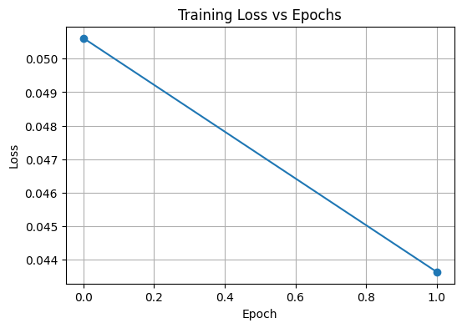
<Figure size 1000x1600 with 15 Axes>
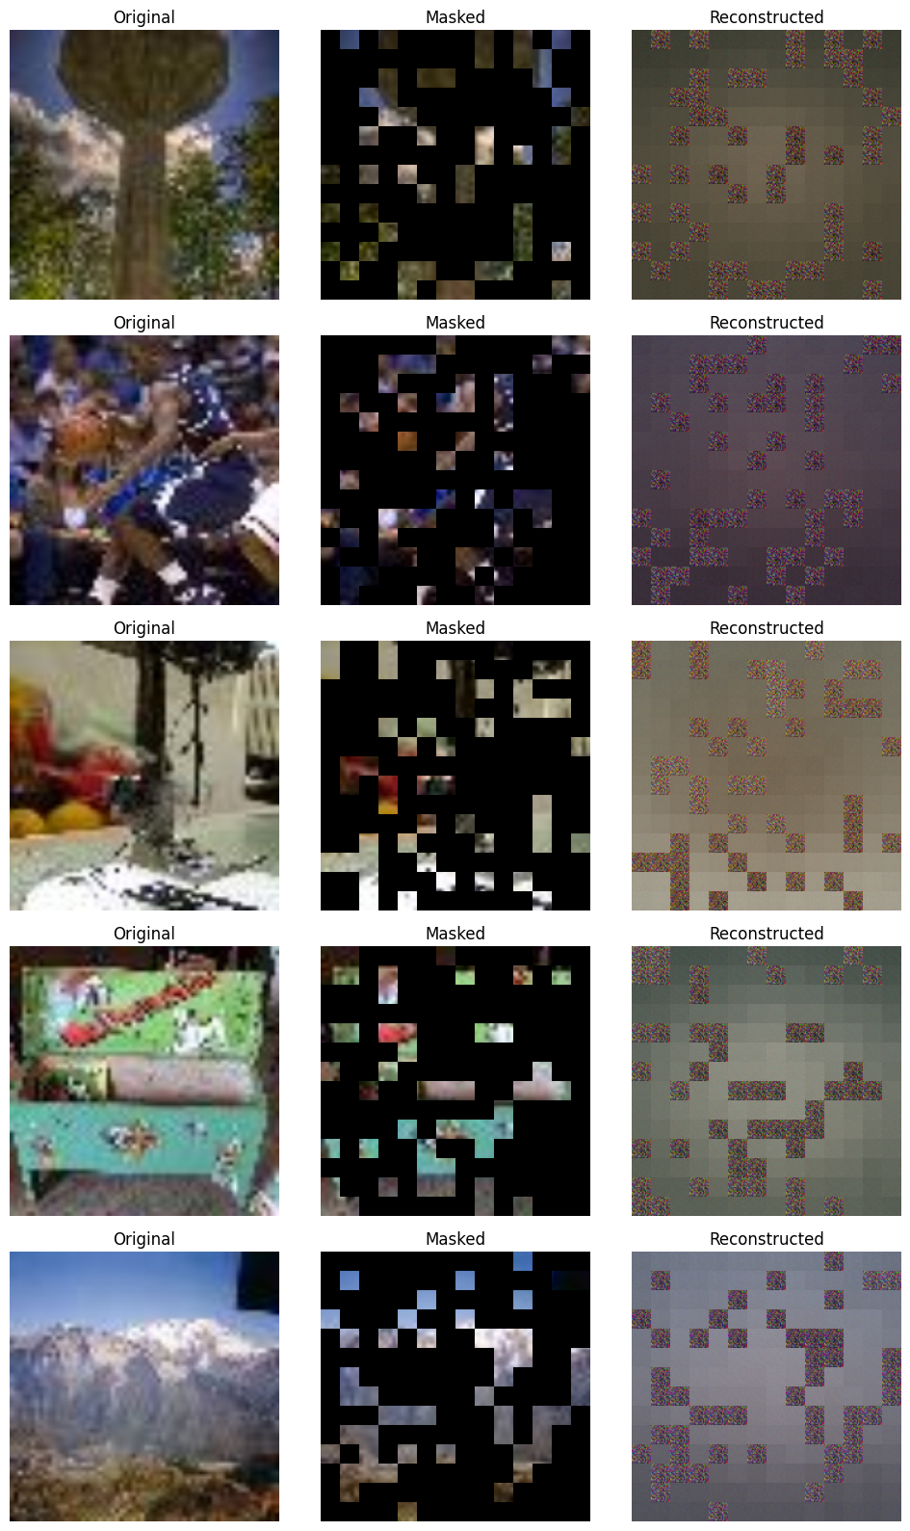

In [22]:
import numpy as np
import matplotlib.pyplot as plt
import torch
# =========================================================
# STEP 1: BUILD FINAL RECONSTRUCTION
# visible patches -> take from original
# masked patches -> take from model prediction
# =========================================================
def combine_visible_and_predicted(original_imgs, pred, mask, patch_size=16, img_size=224):
"""
original_imgs: (B, 3, 224, 224)
pred: (B, 196, 768)
mask: (B, 196) 1=masked, 0=visible
"""
original_patches = patchify(original_imgs, patch_size) # (B, 196, 768)
mask_expanded = mask.unsqueeze(-1).repeat(1, 1, original_patches.shape[-1])
# visible patches from original, masked patches from prediction
final_patches = original_patches.clone()
final_patches[mask_expanded.bool()] = pred[mask_expanded.bool()]
final_imgs = unpatchify(final_patches, patch_size, img_size)
return final_imgs
# =========================================================
# STEP 2: SHOW BETTER VISUALIZATION
# =========================================================
model.eval()
sample_images, _ = next(iter(train_loader))
sample_images = sample_images[:5].to(device)
with torch.no_grad():
pred, mask, target = model(sample_images)
masked_imgs = make_masked_image(sample_images, mask, PATCH_SIZE, IMG_SIZE)
final_recon_imgs = combine_visible_and_predicted(sample_images, pred, mask, PATCH_SIZE, IMG_SIZE)
sample_images_np = sample_images.cpu().permute(0, 2, 3, 1).numpy()
masked_imgs_np = masked_imgs.cpu().permute(0, 2, 3, 1).numpy()
final_recon_np = final_recon_imgs.cpu().permute(0, 2, 3, 1).numpy()
fig, axes = plt.subplots(5, 3, figsize=(10, 16))
for i in range(5):
axes[i, 0].imshow(np.clip(sample_images_np[i], 0, 1))
axes[i, 0].set_title("Original")
axes[i, 0].axis("off")
axes[i, 1].imshow(np.clip(masked_imgs_np[i], 0, 1))
axes[i, 1].set_title("Masked")
axes[i, 1].axis("off")
axes[i, 2].imshow(np.clip(final_recon_np[i], 0, 1))
axes[i, 2].set_title("Final Reconstruction")
axes[i, 2].axis("off")
plt.tight_layout()
plt.show()

Output:
<Figure size 1000x1600 with 15 Axes>
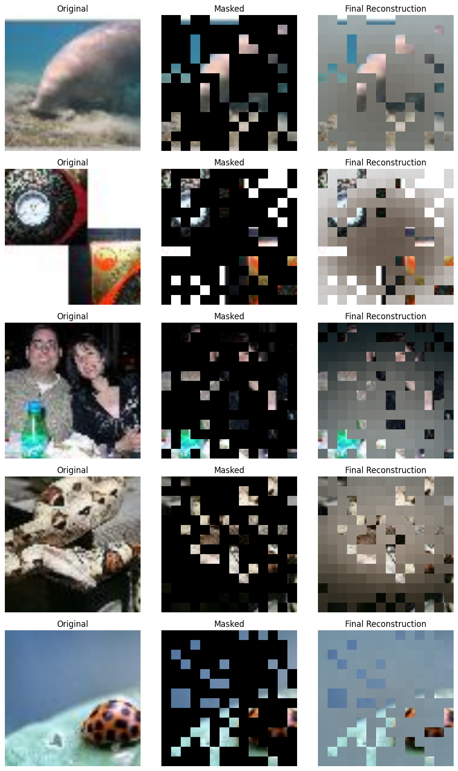

In [23]:
import numpy as np
import torch
from skimage.metrics import peak_signal_noise_ratio as psnr_metric
from skimage.metrics import structural_similarity as ssim_metric
# =========================================================
# STEP 1: EVALUATION FUNCTION
# =========================================================
def evaluate_psnr_ssim(model, dataloader, num_batches=5):
model.eval()
psnr_scores = []
ssim_scores = []
with torch.no_grad():
for batch_idx, (images, _) in enumerate(dataloader):
if batch_idx >= num_batches:
break
images = images.to(device)
pred, mask, target = model(images)
# final reconstruction = visible from original + masked from prediction
final_recon = combine_visible_and_predicted(
images, pred, mask, PATCH_SIZE, IMG_SIZE
)
orig_np = images.cpu().permute(0, 2, 3, 1).numpy()
recon_np = final_recon.cpu().permute(0, 2, 3, 1).numpy()
for i in range(orig_np.shape[0]):
orig_img = np.clip(orig_np[i], 0, 1)
recon_img = np.clip(recon_np[i], 0, 1)
psnr_value = psnr_metric(orig_img, recon_img, data_range=1.0)
ssim_value = ssim_metric(
orig_img,
recon_img,
channel_axis=-1,
data_range=1.0
)
psnr_scores.append(psnr_value)
ssim_scores.append(ssim_value)
avg_psnr = float(np.mean(psnr_scores))
avg_ssim = float(np.mean(ssim_scores))
print("Evaluation completed")
print("Images evaluated:", len(psnr_scores))
print("Average PSNR:", avg_psnr)
print("Average SSIM:", avg_ssim)
return avg_psnr, avg_ssim
# =========================================================
# STEP 2: RUN EVALUATION
# =========================================================
avg_psnr, avg_ssim = evaluate_psnr_ssim(model, train_loader, num_batches=5)

Output:
Evaluation completed
Images evaluated: 160
Average PSNR: 15.798672679162811
Average SSIM: 0.4514067769050598

In [24]:
import os
import torch
from torch.optim import AdamW
from torch.optim.lr_scheduler import CosineAnnealingLR
from tqdm import tqdm
# =========================================================
# STEP 1: SAVE CURRENT MODEL
# =========================================================
save_path = "/kaggle/working/mae_tinyimagenet_epoch2.pth"
torch.save(model.state_dict(), save_path)
print("Model saved at:")
print(save_path)
print("File exists:", os.path.exists(save_path))
# =========================================================
# STEP 2: CLEAN TRAINING FUNCTION (NEW AMP STYLE)
# use this later for longer training like 10, 20 epochs
# =========================================================
def train_mae(model, train_loader, epochs=5, lr=1e-4, weight_decay=0.05):
optimizer = AdamW(model.parameters(), lr=lr, weight_decay=weight_decay)
scheduler = CosineAnnealingLR(optimizer, T_max=epochs)
use_amp = torch.cuda.is_available()
scaler = torch.amp.GradScaler('cuda', enabled=use_amp)
losses = []
print("AMP enabled:", use_amp)
print("Training started...\n")
for epoch in range(epochs):
model.train()
total_loss = 0.0
pbar = tqdm(train_loader, desc=f"Epoch {epoch+1}/{epochs}")
for images, _ in pbar:
images = images.to(device, non_blocking=True)
optimizer.zero_grad()
with torch.amp.autocast('cuda', enabled=use_amp):
pred, mask, target = model(images)
loss = mae_loss(pred, target, mask)
scaler.scale(loss).backward()
torch.nn.utils.clip_grad_norm_(model.parameters(), 1.0)
scaler.step(optimizer)
scaler.update()
total_loss += loss.item()
pbar.set_postfix(loss=f"{loss.item():.4f}")
avg_loss = total_loss / len(train_loader)
losses.append(avg_loss)
scheduler.step()
print(f"Epoch {epoch+1} completed | Average Loss: {avg_loss:.4f}")
print("\nTraining finished")
return losses
# =========================================================
# STEP 3: OPTIONAL LOAD CHECK
# =========================================================
test_model = MAE().to(device)
test_model.load_state_dict(torch.load(save_path, map_location=device))
test_model.eval()
print("\nSaved weights loaded successfully into a new model")

Output:
Model saved at:
/kaggle/working/mae_tinyimagenet_epoch2.pth
File exists: True
Saved weights loaded successfully into a new model

In [ ]:
!pip install -q gradio==4.44.1 websockets==12.0

In [ ]:
import gradio as gr
import numpy as np
import torch
from torchvision import transforms
app_model = MAE().to(device)
app_model.load_state_dict(torch.load("/kaggle/working/mae_tinyimagenet_epoch2.pth", map_location=device))
app_model.eval()
app_transform = transforms.Compose([
transforms.Resize((224, 224)),
transforms.ToTensor()
])
def tensor_to_numpy_img(tensor_img):
img = tensor_img.detach().cpu().permute(1, 2, 0).numpy()
return np.clip(img, 0, 1)
def mae_demo(input_image):
if input_image is None:
return None, None, None
img_tensor = app_transform(input_image).unsqueeze(0).to(device)
with torch.no_grad():
pred, mask, target = app_model(img_tensor)
masked_img = make_masked_image(img_tensor, mask, PATCH_SIZE, IMG_SIZE)
final_recon = combine_visible_and_predicted(img_tensor, pred, mask, PATCH_SIZE, IMG_SIZE)
return (
tensor_to_numpy_img(img_tensor[0]),
tensor_to_numpy_img(masked_img[0]),
tensor_to_numpy_img(final_recon[0]),
)
with gr.Blocks() as demo:
gr.Markdown("# Masked Autoencoder on TinyImageNet")
gr.Markdown("Upload an image to view original, masked, and reconstructed output.")
inp = gr.Image(type="pil", label="Upload Image")
btn = gr.Button("Run")
out1 = gr.Image(type="numpy", label="Original")
out2 = gr.Image(type="numpy", label="Masked")
out3 = gr.Image(type="numpy", label="Reconstructed")
btn.click(mae_demo, inputs=inp, outputs=[out1, out2, out3])
demo.launch(inline=True, share=False)

