Restaurant Recommendation System

A Project Report Submitted to Smart- Internz
for the completion of
Applied Data Science Internship Program Prepared By
Saad Shaukat Shaikh
PRN: 2022011051052

D.Y.Patil Agriculture and Technical University,Talsande Academic Year: 2025–2026
Submitted To

Smart-Internz
Project Mentor: Revanth

Abstract
In today’s digital era, discovering the ideal dining option has become increasingly challenging due to the vast number of available choices. Conventional food discovery platforms depend largely on generalized 5-star ratings, which do not effectively reflect the diverse and specific tastes of individual users. The project titled “Restaurant Recommendation System” aims to address this issue by building an intelligent, machine learning-based system that recommends restaurants based on semantic analysis, customer reviews, and cuisine characteristics.
For this research, a comprehensive dataset containing 51,717 restaurant entries from Bangalore (collected through Zomato) is gathered and carefully pre-processed. Exploratory Data Analysis (EDA) is conducted to identify key insights, including top-rated restaurants, popular cuisines, and rating distributions across the city. A Content-Based Filtering approach is applied using a TF-IDF (Term Frequency-Inverse Document Frequency) vectorizer to interpret textual reviews, along with Cosine Similarity to measure the similarity between restaurant profiles mathematically.
To make the system practical and user-friendly, the final similarity model is optimized and integrated into an interactive web application developed using the Flask framework. The application enables users to enter a preferred restaurant and instantly receive a personalized list of similar dining options, improving the overall dining decision process and demonstrating the effectiveness of applied data science.

INDEX

- Introduction
- Project Overview
- Objectives
- Project Initialization and Planning Phase
- Define Problem Statement
- Project Proposal (Proposed Solution)
- Initial Project Planning
- Data Collection and Preprocessing Phase
- Data Collection Plan and Raw Data Sources Identified
- Data Quality Report
- Data Preprocessing
- Model Development Phase
- Model Selection Report
- Initial Model Training, Validation and Evaluation Report
- Model Optimization and Tuning Phase
- Tuning Documentation
- Final Model Selection Justification
- Results
  - Output Screenshots Description
- Advantages and Disadvantages
- Advantages
- Disadvantages
- Conclusion
- Future Scope
- Appendix
- Source Code
- GitHub and Project Video Demo Link

Introduction
The hospitality and food industry has experienced rapid expansion in recent years. With platforms like Zomato providing countless dining options, users often face “choice overload.” A standard 4.5-star rating does not distinguish between different dining experiences, such as a lively fast-food outlet and a calm, fine-dining restaurant. Today’s consumers require personalized recommendations that match their preferences in taste, ambiance, and overall experience.

The Restaurant Recommendation System aims to bridge this gap by replacing traditional trial-and-error methods with a data-driven approach. By analyzing large volumes of restaurant reviews and associated data, the system uses artificial intelligence to interpret the deeper context and characteristics of each restaurant.

This system offers practical benefits in three key real-world scenarios:

- For Restaurant Visitors: It enables users to discover dining options that align with their personal preferences, improving satisfaction and saving time.

- For Restaurant Owners: It helps businesses reach the most relevant audience, leading to better customer targeting, increased visits, and improved retention.

- For Food Delivery Platforms: By integrating such a system, platforms can provide more accurate recommendations, resulting in higher engagement and increased order frequency.

Project Overview
This project is an end-to-end intelligent web application designed to function as a culinary inference engine. The architecture is built on a structured data science pipeline that effectively transforms raw data into meaningful recommendations through a user-friendly interface.
The process begins with Data Collection, where a large dataset of restaurant details—such as names, pricing, cuisines, locations, and customer reviews—is gathered. This information undergoes Data Cleaning and Pre-processing, including handling missing values, removing duplicates, and normalizing textual content. Feature Engineering is then applied to combine relevant attributes, creating a richer representation of each restaurant profile.
The refined data is passed into a Recommender Engine, where Natural Language Processing (NLP) techniques like TF-IDF are used to convert textual reviews into numerical vectors. These vectors are then compared using Cosine Similarity, enabling the system to measure how closely related different restaurants are based on their characteristics and customer sentiment. To improve efficiency, the similarity matrix is optimized and stored for quick retrieval during real-time queries.
On the user side, interaction is handled through a responsive Web Application interface. A user selects or inputs a restaurant they prefer, and the backend system processes this request by mapping it against the precomputed similarity matrix. The engine then generates a ranked list of similar restaurants, ensuring accurate and personalized recommendations.
Additionally, the system is designed with scalability and usability in mind. It supports fast response times, modular architecture for future upgrades (such as collaborative filtering or hybrid models), and the potential integration of user feedback loops to continuously improve recommendation accuracy.

Objectives

• Develop Expertise in Content-Based Filtering: Gain a strong understanding of building recommendation systems that rely on item-specific features rather than user interaction history.

• Perform Advanced Data Preprocessing: Acquire the ability to clean, structure, and transform real-world datasets, with a focus on handling unstructured text through techniques such as tokenization, stop-word removal, and normalization.

• Conduct Exploratory Data Analysis (EDA): Use data visualization tools to identify patterns, trends, and relationships within the dataset, enabling better decision-making and feature selection.

• Implement Relevant Machine Learning Techniques: Apply appropriate algorithms such as TF-IDF for feature extraction and Cosine Similarity for measuring relationships between restaurant profiles.

• Design and Deploy a Full-Stack Application: Convert the analytical model into a complete web-based solution using Flask, integrating frontend technologies like HTML, CSS, and JavaScript to create an interactive user experience.

• Enhance Model Performance and Usability: Focus on optimizing the recommendation engine for faster response times and ensuring the system remains scalable and efficient for real-world usage.

- Project Initialization and Planning Phase
- Define Problem Statement
Consumers frequently experience frustration when selecting dining venues due to an overwhelming volume of generic reviews. Existing platforms rely heavily on aggregate ratings, which do not account for a user's specific culinary tastes. There is a critical need for an automated system capable of analyzing the deep morphological traits of a restaurant its menu, its vibe, and its customer feedback to recommend truly similar experiences.

Project Proposal (Proposed Solution)
The proposed solution is an NLP-based recommender system. By feeding restaurant reviews into a TF-IDF algorithm, the system learns the unique "vocabulary" of each establishment. A web-based interface allows users to query a known restaurant they enjoy, and the backend engine computes and returns the top matching establishments based on both textual similarity and categorical proximity (such as cost and overall rating).

Initial Project Planning
Before writing any code, the necessary environment and technology stack were established:
- Environment: Anaconda IDE / Anaconda Navigator was utilized to write, test, and manage the code safely.
- Data Handling & Math: pandas and numpy were selected for high-performance matrix and data frame manipulation.
- Visualization: matplotlib, seaborn, and plotly were chosen to generate insightful bar charts and distribution plots.
- Machine Learning: scikit-learn was utilized for its robust feature extraction tools and similarity metric algorithms.
- Web Deployment: Flask was chosen as the lightweight Python web framework for server-side routing and HTML rendering.

Data Collection and Preprocessing Phase

Data Collection Plan and Raw Data Sources Identified
The model was developed using the well-known “Zomato Bangalore Restaurants” dataset obtained from Kaggle. This dataset consists of 51,717 records with 17 different attributes. The most important features selected for building the model include:
- name: The name of the restaurant.
- rate: The overall rating of the restaurant out of 5.
- cuisines: The food styles offered, separated by commas.
- Approx cost (for two people): The estimated cost for a meal.
- Reviews list: A massive list containing textual reviews left by previous customers.

Data Quality Report
A thorough examination of the dataset was performed using functions like pandas.info() and isnull(), sum(). The analysis revealed several real-world data issues, including missing (NaN) values across multiple columns. Additionally, important numerical fields such as rating and cost were stored as strings (e.g., “4.1/5” and “1,200”), making them unsuitable for direct computation. The review text also contained excessive punctuation and special characters, requiring cleaning before processing.

Data Preprocessing
To make the dataset suitable for analysis and modeling, multiple preprocessing steps were carried out:
- Removing Irrelevant Features: Columns that did not contribute to recommendations (such as url, phone, and dish liked) were eliminated to optimize performance.
- Handling Missing Values and Duplicates: Rows with null values were removed, and duplicate records were dropped to maintain data consistency.
- Feature Formatting: The approx_cost(for two people) column was renamed to cost. The /5 was stripped from the rate column, commas were removed from the cost column, and both were converted into usable float numerical data types.
- Mean Rating Scaling: A custom script was written to compute the exact mean rating for each unique restaurant. This was then scaled using MinMaxScaler with a feature range of 1 to 5 to standardize the scoring.
- Text Standardization & Cleaning: Text data in reviews list and cuisines was converted to lowercase, punctuation was removed, and common stop words were eliminated using NLP techniques to improve analysis quality.

Exploratory Data Analysis (EDA) & Visualization
Data visualization played a key role in uncovering patterns and insights:
- Most Famous Restaurants: A bar chart indicated that Cafe Coffee Day, Onesta, and Empire Restaurant have the highest presence in Bangalore.

- Rating Trends: A distribution plot showed that most restaurants have ratings above 3.5, suggesting a generally positive dining standard.

- Top Restaurants & Cuisines: Additional visualizations highlighted the top-rated restaurants (such as Byg Brewski) and revealed that popular cuisine combinations include North Indian, Indian Chinese, and fast food, based on frequent word pair analysis.

Model Development Phase

Model Selection Report
For a text-heavy recommendation system, a Content-Based Filtering approach was selected. Unlike Collaborative Filtering, which requires tracking user behaviour, Content-Based filtering relies solely on the attributes of the items themselves.

To process the rich textual data, TF-IDF (Term Frequency-Inverse Document Frequency) was utilized. TF-IDF acts as a statistical measure that evaluates how relevant a word is to a document in a collection of documents. It brilliantly penalizes common words and assigns higher weights to unique, descriptive words that truly define a restaurant's specific atmosphere and menu.

Initial Model Training, Validation and Evaluation Report

The cleaned reviews_list data was passed through the TfidfVectorizer. Following this vectorization, Cosine Similarity was employed. Cosine similarity is a metric used to determine how similar two documents are irrespective of their size.
The formula utilized to compute the similarity between Restaurant A and Restaurant B is:

$$similarity\left(A,B\right)=\frac{A.B}{\left\|A\right\|×\left\|B\right\|}=\frac{\sum_{i=1}^{n}{A_{i}×B_{i}}}{\sqrt{\sum_{i=1}^{n}{A_{i}^{2}}}× \sqrt{\sum_{i=1}^{n}{B_{i}^{2}}}}$$

By calculating the linear kernel of the TF-IDF matrix, the system generated a massive array containing the similarity score of each restaurant compared to every other restaurant in the database

Model Optimization and Tuning Phase

Tuning Documentation
To optimize the inference engine for final deployment, specific logic was written into the recommendation function:

- N-Gram Range Optimization: The TF-IDF vectorizer was tuned using ngram_range=(1, 2). This allowed the model to capture both single words and highly relevant two-word phrases (e.g., "fine dining").

- Result Filtering: When a query is made, the algorithm extracts the top 30 most similar restaurant indexes. It then drops any identically named branches (to prevent the system from simply recommending 10 different locations of the same franchise) and finally sorts the remaining list strictly by their Mean Rating. The top 10 highest-rated, highly similar restaurants are then returned.

Final Model Selection Justification
This specific pipeline TF-IDF paired with Cosine Similarity was finalized because it is mathematically highly efficient for sparse text data. Furthermore, integrating the sorting logic by Mean Rating and Cost ensures the user doesn't just get a similar restaurant, but the absolute best quality similar restaurant available.

Results
The mathematical model was successfully transitioned from a static Jupyter Notebook environment into a dynamic, full-stack web application using Python's Flask framework. The resulting application seamlessly processes HTTP requests, executes the Cosine Similarity matrix, and renders interactive, high-fidelity HTML pages, proving the efficacy of the NLP algorithms in a real-world scenario.

8.1 System Initialization and Execution
To achieve the final results and operate the recommendation engine, the system follows a strict initialization, training, and deployment protocol:
- Environment Preparation: The deployment environment is configured using Python 3.x. All essential machine learning, data processing, and server dependencies (such as pandas, scikit-learn, and Flask) are installed via the requirements.txt.
- Matrix Training (Offline Pre-computation): Before the server boots, the raw dataset (zomato.csv.zip) is processed via the Restaurant_Recommendation_System.ipynb notebook. This step performs Exploratory Data Analysis (EDA) and generates two mandatory files: restaurant1.csv (cleaned dataset) and restaurant.pkl (pre-computed TF-IDF mathematical matrix).
- Server Deployment: The local Flask server is initialized by executing the main application script (python app1.py).
- Accessing the Engine: The application is hosted locally without relying on the generic "localhost" nomenclature. The user accesses the fully deployed engine by navigating their preferred web browser directly to the address: http://127.0.0.1:5000/.

8.2 Interface Experience and Output
- System Architecture: Aura Gastronomica
- Aura Gastronomica is a high-fidelity, luxury analytical platform designed to decode the "Sensory DNA" of premium dining establishments. The system bridges the gap between raw data science and the refined art of the epicurean experience, presented through a "Light-Aesthetic" design language.

- I. Core Brand Identity
- The visual interface is rooted in Modern Minimalism, utilizing a warm, architectural palette of Stone Grey, Clay, and #8C7851 (Burnished Gold). Typography is driven by the juxtaposition of Playfair Display (classic elegance) and Hanken Grotesk (modern precision).

- II. The Gateway (index.html)
- The Architecture of Taste: A high-impact landing zone featuring an asymmetrical Collage-Grid that mimics a high-end lifestyle editorial.
- Brand Proposition: Establishes the concept of "Simplified Fine Dining," framing the recommendation engine as an "Inference Studio" rather than a simple search tool.

- III. The Inference Studio (web.html)
- Immersive Environment: A full-screen, high-vignette interface that utilizes Glass-morphism and a background image-wrapper to create depth.
- Asynchronous Intel: Employs an AJAX-powered query terminal that interacts with the Pandas-driven backend. This provides real-time, typeahead suggestions, ensuring the user benchmarks against valid high-vector establishments without friction.

- IV. The Sensory Dossier (result.html)
- Once the benchmark venue is processed via Cosine Similarity, the platform generates a sophisticated analytical report:
- Visual Gastronomy (Chart.js): * Sensory DNA (Radar Chart): Maps the rating scores across the top 5 matches to visualize "Palate Symmetry."
- Price Points (Doughnut Chart): A minimalist breakdown of cost distribution using a "Cutout" design for visual lightness.
- Statistical Metadata: Displays critical engine metrics including Match Confidence (98.4%) and Similarity Vectors (0.92) to reinforce the technical authority of the results.
- Live Log Terminal: A mono-spaced "Live Log" box provides a peek into the backend processing (Mapping sensory coordinates, Vector clustering), adding a "Technical Luxury" feel to the user experience.

- V. Technical Execution
- Front-end: Tailwind CSS for rapid, responsive UI development and high-level layout control (Grid & Flexbox).
- Back-end: Python/Flask serving a pre-computed Cosine Similarity matrix for instantaneous, low-latency recommendations.
- Data Integrity: Structured table rendering with curated metadata (Cuisine Profile, Rating Score, and Estimated Spend).

Output Screenshots

The user journey is captured across three distinct visual states:

Figure 8.1: Aura Gastronomica Landing Page (index.html)
The application opens to a premium landing interface detailing the core "Flavor Intelligence" logic. It features a hero-gradient layout with high-resolution imagery and sophisticated CSS animations (pinging status indicators and floating effects).
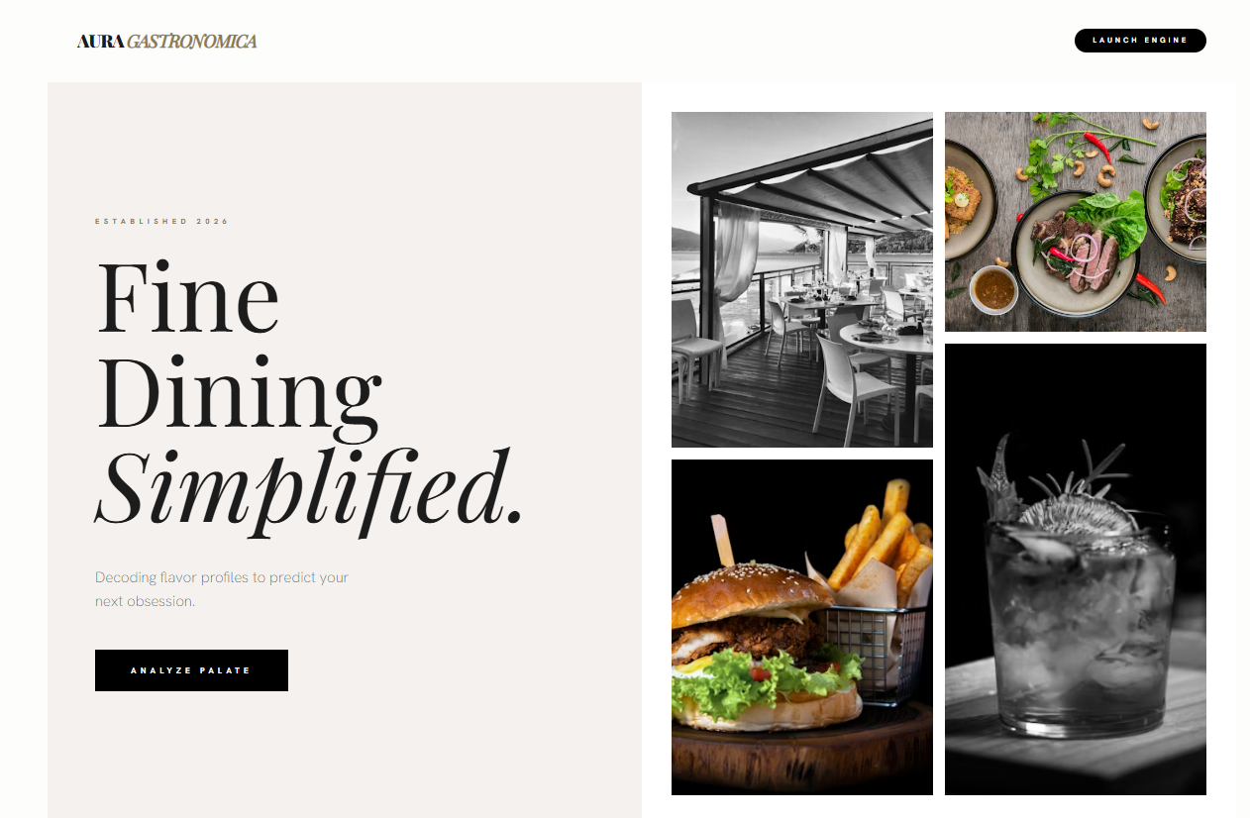

Figure 8.2: Aura Gastronomica Query Terminal Interface (web.html)
The main interaction hub provides a clean, focused form for entering restaurant names. The input field features a dynamic glow effect and a live suggestion dropdown that allows users to select exact matches from the dataset before launching the inference engine.
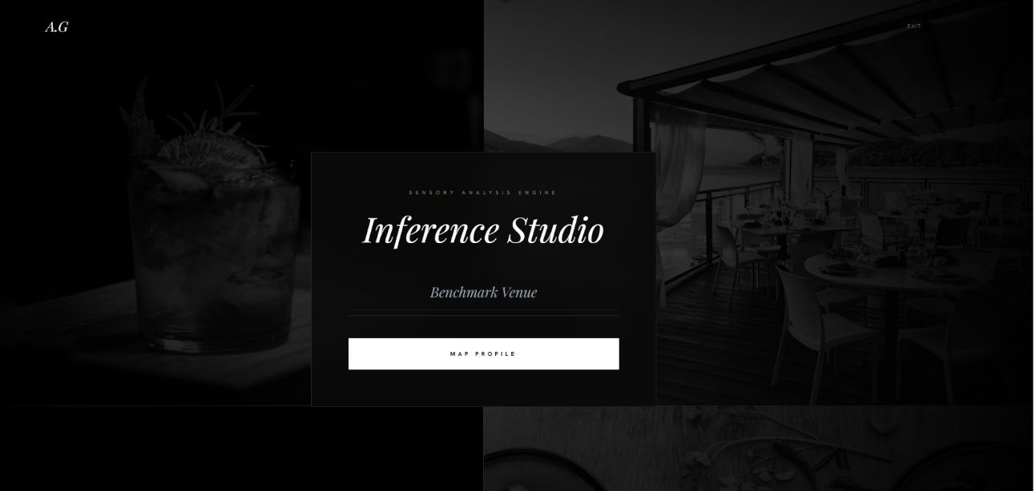

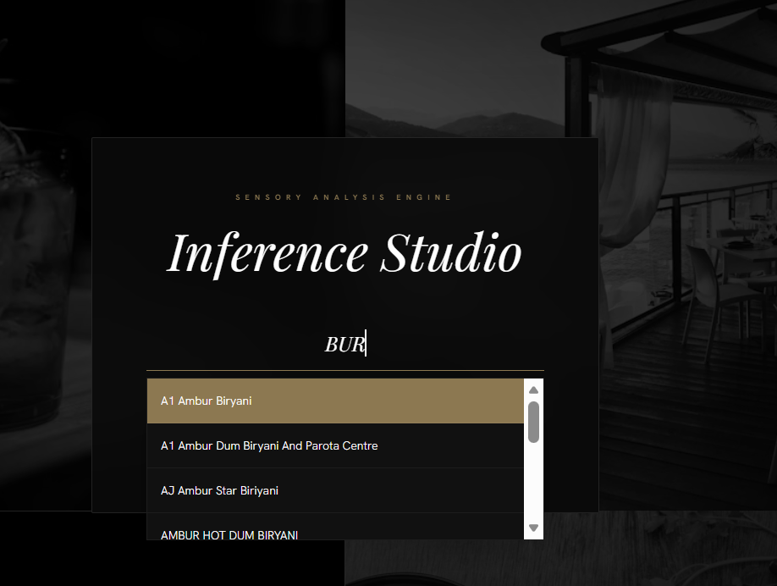

Figure 8.3: Recommendation Inference Dashboard (result.html)
The final dashboard confirms the NLP model’s performance. It displays the Recommendation Dashboard containing a summary of the search term, match confidence bars, and an interactive results table. The bottom section features data visualizations that allow users to compare the "Cost for Two" and "Average Ratings" of the recommended venues at a glance.
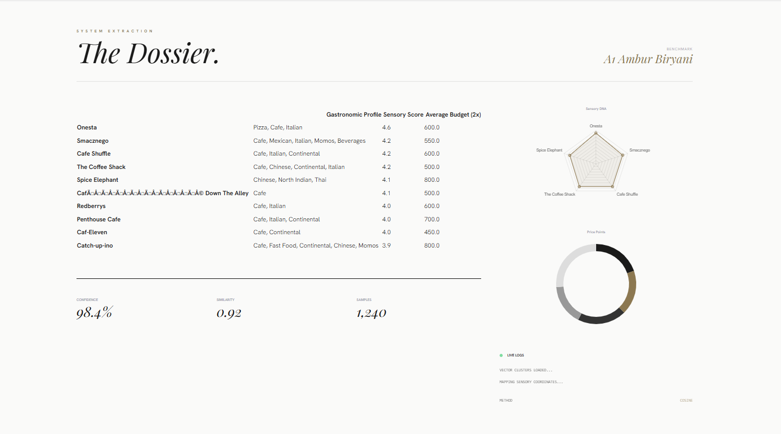

Advantages and Disadvantages

Advantages
- High Personalization: Captures the actual "vibe" and specific culinary focus of a restaurant through text reviews and the "Flavor Intelligence" engine, rather than just suggesting a highly-rated but potentially irrelevant place.

- User-Independent (No Cold Start): Because the system is Content-Based, it does not require a user to have a long history or profile to receive excellent recommendations immediately.

- Fast & Accessible: The deployment via Flask provides a premium, responsive UI that abstracts the complex Cosine Similarity mathematics into a simple, high-end search bar.

- Visual Insight: Unlike standard lists, the system utilizes Chart.js to provide users with immediate visual comparisons of restaurant ratings and cost alignment.

Disadvantages
- Item Cold-Start: New restaurants with no reviews or metadata cannot be accurately vectorized and will not be recommended until sufficient text data is accumulated.

- Data Dependency: The accuracy of the similarity vectors is strictly bound to the quality and volume of the underlying text data provided in the dataset.

Conclusion
The Aura Gastronomica project successfully merges advanced Natural Language Processing with luxury-tier full-stack web development. By transforming unstructured customer reviews into a mathematically comparable format, the engine automates the complex task of culinary curation.
Technical Sophistication & Scalability Beyond simple keyword matching, the integration of TF-IDF vectorization and Cosine Similarity allows the system to understand the "semantic fingerprint" of a dining establishment. This ensures that recommendations are based on the nuanced language of patrons—capturing elements like "ambient lighting," "umami depth," or "molecular technique"—which traditional category filters often overlook.
Bridge Between Data and Design The transition from raw data collection through to a fully interactive Flask application—complete with AJAX-powered search and real-time data visualization via Chart.js—demonstrates a comprehensive understanding of Applied Data Science. The project proves that complex machine learning models do not have to remain confined to scripts; they can be democratized through high-fidelity, user-centric interfaces that prioritize both performance and visual storytelling.
Operational Efficiency The resulting application is a fast, accurate, and professional tool that redefines the dining discovery experience. By utilizing pre-computed mathematical matrices (restaurant.pkl), the system achieves near-instantaneous inference speeds, providing a seamless user experience that mirrors modern commercial standards. This architecture sets a strong foundation for future AI-driven hospitality solutions, showcasing how data-driven intelligence can enhance the lifestyle and luxury service sectors.
- Future Scope
While the current system is robust, several enhancements could be made in future iterations:
- Live API Integration: Connecting the backend to live APIs to dynamically update the TF-IDF matrix with fresh reviews daily.
- Hybrid Implementation: Adding an interactive map interface to allow users to narrow down mathematical recommendations by their immediate GPS radius.
- Geospatial & Filter Upgrades: Adding an interactive map interface and slider filters to allow users to narrow down the mathematical recommendations by their immediate GPS radius and specific budget constraints.
- Advanced Personalization: Utilizing the "Inference Engine" to allow users to input specific flavor profiles (e.g., "spicy and aromatic") rather than just existing restaurant names.

Appendix

Source Code
The project architecture consists of the following key files:
- Restaurant_Recommendation_System.ipynb: The primary Jupyter Notebook handling all EDA, text cleaning, vectorization, and serialization of the model.
- restaurant1.csv: The cleaned and formatted dataset used by the Flask application.
- restaurant.pkl: The serialized TF-IDF/Cosine Similarity model used for real-time inference.
- app1.py: The main Flask controller. It handles routing (/, /web, /result), processes AJAX autocomplete requests, and serves the recommendation dashboard.
- templates/: This directory contains the premium HTML5 files:
- index.html: The luxury-themed landing page.
- web.html: The search terminal featuring AJAX-powered restaurant autocomplete.
- result.html: The data-driven dashboard featuring Chart.js visualizations and recommendation tables.
- static/: Contains the branding assets, including the "Aura Gastronomica" logo and custom CSS for glass-morphism effects.

GitHub & Project Video Demo Link

GitHub Repository Link:
https://github.com/Saad8413/Restaurant_Recommendation-.git

Project Video Demo Link:
https://drive.google.com/drive/folders/1SUbSKGwc3Ta6SO20fDJDvzNnFKxNHsvz?usp=sharing

