**Monash University  
FIT3088 Computer Graphics  
Assignment 1  
Author: Michael Nguyen, 22042962,** [**mhngu10@student.monash.edu**](mailto:mhngu10@student.monash.edu)

## How to play:

- The game can be played with a mouse and/or a keyboard.

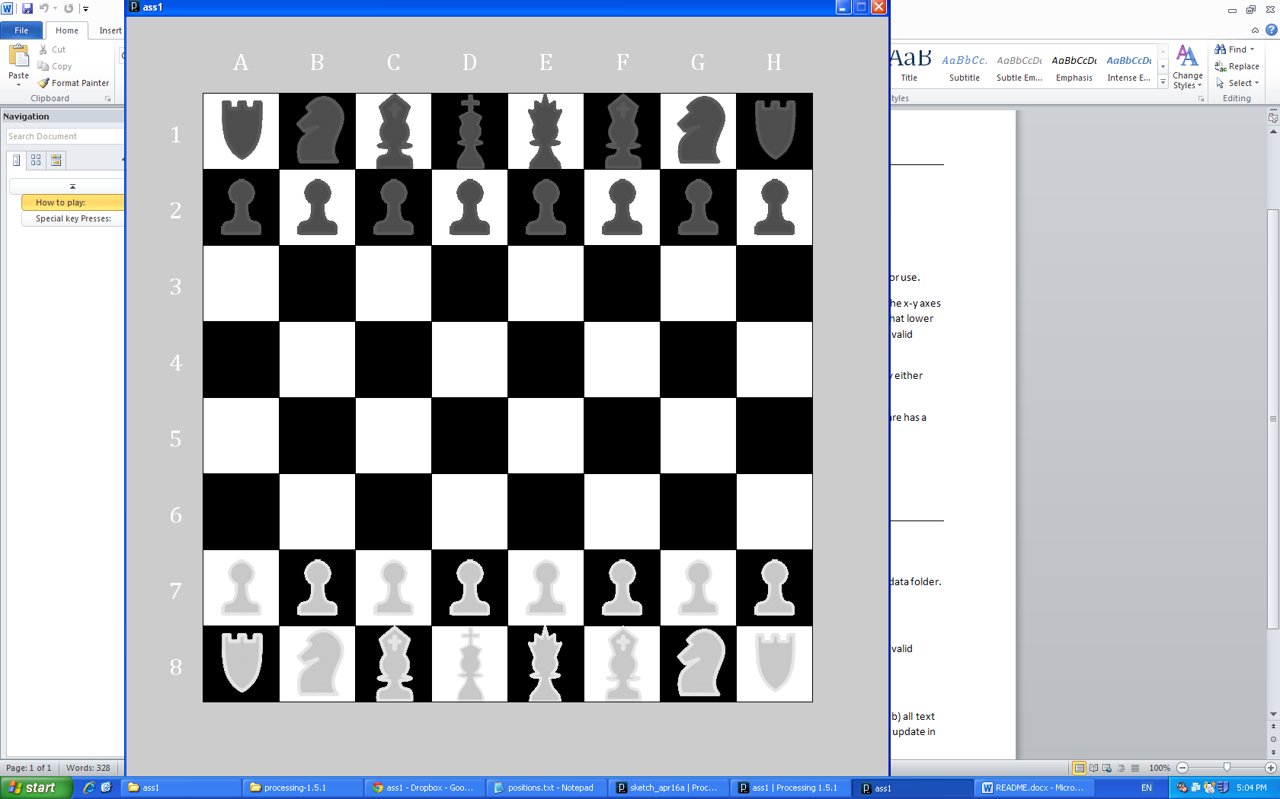

- Using the mouse, the user can click anywhere on a square to select it.

- If the square has no unit occupying it, nothing will happen.

- If the square has a unit, the square will be highlighted red and the unit will be selected for use. If you want to unselect the unit, click it again.

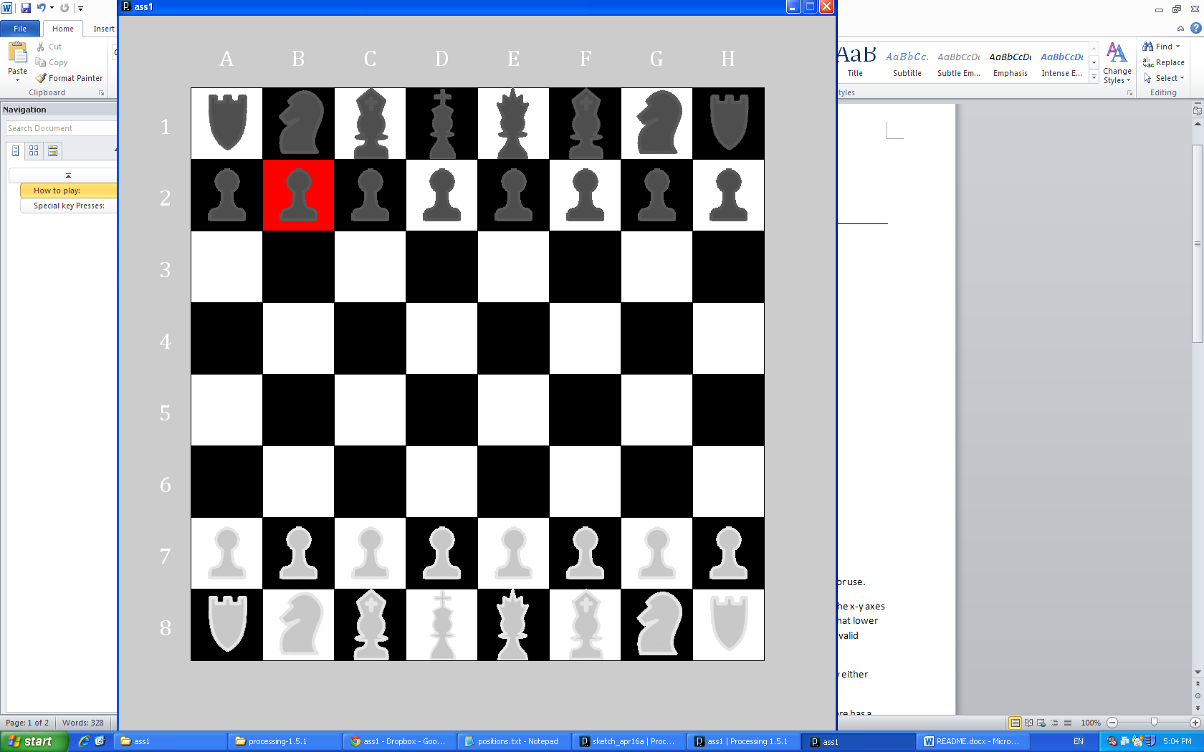

- This action can also be done with the keyboard by typing the cell co-ordinate based off the x-y axes notation. ie: pressing '4' then 'a' will select the 1st column in the 4th row (cell: 4a). Note that only lower case is accepted and that the order matters ie: 4a will work but not a4. Invalid inputs are disregarded. See the console for appropriate logs. Inputs are read in groups of 2: So if typing a position does not work (4a for example) it may mean you have 1 additional leading character which you will need to press a single key again to clear the buffer.

- With a unit selected, the player can move that unit to any cell on the entire chess grid by either clicking a square with a mouse or using the keyboard.

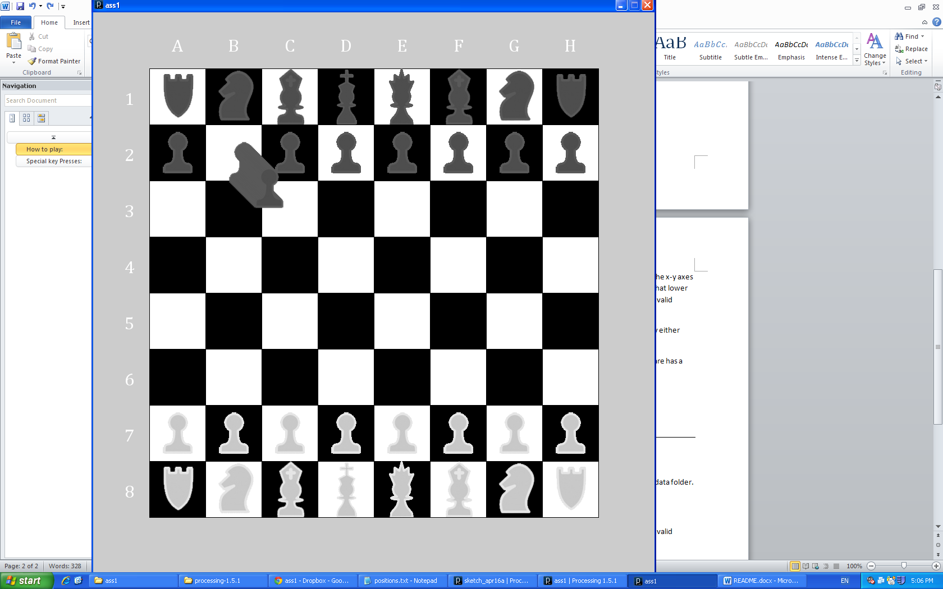

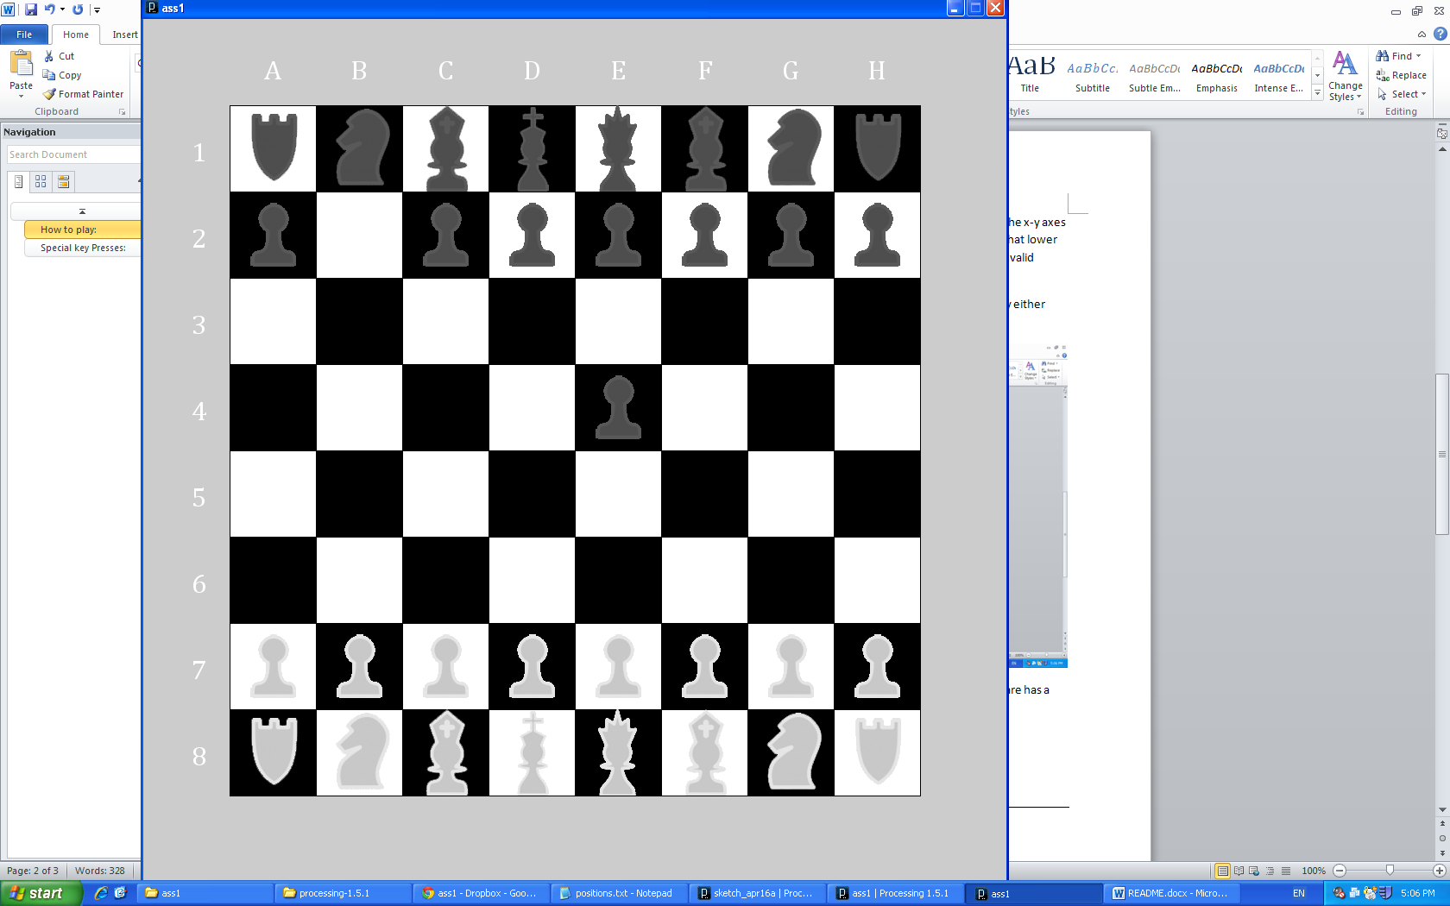

- The selected chess piece will move to that destination square and if the designated square has a piece on it, it will die.

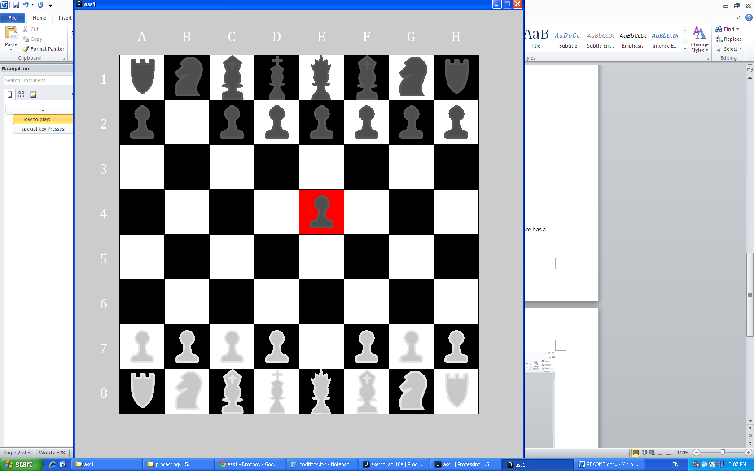

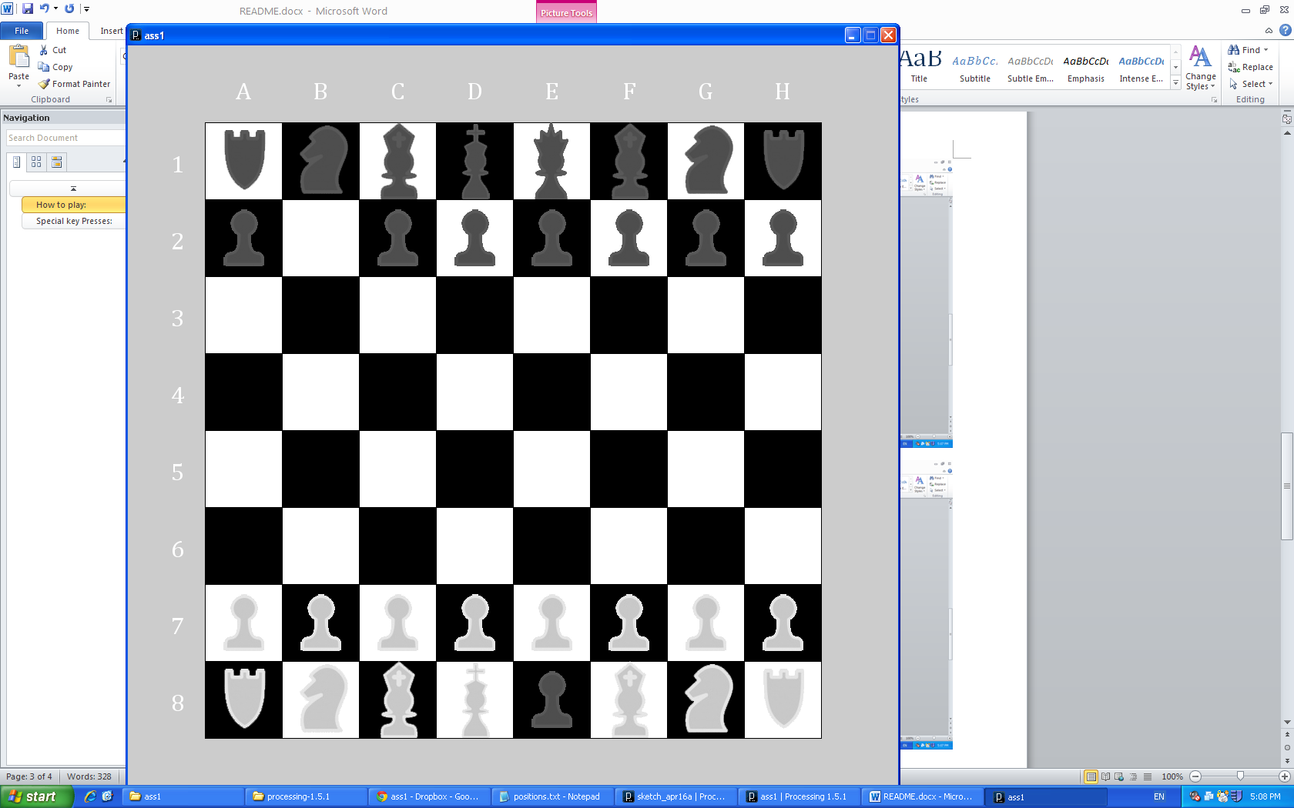

**Moved to 8e**

- The player can control both black and white pieces.

## Special key Presses:

**r/R : Read a file Input**

The program is able to read and play out a series of moves in a file "positions.txt" in the /data folder. The format of each step is important for it to properly work. The format is as follows:

1a>4b

Where '1a' is the first position, followed by a '>' symbol and then the next position. Any invalid positions are disregarded.

Note: The current positions.txt works off Chess Pieces being in a default starting position. If you move them around and then read a file, it will reference chess pieces that aren’t there and obviously will not move them (but still moving the ones that are in position). It is advised to only read a file (the current positions.txt) off starting positions.

**m/M : Change display mode**

The game can switch between different representations of the pieces from a) all graphics b) all text and c) half text, half graphics split in between the middle of the chess vertically which will update in real time. Try moving around while changing the mode mid move!

## Castling:

Castling is enabled in this version. To castle, a king and a rook must not have moved at all in the entire game. The grids in between them (whether that be a knight and a bishop or a knight, a bishop and a queen on the other side) must be empty so that the path between the rook and the king is clear.

Castling works as so (and works for all 4 quadrants):

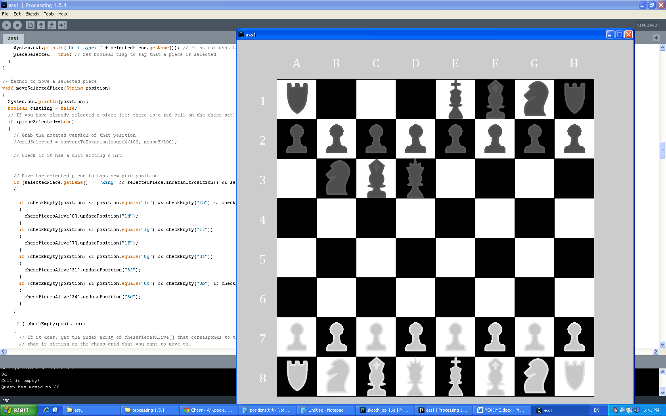

Make sure there is nothing in between the rook and the king and that neither has made any move in the game.

Click to the king to select it.

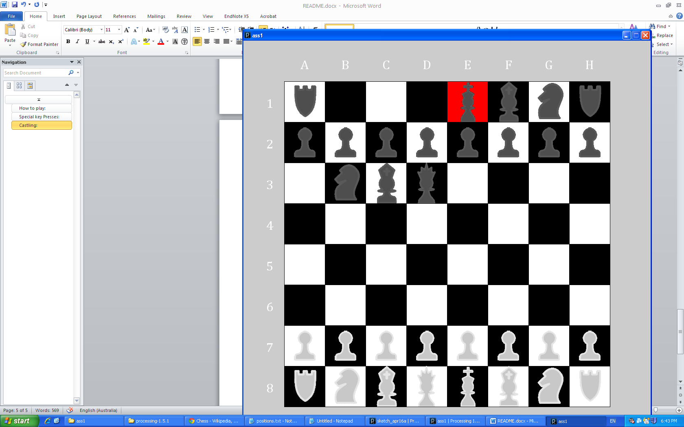

Click the INTENDED CASTLING KING POSITIONING. Ie: in the above example, it would be 1c.

Doing so will cause both the King to move to 1c and the Rook to move to 1d. That is castling.  
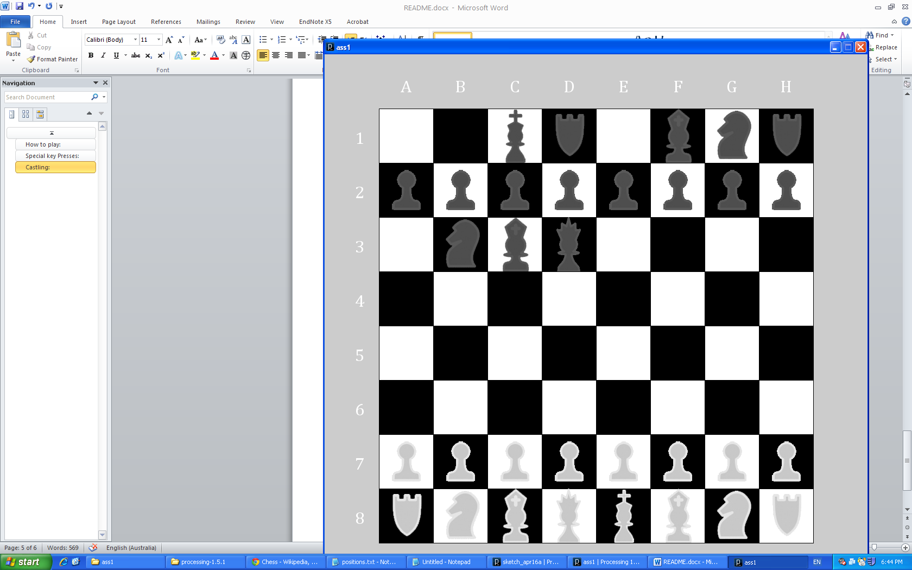

It works for all quadrants. Again, making sure there is nothing between the Rook and the King and that they haven’t moved – the castling positions for the king are top left: 1c, top right: 1g, bottom left: 8c and bottom right: 8g.

NB: It only works if the King is selected and moved to the Castling position, not the Rook being selected first.

## Promotions:

There is pawn promotion in this game. Any time a pawn piece is able to reach the end of the board that isn’t its side, it will be upgraded into a queen piece. This works for both black pieces and white pieces. The example below shows 2a going to 8a.

