SecureChat - Assignment #2 Information Security (Fall 2025)



Name: Saad Abdullah
Roll No: 22i-1045
Section: B
Repository:
https://github.com/SaadAbdullaH3/i221045_InfoSecAssignment2.git

Table of Contents
- Assignment Overview
1.1 System Architecture
1.2 Features Implemented
- Repository Structure
- Software Implementation Tables
3.1 app/client.py
3.2 app/server.py
3.3 app/crypto
3.3.1 crypto/aes.py
3.3.2 crypto/dh.py
3.3.3 crypto/pki.py
3.3.4 crypto/sign.py
3.4 app/common
3.4.1 common/protocol.py
3.4.2 common/utils.py
3.5 scripts/
3.5.1 scripts/gen_ca.py
3.5.2 scripts/gen_cert.py
- Evidence
4.1 Code Execution Screenshots
4.2 MySQL Database Screenshots
- Implementation Details
- Challenges and Solutions

1. Assignment Overview
This assignment involved designing and implementing a secure chat system using cryptographic primitives such as AES-128, RSA with X.509 certificates, Diffie-Hellman key exchange, and SHA-256 hashing. The system achieves Confidentiality, Integrity, Authenticity, and Non-Repudiation (CIANR) in a client-server architecture. I built a mini root CA, issued certificates, implemented registration and authentication, key agreement, and encrypted messaging. The system is a console-based secure chat application that demonstrates real-world cryptographic integration.

1.1 System Architecture
The system consists of a client and server communicating over TCP. The architecture includes: - Control Plane: Mutual authentication using X.509 certificates validated against a root CA. - Authentication: User registration and login with salted SHA-256 password hashing stored in MySQL. - Key Agreement: Diffie-Hellman (DH) exchange to derive a shared AES-128 key. - Data Plane: Encrypted messaging using AES-128-ECB with PKCS#7 padding, per-message RSA signatures for integrity, and an append-only signed transcript for non-repudiation.
The server listens for connections, handles multiple clients via threading, and stores session transcripts in JSON files.

1.2 Features Implemented
- Root CA generation and certificate issuance using cryptography library.
- Certificate validation (chain, expiry, CN/SAN).
- User registration/login with secure password storage in MySQL.
- DH key exchange with 2048-bit safe prime.
- AES-128 encryption/decryption.
- RSA SHA-256 signatures for messages and transcripts.
- Append-only transcript logging and hashing for non-repudiation.
- Pydantic models for message validation.
- Utility functions for timestamps, base64, and hashing.

2. Repository Structure
securechat-A2/
├─ README.md
├─ requirements.txt
├─ .gitignore
├─ certs/
│ ├─ MyRootCA_ca_cert.pem
│ ├─ MyRootCA_ca_key.pem
│ ├─ client.example.com_cert.pem
│ ├─ client.example.com_key.pem
│ ├─ myserver.example.com_cert.pem
│ ├─ myserver.example.com_key.pem
├─ transcripts/
│ └─ demo_session.json
├─ scripts/
│ ├─ gen_ca.py
│ ├─ gen_cert.py
│ ├─ diag_pki.py
│ ├─ cli_commands.txt
├─ scripts_ss/
├─ app/
│ ├─ .env
│ ├─ client.py
│ ├─ server.py
│ ├─ app_ss/
│ ├─ common/
│ ├─ protocol.py
│ ├─ utils.py
│ ├─ common_ss/
│ ├─ crypto/
│ │ ├─ aes.py
│ │ ├─ dh.py
│ │ ├─ pki.py
│ │ ├─ sign.py
│ ├─ crypto_ss/
│ ├─ storage/
│ │ ├─ db.py
│ │ ├─ transcript.py
│ ├─ testing_files/
├─ tests/
│ └─ manual/
└─ NOTES.md

3. Software Implementation Tables

3.1 app/client.py
Implements client workflow: hello exchange, registration/login, DH key agreement, encrypted chat, and receipt verification. Handles console input for user interactions.

3.2 app/server.py
Implements server workflow: listens for connections, handles hello exchange, authentication, DH, chat loop, transcript logging, and signed receipts. Uses threading for multiple clients.

3.3 app/crypto

3.3.1 crypto/aes.py
AES-128-ECB Helpers with PKCS#7:
- pkcs7_pad(data: bytes) -> bytes — Pad input bytes to 16-byte block with PKCS#7
- pkcs7_unpad(data: bytes) -> bytes — Remove PKCS#7 padding; raises ValueError if invalid
- encrypt_aes(key: bytes, plaintext: bytes) -> bytes — AES-128-ECB encrypt with PKCS#7 padding
- decrypt_aes(key: bytes, ciphertext: bytes) -> bytes — AES-128-ECB decrypt and remove PKCS#7 padding
Notes: key must be exactly 16 bytes (AES-128). encrypt_aes outputs raw bytes (can be base64-encoded for JSON transport). decrypt_aes returns the original plaintext bytes.

3.3.2 crypto/dh.py
Constants: - P_2048 — 2048-bit MODP safe prime - G = 2 — generator
Functions
- generate_dh_pair()
- get_dh_public_bytes(public_key)
- compute_shared_secret(own_private_key, peer_public_value)
- derive_aes_key(shared_secret)
- client_dh_initiate()
- server_dh_respond(client_msg, server_private_key)
- client_dh_finalize(client_private_key, server_msg)

3.3.3 crypto/pki.py
Functions:
- load_certificate(pem_path)
- load_ca_certificate(ca_pem_path)
- verify_signature(ca_cert, leaf_cert)
- check_validity(cert)
- get_common_name(cert)
- get_san_dns_names(cert)
- verify_identity(cert, expected_hostname)
- is_ca_certificate(cert)
- validate_certificate(leaf_pem_path, ca_pem_path, expected_hostname)
- validate_server_certificate(server_cert_pem, ca_pem_path, expected_server_name)
- validate_client_certificate(client_cert_pem, ca_pem_path, expected_client_name)
- extract_public_key_from_cert(cert_pem)

3.3.4 crypto/sign.py
Functions:
- sign_data(private_key_pem, data) — Sign data using RSA PKCS#1 v1.5 SHA-256
- verify_signature(public_key_pem, data, signature) — Verify RSA PKCS#1 v1.5 SHA-256 signature

3.4 app/common

3.4.1 common/protocol.py
Pydantic Models:
- BaseMessage(type: str, timestamp: int)
- Hello(client_cert: str)
- Register(username: str, password_hash: str)
- DHClient(p: str, g: str, A: str)
- DHServer(B: str) - Message(sender: str, ciphertext: str)
- Receipt(identity: str, transcript_hash: str, signature: str)

3.4.2 common/utils.py
Helper Functions:
- now_ms()
- b64e(b: bytes)
- b64d(s: str)
- sha256_hex(data: bytes)

3.5 scripts/

3.5.1 scripts/gen_ca.py
Root CA Creation:
- create_root_ca(ca_name, output_dir='certs')

3.5.2 scripts/gen_cert.py
Issue Server/Client Certificate Signed by Root CA:
- issue_certificate(ca_name, cert_name, cert_type, output_dir='certs')

4. Evidence

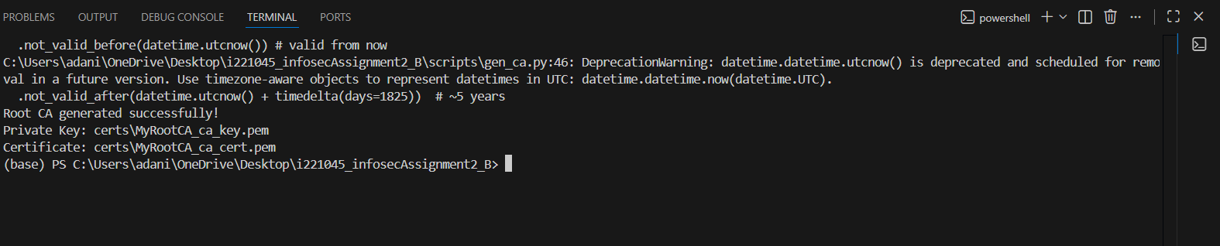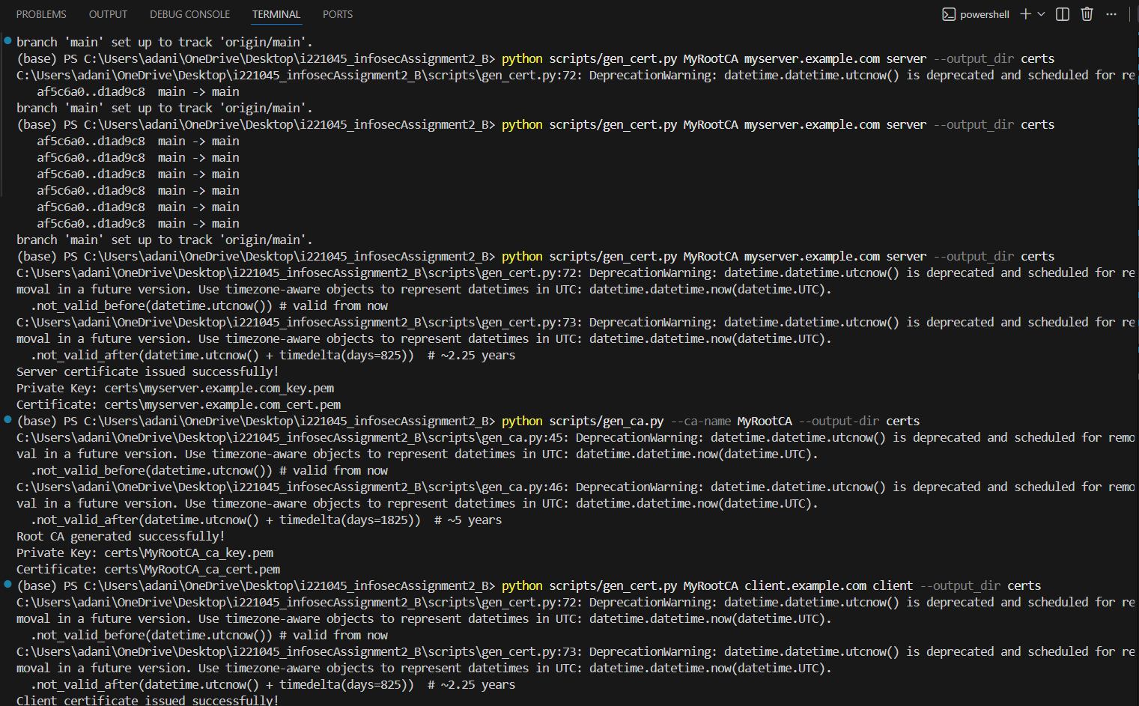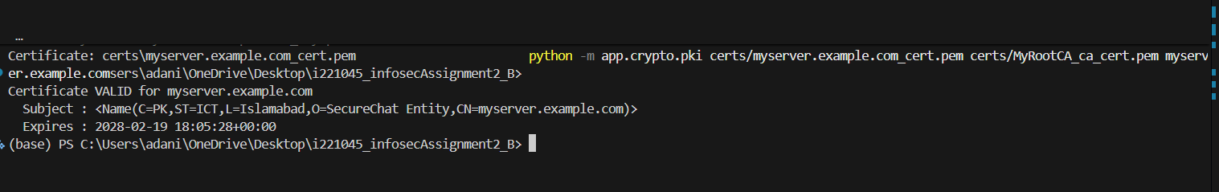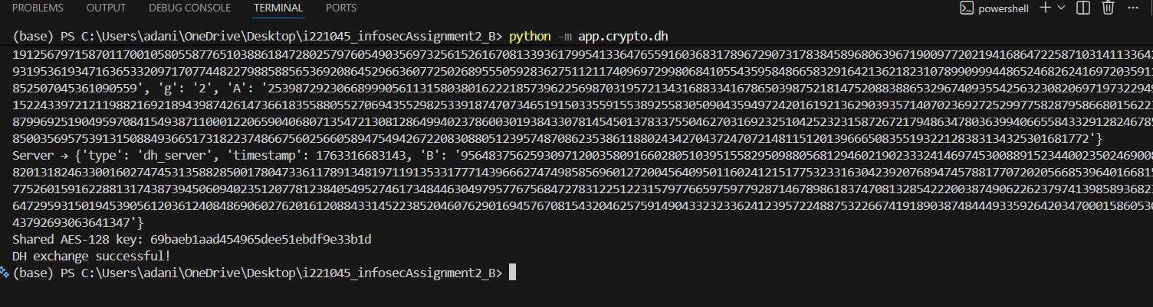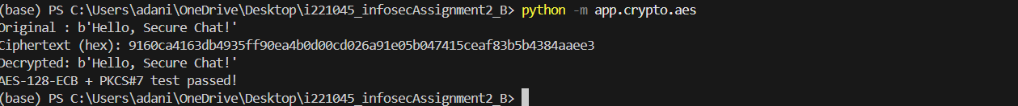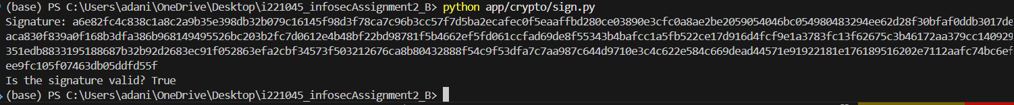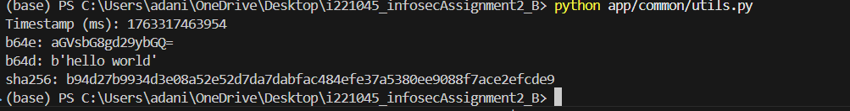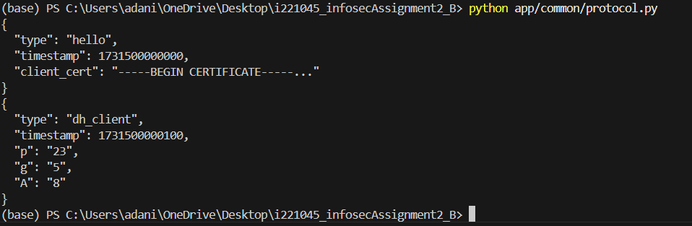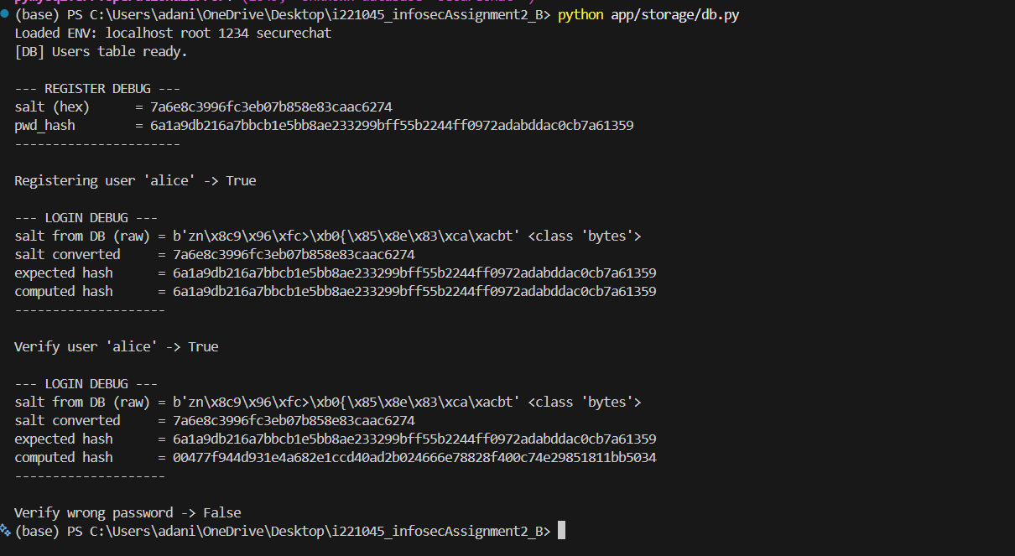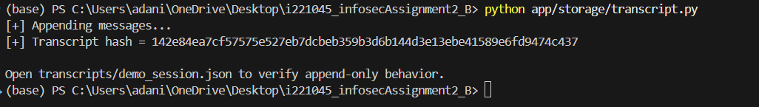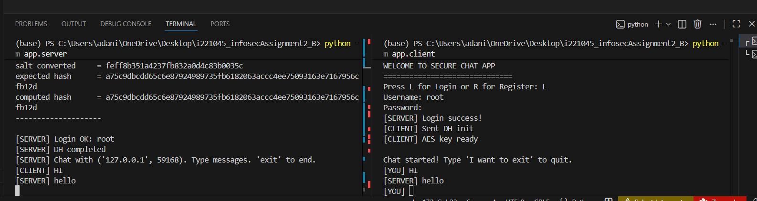

5. Implementation Details
- Root CA and Certificates: gen_ca.py and gen_cert.py for CA and server/client certs; pki.py validates.
- DH Key Exchange: dh.py implements 2048-bit DH.
- AES Encryption: aes.py handles AES-128-ECB with PKCS#7.
- RSA Signing: sign.py ensures integrity and non-repudiation.
- Protocol Models: protocol.py defines Pydantic models.
- Utilities: utils.py provides timestamps, base64, hashing.
- Database: db.py handles MySQL users table with salted SHA-256.
- Transcript: transcript.py logs messages, computes SHA-256 hash.
- Client/Server: client.py handles UI, server.py manages connections and chat.

6. Challenges and Solutions
- Certificate Validation: chain verification, expiry, hostname matching.
- Key Derivation: Trunc16(SHA256(Ks)) for AES key.
- Signature Extraction: extract_public_key_from_cert added.
- Pydantic Validation: DH params converted to str.
- Error Handling: try/except blocks for network and validation errors.

7. Conclusion
This assignment demonstrated practical cryptography in a secure chat system. The implementation meets all CIANR requirements.

