# Sprite Case Study

## Deployment Guide

This document contains information for understanding and deploying the Sprite Case Study example.

A *Sprite* in this context is an animated graphic, such as a character in a video game. The SpriteTodd project is a JEE Netbeans project that implements a playing field of moving sprites.

The entity class in this example is the **Sprite** class.

The architecture of the SpriteTodd project is based on the **address-book** example we have been studying in class. One difference is that in the SpriteTodd project, the business layer made up of Enterprise Java Beans forms a sub-project called SpriteTodd-ejb and the presentation layer made up of web pages and their backing bean forms a sub-project called SpriteTodd-war.

### Manifest:

SpriteTodd : the Netbeans parent project of the server side

SpriteTodd-ejb: the EJB component sub-project of the server side

SpriteTodd-war: the web component sub-project of the server side

SpriteClientEE: An Eclipse (not Netbeans) project with a Java Swing Application client

### Deployment Steps

1. Open the SpriteTodd project in Netbeans
2. Rightclick on the SpriteTodd project in Netbeans, and select “Open Required Projects” to open the two sub-projects of SpriteTodd.
3. Rightclick SpriteTodd-ejb, and select properties, then select Libraries, and verify that the JEE API is properly referenced: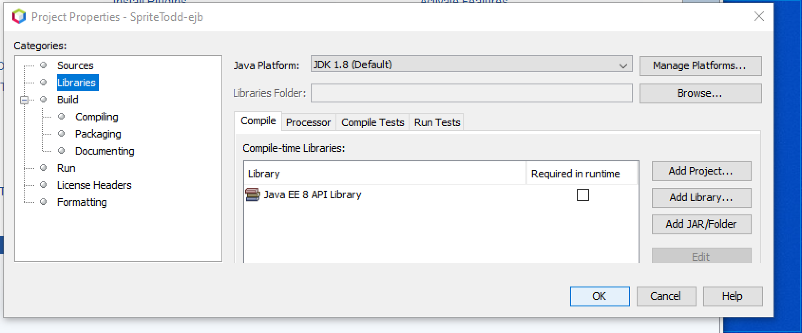
4. The persistence.xml file controlling where the Sprites are stored is in SpriteTodd-ejb->Configuration Files
5. Verify the libraries are correct for the SpriteTodd-war module:

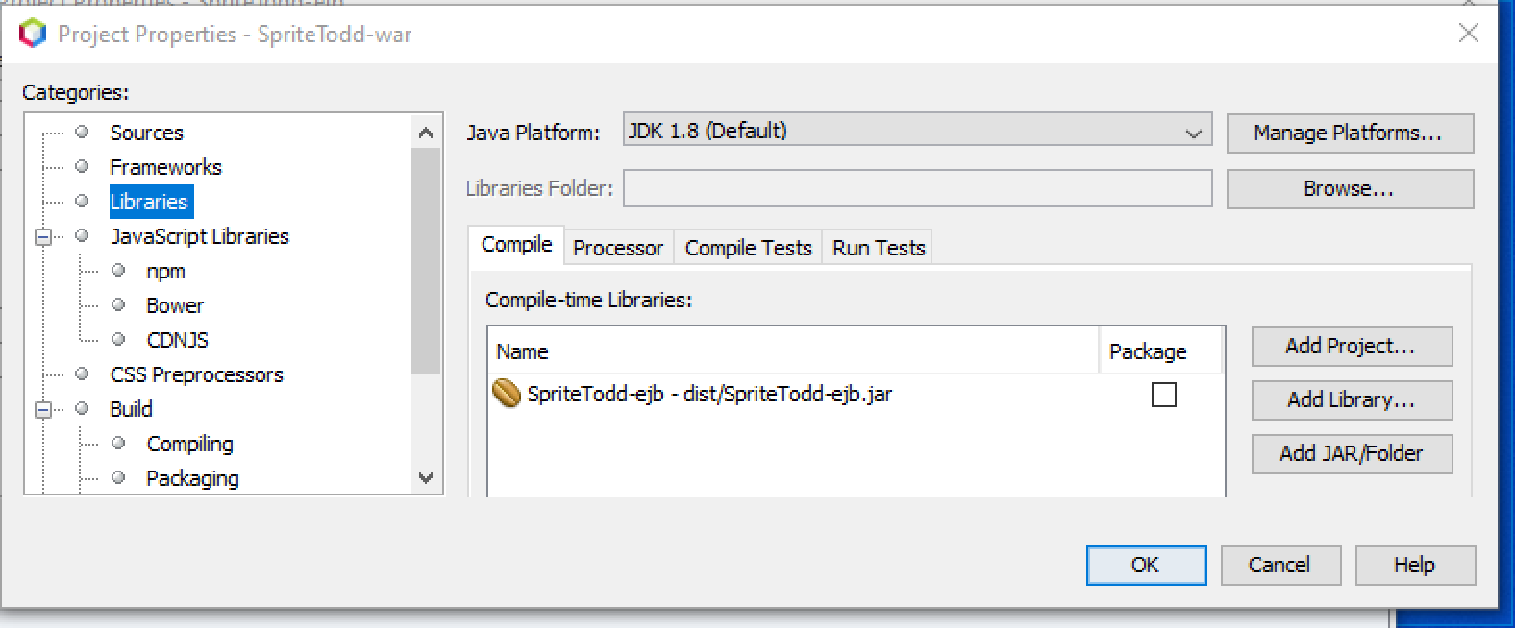

1. You should be able to clean and build, and then run, the SpriteTodd project
2. Open the SpriteClientEE project in Eclipse (not Netbeans)
3. Rightclick on SpriteClientEE in Eclipse, and select properties, select Java Build Path, and add the libraries as shown. The gf-client.jar file is in your C:\glassfish5\glassfish\lib directory: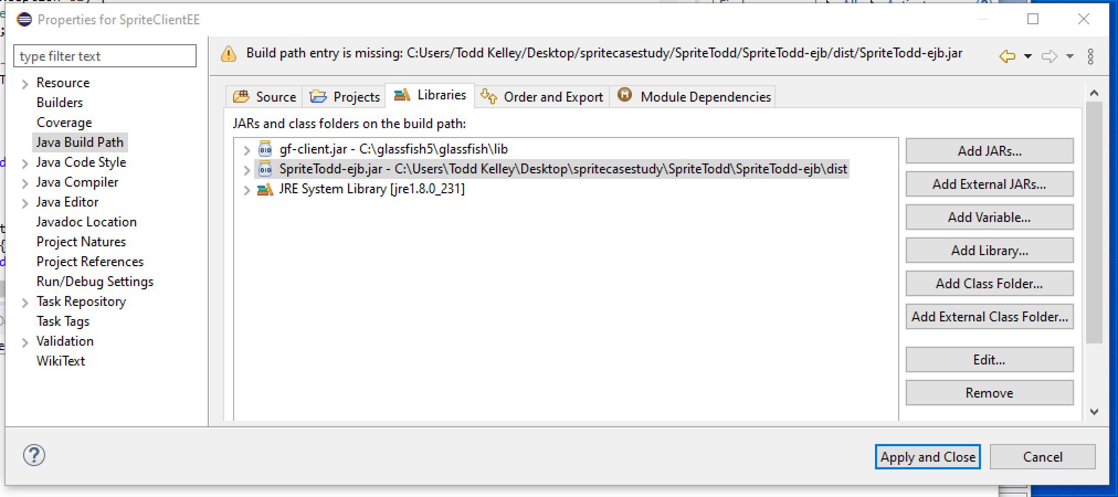
4. Now you should be able to run the SpriteClientEE project, which should connect to your Glassfish server as shown in class.