Assignment: 1 & 2

Group Members

Saad Ali Hafiz (18B-025-SE)

Ahmad Zaman Qureshi (18B-045-SE)

2021

**Assignment: 01**

**Requirements**

1. **A customer decides to buy your product or service.** If you have a physical store, they may ask a sales associate to ring them up. That associate could use a bar code scanner to look up the item’s price. Some POS systems, like square point of sale, also allow you to visually scan items using the camera on your device.
2. **For online stores**, this step happens when a customer finishes adding items to their cart and clicks the checkout button.
3. **Your POS system calculates the price of the item**, including any sales tax, and then updates the inventory count to show that the item is sold.
4. **Your customer pays.** To finish their purchase, your customer will have to use their credit card, tap card, debit card, loyalty points, gift card, or cash to make the payment go through. Depending on the type of payment they choose, your customer’s bank then has to authorize the transaction.
5. **The point-of-sale transaction is finalized.** This is the moment when you officially make a sale. The payment goes through, a digital or printed receipt is created, and you ship or hand your customer the items they bought.

**4.2 Architectural Description (AD):**

A POS system allows your business to accept payments from customers and keep track of sales. It sounds simple enough, but the setup can work in different ways, depending on whether you sell online, have a physical storefront, or both.

A point-of-sale system used to refer to the cash register at a store. Today, modern POS systems are entirely digital, which means you can check out a customer wherever you are. All you need is a POS app and an internet-enabled device, like a tablet or phone.

A customer decides to buy your product or service. Your system receives the request and calculates the price of the item by communicating with the database. Customer pays, the point-of-sale system secure the record of the transactions.

**4.2.Stakeholders and their roles**

1. Cashier

* Processing cash, debit, credit, and check transactions

1. Customers

* Selecting item and using different methods of payment

1. Developer

* Develop a system which provides all the essential functionalities.

1. Maintainers

* Maintain system after some particular period of time.

**5.2 Stakeholders and their concerns**

|  |  |
| --- | --- |
| Stakeholder title | Cashier |
| Goal | * Processing cash, debit, credit, and check transactions using a cash register or other point-of-sale system in a retail environment. |
| Task | * Enter data in the database * Order inventory |
| Concerns | * Which method will customer be using to receive payment? * How to enter the data in the database? |

|  |  |
| --- | --- |
| Stakeholder title | Customer |
| Goal | * Get the desired item |
| Task | * Select items * Pay for the item |
| Concerns | * Which payment method customer will be using? |

|  |  |
| --- | --- |
| Stakeholder title | Maintainer |
| Goal | * Keep the system maintained |
| Task | * Maintain system |
| Concerns | * How long will it take to maintain? * Which Important modules will get affected? |

|  |  |
| --- | --- |
| Stakeholder title | Developer |
| Goal | * Develop a system which has better performance |
| Task | * Researching, designing, implementing, and managing modules. |
| Concerns | * How other modules interact with each other? |

|  |  |
| --- | --- |
| Stakeholder title | Designer |
| Goal | * To convey architecture to different stakeholders in its detailed form. |
| Task | * To understand architecture document and elaborate it further. |
| Concerns | * How to show the system in terms of user action and system response. * How to depict the system in terms of physical objects. * How to show the sequence of steps executed by system against user actions. * How to depict system in terms of user action and different steps of system in order to complete the system response. * How other modules interact with each other? |

|  |  |
| --- | --- |
| Stakeholder title | Project Manager |
| Goal | * To effectively plan and manage the resources for the project. |
| Task | * Plan the schedule for the project completeness. * Plan the budgeting for the project. * Formation of teams * Measure the progress of the project * Management of the resources * How can I know about different components, hardware and Software of the proposed system |
| Concerns | * How is communication established between different servers? Interact with each other? |

**5.3 Selection of architectural viewpoints**:

|  |  |
| --- | --- |
| Viewpoint title | * Module View |
| Stakeholder | * Project Manager, Developer |
| Concerns | * Researching, designing, implementing, and managing modules. |
| Type of information | * How other modules interact with each other? |
| Presentation | * Tree structure of module |
| Stakeholder Oriented terms | * Modules, Sub modules, No. of screens of these modules. |

|  |  |
| --- | --- |
| Viewpoint title | * GUI view |
| Stakeholder | * Cashier |
| Concerns | * How can I enter data? * How can I check inventory? * How can I order inventory? |
| Type of information | * Visual representation of system. Possibly of several screen shots |
| Presentation | * Ninja Mockup |
| Stakeholder Oriented terms | * Buttons Name on Screens |

|  |  |
| --- | --- |
| Viewpoint title | * Customer view |
| Stakeholder | * Customer |
| Concerns | * How can I select items? * How can I pay? * What payment method will I be using? |
| Type of information | * Sequence Diagrams * Activity Diagrams |
| Presentation | * Screens through Ninja mockup |

|  |  |
| --- | --- |
| Viewpoint title | * Maintenance view |
| Stakeholder | * Project Manager , Maintenance Engineer |
| Concerns | * How long will it take to maintain? * Which Important modules will get affected? |
| Type of information | * Scenario based |
| Stakeholder Oriented terms | * Modules, Sub module. Communication services. |

**5.4 Architectural views**

**5.4.1 Module view**

Below is the modular view of our Point-of-Sale System.

**5.4.2 GUI View**

**5.4.3 Maintenance View:**

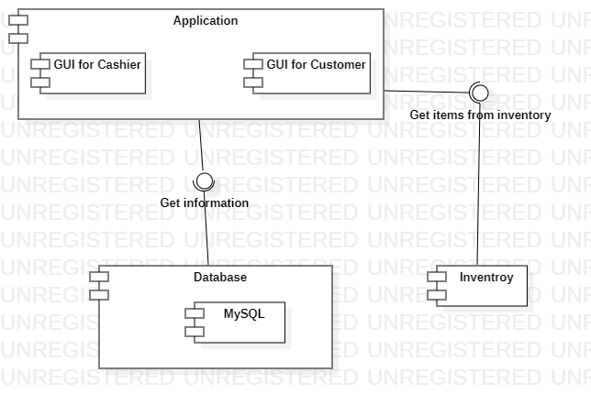

**Assignment: 02**

A POS (Point-Of-Sale) system is a computer system typically used to manage the sales in retail stores. It includes hardware components such as a computer, a bar code scanner, a printer and also software to manage the operation of the store.

**Requirements:**

1. The most basic function of a POS system is to handle sales. When a customer arrives at a POS counter with goods to purchase, the cashier will start a new sale transaction.
2. When the barcode of a good is read by the POS system, it will retrieve the name and price of this good from the backend catalog system and interact with inventory system to deduce the stock amount of this good from database.
3. When the sale transaction is over, the customer can pay in cash, credit card or even check. After the payment is successful, a receipt will be printed.
4. The store frequently issues gift coupons. The customer can use the coupons for a better price when purchasing goods.
5. Cashier will check the inventory and manage database inventory.

**Architecture Decision:**

|  |  |
| --- | --- |
| **Architecture** | **Reasoning** |
| DD | **Ruled out**: DD is not proper as an architecture style at the overview level of complex system. |
| Pipe and filter | **Ruled out**: data is not stream oriented. |
| Process control | **Ruled out**: POS system does not fall in the application domain. |
| Blackboard | **Ruled out**: It is difficult to test and debug the system by using blackboard. |
| Virtual Machine | **Ruled out**: POS System does not lie in the application domain |
| Component-based | **Candidate:** We have different components in pos system. |
| Master/Slave | **Candidate:** Print Job can be used by the architecture master/slave and will be using in database. |
| Layered | **Candidate:** Services can be classified into layers. |

**Candidate Architecture:**

In CBA, components are well-known and not typically published to the outside world, the extra service broker and location services. Master/slave could be the option because it supports the data interconnected from the center i.e., print job. Layered it is consistent and can be easily expandable and modifiable without changing the functionality of the other system.

**Decision:**

The decision is made to select layered architecture over the other alternatives because it supports Consistency in POS system handled by the same group of people, such as an internal architecture. Separation of concerns: Low-experience teams. Technical browsability: To some extent, it helps everyone. With layered architecture you can use the following three tiers to model the system: (1) front-end, (2) business model, and (3) database. Master/Slave will be ruled out since it serves only one purpose which is printing job. Component-based architecture, there is no reutilization of modules, so we don’t need this. Hence, logically the system does not look like a clear-cut choice for this style. The preceding comparison leads to the choice of Layered architecture.