TASK 1:

[org 0x0100]

jmp start

scrollup: push bp

mov bp,sp

push ax

push cx

push si

push di

push es

push ds

mov ax, 80

mul byte [bp+4]

mov si, ax

push si

shl si, 1

mov cx, 2000

sub cx, ax

mov ax, 0xb800

mov es, ax

mov ds, ax

xor di, di

cld

rep movsw

mov ax, 0x0720

pop cx

rep stosw

pop ds

pop es

pop di

pop si

pop cx

pop ax

pop bp

ret 2

start: mov ax,10

push ax

call scrollup

mov ax, 0x4c00

int 0x21

TASK 2:

[org 0x0100]

jmp start

scrolldown: push bp

mov bp,sp

push ax

push cx

push si

push di

push es

push ds

mov ax, 80

mul byte [bp+4]

push ax

shl ax, 1

mov si, 3998

sub si, ax

mov cx, 2000

sub cx, ax

mov ax, 0xb800

mov es, ax

mov ds, ax

mov di, 3998

std

rep movsw

mov ax, 0x0720

pop cx

rep stosw

pop ds

pop es

pop di

pop si

pop cx

pop ax

pop bp

ret 2

start: mov ax,10

push ax

call scrolldown

mov ax, 0x4c00

int 0x21

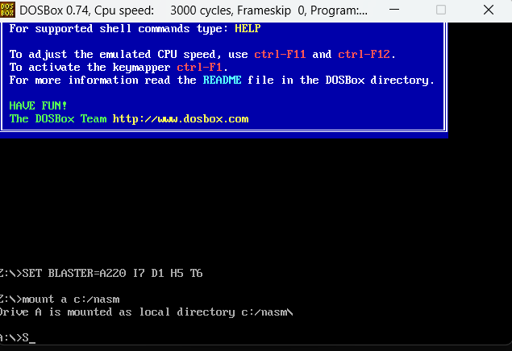

TASK 3:

1+2:

[org 0x0100]

jmp start

string1 : db 'Coal Lab', 0

string2 : db 'Coal Lab', 0

string3 : db 'PF Lab', 0

str1 : db 'Coal', 0

str2 : db 'Lab', 0

str3 : db 'PF', 0

strlen : push bp

mov bp, sp

push es

push cx

push di

les di, [bp + 4]

mov cx, 0xffff

xor al, al

repne scasb

mov ax, 0xffff

sub ax, cx

dec ax

pop di

pop cx

pop es

pop bp

ret 4

strcmp:

push bp

mov bp, sp

push cx

push si

push di

push es

push ds

lds si, [bp + 4]

les di, [bp + 8]

push ds

push si

call strlen

mov cx, ax

push es

push di

call strlen

cmp cx, ax

jne exitfalse

mov ax, 1

repe cmpsb

jcxz exitsimple

exitfalse : mov ax, 0

exitsimple :

pop ds

pop es

pop di

pop si

pop cx

pop bp

ret 8

start:

push ds

mov ax, string1

push ax

call strlen

push ds

mov ax, string2

push ax

call strlen

push ds

mov ax, string3

push ax

call strlen

push ds

mov ax, string1

push ax

push ds

mov ax, string2

push ax

call cmpstr

push ds

mov ax, string2

push ax

push ds

mov ax, string3

push ax

call strcmp

push ds

mov ax, string2

push ax

push ds

mov ax, string3

push ax

call strcmp

mov ax, 0x4c00

int 0x21

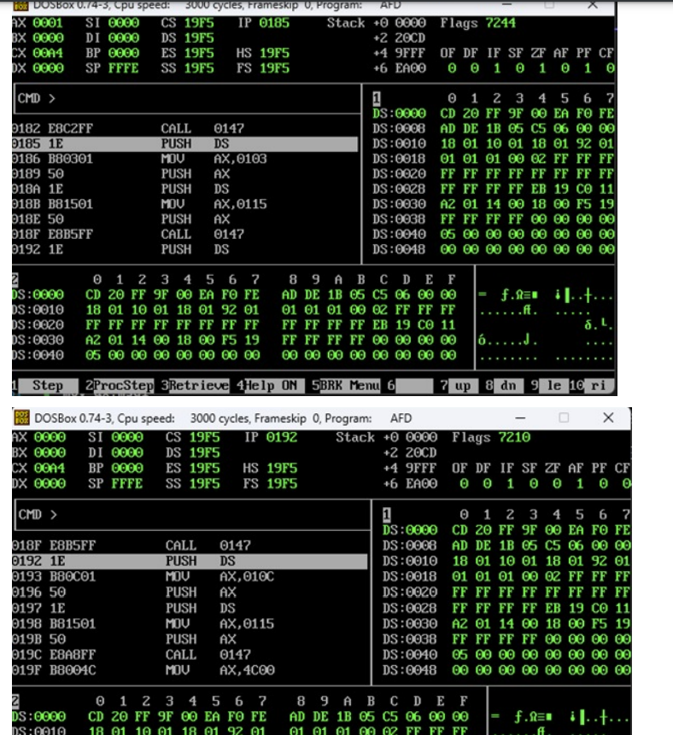

3:

[org 0x0100]

jmp start

string1 : db 'Coal Lab', 0

string2 : db 'Coal Lab', 0

string3 : db 'PF Lab', 0

num1 : db 'Coal', 0

num2 : db 'Lab', 0

num3 : db 'PF', 0

strlen : push bp

mov bp, sp

push es

push cx

push di

les di, [bp + 4]

mov cx, 0xffff

xor al, al

repne scasb

mov ax, 0xffff

sub ax, cx

dec ax

pop di

pop cx

pop es

pop bp

ret 4

strcmp: push bp

mov bp, sp

push cx

push si

push di

push es

push ds

lds si, [bp + 4]

les di, [bp + 8]

push ds

push si

call strlen

mov cx, ax

push es

push di

call strlen

mov ax, 1

repe cmpsb

jcxz exitsimple

exitfalse : mov ax, 0

exitsimple : pop ds

pop es

pop di

pop si

pop cx

pop bp

ret 8

start:

push ds

mov ax, string1

push ax

push ds

mov ax, num3

push ax

call strcmp

mov ax, 0x4c00

int 0x21