TASK 1:

CODE:

[org 0x0100]

mov ax, [num1] ; load first number in ax

mov bx, [num2] ; load second number in bx

add ax, bx ; accumulate sum in ax

mov bx, [num3] ; load third number in bx

add ax, bx ; accumulate sum in ax

mov [num4], ax ; store sum in num4

mov ax, 0x4c00 ; terminate program

int 0x21

num1: dw 5

num2: dw 9

num3: dw 14

num4: dw 0

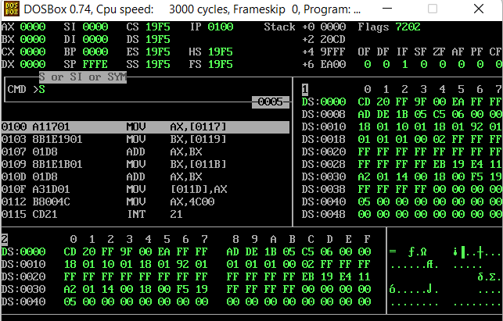

TASK 2:

CODE:

[ORG 0x100]

mov ax, [num1] ; load first number in ax

mov bx, [num2] ; load second number in bx

sub ax, bx ; accumulate sum in ax

mov [num3], ax

mov bx, [num3] ; load third number in bx

mov ax, 0x4c00 ; terminate program

int 0x21

num1: dw 30

num2: dw 18

num3: dw 0

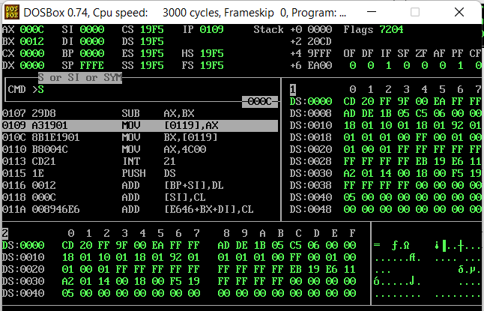

TASK 3:

CODE:

[ORG 0x100]

mov ax,5

mov bx,10

add ax, bx

sub ax,3

mov [num1], ax

add ax, bx

sub ax,9

mov [num2], ax

mov ax, 0x4c00

int 0x21

num1: dw 0

num2: dw 0

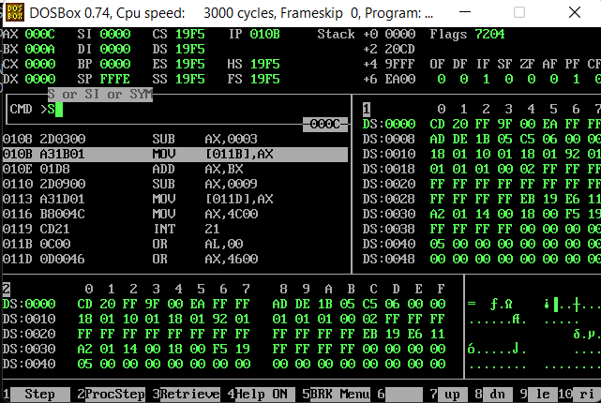

TASK 5:

CODE:

[org 0x100]

mov bx, num1 ; point bx to first number

mov ax, [bx] ; load first number in ax

add ax, 1

mov [num3], ax

mov bx, num2

mov ax, [bx]

sub ax, 1

mov [num4], ax

mov ax, 0x4c00 ; terminate program

int 0x21

num1: dw 6

num2: dw 9

num3: dw 0

num4: dw 0

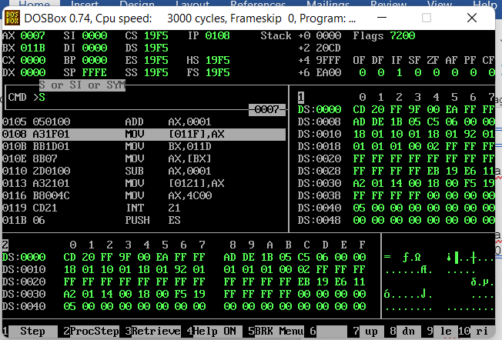

TASK 6:

CODE:

[org 0x0100]

mov al, [num1] ; load first number in al

mov bl, [num1+1] ; load second number in bl

mov al, [num1 +2]

mov ax, 0x4c00 ; terminate program

int 0x21

num1: db 5, 10, 15

