TASK 1:

[org 0x0100]

jmp start

data: dw 15, 30, 12, 50, 10, 20, 55, 40, 7, 0

swap: db 0

start: mov bx, 0

mov byte [swap], 0

loop1: mov ax, [data+bx]

cmp ax, [data+bx+2]

jle noswap

mov dx, [data+bx+2]

mov [data+bx+2], ax

mov [data+bx], dx

mov byte [swap], 1

noswap:

add bx, 2

cmp bx, 18

jne loop1

cmp byte [swap], 1

je start

mov ax, 0x4c00

int 0x21

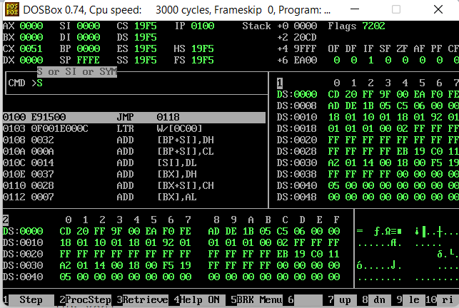

TASK 2:

[org 0x0100]

jmp start

data: dw -15, 30, -12, -50, 10, 20, 55, 40, 7, 0

swap: db 0

start: mov bx, 0

mov byte [swap], 0

loop1: mov ax, [data+bx]

cmp ax, [data+bx+2]

jge noswap

bsort: mov dx, [data+bx+2]

mov [data+bx+2], ax

mov [data+bx], dx

mov byte [swap], 1

noswap: add bx, 2

cmp bx, 18

jne loop1

cmp byte [swap], 1

je bsort

mov ax, 0x4c00

int 0x21

TASK 3 :

[org 0x0100]

jmp start

data: dw -15, 30, -12, -50, 10, 20, 55, 40, 7, 0

swap: db 0

start: mov bx, 0

mov byte [swap], 0

loop1: mov ax, [data+bx]

cmp ax, [data+bx+2]

jle noswap

bsort: mov dx, [data+bx+2]

mov [data+bx+2], ax

mov [data+bx], dx

mov byte [swap], 1

noswap: add bx, 2

cmp bx, 18

jne loop1

cmp byte [swap], 1

je bsort

mov ax, 0x4c00

int 0x21

