TASK 4:

[org 0x0100]

jmp start

data: dw 10, 20, -4, 6, 70, -23, -44, 66, 77, 12, -9

swap: db 0

sign:

add cx,1

add bx,2

cmp bx,22

jne loop1

start:

mov cx,0

mov dx,0

mov bx,0

loop1:

mov ax,[data+bx]

cmp ax,0

jl sign

add dx,1

add bx,2

cmp bx,22

jne loop1

mov ax, 0x4c00

int 0x21

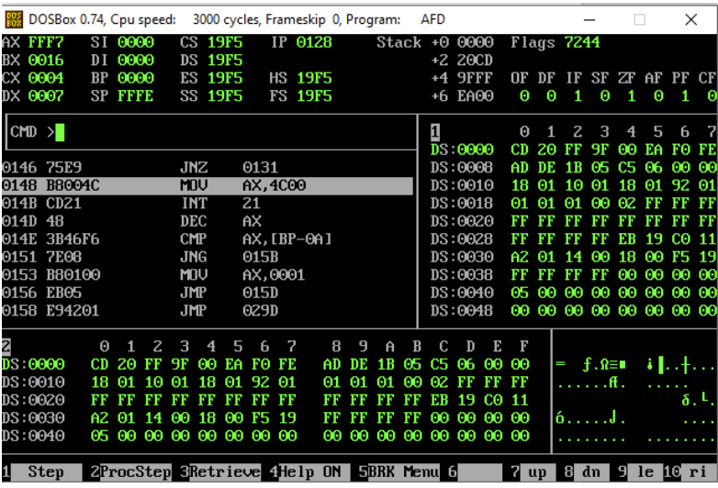

TASK 5:

[org 0x0100]

jmp start

data: dw 10, 12, 13, 15, 17, 18, 19, 22, 21, 22, 14

swap: db 0

check:

add dx,1

add bx,2

cmp bx,20

jne loop1

start:

mov bx,0

loop1:

mov ax,[data+bx]

cmp ax,13

jne check

mov ax, 0x4c00

int 0x21

