TASK 1:

#include<iostream>

using namespace std;

template<class t1>

t1 add(t1 num1, t1 num2)

{

return num1 + num2;

}

template<class u1>

u1 mul(u1 num1, u1 num2)

{

return num1 \* num2;

}

int main()

{

int x1, x2;

float f1, f2;

double d1, d2;

cout << "ENTER TWO INTEGERS : " << endl;

cin >> x1;

cin >> x2;

cout << "ENTER TWO FLOATS : " << endl;

cin >> f1;

cin >> f2;

cout << "ENTER TWO DOUBLES : " << endl;

cin >> d1;

cin >> d2;

cout << " addition of intergers is " << add<int>(x1, x2) << endl;

cout << " addition of float is " << add<float>(f1, f2) << endl;

cout << " addition of two double is " << add<double>(d1, d2) << endl;

cout << " Multiplication of intergers is " << mul<int>(x1, x2) << endl;

cout << " Multiplication of float is " << mul<float>(f1, f2) << endl;

cout << " Multiplication of double is " << mul<double>(d1, d2) << endl;

system("pause");

return 0;

}

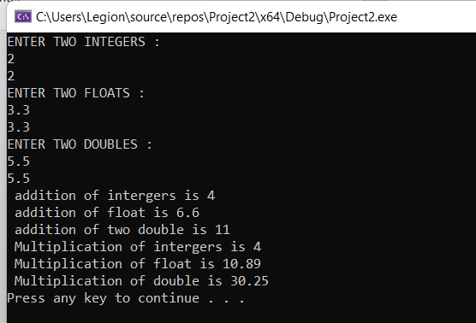

TASK 2:

#include <iostream>

using namespace std;

template <typename T>

double avg(T arrname[], int size) {

double sum = 0;

for (int i = 0; i < size; i++)

{

sum = sum + arrname[i];

}

return sum / size;

}

int main() {

int integers[5];

cout << "ENTER INTEGERS " << endl;

for (int i = 0; i < 5; i++) {

cin >> integers[i];

}

cout << "Average of integers: " << avg<int>(integers, 5) << endl;

cout << "ENTER DOUBLES " << endl;

double doubles[5];

for (int i = 0; i < 5; i++) {

cin >> doubles[i];

}

cout << "Average of doubles: " << avg<double>(doubles, 5) << endl;

cout << "ENTER FLOATS " << endl;

float floats[5];

for (int i = 0; i < 5; i++) {

cin >> floats[i];

}

cout << "Average of long: " << avg<float>(floats, 5) << endl;

char chars[5] = { 'a', 'b', 'c', 'd', 'e' };

cout << "Average of chars: " << avg<char>(chars, 5) << endl;

system("pause");

}

TASK 3:

#include<iostream>

#include<string>

using namespace std;

template <typename t>

void swaps(t& a, t& b){

t temp = a;

a = b;

b = temp;

}

int main(){

int a, b;

cout << "ENTER INTEGERS" << endl;

cin >> a;

cin >> b;

float c, d;

cout << "ENTER FLOATS" << endl;

cin >> c;

cin >> d;

double e, f;

cout << "ENTER DOUBLES" << endl;

cin >> e;

cin >> f;

string str, str2;

cout << "ENTER STRINGS" << endl;

cin >> str;

cin >> str2;

char alpha = 'a', aplha = 'b';

cout << "a = " << a << " " << "b = " << b << endl;

swaps<int>(a, b);

cout << "after swapping" << endl;

cout << "a = " << a << " b = " << b << endl;

cout << "before swapping" << endl;

cout << "c = " << c << " d = " << d << endl;

cout << endl;

swaps<float>(c, d);

cout << "after swapping" << endl;

cout << "c = " << c << " d = " << d << endl;

cout << "before swapping " << endl;

cout << "alpha = " << alpha << " alpha = " << aplha << endl;

swaps<char>(alpha, aplha);

cout << "after swapping " << endl;

cout << "alpha = " << alpha << " alpha = " << aplha << endl;

cout << "before swapping" << endl;

cout << "e = " << e << "f = " << f << endl;

swaps<double>(e, f);

cout << "after swapping" << endl;

cout << "e = " << e << " f = " << f << endl;

cout << endl;

cout << "before swapping " << endl;

cout << "str = " << str << " str2 = " << str2 << endl;

swaps<string>(str, str2);

cout << "after swapping " << endl;

cout << "str = " << str << " str2 = " << str2 << endl;

system("pause");

return 0;

}

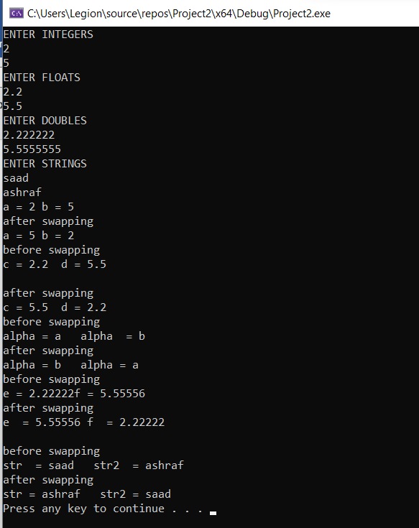

TASK 4:

#include<iostream>

using namespace std;

class triangle

{

public:

template<typename t>

t area(t length, t width)

{

return (length \* width) / 2;

}

template<typename u>

u Perimeter(u length, u width)

{

return length + width;

}

};

int main()

{

int a, b;

cout << "ENTER INTEGERS" << endl;

cin >> a;

cin >> b;

float c, d;

cout << "ENTER FLOATS" << endl;

cin >> c;

cin >> d;

double e, f;

cout << "ENTER DOUBLES" << endl;

cin >> e;

cin >> f;

triangle obj;

cout << "Area(int,int) : " << obj.area<int>(a, b) <<endl;

cout << "Area(float,float) : " << obj.area<float>(c, d) << endl;

cout << "Area(double,double) : " << obj.area<double>(e, f) << endl;

cout << "Area(int,float) : " << obj.area<int>(a, c) << endl;

cout << "Area(float, double) : " << obj.area<float>(c, e) << endl;

cout << "Area(double, int) : " << obj.area<double>(e, a) << endl;

cout << "Perimeter(int,int) : " << obj.Perimeter<int>(a, b) << endl;

cout << "Perimeter(float,float) : " << obj.Perimeter<float>(c, d) << endl;

cout << "Perimeter(double,double) : " << obj.Perimeter<double>(e, f) << endl;

cout << "Perimeter(int,float) : " << obj.Perimeter<int>(a, c) << endl;

cout << "Perimeter(float, double) : " << obj.Perimeter<float>(c,e) << endl;

cout << "Perimeter(double, int) : " << obj.Perimeter<double>(e, a) << endl;

system("pause");

return 0;

}

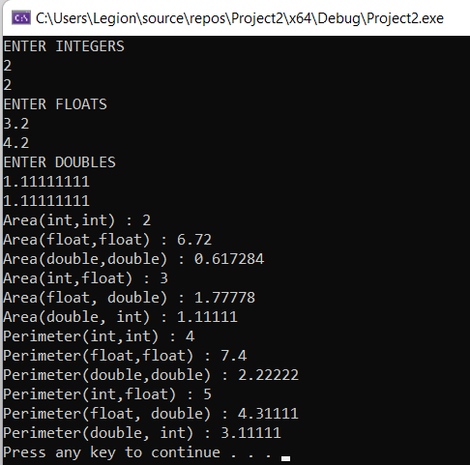

TASK 5:

#include<iostream>

using namespace std;

class Calculator

{

public:

template<typename t>

t add(t a, t b)

{

return a + b;

}

template<typename l>

l subtract(l a, l b)

{

return a - b;

}

template<typename x>

x mul(x a, x b)

{

return a \* b;

}

template<typename y>

y div(y a, y b)

{

return a / b;

}

template<typename z>

z squareRoot(z a)

{

return sqrt(a);

}

};

int main()

{

Calculator obj;

int a, b;

cout << "ENTER INTEGERS" << endl;

cin >> a;

cin >> b;

float c, d;

cout << "ENTER FLOATS" << endl;

cin >> c;

cin >> d;

cout << "Addition(int, int) is : " << obj.add<int>(a, b) << endl;

cout << "Addition(int, float) is : " << obj.add<int>(a, c) << endl;

cout << "Addition(float, int) is : " << obj.add<float>(c, a) << endl;

cout << "Division(int, int) is : " << obj.div<int>(a, b) << endl;

cout << "Division(float, int) is : " << obj.div<float>(c, a) << endl;

cout << "Division(int, float) is : " << obj.div<int>(a, c) << endl;

cout << "SquareRoot(int) is : " << obj.squareRoot<int>(a) << endl;

cout << "SquareRoot(float) is : " << obj.squareRoot<float>(c) << endl;

system("pause");

return 0;

