**TASK 1:**

**A:**

#include <iostream>

using namespace std;

float Division(float num, float den){

return (num / den);

}

int main(){

float numerator = 28.2;

float denominator = 0;

float result;

result = Division(numerator, denominator);

cout << "The answer of 28.2/0 is " << result << endl;

}

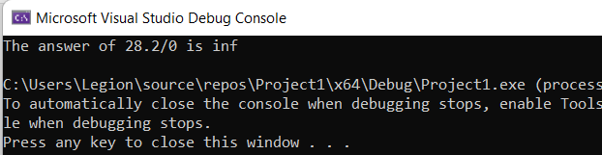

**B:**

#include<iostream>

using namespace std;

int main(){

try {

throw 'a';

}

catch (char c) {

cout << "Exception is being thrown: " << c << endl;

}

float str = 1.5;

try{

throw 1;

}

catch (int i){

cout << "Exception is being thrown: " << i << endl;

}

try{

throw str;

}

catch (float f){

cout << "Exception is being thrown: " << f << endl;

}

try{

throw "abc";

}

catch (const char* s){

cout << "Exception is being thrown: " << s << endl;

}

return 0;

}

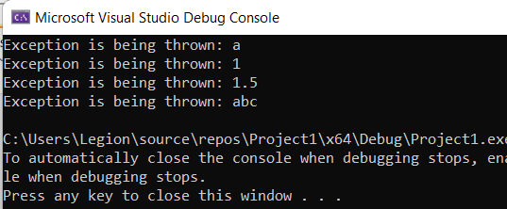

**TASK 2:**

#include<iostream>

using namespace std;

void addFractions(int num1, int den1, int num2, int den2, int result_num, int result_den){

try {

cout << "Enter first number: ";

cin >> num1;

cin >> den1;

throw invalid_argument("Number is not Valid");

cout << "Enter second number: ";

cin >> num2;

cin >> den2;

throw invalid_argument("Number is not Valid");

result_num = num1 * den2 + num2 * den1;

result_den = den1 * den2;

cout << "The sum of two fractions is " << result_num << "/" << result_den;

}

catch (exception eObj){

cout << "Exception: " << eObj.what() << endl;

}

}

void SubtractFraction(int num1, int den1, int num2, int den2, int result_num, int result_den){

try {

cout << "Enter first number: ";

cin >> num1;

cin >> den1;

throw invalid_argument("Invalid Input");

cout << "Enter second number: ";

cin >> num2;

cin >> den2;

throw invalid_argument("Invalid Input");

result_num = num1 * den2 - num2 * den1;

result_den = den1 * den2;

cout << "subtraction of the equation is : " << result_num << "/" << result_den;

}

catch (exception eObj){

cout << "Exception : " << eObj.what() << endl;

}

}

void multiplyFractions(int num1, int den1, int num2, int den2, int result_num, int result_den){

cout << "Enter first number: ";

cin >> num1;

cin >> den1;

cout << "Enter second number: ";

cin >> num2;

cin >> den2;

result_num = num1 * num2;

result_den = den1 * den2;

cout << "subtraction of the equation is : " << result_num << "/" << result_den;

}

void divideFractions(int num1, int den1, int num2, int den2, int result_num, int result_den){

cout << "Enter first number: ";

cin >> num1;

cin>> den1;

cout << "Enter second number: ";

cin >> num2;

cin >> den2;

try {

if (den1 == 0 || den2 == 0) {

throw exception("division by zero is not possibile");

}

result_num = num1 * den2;

cout << result_num << endl;

result_den = den1 * num2;

cout << result_den << endl;

cout << "Division of two Fraction is : " << result_num << "/" << result_den << endl;

}

catch (exception eObj){

cout << "Exception : " << eObj.what() << endl;

}

}

void display() {

cout << " 1- Addition" << endl;

cout << " 2- Subtraction" << endl;

cout << " 3- Division" << endl;

}

int main(){

int num1 = 0, num2 = 0, den1 = 0, den2 = 0;

int result_num = 0;

int result_den = 0;

int choice;

display();

cin >> choice;

switch (choice){

case 1:

addFractions(num1, den1, num2, den2, result_num, result_den);

break;

case 2:

SubtractFraction(num1, den1, num2, den2, result_num, result_den);

break;

case 3:

divideFractions(num1, den1, num2, den2, result_num, result_den);

break;

default:

break;

}

return 0;

}

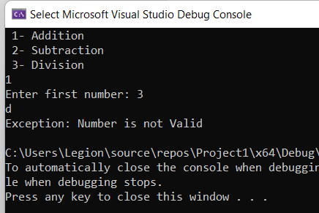

**TASK 3:**

**A:**

#include <iostream>

using namespace std;

int main() {

int lowerLimit = 50;

try

{

cout << "Entering the try block." << endl;

if (lowerLimit < 100)

throw exception("Lower limit violation.");

cout << "Exiting the try block." << endl;

}

catch (exception eObj)

{

cout << "Exception: " << eObj.what() << endl;

}

cout << "After the catch block" << endl;

}

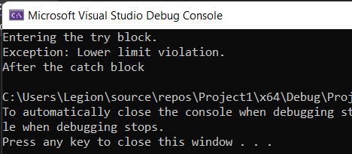

**B:**

#include <iostream>

using namespace std;

int main() {

int lowerLimit = 150;

try

{

cout << "Entering the try block." << endl;

if (lowerLimit < 100)

throw exception("Lower limit violation.");

cout << "Exiting the try block." << endl;

}

catch (exception eObj)

{

cout << "Exception: " << eObj.what() << endl;

}

cout << "After the catch block" << endl;

}

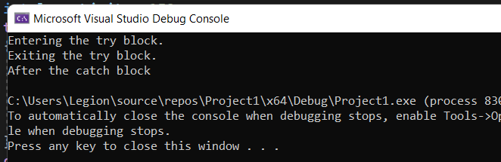

**TASK 4:**

**TASK 5:**

#include<iostream>

using namespace std;

class invalidHr{

public:

invalidHr(){

cout << "Invalid Hour" << endl;

}

};

class invalidMin{

public:

invalidMin(){

cout << "Invalid Minutes" << endl;

}

};

class invalidSec{

public:

invalidSec(){

cout << "Invalid seconds" << endl;

}

};

int main(){

int h, m, s;

cout << "Enter hour" << endl;

cin >> h;

cout << "Enter minute" << endl;

cin >> m;

cout << "Enter second" << endl;

cin >> s;

try{

if (h < 0 || h>12){

throw invalidHr();

}

if (m < 0 || m>60){

throw invalidMin();

}

if (s < 0 || s >60){

throw invalidSec();

}

else {

cout << " Time : " << h + 12 << " : " << m << " : " << s << endl;

}

}

catch (invalidHr h) {}

catch (invalidMin m) {}

catch (invalidSec s) {}

}

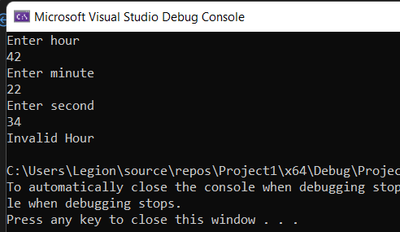

**TASK 6 :**

#include<iostream>

using namespace std;

class invalidDay{

public:

invalidDay(){

cout << "Invalid Day" << endl;

}

};

class invalidMonth{

public:

invalidMonth(){

cout << "Invalid Month" << endl;

}

};

class invalidyear {

public:

invalidyear() {

cout << "Invalid year" << endl;

}

};

int main(){

int d, m, y;

cout << "Enter day" << endl;

cin >> d;

cout << "Enter Month" << endl;

cin >> m;

cout << "Enter Year" << endl;

cin >> y;

try

{

if (d < 0 || d>31)

{

throw invalidDay();

}

else if (m < 0 || m>12)

{

throw invalidMonth();

}

else if (y < 0) {

throw invalidyear();

}

else

{

cout << "Date of Birth : " << d << "/" << m << "/" << y << endl;

}

}

catch (invalidDay d) {}

catch (invalidMonth m) {}

catch (invalidyear y) {}

}

