Problem 5:

#include<iostream>

using namespace std;

int main()

{

/\*int size;

cin >> size;\*/

int\* ptr = new int[999], n;

for (int i = 0; i < 999; i++)

{

cout << "Enter Array: ";

cin >> n;

if (n == -1)

{

exit(0);

int\* ptr1 = new int[i];

for (int i = 0; i < i; i++)

{

ptr1[i] = ptr[i];

}

}

else

{

ptr[i] = n;

}

}

}

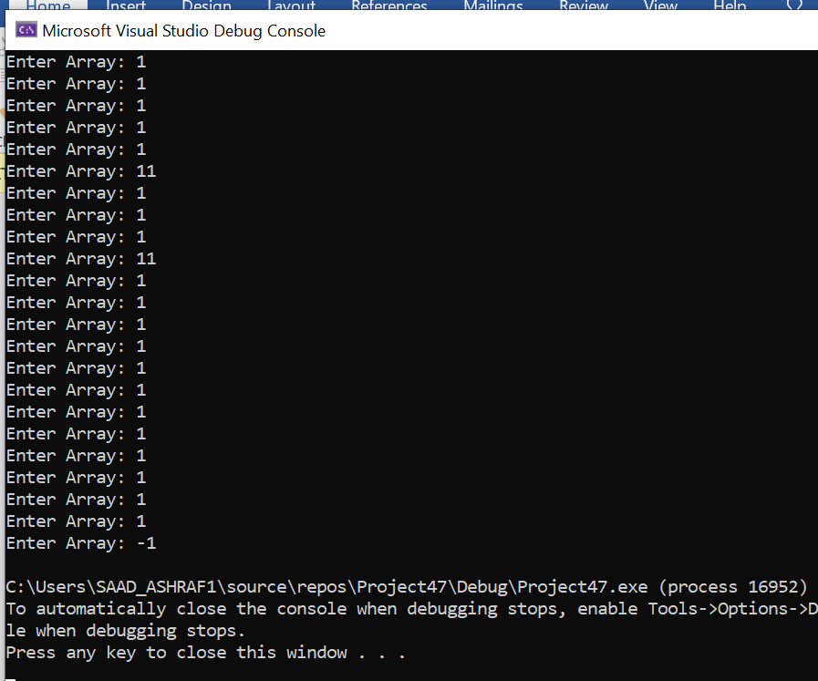

Problem 7:

#include <iostream>

#include <string>

using namespace std;

int main(){

int rows;

cout << "Enter rows of array: ";

cin >> rows;

int\* numbers = new int[rows];

//declaration of array

int\*\* array = new int\* [rows]; //jagged array

int i = 0;

while ( i < rows)

{

cout << "Enter column in row " << i << ": ";

cin >> numbers[i];

array[i] = new int[numbers[i]]; //creating new dynamic memory

i++;

}

//Input values in array

for (int i = 0; i < rows; i++)

{

for (int j = 0; j < numbers[i]; j++)

{

cout << "Row " << i << ":- input value " << i \* numbers[i] + j << ": ";

cin >> array[i][j];

}

}

//Output values of array

for (int i = 0; i < rows; i++)

{

for (int j = 0; j < numbers[i]; j++)

{

cout << array[i][j] << " "; //printing the jagged array

}

cout <<endl;

}

delete array; //deleting dynamic array

system("pause");

return 0;

}

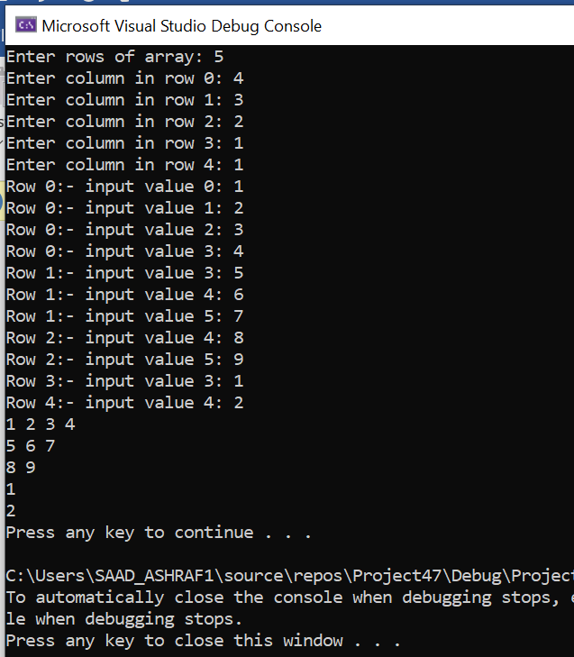

Task 8: #include<iostream>

#include<string>

using namespace std;

int main() {

int s;

string a;

cout << "Enter Size of Array : " << endl;;

cin >> s;

char\*\* arr;

cout << endl;

int i = 0;

arr = new char\* [s];

int size1 = 0;

while (true) {

cin >> a;

size1 = a.length();

arr[i] = new char[size1 + 1];

int j = 0;

for (j = 0; a[j] != '\0'; j++) {

arr[i][j] = a[j];

}

arr[i][j + 1] = NULL;

if (i == s - 1) {

break;

}

i++;

}

cout << endl;

i = 0;

while (i < s) {

cout << endl;

int k = 0;

while (k < strlen(arr[i]) - 1)

{

cout << arr[i][k] << "|";

k++;

}

cout << "NULL" << "|";

cout << endl;

i++;

}

}

