# Lab 11

# NAME : Saad Ahraf Class: 4b Roll No: 21f-9167 STEP 1

Command to Find the Grub

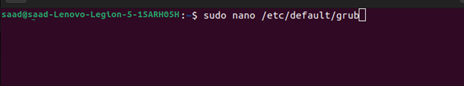

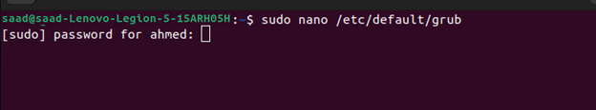

# STEP 2

Updating the Grub

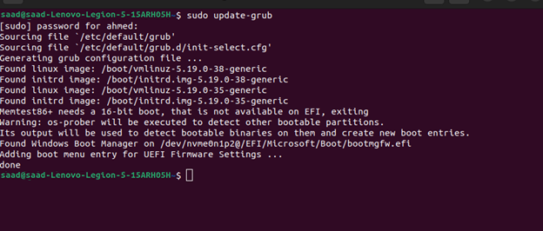

# STEP 3

Finding the The Kernal Version



# 

# STEP 4

Downloading latest stable Kernel code from kernel.org

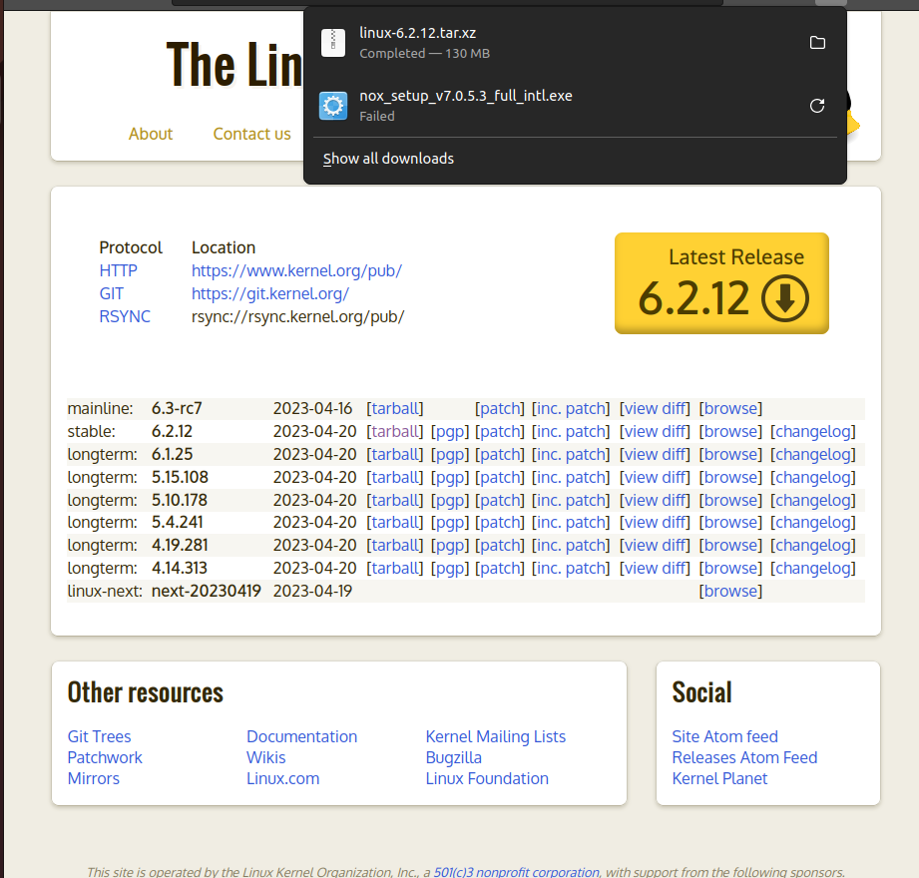

# STEP 5

Open the terminal and use the [wget command](https://phoenixnap.com/kb/wget-command-with-examples) to download the Linux kernel source code  
The output shows the “saved” message when the download completes

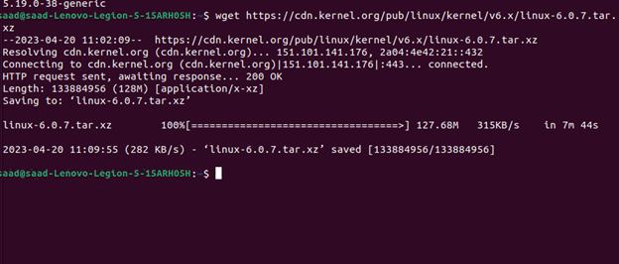

# STEP 6

Extracting the Source code

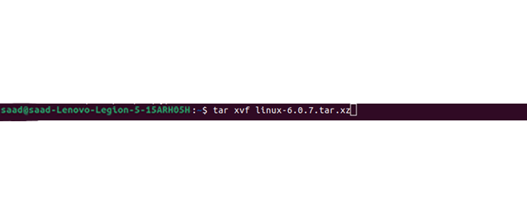

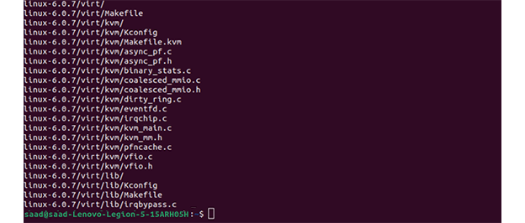

# STEP 7

Installing the required Packages

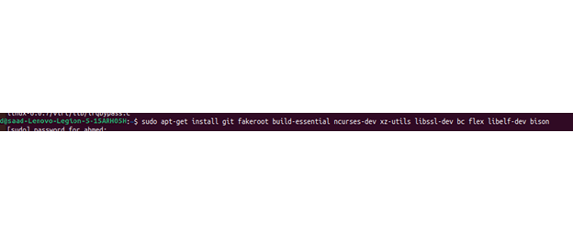

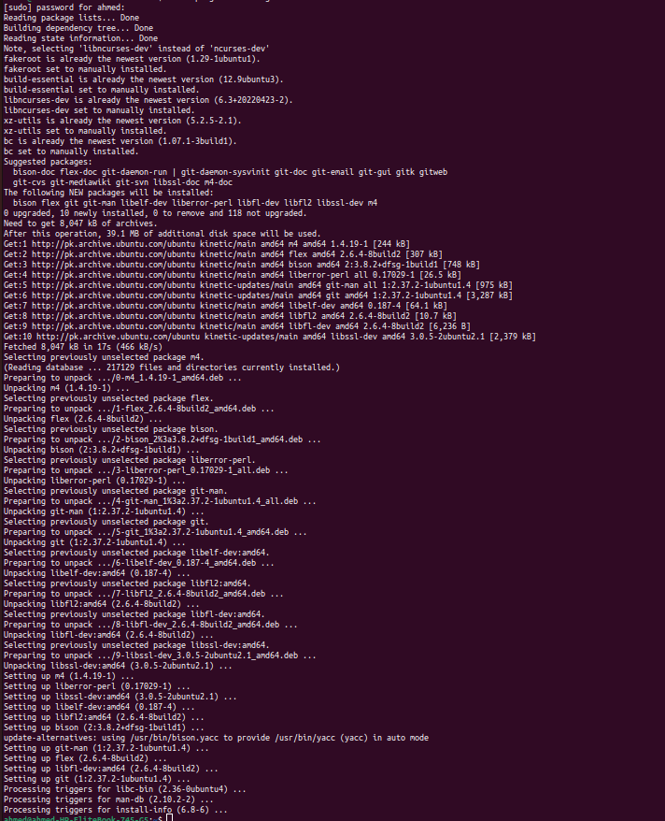  
  
  
  
  
  
  
STEP 8

Configuring the kernel

The Linux kernel source code comes with the default configuration. However, you can adjust it to your needs. To do so, follow the steps below  
  
Navigating to the **linux-6.0.7**

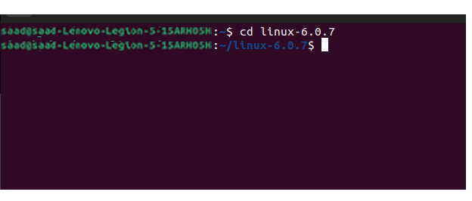  
  
STEP 9  
  
Coping the existing configuration file using the cp command  
  
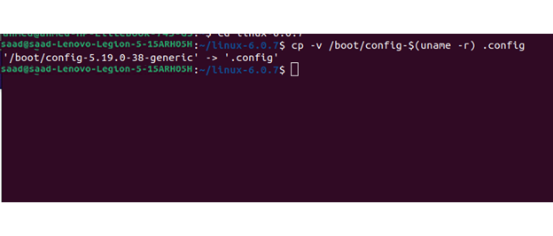

STEP 10

# 

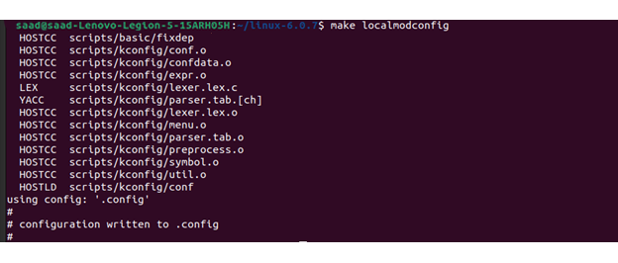

PACKAGES

# GIT

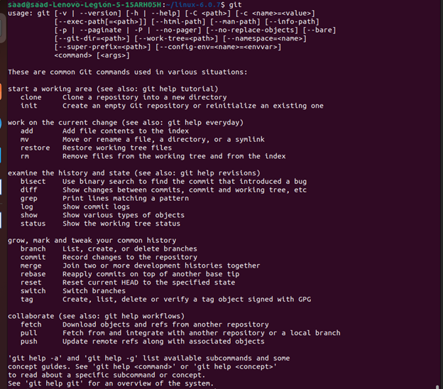

# FAKE ROOT

# BC

# 

# FLEX

# 

# BISION

# 

# STEP 11

Make Packages to debug

# ––

# 

# STEP 12

Shut down the computer

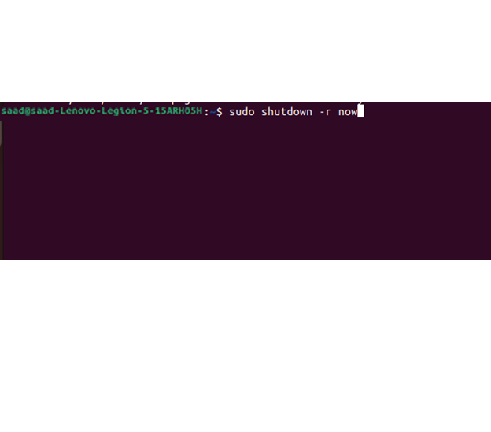

# STEP 13

Latest version

