TASK 1:

Implement a code that take two matrix name MATA of size n*m and second Matrix MATB of
size m*k and generate a resultant matrix MATC of size n*k by performing multiplication using
threads. The number of threads created in system will be equal to n. each thread perform
multiplication of each row in MATA with MATB to produced the resultant value for particular
row in MATC .

SOLUTION:

#include <iostream>
#include <vector>
#include <thread>
using namespace std;
const int MAXN = 1000;
int n, m, k;
int matrix_a[MAXN][MAXN], matrix_b[MAXN][MAXN], matrix_c[MAXN][MAXN];
void multiply(int row) {
for (int col = 0; col < k; ++col) {
matrix_c[row][col] = 0;
for (int i = 0; i < m; ++i) {
matrix_c[row][col] += matrix_a[row][i] * matrix_b[i][col];
}
}
}
int main() {
cout<<"Enter Number of rows : ";
cin >> n;
cout<<"Enter Number of columns : ";
cin >> m;
cin >> k;
for (int i = 0; i < n; ++i) {
for (int j = 0; j < m; ++j) {
cin >> matrix_a[i][j];
}
}
for (int i = 0; i < m; ++i) {
for (int j = 0; j < k; ++j) {
cin >> matrix_b[i][j];
}
}
vector<thread> threads;
for (int i = 0; i < n; ++i) {
threads.emplace_back(multiply, i);
}
for (auto& t : threads) {
t.join();
}
cout<<"Matrix C is : "<<endl;
for (int i = 0; i < n; ++i) {
for (int j = 0; j < k; ++j) {
cout << matrix_c[i][j] << " | ";
}
cout << endl;
}

return 0;
}

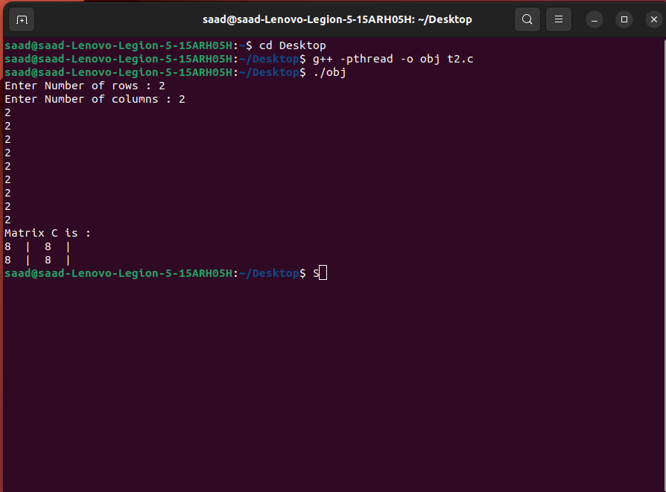

TASK 2:

Implement an "alarm clock" class. Threads call "Alarm:GoToSleepFor(int howLong)" to go to sleep
for a period of time. The alarm clock can be implemented using the hardware Timer device
(i.e. timer.h). When the timer interrupt goes off, the Timer interrupt handler checks to see if any
thread that had been asleep needs to wake up now. There is no requirement that threads start
running immediately after waking up; just put them on the ready queue after they have waited
for the approximately the right amount of time. The person will set an alarm and it will display a
message after the set amount of time. Provide the options to snooz alarm for 10 sec or stop the
alarm as well.

SOLUTION:

#include <iostream>
#include <thread>
#include <chrono>
#include <condition_variable>
#include <mutex>
#include <deque>

using namespace std;

class AlarmClock {
public:
AlarmClock() {
timer_thread_ = thread(&AlarmClock::timer_thread_func_, this);
}

~AlarmClock() {
{
unique_lock<mutex> lock(mutex_);
stop_ = true;
cv_.notify_all();
}
timer_thread_.join();
}

void GoToSleepFor(int howLong) {
unique_lock<mutex> lock(mutex_);
auto wake_time = chrono::steady_clock::now() + chrono::seconds(howLong);
alarms_.push_back(wake_time);
cv_.notify_all();
}

void Snooze() {
unique_lock<mutex> lock(mutex_);
if (!alarms_.empty()) {
alarms_.back() += chrono::seconds(10);
cv_.notify_all();
}
}

void StopAlarm() {
unique_lock<mutex> lock(mutex_);
if (!alarms_.empty()) {
alarms_.pop_back();
cv_.notify_all();
}
}

private:
void timer_thread_func_() {
while (true) {
unique_lock<mutex> lock(mutex_);
auto now = chrono::steady_clock::now();
while (!alarms_.empty() && alarms_.front() <= now) {
cout << "ALARM! Time to wake up!" << endl;
alarms_.pop_front();
}
if (stop_) {
break;
}
if (alarms_.empty()) {
cv_.wait(lock);
} else {
cv_.wait_until(lock, alarms_.front());
}
}
}

thread timer_thread_;
deque<chrono::steady_clock::time_point> alarms_;
bool stop_ = false;
mutex mutex_;
condition_variable cv_;
};

int main() {
AlarmClock alarm;

cout << "Setting alarm for 5 seconds..." << endl;
alarm.GoToSleepFor(5);

cout << "Sleeping..." << endl;
this_thread::sleep_for(chrono::seconds(2));

cout << "Snoozing alarm for 10 seconds..." << endl;
alarm.Snooze();
this_thread::sleep_for(chrono::seconds(10));

cout << "Stopping alarm..." << endl;
alarm.StopAlarm();

cout << "Done." << endl;
return 0;
}

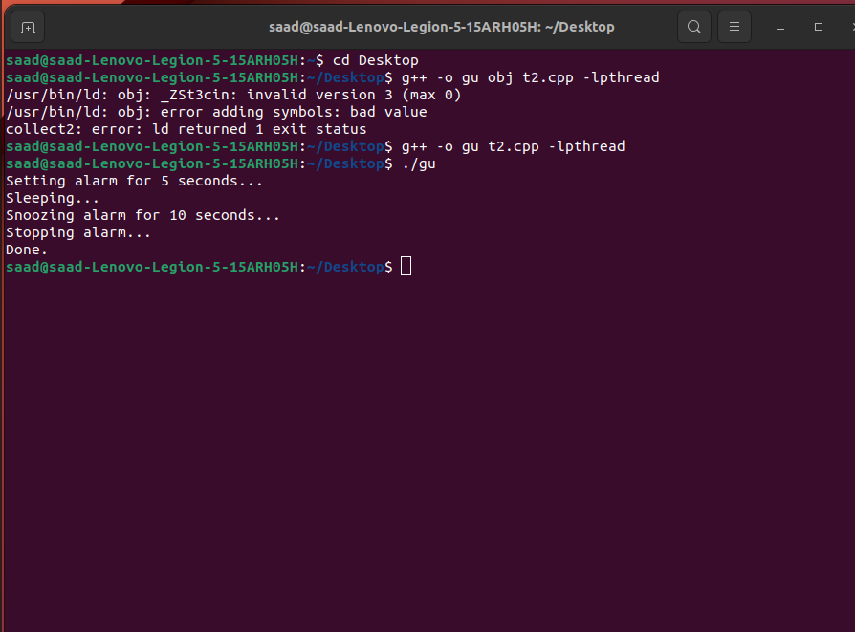

TASK 3:

Implement a queue using a singly linked list. Declare a global variable to hold the value of an
integer. Now create two threads. One will open a file and read integers from the file one by one
in the declared variable. Second thread will be reading the variable and insert the data into the
linked list. After both threads complete their task the main program will output the contents of
the queue to the screen. Your task is to find out if the queue has same numbers that were there
in the file or are there some missing values or some numbers in access.

SOLUTION:

#include <iostream>
#include <list>
#include <fstream>
#include <pthread.h>
#include <string>
#include<unistd.h>
#define ARRAY_SIZE 2
using namespace std;
int count = 0;
int data1 = 0;
bool m = false;
pthread_mutex_t mutex = PTHREAD_MUTEX_INITIALIZER;
pthread_cond_t cond_var = PTHREAD_COND_INITIALIZER;
list<int> List;
void* reader(void* arg) {
while (count < 5) {
pthread_mutex_lock(&mutex);
while (!m) {
pthread_cond_wait(&cond_var, &mutex);
}

m = false;
List.push_front(data1);
pthread_mutex_unlock(&mutex);
}

return NULL;
}
void* writer(void* arg) {
ifstream a;
a.open("Data.txt");
while (a >> data1) {
m = true;
pthread_mutex_lock(&mutex);
pthread_cond_signal(&cond_var);
pthread_mutex_unlock(&mutex);
count++;
sleep(1);
}

pthread_exit(NULL);
}

int main() {
pthread_t thread1;
pthread_t thread2;
int i = 0;
pthread_create(&thread1, NULL, writer, NULL);
pthread_create(&thread2, NULL, reader, NULL);
pthread_join(thread1, NULL);
pthread_join(thread2, NULL);
cout << "Your Data is:\n\n";

while (!List.empty()) {
i = List.front();
List.pop_front();
cout << i << std::endl;
}
cout << std::endl;

return 0;
}

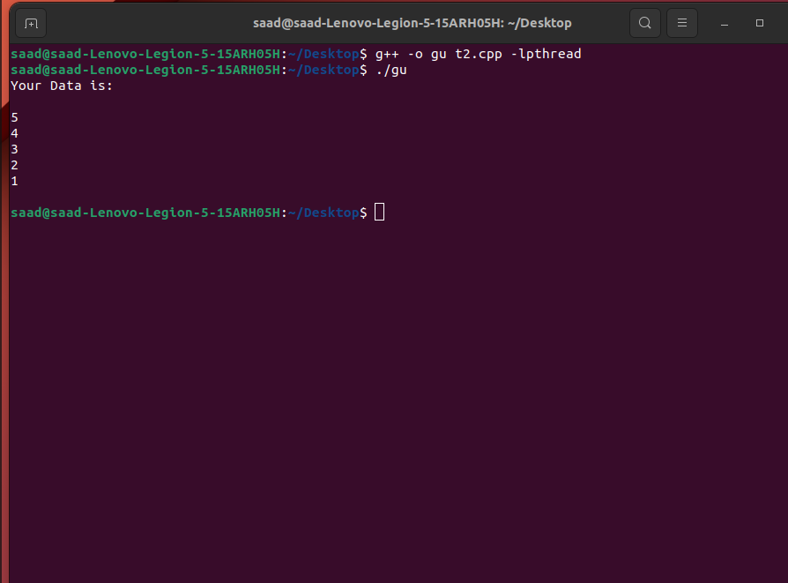
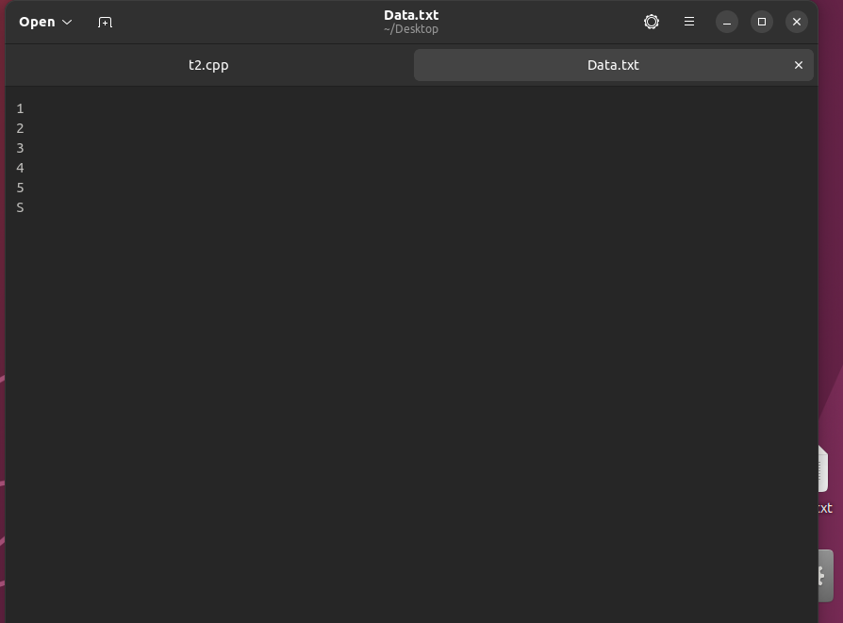

TASK 4:

Write a C++/C code to implement the given sorting Algorithms. The main program thread first
generates 1,000,000 Random Integers (or array range can be inserted dynamically) at runtime
and stores these integers in four files (Unsorted_00.txt, Unsorted_01.txt, Unsorted_02.txt,
Unsorted_03.txt) each containing 250,000 integers.
• The main thread will then create different threads each one implementing one of the below
given sorting algorithm and parent will wait for these threads to complete their execution.
• Each chunk is to be treated as an individual sorting task and implemented by a separate
thread running one of the algorithms given below
• Finally when all the threads complete their tasks, they will exit by saving the results in their
respective files, merge.txt, selection.txt, insertion.txt and quick.txt.
• When a thread starts it will print its algorithm name, start time and thread id
• When the thread ends it will print its exit time
• The main program then uses these results further and merges the four sorted lists together
to make one big sorted list
• Final sorted list should be stored in a text file named as (Sorted.txt).
The sorting algorithms that you are supposed to implement are:

I. Merge Sort
II. Selection Sort
III. Insertion Sort
IV. Quick Sort

SOLUTION:

#include<iostream>
#include<fstream>
#include<time.h>
#include<chrono>
#include<cstdlib>
#include<iomanip>
#include<unistd.h>
#include<pthread.h>
using namespace std;
int size1=100;
struct merge_quick
{
int *arr,low,high;
};
struct sel_ins
{
int *arr,n;
};
void get_time()
{
auto time=chrono::system_clock::now();
auto now_time=chrono::system_clock::to_time_t(time);
cout<<put_time(std::localtime(&now_time),"%H:%M:%S");
}
void merge(int arr[], int l, int m, int r) {
int n1 = m - l + 1;
int n2 = r - m;

int L[n1], R[n2];

for (int i = 0; i < n1; i++)
L[i] = arr[l + i];
for (int j = 0; j < n2; j++)
R[j] = arr[m + 1 + j];

int i = 0, j = 0, k = l;

while (i < n1 && j < n2) {
if (L[i] <= R[j]) {
arr[k] = L[i];
i++;
}
else {
arr[k] = R[j];
j++;
}
k++;
}

while (i < n1) {
arr[k] = L[i];
i++;
k++;
}

while (j < n2) {
arr[k] = R[j];
j++;
k++;
}
}

void mergeSort(int arr[], int l, int r) {
if (l < r) {
int m = l + (r - l) / 2;

mergeSort(arr, l, m);
mergeSort(arr, m + 1, r);

merge(arr, l, m, r);
}
}
void selectionSort(int arr[], int n)
{
int i, j, min_idx;
for (i = 0; i < n-1; i++)
{
min_idx = i;
for (j = i+1; j < n; j++)
{
if (arr[j] < arr[min_idx])
min_idx = j;
}
if (min_idx!=i)
swap(arr[min_idx],arr[i]);
}
}

void insertionSort(int arr[], int n)
{
int i, key, j;
for (i = 1; i < n; i++)
{
key = arr[i];
j = i - 1;
while (j >= 0 && arr[j] > key)
{
arr[j + 1] = arr[j];
j = j - 1;
}
arr[j + 1] = key;
}
}

int partition(int arr[], int start, int end)
{

int pivot = arr[start];

int count = 0;
for (int i = start + 1; i <= end; i++) {
if (arr[i] <= pivot)
count++;
}

// Giving pivot element its correct position
int pivotIndex = start + count;
swap(arr[pivotIndex], arr[start]);

// Sorting left and right parts of the pivot element
int i = start, j = end;

while (i < pivotIndex && j > pivotIndex) {

while (arr[i] <= pivot) {
i++;
}

while (arr[j] > pivot) {
j--;
}

if (i < pivotIndex && j > pivotIndex) {
swap(arr[i++], arr[j--]);
}
}

return pivotIndex;
}

void quickSort(int arr[], int start, int end)
{

if (start >= end)
return;
int p = partition(arr, start, end);
quickSort(arr, start, p - 1);
quickSort(arr, p + 1, end);
}

void *merge_call(void *temp)
{
cout<<"Merge Sorting Starting Time:";
get_time();
cout<<endl;
merge_quick *m = (merge_quick*)temp;
mergeSort(m->arr, m->low, m->high);
cout<<"Merge Sorting Ending Time:";
get_time();
cout<<endl;
pthread_exit(NULL);
}

void *quick_call(void *temp)
{
cout<<"Quick Sorting Starting Time:";
get_time();
cout<<endl;
merge_quick *q = (merge_quick*)temp;
quickSort(q->arr, q->low, q->high);
cout<<"Quick Sorting Ending Time:";
get_time();
cout<<endl;
pthread_exit(NULL);
}

void *select_call(void *temp)
{
cout<<"Selection Sorting Starting Time:";
get_time();
cout<<endl;
sel_ins *s = (sel_ins*)temp;
selectionSort(s->arr, s->n);
cout<<"Selection Sorting Ending Time:";
get_time();
cout<<endl;
pthread_exit(NULL);
}

void *insert_call(void *temp)
{
cout<<"Insertion Sorting Starting Time:";
get_time();
cout<<endl;
sel_ins *i = (sel_ins*)temp;
insertionSort(i->arr, i->n);
cout<<"Insertion Sorting Ending Time:";
get_time();
cout<<endl;
pthread_exit(NULL);
}

int main()
{
ofstream outfile,sortfile;
sortfile.open("Sorted",ios::app);
ifstream infile;
int val;
//Quick Sort
outfile.open("unsorted_quick");
for(int i=0;i<size1;i++)
{
val=(rand()%100)+1;
outfile<<val<<endl;
}
outfile.close();
merge_quick q;
q.arr=new int [size1];
infile.open("unsorted_quick");
if(!infile.is_open())
{
cout<<"File not Opened."<<endl;
}
else
{
for(int i=0;i<size1;i++)
{
infile>>val;
q.arr[i]=val;
}
infile.close();
q.low=0;
q.high=size1-1;
pthread_t th;
pthread_create(&th,NULL,quick_call,&q);
pthread_join(th,NULL);
}
outfile.open("quick");
for(int i=0;i<size1;i++)
{
outfile<<q.arr[i]<<endl;
sortfile<<q.arr[i]<<endl;
}
outfile.close();

//Selection Sort
outfile.open("unsorted_selection");
for(int i=0;i<size1;i++)
{
val=(rand()%100)+1;
outfile<<val<<endl;
}
outfile.close();
sel_ins s;
s.arr=new int [size1];
infile.open("unsorted_selection");
if(!infile.is_open())
{
cout<<"File not Opened."<<endl;
}
else
{
for(int i=0;i<size1;i++)
{
infile>>val;
s.arr[i]=val;
}
infile.close();
s.n=size1;
pthread_t th;
pthread_create(&th,NULL,select_call,&s);
pthread_join(th,NULL);
}
outfile.open("selection");
for(int i=0;i<size1;i++)
{
outfile<<s.arr[i]<<endl;
sortfile<<s.arr[i]<<endl;
}
outfile.close();

//Insertion Sort
outfile.open("unsorted_insertion");
for(int i=0;i<size1;i++)
{
val=(rand()%100)+1;
outfile<<val<<endl;
}
outfile.close();

sel_ins in;
in.arr=new int [size1];
infile.open("unsorted_selection");
if(!infile.is_open())
{
cout<<"File not Opened."<<endl;
}
else
{
for(int i=0;i<size1;i++)
{
infile>>val;
in.arr[i]=val;
}
infile.close();
in.n=size1;
pthread_t th;
pthread_create(&th,NULL,insert_call,&in);
pthread_join(th,NULL);
}
outfile.open("insertion");
for(int i=0;i<size1;i++)
{
outfile<<in.arr[i]<<endl;
sortfile<<in.arr[i]<<endl;
}
outfile.close();
//Merge Sort
outfile.open("unsorted_merge");
for(int i=0;i<size1;i++)
{
val=(rand()%100)+1;
outfile<<val<<endl;
}
outfile.close();
merge_quick m;
m.arr=new int [size1];
infile.open("unsorted_merge");
if(!infile.is_open())
{
cout<<"File not Opened."<<endl;
}
else
{
for(int i=0;i<size1;i++)
{
infile>>val;
m.arr[i]=val;
}
infile.close();
m.low=0;
m.high=size1-1;
pthread_t th;
pthread_create(&th,NULL,merge_call,&m);
pthread_join(th,NULL);
}
outfile.open("merge");
for(int i=0;i<size1;i++)
{
outfile<<m.arr[i]<<endl;
sortfile<<m.arr[i]<<endl;
}
outfile.close();
return 0;
}

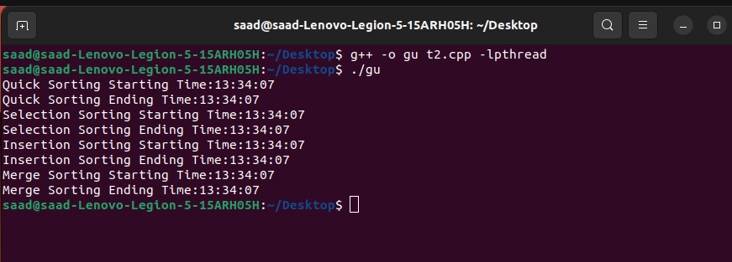

TASK 5:

Fork-Join Parallelism
Take an array of N size sort the data using thread. The apply fork and joint framework to divide
the array into left and right array then create two processes using fork system call that is left
process and right process that find the maximum number in each sub array. Finally combine the
result to find the maximum value among both resultant values.

SOLUTION:

#include <iostream>
#include <vector>
#include <thread>
#include <unistd.h>
#include <sys/wait.h>
#include <algorithm>
#include <cstdlib>
using namespace std;

int find_max(const vector<int>& arr) {
int max_val = arr[0];
for (int i = 1; i < arr.size(); ++i) {
if (arr[i] > max_val) {
max_val = arr[i];
}
}
return max_val;
}

int main() {
const int N = 10;
vector<int> arr = {5, 3, 7, 2, 9, 1, 8, 4, 6, 0};
thread t([&]() { sort(arr.begin(), arr.end()); });

if (t.joinable()) {
t.join();
}

int mid = N / 2;
vector<int> left_arr(arr.begin(), arr.begin() + mid);
vector<int> right_arr(arr.begin() + mid, arr.end());

int left_pid = fork();
if (left_pid == -1) {
cerr << "Error creating left child process" << endl;
return 1;
} else if (left_pid == 0) {

int max_val = find_max(left_arr);
cout << "Left process found maximum value: " << max_val << endl;
return max_val;
} else {
int right_pid = fork();
if (right_pid == -1) {
cerr << "Error creating right child process" << endl;
return 1;
} else if (right_pid == 0) {
int max_val = find_max(right_arr);
cout << "Right process found maximum value: " << max_val << endl;
return max_val;
} else {
int left_max, right_max;
waitpid(left_pid, &left_max, 0);
waitpid(right_pid, &right_max, 0);
left_max = WEXITSTATUS(left_max);
right_max = WEXITSTATUS(right_max);
int max_val = max(left_max, right_max);
cout << "Maximum value among both subarrays: " << max_val << endl;
return 0;
}
}
}

