TASK 1:

1. Write a program using fork() system call to create two child of the same process i.e.,
Parent P having child process P1 and P2.

SOLUTION:

#include <stdio.h>
#include <stdlib.h>
#include <unistd.h>

int main() {
pid_t pid1, pid2;
pid1 = fork();
if (pid1 == 0) {
printf("I am the first child process (P1) with PID %d\n", getpid());
exit(0);
} else if (pid1 < 0) {
fprintf(stderr, "Error forking first child process (P1)\n");
exit(1);
} else {
pid2 = fork();
if (pid2 == 0) {
printf("I am the second child process (P2) with PID %d\n", getpid());
exit(0);
} else if (pid2 < 0) {
fprintf(stderr, "Error forking second child process (P2)\n");
exit(1);
} else {
printf("I am the parent process (P) with PID %d\n", getpid());
printf("My first child process (P1) has PID %d\n", pid1);
printf("My second child process (P2) has PID %d\n", pid2);
exit(0);
}
}

return 0;
}

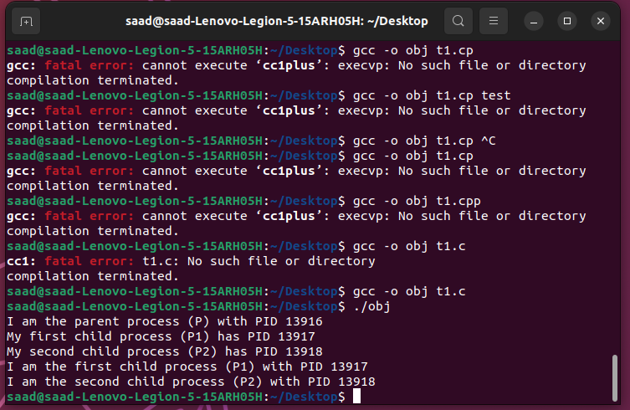
TASK 2:

Write a program using fork() system call to create a hierarchy of 3 process such that P2
is the child of P1 and P1 is the child of P.

SOLUTION:

#include <stdio.h>
#include <stdlib.h>
#include <unistd.h>
#include<sys/wait.h>
int main() {
pid_t pid1, pid2;
pid1 = fork();
if (pid1 == 0) {
printf("I am the first child process (P1) with PID %d and my parent is P with PID %d\n", getpid(), getppid());
pid2 = fork();
if (pid2 == 0) {
printf("I am the second child process (P2) with PID %d and my parent is P1 with PID %d\n", getpid(), getppid());
exit(0);
} else if (pid2 < 0) {
fprintf(stderr, "Error forking second child process (P2)\n");
exit(1);
} else {
wait(NULL);
exit(0);
}
} else if (pid1 < 0) {
fprintf(stderr, "Error forking first child process (P1)\n");
exit(1);
} else {
printf("I am the parent process (P) with PID %d\n", getpid());
printf("My first child process (P1) has PID %d\n", pid1);
wait(NULL);
exit(0);
}
return 0;
}

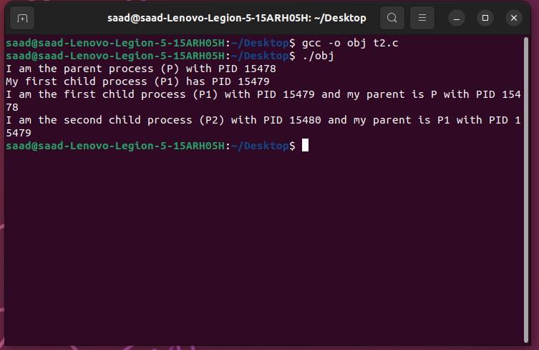
TASK 3:

Create a parent-child relationship between two processes. The parent should print two
statements:
A) Parent (P) is having ID &lt;PID&gt;
B) ID of P’s Child is &lt;PID_of_Child&gt;
The child should print two statements:
C) Child is having ID &lt;PID&gt;
D) My Parent ID is &lt;PID_of_Parent&gt;
Make use of wait() in such a manner that the order of the four statements A, B, C and D
is:
A
C
D
B
You are free to use any other relevant statement/printf as you desire and their order of
execution does not matter.

SOLUTION:

#include <stdio.h>
#include <unistd.h>
#include <sys/wait.h>
int main() {
pid_t child_pid = fork();
if (child_pid == 0) {
printf("Child is having ID %d\n", getpid());
printf("My Parent ID is %d\n", getppid());
}
else if (child_pid > 0) {
wait(NULL);
printf("Parent (P) is having ID %d\n", getpid());
printf("ID of P's Child is %d\n", child_pid);
} else { // fork failed
printf("Fork failed\n");
return 1;
}

return 0;
}

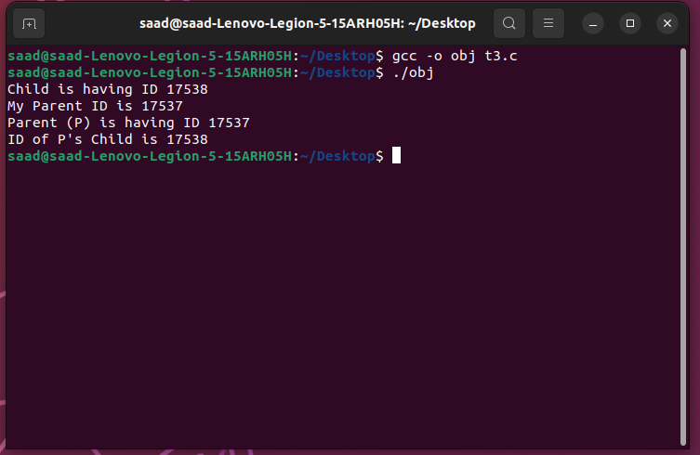
TASK 4:

Write a program to create two child process. The parent process should wait for both the
child to finish.
SOLUTION:

#include <stdio.h>
#include <stdlib.h>
#include <unistd.h>
#include <sys/wait.h>

int main() {
pid_t pid1, pid2;
pid1 = fork();
if (pid1 < 0) {
fprintf(stderr, "Error creating first child process\n");
exit(1);
} else if (pid1 == 0) {
printf("Child process 1 with pid %d\n", getpid());
sleep(5);
printf("Child process 1 exiting\n");
exit(0);
} else {
pid2 = fork();
if (pid2 < 0) {
fprintf(stderr, "Error creating second child process\n");
exit(1);
} else if (pid2 == 0) {
printf("Child process 2 with pid %d\n", getpid());
sleep(10);
printf("Child process 2 exiting\n");
exit(0);
} else {
int status1, status2;
waitpid(pid1, &status1, 0);
waitpid(pid2, &status2, 0);
printf("Parent process with pid %d: Child processes finished\n", getpid());
}
}
return 0;
}

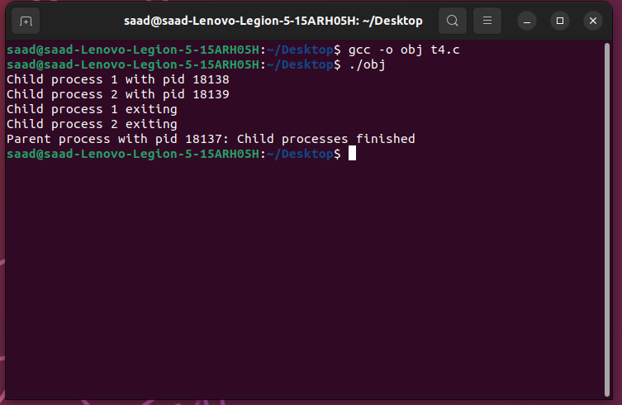
TASK 5:

Create two child process C1 and C2. Make sure that only C2 becomes an orphan process.

SOLUTION:

#include <stdio.h>
#include <stdlib.h>
#include <unistd.h>
#include <sys/types.h>
#include <sys/wait.h>

int main() {
pid_t pid1, pid2;
int status;

pid1 = fork();

if (pid1 == -1) {
perror("fork");
exit(EXIT_FAILURE);
} else if (pid1 == 0) {
printf("I am C1, my PID is %d and my parent's PID is %d.\n", getpid(), getppid());
exit(EXIT_SUCCESS);
} else {
pid2 = fork();

if (pid2 == -1) {
perror("fork");
exit(EXIT_FAILURE);
} else if (pid2 == 0) {
printf("I am C2, my PID is %d and my parent's PID is %d.\n", getpid(), getppid());
sleep(5);
exit(EXIT_SUCCESS);
} else {
printf("I am the parent process, my PID is %d and I have created two child processes: C1 (PID=%d) and C2 (PID=%d).\n", getpid(), pid1, pid2);
waitpid(pid1, &status, 0);
waitpid(pid2, &status, 0);
printf("All child processes have exited.\n");
}
}

return 0;
}

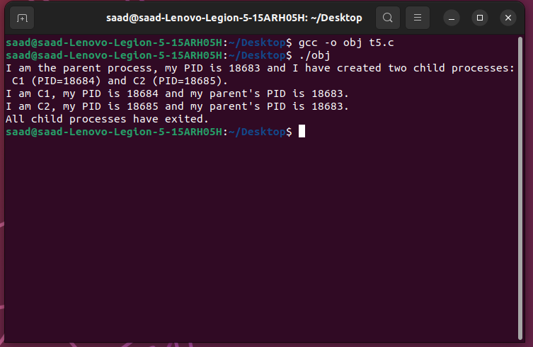
TASK 6:
#include <stdio.h>
#include <stdlib.h>
#include <unistd.h>
#include <sys/types.h>
#include <sys/wait.h>

int main() {
pid_t pid1, pid2;
pid1=fork();
if(pid1==0){
execl(example.c);
}
else{
printf("hello from parent");
return 0;
}

#include <stdio.h>
#include <stdlib.h>
#include <unistd.h>
#include <sys/types.h>
#include <sys/wait.h>

int main() {
printf("hello from example");
return 0;
}

