TASK 1:
CODE:
READER:
#include <stdio.h>
#include <stdlib.h>
#include <unistd.h>
#include <fcntl.h>
#include <sys/stat.h>
#include <string.h>

#define MAX_BUF 1024

int main()
{
int fd;
char *myfifo = "/tmp/mypipe";
char buf[MAX_BUF];

// create the named pipe
mkfifo(myfifo, 0666);

printf("Creating named pipe: %s\n", myfifo);

// open the named pipe for reading
fd = open(myfifo, O_RDONLY);
printf("Waiting for input...\n");

// read from the named pipe until 'exit' is received
while (1) {
int n = read(fd, buf, MAX_BUF);
buf[n] = '\0';
printf("WRITEN: '%s'\n", buf);
if (strcmp(buf, "exit\n") == 0) {
break;
}
}

// close the named pipe and remove it
close(fd);
unlink(myfifo);

printf("Exiting\n");

return 0;
}

WRITER:
#include <stdio.h>
#include <stdlib.h>
#include <unistd.h>
#include <fcntl.h>
#include <sys/stat.h>
#include <string.h>

#define MAX_BUF 1024

int main()
{
int fd;
char *myfifo = "/tmp/mypipe";
char buf[MAX_BUF];

// open the named pipe for writing
fd = open(myfifo, O_WRONLY);
printf("Opening named pipe: %s\n", myfifo);

// read from user input and write to the named pipe
while (1) {
printf("Enter Input: ");
fgets(buf, MAX_BUF, stdin);
printf("Writing :");
write(fd, buf, strlen(buf) + 1);
printf("done\n");
if (strcmp(buf, "exit\n") == 0) {
break;
}
}

// close the named pipe
close(fd);

printf("Exiting\n");

return 0;
}

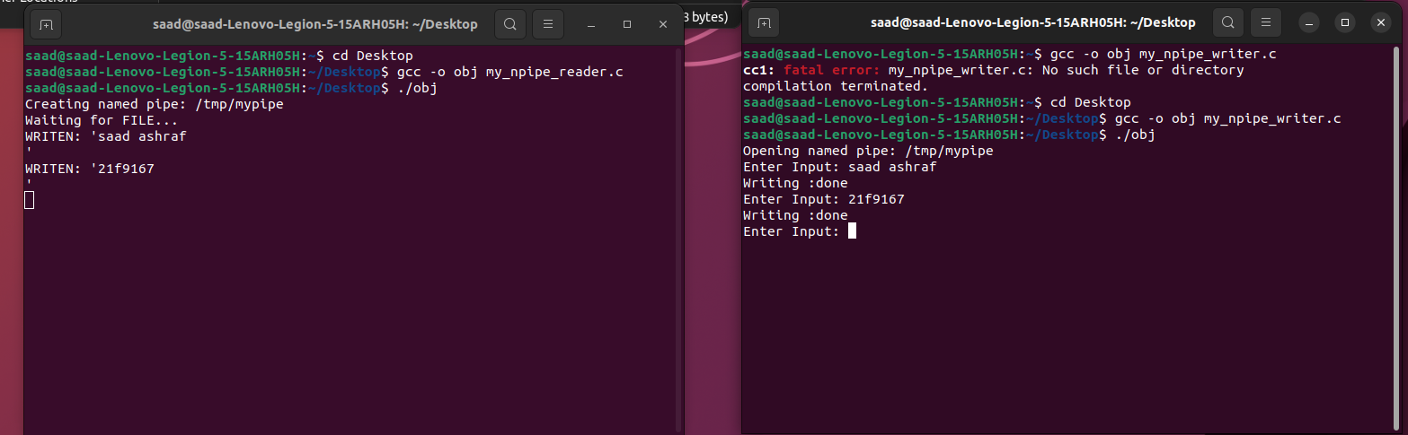

TASK 2:

CODE:
#include <stdio.h>
#include <stdlib.h>
#include <unistd.h>
#include <sys/types.h>
#include <sys/wait.h>

int main() {
int a, b, c, d, sum, diff, prod, quotient;
pid_t pid1, pid2, pid3;

printf("Enter two numbers: ");
scanf("%d %d", &a, &b);
pid1 = fork();
if (pid1 == 0) {
sum = a + b;
diff = a - b;
printf("Child 1 - Sum: %d, Difference: %d\n", sum, diff);
pid2 = fork();
if (pid2 == 0) {
printf("Enter two more numbers: ");
scanf("%d %d", &c, &d);
prod = c * d;
quotient = c / d;
printf("Child 2 - Product: %d, Quotient: %d\n", prod, quotient);
pid3 = fork();
if (pid3 == 0) {
printf("Child 3 - Results: %d, %d, %d, %d\n", sum, diff, prod, quotient);
exit(0);
}
else {
wait(NULL);
exit(0);
}
}
else {
wait(NULL);
exit(0);
}
}
else {
wait(NULL);
printf("All child processes completed.\n");
}

return 0;
}

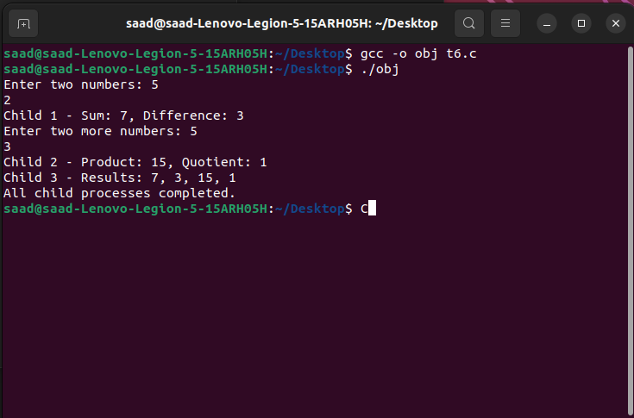
TASK 3:
CODE:

