TASK 1:

You have to simulate the opening bridge that usually build upon river/sea. Take input from user:
number of cars and number of boats Also input time (in seconds) needed by a boat to pass
through bridge and time (in seconds) needed by car to pass through bridge You have only one
bridge (Single Lane) Only one boat or car can pass through bridge at a particular time.
Note: Use Binary Semaphore in this task

SOLUTION:

#include <iostream>
#include <thread>
#include <chrono>
#include <mutex>
#include <semaphore.h>
using namespace std;
int num_cars, num_boats, boat_time, car_time;
sem_t bridge;
void boat_thread(int id) {
cout << "Boat #" << id << " has arrived at the bridge." << endl;
sem_wait(&bridge); // acquire the semaphore
cout << "Boat #" << id << " is passing through the bridge." << endl;
this_thread::sleep_for(chrono::seconds(boat_time));
cout << "Boat #" << id << " has passed through the bridge." << endl;
sem_post(&bridge); // release the semaphore
}
void car_thread(int id) {
cout << "Car #" << id << " has arrived at the bridge." << endl;
sem_wait(&bridge); // acquire the semaphore
cout << "Car #" << id << " is passing through bridge." << endl;
this_thread::sleep_for(chrono::seconds(car_time));
cout << "Car #" << id << " has passed through bridge." << endl;
sem_post(&bridge); // release the semaphore
}
int main() {
cout << "Enter number of cars: ";
cin >> num_cars;
cout << "Enter number of boats: ";
cin >> num_boats;
cout << "Enter time (in seconds) needed by a boat to pass through bridge: ";
cin >> boat_time;
cout << "Enter time (in seconds) needed by a car to pass through bridge: ";
cin >> car_time;
sem_init(&bridge, 0, 1); // initialize binary semaphore
thread t[num_cars + num_boats];
int id = 1;
for (int i = 0; i < num_boats; i++) {
t[i] = thread(boat_thread, id);
id++;
}
for (int i = num_boats; i < num_cars + num_boats; i++) {
t[i] = thread(car_thread, id);
id++;
}
for (int i = 0; i < num_cars + num_boats; i++) {
t[i].join();
}
sem_destroy(&bridge);
return 0;
}

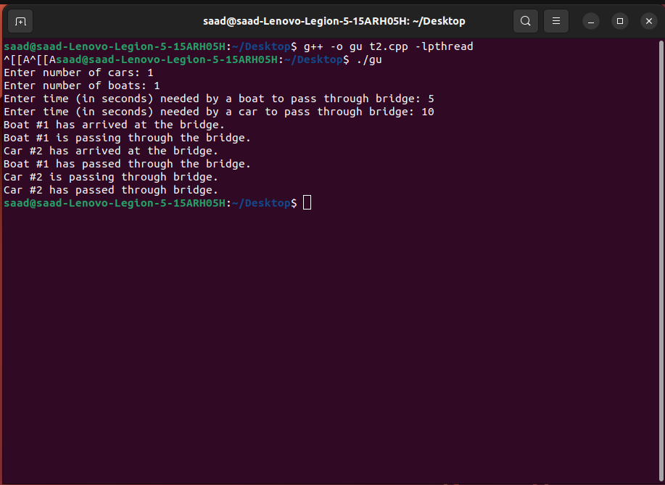

TASK 2:

Edit the Lab Task 1 according to the following constraints. Constraints: At a time, at max. TWO
(2) boats can pass under the bridge or at max. THREE (3) cars can pass over the bridge at a
particular time. No more than 2 boats or 3 cars can pass at a time. Check your code by taking 10
cars and 10 boats for example.
Hint: You can use counting Semaphore for this task

SOLUTION:

#include <iostream>
#include <thread>
#include <chrono>
#include <mutex>
#include <semaphore.h>
using namespace std;
int num_cars, num_boats, boat_time, car_time;
sem_t bridge, car_count, boat_count;
void boat_thread(int id) {
cout << "Boat #" << id << " has arrived at the bridge." << endl;
sem_wait(&boat_count);
sem_wait(&bridge);
cout << "Boat #" << id << " is passing through the bridge." << endl;
this_thread::sleep_for(chrono::seconds(boat_time));
cout << "Boat #" << id << " has passed through the bridge." << endl;
sem_post(&bridge);
sem_post(&boat_count);
}
void car_thread(int id) {
cout << "Car #" << id << " has arrived at the bridge." << endl;
sem_wait(&car_count);
sem_wait(&bridge);
cout << "Car #" << id << " is passing through bridge." << endl;
this_thread::sleep_for(chrono::seconds(car_time));
cout << "Car #" << id << " has passed through bridge." << endl;
sem_post(&bridge);
sem_post(&car_count);
}
int main() {
cout << "Enter number of cars: ";
cin >> num_cars;
cout << "Enter number of boats: ";
cin >> num_boats;
cout << "Enter time (in seconds) needed by a boat to pass through bridge: ";
cin >> boat_time;
cout << "Enter time (in seconds) needed by a car to pass through bridge: ";
cin >> car_time;
sem_init(&bridge, 0, 1);
sem_init(&car_count, 0, 3);
sem_init(&boat_count, 0, 2);
thread t[num_cars + num_boats];
int id = 1;
for (int i = 0; i < num_boats; i++) {
t[i] = thread(boat_thread, id);
id++;
}
for (int i = num_boats; i < num_cars + num_boats; i++) {
t[i] = thread(car_thread, id);
id++;
}
for (int i = 0; i < num_cars + num_boats; i++) {
t[i].join();
}
sem_destroy(&bridge);
sem_destroy(&car_count);
sem_destroy(&boat_count);
return 0;
}
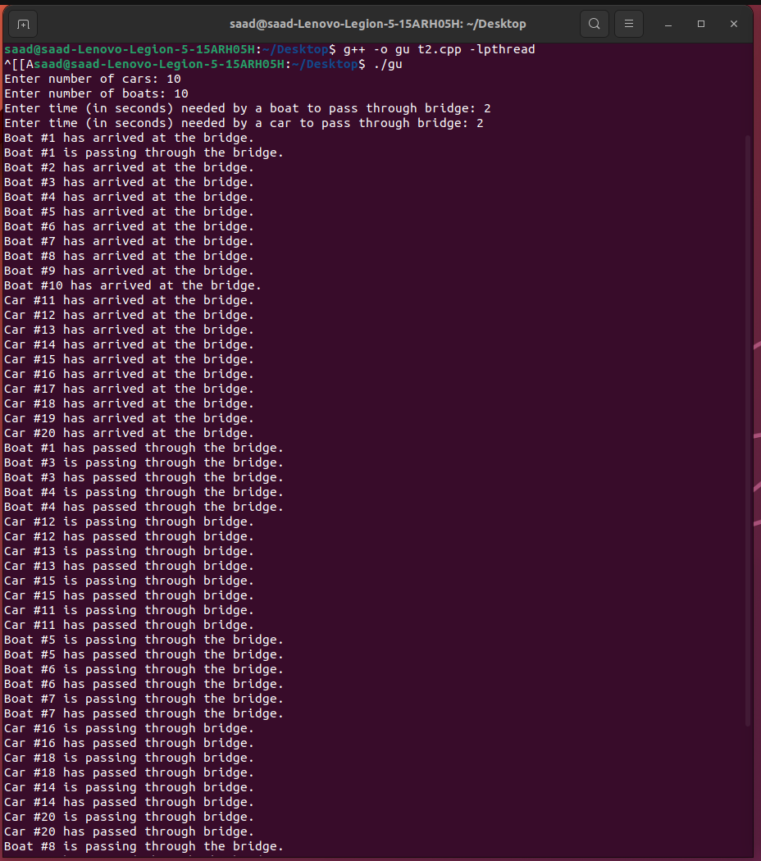

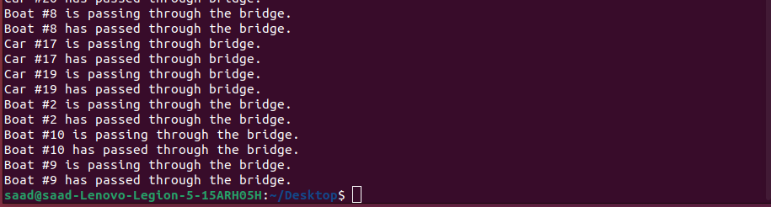

TASK 3:

Implement Dining Philosopher Problem.

SOLUTION:

#include <iostream>
#include <pthread.h>
#include <semaphore.h>
#include <unistd.h>

using namespace std;

const int NUM_PHILOSOPHERS = 5;
pthread_mutex_t forks[NUM_PHILOSOPHERS];
sem_t sem_forks[NUM_PHILOSOPHERS];

void *philosopher(void *arg) {
int id = *((int*) arg);
int left_fork = id;
int right_fork = (id + 1) % NUM_PHILOSOPHERS;

while (true) {
// thinking
cout << "Philosopher " << id << " is thinking." << endl;
usleep(rand() % 1000);

// get forks
sem_wait(&sem_forks[left_fork]);
sem_wait(&sem_forks[right_fork]);

// eating
cout << "Philosopher " << id << " is eating." << endl;
usleep(rand() % 1000);

// put forks back
sem_post(&sem_forks[left_fork]);
sem_post(&sem_forks[right_fork]);
}
}

int main() {
pthread_t threads[NUM_PHILOSOPHERS];
int ids[NUM_PHILOSOPHERS];

// initialize mutexes and semaphores
for (int i = 0; i < NUM_PHILOSOPHERS; i++) {
pthread_mutex_init(&forks[i], NULL);
sem_init(&sem_forks[i], 0, 1);
}

// create threads
for (int i = 0; i < NUM_PHILOSOPHERS; i++) {
ids[i] = i;
pthread_create(&threads[i], NULL, philosopher, &ids[i]);
}

// join threads
for (int i = 0; i < NUM_PHILOSOPHERS; i++) {
pthread_join(threads[i], NULL);
}

// destroy mutexes and semaphores
for (int i = 0; i < NUM_PHILOSOPHERS; i++) {
pthread_mutex_destroy(&forks[i]);
sem_destroy(&sem_forks[i]);
}

return 0;
}

