TASK 1:

Write a multithreaded program that calculates various statistical values for a list of
numbers. This program will be passed a series of numbers on the command line and will
then create three separate worker threads. One thread will determine the average of the
numbers, the second will determine the maximum value, and the third will calculate the
minimum of the list.

SOLUTION:

#include <stdio.h>
#include <stdlib.h>
#include <pthread.h>

#define NUM_THREADS 3
typedef struct {
double average;
int max;
int min;
} stats_t;

int* numbers;
int num_count;
stats_t stats;

void* average_worker(void* arg) {
double sum = 0;
for (int i = 0; i < num_count; i++) {
sum += numbers[i];
}
stats.average = sum / num_count;
pthread_exit(NULL);
}

void* max_worker(void* arg) {
int max_val = numbers[0];
for (int i = 1; i < num_count; i++) {
if (numbers[i] > max_val) {
max_val = numbers[i];
}
}
stats.max = max_val;
pthread_exit(NULL);
}

void* min_worker(void* arg) {
int min_val = numbers[0];
for (int i = 1; i < num_count; i++) {
if (numbers[i] < min_val) {
min_val = numbers[i];
}
}
stats.min = min_val;
pthread_exit(NULL);
}

int main(int argc, char* argv[]) {
num_count = argc - 1;
numbers = malloc(num_count * sizeof(int));
for (int i = 0; i < num_count; i++) {
numbers[i] = atoi(argv[i+1]);
}
pthread_t threads[NUM_THREADS];
int rc;

rc = pthread_create(&threads[0], NULL, average_worker, NULL);
if (rc) {
printf("Error creating thread 0\n");
return 1;
}

rc = pthread_create(&threads[1], NULL, max_worker, NULL);
if (rc) {
printf("Error creating thread 1\n");
return 1;
}

rc = pthread_create(&threads[2], NULL, min_worker, NULL);
if (rc) {
printf("Error creating thread 2\n");
return 1;
}
for (int i = 0; i < NUM_THREADS; i++) {
rc = pthread_join(threads[i], NULL);
if (rc) {
printf("Error joining thread %d\n", i);
return 1;
}
}
printf("Average: %.2f\n", stats.average);
printf("Maximum: %d\n", stats.max);
printf("Minimum: %d\n", stats.min)
free(numbers);
return 0;
}

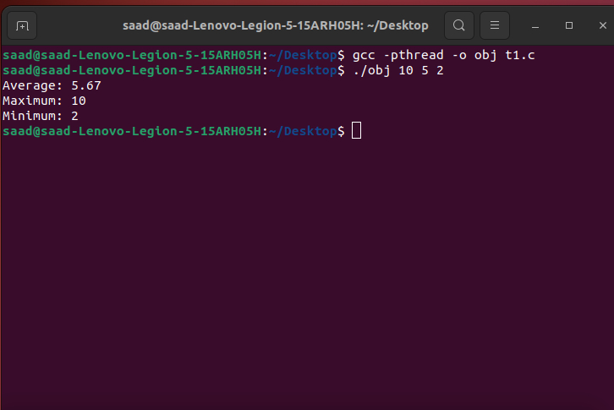

TASK 2:

Make a C++ program using multi-threading such that it takes length and
width of a rectangle as an input from user in the main () and compute its
Area and Perimeter. You have to pass only one argument as an input which
can contain information of both length and width, this can be done using
arrays or structure. You can create 2 threads: one for Area and other for
Perimeter

SOLUTION:

#include <stdio.h>
#include <pthread.h>

struct rect {
int length;
int width;
};

void *compute_area(void *arg) {
struct rect *r = (struct rect *) arg;
int area = r->length * r->width;
printf("Area of the rectangle: %d\n", area);
pthread_exit(NULL);
}

void *compute_perimeter(void *arg) {
struct rect *r = (struct rect *) arg;
int perimeter = 2 * (r->length + r->width);
printf("Perimeter of the rectangle: %d\n", perimeter);
pthread_exit(NULL);
}

int main() {
struct rect r;
printf("Enter the length and width of the rectangle: ");
scanf("%d %d", &r.length, &r.width);

pthread_t threads[2];
pthread_create(&threads[0], NULL, compute_area, (void *) &r);
pthread_create(&threads[1], NULL, compute_perimeter, (void *) &r);

pthread_join(threads[0], NULL);
pthread_join(threads[1], NULL);

return 0;
}

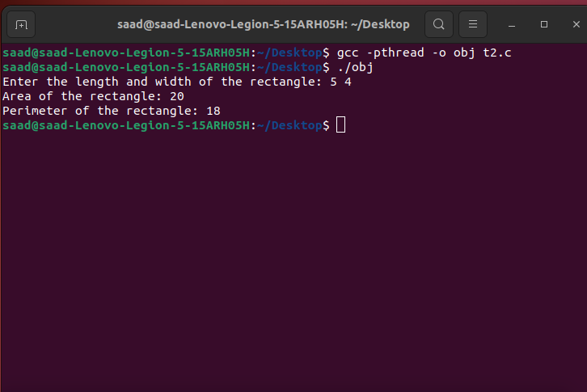

TASK 3:

Given an input string and a substring. Find the frequency of occurrences of a substring in the given
string using pthreads.

Input: string = &quot;man&quot;
substring = &quot;dhimanman&quot;
Output: 2
Input: string = &quot;banana&quot;
substring = &quot;nn&quot;
Output: 0

SOLUTION:

#include <stdio.h>
#include <stdlib.h>
#include <string.h>
#include <pthread.h>

#define MAX_STRING_SIZE 1000

char input_string[MAX_STRING_SIZE];
char substring[MAX_STRING_SIZE];

struct thread_data {
char *string;
char *sub;
int count;
};

void *find_substring(void *arg) {
struct thread_data *data = (struct thread_data *) arg;
char *string = data->string;
char *sub = data->sub;
int count = 0;

while ((string = strstr(string, sub)) != NULL) {
count++;
string++;
}

data->count = count;
pthread_exit(NULL);
}

int main() {
pthread_t thread;
struct thread_data data = {input_string, substring, 0};
printf("Enter the input string: ");
fgets(input_string, MAX_STRING_SIZE, stdin);
input_string[strcspn(input_string, "\n")] = '\0';

printf("Enter the substring: ");
fgets(substring, MAX_STRING_SIZE, stdin);
substring[strcspn(substring, "\n")] = '\0';

if (pthread_create(&thread, NULL, find_substring, (void *) &data) != 0) {
fprintf(stderr, "Error: failed to create thread.\n");
return 1;
}

if (pthread_join(thread, NULL) != 0) {
fprintf(stderr, "Error: failed to join thread.\n");
return 1;
}
printf("Frequency of occurrences of '%s' in '%s': %d\n", substring, input_string, data.count);

return 0;
}

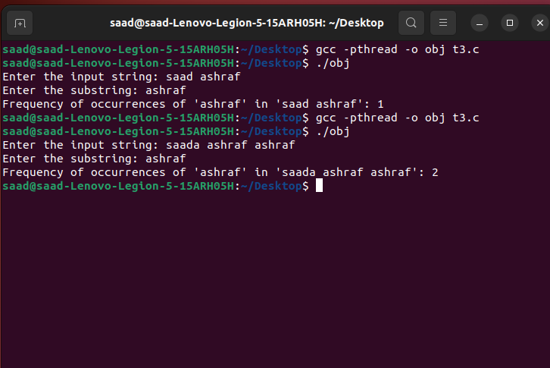
TASK 4:

Write a C/C++ program where you need to initialize a local array of integers of size 10 in the
main (). You need to calculate the multiplication and summation of a complete array using
multi-threading. The main thread will display the result of both multiplication and addition of all
array elements.
Note: You have to pass array as input argument to all threads.
Thread functions must return the summation and multiplication result to the main thread where
main () thread will display both results. Sample output will be as follows.

SOLUTION:

#include <stdio.h>
#include <pthread.h>

#define ARRAY_SIZE 10

int array[ARRAY_SIZE] = {1, 2, 3, 4, 5, 6, 7, 8, 9, 10};
struct thread_data {
int *array;
int size;
int sum;
int product;
};

void *calc_sum(void *arg) {
struct thread_data *data = (struct thread_data *) arg;
for (int i = 0; i < data->size; i++) {
data->sum += data->array[i];
}
pthread_exit(NULL);
}

void *calc_product(void *arg) {
struct thread_data *data = (struct thread_data *) arg;
data->product = 1;
for (int i = 0; i < data->size; i++) {
data->product *= data->array[i];
}
pthread_exit(NULL);
}

int main() {
pthread_t threads[2];
struct thread_data data = {array, ARRAY_SIZE, 0, 1};
int rc;
rc = pthread_create(&threads[0], NULL, calc_sum, (void *) &data);
if (rc) {
printf("Error: return code from pthread_create() is %d\n", rc);
return -1;
}

rc = pthread_create(&threads[1], NULL, calc_product, (void *) &data);
if (rc) {
printf("Error: return code from pthread_create() is %d\n", rc);
return -1;
}
for (int i = 0; i < 2; i++) {
pthread_join(threads[i], NULL);
}

printf("Sum of array elements: %d\n", data.sum);
printf("Product of array elements: %d\n", data.product);

pthread_exit(NULL);
}
