TASK 1:

You have to simulate the opening bridge that usually build upon river/sea. Take input from user:
number of cars and number of boats Also input time (in seconds) needed by a boat to pass
through bridge and time (in seconds) needed by car to pass through bridge You have only one
bridge (Single Lane) Only one boat or car can pass through bridge at a particular time
Note: Use Mutex Lock in this task.

SOLUTION:

#include <stdio.h>
#include <stdlib.h>
#include <pthread.h>
#include <unistd.h>
int car_timeee;
int boat_time;
pthread_mutex_t lock = PTHREAD_MUTEX_INITIALIZER;
void *car_passing(void *arg) {
int *id = (int *)arg;
printf("Car %d is waiting to pass bridge.\n", *id);
pthread_mutex_lock(&lock);
sleep(car_timeee);
printf("Car %d is passing bridge.\n", *id);
pthread_mutex_unlock(&lock);
printf("Car %d has passed bridge.\n", *id);
pthread_exit(NULL);
}
void *boat_passing(void *arg) {
int *id = (int *)arg;
printf("Boat %d is waiting to pass through the bridge.\n", *id);
pthread_mutex_lock(&lock);
sleep(boat_time);
printf("Boat %d is passing through the bridge.\n", *id);
pthread_mutex_unlock(&lock);
printf("Boat %d has passed through the bridge.\n", *id);
pthread_exit(NULL);
}

int main() {
int num_cars, num_boats, car_time;
printf("Enter the no of cars# ");
scanf("%d", &num_cars);
printf("Enter the no of boats# ");
scanf("%d", &num_boats);
printf("Enter time (in seconds) needed by a car to pass the bridge: ");
scanf("%d", &car_timeee);
printf("Enter time (in seconds) needed by a boat to pass the bridge: ");
scanf("%d", &boat_time);
pthread_t threads[num_cars + num_boats];
int i=0;
while (i < num_cars) {
int *id = malloc(sizeof(*id));
*id = i+1;
pthread_create(&threads[i], NULL, car_passing, (void *)id);
i++;
}
i=0;
while (i < num_boats) {
int *id = malloc(sizeof(*id));
*id = i+1;
pthread_create(&threads[i+num_cars], NULL, boat_passing, (void *)id);
i++;
}
for (i = 0; i < num_cars + num_boats; i++) {
pthread_join(threads[i], NULL);
}
pthread_mutex_destroy(&lock);
return 0;
}

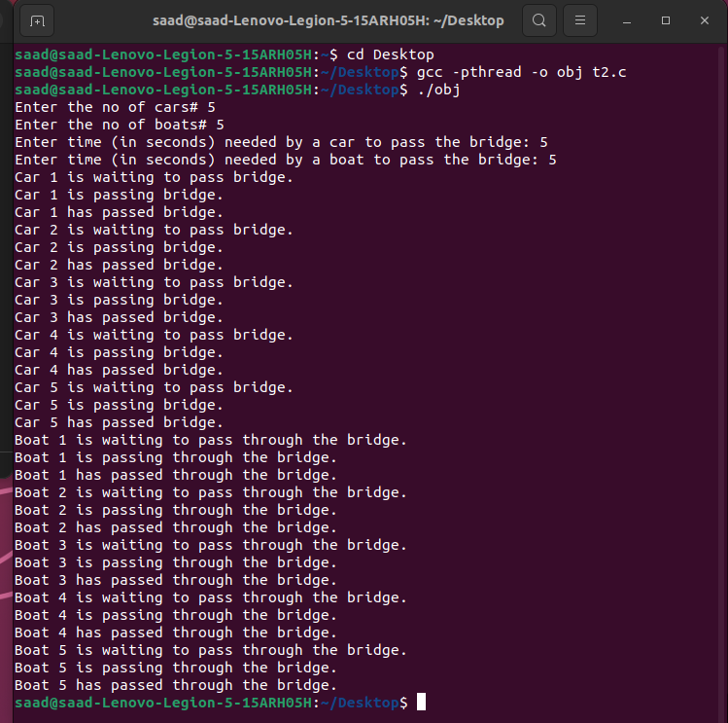
TASK 2:
Write an amount withdrawal code that satisfies the condition that withdrawal is only possible
when it is more than $500.
Note: - Use conditional Variable

SOLUTION:

#include <pthread.h>
#include <stdio.h>
#include <stdlib.h>
#include <unistd.h>
#include <errno.h>

pthread_mutex_t deposit;
pthread_cond_t withdraw;
int cash = 0;

void* fuel_filling(void* arg) {
for (int i = 0; i < 4; i++) {
pthread_mutex_lock(&deposit);
cash += 200;
printf("Adding 200 in Cash\n");
printf("Cash is : %d\n", cash);
pthread_mutex_unlock(&deposit);
pthread_cond_signal(&withdraw);
sleep(1);
}
}

void* car(void* arg) {
pthread_mutex_lock(&deposit);
while (cash < 500) {
printf("Cannot withdraw\n");
pthread_cond_wait(&withdraw, &deposit);
}
printf("Withdrew Cash since greater than 500\n");
cash = cash-500;
printf("Remaining Cash is : %d\n", cash);
pthread_mutex_unlock(&deposit);
}

int main(int argc, char* argv[]) {
pthread_t th[2];
pthread_mutex_init(&deposit, NULL);
pthread_cond_init(&withdraw, NULL);
for (int i = 0; i < 2; i++) {
if (i == 1) {
if (pthread_create(&th[i], NULL, &fuel_filling, NULL) != 0) {
perror("Failed to create thread");
}
} else {
if (pthread_create(&th[i], NULL, &car, NULL) != 0) {
perror("Failed to create thread");
}
}
}

for (int i = 0; i < 2; i++) {
if (pthread_join(th[i], NULL) != 0) {
perror("Failed to join thread");
}
}
pthread_mutex_destroy(&deposit);
pthread_cond_destroy(&withdraw);
return 0;
}

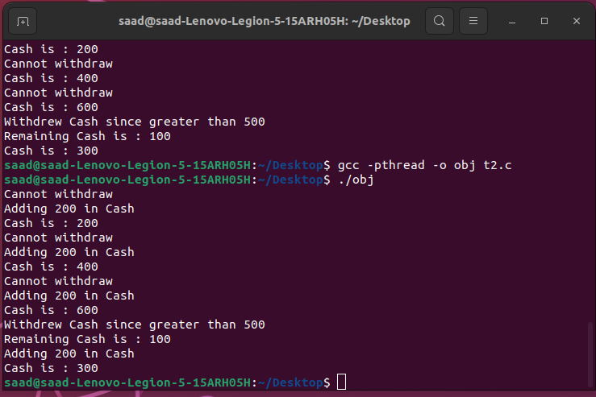

TASK 3:

Write a simple program that create two threads sender and receiver. The sender thread send a message
string to receiver thread. This program uses condition variables to achieve synchronization.

SOLUTION:

#include <iostream>
#include <thread>
#include <mutex>
#include <condition_variable>
#include <string>
using namespace std;
mutex var2;
condition_variable var;
string str;
bool ready = false;
void receiver(){
{
unique_lock<mutex> lck(var2);
var.wait(lck, []{ return ready; });
cout << "MESSAGE RECEIVED FROM SENDER # " << str << endl;
}
}
void sender(){
{
unique_lock<mutex> lck(var2);
str = "THIS MESSAGE IS SENT TO RECEIVER";
ready = true;
var.notify_one();
}
}
int main(){
thread t1(sender);
thread t2(receiver);
t1.join();
t2.join();
return 0;
}

