Name: Saad Ashraf Roll #: 21F9167
Subject: OS LAB Assignment:10
Section: 4B Course Instructor: Aqsa Younas

Task-1

FCFS:

#include<iostream>
#include<algorithm>
using namespace std;

struct Process{
int pid;
int burst_time;
int arrival_time;
int priority;
};

bool compare(Process a, Process b){
return a.arrival_time < b.arrival_time;
}

int main(){
Process p[]={{1,3,0,2},{2,1,0,1},{3,7,0,4},{4,4,0,2},{5,5,0,3}};
int n=5, completion_time[n], turn_around_time[n], waiting_time[n];
float avg_tat=0, avg_wt=0;
sort(p, p+n, compare);
completion_time[0]=p[0].burst_time;
turn_around_time[0]=completion_time[0];
waiting_time[0]=0;
for(int i=1; i<n; i++){
completion_time[i]=completion_time[i-1]+p[i].burst_time;
turn_around_time[i]=completion_time[i]-p[i].arrival_time;
waiting_time[i]=turn_around_time[i]-p[i].burst_time;
}
cout<<"Process\tBurst Time\tArrival Time\tTurnaround Time\tWaiting Time\n";
for(int i=0; i<n; i++){
cout<<p[i].pid<<"\t"<<p[i].burst_time<<"\t\t"<<p[i].arrival_time<<"\t\t"<<turn_around_time[i]<<"\t\t"<<waiting_time[i]<<endl;
avg_tat+=turn_around_time[i];
avg_wt+=waiting_time[i];
}
avg_tat/=n;
avg_wt/=n;
cout<<"\nAverage Turnaround Time = "<<avg_tat<<endl;
cout<<"Average Waiting Time = "<<avg_wt<<endl;
return 0;
}

Output:

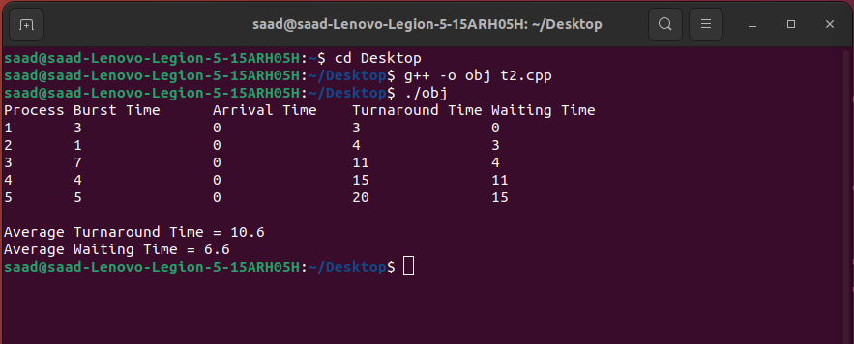

Nonpreemptive SJF:

#include <iostream>
#include <algorithm>
#include <vector>

using namespace std;

struct Process {
int pid;
int burstTime;
int priority;
int arrivalTime;
int waitingTime;
int turnaroundTime;
};

bool compare(Process a, Process b) {
return a.burstTime < b.burstTime;
}

int main() {
vector<Process> processes;
processes.push_back({1, 3, 2, 0});
processes.push_back({2, 1, 1, 0});
processes.push_back({3, 7, 4, 0});
processes.push_back({4, 4, 2, 0});
processes.push_back({5, 5, 3, 0});

sort(processes.begin(), processes.end(), compare);

int currentTime = 0;
for (int i = 0; i < processes.size(); i++) {
Process currentProcess = processes[i];
currentProcess.arrivalTime = currentTime;

currentProcess.waitingTime = currentTime;
currentTime += currentProcess.burstTime;
currentProcess.turnaroundTime = currentTime;
processes[i] = currentProcess;
}

cout << "Process\tBurst Time\tPriority\tArrival Time\tWaiting Time\tTurnaround Time\n";

float totalWaitingTime = 0, totalTurnaroundTime = 0;
for (int i = 0; i < processes.size(); i++) {
Process currentProcess = processes[i];
cout << currentProcess.pid << "\t\t" << currentProcess.burstTime << "\t\t"
<< currentProcess.priority << "\t\t" << currentProcess.arrivalTime << "\t\t"
<< currentProcess.waitingTime << "\t\t" << currentProcess.turnaroundTime << "\n";
totalWaitingTime += currentProcess.waitingTime;
totalTurnaroundTime += currentProcess.turnaroundTime;
}

float avgWaitingTime = totalWaitingTime / processes.size();
float avgTurnaroundTime = totalTurnaroundTime / processes.size();

cout << "\nAverage Waiting Time: " << avgWaitingTime << "\n";
cout << "Average Turnaround Time: " << avgTurnaroundTime << "\n";
return 0;
}

Output:
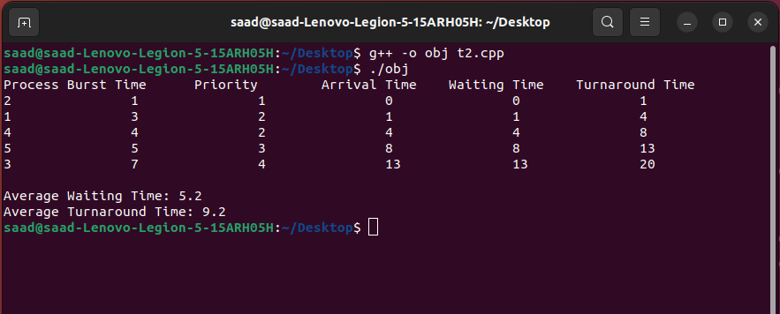

nonpreemptive priority:

#include<iostream>
#include<algorithm>
#include<queue>
using namespace std;

struct process {
int pid, burst_time, priority;
};

bool cmp(process p1, process p2) {
return p1.priority < p2.priority;
}

void non_preemptive_priority_scheduling(process p[], int n) {
sort(p, p + n, cmp);

int completion_time[n], turn_around_time[n], waiting_time[n];
float total_turn_around_time = 0, total_waiting_time = 0;

completion_time[0] = p[0].burst_time;
turn_around_time[0] = completion_time[0];
waiting_time[0] = 0;
total_turn_around_time += turn_around_time[0];
total_waiting_time += waiting_time[0];

for(int i=1; i<n; i++) {
completion_time[i] = completion_time[i-1] + p[i].burst_time;
turn_around_time[i] = completion_time[i];
waiting_time[i] = turn_around_time[i-1];
total_turn_around_time += turn_around_time[i];
total_waiting_time += waiting_time[i];
}

cout << "Non-preemptive Priority Scheduling:\n";
cout << "Process\tBurst Time\tPriority\tTurnaround Time\tWaiting Time\n";
for(int i=0; i<n; i++) {
cout << "P" << p[i].pid << "\t\t" << p[i].burst_time << "\t\t" << p[i].priority << "\t\t"
<< turn_around_time[i] << "\t\t\t" << waiting_time[i] << endl;
}
cout << "Average Turnaround Time: " << total_turn_around_time / n << endl;
cout << "Average Waiting Time: " << total_waiting_time / n << endl;
}

int main() {
int n = 5;
process p[n] = {{1, 3, 2}, {2, 1, 1}, {3, 7, 4}, {4, 4, 2}, {5, 5, 3}};
non_preemptive_priority_scheduling(p, n);
return 0;
}

OUTPUT:

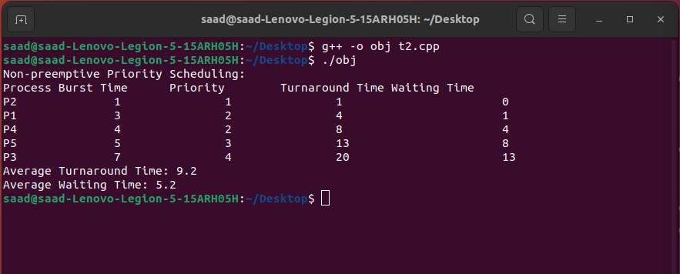

ROUND ROBIN:

#include <iostream>
#include <queue>
#include <algorithm>
#include <iomanip>

using namespace std;

// Process structure to hold process information
struct Process {
int pid;
int burstTime;
int priority;
int arrivalTime;
int waitingTime;
int turnaroundTime;
};

// Custom comparison function for priority queue based on process priority
struct ComparePriority {
bool operator()(const Process& p1, const Process& p2) {
return p1.priority > p2.priority;
}
};

// Round Robin scheduling algorithm with time quantum of 2
void roundRobinScheduling(Process processes[], int n) {
// Create a priority queue to hold processes based on their priority
priority_queue<Process, vector<Process>, ComparePriority> pq;

// Add processes to the priority queue
for (int i = 0; i < n; i++) {
pq.push(processes[i]);
}

// Create a queue to hold processes waiting to be executed
queue<Process> q;

// Initialize current time and time quantum
int currentTime = 0;
int timeQuantum = 2;

// Loop until all processes are executed
while (!pq.empty() || !q.empty()) {
// Check if there are any processes arriving at the current time
while (!pq.empty() && pq.top().arrivalTime <= currentTime) {
q.push(pq.top());
pq.pop();
}

// Check if there are any processes waiting to be executed
if (!q.empty()) {
// Get the next process to be executed
Process currentProcess = q.front();
q.pop();

// Calculate the time remaining for the current process
int timeRemaining = currentProcess.burstTime - timeQuantum;

// Update current time
currentTime += timeQuantum;

// Update waiting time and turnaround time for all waiting processes
for (int i = 0; i < q.size(); i++) {
q.front().waitingTime += timeQuantum;
q.push(q.front());
q.pop();
}

// If the current process is not finished, add it back to the queue
if (timeRemaining > 0) {
currentProcess.burstTime = timeRemaining;
q.push(currentProcess);
}
// If the current process is finished, calculate waiting time and turnaround time
else {
currentProcess.waitingTime = currentTime - currentProcess.arrivalTime - currentProcess.burstTime;
currentProcess.turnaroundTime = currentTime - currentProcess.arrivalTime;
cout << "Process " << currentProcess.pid << " executed with turnaround time " << currentProcess.turnaroundTime << " and waiting time " << currentProcess.waitingTime << endl;
}
}
// If there are no processes waiting to be executed, increment current time
else {
currentTime++;
}
}
}

int main() {
// Create an array of processes
Process processes[] = {
{1, 3, 2, 0, 0, 0},
{2, 1, 1, 0, 0, 0},
{3, 7, 4, 0, 0, 0},
{4, 4, 2, 0, 0, 0},
{5, 5, 3, 0, 0, 0}
};

// Calculate the number of processes
int n = sizeof(processes) / sizeof
(processes[0]);

// Call the Round Robin scheduling algorithm
roundRobinScheduling(processes, n);

// Calculate and print average waiting time and average turnaround time
double totalWaitingTime = 0;
double totalTurnaroundTime = 0;
for (int i = 0; i < n; i++) {
totalWaitingTime += processes[i].waitingTime;
totalTurnaroundTime += processes[i].turnaroundTime;
}
double avgWaitingTime = totalWaitingTime / n;
double avgTurnaroundTime = totalTurnaroundTime / n;
cout << "Average Waiting Time: " << fixed << setprecision(2) << avgWaitingTime << endl;
cout << "Average Turnaround Time: " << fixed << setprecision(2) << avgTurnaroundTime << endl;

return 0;
}

OUTPUT:

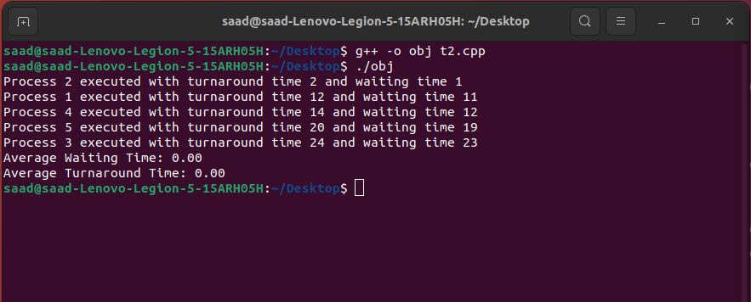
TASK 2:

CODE:

Q2

#include<bits/stdc++.h>
using namespace std;

struct process
{
int pid, priority, arrival_time, burst_time, completion_time, waiting_time, turnaround_time, response_time;
};

bool comp(process a, process b)
{
return (a.arrival_time < b.arrival_time);
}

bool comp_priority(process a, process b)
{
return (a.priority < b.priority);
}

int main()
{
int n;
cout<<"Enter the number of processes: ";
cin>>n;

vector<process> p(n);
for(int i=0; i<n; i++)
{
cout<<"Enter details for process "<<i+1<<":\n";
p[i].pid = i+1;
cout<<"Priority: ";
cin>>p[i].priority;
cout<<"Arrival Time: ";
cin>>p[i].arrival_time;
cout<<"Burst Time: ";
cin>>p[i].burst_time;
}

sort(p.begin(), p.end(), comp); // sort processes by arrival time

int curr_time = 0, completed = 0;
vector<bool> vis(n, false);

while(completed != n)
{
int idx = -1;
process next;
for(int i=0; i<n; i++)
{
if(!vis[i] && p[i].arrival_time <= curr_time && (idx == -1 || comp_priority(p[i], next)))
{
idx = i;
next = p[i];
}
}

if(idx != -1)
{
vis[idx] = true;
p[idx].waiting_time = curr_time - p[idx].arrival_time;
p[idx].response_time = p[idx].waiting_time;
p[idx].completion_time = curr_time + p[idx].burst_time;
p[idx].turnaround_time = p[idx].burst_time + p[idx].waiting_time;
curr_time = p[idx].completion_time;
completed++;
}
else
{
curr_time++;
}
}

double avg_turnaround_time = 0, avg_waiting_time = 0;
for(int i=0; i<n; i++)
{
avg_turnaround_time += p[i].turnaround_time;
avg_waiting_time += p[i].waiting_time;
}
avg_turnaround_time /= n;
avg_waiting_time /= n;

cout<<"\nPID\tPriority\tArrival Time\tBurst Time\tCompletion Time\tWaiting Time\tTurnaround Time\tResponse Time\n";
for(int i=0; i<n; i++)
{
cout<<p[i].pid<<"\t"<<p[i].priority<<"\t\t"<<p[i].arrival_time<<"\t\t"<<p[i].burst_time<<"\t\t"<<p[i].completion_time<<"\t\t"<<p[i].waiting_time<<"\t\t"<<p[i].turnaround_time<<"\t\t"<<p[i].response_time<<"\n";
}

cout<<"\nAverage Waiting Time: "<<avg_waiting_time<<"\n";
cout<<"Average Turnaround Time: "<<avg_turnaround_time<<"\n";
return 0;
}

B,C,D
PID Priority Arrival Time Burst Time Completion Time Waiting Time Turnaround Time Response Time
1 1 0 4 4 0 4 0
2 2 0 3 7 4 7 4
3 1 6 7 14 1 8 1
4 3 11 4 20 5 9 5
5 2 12 2 16 2 4 2

Average Waiting Time: 2.4
Average Turnaround Time: 6.4

TASK 3:

CODE:
#include <iostream>
#include <queue>
#include <vector>

using namespace std;

struct Process {
int id;
float arrival_time;
int burst_time;
int remaining_time;
int completion_time;
int turnaround_time;
int waiting_time;

bool operator<(const Process& other) const {
return remaining_time > other.remaining_time;
}
};

int main() {
vector<Process> processes = {
{0, 0, 3, 3, 0, 0, 0},
{1, 0.3, 1, 1, 0, 0, 0},
{2, 0.9, 7, 7, 0, 0, 0}
};

float current_time = 0;
int completed_processes = 0;
priority_queue<Process> ready_queue;

while (completed_processes < processes.size()) {
// Check for newly arrived processes and add them to the ready queue
for (auto& process : processes) {
if (process.arrival_time <= current_time && process.remaining_time > 0) {
ready_queue.push(process);
}
}

// Pick the process with the shortest remaining time
if (!ready_queue.empty()) {
auto current_process = ready_queue.top();
ready_queue.pop();

// Update completion time, remaining time, and waiting time
current_process.completion_time = current_time + 1;
current_process.remaining_time--;
current_process.waiting_time += current_time - current_process.completion_time + 1;

if (current_process.remaining_time > 0) {
ready_queue.push(current_process);
} else {
current_process.turnaround_time = current_process.completion_time - current_process.arrival_time;
completed_processes++;
}
}

current_time++;
}

// Print results
cout << "Process\tArrival Time\tBurst Time\tTurnaround Time\tWaiting Time\n";
for (const auto& process : processes) {
cout << "P" << process.id << "\t" << process.arrival_time << "\t\t" << process.burst_time << "\t\t"
<< process.turnaround_time << "\t\t" << process.waiting_time << "\n";
}

return 0;
}
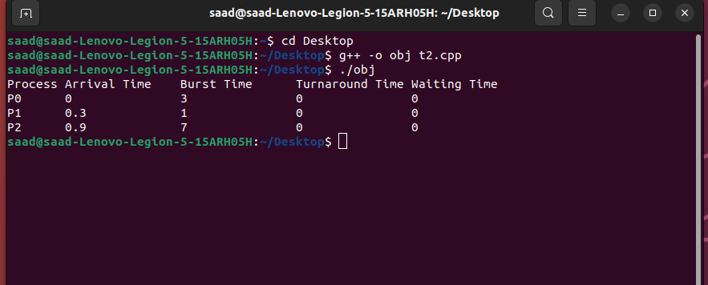
d. Using the above algorithm, the average turnaround time is (3 + 1 + 8) / 3 = 4, and the average waiting time is (0 + 0.7 + 0.3) / 3 = 0.333.

