

**NAME: SAAD ASHRAF**

**ROLL NUMBER: 21F-9167**

**SECTION: 6B**

**ASSIGNMENT 1**

**TASK 1:**

<!DOCTYPE html>

<html>

<head>

<title>Task 1</title>

</head>

<body>

<h1>Name: Saad Ashraf</h1>

<h1>Roll Number: 21F-9167</h1>

<p>I am from Lahore and I study computer science in fast university and I like watching movies</p>

</body>

</html>

**OUTPUT:**

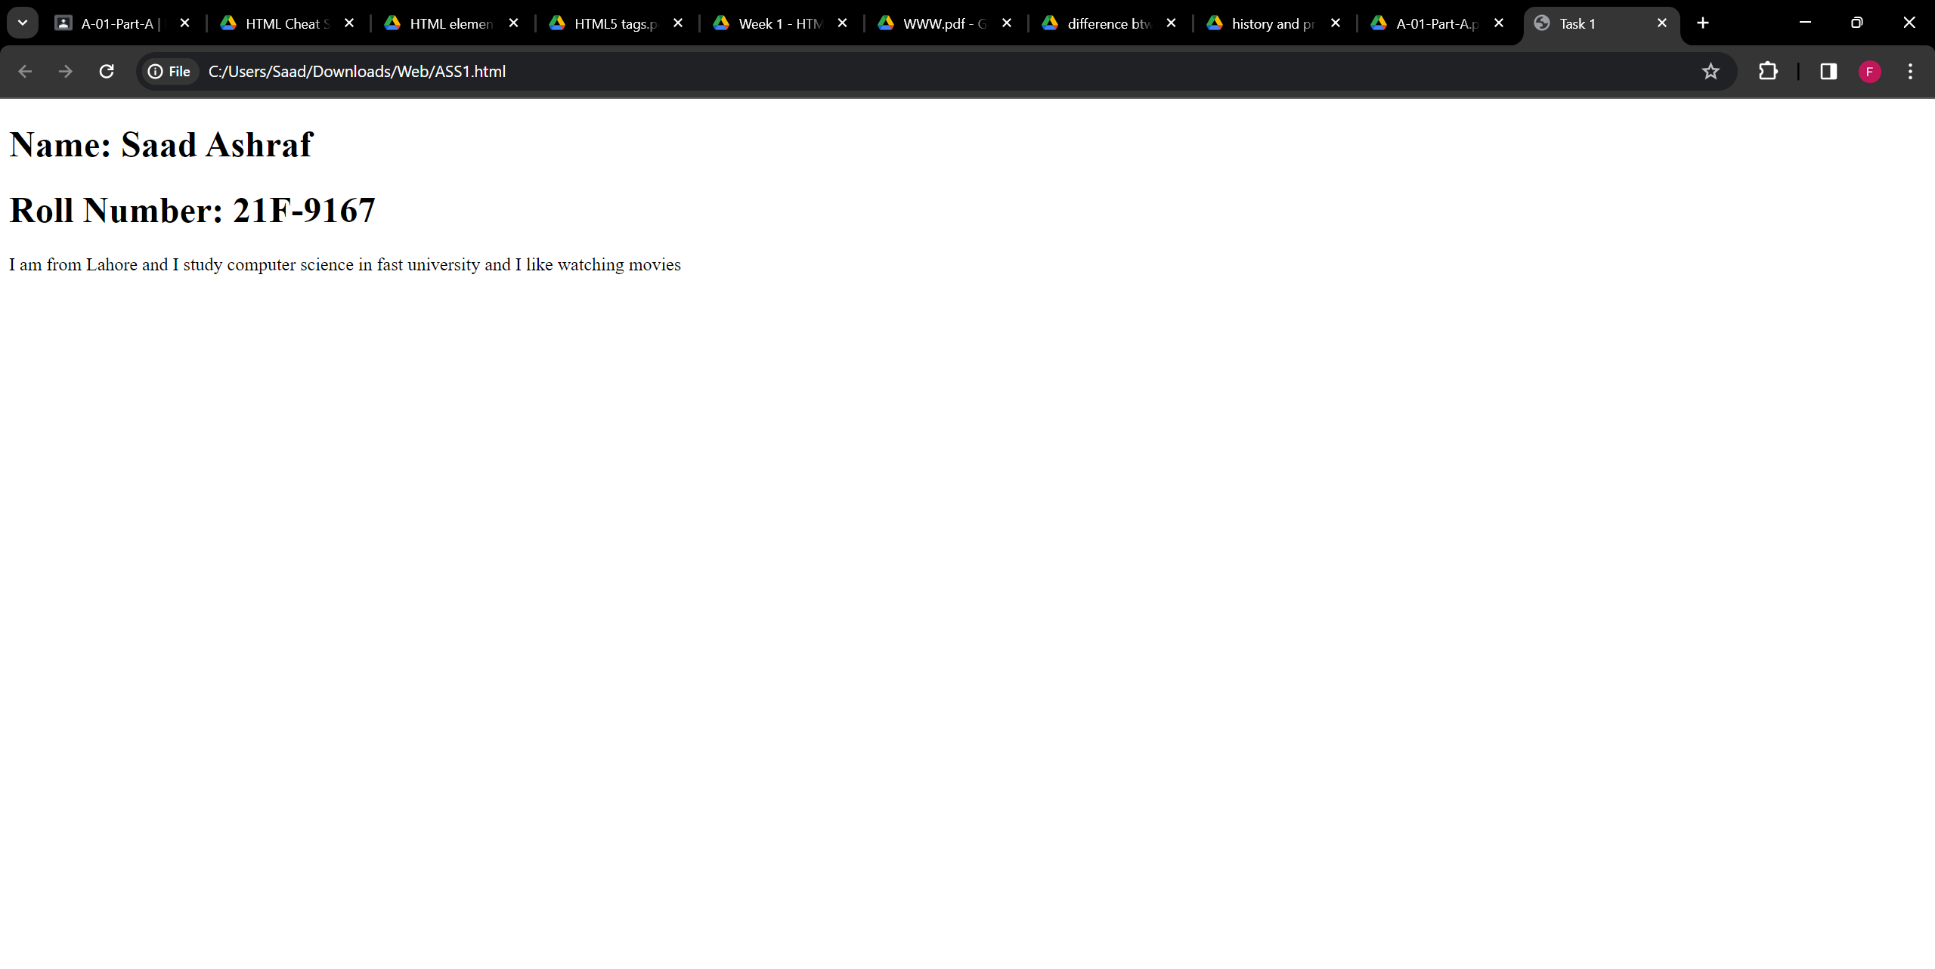

**TASK 2:**  
<!DOCTYPE html>

<html>

<head>

<title>Task 2</title>

</head>

<body>

<b>This text is bold</b>

<br>

<strong>This text is strong</strong>

<h2>This text is big</h2>

<i>This text is italic</i>

<br>

<em>This text is emphasized</em>

<br>

<code>This text is computer output</code>

<br>

<p>This is <sub>subscript</sub> and <sup>superscript</sup></p>

</body>

</html>

**OUTPUT:**

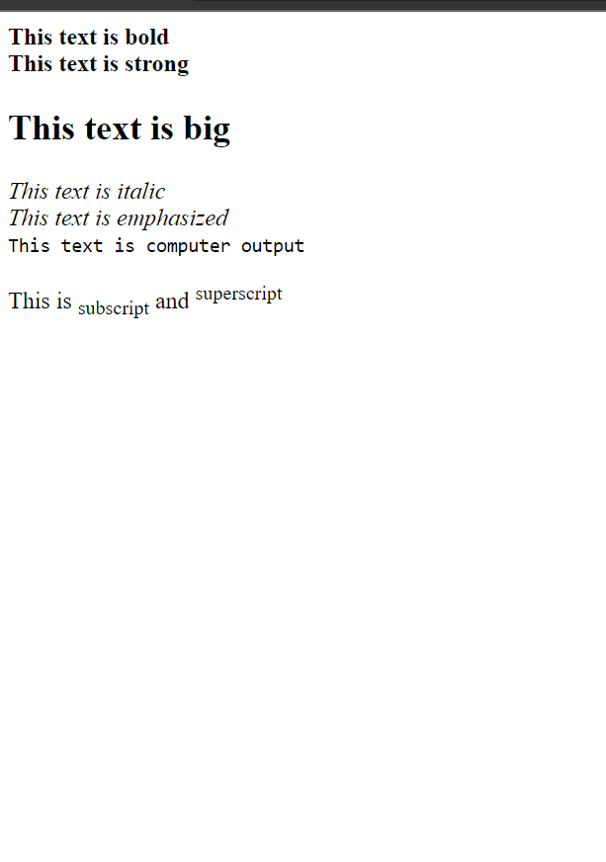

**TASK 3:**

<!DOCTYPE html>

<html>

<head>

<title>Task 3</title>

</head>

<body>

<img src="C:\Users\Saad\Downloads\sdsd.png" alt="Fast Logo" width="1000" height="1000">

</body>

</html>

**OUTPUT:**



**TASK 4:**

<!DOCTYPE html>

<html>

<head>

<title>Task 4</title>

</head>

<body>

<a href="https://cfd.nu.edu.pk/" target="_blank">

<img src="C:\Users\Saad\Downloads\sdsd.png" alt="Fast Logo" width="1000" height="1000">

</a>

</body>

</html>

**OUTPUT:**



**TASK 5:**

<!DOCTYPE html>

<html>

<body>

<h1>HTML Lists</h1>

<h2>Unordered List</h2>

<p>we have books on variety of languages</p>

<ul>

    <li>Oracle</li>

    <li>Java</li>

    <li>HTML</li>

    <li>CSS</li>

</ul>

<h2>Ordered List</h2>

<p>Follow these steps to install Java</p>

<ol>

    <li>Download the software.</li>

    <li>Extract to a folder.</li>

    <li>Double click the exectuable to run.</li>

</ol>

</body>

</html>

**OUTPUT:**

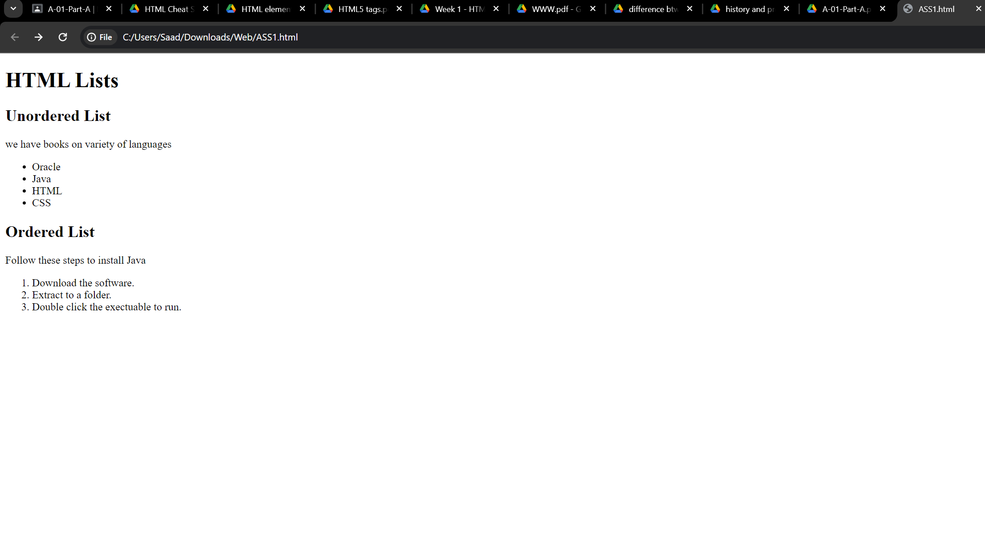

**TASK 6:**

<!DOCTYPE HTML>

<HTML>

<HEAD>

<style>

table,tr,td{

border:2px solid black;

border-collapse: collapse;

}

td{

text-align:center;

}

</style>

</HEAD>

<BODY>

<table style="width:35%">

<tr style="height:25px">

<td rowspan='3' style="width:43.33%"><b>APRIL<b></td>

<td></td>

<td></td>

</tr>

<tr style="height:25px">

<td></td>

<td></td>

</tr>

<tr style="height:25px">

<td></td>

<td></td>

</tr>

<tr style="height:25px">

<td></td>

<td></td>

<td></td>

</tr>

<tr style="height:25px">

<td></td>

<td></td>

<td></td>

</tr>

<table>

</BODY>

</HTML>

**OUTPUT:**

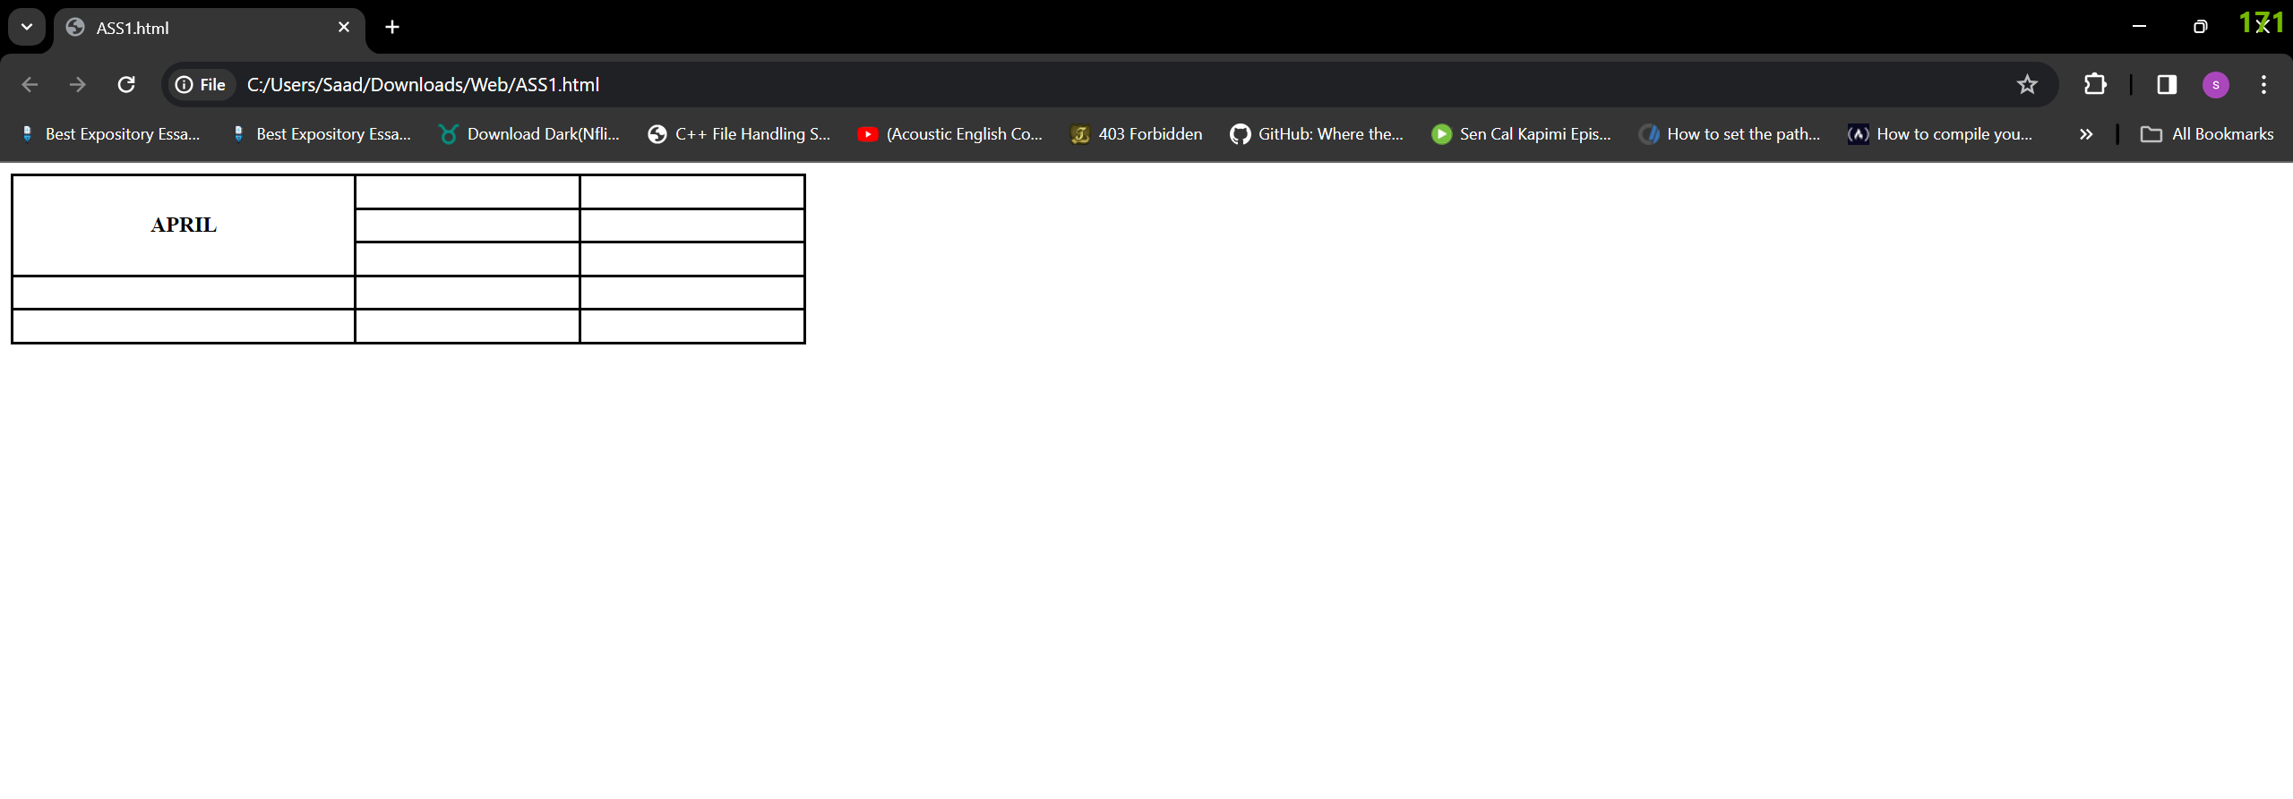

**TASK 7:**

<!DOCTYPE HTML>

<HTML>

<HEAD>

<style>

table,tr,td {

border:1px solid black;

border-collapse: collapse;

}

td{

text-align:center;

width:33.33%;

}

</style>

</HEAD>

<BODY>

<table style="width:35%">

<tr style="height:35px">

<td colspan='3' ><b>2022<b></td>

</tr>

<tr style="height:25px">

<td></td>

<td></td>

<td></td>

</tr>

<tr style="height:25px">

<td rowspan='2' colspan='2' ><b>FIESTA</b></td>

<td></td>

</tr>

<tr style="height:25px">

<td></td>

</tr>

<tr style="height:25px">

<td></td>

<td></td>

<td></td>

</tr>

<table>

</BODY>

</HTML>

**OUTPUT:**

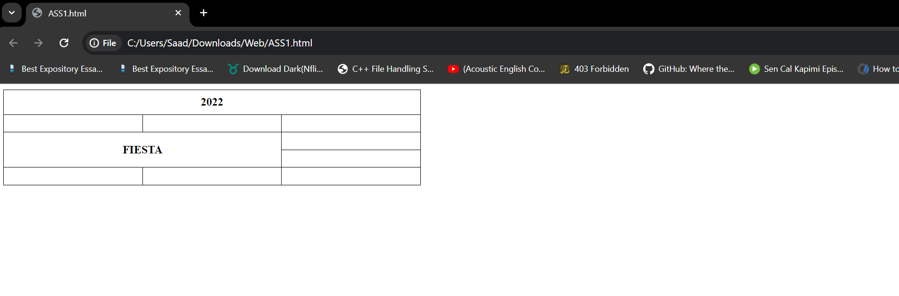

**TASK 8:**

<!DOCTYPE HTML>

<HTML>

<HEAD>

<h1>SIGN-UP</h1>

</HEAD>

<BODY>

<form action="/action_page.php">

<label>User Name :</label><br>

<input type="text"><br>

<label>Email : </label><br>

<input type="email"><br>

<label>Password : </label><br>

<input type="password"><br>

<label>Confirm Password : </label><br>

<input type="Password"><br><br>

<input type="submit">

<input type='reset'>

</form>

</BODY>

</HTML>

**OUTPUT:**

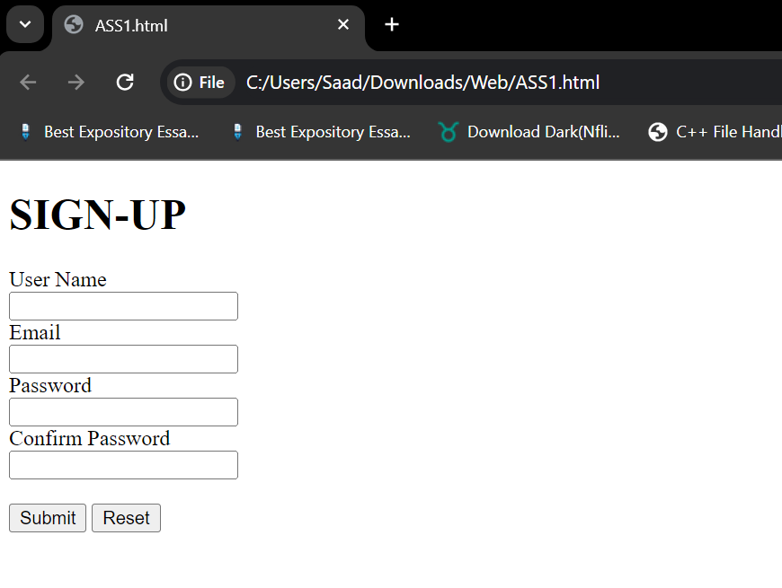

**TASK 9:**

<!DOCTYPE html>

<html>

<head>

  <style>

    .btn {

      text-align: center;

    }

    .heading {

      text-align: center;

    }

    .info {

      display: flex;

    }

    .contact {

      width: 50%;

    }

    .contact1 {

      width:50%;

    }

    .infor {

      width: 100%;

      box-sizing: border-box;

    }

    .lbles {

      font-weight: bold;

      display: inline-block;

      width: 30%;

      text-align: right;

      padding-right: 8px;

      box-sizing: border-box;

    }

    h3 {

      margin-bottom: 8px;

    }

    .delivery_details {

      text-align: center;

    }

    .required_field {

      display: flex;

    }

    .extra {

      margin-left:170px;

      width: 33.33%;

    }

  </style>

</head>

<body>

  <form action="/action_page.php">

    <div class="heading">

      <h1>Pete's Pizza Delivery</h1>

      <h3>Online Order Form</h3>

    </div>

    <div class="info">

      <div class="contact">

        <div class="infor">

          <div class="lbles">

            <label for="username">*Name:</label>

          </div>

          <input type="text" id="username" name="username"><br><br>

        </div>

        <div class="infor">

          <div class="lbles">

            <label>*Address:</label>

          </div>

          <input type="text"><br><br>

        </div>

        <div class="infor">

          <div class="lbles">

            <label>*Town/City:</label>

          </div>

          <input type="text"><br><br>

        </div>

        <div class="infor">

          <div class="lbles">

            <label>*Postcode:</label>

          </div>

          <input type="text"><br><br>

        </div>

      </div>

      <div class="contact1">

        <div class="infor">

          <div class="lbles">

            <label>*Tel:</label>

          </div>

          <input type="tel"><br><br>

        </div>

        <div class="infor">

          <div class="lbles">

            <label>*Email:</label>

          </div>

          <input type="email"><br><br>

        </div>

      </div>

    </div>

    <div class="heading">

      <p><b>*required fields</b></p>

    </div>

    <div class="required_field">

      <div class="extra">

        <h3>Topping</h3>

        <div>

        <input type="radio" name="fav_language">

        <label>Margherita</label><br>

        <input type="radio" name="fav_language">

        <label>Four Seasons</label><br>

        <input type="radio" name="fav_language">

        <label>Meat Feast</label>

        </div>

      </div>

      <div class="extra">

        <h3>Size</h3>

        <input type="radio" id="small" name="fav_language" value="small">

        <label for="small">Small</label><br>

        <input type="radio" id="medium" name="fav_language" value="medium">

        <label for="medium">Medium</label><br>

        <input type="radio" id="large" name="fav_language" value="large">

        <label for="large">Large</label>

      </div>

      <div class="extra">

        <h3>Extras</h3>

        <div class="infor">

          <input type="checkbox">

          <label>Mushrooms</label><br>

          <input type="checkbox">

          <label>Green peppers</label><br>

          <input type="checkbox">

          <label>Anchovies</label><br>

          <input type="checkbox">

          <label>Extra cheese</label><br><br><br>

        </div>

      </div>

    </div>

    <div class="delivery_details">

      <label>Preffered delivery time: </label>

      <input type="time">

      <br><br>

      <label>Delivery instructions:</label>

      <textarea rows='4'></textarea>

    </div><br>

    <div class="btn">

      <button type="submit">Submit Order</button>

    </div>

  </form>

</body>

</html>

**OUTPUT:**

