

**NAME: SAAD ASHRAF**

**ROLL NUMBER: 21F-9167**

**SECTION: 6B**

**ASSIGNMENT 1 PART B**

**TASK 1:**

**HTML:**

<!DOCTYPE html>

<html lang="en">

<head>

    <meta charset="UTF-8">

    <meta name="viewport" content="width=device-width, initial-scale=1.0">

    <title>My Webpage</title>

    <style>

        body {

            background-color: blue;

        }

        h1 {

            font-size: 36px;

        }

    </style>

    <link rel="stylesheet" href="styling.css">

</head>

<body>

    <div class="shadowstyle">

        <h1>Name: Saad Ashraf</h1>

        <p>Roll Number: 21F-9167</p>

        <p>Brief: I study computer science in FAST university</p>

    </div>

</body>

</html>

**CSS:**

.shadowstyle {

    box-shadow: 5px 5px 10px rgba(0, 0, 0, 0.5);

}

**OUTPUT:**

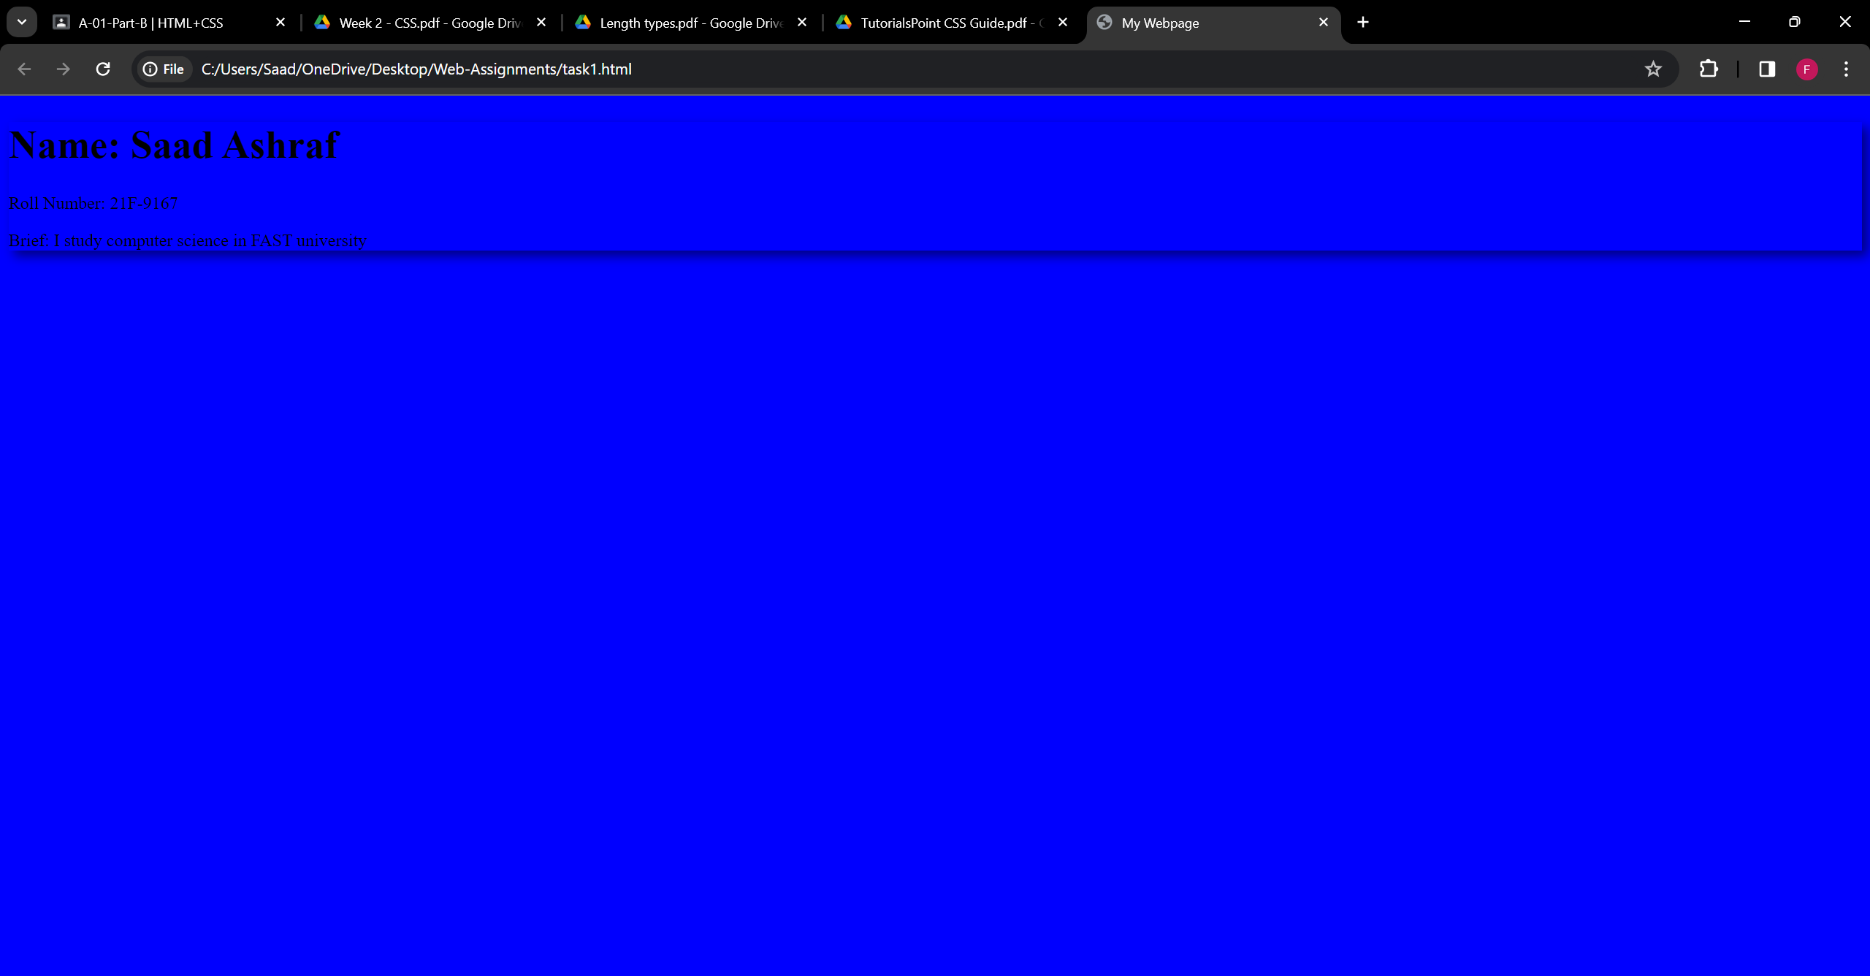

**TASK 2:**

**HTML:**

<!DOCTYPE html>

<html lang="en">

<head>

    <meta charset="UTF-8">

    <meta name="viewport" content="width=device-width, initial-scale=1.0">

    <title>My Webpage</title>

    <style>

        body {

            background-color: rgb(37, 37, 40);

        }

        h1 {

            font-size: 36px;

            color: white

        }

        h4 {

            color: white

        }

    </style>

    <link rel="stylesheet" href="styling.css">

</head>

<body>

    <div class="shadowstyle">

        <h1>Start CSS Exercise</h1>

        <h4>Good luck!</h4>

    </div>

    <button id="myButton" class="primaryButton">Start CSS Exercises ></button>

</body>

</html>

**CSS:**

.primaryButton {

    background-color: rgb(15, 148, 15);

    color: white;

    padding: 10px 20px;

    border: none;

    border-radius: 5px;

    cursor: pointer;

}

**OUTPUT:**

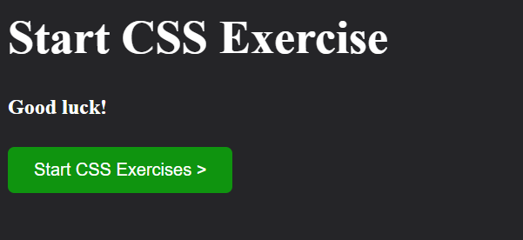

**TASK 3:**

**HTML:**

<!DOCTYPE html>

<html lang="en">

<head>

<meta charset="UTF-8">

<meta name="viewport" content="width=device-width, initial-scale=1.0">

<title>Contact Form</title>

<link rel="stylesheet" type="text/css" href="styling.css">

</head>

<body>

    <div class="container">

        <form class="form">

            <h2>Contact Us</h2>

            <div class="form-group">

                <label for="name">Your Name:</label>

                <input type="text" id="name" name="name" required>

            </div>

            <div class="form-group">

                <label for="email">Your Email:</label>

                <input type="email" id="email" name="email" required>

            </div>

            <div class="form-group">

                <label for="phone">Your Phone Number:</label>

                <input type="tel" id="phone" name="phone" required>

            </div>

            <div class="form-group">

                <label for="message">Your Message:</label>

                <textarea id="message" name="message" required></textarea>

            </div>

            <div class="button-group">

                <button type="submit" class="btn-submit">Submit</button><br><br>

                <button type="reset" class="btn-reset">Reset</button>

            </div>

        </form>

    </div>

</body>

</html>

**CSS:**

body {

    margin: 0;

    padding: 0;

    font-family: Arial, sans-serif;

    background-color: rgb(240, 240, 240);

    display: flex;

    justify-content: center;

    align-items: center;

    height: 100vh;

}

h2{

    text-align:center;

}

.container {

    width: 400px;

    background-color: white;

    padding: 20px;

    border-radius: 8px;

    box-shadow: 0 0 10px rgba(0, 0, 0, 0.1);

}

.form {

    display: flex;

    flex-direction: column;

}

.form-group {

    margin-bottom: 20px;

}

label {

    font-weight: bold;

}

input,

textarea {

    width: 100%;

    padding: 8px;

    border: 1px solid #ccc;

    border-radius: 4px;

}

.btn-submit,

.btn-reset {

    width: 100%;

    padding: 10px 20px;

    border: none;

    border-radius: 4px;

    color: #fff;

    cursor: pointer;

}

.btn-submit {

    background-color: #4CAF50;

}

.btn-reset {

    background-color: #4CAF50;

}

**OUTPUT:**

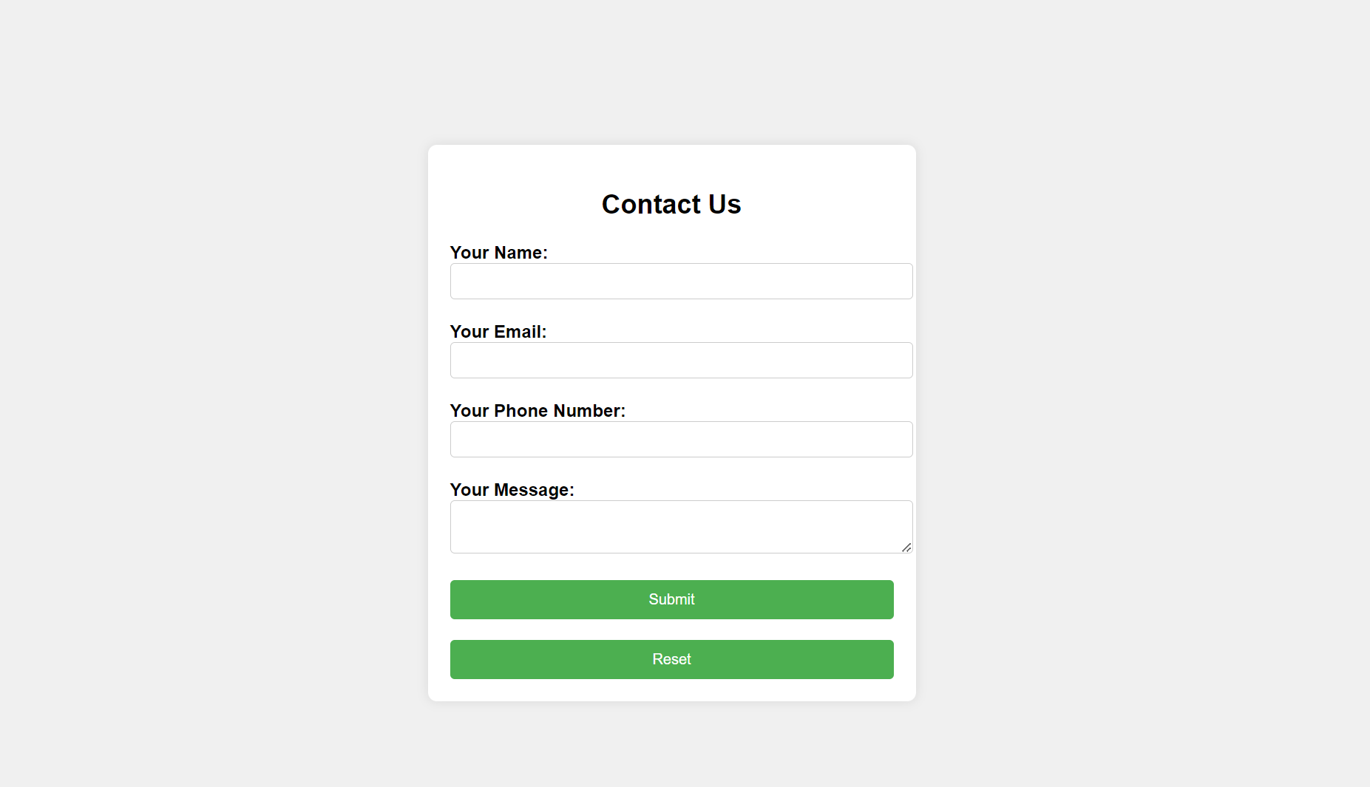

**TASK 4:**

**HTML:**

<!DOCTYPE html>

<html>

<head>

<style>

div.polaroid {

  width: 250px;

  box-shadow: 0 4px 8px 0 rgba(0, 0, 0, 0.2), 0 6px 20px 0 rgba(0, 0, 0, 0.19);

  text-align: center;

}

.polaroid  img{

  width: 200px;

  height: 150px;

}

div.container {

  padding: 2px;

}

</style>

</head>

<body>

<div class="polaroid">

  <img src="img1.jpg" alt="Norway" style="width:100%">

  <div class="container">

    <p>Cnique, Terre</p>

  </div>

</div>

</body>

</html>

**OUTPUT:**

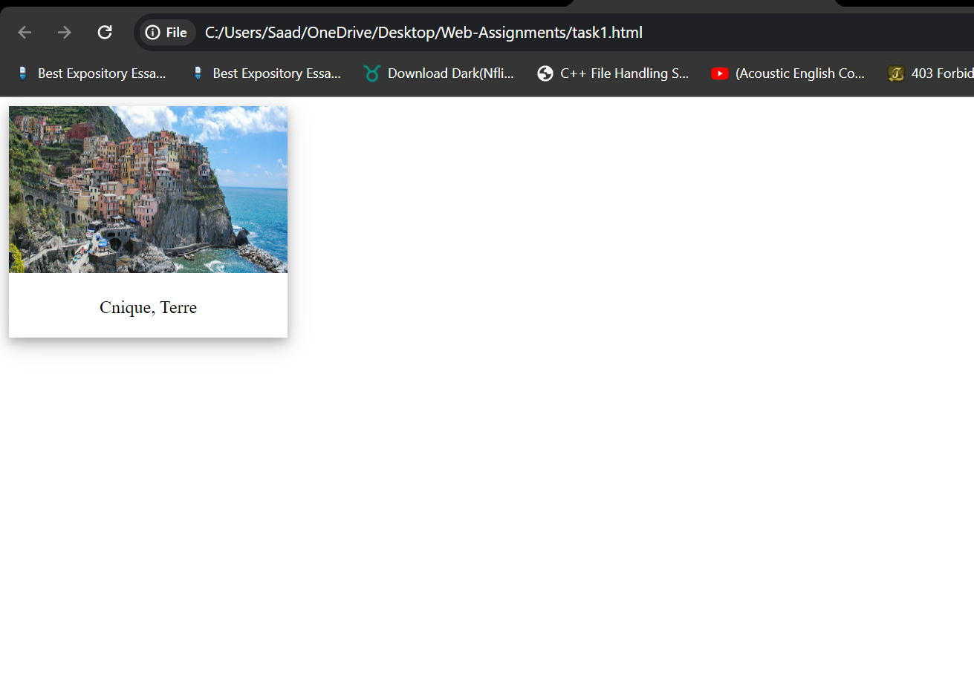

**TASK 5:**

**HTML:**

<!DOCTYPE html>

<html lang="en">

<head>

  <meta charset="UTF-8">

  <meta name="viewport" content="width=device-width, initial-scale=1.0">

  <link rel="stylesheet" href="styling.css">

  <script src="https://kit.fontawesome.com/120dc2ca68.js" crossorigin="anonymous"></script>

  <title>HTML Formatting</title>

</head>

<body>

  <header>

    <div class="MainHeading">

      <div class="name">

        <div class="Main">

          <h1>Saad Ashraf</h1>

          <h2 id="h2AboutMe">Computer Scientist</h2>

        </div>

        <div class="Info">

          <img src="saad.jpg" alt="Saad image">

        </div>

      </div>

      <div id="Links">

        <a class="links" href="https://github.com/SaadAshraf12" target="_blank">

          <i class="fa-brands fa-github"></i>

          GitHub</a>

          <a class="links" href="mailto:saadashraf4512@gmail.com" target="_blank">

            <i class="fa-regular fa-envelope"></i>

            saadashraf4512@gmail.com</a>

        <a class="links" id="end-link" href="https://pk.linkedin.com/" target="_blank">

          <i class="fa-brands fa-linkedin"></i>

          LinkedIn</a>

      </div>

    </div>

    <div class="About_Me">

      <h1>About Me</h1>

      <p>I am Passionate Computer Scientist</p>

      <p>Currently, I am studying Computer Science at FAST-NU</p>

    </div>

    <div class="About_Me">

      <h1>Personal Information</h1>

      <ul>

        <li><b>Date of Birth :</b> December 17, 2003 </li>

        <li><b>Nationality :</b> Pakistan</li>

        <li><b>Address :</b> Lahore, Nasheman Iqbal Phase 2</li>

        <li><b>Email :</b> saadashraf4512@gmail.com</li>

        <li><b>Phone Number :</b> 03108900129</li>

      </ul>

    </div>

    <div class="About_Me">

      <h1>Education</h1>

      <ul>

        <li><b>Degree:</b> Computer Science</li>

        <li><b>Institution:</b> FAST NUCES</li>

        <li><b>Graduation Year:</b> 2025</li>

      </ul>

    </div>

    <div class="About_Me">

      <h1>My Projects</h1>

      <h3>Project 1</h3>

      <p>I developed a predictive model using the ARIMA (Autoregressive Integrated Moving Average) algorithm to forecast Bitcoin prices. This model leverages historical data to analyze patterns and trends in Bitcoin's price movements, enabling users to make informed decisions in the volatile cryptocurrency market.</p>

      <a href="https://github.com/SaadAshraf12/Bitcoin-Prediction-ARIMA-2/blob/main/Bitcoin%201.ipynb" target="_blank"><button class="button" style="vertical-align:middle"><span>View Details</span></button></a>

      <h3>Project 2</h3>

      <p>Building a stock market prediction system using the Decision Tree algorithm. By analyzing various factors such as historical stock prices, trading volumes, and market indicators, the model generates forecasts to help investors identify potential opportunities and risks in the stock market.</p>

      <a href="https://github.com/SaadAshraf12/Stock-Market-Prediction-Decision-Tree/blob/main/Stock%20Market%20Prediction.ipynb" target="_blank"><button class="button" style="vertical-align:middle"><span>View Details</span></button></a>

      <h3>Project 3</h3>

      <p>I created a predictive model to estimate gold prices using the ARIMA algorithm. By analyzing historical gold price data along with relevant economic and market indicators, the model provides insights into potential future trends in the gold market, aiding investors and traders in their decision-making processes.</p>

      <a href="https://github.com/SaadAshraf12/Gold-Price-Prediction-using-ARIMA/blob/main/Gold%20Price%20Prediction.ipynb" target="_blank"><button class="button" style="vertical-align:middle"><span>View Details</span></button></a>

      <h3>Project 4</h3>

      <p>I developed a machine learning model using Linear Regression to predict laptop prices. By considering features such as processor speed, RAM capacity, storage size, and brand, the model offers price estimations for different laptop configurations, assisting consumers and retailers in pricing strategies and purchasing decisions.</p>

      <a href="https://github.com/SaadAshraf12/Laptop-Price-Predictor" target="_blank"><button class="button" style="vertical-align:middle"><span>View Details</span></button></a>

    </div>

    <div class="About_Me">

      <h1>Skills</h1>

      <ul>

        <li>C++/C#/Python Expert</li>

        <li>Reinforcement Learning</li>

        <li>Machine Learning Engineer</li>

      </ul>

    </div>

    <div class="end">

      <p>Contact me at saadashraf4512@gmail.com</p>

    </div>

  </header>

  <section>

  </section>

</body>

</html>

**CSS:**

body{

    font-family: Arial, Helvetica, sans-serif;

  }

  .MainHeading {

    background-color: lightslategray;

    color: #fff;

    display: flex;

    flex-direction: column;

    justify-content: space-between;

    align-items: center;

    border-width: 10px;

    height: 265px;

  }

  .end{

    background-color: lightslategray;

    color: #fff;

    display: flex;

    flex-direction: column;

    justify-content: space-between;

    align-items: center;

    border-width: 10px;

    height: 100px;

  }

  #h2AboutMe{

    margin-left: 20px;

  }

  .name{

    display: flex;

    justify-content: center;

    gap:15px;

  }

  .Info{

    padding-top: 20px;

  }

  .Main{

    display:flex;

    flex-direction: column;

  }

  .Info img{

    width: 120px;

    height: 150px;

    object-fit: cover;

    border: 5px solid lightgray;

    border-radius: 10%;

  }

  #Links{

    display: flex;

    gap:10px;

  }

  body{

    background-color:  whitesmoke;

  }

  .About_Me{

    box-shadow: 0 8px 16px 0 rgba(0,0,0,0.2), 0 6px 20px 0 rgba(0,0,0,0.19);

    border-radius: 5px;

    padding-left: 20px;

    margin: 15px;

    padding: 10px;

  }

  .About_Me {

    transition: all 0.4s ease;

  }

  .button {

    display: inline-block;

     border-radius: 4px;

     background-color: blue;

     border: solid 1px;

     border-color: blue;

     color: #FFFFFF;

     font-size: 12px;

     padding: 20px;

     width: 120px;

     transition: all 0.5s;

     cursor: pointer;

     padding-bottom: 100;

   }

  .button span {

    cursor: pointer;

    display: inline-block;

    position: relative;

    transition: 0.5s;

  }

  .button span:after {

    content: '\00bb';

    position: absolute;

    opacity: 0;

    top: 0;

    right: -20px;

    transition: 0.5s;

  }

  .button:hover span {

    padding-right: 8px;

  }

  .button:hover span:after {

    opacity: 1;

    right: 0;

  }

  .About_Me:hover {

    transform: scale(1.025);

  }

  .About_Me h1 {

    font-size: 24px;

  }

  .About_Me p {

    font-size: 16px;

  }

  .links{

    color: lightcyan;

    text-decoration: none;

  }

  #Links{

    padding-right: 40px;

  }

  .div2 {

    background-color: green;

    margin-top: 10px;

  }

**OUTPUT:**

