TASK 1:

#include <iostream>

using namespace std;

int main() {

int array[50], i, sum = 0, size;

int\* ptr;

cout << "Enter The Size Of Array : ";

cin >> size;

cout << "Enter The Elements Of The Array : " << endl;

for (i = 0; i < size; i++) {

cin >> array[i];

}

ptr = array;

for (i = 0; i < size; i++) {

sum = sum + \*(ptr + i);

}

cout << endl;

cout << "The Sum Of Array Elements :" << sum;

return 0;

}

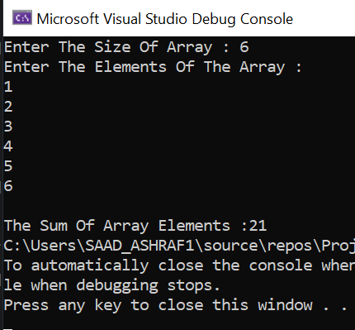

TASK 3:

STRLEN:

#include<iostream>

using namespace std;

int main()

{

string str;

cout << "Enter Your String : ";

cin >> str;

int i = 0, count = 0;

for (i = 0; str[i] !=NULL ; i++)

{

count++;

}

cout << "Length Of Your String is : " << count << endl;

return 0;

}

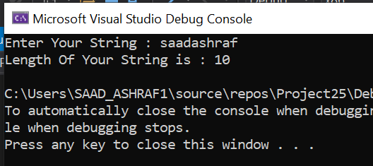

STRCMP:

#include<iostream>

using namespace std;

int main()

{

char str1[50], str2[50];

int i = 0, X = 0;

cout << "Enter the First String: ";

cin >> str1;

cout << "Enter the Second String: ";

cin >> str2;

while (str1[i] != NULL || str2[i] != NULL)

{

if (str1[i] != str2[i])

{

X = 1;

break;

}

i++;

}

if (X == 0)

cout << "\nStrings are Equal";

else

cout << "\nStrings are not Equal";

cout << endl;

return 0;

}

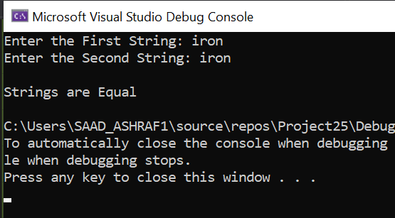

STRNCMP:

#include<iostream>

using namespace std;

int main()

{

char str1[50], str2[50];

int i, size, x = 0;

cout << "Enter string 1 : ";

cin>>str1;

cout << "Enter string 2 : ";

cin>>str2;

cout << "Enter number of characters to be compared : ";

cin >> size;

for (i = 0; i < size; i++)

{

if (str1[i] != str2[i])

{

x = 1;

break;

}

}

if (x == 0)

cout << "Compared strings are equal.";

else

cout << "Strings are not equal.";

return 0;

}

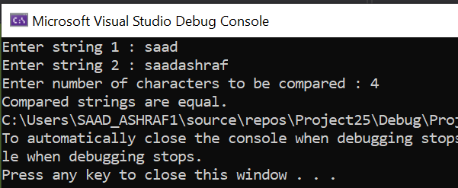

STRCPY:

#include <iostream>

using namespace std;

int main() {

char str1[100];

cout << "Enter The String : ";

cin >> str1;

char str2[100];

int i;

for (i = 0; str1[i] != NULL; i++) {

str2[i] = str1[i];

}

str2[i] = '\0';

cout << "The 2nd string str2 iss : " << str2;

return 0;

}

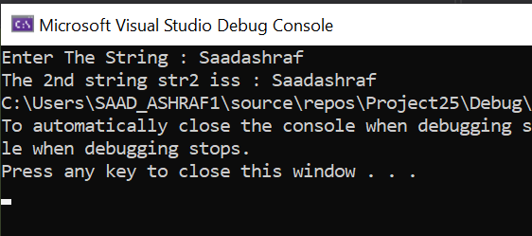

TASK 2:

#include<iostream>

using namespace std;

int Frequency(int\* p, int size)

{

int i,j,y=0,counter=0;

int\* p1 = new int[size];

int\* num = new int[size];

int k = 0;

for (i = 0; i < size; i++)

{

for (j = i; j < size; j++)

{

if (p[i] == p[j])

{

counter++;

y = p[i];

}

}

num[k] = y;

p1[k] = counter;

counter = 0;

k++;

}

int temp1 = 0;

int temp2 = 0;

int temp3 = 0;

int temp4 = 0;

for (i = 0; i < size; i++)

{

for (j = i + 1; j < size; j++)

{

if (p1[i] < p1[j])

{

temp1 = p[i];

temp2 = p[j];

p[j] = temp1;

p[i] = temp2;

temp3 = num[i];

temp4 = num[j];

num[i] = temp4;

num[j] = temp3;

}

}

}

int n = 0;

n = num[0];

return n;

}

int main()

{

int size, i=0;

cout << "Enter The Array Size : ";

cin >> size;

int\* p = new int[size];

cout << "Please input the array elements";

cout << endl;

for (i = 0; i < size; i++)

{

cin >> p[i];

}

cout << endl;

cout << "Number with the highest frequency is : ";

cout << Frequency(p, size) << endl;

system("pause");

return 0;

}

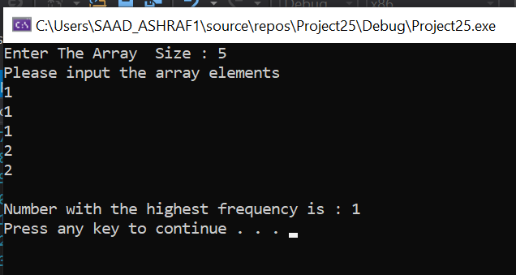

TASK 4:

#include<iostream>

#include<cstring>

#include<string>

using namespace std;

int y = 0;

int y2 = 0;

double\* Maximumprice(double\* p, int\* p2, char\*\* p3)

{

int j=0;

double temp1 = 0, temp2=0;

int temp3 = 0, temp4 = 0;

for (int i = 0; i < 10; i++)

{

for (j = i + 1; j < 10; j++)

{

if (p[i] < p[j])

{

temp1 = p[i];

temp2 = p[j];

p[i] = temp2;

p[j] = temp1;

temp3 = p2[i];

temp4 = p2[j];

p2[j] = temp3;

p2[i] = temp4;

swap(p3[i], p3[j]);

}

}

}

return p;

}

int\* MaximumQuantity(double\* p, int\* p2, char\*\* p3)

{

int i = 0;

int j = 0;

double temp1 = 0;

double temp2 = 0;

int temp3 = 0;

int temp4 = 0;

for (i = 0; i < 10; i++)

{

for (j = i + 1; j < 10; j++)

{

if (p2[i] < p2[j])

{

temp1 = p[i];

temp2 = p[j];

p[i] = temp2;

p[j] = temp1;

temp3 = p2[i];

temp4 = p2[j];

p2[j] = temp3;

p2[i] = temp4;

swap(p3[i], p3[j]);

}

}

}

return p2;

}

int main()

{

double price[10];

int qunatity[10];

char\* Name[10];

int i = 0;

int j = 0;

double\* p9 = 0;

for (i = 0; i < 10; i++)

{

Name[i] = new char[20];

}

for (i = 0; i < 10; i++)

{

cout << i;

cout << endl;

cout << "Enter The Name Of The Item" << " " << endl;

cin >> Name[i];

cout << endl;

cout << "Enter The Price Of The Item" << " " << endl;

cin >> price[i];

cout << endl;

cout << "Enter The Total Quantity Of The Item" << " " << endl;

cin >> qunatity[i];

cout << endl;

}

cout << endl;

p9 = Maximumprice(price, qunatity, Name);

cout << "The Product with the Max price is As Following" << " " << endl;

cout << "The Name of the Product is" << " ";

cout << Name[0]<< endl;

cout << "The Price Of The Item" << " ";

cout << price[0]<<endl;

cout << "The Total Quantity Of Item" << " ";

cout << qunatity[0]<<endl;

cout << endl;

int\* o;

o = MaximumQuantity(price, qunatity, Name);

cout << endl;

cout << "The Product with the Max Quantiy is As Following" << " " << endl;

cout << "The Name of the Product is" << " ";

cout << Name[0] << endl;

cout << "The Price of The Item" << " ";

cout << price[0]<<endl;

cout << "The Total Quantity Of Item" << " ";

cout << qunatity[0] << endl;

}

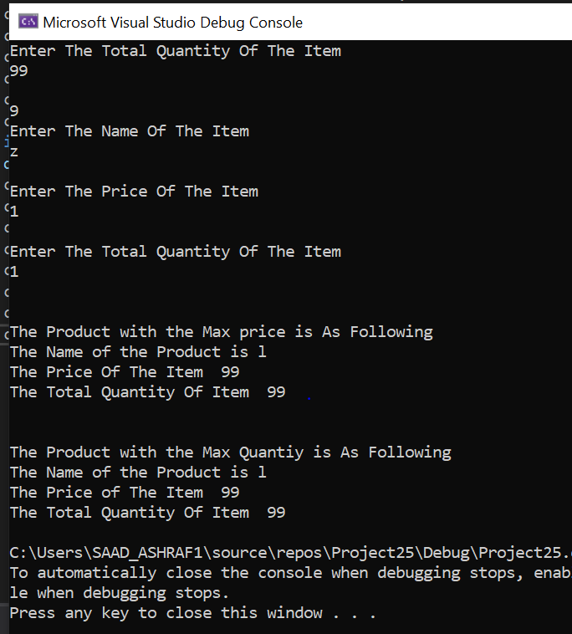

TASK 5: