Task 1:

#include <iostream>

#include <string>

using namespace std;

class Employee{

private:

string name; // Employee's name

string idNumber; // ID number

string department; // Department name

string bank; // Employee's position

string grade;

public:

// Constructors

Employee() {

name = " ";

idNumber = " ";

department = " ";

bank = " ";

grade = " ";

}

Employee(string a, string b, string c, string d, string e) {

a = "saad";

b = "123";

c = "Cs";

d = "198289793879";

e = "7";

name =a;

idNumber =b;

department =c;

bank =d;

grade = e;

cout << "Name : " << name << endl;

cout << "Id Number : " << idNumber << endl;

cout << "Department : " << department << endl;

cout << "Bank Account Number : " << bank << endl;

cout << "Grade : " << grade << endl;

}

void input() {

cout << endl;

string f, g, h, i, j;

cin >> f >> g >> h >> i >> j;

name = f;

idNumber = g;

department = h;

bank = i;

grade = j;

}

void display() {

cout << endl;

cout << "DATA IS : " << endl;

cout << "Name : " << name << endl;

cout << "Id Number : " << idNumber << endl;

cout << "Department : " << department << endl;

cout << "Bank Account Number : " << bank << endl;

cout << "Grade : " << grade << endl;

}

~Employee(){}

};

// Driver program to demonstrate the class

int main(){

Employee emp("a", "b", "c", "d", "e");

emp.input();

emp.display();

Employee\* ptr0;

ptr0 = new Employee;

ptr0->input();

ptr0->display();

ptr0->~Employee();

Employee\* ptr1;

ptr1 = new Employee;

ptr1->input();

ptr1->display();

ptr1->~Employee();

Employee\* ptr2;

ptr2 = new Employee;

ptr2->input();

ptr2->display();

ptr2->~Employee();

}

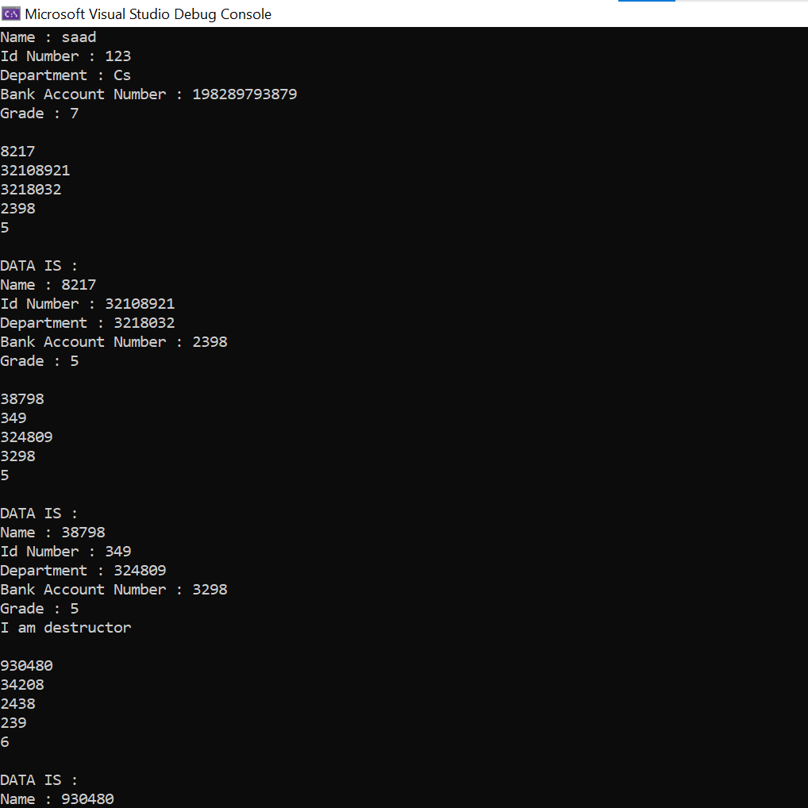

TASK 2:

#include <iostream>

#include<iomanip>

#include <string>

using namespace std;

class Employee {

private:

string name;

int idNumber;

string department;

string position;

public:

Employee(string n, int i, string d, string p)

{

name = n;

idNumber = i;

department = d;

position = p;

}

Employee(string n, int i) {

name = n;

idNumber = i;

department = "";

position = "";

}

Employee() {

name = "";

idNumber = 0;

department = "";

position = "";

}

void setName(string n) {

name = n;

}

void setIdNumber(int i) {

idNumber = i;

}

void setDepartment(string d) {

department = d;

}

void setPosition(string p) {

position = p;

}

string getName() {

return name;

}

int getIdNumber() {

return idNumber;

}

string getDepartment() {

return department;

}

string getPosition() {

return position;

}

};

void displayEmployee(Employee);

int main() {

Employee x("Saad Ashraf", 2122, "Engineering", "CEO");

Employee y("Omar Ashraf", 323232);

y.setDepartment("CS");

y.setPosition("Developer");

Employee z;

z.setName("Auesha omar");

z.setIdNumber(81774);

z.setDepartment("doctor");

z.setPosition("Phd");

displayEmployee(x);

displayEmployee(y);

displayEmployee(z);

return 0;

}

void displayEmployee(Employee e) {

cout << setw(20) << e.getName() << setw(20) << e.getIdNumber() << setw(20) << e.getDepartment() << " " << setw(20) << e.getPosition() << endl;

}

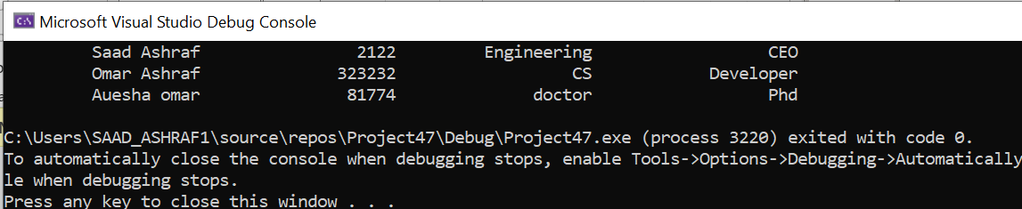

Task 3:

HEADER FILE

#include<iostream>

using namespace std;

class Person

{

private:

string name;

const string DOB;

const string cnic;

static int Count;

public:

Person(string a, string dob, string CNIC);

const string dobb();

const string cnicc();

const void Display();

};

IMPLEMNTATON:

Person::Person(string a, string dob, string CNIC) :name(a), DOB(dob), cnic(CNIC){

Count++;

cout << endl << "Number Objects created are : " << Count << endl;

}

string const Person::dobb(){

return DOB;

}

string const Person::cnicc(){

return cnic;

}

void const Person::Display(){

cout << "Data of the Person : \n";

cout << "\nSerial Number : " << Count;

cout << "\nName :" << name;

cout << "\nDate of birth : " << dobb();

cout << "\nCNIC : " << cnicc() << endl;

}

int Person::Count = 0;

MAIN FILE:

#include<iostream>

#include"header.h"

using namespace std;

int main()

{

string dob;

Person P("Mr.X", "1st January 2001", "12345-6789101-1");

P.Display();

cout<< endl << "enter date of birth : ";

cin >> dob;

Person x("MrX", dob, "12345-6789101-1");

x.Display();

}

