TASK 1:

#include <iostream>

using namespace std;

int main(){

int\*\* arr;

int n, m, i = 0;

cout << "Enter Number of vertices: ";

cin >> n;

arr = new int\* [n];

while (i < n){

arr[i] = new int[n];

i++;

}

for (int i = 0; i < n; i++){

for (int j = 0; j < n; j++){

arr[i][j] = 0;

}

}

cout << "Enter number of edges: ";

cin >> m;

int x, y;

for (int k = 0; k < m; k++){

cout << "Enter the 1st vertice: ";

cin >> x;

cout << "Enter the 2nd vertice: ";

cin >> y;

arr[x - 1][y - 1] = 1;

arr[y - 1][x - 1] = 1;

}

cout << "Adjacency Matrix: " << endl;

for (int i = 0; i < n; i++){

for (int j = 0; j < n; j++){

cout << arr[i][j] << " ";

}

cout << endl;

}

}

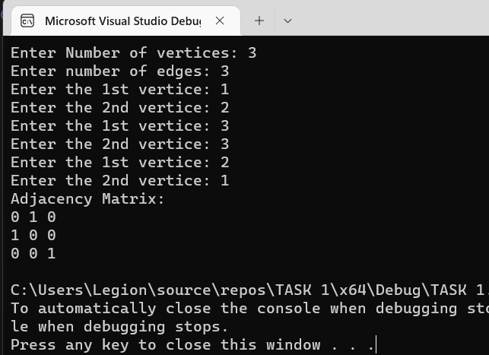

TASK 2:

#include<iostream>

using namespace std;

void number(int arr[][10]){

int count;

for (int i = 0; i < 10; i++){

count = 0;

cout << i << " : ";

for (int j = 0; j < 10; j++){

if (arr[i][j] == 1){

cout << "{" << i << " , " << j << "} , ";

count++;

}

}

cout << endl << "Total edges with " << i << " are " << count << endl;

}

}

void insertion(int arr[][10], int x, int y) {

arr[x][y] = 1;

if (x != y)

arr[y][x] = 1;

}

int main(){

int arr[10][10];

for (int i = 0; i < 10; i++){

for (int j = 0; j < 10; j++){

arr[i][j] = 0;

}

}

insertion(arr, 0, 2);

insertion(arr, 0, 4);

insertion(arr, 0, 5);

insertion(arr, 1, 4);

insertion(arr, 1, 6);

insertion(arr, 1, 9);

insertion(arr, 2, 7);

insertion(arr, 1, 6);

insertion(arr, 2, 4);

insertion(arr, 3, 5);

insertion(arr, 3, 1);

insertion(arr, 5, 5);

insertion(arr, 9, 2);

insertion(arr, 7, 8);

insertion(arr, 7, 9);

for (int i = 0; i < 8; i++){

for (int j = 0; j < 10; j++){

cout << arr[i][j] << " ";

}

cout << endl;

}

number(arr);

return 0;

}

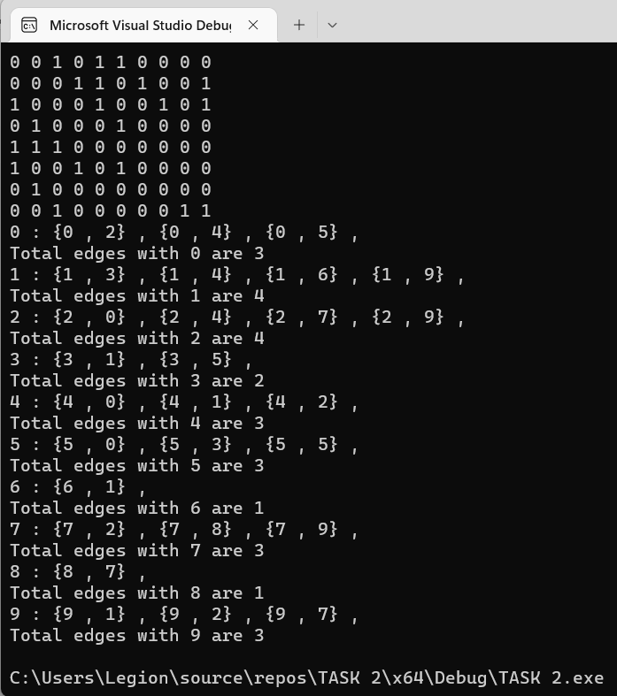

TASK 3:

#include <iostream>

using namespace std;

int main(){

int\*\* arr;

int\* count;

int vertices, m;

cout << "Input number of vertices: ";

cin >> vertices;

arr = new int\* [vertices];

count = new int[vertices];

int i = 0;

while ( i < vertices){

arr[i] = new int[vertices];

count[i] = 0;

i++;

}

i = 0;

while ( i < vertices){

for (int j = 0; j < vertices; j++){

arr[i][j] = 0;

}

i++;

}

cout << "Enter number of edges: ";

cin >> m;

int x, y;

for (int k = 0; k < m; k++){

cout << "Enter 1st vertice: ";

cin >> x;

cout << "Enter 2nd vertice: ";

cin >> y;

arr[x][y] = 1;

arr[y][x] = 1;

}

cout << "Adjacency Matrix: " << endl;

for (int i = 0; i < vertices; i++){

for (int j = 0; j < vertices; j++){

if (arr[i][j] == 1){

count[i]++;

}

cout << arr[i][j] << " ";

}

cout << endl;

}

int\*\* list;

list = new int\* [vertices];

i = 0;

while ( i < vertices){

list[i] = new int[count[i]];

i++;

}

for (int i = 0; i < vertices; i++){

for (int j = 0; j < count[i]; j++){

for (int k = 0; k < vertices; k++){

if (arr[i][k] == 1){

list[i][j] = k;

j++;

}

}

}

}

cout << "adjacency list: " << endl;

for (int i = 0; i < vertices; i++){

cout << "for " << i << " : ";

for (int j = 0; j < count[i]; j++){

cout << list[i][j];

}

cout << endl;

}

}

