Task 1:

#include <iostream>

using namespace std;

int sum(int n) { //function

if (n == 1 || n == 0)

return 1;

else

return n + sum(n - 1); //recursive calling with proper conditon

}

int main() {

int number;

cout << "Input number:";

cin >> number;

cout << "The answer is : " << sum(number) << endl; //printing

}

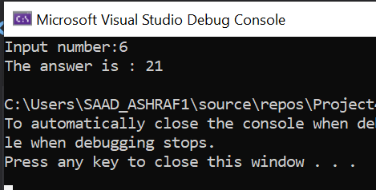

Task 2:

#include <iostream>

using namespace std;

int fibonachi(int x) { //function

if ((x == 1) || (x == 0)) {

return(x);

}

else {

return(fibonachi(x - 1) + fibonachi(x - 2)); //recursive calling using the proper condition x-1 + x-2

}

}

int main() {

int x;

cout << "Enter the number of terms of series : ";

cin >> x;

cout << "Fibonnaci Series : ";

for (int i = 0; i < x; i++) {

cout << " " << fibonachi(i); //calling function

}

return 0;

}

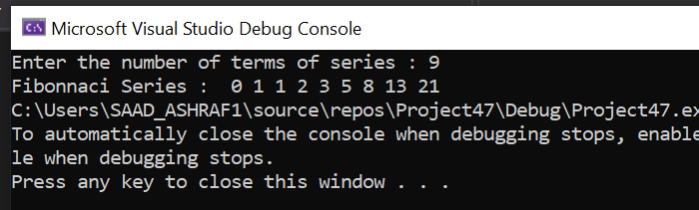

Task 3:

#include <iostream>

using namespace std;

void func(int n, string sux_rod, string ox_rod, string on_rod){

if (n == 0){

return;

}

func(n - 1, sux_rod, on_rod, ox_rod);

cout << "Move disk " << n << " from rod " << sux_rod << " to rod " << ox_rod << endl;

func(n - 1, on_rod, ox_rod, sux_rod);

}

int main(){

int n = 4;

func(n, "NO_1", "NO_2", "NO_3");

return 0;

}

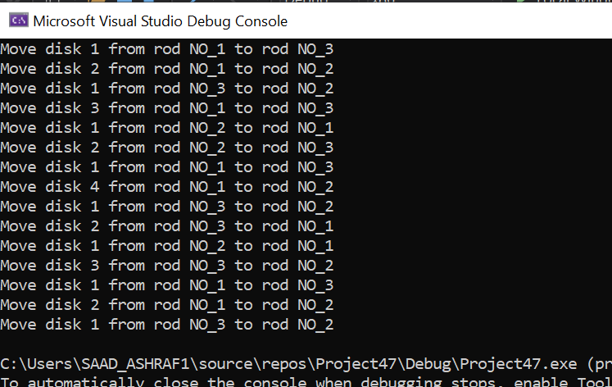

Task 4:

#include<iostream>

using namespace std;

struct Car //structre with name Car

{

char carName[20]; //memebers

char carModel[20];

int yearModel;

double cost;

};

int main() {

Car c1 = {"toyota" , "mustang", 2000, 25000}; //inputs given in question

int price;

cout << "enter cost of tesla : ";

cin >> price; //taking price in input

system("pause");

system("cls");

Car c2 = { "tesla", "MODEL-X", 2021, price }; //c2 object of car structure

if (c2.cost > c1.cost) { //if c2 cost is greater than c1 cost then print c2 car name

cout << "Car with higher cost is : "<< c2.carName;

}

else {

cout << "Car with higher cost is : " << c1.carName; //if c1 cost is greater than c2 cost then print c1 car name

}

//displaying all data of both objects c1 and c2

cout << "*** Data through objects ***" << endl;

cout << " Data through object 1 " << endl;

cout << "Name : " << c1.carName << endl;

cout << "Model : " << c1.carModel << endl;

cout << "Year : " << c1.yearModel << endl;

cout << "Cost : " << c1.cost << endl;

cout << endl;

cout << " Data through object 2 " << endl;

cout << "Name : " << c2.carName << endl;

cout << "Model : " << c2.carModel << endl;

cout << "Year : " << c2.yearModel << endl;

cout << "Cost : " << c2.cost << endl;

}

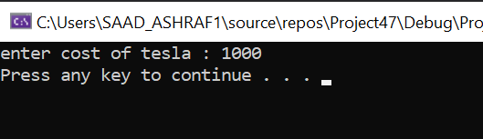

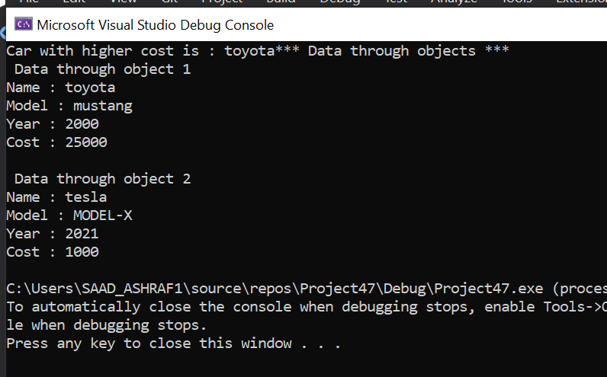

Task 5:

#include<iostream>

using namespace std;

struct Distance{

int feet;

float inches;

};

int main(){

Distance d1, d3;

Distance d2 = { 11, 6.25 };

cout << "\n Enter feet: ";

cin >> d1.feet;

cout << "Enter inches : ";

cin >> d1.inches;

d3.inches = d1.inches + d2.inches;

d3.feet = d1.feet + d2.feet;

if (d3.inches >= 12.0){

d3.inches = d3.inches - 12.0;

d3.feet++;

}

cout << d1.feet << " foot " << d1.inches<<" inches "<< " + ";

cout << d2.feet << " foot " << d2.inches<<" inches " << " = ";

cout << d3.feet << " foot " << d3.inches << " inches "<<endl;

}

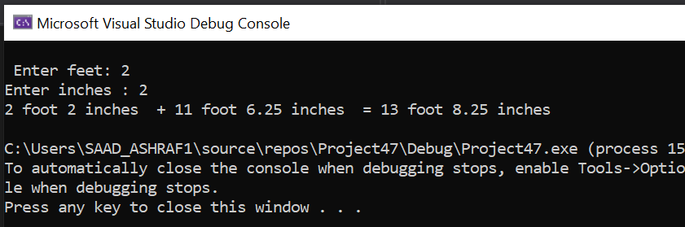

Task 6:

#include <iostream>

#include <cstdlib>

#include <iomanip>

#include <cstring>

using namespace std;

struct Drink

{

char name[12];

double price;

int num;

};

int getinput(Drink m[]) {

int choice;

cout << endl;

for (int x = 0; x < 5; x++) {

cout << (x + 1) << ") " << m[x].name << "\t\t";

cout << m[x].price << endl;

}

cout << (5 + 1) << ") Leave the drink machine\n\n";

cout << "Choose One: ";

cin >> choice;

while (choice < 1 || choice > 6) {

cout << "Enter valid choice plz : ";

cin >> choice;

}

if (choice == -1) {

return 0;

}

return choice - 1;

}

void func(Drink m[], int choice, double& earnings) {

double money;

if (m[choice].num == 0) {

cout << "item is not available anymore :( " << endl;

return;

}

cout << "Enter money: ";

cin >> money;

while (money < m[choice].price || money > 1.0) {

cout << "Enter at least " << m[choice].price << " and not above than 1 dollar.\n";

cin >> money;

}

if (money >= m[choice].price) {

cout << "Your change is : " << (money - m[choice].price) <<endl;

earnings += m[choice].price;

m[choice].num--;

cout << "Remaining drinks : " << m[choice].num<<endl;

}

}

int main(){

int choice;

double earn = 0;

Drink machine[5] = {{"Cola ", 0.75, 20}, {"Root Beer", .75, 20}, {"Lemon-Lime", .75, 20}, {"Grape Soda", .80, 20}, {"Cream Soda", .80, 20} };

cout << setprecision(4);

choice = getinput(machine);

while (choice != 5){

func(machine, choice, earn);

choice = getinput(machine);

}

cout << "Total earning is : $" << earn << endl;

return 0;

}

