Task 1:

#include<iostream>

using namespace std;

int main() {

int x =10.2, y=20.8, z=50.6;

if (!(z > 10)) {

cout << "true"<<endl;

}

else {

cout << "false"<<endl;

}

if (x <= 5 || y < 15) {

cout << "true"<<endl;

}

else {

cout << "false"<<endl;

}

if ((x != 5) && (x != z)) {

cout << "true"<<endl;

}

else {

cout << "false" << endl;

}

if(z >= x || (x + y >= z)) {

cout << "true"<<endl;

}

else {

cout << "false"<<endl;

}

if ((x <= y - 20) && (y >= z * 2) || (z / 2 - 2 != 20)) {

cout << "true"<<endl;

}

else {

cout << "false"<<endl;

}

system("pause");

}

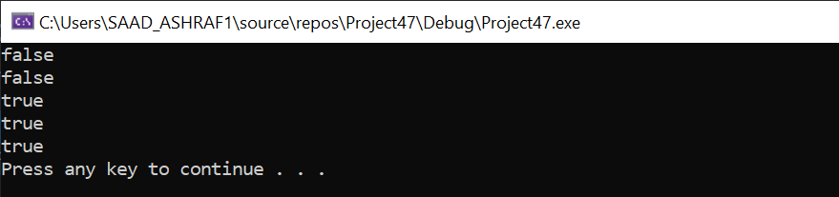

Task 2:

#include<iostream>

using namespace std;

int main()

{

float previous_unit, new_unit;

cout << "Enter previous unit : " << endl;

cin >> previous_unit;

cout << "ENTER new units : " << endl;

cin >> new_unit;

if (new_unit > previous_unit)

{

new_unit = new_unit - previous_unit;

cout << "YOUR UNITS ARE :" << new_unit << endl;

if (new_unit <= 100)

{

new_unit = new_unit * 6;

cout << " total bill is : " << new_unit << endl;

}

else if (new_unit > 100 && new_unit <= 300)//formula to calculate total bill if its is above 100 and less than 300

{

new_unit = new_unit - 100;

new_unit = (100 * 6) + (new_unit * 7.5) + (new_unit * 7.5 * 10 / 100);

cout << "total bill is " << new_unit << endl;

}

else if (300 < new_unit)//total bill is calculated by formula in this part if the bill exceeds 300 this statment will be excecuted

{

new_unit = new_unit - 300;

new_unit = (100 * 6) + (200 * 7.5) + (new_unit * 9) + (200 * 7.5 * 10 / 100) + (new_unit * 9 * 20 / 100);

cout << "total bill is : " << new_unit << endl;

}

}

system("pause");

return 0;

}

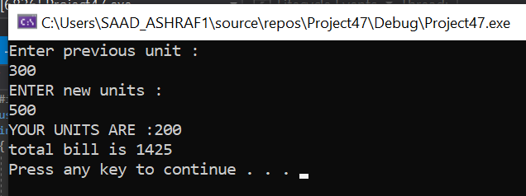

Task 3:

#include <iostream>

using namespace std;

int main(){

char membership =NULL; //assigned null to variable

int age;

int Fee;

cout << "Enter Age : " ;

cin >> age ; //user enters age

cout << "MEMBERSHIP OR NOT : (M for membersip) (N for not) : " ;

cin >> membership ; //user enters membership status

if (membership=='M' || membership =='m') //if condition for checking membership status

if (age <=65) //if condition to check whether age is less than or equal to 65

Fee = 10 ; //fee variable gets value 10

else

Fee = 5 ;

else if (membership=='N' || membership == 'n') //if condition for checking membership status

if (age<=65)

Fee =20 ;

else

Fee =15;

cout << "Age: " << age<< endl;

cout << "Membership status : " << membership << endl ;

cout << "Fee : $ " << Fee << endl ;

return 0 ;

}

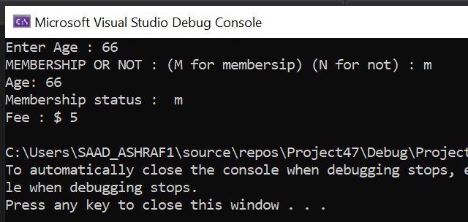

Task 4:

#include <iostream>

using namespace std;

int main() {

int i, n;

int arr[100];

cout << "Enter total number of elements : ";

cin >> n;

while (n <= 9) {

cout << "enter value greater or equal to 10" << endl;

cin >> n;

}

cout << endl;

// Store number entered by the user

for (i = 0; i < n; ++i) {

cout << "Enter Number " << i + 1 << " : ";

cin >> arr[i];

}

// Loop to store largest number to arr[0]

for (i = 1; i < n; ++i) {

// Change < to > if you want to find the smallest element

if (arr[0] < arr[i])

arr[0] = arr[i];

}

cout << endl << "Largest number is : " << arr[0]<<endl;

int min;

min = arr[0];

// search num in inputArray from index 0 to elementCount-1

for (i = 0; i < n; i++) {

if (arr[i] < min) {

min = arr[i];

}

}

cout << "Minimum number is : " << min;

return 0;

}

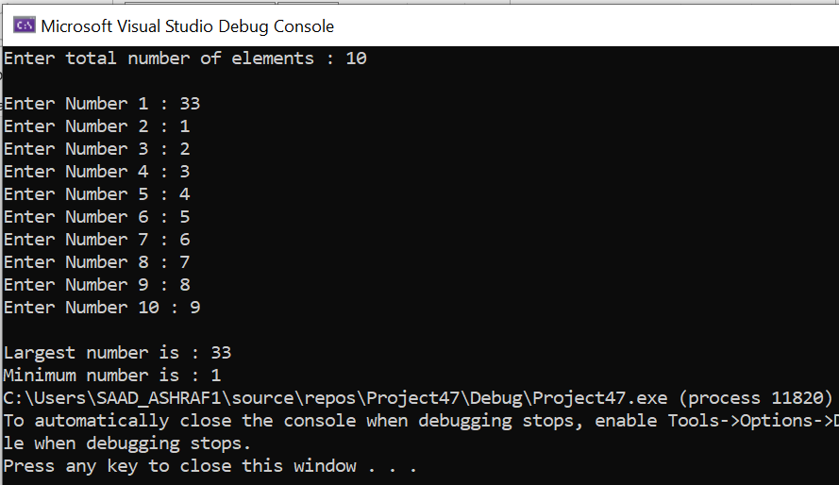

Task 5:

A:

#include<iostream>

using namespace std;

int main()

{

int i, j, rows; //necessary variables

cout << "Enter number of rows : ";

cin >> rows;

for (i = 1; i <= rows; i++)

{

for (j = 1; j <= i; j++)

{

cout << "*";

}

cout << "\n";

}

return 0;

}

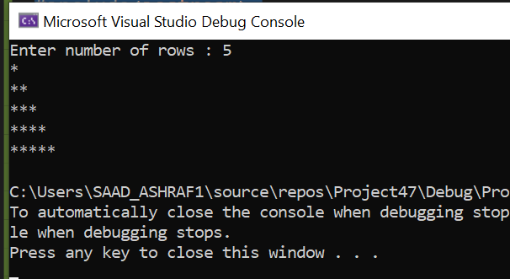

B:

#include<iostream>

using namespace std;

int main(){

int i, j, rows;

cout << "Enter number of rows : ";

cin >> rows;

for (i = rows; i > 0; i--)

{

for (j = 0; j < i; j++)

{

cout << "*";

}

cout << "\n";

}

return 0;

}

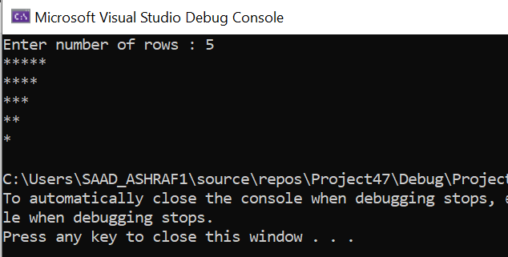

C:

#include<iostream>

using namespace std;

int main(){

int i, j, k, rows;

cout << "Enter number of rows : ";

cin >> rows;

for (i = rows; i > 0; i--)

{

for (j = rows - i; j > 0; j--)

{

cout << " ";

}

for (k = 0; k < i; k++)

{

cout << "*";

}

cout << "\n";

}

return 0;

}

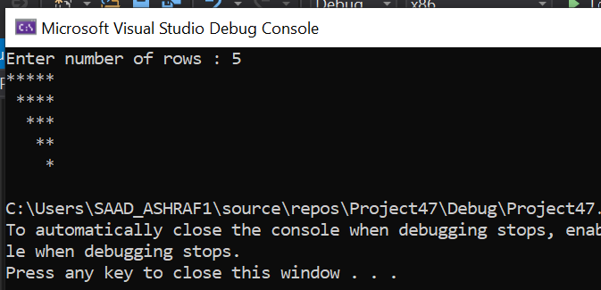

D:

#include <iostream>

#include <conio.h>

using namespace std;

int main(){

int i, j, rows;

cout << "Enter the number of rows :";

cin >> rows;

for (i = 1; i <= rows; i++) {

for (j = 0; j < rows - i; j++) {

cout << " ";

}

for (j = 0; j < i; j++) {

cout <<"*";

}

cout << endl;

}

return 0;

}

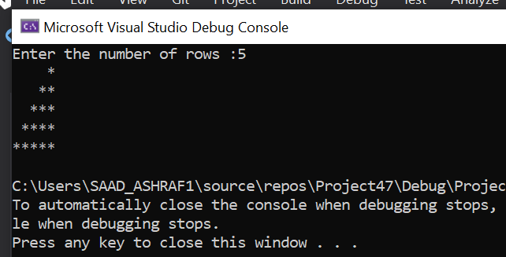

Task 6:

#include<iostream>

using namespace std;

int main() {

float item1 = 10, item2 = 20, item3 = 30;

cout << "item 1 is chocolate" << endl;

for (int i= 1; i < 8; i++) {

cout << "item prize of day" << i << " is= " << item1 << endl;

item1 = item1 - item1 / 10;

cout << "item 2 is juice" << endl;

cout << endl;

cout << "item prize of day" << i <<"is " << item2 << endl;

item2 = item2 - item2 / 10;

cout<< "item prize of day"<<i<<"is"<<item3<<endl;

}

}

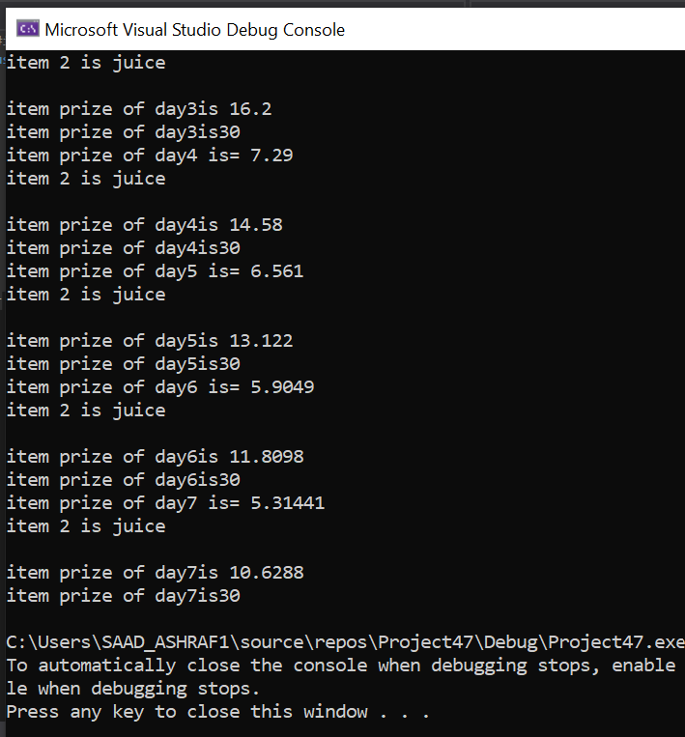

Task 7:

#include <iostream>

using namespace std;

void fibonacci(int a) {

int t1 = 0, t2 = 1, nextTerm = 0;

for (int i = 1; i <= a; ++i) {

// Prints the first two terms.

if (i == 1) {

cout << t1 << ", ";

continue;

}

if (i == 2) {

cout << t2 << ", ";

continue;

}

nextTerm = t1 + t2;

t1 = t2;

t2 = nextTerm;

cout << nextTerm << ", ";

if (i == a) {

cout << endl;

cout << "Largest Term is : " << endl;

cout << nextTerm << endl;

}

}

}

int main() {

int n;

cout << "Enter the number of terms: ";

cin >> n;

cout << "Fibonacci Series: ";

fibonacci(n);

return 0;

}

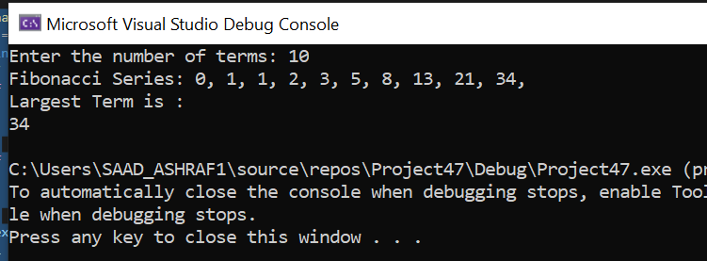

Task 8:

#include<iostream>

using namespace std;

void Reverse_Number(long long& a) {

long long b = a;

long long c = 0;

long long d = 0;

long long f = 0;

while (b != 0) {

c = b % 10;

b = b / 10;

f = f * 10 + c;

}

cout << "Your Reverse Number is ::";

cout << f;

}

int main() {

long long a;

cout << "Input the Number::";

cin >> a;

Reverse_Number(a);

}

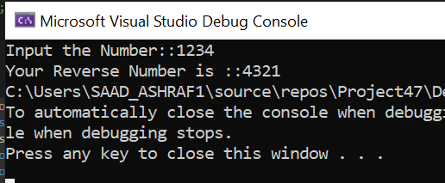

Task 10:

#include <iostream>

#include <iomanip>

using namespace std;

int main(){

double alpha[50];

for (int i = 0; i < 50; i++){

alpha[i] = i * i; //for first 25 elemnts it is square the index vale

if (i >= 25) //for elements from 26 to 50

{

alpha[i] = 3 * i; //3 times the value of index

}

}

for (int i = 0; i < 50; i++)

{

if (i % 10 == 0)

{

cout << endl;

}

cout << " " << alpha[i] << " ";

}

return 0;

}

