Task 7:

#include <iostream>

using namespace std;

int main()

{

int firstvalue = 5, secondvalue = 15;

int* p1, * p2, ** p3, ** p4;

p1 = &firstvalue;// p1 = address of firstvalue

p2 = &secondvalue;// p2 = address of secondvalue

p3 = &p1;// p3 = address of firstpointer

p4 = &p2;// p4 = address of secondpointer

*p1 += 5;// value pointed by p1 = 10

*p2 = *p1;// value pointed by p2 = value pointed by p1

p1 = p2;// p1 = p2 (address of pointer is copied or not)

cout << "&p1=" << p1 << endl << "&p2=" << p2 << endl;

p3 = p4;// p1 = p2 (address of pointer is copied or not)

cout << "&p3=" << p3 << endl << "&p4=" << p4 << endl;

*p1 += 10;// value pointed by p1 = 10

cout << "FirstValue=" << firstvalue << " " << "Second Value=" << secondvalue;

}

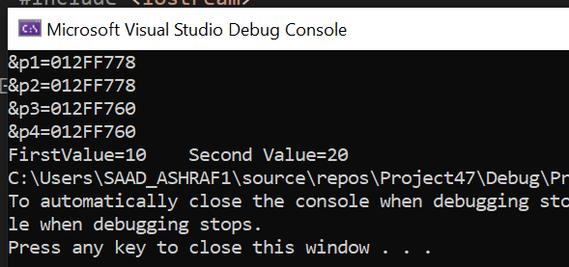

Task 8:

#include<iostream>

using namespace std;

int main(){

// a

double numbers[10] = { 0.0,1.1,2.2,3.3,4.4,5.5,6.6,7.7,8.8,9.9 };

// b

double* nptr;

// c

int i = 0;

while(i < 10)

{

cout << numbers[i] << " , ";

i++;

}

cout << endl;

// d

nptr = numbers;

nptr = &numbers[0];

// e

i = 0;

while (i < 10)

{

cout << *(nptr + i) << " , ";

i++;

}

cout << endl;

// f

i = 0;

while(i < 10)

{

cout << *(numbers + 1) << " , ";

i++;

}

i = 0;

while (i < 10)

{

cout << nptr[i] << " , ";

i++;

}

cout << endl;

// h

numbers[4];

*(numbers + 4);

nptr[4];

*(nptr + 4);

// i

nptr = numbers;

cout << "&(nPtr + 8) is : " << (nptr + 8) << endl;

cout << "*(nPtr + 8) is : " << *(nptr + 8) << endl;

// j

nptr = &numbers[5];

cout << "&(nPtr = nPtr - 4) is : " << (nptr -= 4) << endl;

cout << "*(nPtr = nPtr - 4) is : " << *nptr << endl;

}

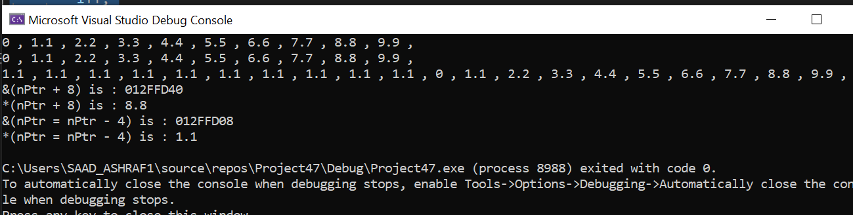

Task 9:

#include<iostream>

using namespace std;

void Print_Value(int p1[][3], int size1) {

cout << "Matrix";

cout << endl;

cout << "--------";

cout << endl;

for (int i = 0; i < 3; i++) {

for (int j = 0; j < 3; j++) {

cout << p1[i][j];

}

cout << endl;

}

}

int main() {

int a[3][3];

cout << "Enter the Vlaue of The Array";

cout << endl;

cout << "------------------------------";

cout << endl;

for (int i = 0; i < 3; i++) {

for (int j = 0; j < 3; j++) {

cin >> a[i][j];

}

}

Print_Value(a, 3);

}

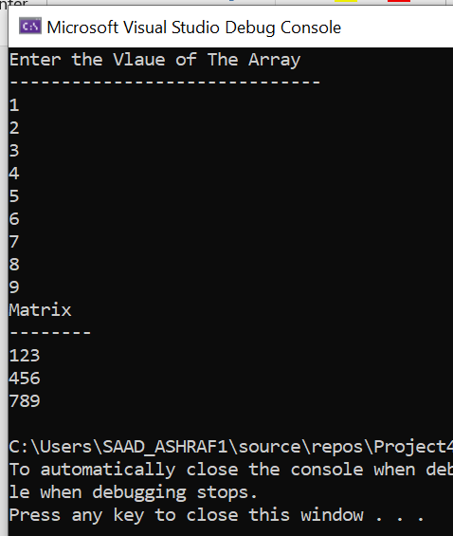

Task 10:

#include<iostream>

using namespace std;

void Print_Value(int* p1) {

cout << "Your array is";

cout << endl;

cout << "----------------";

cout << endl;

for (int i = 0; i < 5; i++) {

cout<<p1[i]<<" ";

}

}

int main() {

int* a = new int[5];

a[0] = 3;

a[1] = 7;

a[2] = 11;

a[3] = 15;

a[4] = 9;

Print_Value(a);

}

