Task 1:

#include <iostream>

#include <fstream>

#include <string>

using namespace std;

struct Players{

char name[20];

int home_runs;

int number_hits;

};

void displayMenu();

int index(struct Players s[], int size);

void outputData(struct Players st[], int size);

int main() {

struct Players pl[3];

fstream file;

file.open("data.txt", ios::in);

for (int i = 0; i < 3; i++) {

file >> pl[i].name >> pl[i].home_runs >> pl[i].number_hits;

}

displayMenu();

int choice;

cin >> choice;

if (choice == 1) {

outputData(pl, 3);

}

else if (choice == 2) {

cout << "The player is at position " << index(pl, 3) + 1 << endl;

}

else if (choice == 3) {

int n = index(pl, 3);

int hom, run;

cout << "Enter the player number of home runs"<<endl;

cin >> hom;

cout << "Enter the player number of hits"<<endl;

cin >> run;

fstream file1;

file1.open("data.txt", ios::out);

for (int i = 0; i < 3; i++) {

if (i == n) {

file1 << pl[i].name << " " << hom << " " << run << endl;

}

else {

file1 << pl[i].name << " " << pl[i].home_runs << " " << pl[i].number_hits << endl;

}

}

}

}

void outputData(struct Players st[], int size) {

cout << "Displaying information" << endl;

cout << "Player Name Number of home runs Number of hits"<<endl;

for (int i = 0; i < size; i++) {

cout << st[i].name << " " << st[i].home_runs << " " << st[i].number_hits << endl;

}

}

int index(struct Players p[], int s) {

string name1;

cout << "Enter name of player to update: " << endl;

cin >> name1;

for (int i = 0; i < s; i++) {

if (p[i].name == name1) {

return i;

}

}

return -1;

}

void displayMenu(){

system("CLS");

cout << "Select a function to perform" << endl;

cout << "1. Display Information" << endl;

cout << "2. Search a certain Player" << endl;

cout << "3. Update player Information and " << endl;

cout << "4 save in file: " << endl;

cout << "0 to Exit" << endl;

}

Task 2:

#include <iostream>

using namespace std;

struct address {

string houseno[100];

string street[100];

string city[100];

string province[100];

};

struct Student {

string name[100];

float gpa[100];

int age[100];

address a;

};

int main(){

Student student;

int numberofstudents;

cout << "Enter how many students data you want to enter : " << endl;

cin >> numberofstudents;

cout << "-------------------------" << endl;

for (int i = 0; i < numberofstudents; i++) {

cout << "Enter Data of Student : " << i << endl;

cout << "Enter Name : ";

cin >> student.name[i];

cout << "Enter gpa : ";

cin >> student.gpa[i];

cout << "Enter age : ";

cin >> student.age[i];

cout << "Enter house number : ";

cin >> student.a.houseno[i];

cout << "Enter street number : ";

cin >> student.a.street[i];

cout << "Enter city : ";

cin >> student.a.city[i];

cout << "Enter province : ";

cin >> student.a.province[i];

cout << "-------------------------" << endl;

}

cout << endl << endl << "DATA IS AS FOLLOWS : " << endl;

cout << "-------------------------" << endl;

for (int i = 0; i < numberofstudents; i++) {

cout << "Data of Student : " << i << endl;

cout << "Name : " << student.name[i] << endl;

cout << "gpa : " << student.gpa[i] << endl;

cout << "age : " << student.age[i] << endl;

cout << "house number : " << student.a.houseno[i] << endl;

cout << "street number : " << student.a.street[i] << endl;

cout << "city : " << student.a.city[i] << endl;

cout << "province : " << student.a.province[i] << endl;

cout << "-------------------------" << endl;

}

system("pause");

}

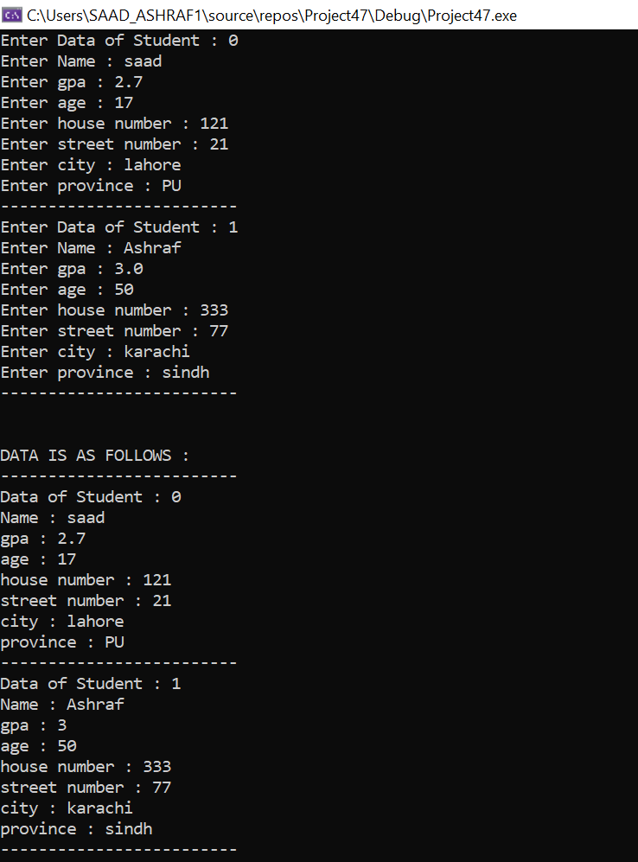

Task 3:

#include<iostream>

using namespace std;

union Person_Record {

char name[100];

char address[100];

long number;

};

int main() {

Person_Record up;

int choice;

cout << "Press 1 for name" << endl;

cout << "Press 2 for address" << endl;

cout << "Press 3 for phone number" << endl;

cout << "Enter your choice :";

cin >> choice;

switch (choice)

{

case 1:

cout << "Enter Name" << endl;

cin >> up.name;

cout << "Name you entered is : " << up.name << endl;

break;

case 2:

cout << "Enter address" << endl;

cin >> up.address;

cout << "address you entered is : " << up.address << endl;

break;

case 3:

cout << "Enter phone number" << endl;

cin >> up.number;

cout << "phone number you entered is : " << up.number << endl;

break;

default:

break;

}

system("pause");

}

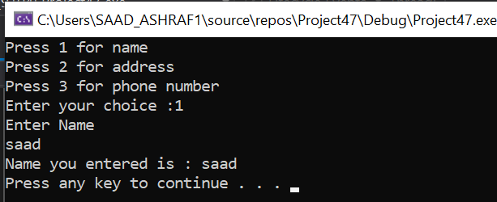

Task 4:

#include <iostream>

using namespace std;

class date{ //class with name date

//private members

int month;

int day;

int year;

public:

//public methods

date(int month = 1, int day = 1, int year = 2001){ // parameterized constructor

date::month = month;

date::day = day;

date::year = year;

};

void print() { //member function

cout << month << "/" << day << "/" << year << endl; //pritning month/day/year

}

};

int main(){

int month;

int day;

int year;

string monthName[12] = { "January","February","March","April","May","June","July", // string array of months including all months name

"August","September","October","November","December" };

cout << "enter month : " << endl;

cin >> month;

while (month > 12 || month < 1){ //asking user to keep entering month until it's valid

cout << "Invalid chocie :( " << endl;

cin >> month;

}

cout << "enter day : " << endl;

cin >> day;

while (day > 31 || day < 1) //asking user to keep entering day until it's valid

{

cout << "Invalid chocie :( " << endl;

cin >> day;

}

cout << "enter year : " << endl;

cin >> year; // inputting year

date newDate(month, day, year); //creating object of class date and giving the parameters so parametrized constructor is called

newDate.print(); //calling print method of class date

cout << monthName[month - 1] << " " << day << ", " << year << endl;

cout << day << " " << monthName[month - 1] << " " << year << endl;

system("PAUSE");

return 0;

}

