Task 8:

#include<iostream>

using namespace std;

void Reverse_Number(long long& a) {

long long b = a;

long long c = 0;

long long d = 0;

long long f = 0;

while (b != 0) {

c = b % 10;

b = b / 10;

f = f * 10 + c;

}

cout << "Your Reverse Number is ::";

cout << f;

}

int main() {

long long a;

cout << "Input the Number::";

cin >> a;

Reverse_Number(a);

}

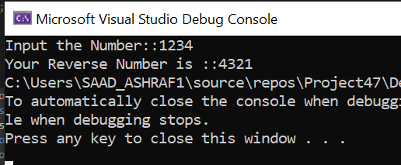

Task 9:

#include<iostream>

#include<iomanip>

using namespace std;

void precisefunc(float arr[]){

for (int j = 0; j < 20; j++)

{

for (int k = j; k < 20; k++)

{

for (int l = k; l < 20; l++)

{

if (arr[k] > arr[l])

{

arr[k] = arr[l];

}

}

}

}

}

int main(){

float arr[20];

int i = 0;

while (i != 20){

cout << "Enter the Number (" << i + 1 << ") :";

cin >> arr[i];

i++;

}

precisefunc(arr);

cout << setprecision(2) << arr[0];

}

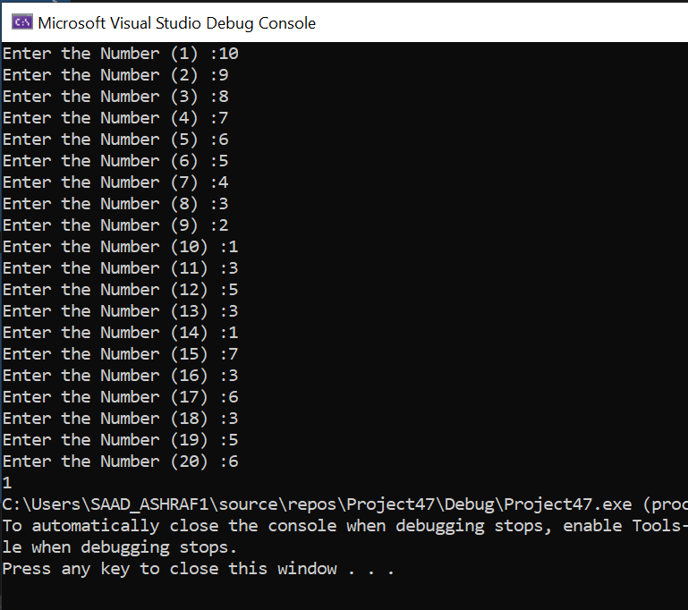

Task 10:

#include <iostream>

#include <iomanip>

using namespace std;

int main(){

double alpha[50];

for (int i = 0; i < 50; i++){

alpha[i] = i * i; //for first 25 elemnts it is square the index vale

if (i >= 25) //for elements from 26 to 50

{

alpha[i] = 3 * i; //3 times the value of index

}

}

for (int i = 0; i < 50; i++)

{

if (i % 10 == 0)

{

cout << endl;

}

cout << " " << alpha[i] << " ";

}

return 0;

}

