Problem 1:

Part A:

variable “number” is not initialized with any value. You must initialize it with any value then the issue is resolved. It then prints “number” and the program is executed.

Solution:

#include<iostream>

using namespace std;

int main()

{

**int* number=0; //solution**

cout << number << endl;

}

Part B:

variables or pointers of different data types cannot be made equal i.e. Long and double cannot be made equal due to different data types. Making the data type same resolves the issue.

Solution:

#include<iostream>

using namespace std;

int main()

{

long* realPtr;

long* integerPtr;

integerPtr = realPtr;

}

Part C:

a value of type "int" cannot be assigned to an entity of type "int *".

Solution :

#include<iostream>

using namespace std;

int main()

{

int* x, y;

*x = y;

}

Part D:

Solution :

#include <iostream>

using namespace std;

int main()

{

char s[] = "this is a character array";

for(int i=0;s[i]!='\0';i++)

cout << s[i] <<"";

}

Part F:

a value of type "double *" cannot be used to initialize an entity of type "double". 'initializing': cannot convert from 'double *' to 'double'

Solution :

#include<iostream>

using namespace std;

int main()

{

double x = 19.34;

double xPtr = x;

cout << xPtr << endl;

}

Problem 2:

#include <iostream>

#include<fstream>

using namespace std;

void Copy(char a[]) {

char array1[5];

for (int i = 0; i < 5; i++) {

array1[i] = a[i];

}

}

int main() {

char array1[5], arr1[5];

int i = 0;

while (i < 5)

{

cin >> array1[i];

i++;

}

int j = 0;

while (j < 5) {

arr1[i] = array1[i];

j++;

}

fstream file;

file.open("myfile.txt", ios::out);

// Write in file

int k = 0;

while (k < 5) {

file << array1[i];

k++;

}

file.close();

Copy(arr1);

}

Problem 3:

#include <iostream>

#include <new>

#include <cstdlib>

using namespace std;

void print(float f[], int size) {

for (int i = 0; i < size; ++i) // Loop to display array contents

cout << f[i] << ' ';

}

int main()

{

const int size = 10;

float* f = new float[size];

*f = 10; // assign value to first element.

for (float* p = f + 1; p < f + size; ++p) // loop through array

*(p) = *(p - 1) + 1; // assign each element in sequence

cout << "The array containss : "<<endl;

print(f, size); //calling function

};

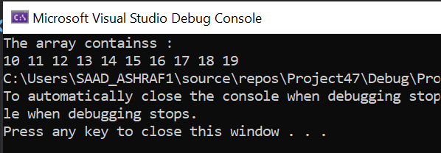

Problem 4:

#include<iostream>

#include<algorithm>

using namespace std;

int* sorting_Array(int arr[], int size) {

int* arr1 = new int[size];

for (int i = 0; i < size; i++) {

arr1[i] = arr[i];

}

int n = sizeof(arr1) / sizeof(arr1[0]);

sort(arr1, arr1 + n);

return arr1;

}

int main() {

int a[10];

int* arr;

cout << "Enter the Elements of the Array";

cout << endl;

cout << "--------------------------------";

cout << endl;

for (int i = 0; i < 10; i++) {

cin >> a[i];

}

arr = sorting_Array(a, 10);

cout << endl;

cout << "The Elements of the Array";

cout << endl;

cout << "--------------------------------";

cout << endl;

for (int i = 0; i < 10; i++) {

cout << arr[i] << " ";

}

}

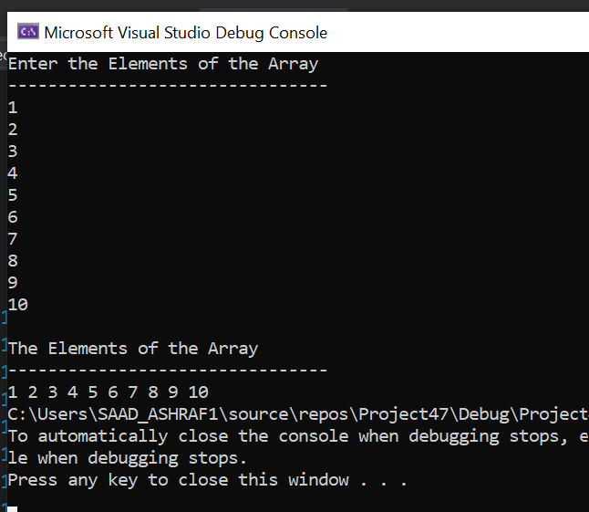

Problem 7:

#include <iostream>

#include <string>

using namespace std;

int main(){

int rows;

cout << "Enter rows of array: ";

cin >> rows;

int* numbers = new int[rows];

//declaration of array

int** array = new int* [rows]; //jagged array

int i = 0;

while ( i < rows)

{

cout << "Enter column in row " << i << ": ";

cin >> numbers[i];

array[i] = new int[numbers[i]]; //creating new dynamic memory

i++;

}

//Input values in array

for (int i = 0; i < rows; i++)

{

for (int j = 0; j < numbers[i]; j++)

{

cout << "Row " << i << ":- input value " << i * numbers[i] + j << ": ";

cin >> array[i][j];

}

}

//Output values of array

for (int i = 0; i < rows; i++)

{

for (int j = 0; j < numbers[i]; j++)

{

cout << array[i][j] << " "; //printing the jagged array

}

cout <<endl;

}

delete array; //deleting dynamic array

system("pause");

return 0;

}

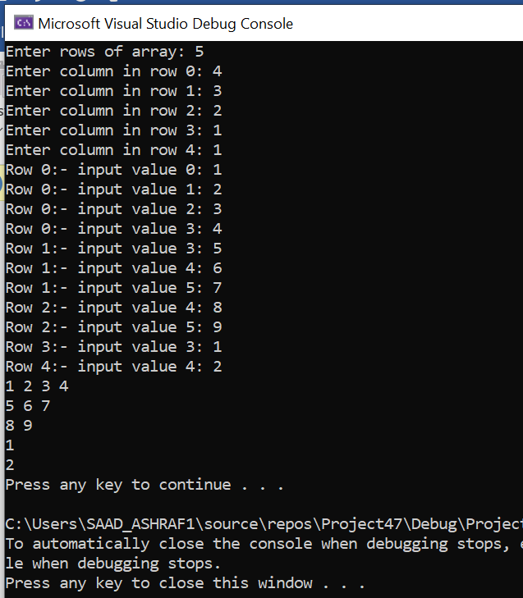

Task 8:

#include<iostream>

#include<string>

using namespace std;

int main() {

int size;

string a;

cout << "Enter the Size of the Array";

cout << endl;

cout << "----------------------------";

cout << endl;

cin >> size;

char** arr;

cout << "Enter The Strings According the Required Size";

cout << endl;

cout << "---------------------------------------------";

cout << endl;

int i = 0;

arr = new char* [size];

int size1 = 0;

while (1) {

cin >> a;

size1 = a.length() + 1;

arr[i] = new char[size1];

for (int j = 0; a[j] != '\0'; j++) {

arr[i][j] = a[j];

}

i++;

if (i == size1) {

break;

}

}

cout << endl;

cout << "The Strings According the Required Size";

cout << endl;

cout << "---------------------------------------------";

cout << endl;

for (int i = 0; i < size; i++)

{

for (int j = 0; j < sizeof(arr[i]); j++) {

cout << arr[j];

cout << "NULL";

}

cout << endl;

}

}