Operating System Lab

Task2:
Source Code
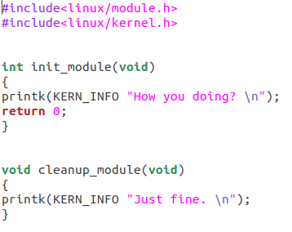

Source Code 2:
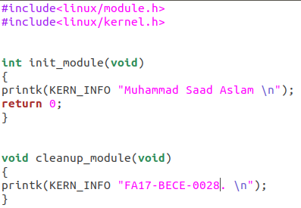

Make-file:
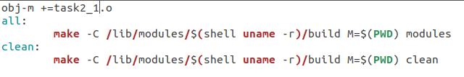
Results:
