**DATA COMMUNICATION AND NETWORKS**

**(EE-317)**



**Project 2**

**Designing a Network in Packet Tracer to provide Internet Services to all campuses of a University.**

**Student Name:** __Saad Farooq___

**Roll No: ___**18F0462**____ Section: _**A**_**

Contents

Project Objective: 4

Software: 4

Hardware: 4

Project Solution: 4

Introduction: 5

The main devices used in the project are as following. 5

Router: 5

Switches: 5

Server: 5

Frame Relay: 6

Concept of RIP Protocol: 6

Explanation/Working: 6

Cloud-PT: 6

RIP Protocol: 7

Problems Faced using RIP: 8

IP Address and Subnetting Calculations: 8

DHCP: 10

Lahore Campus: 10

Islamabad Campus: 11

Peshawar Campus: 11

Chiniot-Faisalabad Campus: 12

Karachi Campus: 12

A rule for the allocation of unique IP addresses: 12

Star Topology: 13

Advantages: 13

Improvement for project: 13

Snapshots of the Project: 13

# Project Objective:

**“To design a network in packet tracer and provide internet services according to given scenario”**

The objective of our project is to design a network consisting of a total of 5 campuses of university. We are given a scenario in which the higher management of FAST University has contacted with an ISP Provider to provide internet services to the 5 campuses of FAST along with the Head Office.

For example, we need to design a whole network with own choice of topology such that we can fulfil the required users need. For example, if a campus has 5 departments then we have to make sure that all the users can communicate with each other and also communication between campuses and departments.

# Software:

* Cisco Packet Tracer

# Hardware:

* Router-PT
* Cloud-PT
* Server-PT (DHCP)
* PC-PT
* Switch-PT
* 2960-24TT
* Access Point-PT
* Laptop-PT
* Smart Phone-PT
* Tablet PC-PT

# Project Solution:

There are multiples way to approach the given problem statement such as we can use static routing or RIP protocol also, we can also use only routers to show WAN. The solution that I have given in this project is that we are going to use a very simple approach in which we use a frame relay using Cloud-PT which is used to communicate between the campuses and head office as the distance between each campus is very large so we need to simulate WAN. So, frame relay is protocol standard for WAN internetworking which provides a fast and efficient method of transmitting packets through the network. Frame relay provides an alternative for both dedicated lines and x.25 networks for WAN links. So, I am basically interconnecting the routers using the frame relay by using a serial connection. Behind the Frame relay we have the traditional ISP Provider. Also, in practically all these serial connections are already lain which interconnects cities in a country by the ISP Provider. We directly use those connections to transfer data from one campus to another campus. So, routers are used to provide the IP address and the Routing path for the users to exchange information. Next, we simply use switches to handle all the user and to provide them internet services. The basic topology that I have used is the star topology. The number of switches for each department depends upon its number of users. Also, I have used an Access Point-PT to connect any wireless devices for example if any guest comes to the department and want to use its internet so it can connect with the wireless network. Also, I have used the DHCP server to provide IP Address to the connected PC’s/Users.

# Introduction:

Networking, also known as computer networking, is the practice of transporting and exchanging data between [nodes](https://searchnetworking.techtarget.com/definition/node) over a shared medium in an information system. Networking comprises not only the design, construction and use of a network, but also the management, maintenance and operation of the network infrastructure, software and policies. Computer networking enable devices and endpoints to be connected with each other over a LAN (Local Area Network) or over a large network such as internet or private WAN (Wide Area Network).

Networking is used in nearly every type of information or data exchange such as in Universities, Airports, Schools, Organization etc. In this era of technology nearly everyone is using internet. This is to such extent that almost 4.66 billion people use internet. And to use internet we need networking which is used to provide internet to users.

# The main devices used in the project are as following.

## Router:

A router is a networking device that forwards data packets between computer networks. Routers perform the traffic directing functions on the Internet. Data sent through the internet, such as a web page or email, are in the form of packets. A packet is typically forwarded from one router to another router to reach its destination. And the path that the packet follows depends upon the routing algorithm.

## Switches:

Switches are networking devices operating at data link layer of the OSI model. They connect devices in a network and use packet switching to send, receive or forward data packets or data frames over the network. A switch has many ports, to which computers are plugged in and also switches are self-learning devices and use switch table to forward the frame.

**Server:**

A server is a piece of Computer hardware or Software which provides functionality, resources, data, service for other programs or computers which are called Clients. **Client** is a piece of computer hardware or software that accesses a service made available by a server as part of the client–server model of computer networks.

## Frame Relay:

Frame relay is protocol standard for WAN internetworking which provides a fast and efficient method of transmitting packets through the network. Frame relay provides an alternative for both dedicated lines and x.25 networks for WAN links. In this project I am using frame relay using the **Cloud-PT.**

# Concept of RIP Protocol:

The Routing Information Protocol is one of the oldest distance-vector routing protocols which employs the hop count as a routing metric. RIP prevents routing loops by implementing a limit on the number of hops allowed in a path from source to destination. In the is project I am using the version 1 of RIP protocol in Packet Tracer. In version 1 of RIP routers simply broadcast updates with their routing table every 30 sec. It is better then static routing as when we want the configure a large network, we can’t do it manually as its time taking and also complex so RIP protocol in easy works is an automatic way doing routing.

# Explanation/Working:

## Cloud-PT:

First of all, we have a Cloud-PT which is in the middle of all the routers and at the backhand of the Cloud-PT we have the ISP Provider. So, the basic purpose of using the Cloud-PT is the use of Frame Relay for WAN emulation. As we know that there is a large distance in between the campuses so we need to use WAN and Frame Relay provides a fast and efficient method of transmitting packets through the network. Frame relay provides an alternative for both dedicated lines and x.25 networks for WAN links. So, it is much better to use it in place of router as the main forwarding device. For the setting of the Cloud-PT

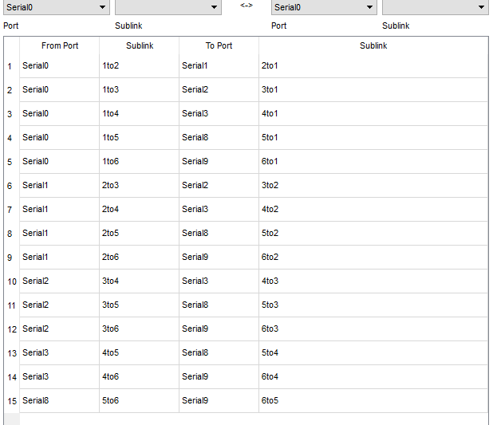

In Frame Relay we define the sub-links from one port to another port such that we need to cover all the paths for all the router for example from router 1 to 2,3,4,5,6 we need to create a sub-link and at the To Port side we need to make the same but opposite in direction path so its bidirectional. Then in each router we just define each respective path using the frame-relay map ip command.

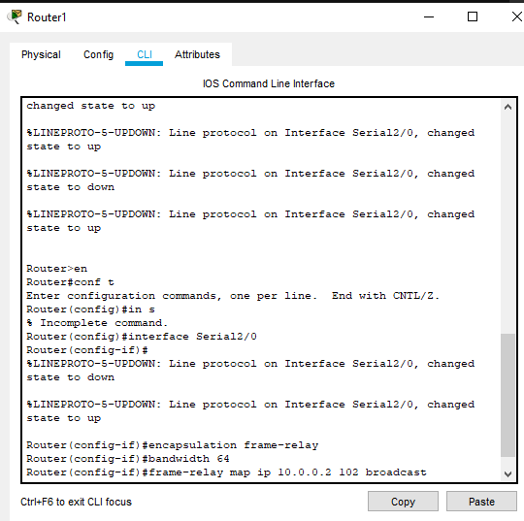

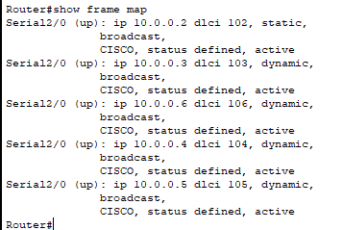So, for router 1 we first of all need to select the interface of the serial port with which it is connected with the Cloud-PT so after that we encapsulate the frame relay and then simply define the bandwidth and the we map the IP of the selected router with its first sub-link for router 1 its 102 for router 2 its 203 for router 3 its 204 for router 5 its 506 and for router 6 its 601 so we have a closed loop path and the remaining path are automatically calculated by the routers themselves. Then we also use the no shut command to bring up of on the serial port so that it’s in working state. Also, if we need to check the active frame relay path, we can use the command show frame map in the router# in cli. And also, we need to use the broadcast when we are mapping the frame relay IP with the sub-link so that each router can know if any change occurs in the network. And it also helps in the RIP protocol as well. Also, what happens is that in frame relay if we don’t use the broadcast that the query packet which went through a path cannot come back from the same path so we need to use the broadcast must as it avoid this disadvantage. Also, there is another method of doing it by turning of the Split-Horizon in the router which is enabled by default.

## RIP Protocol:

The routing algorithm that I used in this project is the rip protocol which is basically a distance-vector routing protocols which employs the hop count as a routing metric. RIP prevents routing loops by implementing a limit on the number of hops allowed in a path from source to destination. In the is project I am using the version 1 of RIP protocol in Packet Tracer. In version 1 of RIP routers simply broadcast updates with their routing table every 30 sec. It is better than static routing as when we want the configure a large network, we can’t do it manually as its time taking and also complex so RIP protocol in easy works is an automatic way doing routing. We can simply use the cli to implement the rip routing or using subtab RIP in the tab config of the router. For example

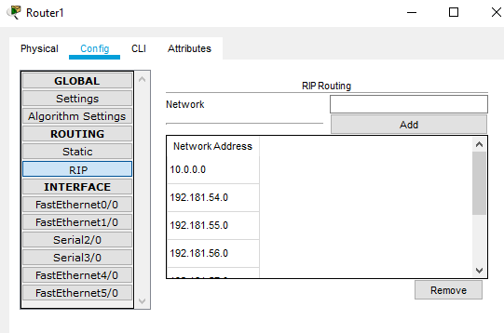We can simply add the IP that we want in our rip routing algorithm or we can use the router rip command in the config mode of the router in cli and the network (IP) command to add an IP in the RIP routing. We simply add all the networks in the rip routing. This process has been dome in each router in this project..

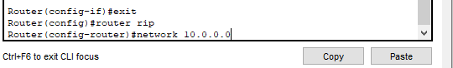

# Problems Faced using RIP:

So, with its advantage of ease of implementation I faced some problems in the rip routing which that if we use the 2 Subnets of an IP in 2 different serial interfaces of the Cloud-PT then the RIP protocol cannot calculate the path which results in the loss of the packet that can be overcome using static routing but for a larger network it’s not suitable. To be more precise RIP cannot handle subnetting when done in different serial interfaces or if 2 routers are separated using a middle man/router/Cloud-PT. So due to this I have to completely use both subnets of my IP in evert campus. But if it done with static routing then it can be overcome easily but again for a large network which can be unscalable its not a good approach. As the packet tracer only offers two routing algorithms which are rip and static only so we can’t use any other routing algorithm. Also, if no routing update is not heard after 180 sec neighbor/link is declared dead.

# IP Address and Subnetting Calculations:

The IP that I choose is 192.181.54.62 in which 192 is for using class C IP and 18 is first 2 number of the roll number and then 15 is the decimal value of F (F as in hex). And the 462 last three letters of my Roll Number. The calculations are given below. Th number of IP’s and Subnet that were used in the project in the Fast Ethernet port were

|  |  |  |  |  |
| --- | --- | --- | --- | --- |
| **IP 1** | **Subnet** | **1** | **192.181.54.0** | **192.181.54.127** |
| **IP 1** | **Subnet** | **2** | **192.181.54.129** | **192.181.54.255** |
| **IP 2** | **Subnet** | **1** | **192.181.55.0** | **192.181.55.127** |
| **IP 2** | **Subnet** | **2** | **192.181.55.128** | **192.181.55.255** |
| **IP 3** | **Subnet** | **1** | **192.181.56.0** | **192.181.56.127** |
| **IP 3** | **Subnet** | **2** | **192.181.56.128** | **192.181.56.255** |
| **IP 4** | **Subnet** | **1** | **192.181.57.0** | **192.181.57.127** |
| **IP 4** | **Subnet** | **2** | **192.181.57.128** | **192.181.57.255** |
| **IP 5** | **Subnet** | **1** | **192.181.58.0** | **192.181.58.127** |
| **IP 5** | **Subnet** | **2** | **192.181.58.128** | **192.181.58.255** |
| **IP 6** | **Subnet** | **1** | **192.181.59.0** | **192.181.59.127** |
| **IP 6** | **Subnet** | **2** | **192.181.59.128** | **192.181.59.255** |

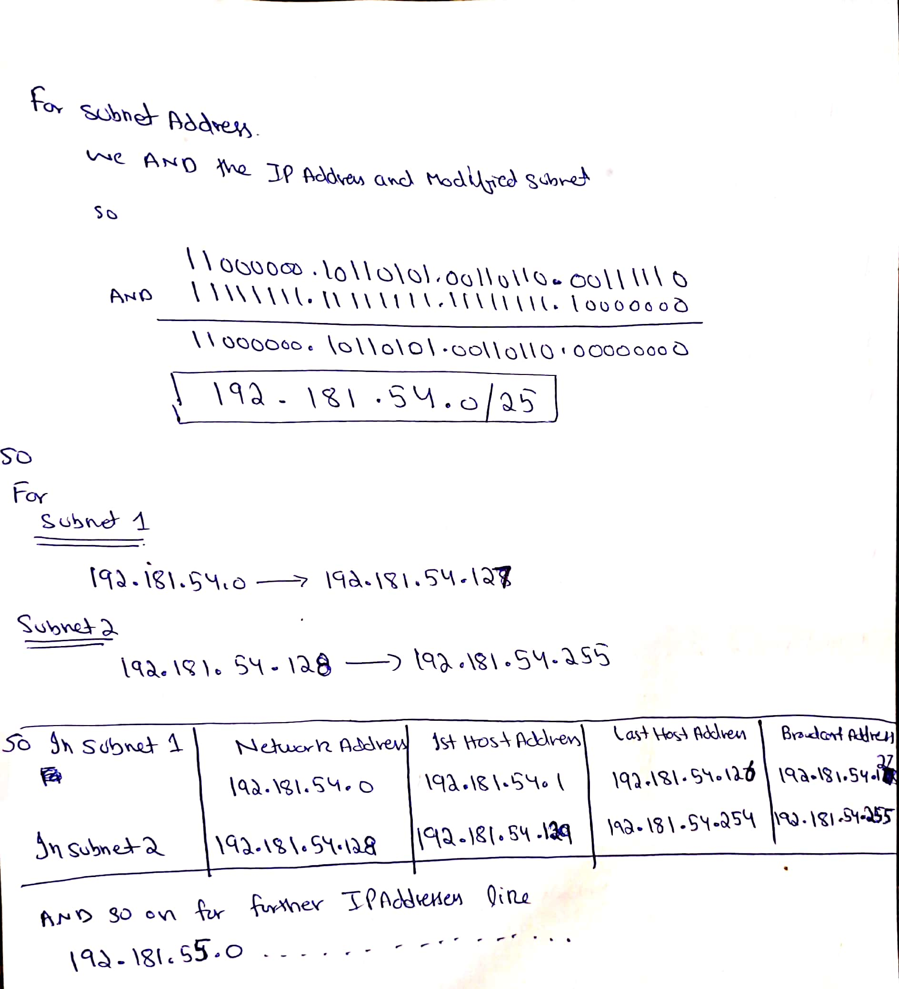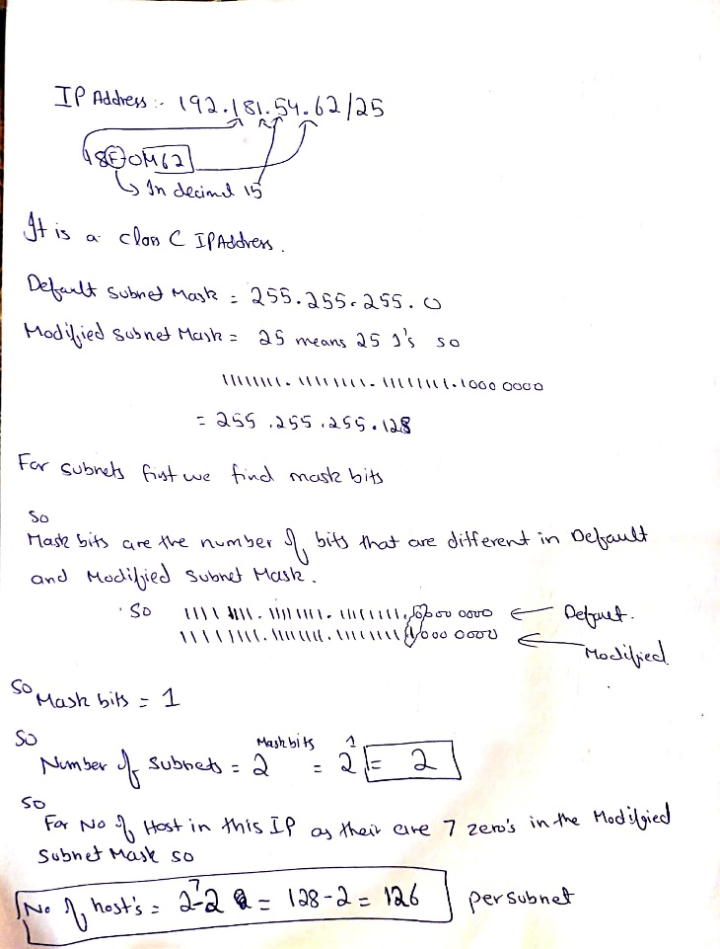

As for the serial’s ports, I used IP Address 10.0.0.0 with subnet 255.0.0.0

For Router 1 its 10.0.0.1 255.0.0.0

For Router 2 its 10.0.0.2 255.0.0.0

For Router 3 its 10.0.0.3 255.0.0.0

For Router 4 its 10.0.0.4 255.0.0.0

For Router 5 its 10.0.0.5 255.0.0.0

For Router 6 its 10.0.0.6 255.0.0.0

So, explaining the distribution of IP. I have divided my main IP address which is 192.181.54.62 into two subnets so that I have about 126 hosts in each subnet with total of 128 IP’s in each subnet where the first address is the Network address and the last IP is the broadcast address so we are left with 126 hosts in each subnet. So, starting with the Head office where we have 30 staff users and 15 higher management users. So, I simply used a main switch which is further divided into two switches which makes up the star topology as we know that for local area network start topology is one of the best one to use. Star topology is explained further below. So, from the frame relay we have 6 routers out of which 5 of them are for the 5 campuses and the remaining 1 is for the head office. For the head office I have only used the first subnet of the 1st IP address but due to the problem in RIP protocol of not being able to use the subnet of a different IP in the different interface I had to neglect or we can say that we can leave that IP for future usage. Then I have attached a DHCP server with the First Subnet of the IP used in the Head office. And then from the main switch we have further switches for each department and then simply their users.

## DHCP:

DHCP stands for Dynamic Host Configuration Protocol. It allows the host to dynamically obtain the IP address from the network server when it joins the network. So, we don’t need to use to static approach in which we assign the IP to the host by ourself to use the internet and DHCP is also more efficient then the Static. For example, if a host leaves the network then we need to keep an eye on it so that we know that when the IP which is used by this host is usable again but where as in DHCP server it automatically updates it IP pool with it so that of a host leaves it knows that now this IP is usable again so it’s a more efficient way of assigning IP address to the host as compare to the static as DHCP allows the reuse of an IP as it only hold the IP address while they are being used. It also supports the smart devices if they want to connect to that network.

## Lahore Campus:

For the Lahore campus we have a router from which from its fast ethernet port 0 we have the first subnet of the IP and from port 1 we have the second subnet of the Ip address. From each subnet we have a main switch so to ensure the star topology and the DHCP server is connect with each switch so that it can deploy the respective subnet IP’s to each host as I am using two ports of the DHCP server one for each subnet.so from port 0 it deploys the IP’s of the first subnet and from port 1 it deploys the IP’s of the second subnet. We have a total of 220 users in the Lahore campus so we need to use both of the subnets. At the left side we have the EE department. As in packet tracer the maximum Fast Ethernet ports in a switch are 24 so this network design is according to it. So, in EE department we have 40 users so we need to use at least 2 switches in it so here the 2 PC shows multiple users connected with that switch as there is not much space in the packet tracer to show all the PC’s so 2 PC’s are showing the whole bunch of PC’s. Then we have the ME department which only consist of 10 users and the HR department also consist of the 10 users so I am using only one switch for both of these departments where the first 10 ports are for the ME and the last 10 are for the HR. Then we have the CS department which consist of 50 persons so we are using 2 switches from which each switch can use 23 of its Fast Ethernet port for the connectivity so we can accommodate 46 users in the Fast ethernet ports and the remain 2 gigabit ports can also be used with the change of module in the PC. So, by putting the single-port Cisco Gigabit Ethernet Network Module (part number PT-HOST-NM-1CGE) provides Gigabit Ethernet copper connectivity in the PC we can also use the last two ports of the switch so we can accommodate a total of 50 users in each switch. Also, we can use a 1 to 3 port Fast ethernet connector in one port of the switch we ensure that whole network is in the fast ethernet ports. Then we have the FSM department which consist of 20 users so we are simply using one switch for it. **For the configuration of the PC, we simply go to the Desktop then IP Configuration panel then simply switch it from static to DHCP and it automatically obtains the IP, Subnet and the default gateway from the DHCP Server.** For the Subnet 2 the S&H I again used a single switch as there are only 20 users in it. Then for the SE and IT departments I used 2 switches for each department. As se has 30 users and the IT has 34 users. For the Director Office I have directly connected it with the first subnet switch as there are only 5 users in director office. Also, it is much easier for the communication to occur from the upper-level switches to another campus or head office. In Lahore campus all of the hosts in the first subnet are used and for the remaining users they are accommodated in the second subnet. Also, I have also connected an Access Point PT with the second subnet so that the reaming IP that are unassign can be used for any guest or any smart device which uses WIFI/Wireless. To connect with the WIFI we need a WIFI card in the PC/Laptop which can be easily replaced in the Packet tracer and the smart devices has it built in WIFI card. For the security I am using WEP in the access point with a password of 1234567890 which is used if anyone wants to connect with it. This access point also helps with any unique IP address allocation. Other campuses have the same network configurations and topology as the Lahore campuses so I will go over them briefly as all of the key points has been explained in the Lahore campus.

## Islamabad Campus:

The total users in the Islamabad campus are 230 so we need to use the both subnets. So, for the director office we directly connect it with the first switch with the 1st subnet as there only 10 users in the director office. For the remaining departments I am using additional switches. For the EE department I am using 2 switches as there are 35 users in it. then for the CS department I am using 3 switches as there are 55 users in it as its also in star topology. Then for SE I am using only one switch as there are only 25 users so the switch has 24 fast ethernet port and 2 gigabit ethernet port so they can easily accommodate it also we can use a 1 to 2 or 3 Fast ethernet port connector also. For the FSM, IT, S&H, HR, and for any wireless device we are using the subnet 2 as all the host in the first subnet are used up. So for the FSM I am using only 1 switch as FSM has 20 users only. For the IT I am using 2 switches as it has 40 users in it. for the S&H I am again using 2 switches as it has 30 users in it. Then for any wireless device again using the Access Point PT with WEP and password 1234567890.

## Peshawar Campus:

For Peshawar campus we have 95 users in it so we need only the first subnet of the 4th Ip which is 192.181.57.0. For the Director office I have directly connected it with the main switch as it have only 5 users in it then for the S&H and HR I have used one switch for them as both have 10 users in it. Then for the IT and SE department again I have used only one switch for both of them as IT has 15 users and the Se has 10 users so they can easily be accommodated in a single switch. For the EE department I have used a single switch as it has 15 users in it and then for the CS department, I have used 2 switches as it has 30 users in it. Again, all the networks are in the star topology. For any wireless device for any visitor, I have used the Access Point Pt with WEP with password 1234567890.

## Chiniot-Faisalabad Campus:

In CFD campus we have a total of 177 users. So, we need both subnets again. For the director office I have directly connected it with the main switch of the first subnet. Then for the EE department I have used a single switch for it as it has 25 users in it. For the CS department I have used 3 switches in it in star topology as it has 65 users in it. and then for the S&H I have again used a single switch as it has 20 users in it and the for the FSM department, I have again used a single switch as it has 10 users in it and this fills up all the available hosts in the first subnet. For the assigning of IP address, I am using a DHCP server in each campus. In the second subnet for the IT 1 switch is being used as it has 22 users in it and then for the SE 1 switch is being used as it has 15 users in it and then for the last HR again 1 switch is being used as it has 15 users in it. For wireless device I am using Access Point PT with WEP with password 1234567890 to accommodate any wireless device or any visitor.

## Karachi Campus:

In Karachi campus we have a total of 230 users in it so we need to use both of the Subnet in the IP address. So, in the 1st subnet the director office has been directly connected with the first subnet main switch as it has only 5 users in it. For the EE department I have used 1 switch as it has 20 users in it. Then for the CS department I have used 5 switches which are connected in star topology to accommodate 100 users in the CS department. This completes the 1st subnet hosts. In the 2nd subnet for SE 1 switch is being used as it has 25 users in it. For the FSM again 1 switch is being used as it has 15 users in it. For the IT department I am using 2 switches as it has 40 users in it. For the HR and S&H 1 switch is being used as HR has 10 users and S&H has 15 users so a single switch can accommodate both of these departments. For any wireless device I am using Access Point PT with WEP with password 1234567890.

# A rule for the allocation of unique IP addresses:

For any unique IP address allocation there are three possibilities:

1. For a single person to be in more than one department for example teachers. So, for this the extra ports which I have left unused in every department can be used for this purpose also has I am using DHCP so the user can obtain IP Address dynamically.
2. A person is in more then one campus as a student or teacher. So as a student or teacher it should be visiting a department so again same as the first case the unused ports in the department switch can be used also as I am using DHCP so IP’s can also be reused. And also, the host can obtain the IP address dynamically.
3. For the third possibility is that a person is visiting the campus so for this purpose I have attached an Access Point PT as the visiting person will be using a smart device so it needs WIFI so for that purpose the I am providing the wireless using the Access Point PT. so that a visitor can use internet by connecting with it. Also, it uses DHCP server so the user can obtain the IP address dynamically.

# Star Topology:

A star topology is a topology for a Local Area Network (LAN) in which all nodes are individually connected to a central connection point, like a hub or a switch. A star takes more cable than a bus, but the benefit is that if a cable fails, only one node will be brought down.

## Advantages:

* It is high-performing as no data collisions can occur.
* Less expensive because each device only needs one I/O port and wishes to be connected with hub or switch with one link.
* Easier to implement.
* Robust in nature.
* Easy fault detection because the link is often easily identified.
* No disruptions to the network when connecting or removing devices.
* Can easily expand your network in future.

# Improvement for project:

We can use VLAN which can better control the traffic where a single switch is being used for more than one department. We can use any other routing protocol such as **EIGRP, OSPF** etc. we can also use a better switch with large number of ports with VLAN capability.

# Snapshots of the Project:

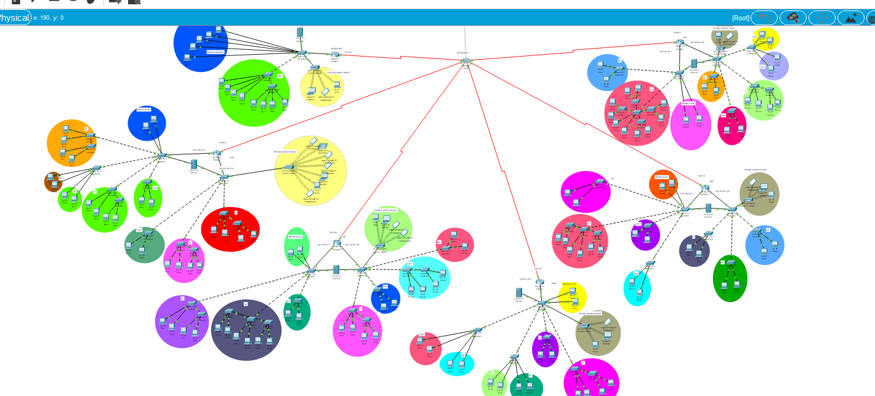

**DHCP Snapshot:**

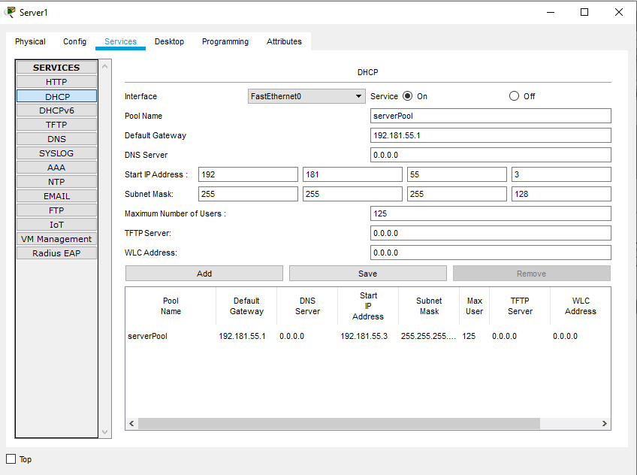

**Router Snapshot:**

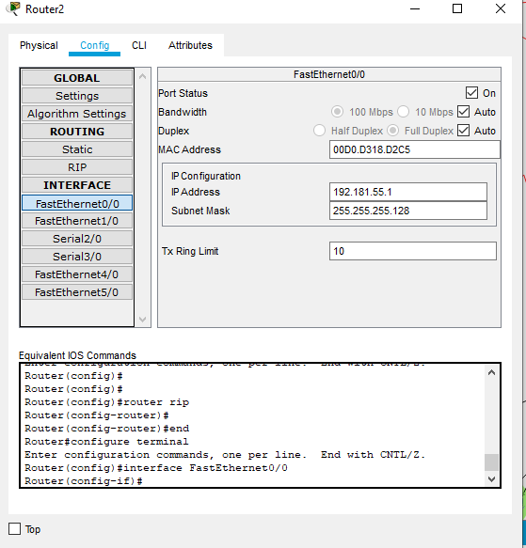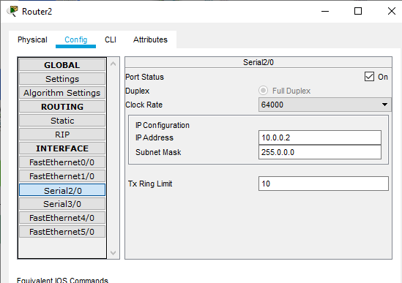

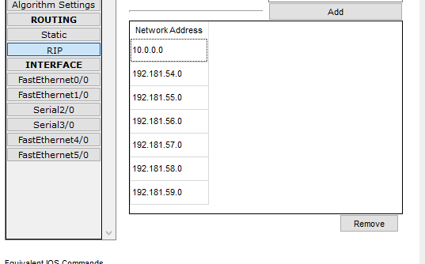

**Cloud-PT Snapshot:**



**Access Point-PT Snapshot:**

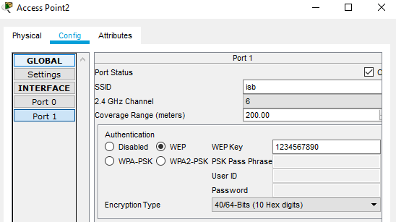

**Smart Device-PT Snapshot:**

