

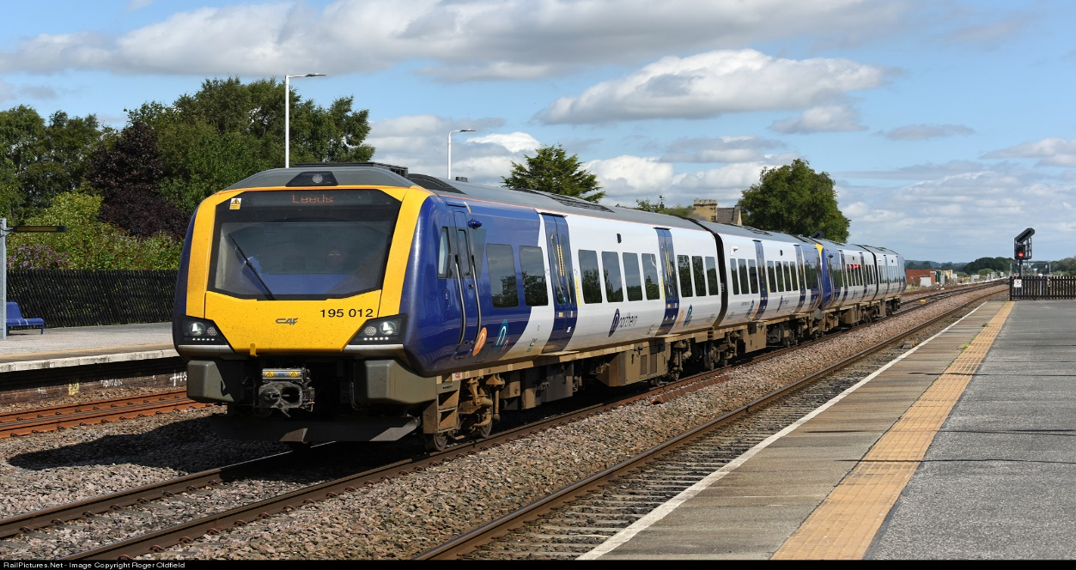
UK Railway Project
Cleaning, Pre-processing, Development & Analysis

Digital Egypt Pioneers Initiative (DEPI)
Google Data Analysis Specialist Track
CAI2_DAT1_G6

Project documentation
Supervised by

Eng. Ahmed Samir

team members

Ahmed Saad
George Ayad
Dina Sherif
Marwa Adel
Sara Samy
Hoda Gamal

Abstract

A data-driven analysis project for the UK Railway network, using SQL, Python, and Tableau to assess performance, ticket sales, passenger trends, and operational efficiency. The insights supported strategic decisions on revenue optimization, service reliability, and digital channel growth.

Table of Contents
1.0 Introduction 4
1.1 Project Overview 4
1.2 Project Objectives 5
1.3 Tools & Technologies Used 6
2.0 Data Description 7
2.1 Overview of the Dataset 7
2.2 Columns and Data Attributes 7
2.3 Sample Data 8
2.4 Data Characteristics 8
3.0 Data Validation, Cleaning & Pre-Processing 9
3.1 Overview 9
3.2 Data Validation Check 9
3.3 Data Cleaning Steps 10
3.4 Data Pre-Processing Steps 12
3.4 Python Codes used for Data Validation, Cleaning & Pre-Processing 13
3.5 SQL Codes used for Data Validation, Cleaning & Pre-Processing 17
4.0 Data Modeling & Database Design 21
4.1 Objectives of Database Design 21
4.2 Normalization Process 21
4.3 Database Schema & Table Structure 21
4.4 Entity-Relationship Diagram (ERD) 23
4.5 Implementation Approach 24
5.0 Implementation Details & Codes 25
5.1 Overview 25
5.2 Database Creation and Table Structure 25
5.3 Inserting Data into Structured Tables 28
5.4 Data Analysis and Visualization 33
6.0 Analysis Questions Phase 34
6.1 Analysis Questions 34
a) Passenger Performance 34
b) Railway Performance 34
c) Routes & Stations Analysis 35
d) Sales & financial Analysis 35
6.1 Analysis Questions Answers & Feedback 36
a) Passenger Performance Analysis 36
b) Railway Performance Analysis 46
c) Routes & Stations Analysis 53
d) Sales & financial Analysis 55
8.0 Recommendations 59
a) Immediate (0–3 Months): 59
b) Short-Term (3–6 Months): 59
c) Long-Term (6+ Months): 59

1.0 Introduction

1.1 Project Overview
- The UK Railway Data Management Project focuses on cleaning, preprocessing, designing, and modeling a structured database to efficiently store and manage railway transaction and journey details. The dataset initially consisted of a single large table containing various attributes related to ticket purchases, journey details, delays, and refunds.
- To enhance data integrity, eliminate redundancy, and improve query performance, the data was normalized and divided into five related tables. An Entity-Relationship Diagram (ERD) was created to illustrate the relationships between these tables, and the entire database was implemented using SQL, Python, and Excel.
- After building the database structure, we formulated a set of analytical questions based on our understanding of the project and the key performance indicators. We used SQL and Python to answer these questions by querying and processing the cleaned data. The results were then visualized using Tableau to provide interactive dashboards and clear insights.
- Finally, to support forward-looking decision-making, we applied forecasting techniques using Python to predict key metrics for the upcoming month, enabling proactive planning and performance monitoring.

1.2 Project Objectives
The main objectives of this project were:
- To clean and preprocess the raw dataset by handling missing values, duplicates, and inconsistencies.
- To design and implement a relational database that follows normalization principles (1NF, 2NF, 3NF).
- To eliminate data redundancy and ensure referential integrity through well-structured relationships.
- To create an Entity-Relationship Diagram (ERD) that visually represents the database structure.
- To write and execute SQL queries for accurate data retrieval, reporting, and in-depth analysis.
- To utilize Python for data transformation, preprocessing, and integration with the database.
- To develop relevant analysis questions based on the project’s context and objectives.
- To answer those questions using SQL and Python for both data extraction and analytical computation.
- To create insightful and interactive dashboards using Tableau for visualizing the results.
- To apply forecasting techniques in Python to predict key trends and metrics for the upcoming month.

1.3 Tools & Technologies Used
The following tools and technologies were used for various stages of the project:
- SQL – For database design, normalization, and query execution.
- Python (Pandas, Matplotlib) – For data cleaning, transformation, forecasting, and integration with SQL databases.
- Excel – For initial data exploration, validation, and structuring.
- Tableau – For creating interactive dashboards and visualizing analytical insights from the processed data.
This structured approach ensures that railway data is efficiently stored and managed, allowing for seamless retrieval, visualization, and analysis of key insights such as delay patterns, ticket trends, and refund requests. Additionally, forecasting models were developed using Python to predict important metrics for the upcoming month, enabling proactive planning and improved decision-making.

2.0 Data Description

2.1 Overview of the Dataset
The dataset contains information on railway transactions, ticket details, and journey statuses. It includes records of ticket purchases, travel details (departure, arrival, and journey status), and factors affecting travel, such as delays and refunds. The dataset serves as the foundation for database design and analysis, enabling efficient storage, retrieval, and reporting of railway-related data.

2.2 Columns and Data Attributes
The dataset consists of multiple attributes categorized into purchase details, ticket details, journey details, and journey outcomes. Below is a breakdown of each column and its description:
Column Name | Description
Purchase Type | Specifies whether the ticket was purchased online or at the station.
Payment Method | The method used for the transaction (Contactless, Credit Card, Debit Card).
Railcard | The type of railcard used, if applicable (Adult, Disabled, Senior, None).
Ticket Class | The class of the ticket purchased (Standard, First Class).
Ticket Type | Defines the type of ticket (Advance, Off-Peak, Anytime).
Departure Station | The station where the journey starts.
Arrival Destination | The station where the journey ends.
Journey Status | Indicates whether the journey was On Time, Delayed, or Cancelled.
Reason for Delay | If the journey was delayed or canceled, this column records the reason (Traffic, Signal Failure, Weather Conditions, Technical Issue, Staffing, etc.).
Refund Request | Indicates whether the passenger has requested a refund (Yes or No).

2.3 Sample Data
The dataset contains various entries covering different stations, ticket classes, and delay reasons. A sample of the dataset is shown below:
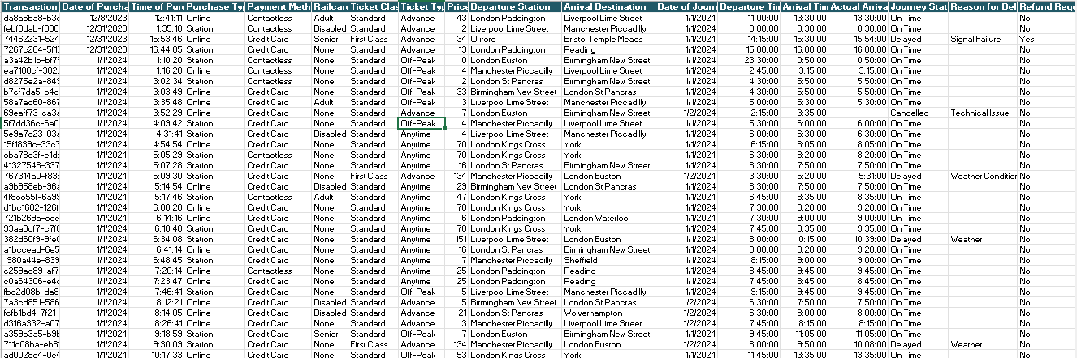

2.4 Data Characteristics
- The dataset includes categorical and numerical data, requiring preprocessing for standardization.
- Some columns contain missing values (e.g., "Reason for Delay" is empty for on-time journeys).
- The dataset captures real-world railway operations, making it useful for trend analysis, delay monitoring, and refund processing.

3.0 Data Validation, Cleaning & Pre-Processing

3.1 Overview
Before designing the database and performing analysis, the dataset underwent a data cleaning and pre-processing phase to ensure data quality, consistency, and accuracy. This step was crucial in handling missing values, inconsistencies, duplicates, and standardizing formats before normalization and database implementation.

3.2 Data Validation Check
1. Distinct Value Checks for Key Columns
- Checked distinct values → to ensure consistency and standardization:
A. Ticket Class B. Purchase Type
C. Payment Method D. Railcard
E. Ticket Type F. Journey Status
G. Reason for Delay H. Refund Request
2. Schema & Data Type Verification
- Reviewed all column names, data types, maximum lengths, and nullability using the information schema.
3. Duplicate Record Check
- Verified the dataset for any duplicate records based on key fields like transaction and journey details.
4. Null Value Detection
- Checked all columns for null values to assess data completeness.
5. Date Outlier Validation
- Validated Date of Purchase and Date of Journey fields to detect any outliers.
6. Price Outlier Detection
- Applied Interquartile Range (IQR) logic to detect unusually high or low prices.

3.3 Data Cleaning Steps
1. Handling Missing Values
- "Reason for Delay" Column:
  - This column had missing values for journeys that were "On Time." These were logically left as NULL to indicate no delay.
  - Updated “Staffing” in this column to be “Staffing Shortage” for better understanding.
  - Updated “Weather” and “Weather Condition” to be “Weather Conditions” for consistency.
- “Departure_station , Arrival_station” Column:
  - Updated station “Edinburgh” to be “Edinburgh Waverley” for consistency whether in departure stations column or arrival stations column.
- "Refund Request" Column: Missing values were filled with "No" where journey status was "On Time” which is left unchanged.
- “Railcard” Column: This column contains values named “None” which was perceived by python as if it is null values. So, it was replaced by “No Railcard” to avoid any errors.
2. Created Columns
  - Created column “Departure_station_Code” which consists of the first 3 digits of each “Departure_station” column to be easier for reference in analysis phase.
  - Created column “Arrival_station_Code” which consists of the first 3 digits of each “Arrival _station” column to be easier for reference in analysis phase.
3. Removing Duplicates
- Checked for duplicate records to ensure each transaction and journey was unique, but there were no duplicated records.
4. Standardizing Data Formats
- Date & Time Columns (Date of Purchase, Date of Journey):
  - Converted to standardized datetime format (MM-DD-YYYY) for consistency.

5. Capitalization Formatting:
- Applied String Formatting Logic To Ensure That The First Letter Of Every Word In Relevant Text Columns (Such As Station Names, Ticket Types, And Status Fields) Is Capitalized.

3.4 Data Pre-Processing Steps
1. Route Code Assignment
- A Standardized Set Of Station Codes Was Assigned To Each Departure And Arrival Station In The Dataset To Facilitate Route Identification And Simplify Analysis.
- Each Station Was Mapped To A Unique 3-Letter Code Based On Common Railway Abbreviations (E.G., “Birmingham New Street” → “BHM”, “York” → “YRK”).
2. Creating Unique Identifiers
- Primary Keys (IDs) were assigned where necessary to maintain uniqueness across different tables after database normalization (Journey_ID).
3. Splitting Data into Related Tables
To eliminate redundancy and achieve normalization, the dataset was divided into five separate tables:
- Stations Table → Listing all available stations (Station Code, Station Name)
- Routes Table → Holding the available routes (Departure / Arrival)
- Journeys Table → Storing journey-specific data (Date of Journey, Timings, Journey Status, Delay Duration & Reason of delay)
- Transactions Table → Containing purchase details (Purchase Type, Payment Method, Date of Purchase, etc.).
- Calendar → Listing the dates needed to record the Journeys and mentioning the date type (holiday or weekday, etc.)
4. Handling Foreign Key Relationships
- Established foreign key constraints to maintain referential integrity between tables.
5. Indexing for Performance Optimization
- Indexed frequently queried columns (Transaction ID, Journey ID, Departure Station, etc.) to improve query speed.

3.5 Tools Used
- Python (Pandas, NumPy, Matplotlib) → For data cleaning, handling missing values, and standardization.
- SQL → For database normalization, integrity constraints, and indexing.
- Excel → For initial data exploration and validation.

3.6 Python Codes used for Data Validation, Cleaning & Pre-Processing
Below Screenshots shows the cleaning & pre-processing codes done in python; as illustrated above:
- Updated “Staffing, Weather” in this column to be “Staffing Shortage, Weather Conditions” for better understanding.
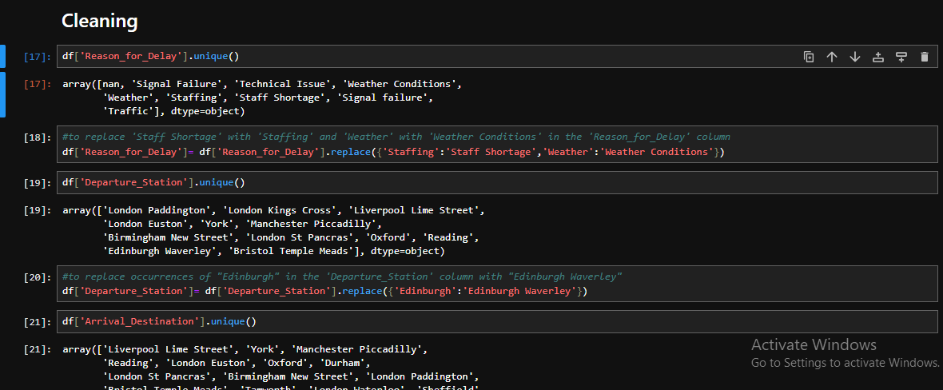
- Updated station “Edinburgh” to be “Edinburgh Waverley” for consistency whether in departure stations column or arrival stations column.
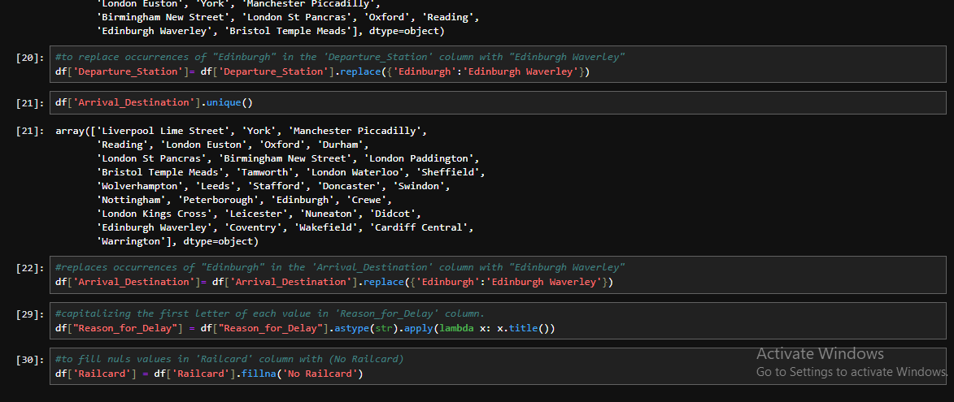
- Applied String Formatting Logic To Ensure That The First Letter Of Every Word In Relevant Text Columns

- This column contains values named “None” which was perceived by python as if it is null values. So, it was replaced by “No Railcard” to avoid any errors.

- Checked for duplicate records to ensure each transaction and journey was unique, but there were no duplicated records.
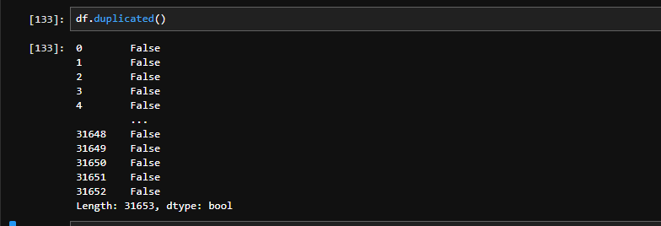

- Converted to standardized datetime format (MM-DD-YYYY) for consistency.
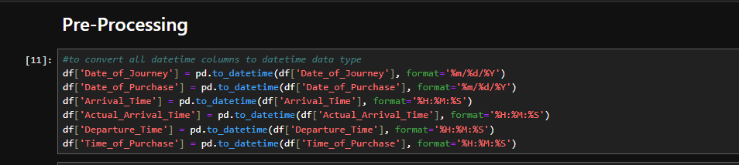
- Converted to standardized time format (00:00:00) for consistency.
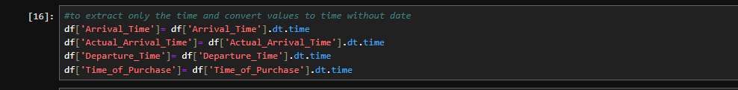
- Created column “station_Code” which consists of the first 3 digits of each “Departure_station, Arrival _station” column to be easier for reference in analysis phase.
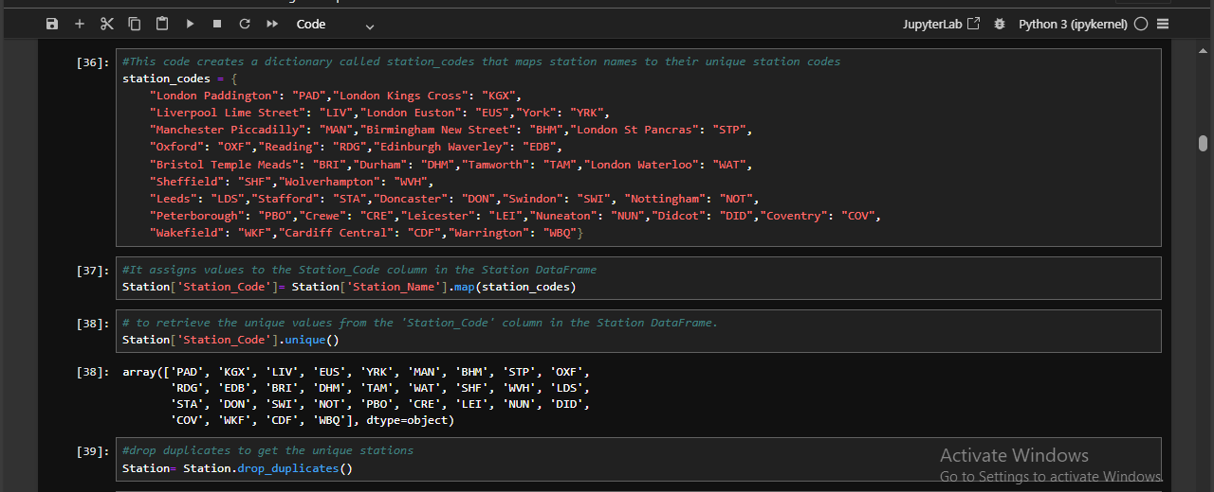
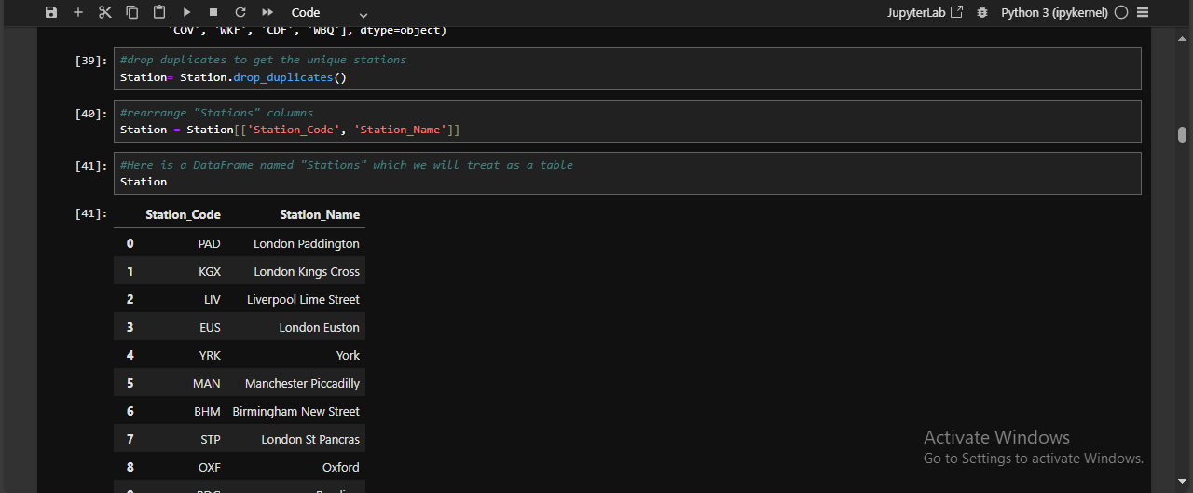

- Listing all available route Code (Departure Station Code / Arrival Destination Code)
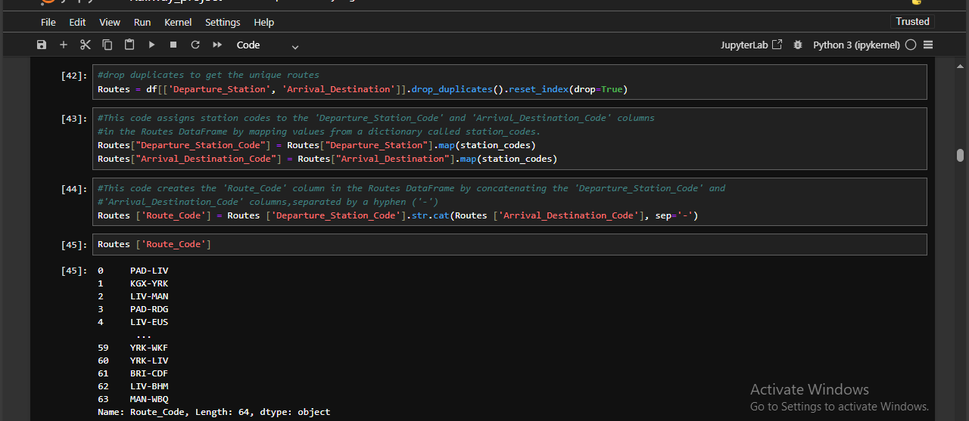
- Storing journey-specific data (Date of Journey, Timings, Journey Status, Reason of delay & Stations)
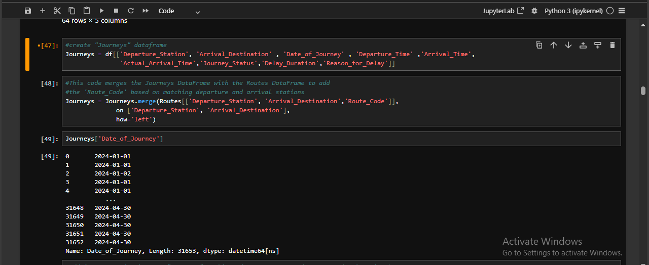
- Add the Route Code to the Journey Table Based on (Departure Station / Arrival Destination)

- Drop the duplicate from the Journey Table
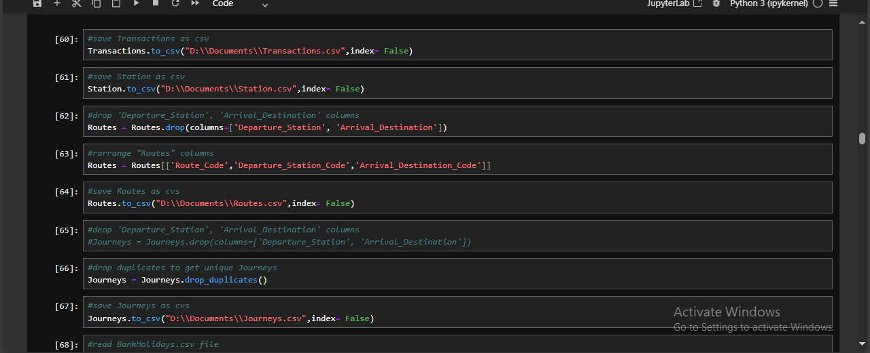
- Final version of Journey Table
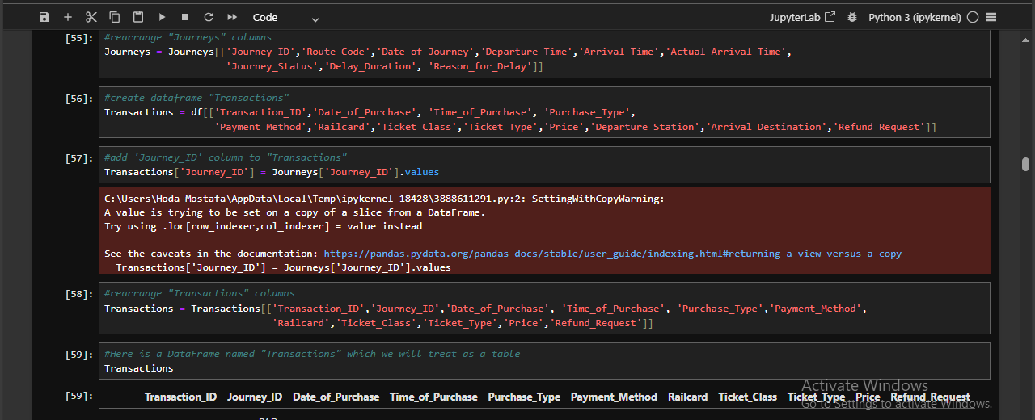
- Creating the Transaction Table Containing purchase details (Purchase Type, Payment Method, Date of Purchase, etc.).

- Add the Journey id to the Transaction Table

- Final version of Transaction Table


- Drop the unused Columns and arranging them in the right order

- Transform to CSV Files for using in future Analysis




3.7 SQL Codes used for Data Validation, Cleaning & Pre-Processing
Below Screenshots shows the cleaning & pre-processing codes done in SQL; as illustrated above:
- Checked distinct values → to ensure consistency and standardization
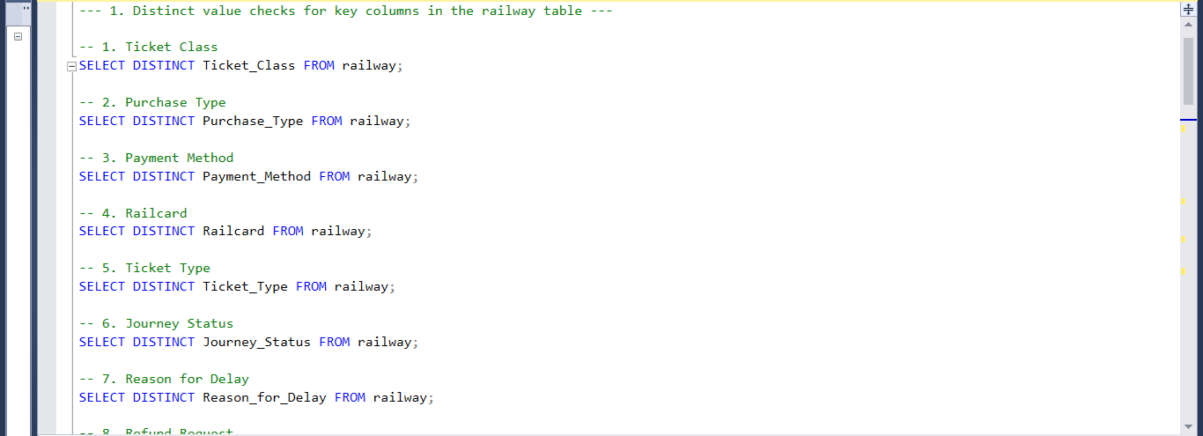
- Reviewed all column names, data types, maximum lengths, and nullability using the information schema.
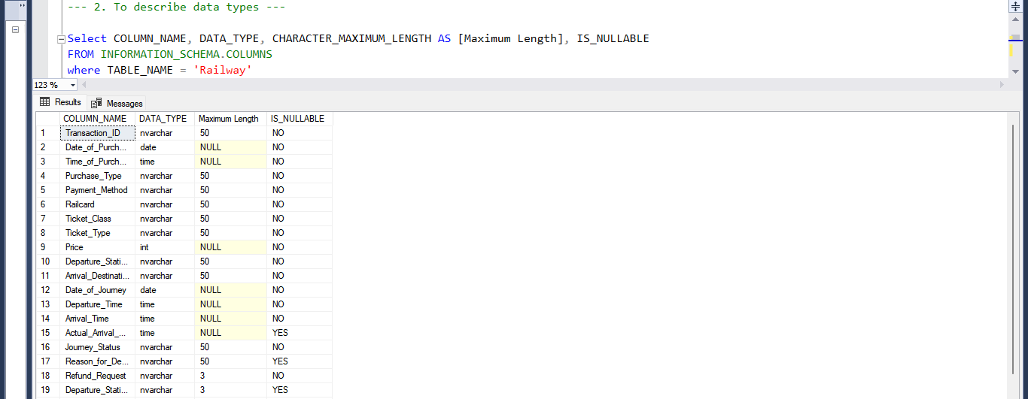
- Verified the dataset for any duplicate records
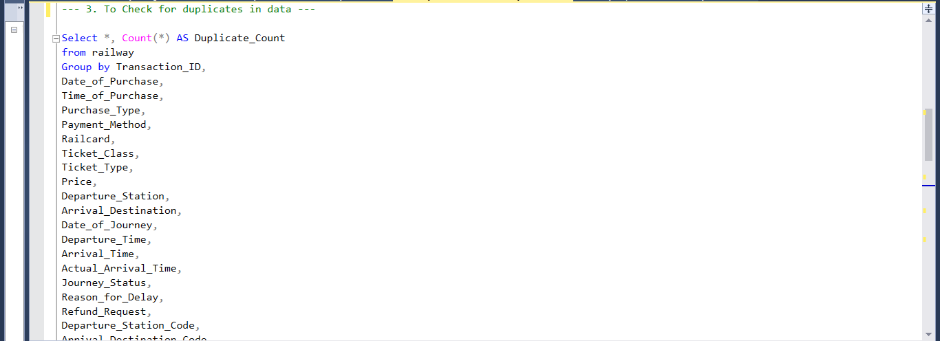
- Checked all columns for null values to assess data completeness.
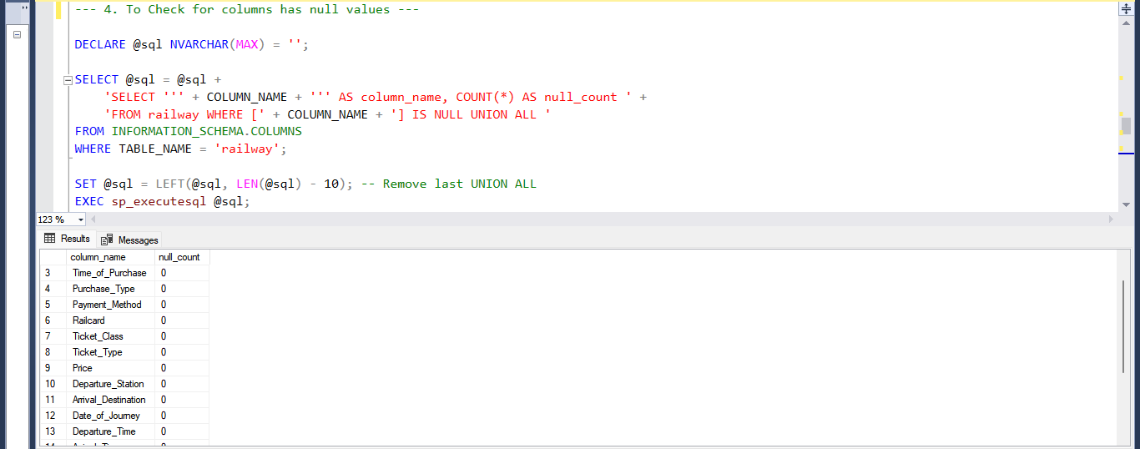
- Validated Date of Purchase and Date of Journey fields to detect any outliers.
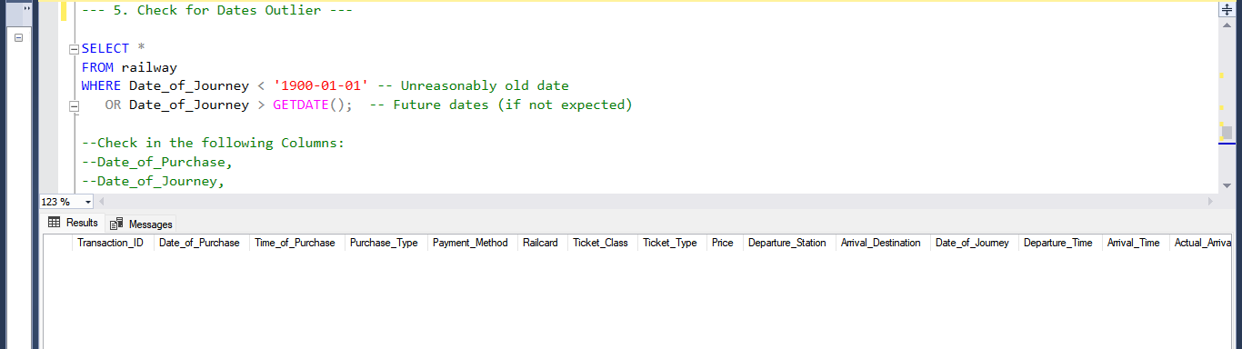
- Applied Interquartile Range (IQR) logic to detect unusually high or low prices.
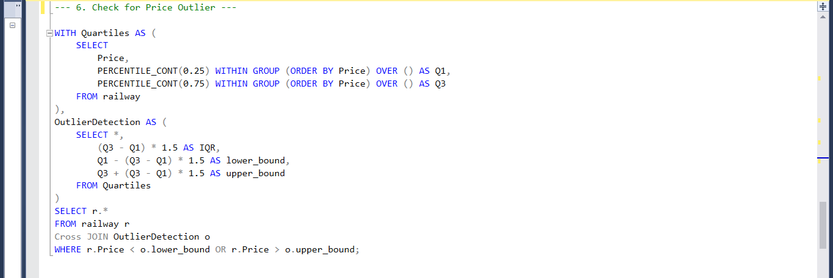
- Applied String Formatting Logic To Ensure That The First Letter Of Every Word In Relevant Text
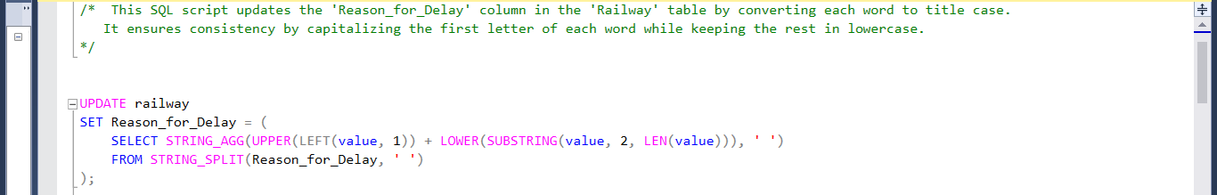

- Updated “Staffing, Weather” in this column to be “Staffing Shortage, Weather Conditions” for better understanding.
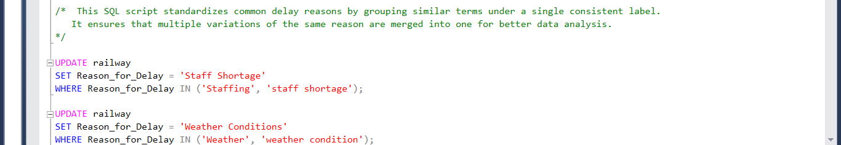
- This column contains values named “None” which was perceived by python as if it is null values. So, it was replaced by “No Railcard” to avoid any errors.
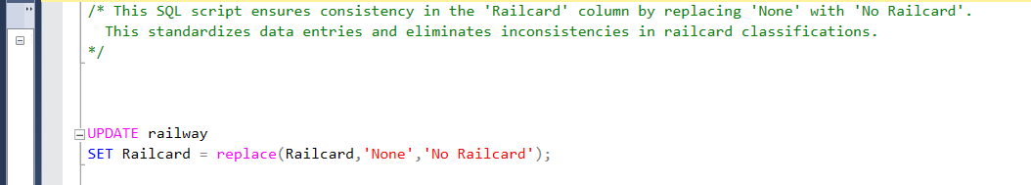
- Updated station “Edinburgh” to be “Edinburgh Waverley” for consistency whether in departure stations column or arrival stations column.
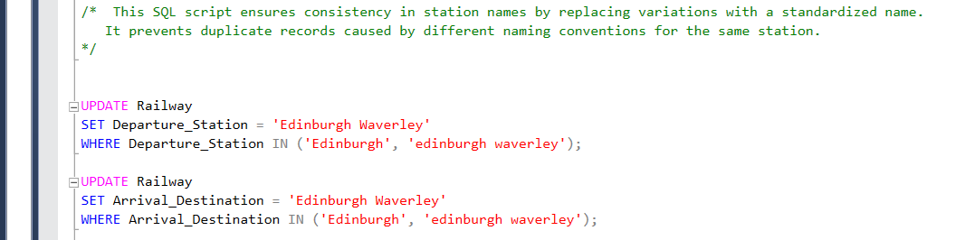
- Created column “Departure_station_Code, Arrival_station_Code” which consists of the first 3 digits of each “Departure_station, Arrival _station” column to be easier for in analysis phase.
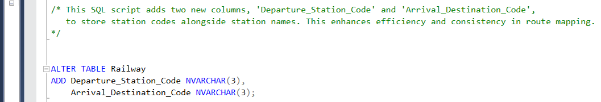

- Set Of Station Codes Was Assigned To Each Departure And Arrival Station In The Dataset
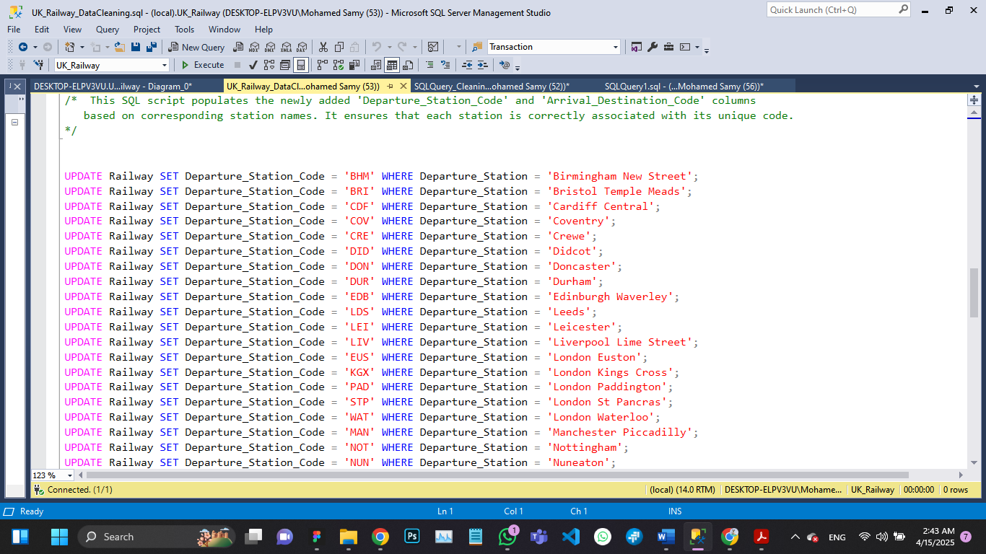
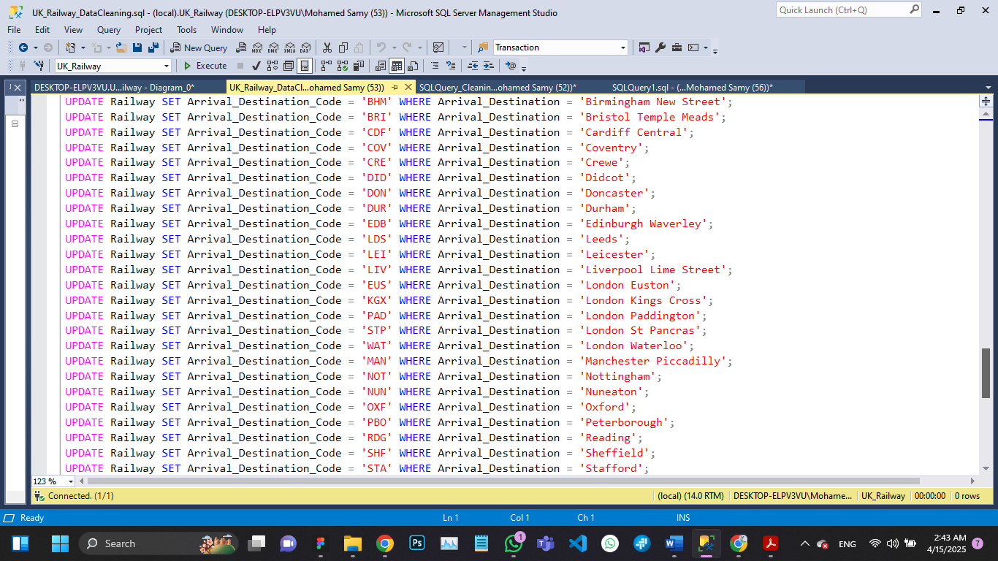

Summary
This section highlights the Validation, cleaning and preprocessing steps performed to ensure high data quality before database design and modeling. These steps allowed for an optimized relational database structure while ensuring consistency and accuracy in railway data storage and retrieval.

4.0 Data Modeling & Database Design

4.1 Objectives of Database Design
The goal of database design in this project was to eliminate redundancy, ensure data integrity, and improve query performance by applying normalization principles. The dataset was originally a single table containing all transaction and journey details, which was broken down into five related tables to optimize data storage and retrieval.

4.2 Normalization Process
To achieve a well-structured relational database, we applied the following normalization steps:
- First Normal Form (1NF): Ensured all attributes contained atomic values and removed duplicate records.
- Second Normal Form (2NF): Eliminated partial dependencies by separating purchase details, ticket details, and journey details into distinct tables.
- Third Normal Form (3NF): Removed transitive dependencies by creating separate tables for journey status and refunds.

4.3 Database Schema & Table Structure
After normalization, the data was divided into the following five tables:
- Transactions Table
This table stores purchase-related information.
- Primary Key: Transaction_ID
- Attributes: Date_of_Purchase, Time_of_Purchase, Purchase_Type, Payment_Method, Ticket_Class, Ticket_Type, Ticket_RailCard, Price, Refund_Request
- Journeys Table
This table stores journey-related data, ensuring a separate structure for travel details.
- Primary Key: Journey_ID
- Foreign Key: Route_Code (references Routes)
- Attributes: Date_of_Journey, Departure_Time, Arrival_Time, Actual_Arrival_Time, Journey_Status, Reason_for_delay.
- Routes Table
This table contains Routes-related details and links to Stations.
- Primary Key: Route_Code
- Foreign Key: Departure_Station_Code, Arrival_Destination_Code (references Stations)

- Stations Table
This table lists all the available Stations, including the Station’s Code.
- Primary Key: Station_Code
- Attributes: Station_Name

- Calendar Table
This table holds the dates and the description of each one (Holiday or weekday, weekend or not, etc.)
- Primary Key: Date
- Foreign Key: Journey_ID (references Journeys)
- Attributes: Refund_Request

4.4 Entity-Relationship Diagram (ERD)
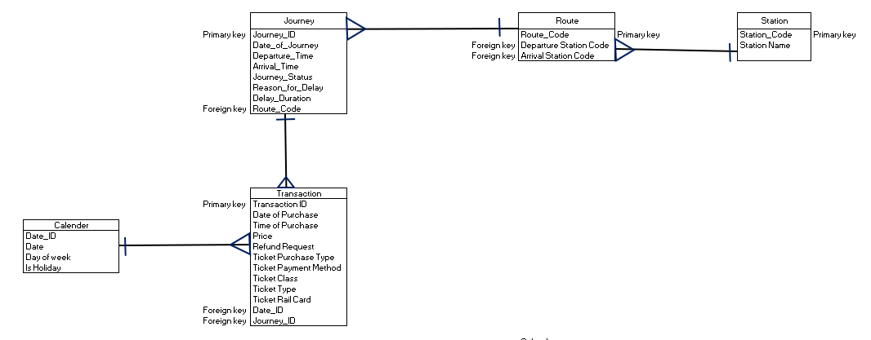

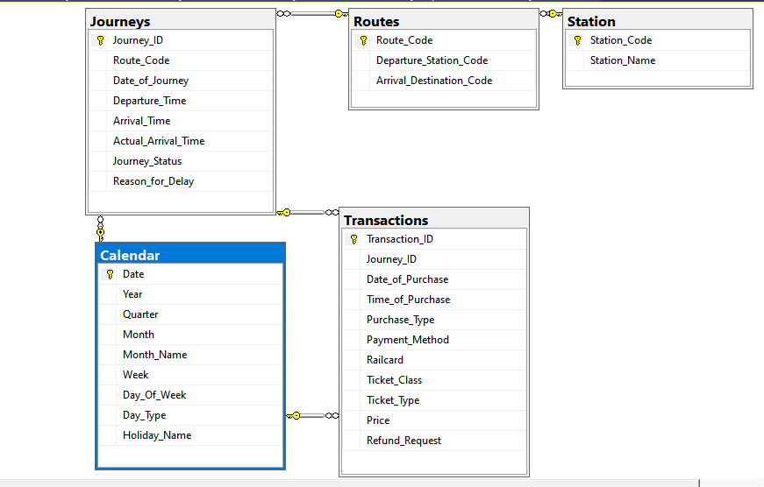

4.5 Implementation Approach
- SQL was used to create and establish relationships between tables.
- Indexes were added on frequently queried columns to optimize performance.
- Foreign keys were enforced to maintain referential integrity.
- Python was used for data processing and transformation before loading it into the database.
- Tableau and Power BI was used for analysis and data visualization.

5.0 Implementation Details & Codes

5.1 Overview
The implementation phase involved setting up the database schema, loading the cleaned data, and establishing relationships between tables to ensure efficient data management and retrieval. SQL was used for database creation, Python for data processing, and Excel for initial data exploration and validation.

5.2 Database Creation and Table Structure
After normalizing the dataset into five related tables, the database was created using SQL. The schema was designed to enforce data integrity, eliminate redundancy, and improve query performance.
SQL Implementation Steps:
- Created the database:

- Created the normalized tables:
  - Stations Table: Stores List of Stations.
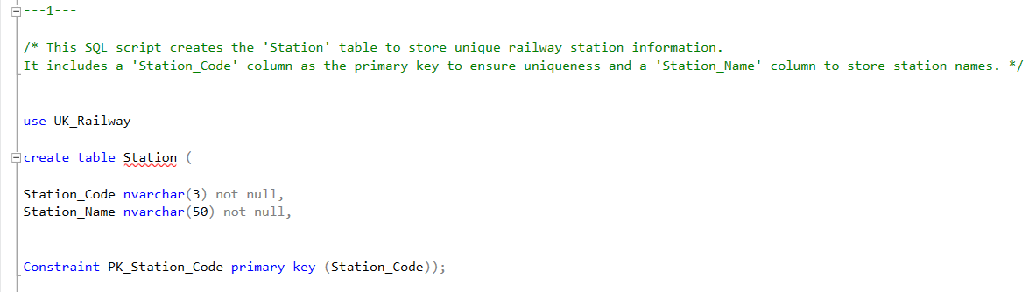

  - Routes Table: Contains Routes details and links to Stations.
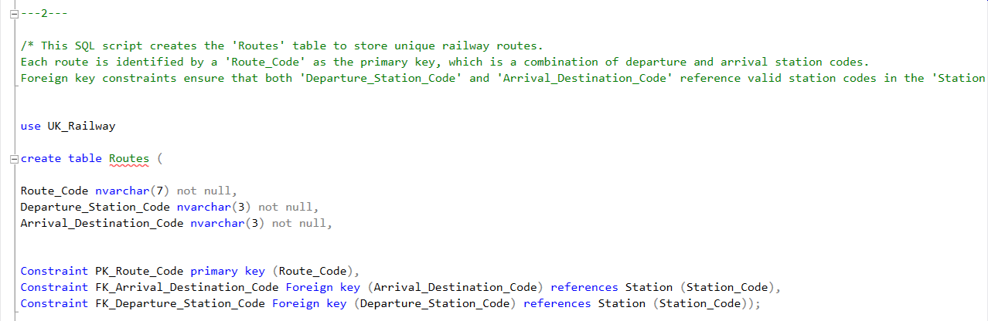

  - Calendar Table: Tracks dates with description.
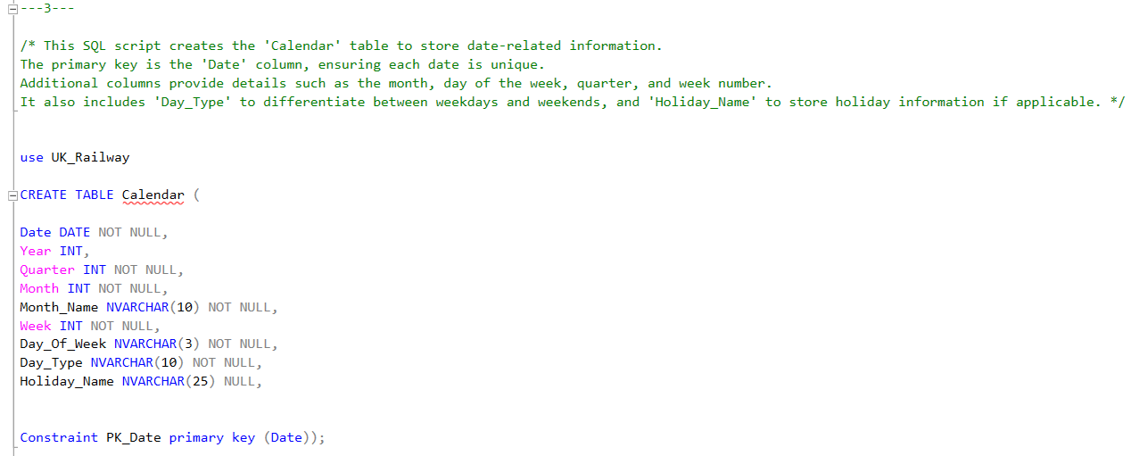

  - Journeys Table: Stores journey details, including station names and times.
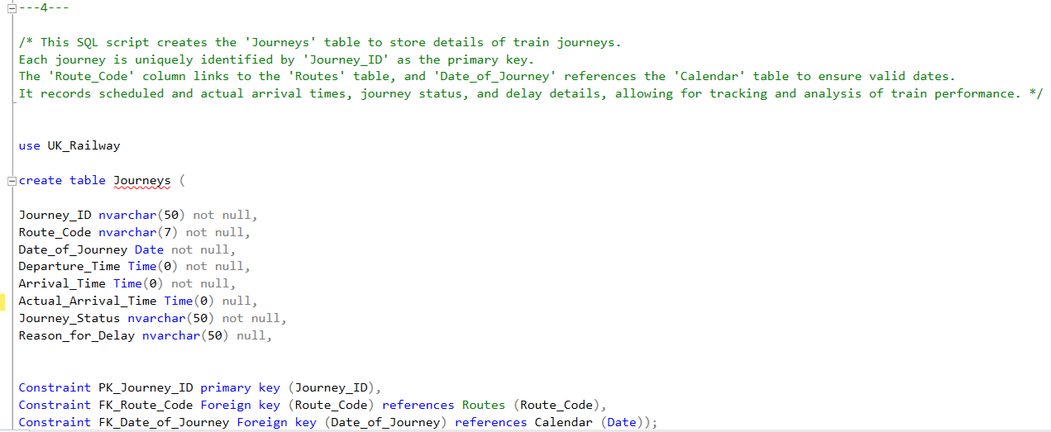
  - Transactions Table: Stores ticket purchase details.
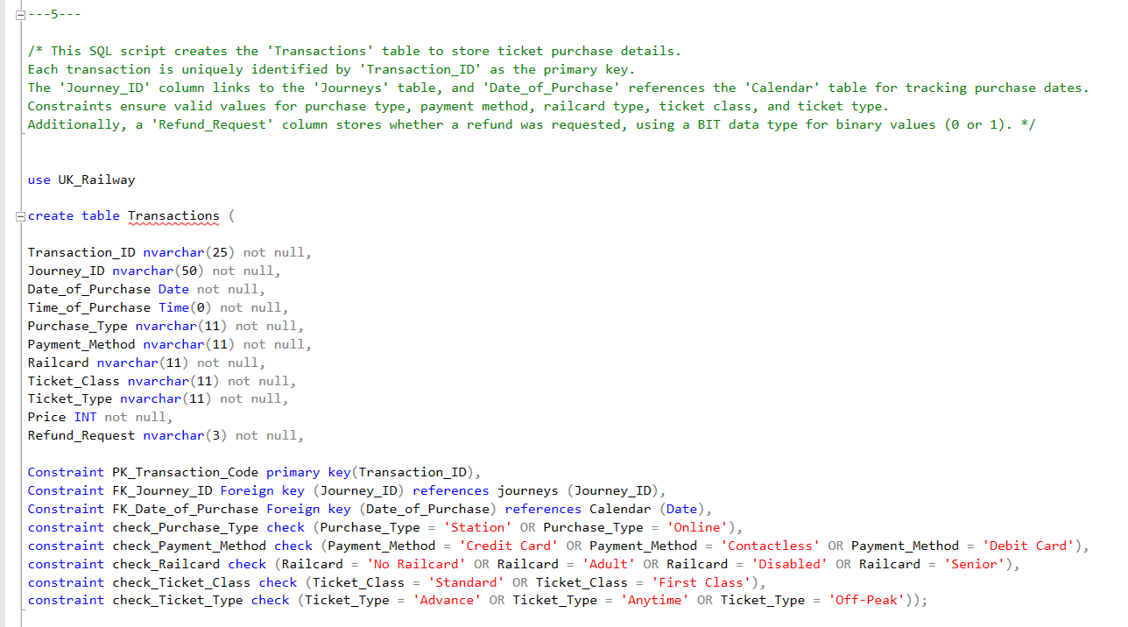

5.3 Inserting Data into Structured Tables
After creating the normalized table structures, the next step involved populating each table with relevant, deduplicated, and structured data extracted from the raw dataset. This process was performed using SQL and ensured referential integrity across all relational tables.
Data Insertion Steps:
- Station Table:
Populated with a unique list of all departure and arrival stations found in the dataset. Ensured no duplication by checking against existing entries before insertion.
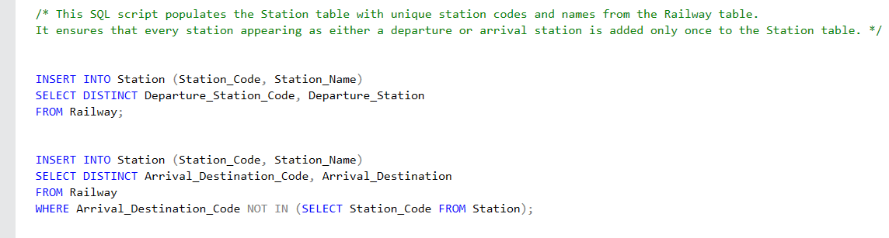
The final result of the table:
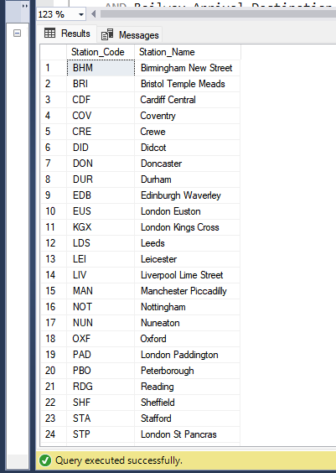

- Routes Table:
Created unique route entries by combining each distinct pair of departure and arrival station codes. Each route was assigned a unique Route_Code.
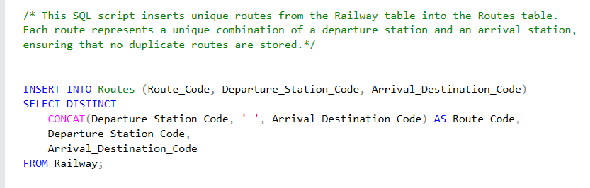
The final result of the table:
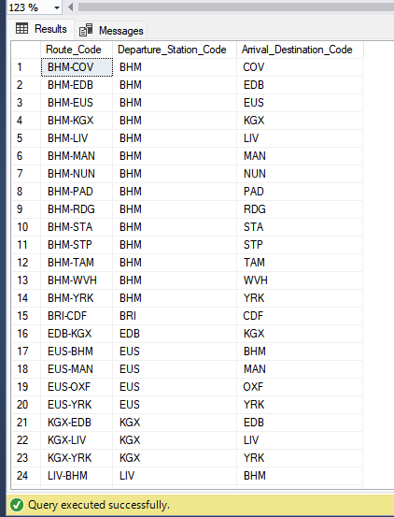

- Calendar Table:
Generated a complete date dimension from December 2023 to May 2024, with key date attributes including day of week, week number, month, quarter, year, and day type UK national holidays were flagged and labeled accordingly.
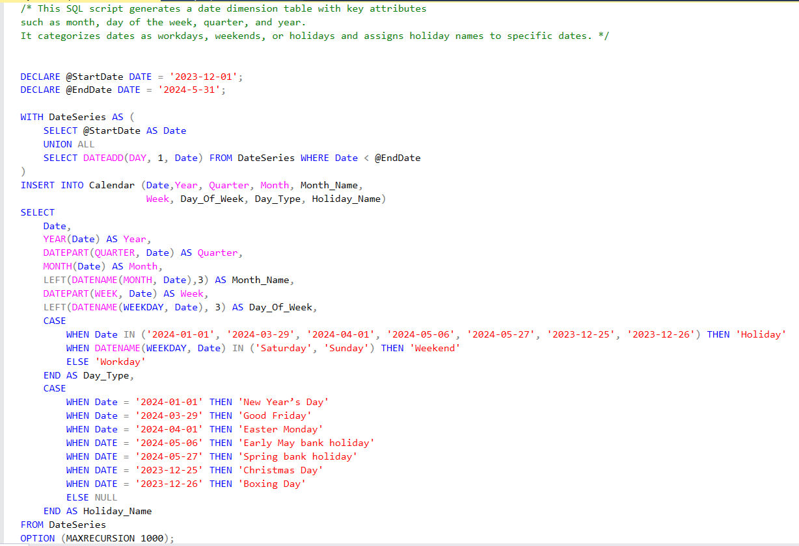
The final result of the table:
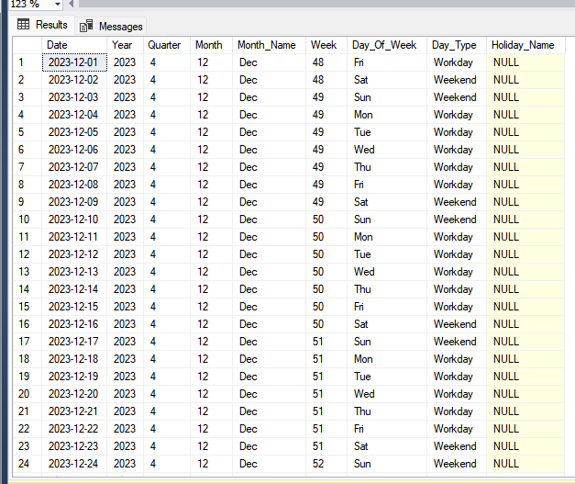
- Journeys Table:
Inserted distinct journey records by combining route codes, journey dates, and departure times. A unique Journey_ID was generated for each entry, linking back to the Routes table and ensuring traceability of status and delay reasons.
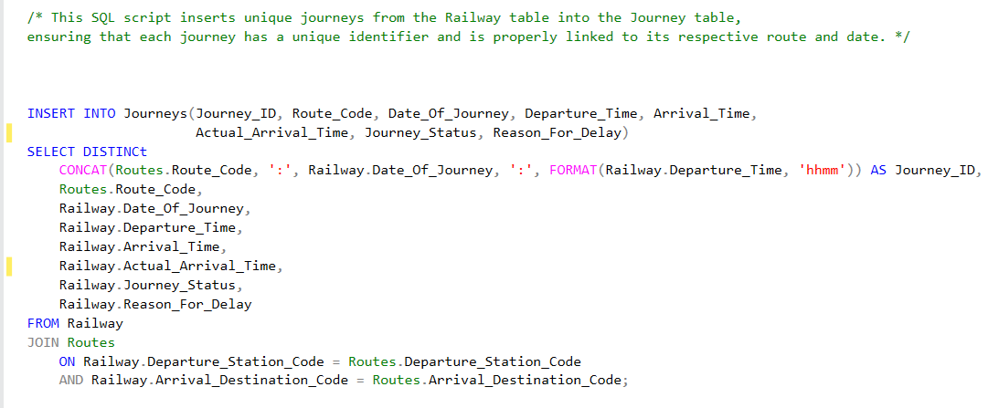
The final result of the table:
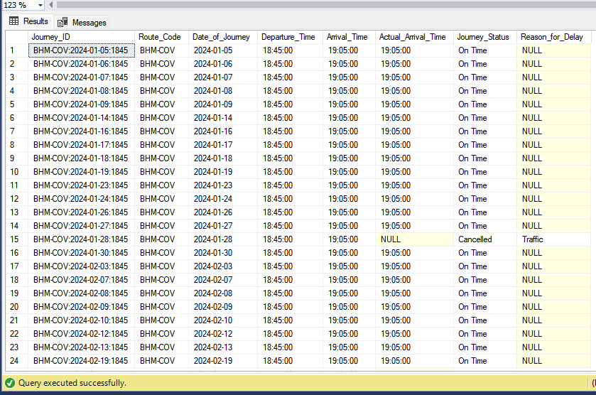

- Transactions Table:
Inserted transaction records by linking each one to its corresponding journey using Journey_ID.
This ensured that every ticket purchase was connected to a valid journey based on route, date, and departure time.
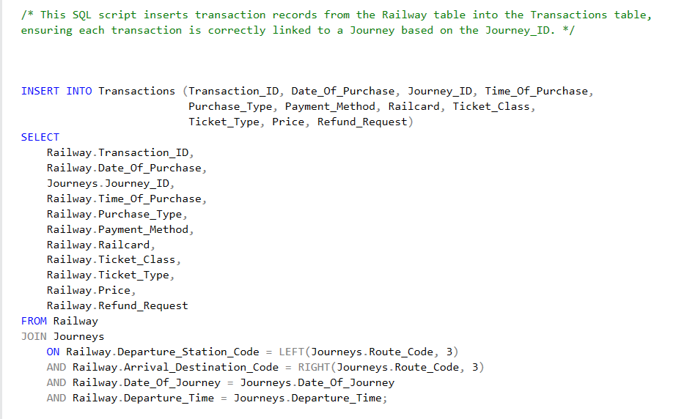
The final result of the table:
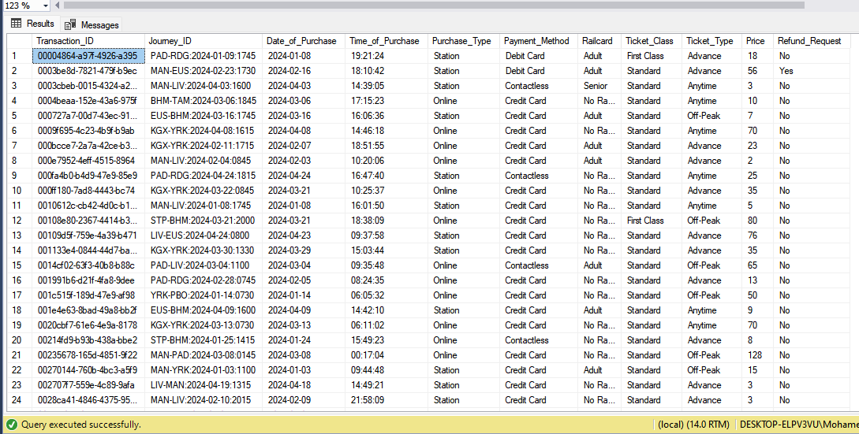

5.4 Data Analysis and Visualization
After defining the database schema, the cleaned and preprocessed data was loaded into SQL tables using SQL.
The ready cleaned and pre-processed data was linked to Tableau (as CSV file) to start the Analysis Phase which will be discussed in the following chapters.
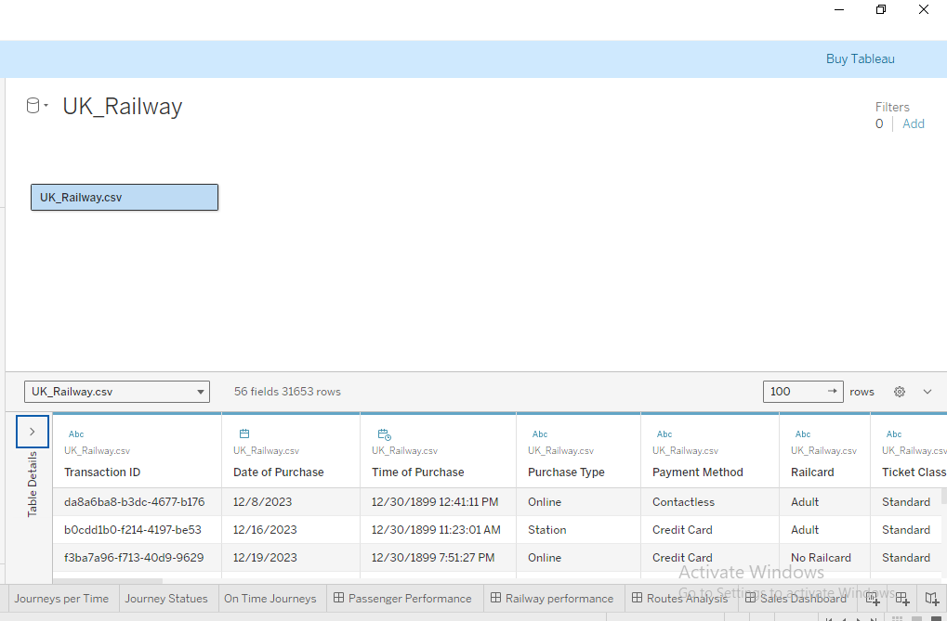

6.0 Analysis Questions Phase

6.1 Analysis Questions

Passenger Performance
- What is the number of Tickets sold?
- What is the most Payment Method?
- What is the most common Ticket Type?
- What is the most common Ticket Class?
- What is the Number of online Transactions vs station Transactions?
- What percentage of customers use railcard?
- What is the number of Tickets per Month?
- What are the Numbers of Passenger per Day?
- What is the Average Number of Transactions per Day Type?
- What are the Numbers of Passenger per Hour?

Railway Performance
- What is the total number of Journeys?
- What is the total number of Journeys On Time?
- How many journeys are delayed?
- How many journeys are cancelled?
- How is Journeys distributed by Journey per month?
- What is the number of Journeys On Time per Month?
- What is the Reliability Score for On Time Journeys?
- What is the number of Journeys per Day?
- How were journeys distributed by delay reasons?
- Number of Transactions on Cancelled and Delayed Journeys + Refunds of Them
- What is the Average Number of Journeys per Day Type?
- What is the average delay duration?

Routes & Stations Analysis
- What is the number of Routes ?
- What is the number of Departure Stations?
- What is the number of Arrival Stations?
- What are the top 5 routes with highest percentage of delays?
- What are the top 5 routes with highest percentage of cancellations ?
- What is the top 5 of used Departure?
- What is the Bottom 5 of used Departure Stations?
- What is the top 5 of used Arrival Stations?
- What is the Bottom 5 of used Arrival Stations?
- What is the top 5 Routes of number of journeys?
- What is the bottom 5 Routes of number of journeys?

Sales & financial Analysis
- What is the total revenue and net revenue?
- What is the total refund?
- What is the average ticket price?
- What is the top 5 Routes by Revenue?
- What is the bottom 5 Routes by Revenue?
- How is revenue distributed by payment method?
- How is revenue distributed by Purchase Type?
- How are ticket sales distributed by ticket type?
- What is the monthly Trend of Net Revenue?
- What is the Average Net Revenue per Day Type?
- What is the Net Revenue by Journey Statues?
- What is the Impact of Delay Time on refund?
- What is the total refund by journey statues?

6.1 Analysis Questions Answers & Feedback

Passenger Performance Analysis
- Total Number of Tickets Sold
The total number of tickets sold is 31,653.
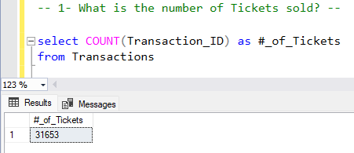
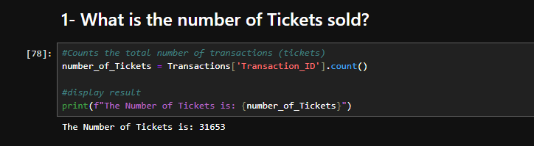
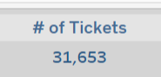

- Most Used Payment Method
The dominant method of payment among passengers is Credit Card, accounting for the highest share of transactions.
- Payment Method: Credit Card
- Percentage: 60.46%
- Total Transactions: 19,136
Other payment methods include:
- Contactless: 34.23% (10,834 tickets)
- Debit Card: 5.32% (1,683 tickets)
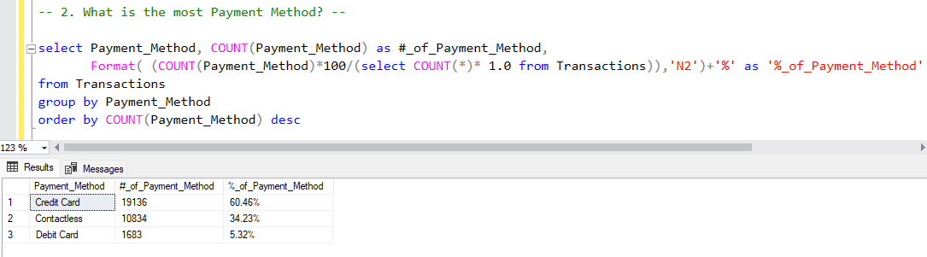
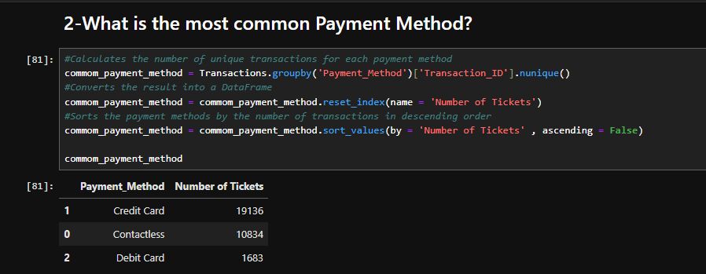
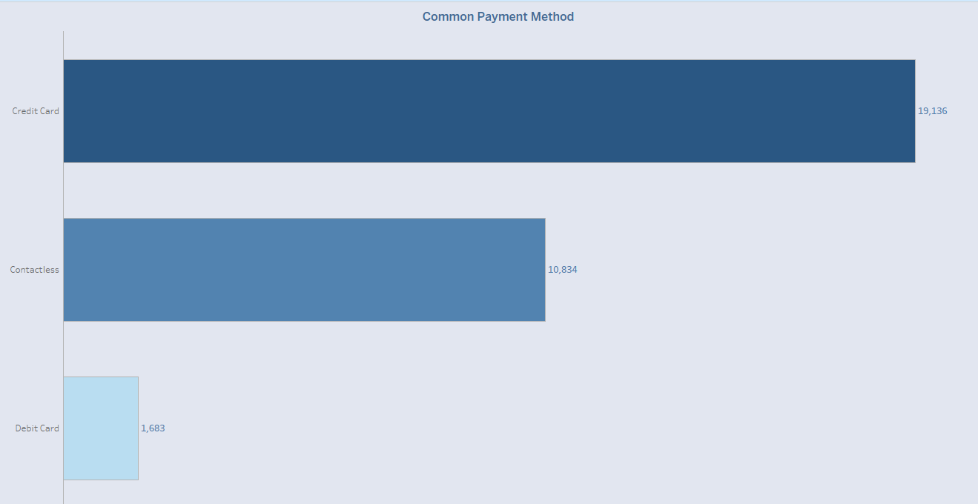

- Most Common Ticket Type
Ticket Type
- Advance is the most commonly purchased ticket type.
- Percentage: 55.48%
- Total Tickets: 17,561
Other ticket types include:
- Off-Peak: 27.65% (8,752 tickets)
- Anytime: 16.87% (5,340 tickets)
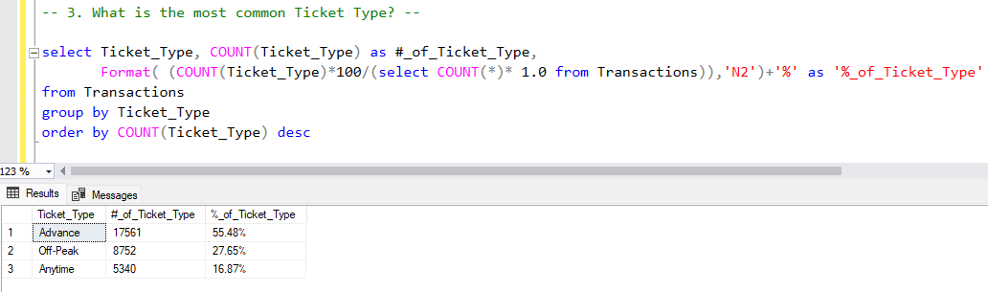
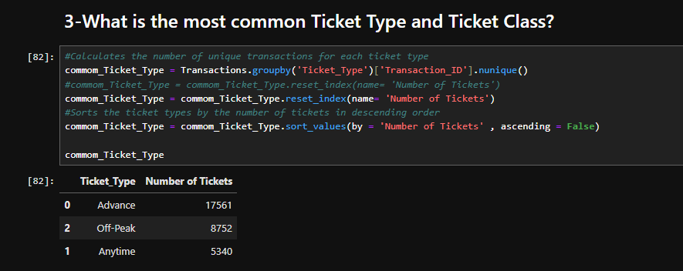
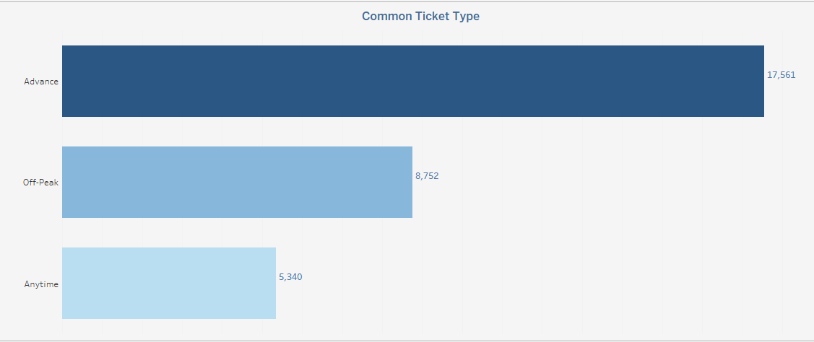

- Most Common Ticket Type and Ticket Class
Ticket Class
- The overwhelming majority of passengers travel in Standard Class.
- Percentage: 90.34% (28,595 tickets)
- First Class: 9.66% (3,058 tickets)
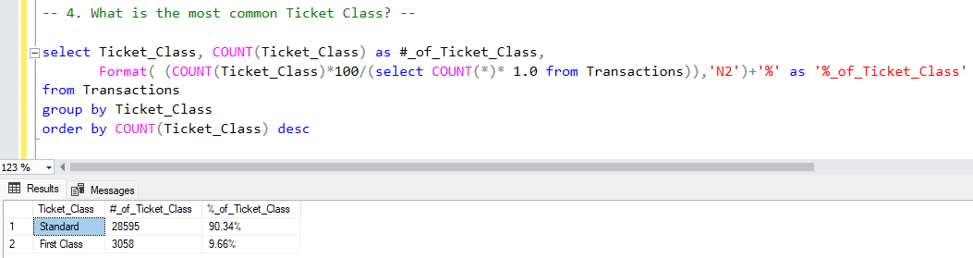
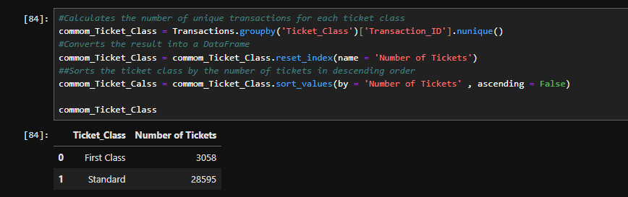
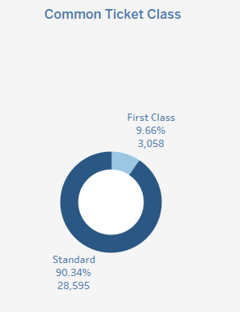

- Online Transactions vs. Station Transactions
Digital purchasing channels are more commonly used by passengers.
- Online Transactions: 18,521 (58.52%)
- Station Transactions: 13,132 (41.48%)
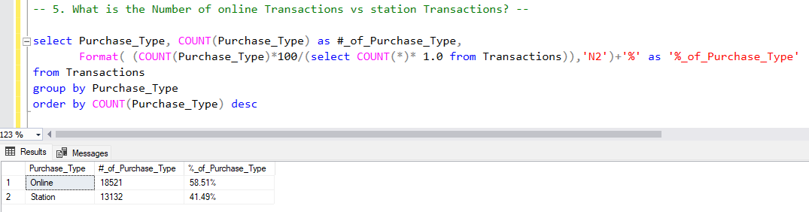
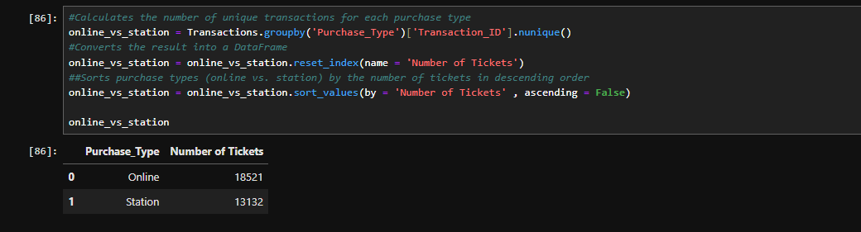
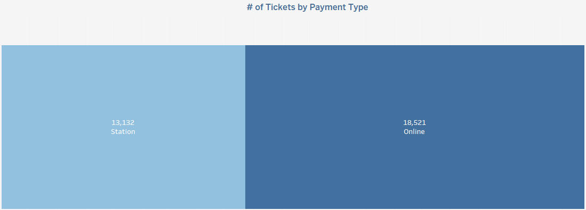

- Percentage of Customers Using Railcards
Railcards offer discounted fares for specific passenger segments. The breakdown is as follows:
- No Railcard Users: 20,918(66.09%)
- Adult Railcard Users: 4,846 (15.31%)
- Disabled Railcard Users: 3,089 (9.76%)
- Senior Railcard Users: 2,800 (8.85%)
- Total Railcard Users: 10,735
- Total Passengers: 31,653
Percentage of Railcard Users:
(10,735 / 31,653) *100 ≈ 33.91%
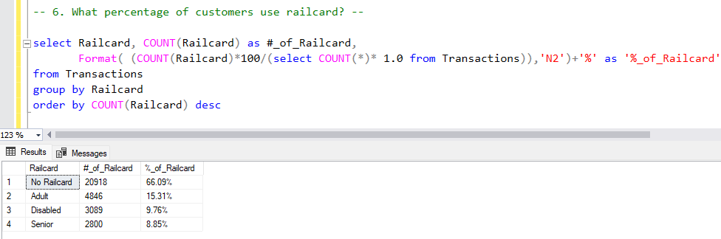
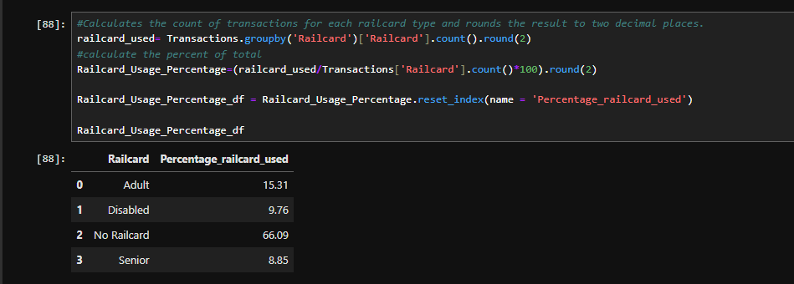
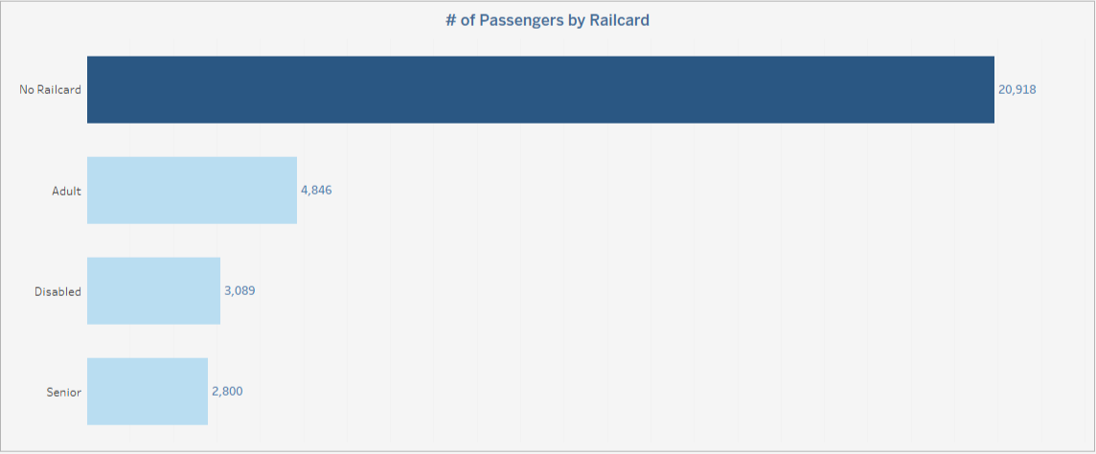

- Number of Tickets Sold per Month
- January: 8,434 tickets
- February: 7,337 tickets (Decrease by 1,097 from January)
- March: 8,100 tickets (Increase by 763 from February)
- April: 7,748 tickets (Decrease by 352 from March)
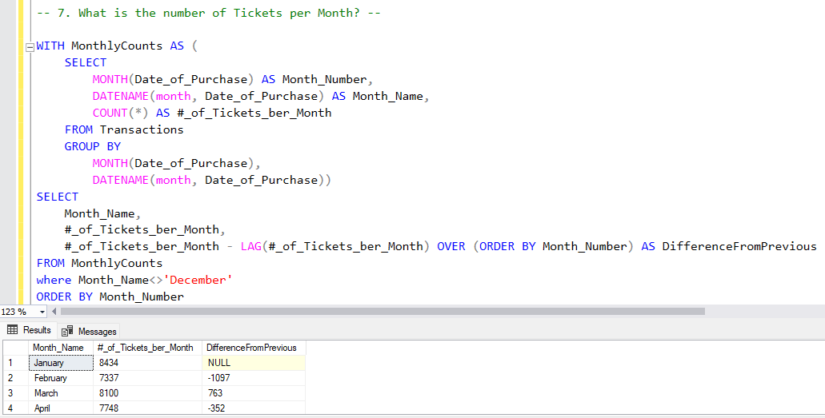
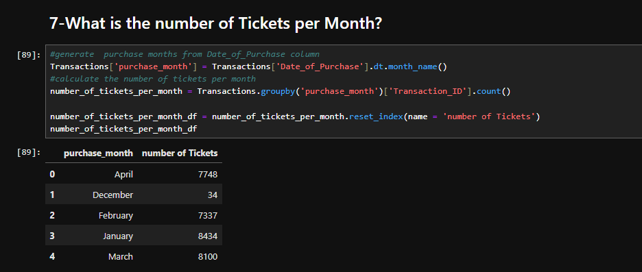
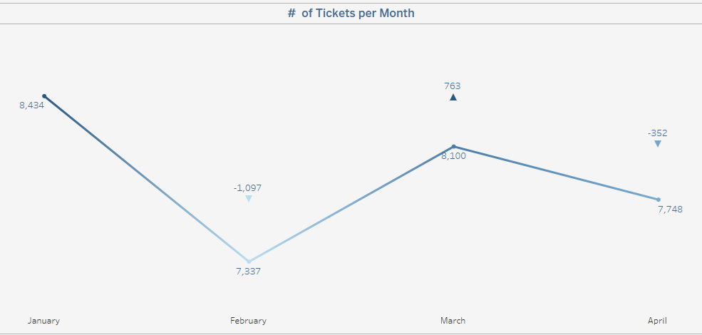

- Peak days:
The highest ticket sales by day are observed on:
Wednesday: 4,692 tickets
Tuesday: 4,607 tickets
Sunday: 4,580 tickets
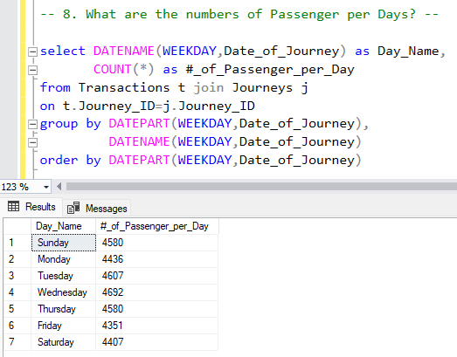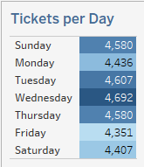

- Average Transactions per Day by Day Type:
- Workday: 251 transactions per day
- Weekend: 247 transactions per day
- Holiday: 131 transactions per day
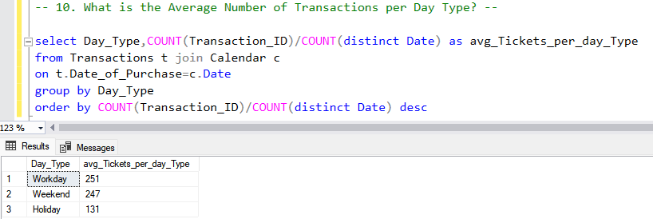
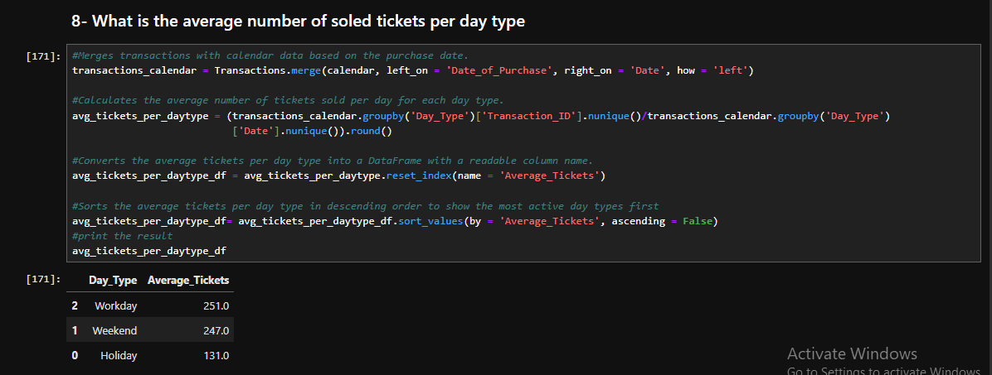
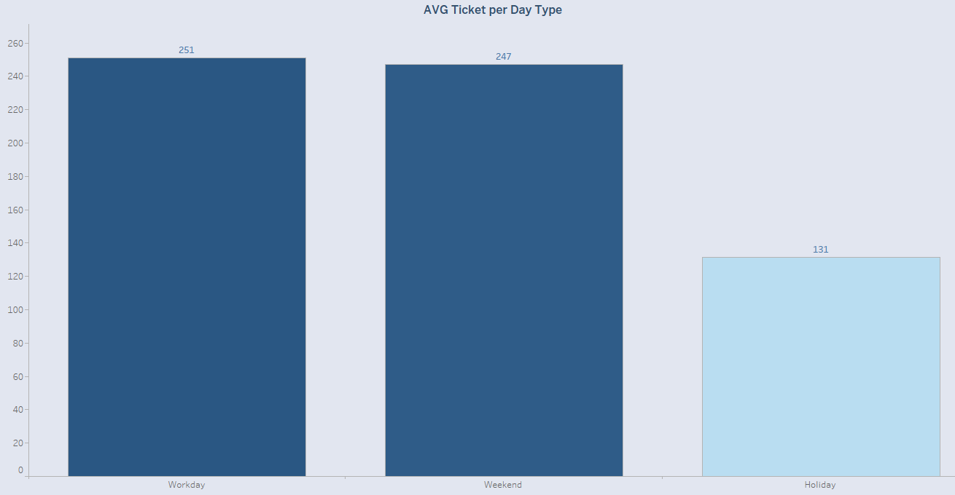

- Peak and Off-Peak Travel Hours
Peak Hours:
Highest ticket volumes occur during early morning hours, particularly:
- 6 AM: 2,925 tickets
- 7 AM: 2,541 tickets (Highest)
- 8 AM: 2,031 tickets
And Highest ticket volumes occur during late afternoon to early evening, particularly:
- 4 PM: 2,197 tickets
- 5 PM: 2,709 tickets (Highest)
- 6 PM: 2,802 tickets
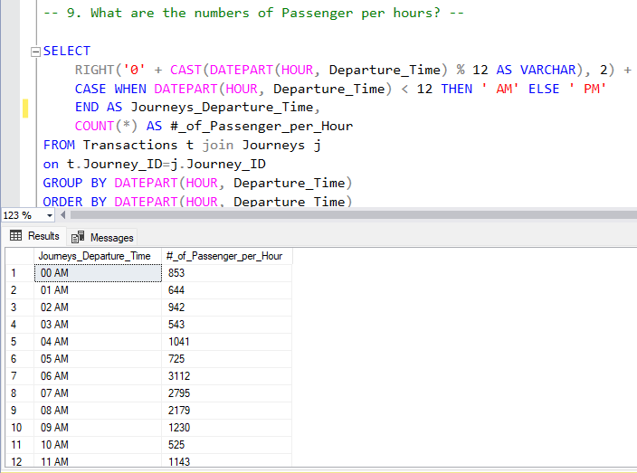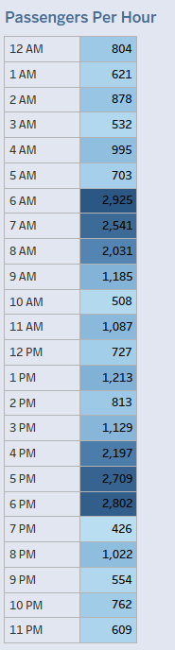
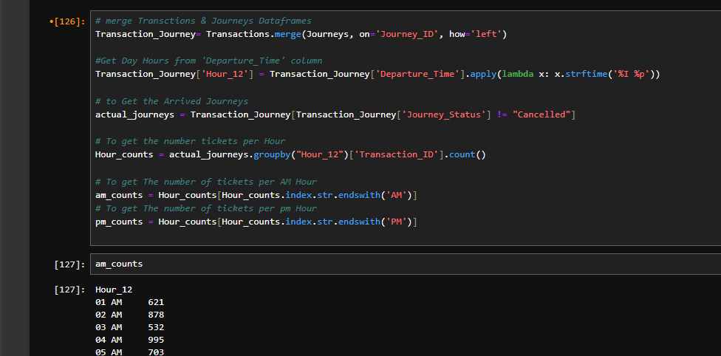
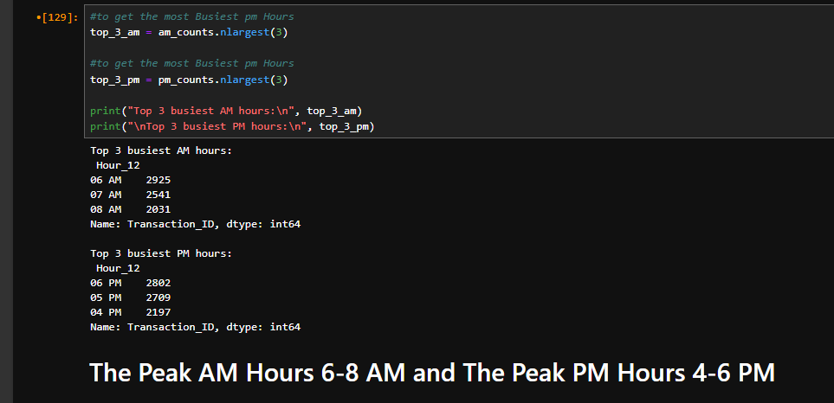

Conclusion
The insights indicate a preference for:
- Credit card payments
- Online ticket purchasing
- Standard class travel with advance booking
- Peak travel in the late afternoon and early evening
- A significant proportion (approximately one-third) of passengers using railcards
These patterns can guide strategic decisions in pricing, marketing, and service availability to optimize passenger satisfaction and operational efficiency.

Railway Performance Analysis
- Total Number of Journeys
- Total Journeys: 19,871
This represents the complete number of scheduled railway journeys within the reporting period.
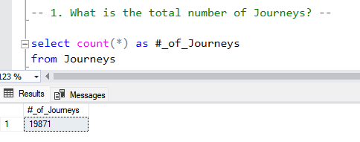
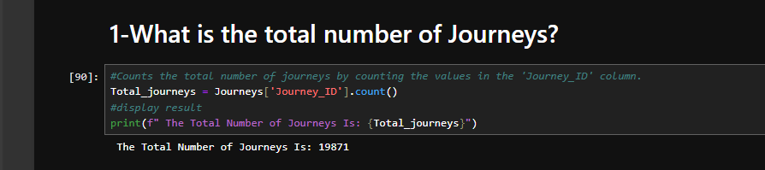
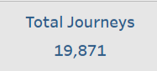

- Total Number of On-Time Journeys
There are 18,019 journeys recorded as on-time.
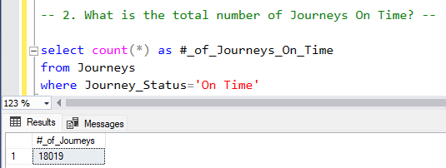
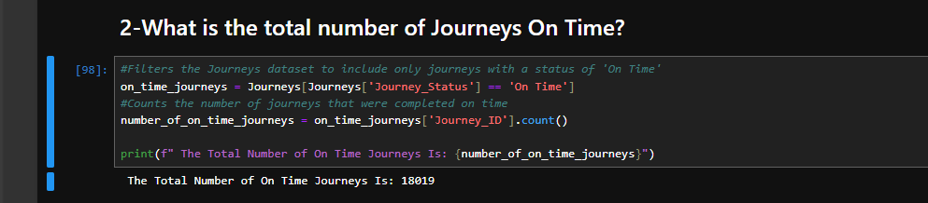
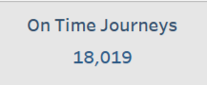

- Total Number of Delayed Journeys
There are 1,062 journeys recorded as Delayed.
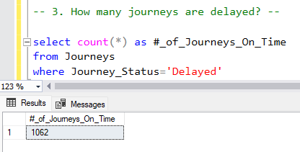
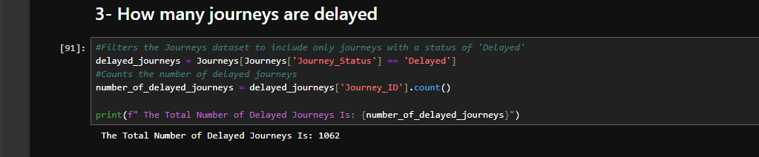
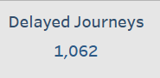

- Total Number of Cancelled Journeys
There are 790 journeys recorded as Cancelled.
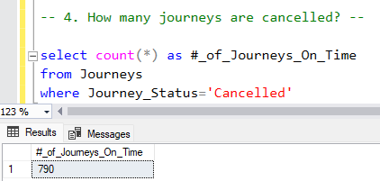
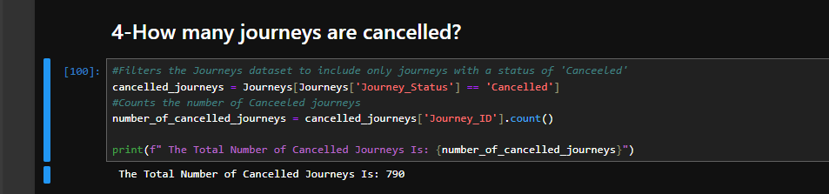
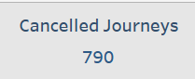

- Journeys per Month
- January: 5,060 journeys
- February: 4,839 journeys
- March: 5,083 journeys
- April: 4,889 journeys
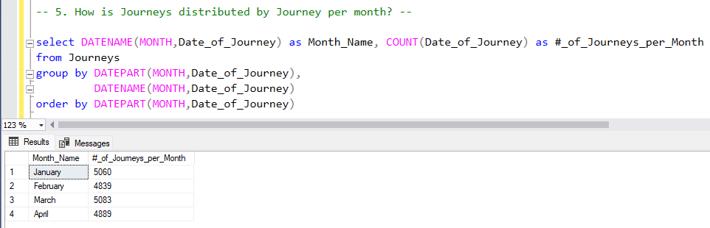
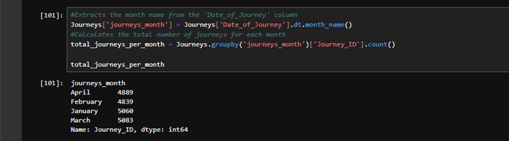
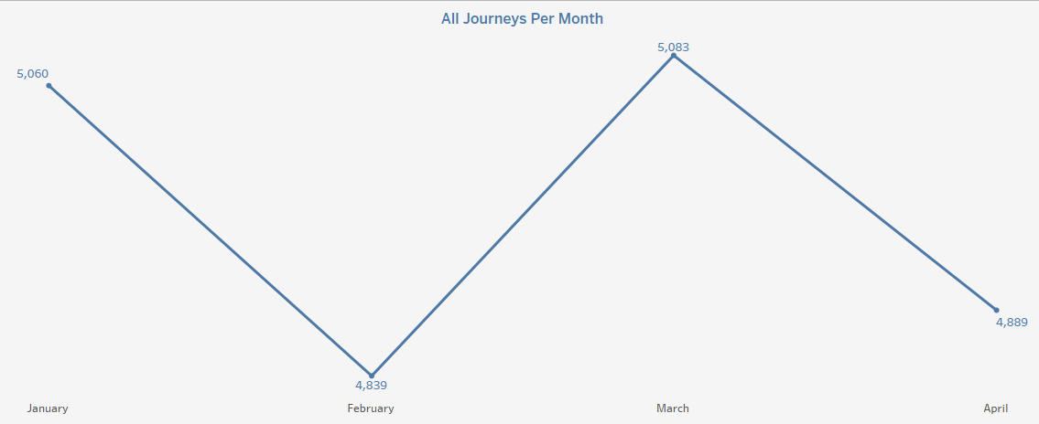

- On-Time Journeys per Month:
- January: 4,587 journeys
- February: 4,402 journeys
- March: 4,574 journeys
- April: 4,456 journeys
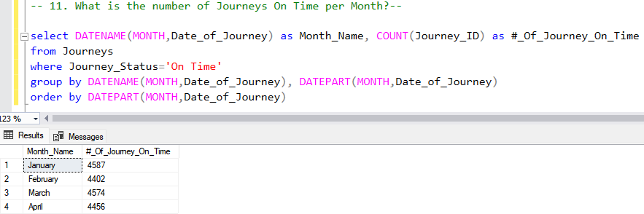
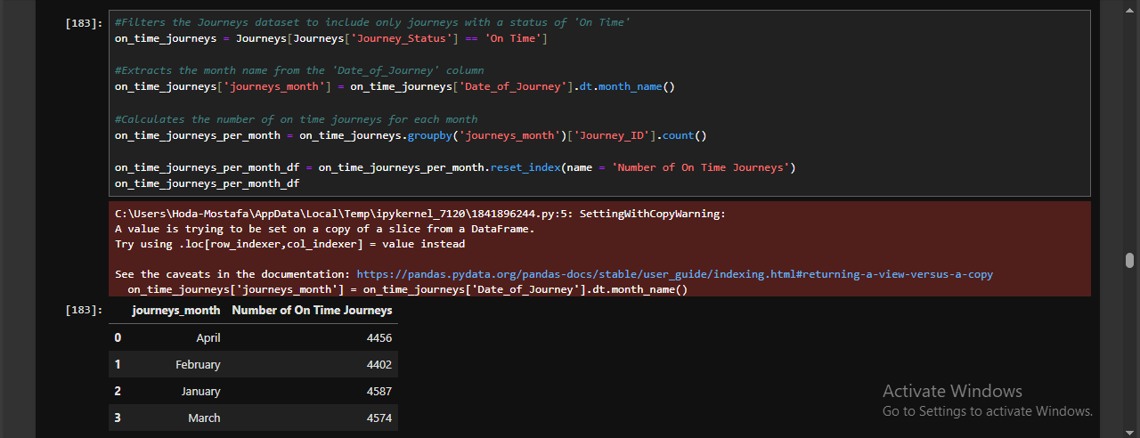
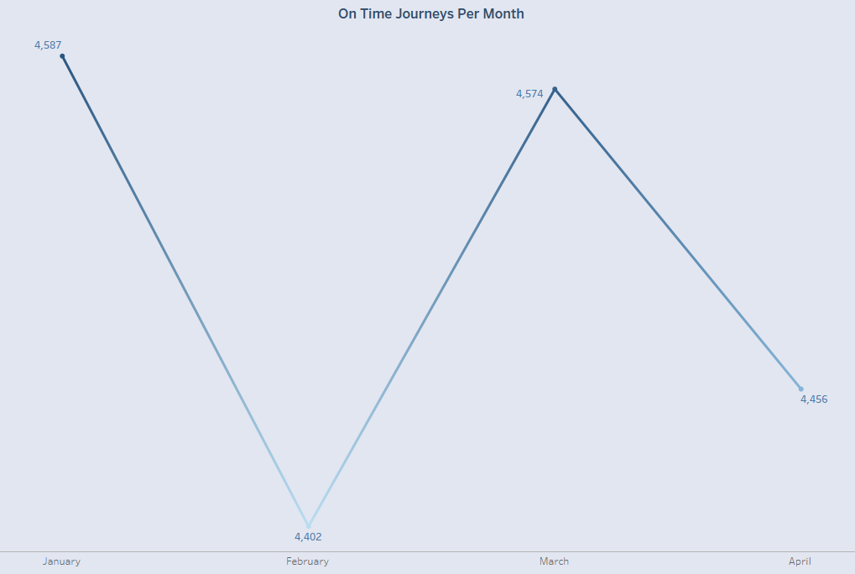

- On-Time Journey Percentage per Month:
- January: 90.65%
- February: 90.97%
- March: 89.99%
- April: 91.14%
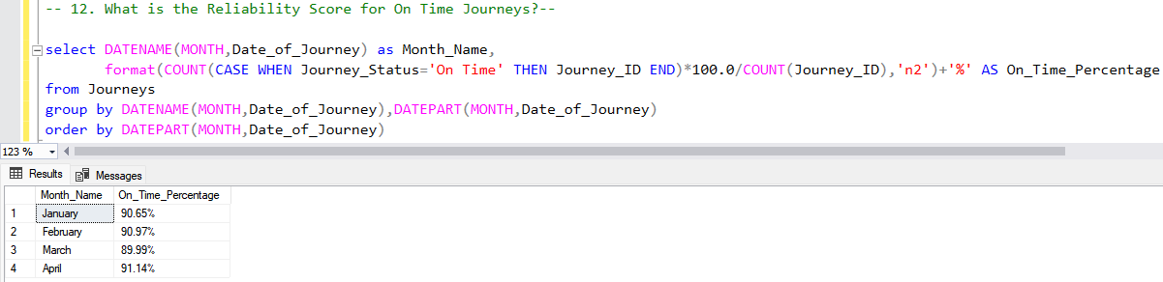
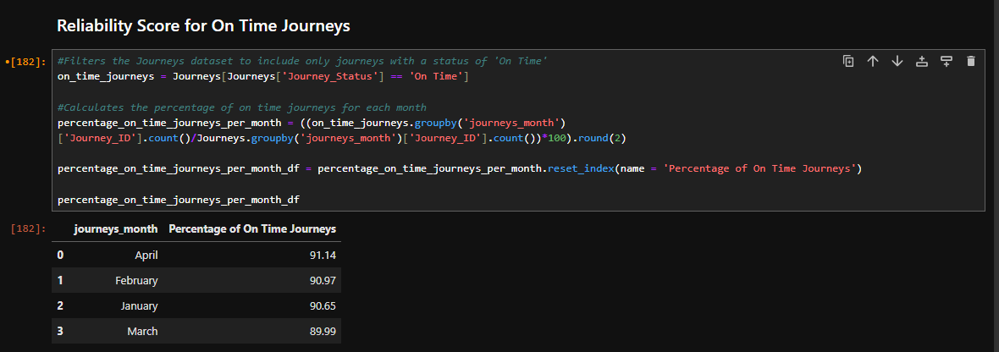
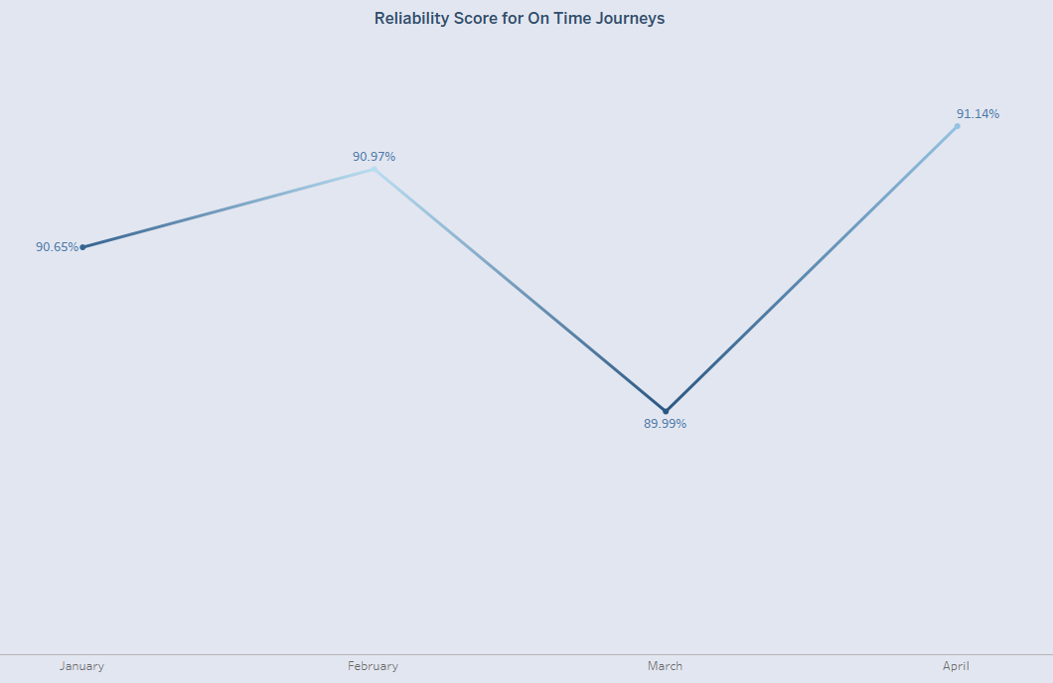

- Journeys per Day:
  - Tuesday: 2,950 journeys (highest)
  - Friday: 2,295 journeys (lowest)
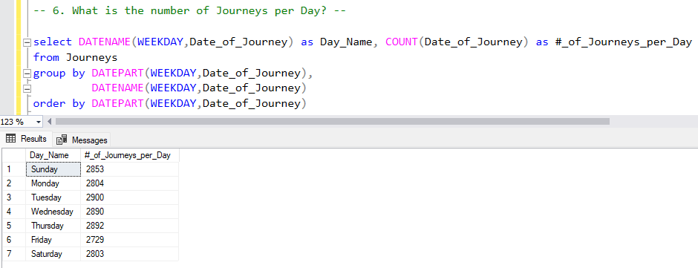
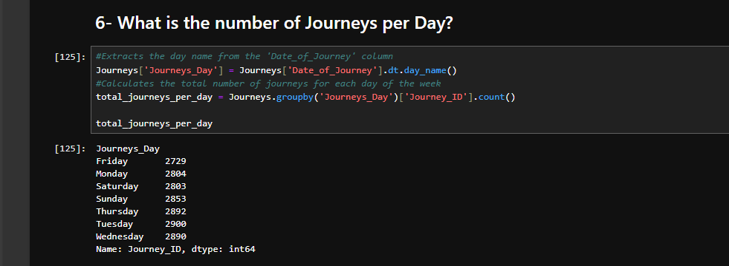
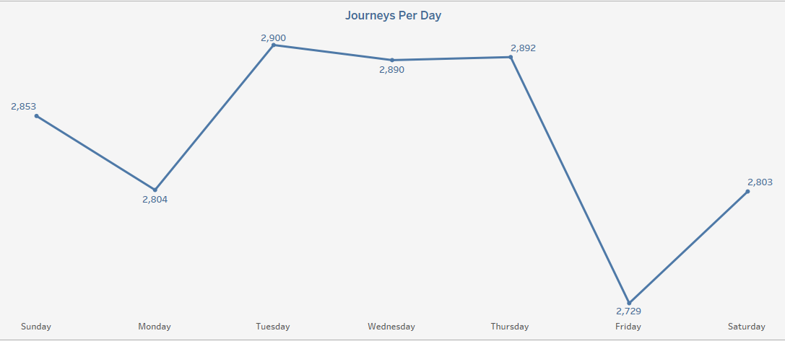

- Distribution of Journeys by Delay Reasons
Delay Reason | # of Journeys
Weather Conditions | 466
Staff Shortage | 437
Signal Failure | 424
Technical Issue | 373
Traffic | 152
These factors contribute to the majority of journey delays, with weather conditions being the most common cause.
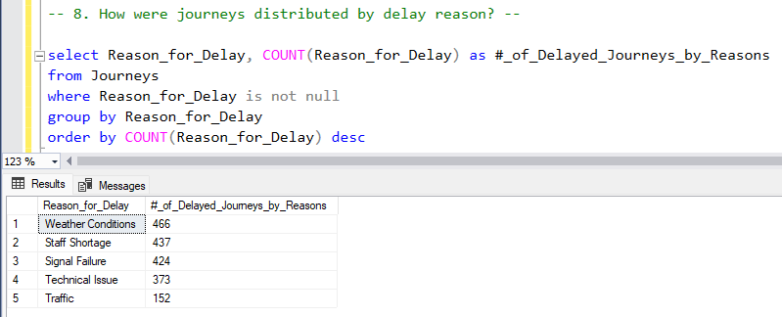
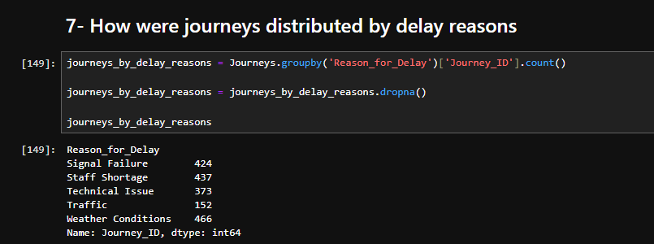
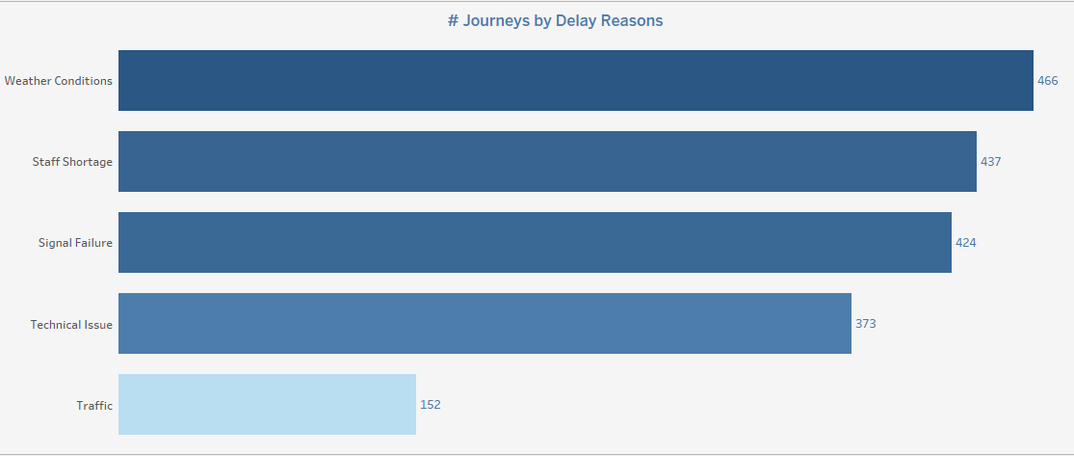

- Number of Transactions on Cancelled and Delayed Journeys + Refunds of Them
- Cancelled Journeys: 1,880 passengers, and its refund requests is 572.
- Delayed Journeys: 2,292 passengers, and its refund requests is 546.
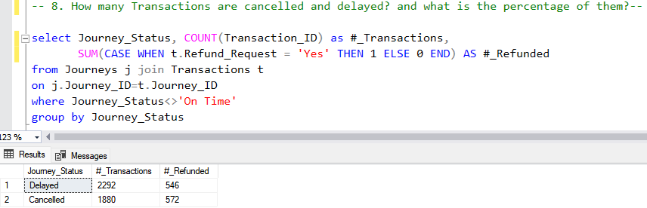
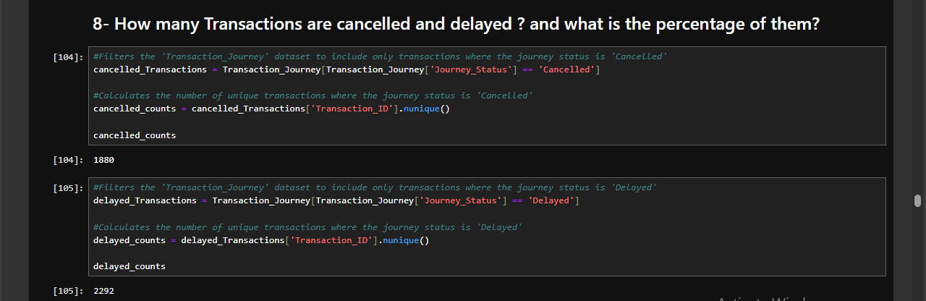
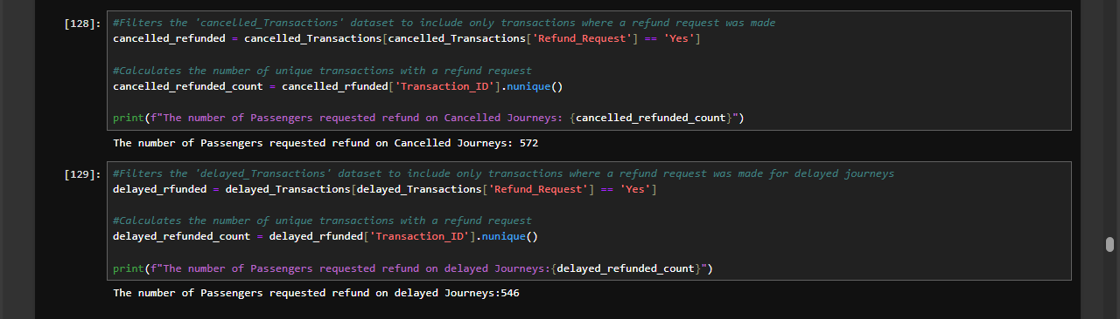
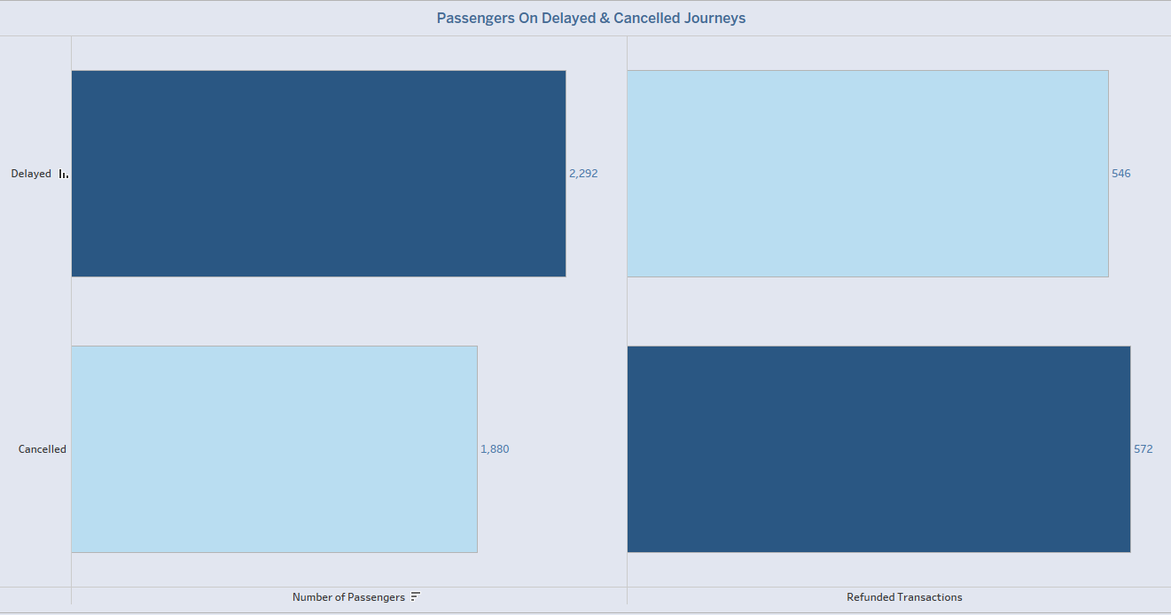

Average Journeys per Day by Day Type:
- Weekend: 166.4 journeys per day
- Workday: 165.8 journeys per day
- Holiday: 96.3 journeys per day
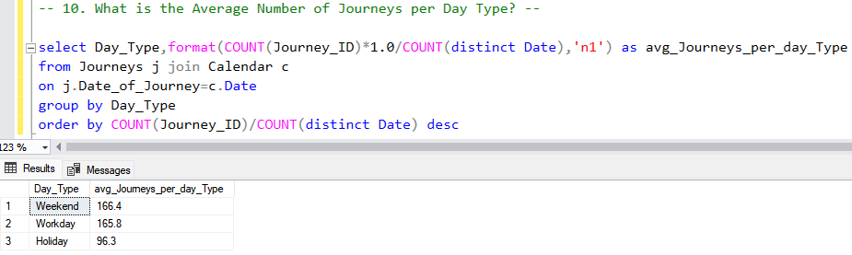
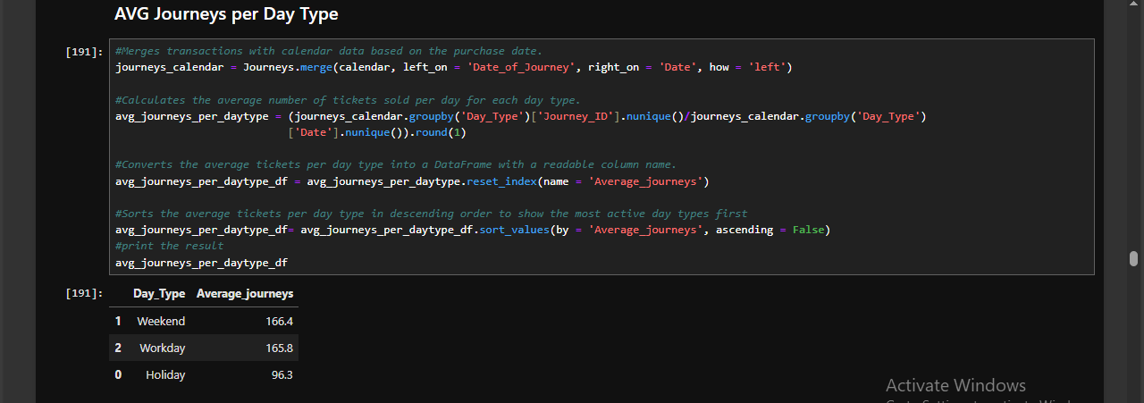
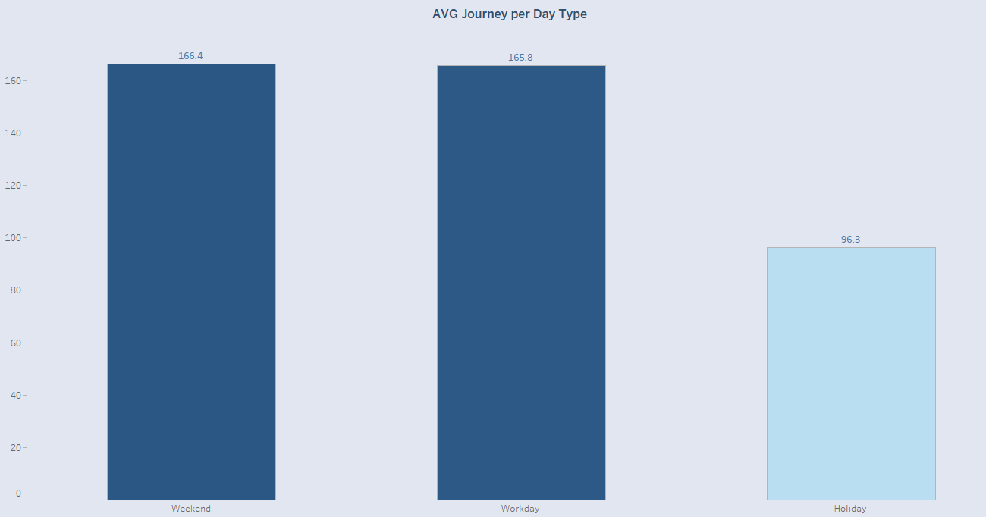

- Average Delay Duration
- Average Delay Time: 00:37:44
This indicates that, on average, delayed journeys experience a 37-minute and 44-second delay.
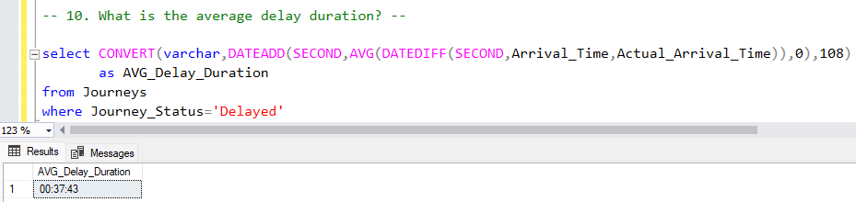
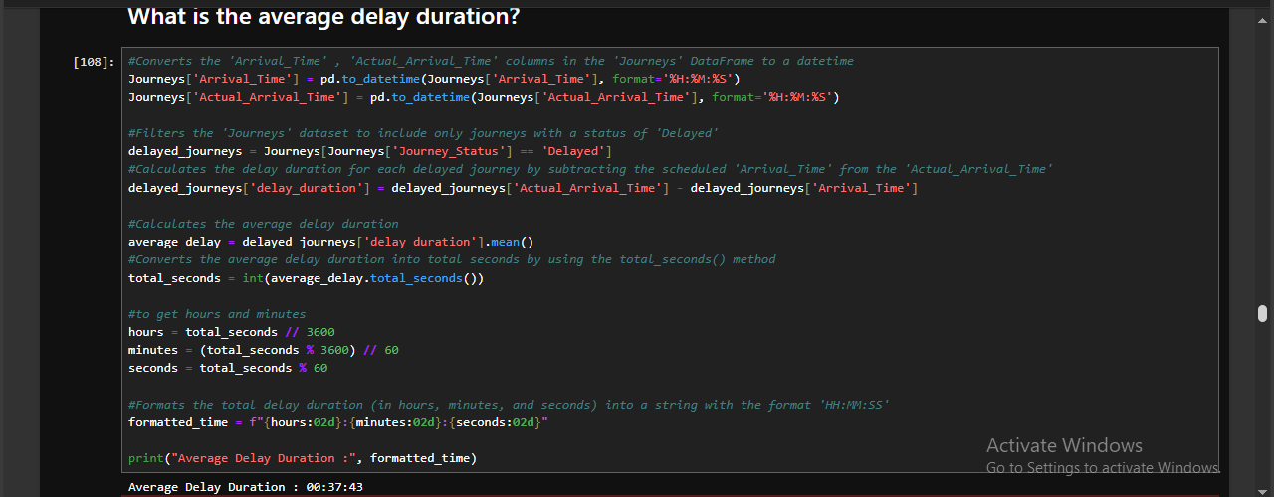
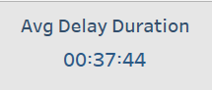

Conclusion
The railway network achieved a high punctuality rate with over 90% on-time journeys. However, delays and cancellations still impacted 1,852 journeys combined, largely due to uncontrollable external factors like weather and operational constraints such as staff shortages and signal failures.
Understanding peak delay causes can assist with future planning, resource allocation, and risk mitigation strategies to improve service reliability.

Routes & Stations Analysis

- Number of Routes
The total number of routes is 64.
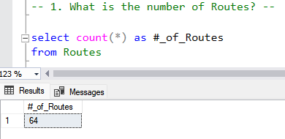
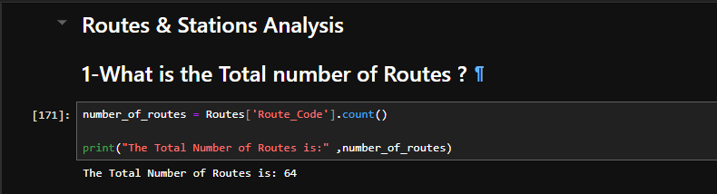
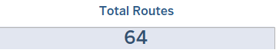

- Number of Departure and Arrival Stations
- Departure Stations: 12
- Arrival Stations: 31
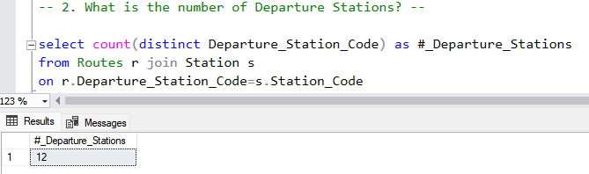
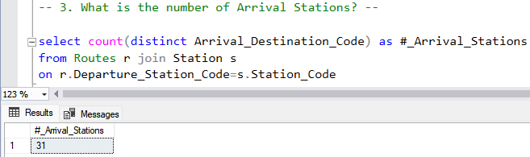
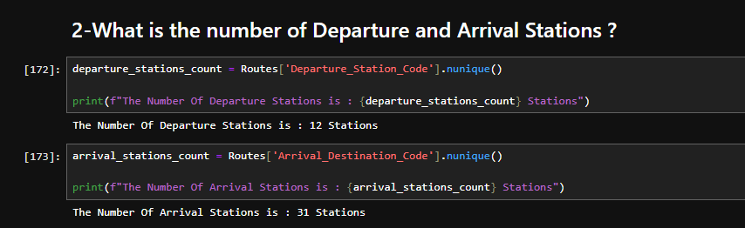
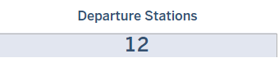

- Top 5 Used Departure and Arrival Stations
- Top Departure Stations:
  - Manchester Piccadilly – 3,521 journeys
  - London Euston – 3,059 journeys
  - Liverpool Lime Street – 2,997 journeys
  - London Paddington – 2,643 journeys
  - London Kings Cross – 2,625 journeys
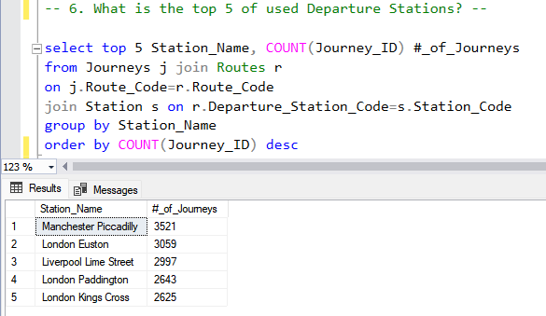
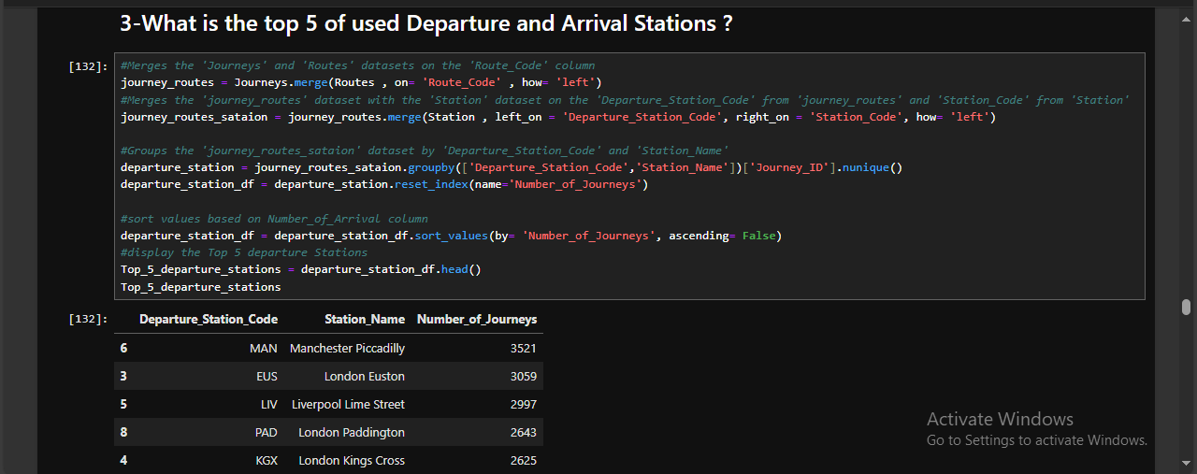
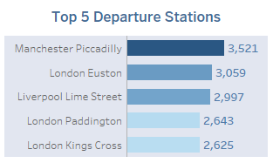

- Top Arrival Stations:
  - Birmingham New Street – 4,680 journeys
  - Liverpool Lime Street – 3,042 journeys
  - Manchester Piccadilly – 2,946 journeys
  - York – 2,480 journeys
  - Reading – 2,457 journeys
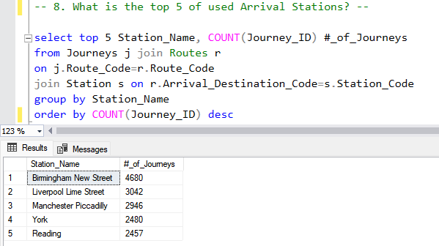
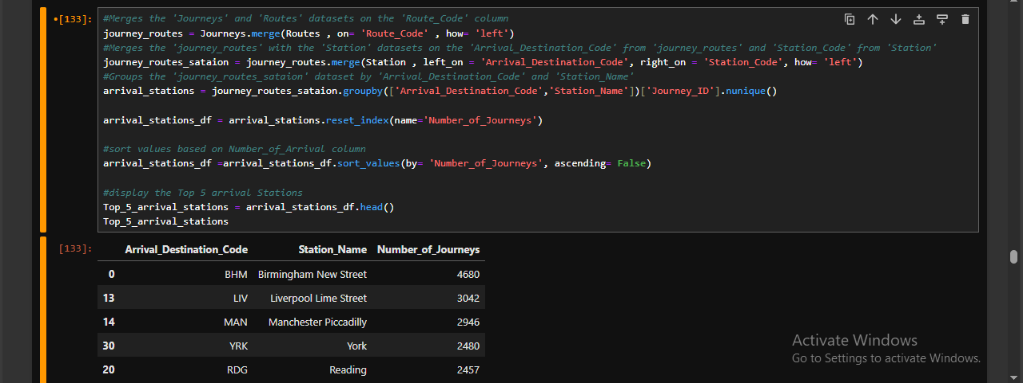
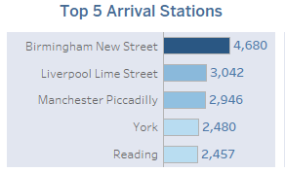

- Top 5 Routes by Number of Journeys
Route | Number of Journeys
MAN–LIV | 2,675
EUS–BHM | 2,515
PAD–RDG | 2,412
KGX–YRK | 2,400
LIV–MAN | 2,267
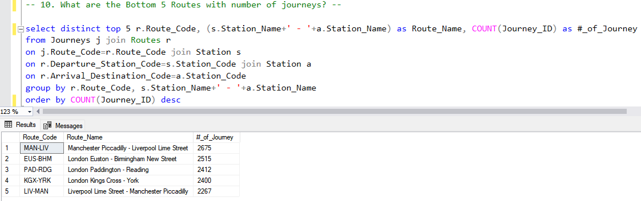
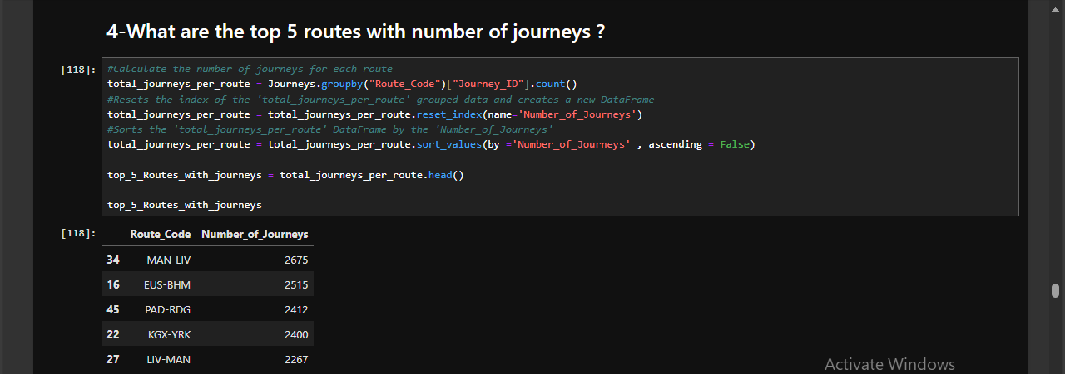

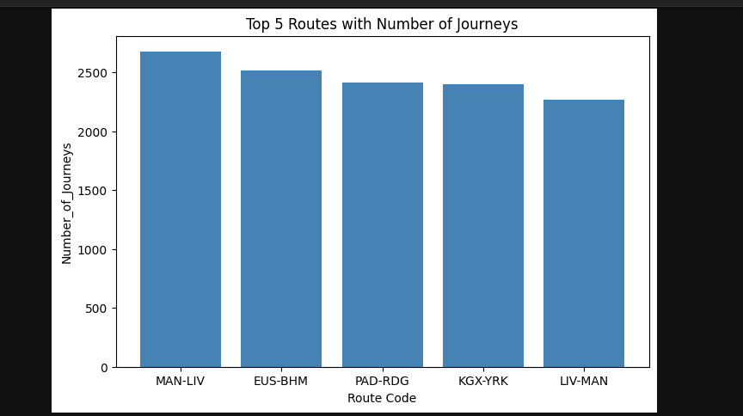
- Bottom 5 Routes by Number of Journeys
Route | Number of Journeys
BRI–CDF | 15
LIV–BHM | 14
YRK–LIV | 13
MAN–WAC | 13
MAN–YRK | 12
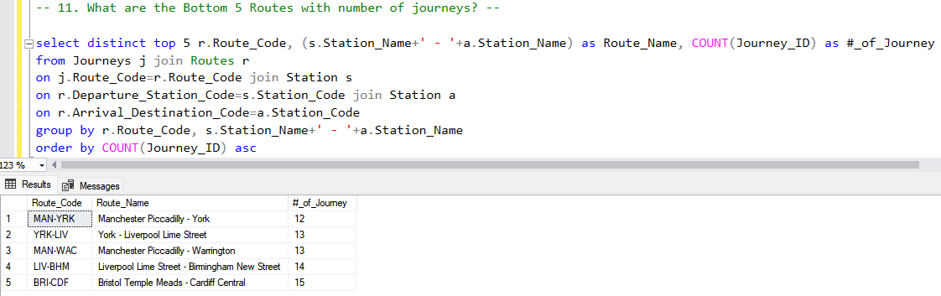
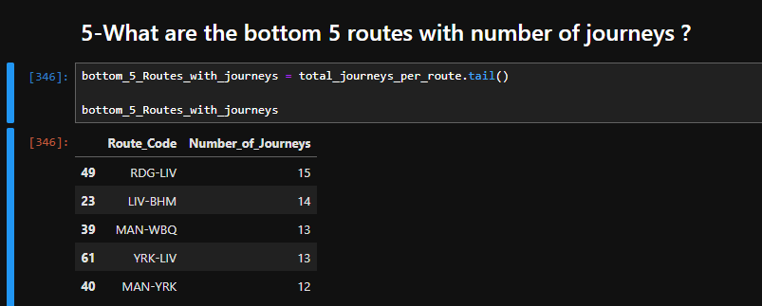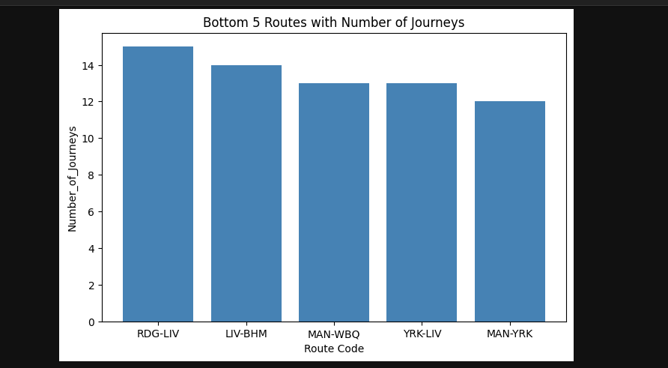
These routes reflect the lowest utilization, indicating either lower demand or reduced frequency.

- Top 5 Routes with Highest Percentage of Delays
Route | Delay Percentage
YRK–WKF | 100%
EUS–YRK | 100%
EDB–KGX | 100%
MAN–EUS | 66%
LIV–EUS | 56%
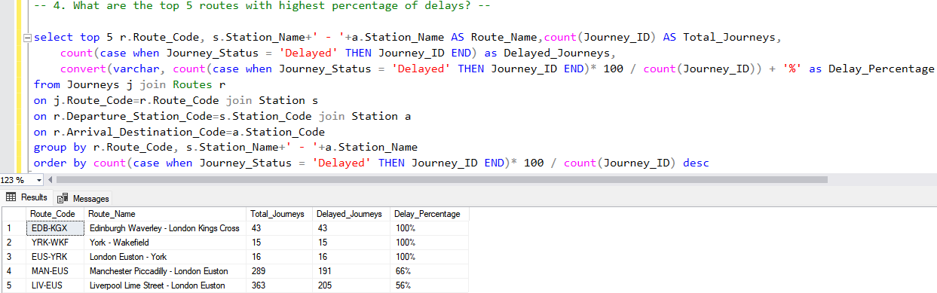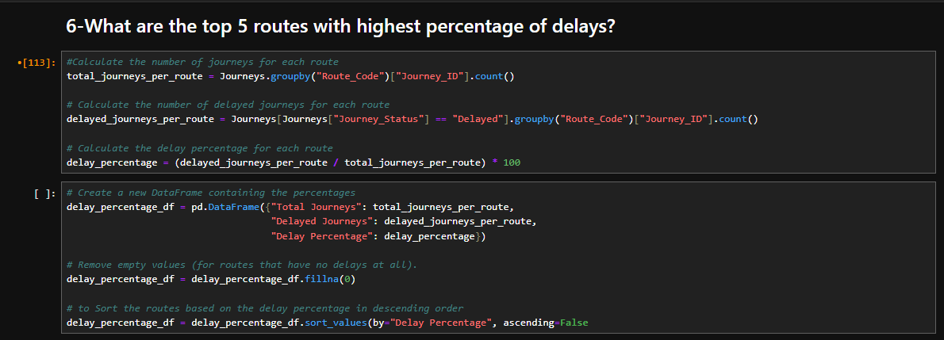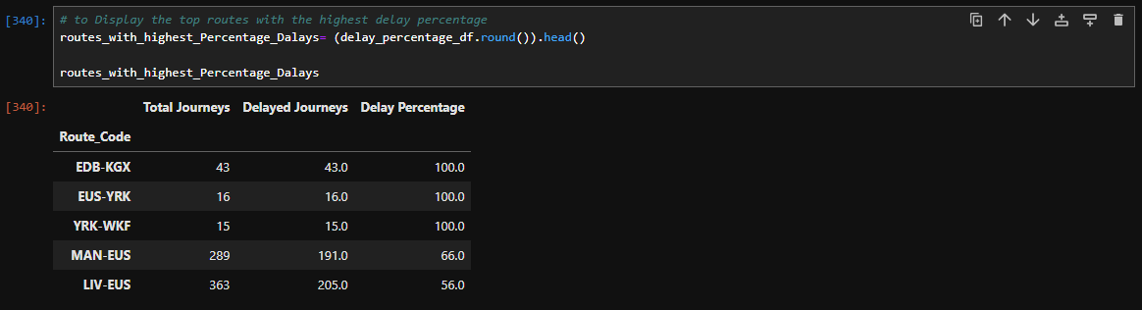
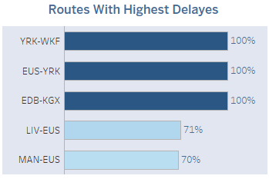
Three of these routes experience delays on every journey, highlighting significant reliability issues.

- Top 5 Routes with Highest Percentage of Cancellations
Route | Cancellation Rate
LIV-BHM | 14%
PAD-OXF | 11%
RDG-DID | 11%
BHM-PAD | 10%
LIV-STP | 10%
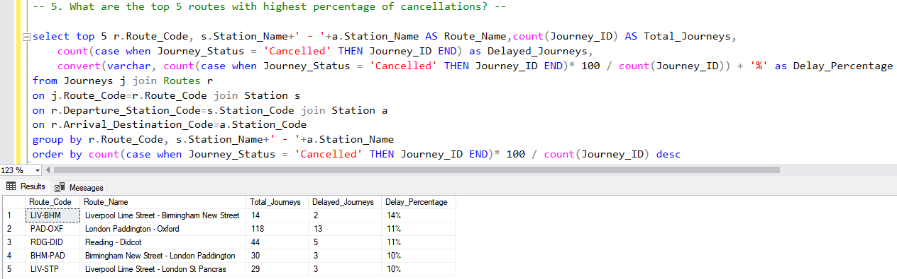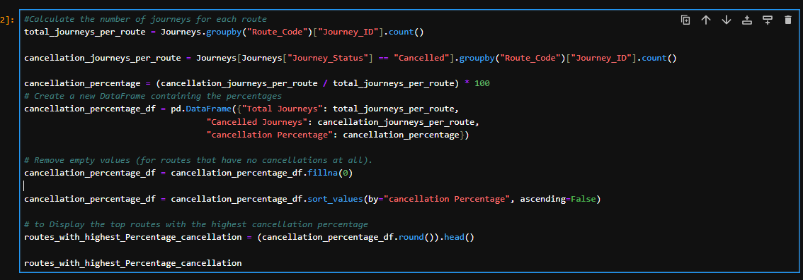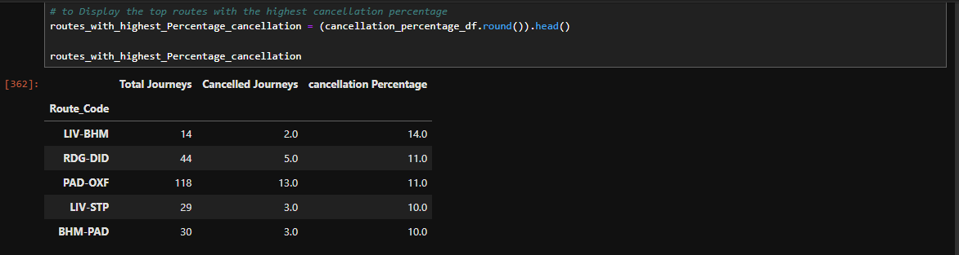
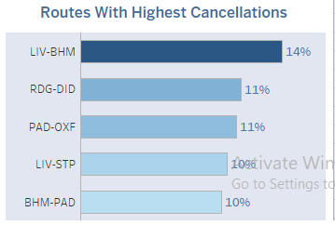
These routes have the highest disruption rates due to cancellations, suggesting a need for operational improvements or contingency planning.

Conclusion
- Manchester Piccadilly remains the most active departure station, while Birmingham New Street is the top arrival station.
- Certain routes show excellent traffic but suffer from extreme delay rates, particularly YRK–WKF, EUS–YRK, and EDB–KGX, all with 100% delays.
- Routes such as LIV–BHM and PAD–OXF exhibit both significant journey volumes and high cancellation percentages, indicating service reliability challenges.

Sales & financial Analysis

- Total Revenue and Net Revenue
Metric | Amount (USD)
Total Revenue | $741,921
Total Refunded | $38,702
Net Revenue | $703,219
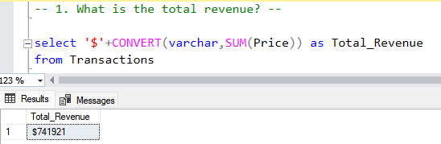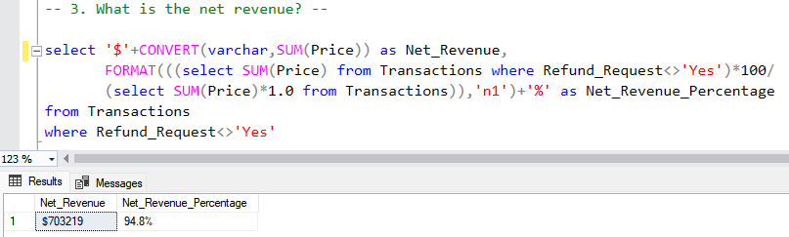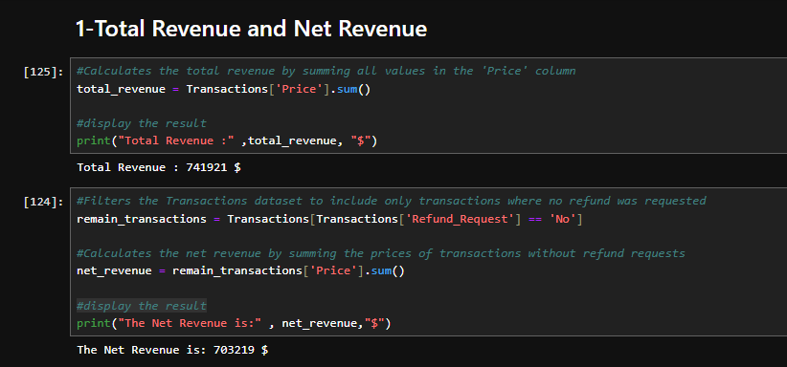
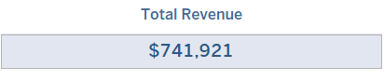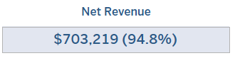These figures reflect total income from ticket sales, the refunds processed, and the resultant net income (Net Revenue is calculated after deducting refunds from total revenue).

- Total Refunded
- $38,702
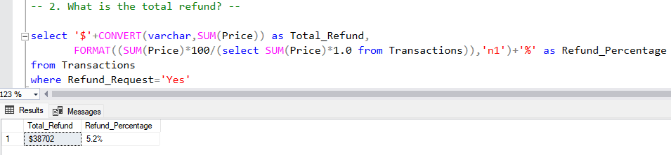
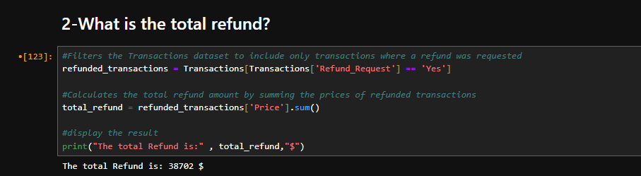
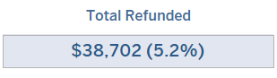
This represents the cumulative amount refunded due to cancelled or delayed journeys.

- What are the Top 5 Routes with Revenue?
Route | Route
KGX-YRK | $ 179,498
LIV-EUS | $ 100,173
PAD-RDG | $ 63,841
EUS-MAN | $ 59,320
STP-BHM | $ 52,038
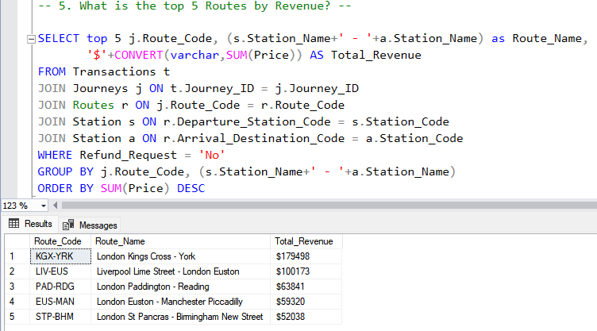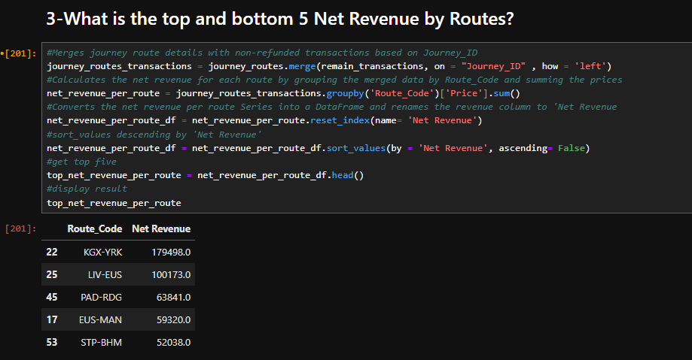
- KGX-YRK (London Kings Cross to London York) generates the highest revenue and likely serves as a major commuter or intercity corridor.

What are the Bottom 5 Routes with Revenue?
Route | Revenue (USD)
YRK–LDS | $78
BHM–WVH | $59
MAN–WAC | $53
EUS–OXF | $41
EDB–KGX | $0

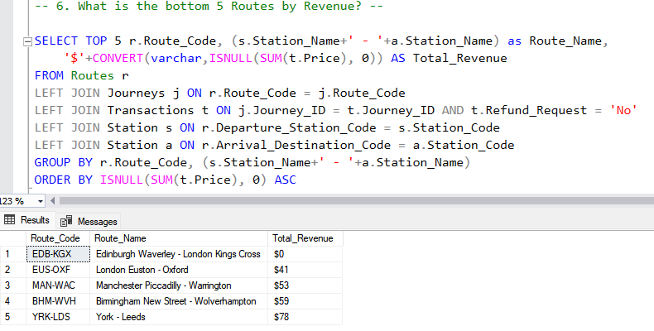

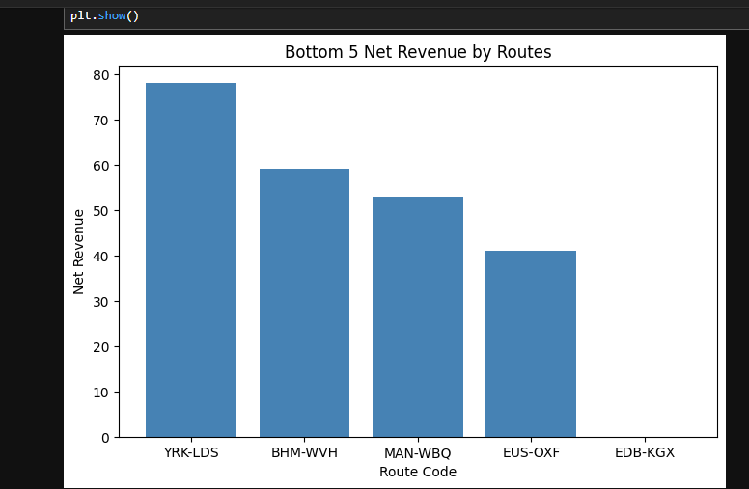
- These routes may be experiencing low passenger demand, limited-service frequency, or short travel distances affecting pricing.
- The Zero value for EDB–KGX highlights that all routes have refund requests so the Net Revenue equals Zero.

- Average Ticket Price
- $23.4
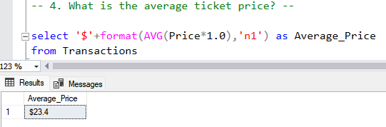
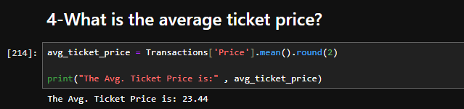
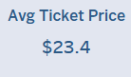
This value represents the mean ticket price across all routes and ticket types.

- Net Revenue Distribution by Payment Method
Payment Method | Revenue (USD)
Credit Card | $460.5K
Contactless | $214.5K
Debit Card | $28.2K
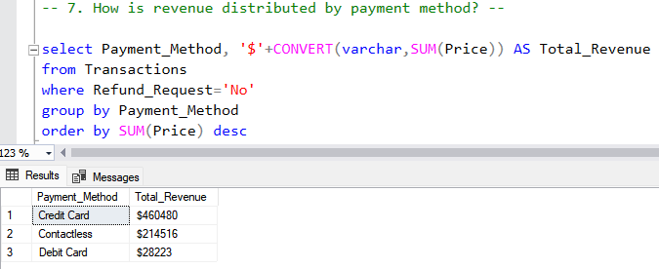
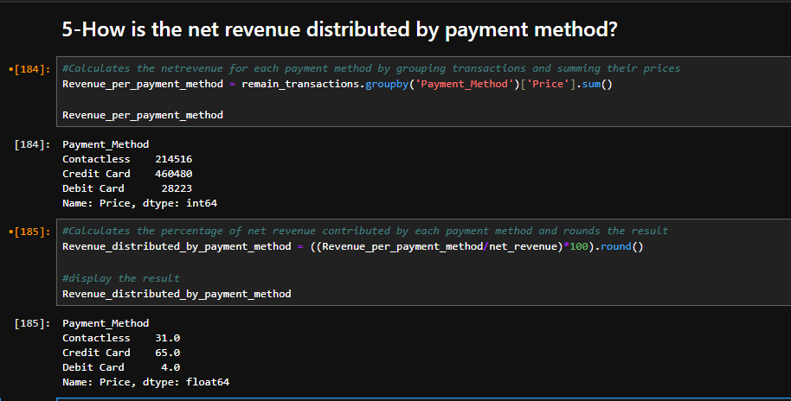
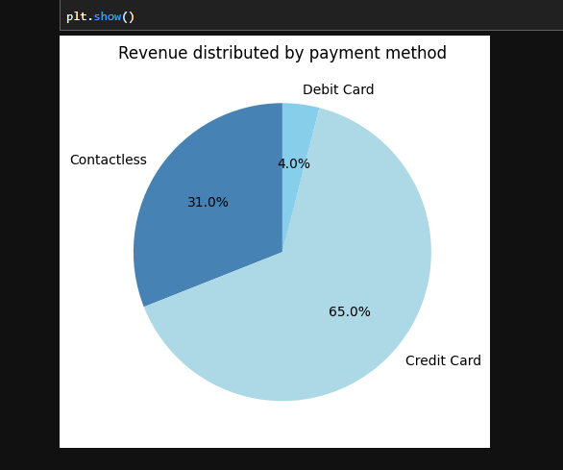
Credit cards dominate as the preferred payment method, accounting for over 62% of total revenue.

- Net Revenue Distribution by Purchase Type
Purchase Type | Revenue (USD)
Online | $374.5K
Station | $328.7K
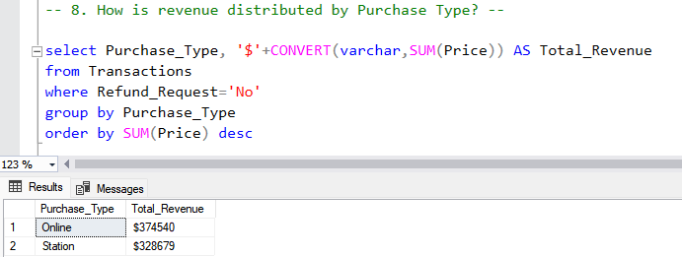
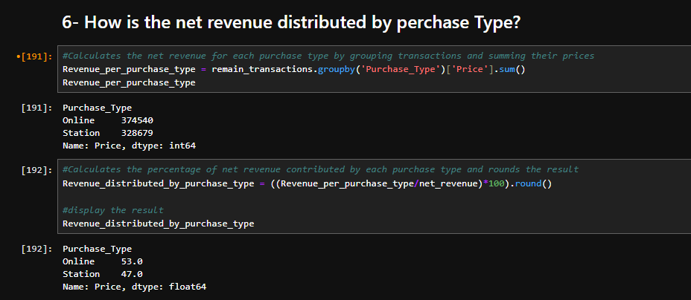
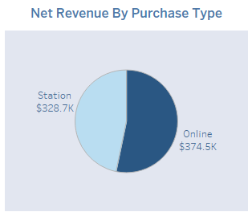
Online purchases slightly exceed station-based purchases, indicating a shift toward digital channels.

- Net Revenue Distribution by Ticket Type
Ticket Type | Revenue (USD)
Advance | $293.6K
Anytime | $200.4K
Off-Peak | $209.2K
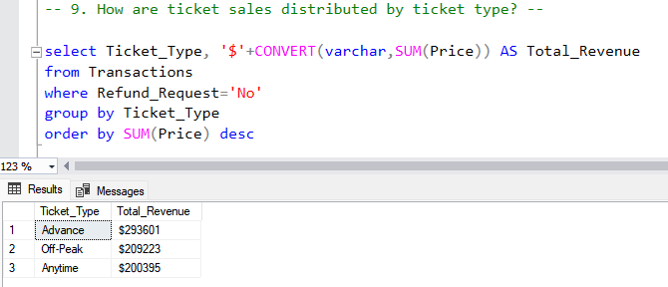
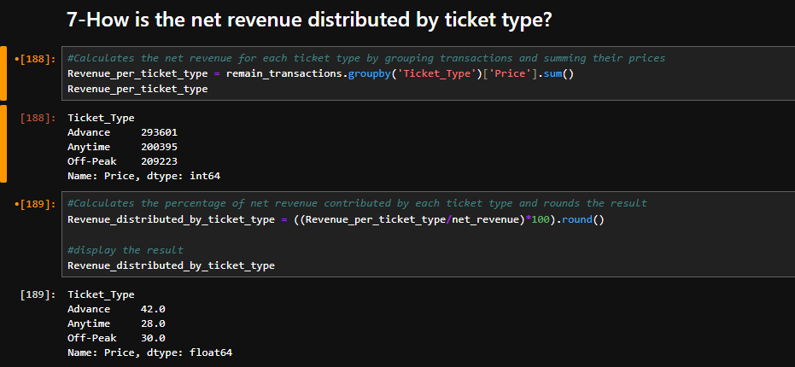
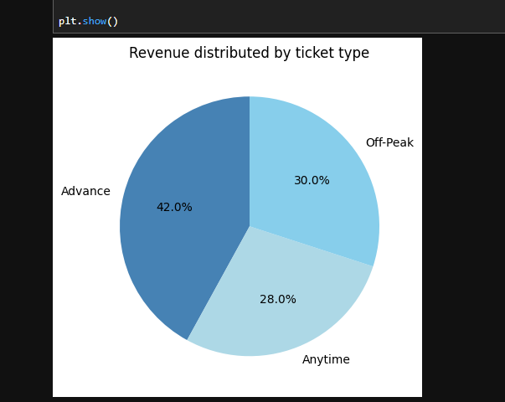
- Advance tickets generate the most revenue, likely due to volume and promotional pricing strategies.

- Monthly Trend of Net Revenue
Month | Net Revenue (USD)
January | $188,612
February | $131,529
March | $184,593
April | $178,485
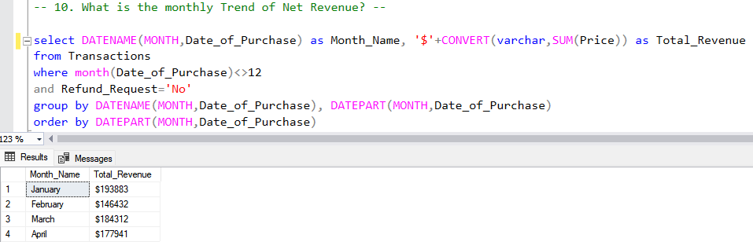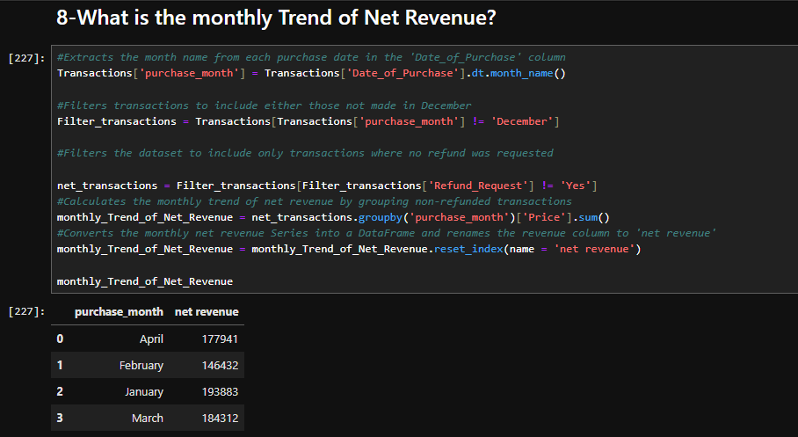
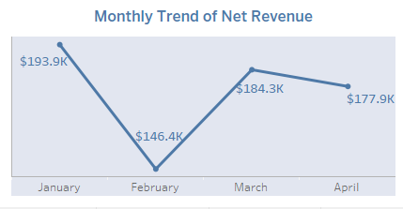
- A significant drop in February may correlate with service delays or seasonal factors, followed by a recovery in March.

- total refund by journey statues
  - Cancelled = 12,537 $
  - Delayed = 26,165 $
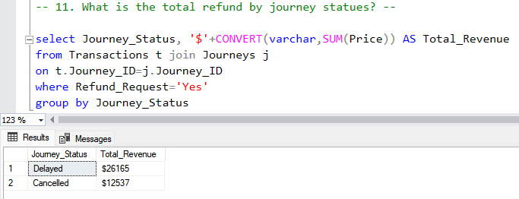
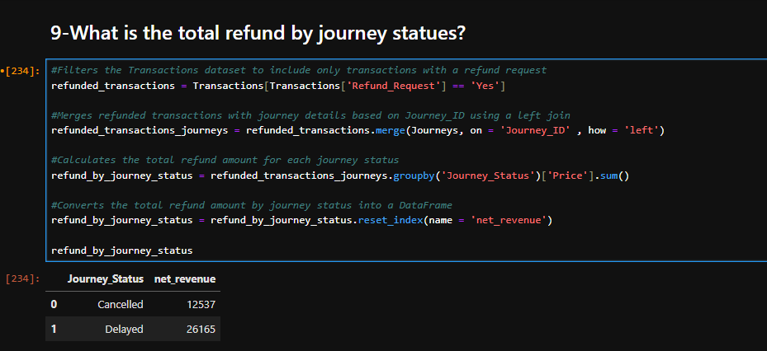
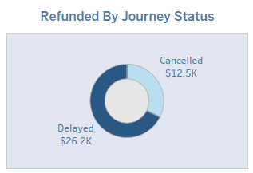

- Net Revenue by Day Type:
- Workday: $6,029
- Weekend: $5,510
- Holiday: $3,122
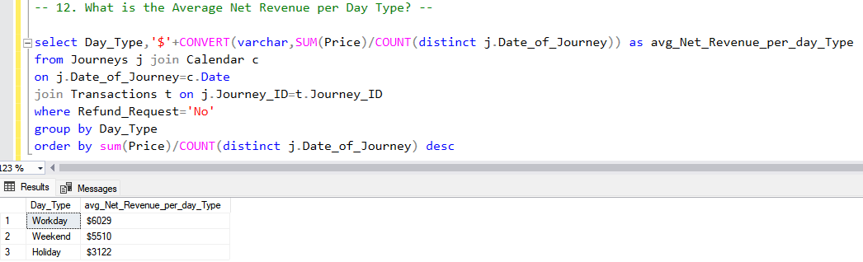
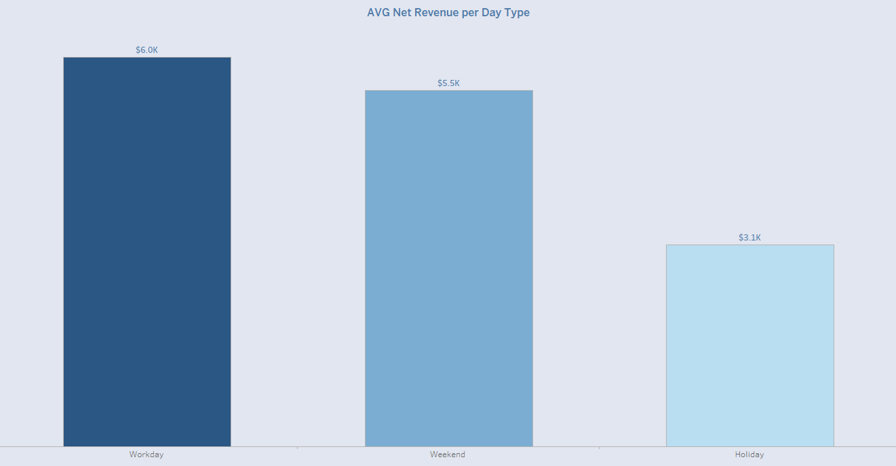

- Revenue by Journey Status:
- On Time: $569,651 (81%)
- Delayed: $100,649 (14%)
- Cancelled: $32,919 (5%)
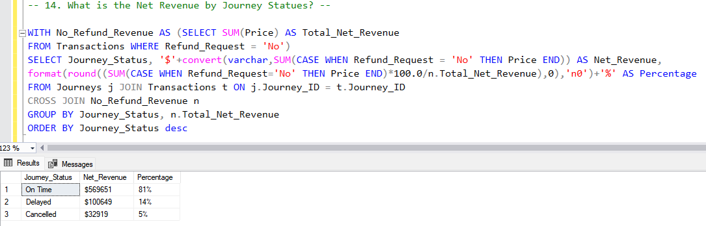
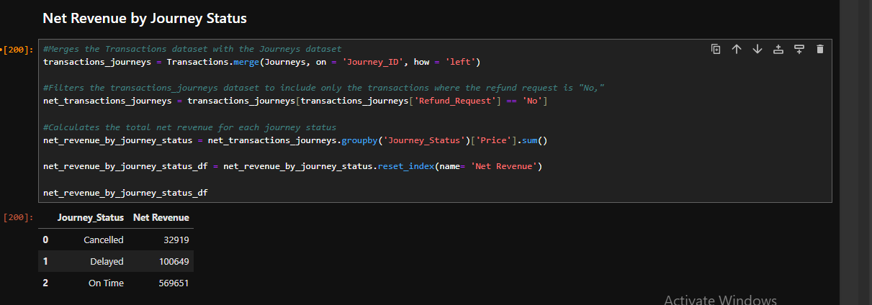
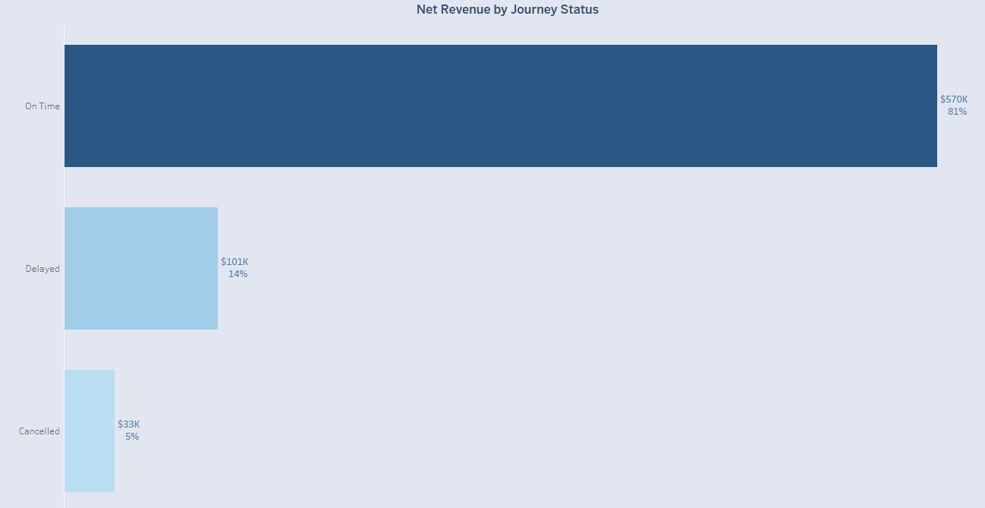

- Revenue by Delay Category:
- 0 mins: $678
- 1–15 mins: $9,994
- 16–30 mins: $14,080
- 31–45 mins: $1,032
- 46–60 mins: $381
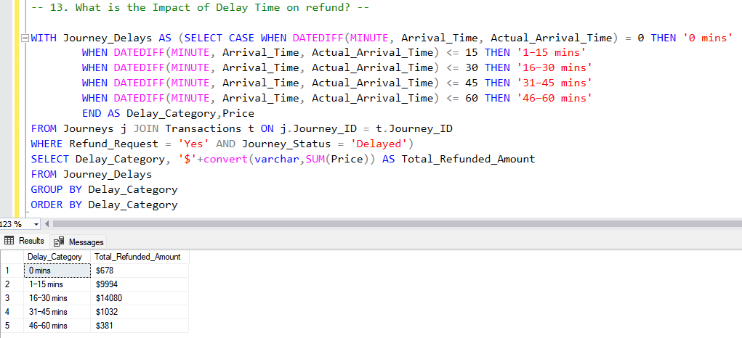
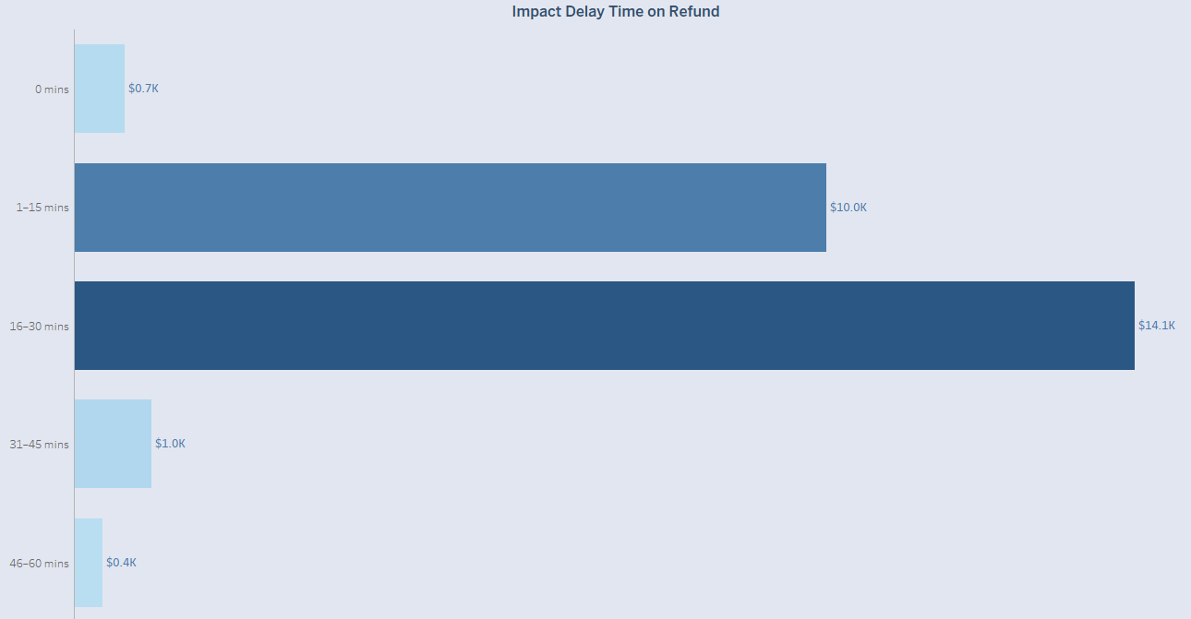

Conclusion
- Birmingham clearly acts as a major revenue hub, with multiple high-performing routes.
- On the other hand, routes like YRK–LDS and MAN–WBQ appear underutilized and may require operational review or marketing support.
- The railway service is maintaining strong digital performance with a majority of revenue coming from online purchases and credit card transactions.
- While Advance ticketing is the highest revenue segment, its pricing and promotional models should be revisited to ensure long-term profitability.
- Monitoring refund trends, especially for delayed journeys (which account for $26,165 in refunds), can help identify service weaknesses.
- Revenue dipped sharply in February mainly due to the number of days impact because February is 28 days unlike January 31 days.

8.0 Forecasting
8.1 Bookings Forecasting
- importing the neccessary libraries
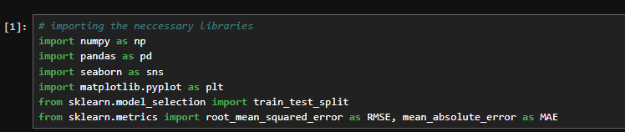
- reads the dataset, parses date columns, and displays a preview and summary of the data."
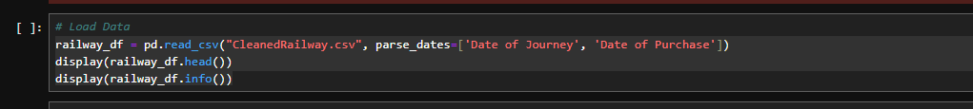
aggregates the railway data by journey date to calculate daily metrics, including:
- total bookings and unique journeys,
- number of delayed and cancelled journeys,
- total revenue and refunded amount,
- and number of first-class tickets sold
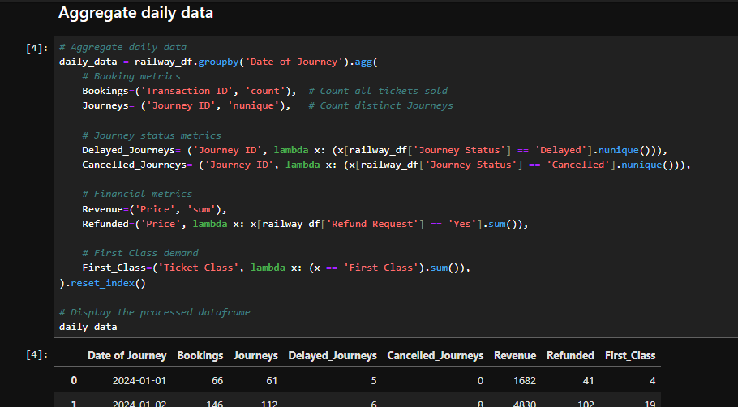

- merges calendar information with daily railway data to enrich it with date-related features, then cleans and processes the result by:
- Joining on matching dates between the calendar and transaction data.
- Removing the duplicate 'Date of Journey' column.
- Converting the day of the week into a numerical format (Monday = 0, ..., Sunday = 6)
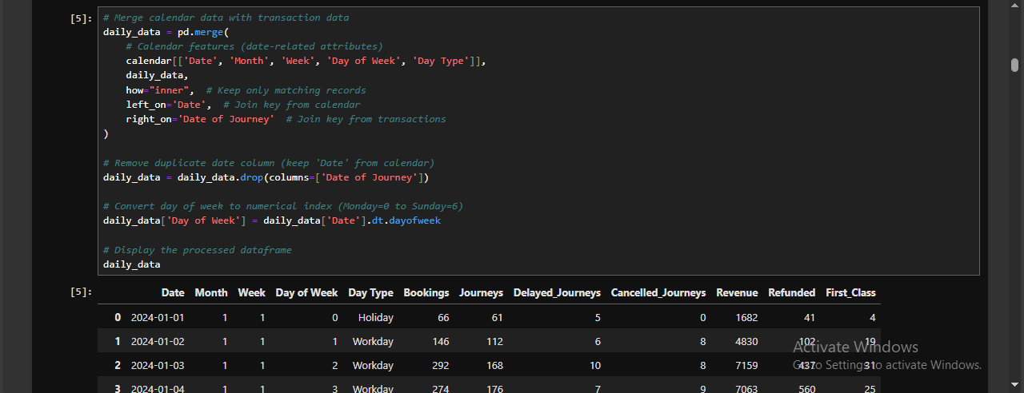
- plots daily trends for key performance metrics — Bookings, Journeys, First Class demand, and Revenue — as separate line charts using the 'Date' column as the index.
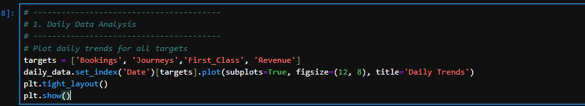
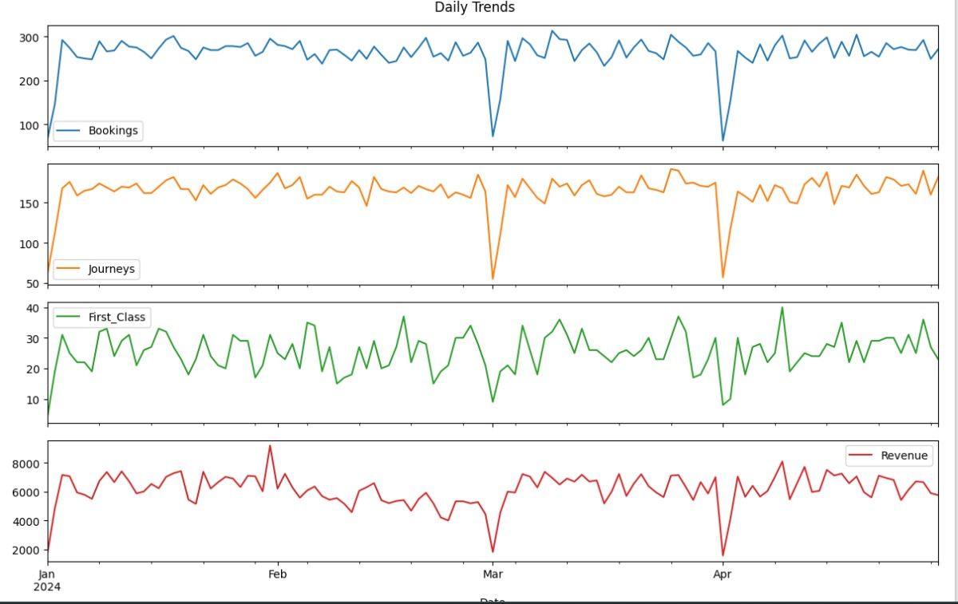
Conclusion:
There are specific days that show a sudden drop across all indicators, which likely points to days when many journeys were canceled or significant operational issues occurred. Apart from those outliers, the data shows relatively stable daily performance.
- calculates and visualizes the average number of bookings, journeys, delayed journeys, and cancelled journeys for each day type (e.g., Weekday, Weekend, Holiday).
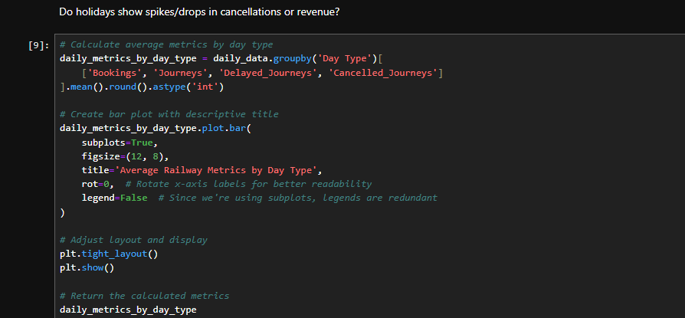
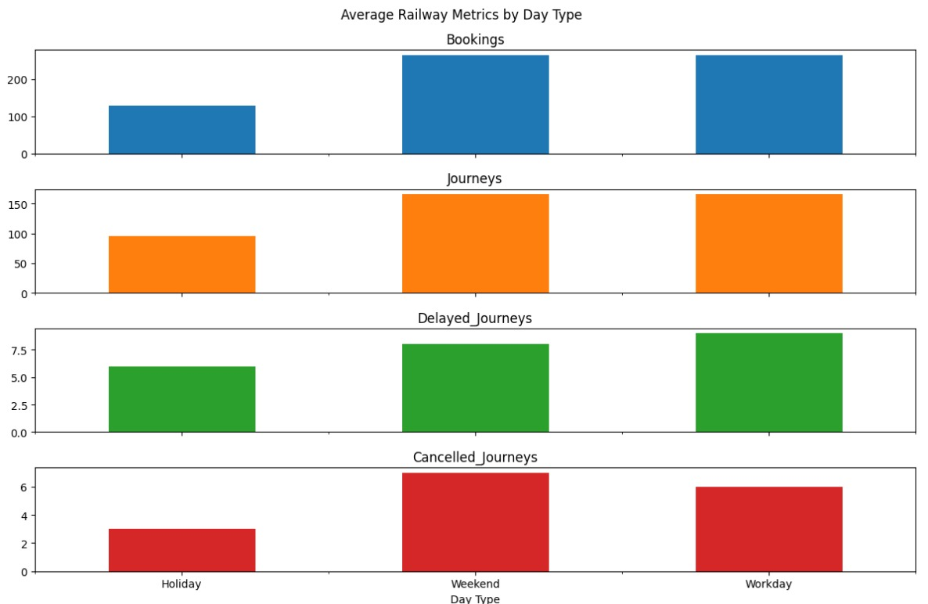
Conclusion:
Workdays and weekends are the busiest in terms of bookings and journeys, but they also experience more delays and cancellations. Holidays are generally quieter and more stable.
- groups the daily railway data by month, calculates the total number of bookings, journeys, and revenue for each month, and then plots them to show monthly trends
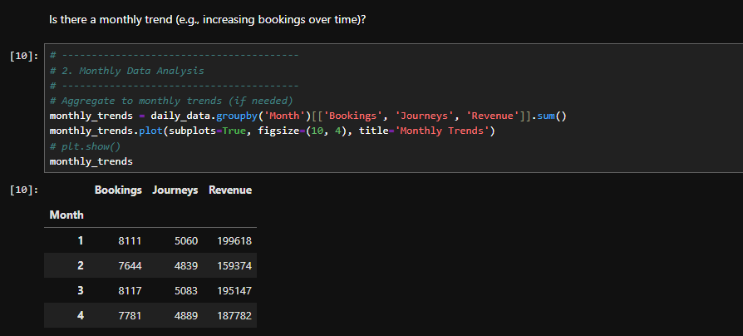
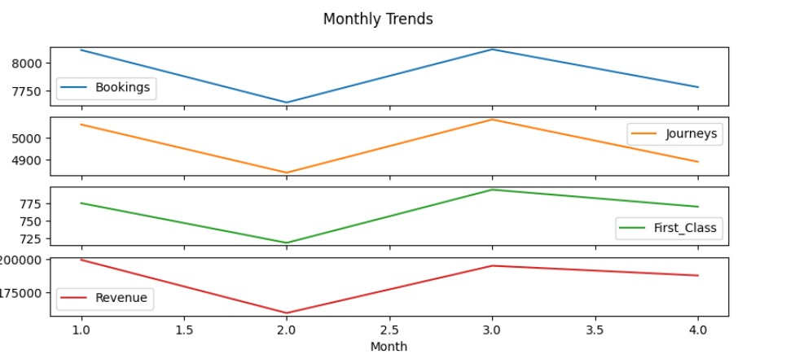
- prepares the data for machine learning by creating binary columns for weekends and holidays, and dropping the original 'Day Type' column.

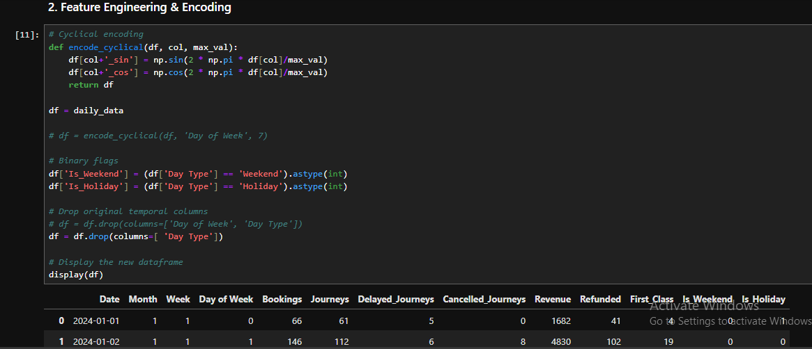

- calculates the correlation matrix for selected columns in the DataFrame and visualizes it as a heatmap using Seaborn, showing the strength and direction of relationships between variables.
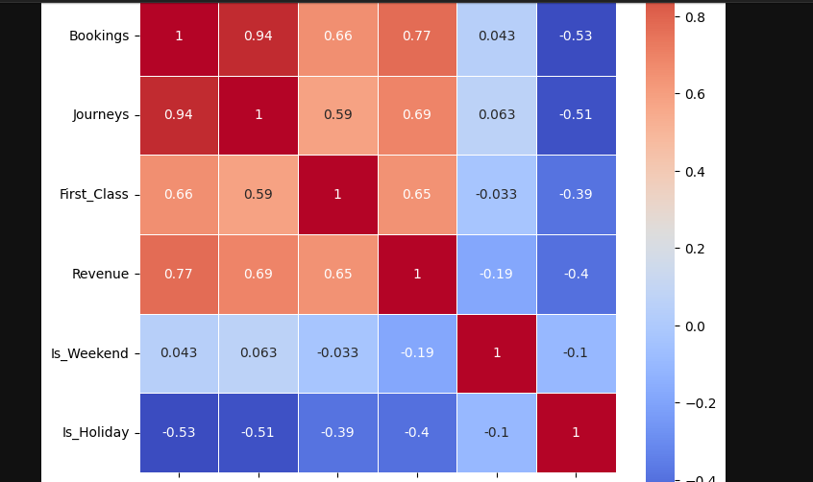

- Building the model using Prophet
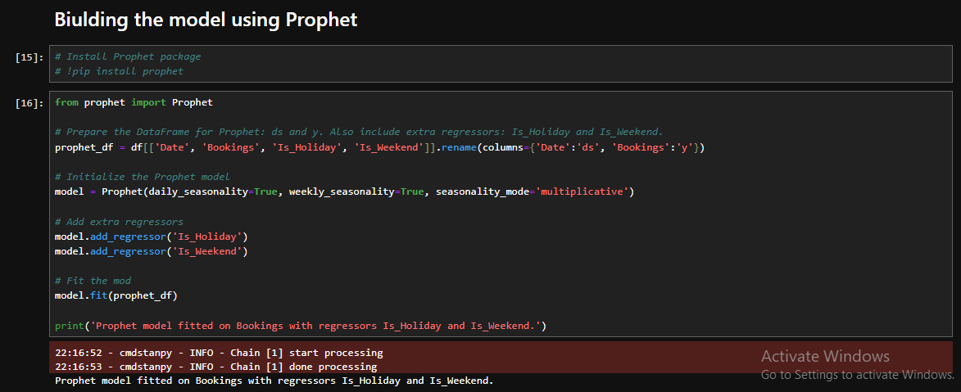
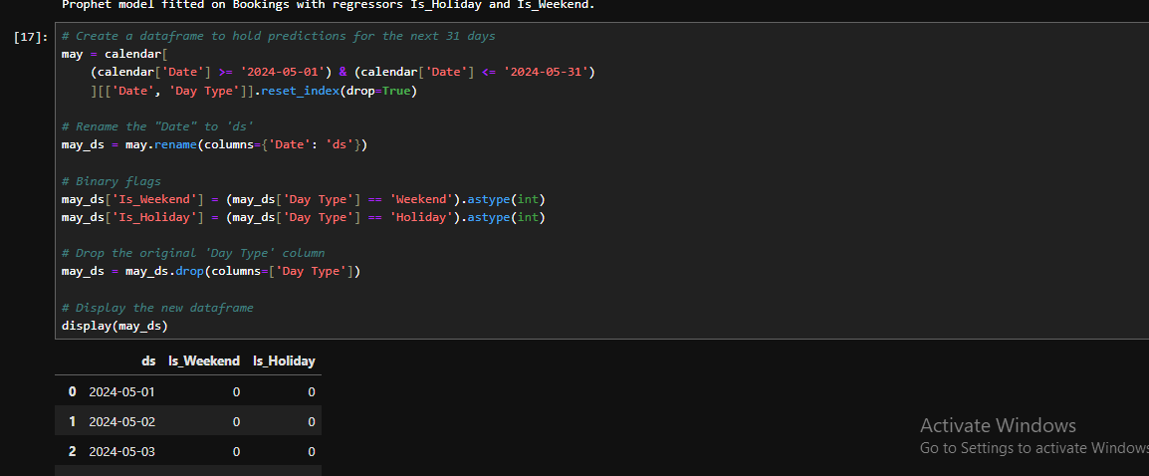
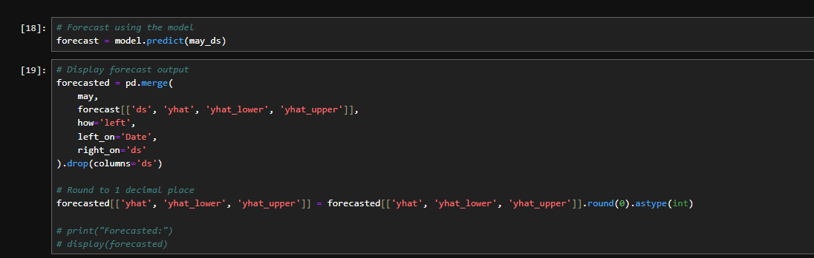
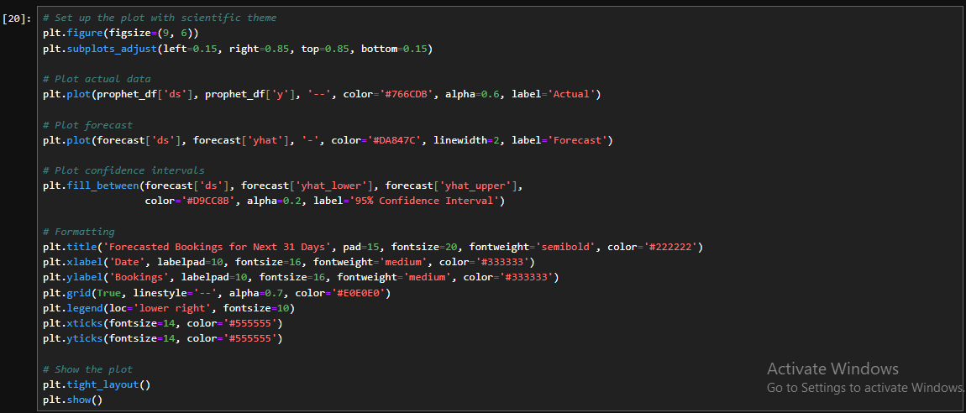

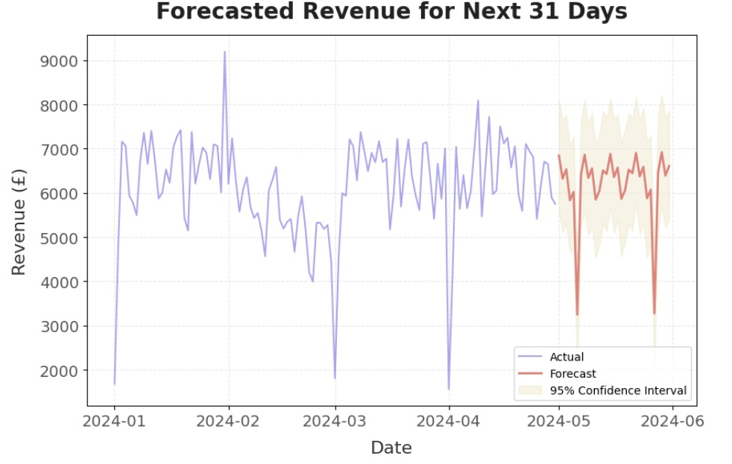

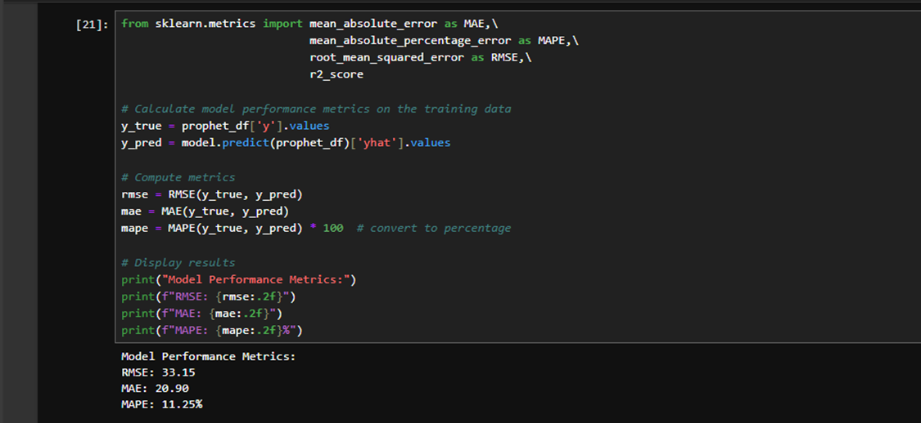Conclusion:
Based on the model performance metrics:
- RMSE (Root Mean Square Error): 33.15 - This indicates that, on average, our predictions deviate from actual values by about 33 bookings. Given that the average number of bookings appears to be around 260-290 per day, this represents roughly a 10-15% error margin.
- MAE (Mean Absolute Error): 20.9 - On average, our predictions are off by about 21 bookings in either direction.
- MAPE (Mean Absolute Percentage Error): 11.25% - This is perhaps the most intuitive metric, showing that our predictions are typically within 11.25% of the actual values, which is reasonably good for time series forecasting.
The forecast shows a relatively stable pattern with appropriate confidence intervals for the next 31 days. The model has incorporated both weekend effects and holiday impacts

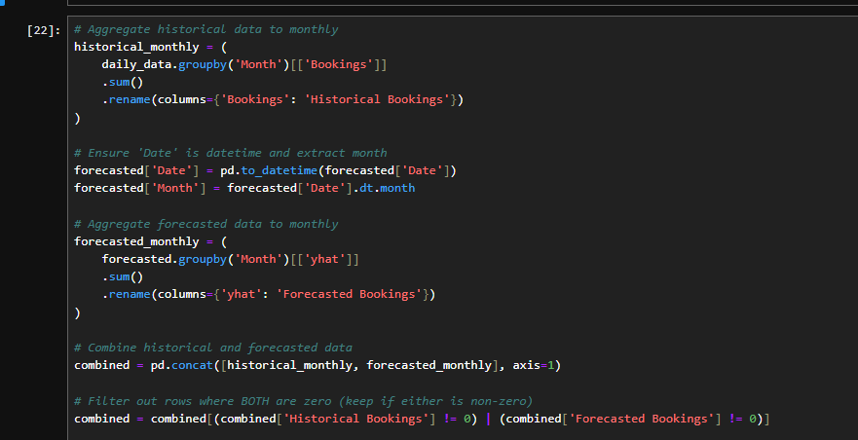
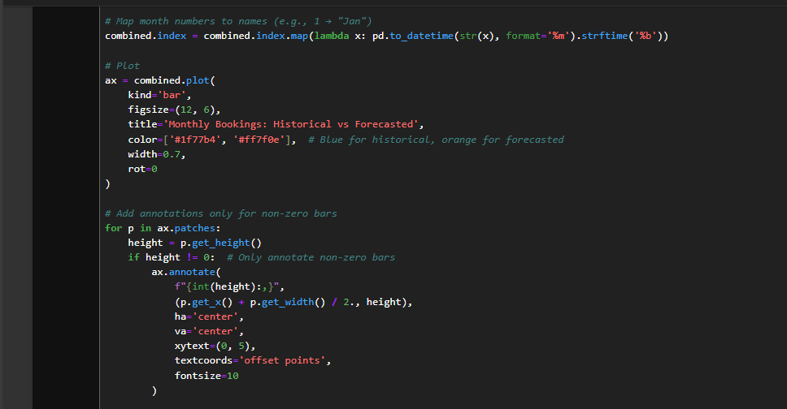

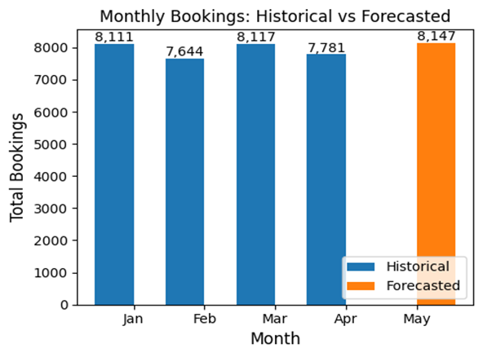
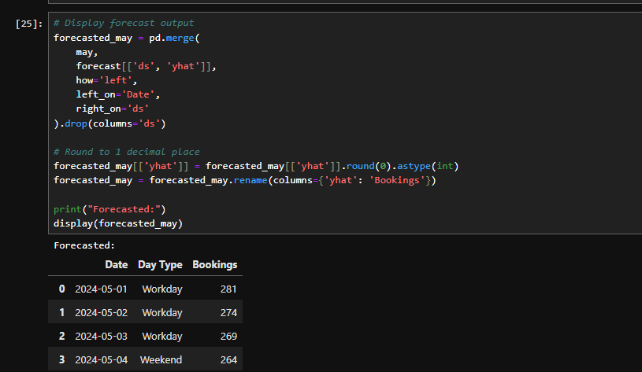
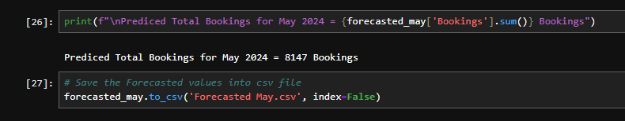
Conclusion: Predicted Total Bookings for May 2024 = 8147 Bookings.

8.2 First Class Forecasting
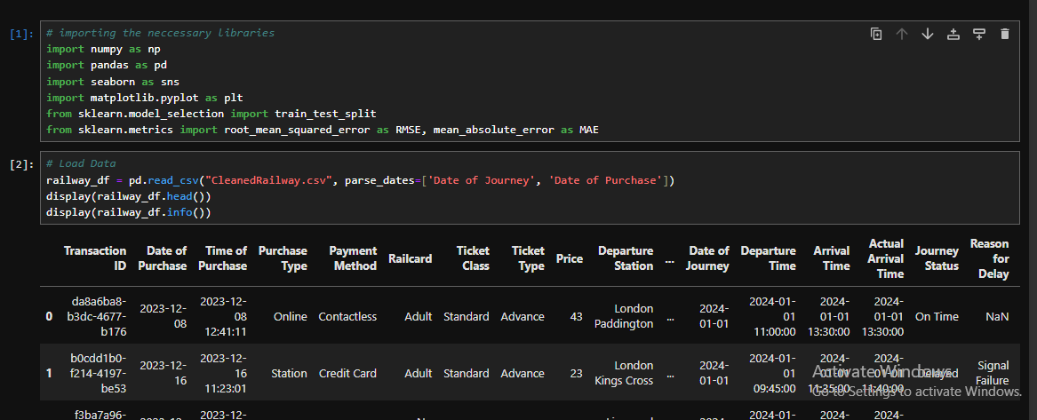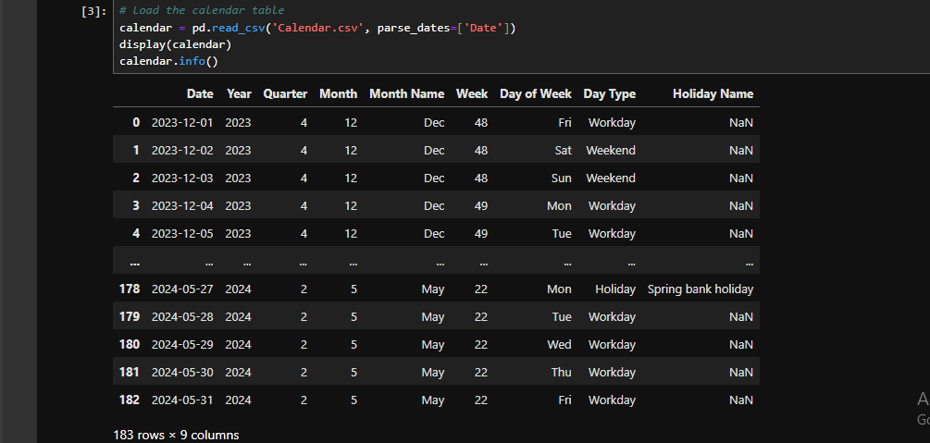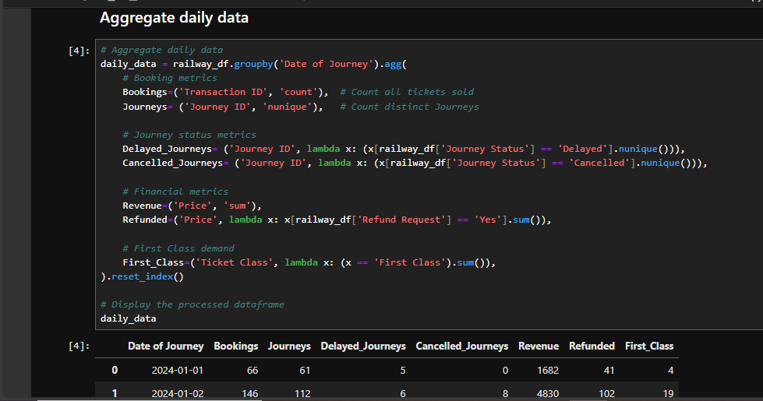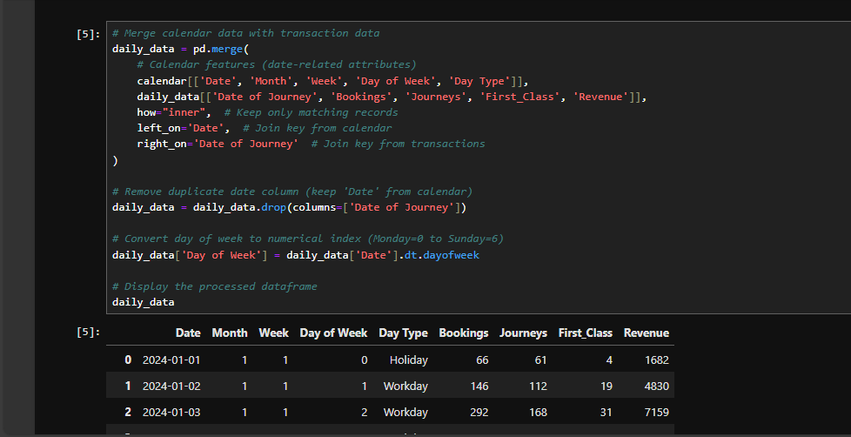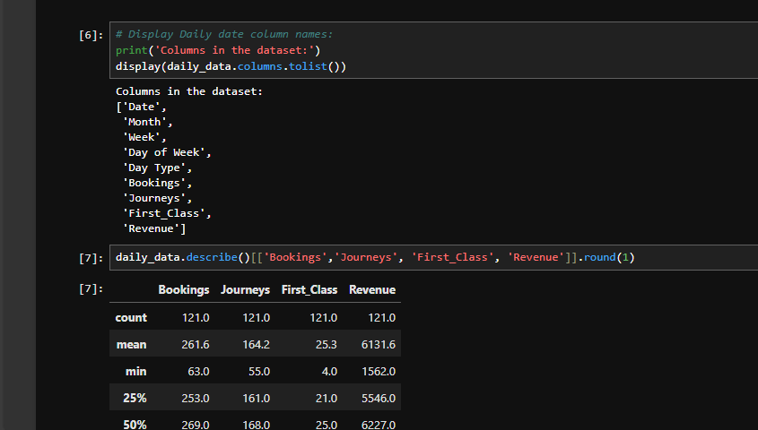
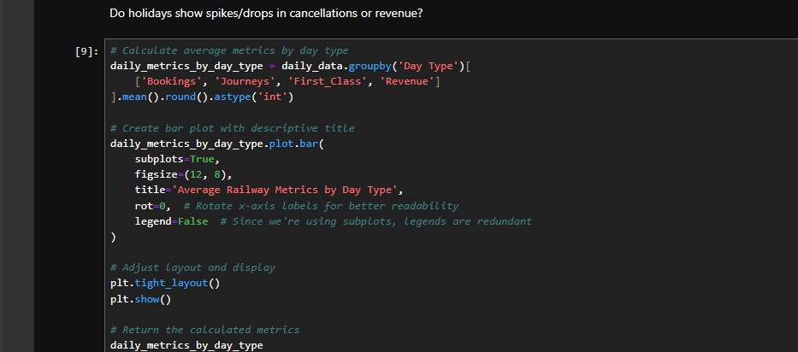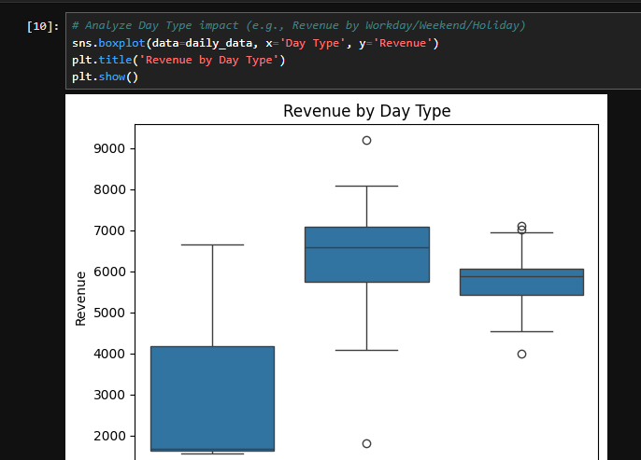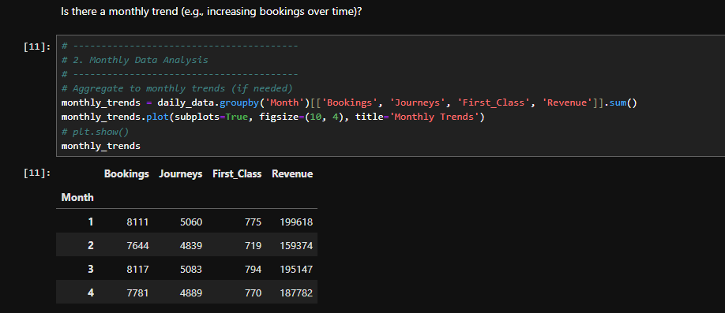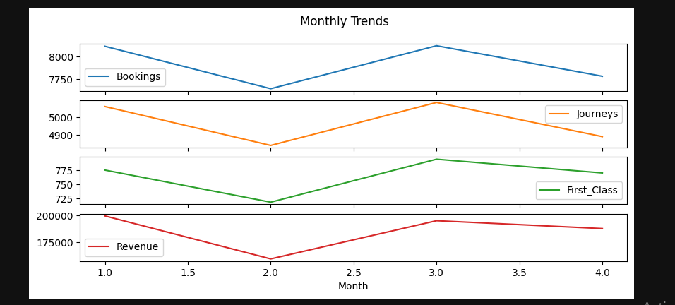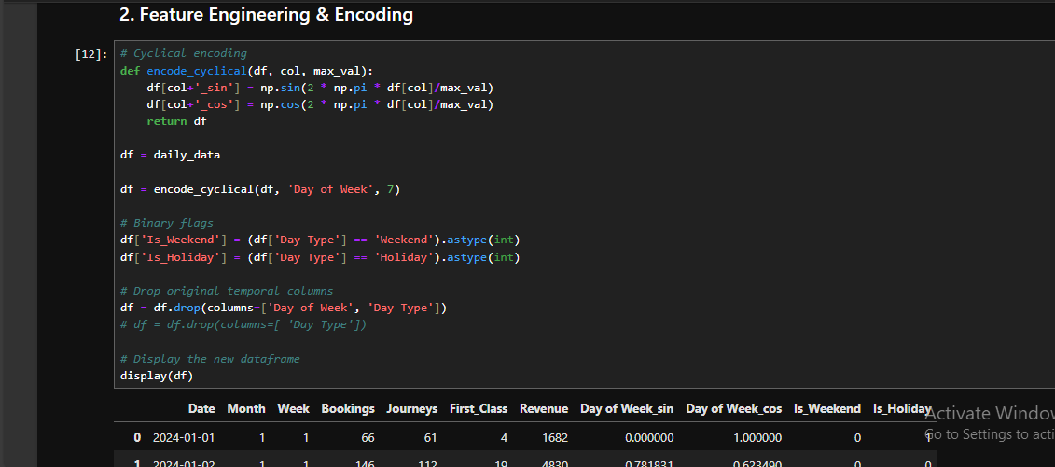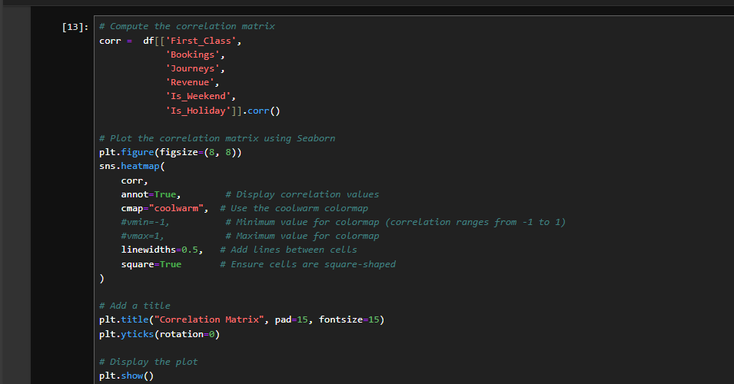
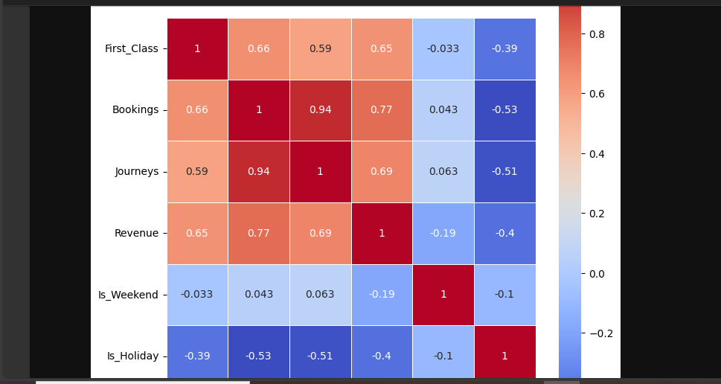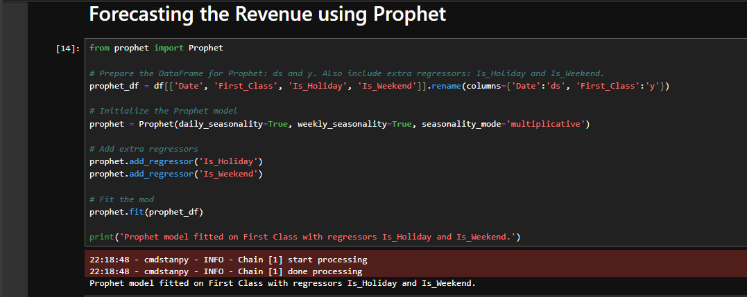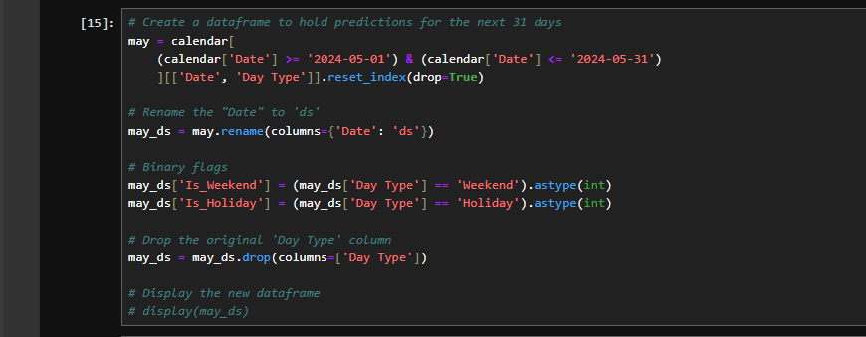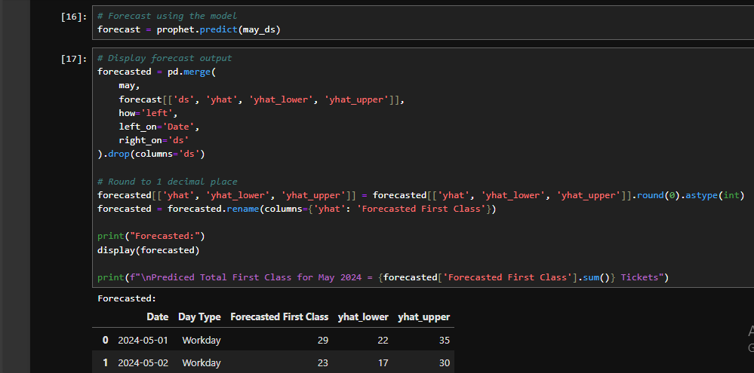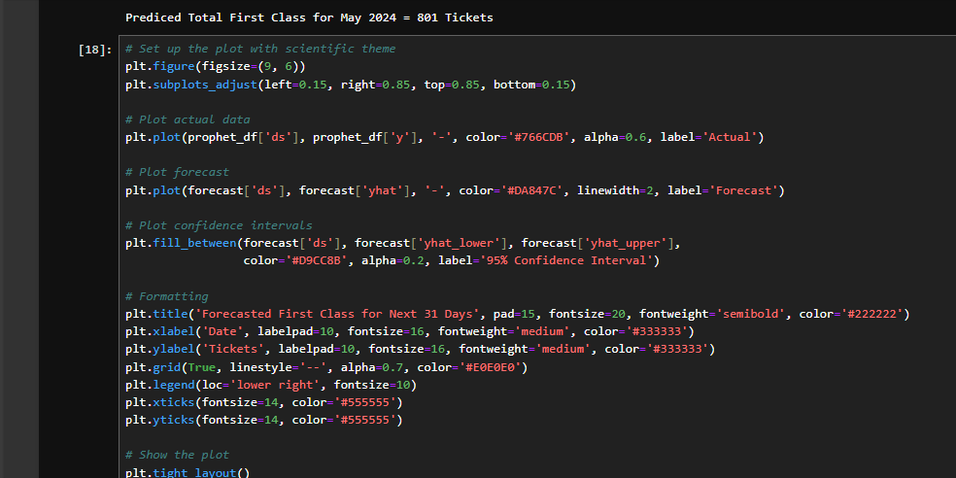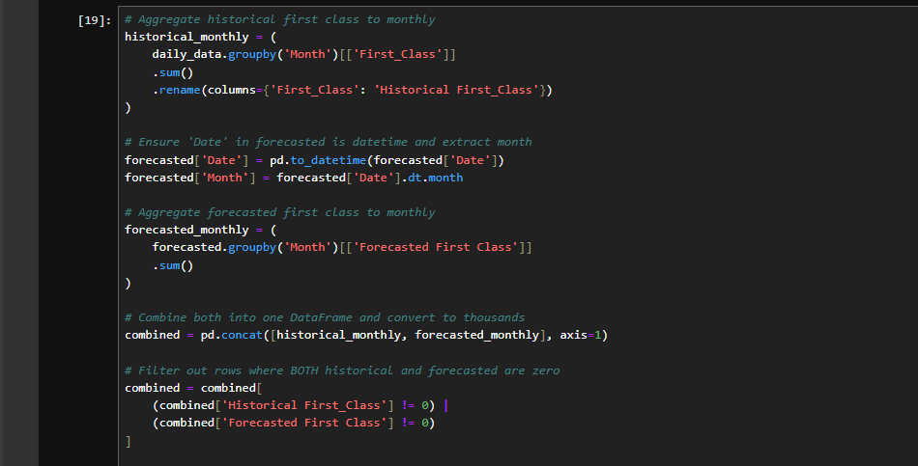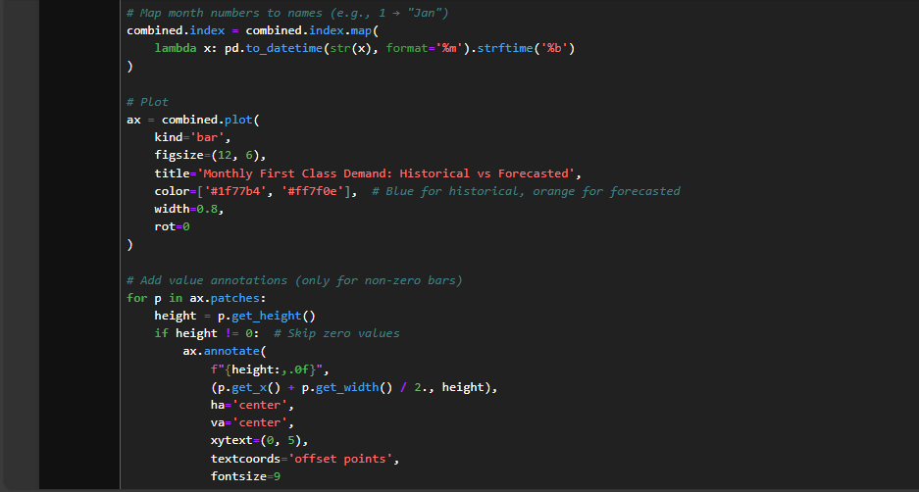
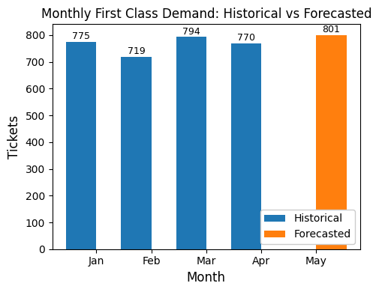
- Conclusion: Predicted Total First Class for May 2024 $≈$ 800 Tickets

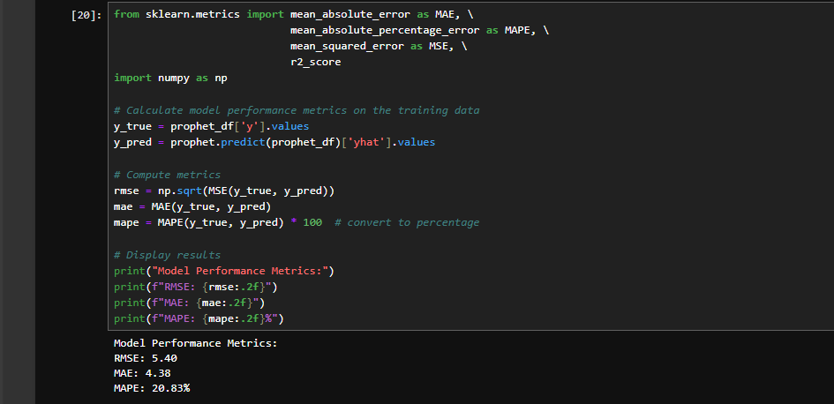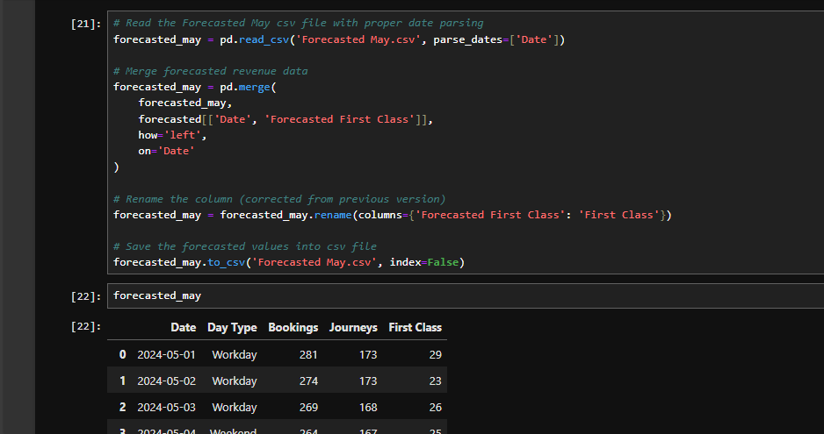

8.3 Journeys Forecasting
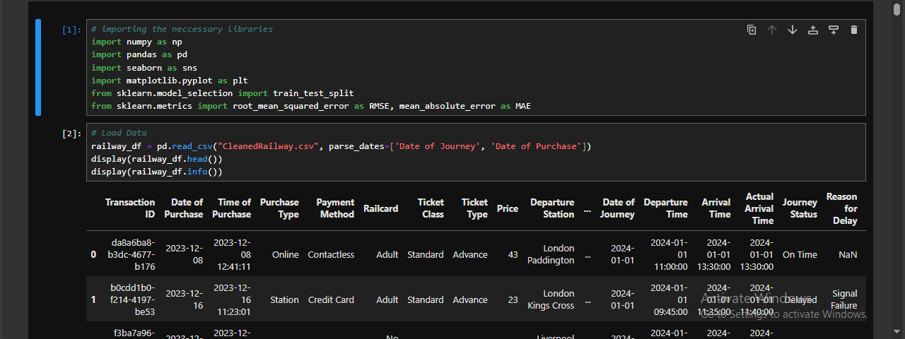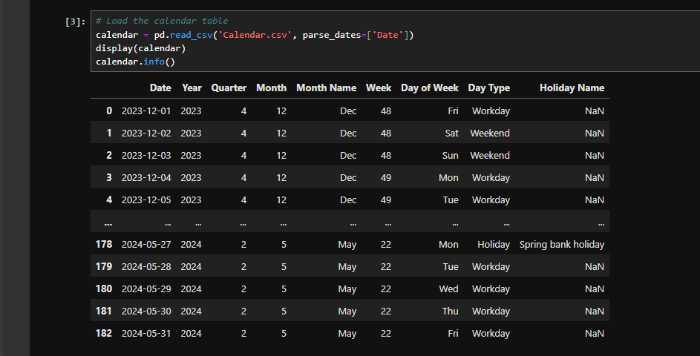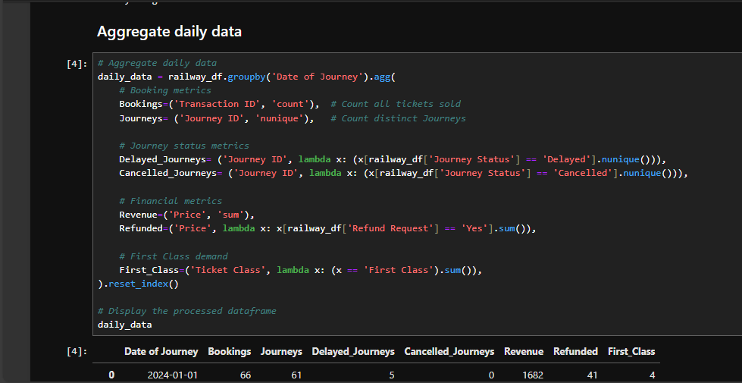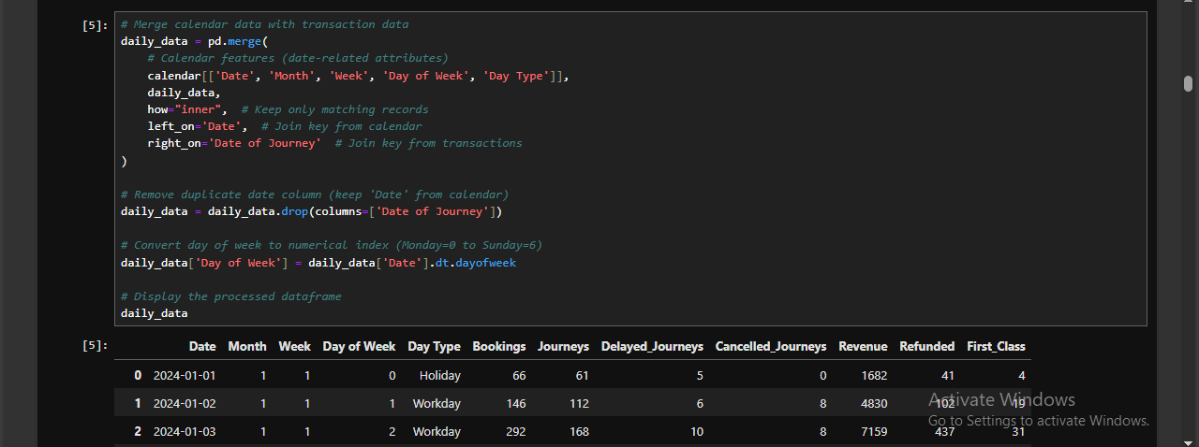
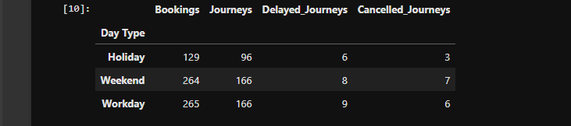

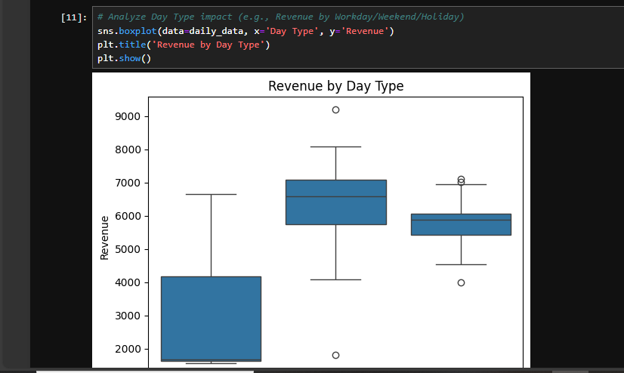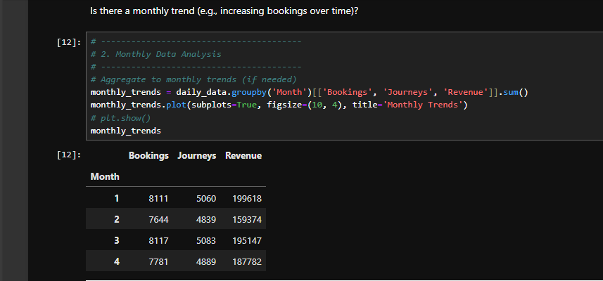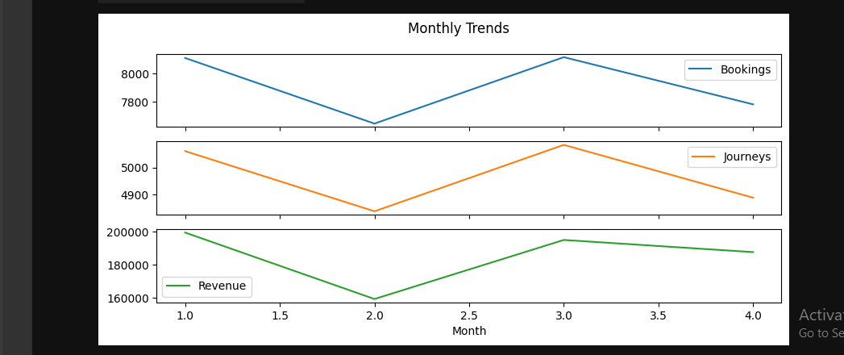

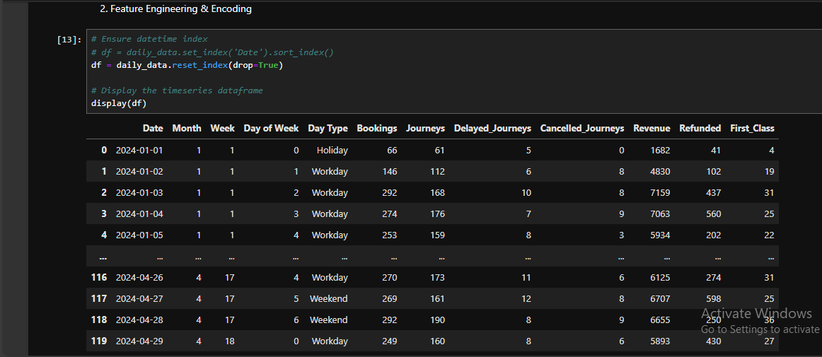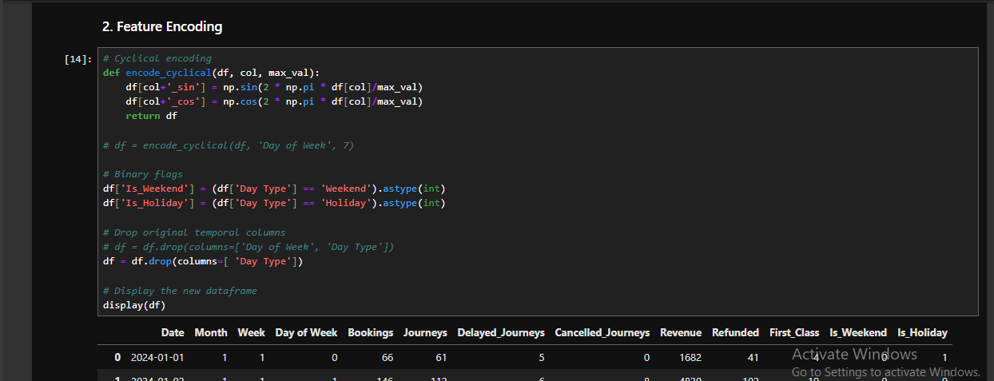
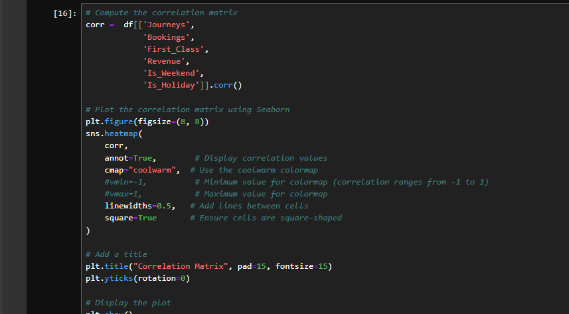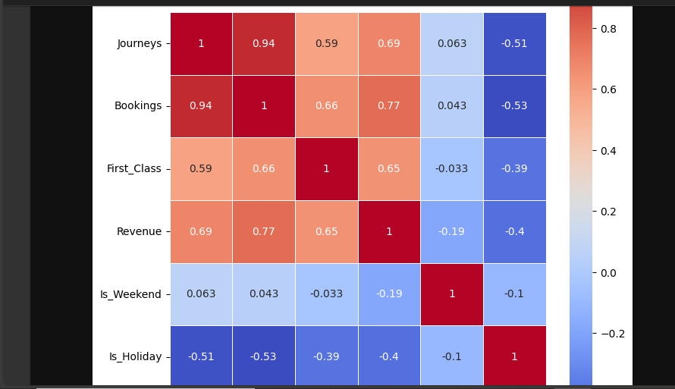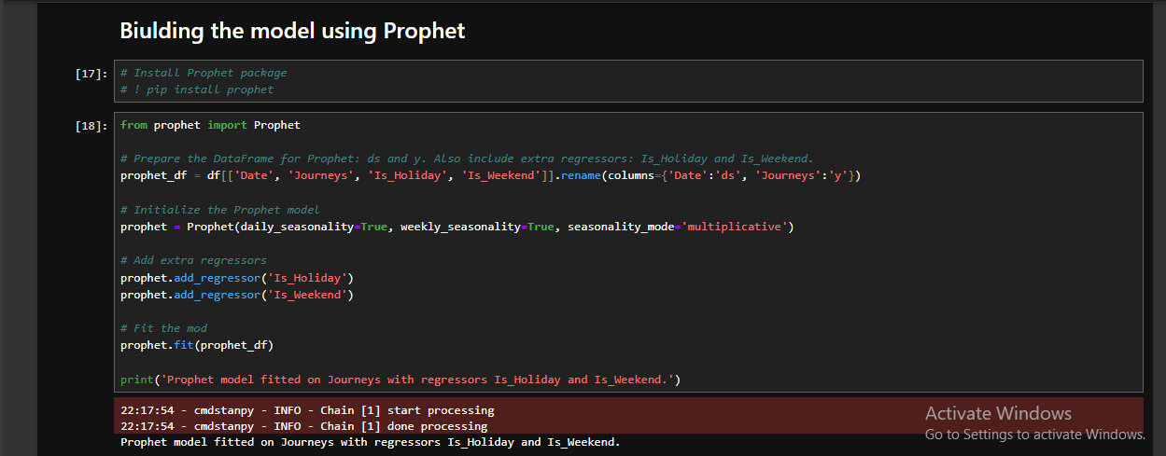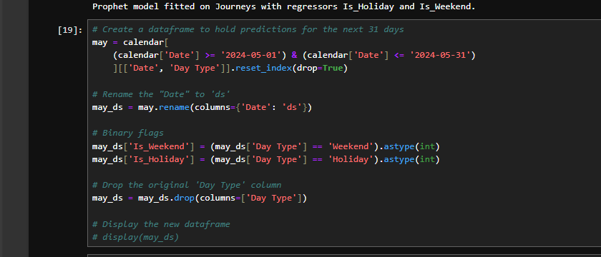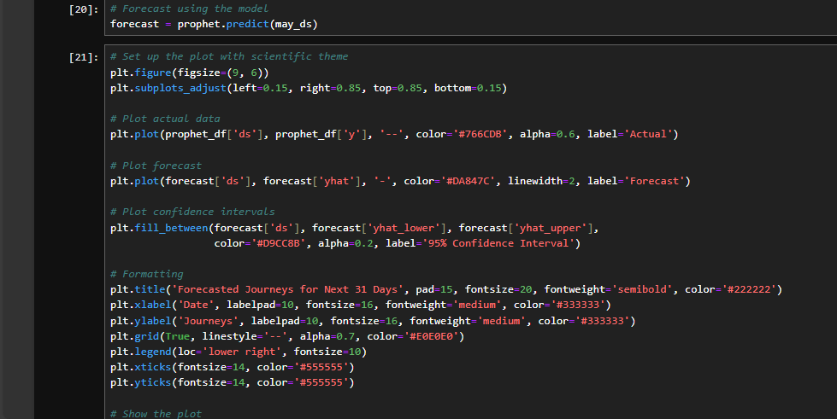

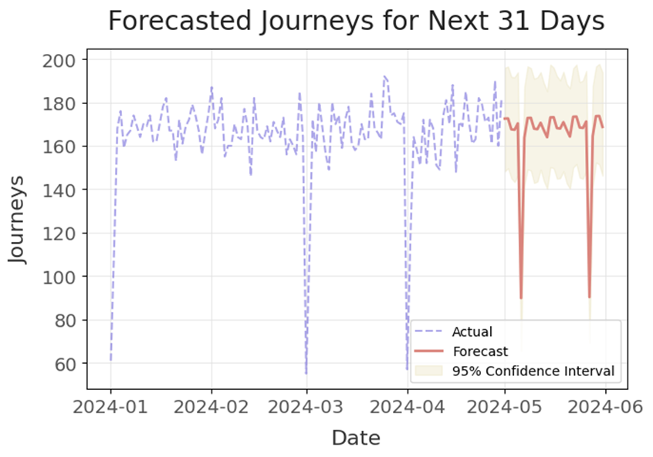
- Predicted Total Journeys for May 2024 $≈$ 5100 Journeys
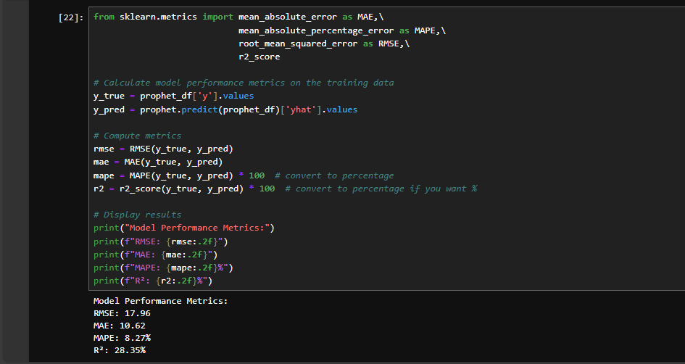

Based on the model performance metrics:
- RMSE (Root Mean Square Error): 17.96 - This indicates that, on average, our predictions deviate from actual values by about 18 journeys. Given that the average number of journeys appears to be around 100-200 per day, this represents roughly a 10-15% error margin.
MAE (Mean Absolute Error): 10.62 - On average, our predictions are off by about 11 journeys in either direction.
MAPE (Mean Absolute Percentage Error): 8.27% - This is perhaps the most intuitive metric, showing that our predictions are typically within 8.27% of the actual values, which is reasonably good for time series forecasting.
The forecast shows a relatively stable pattern for the next 31 days with appropriate confidence intervals. The model has incorporated both weekend effects and holiday impacts.
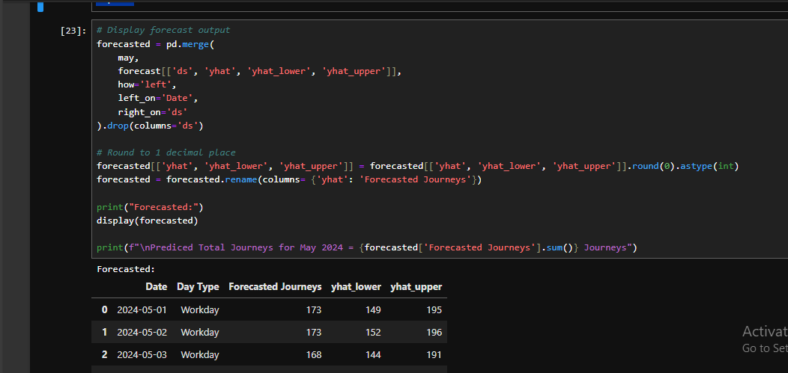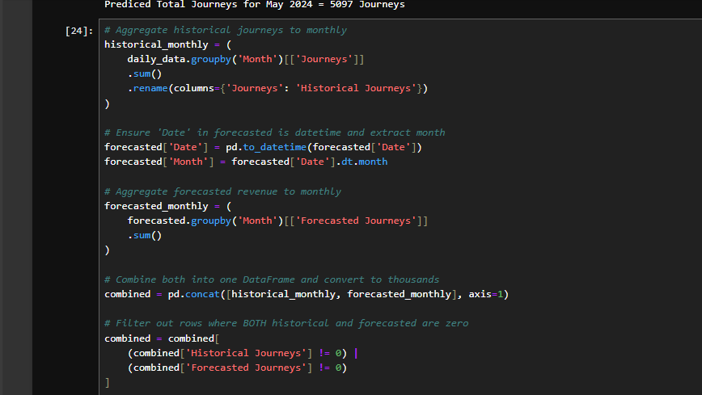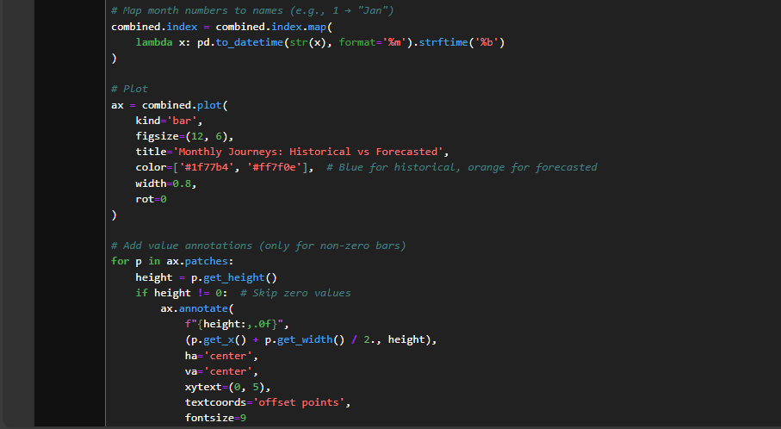
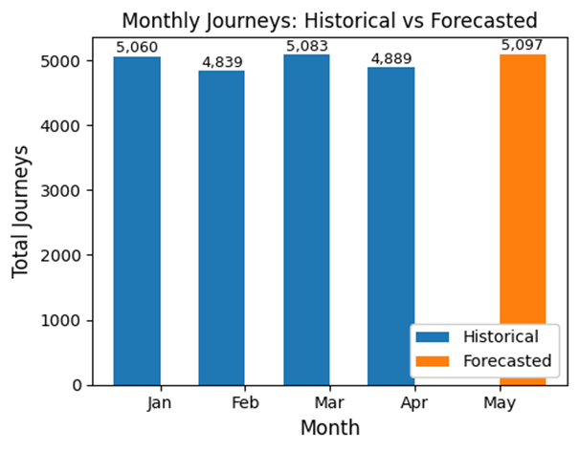
- Predicted Total Journeys for May 2024 $≈$ 5100 Journeys

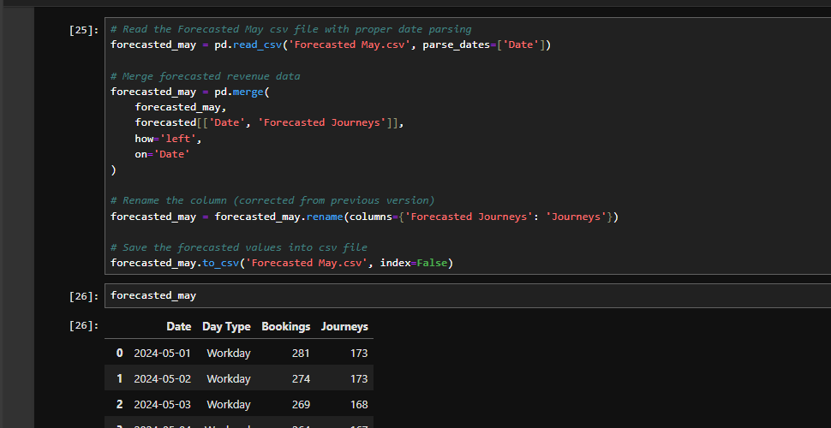

8.4 Revenue Forecasting
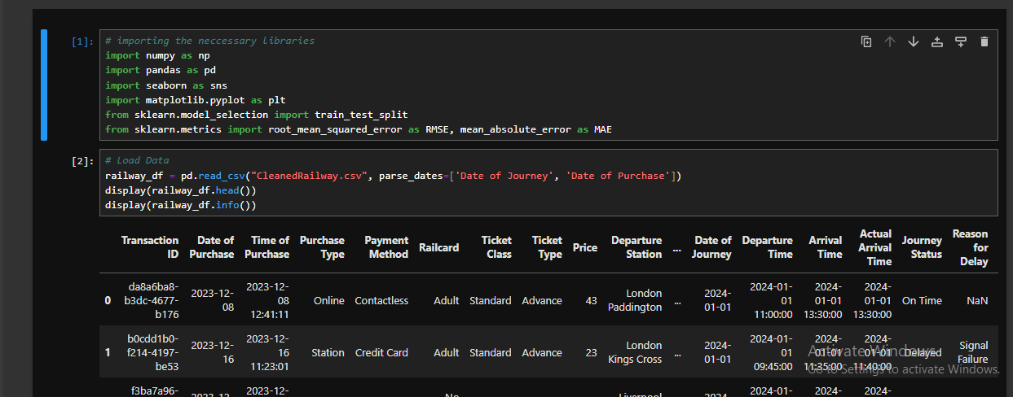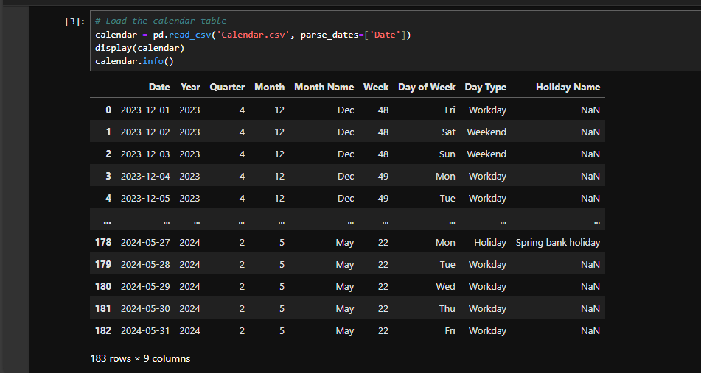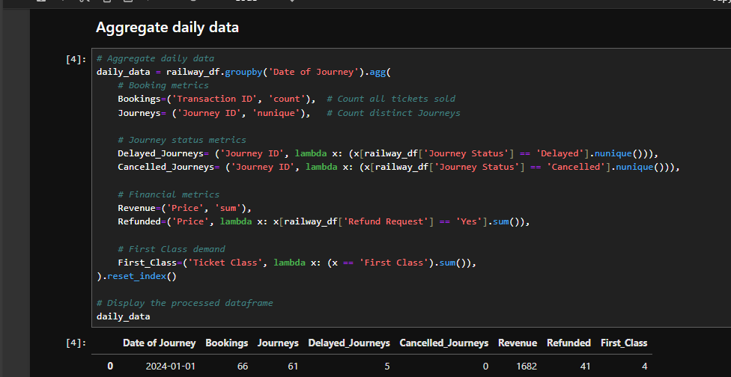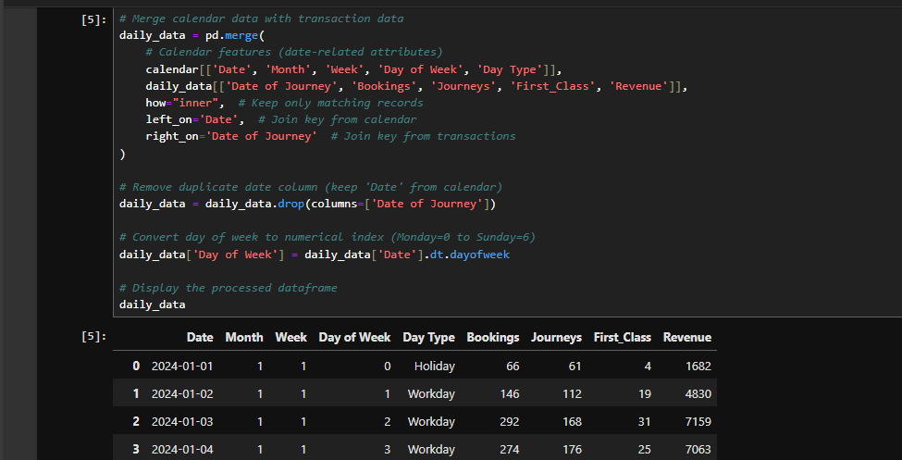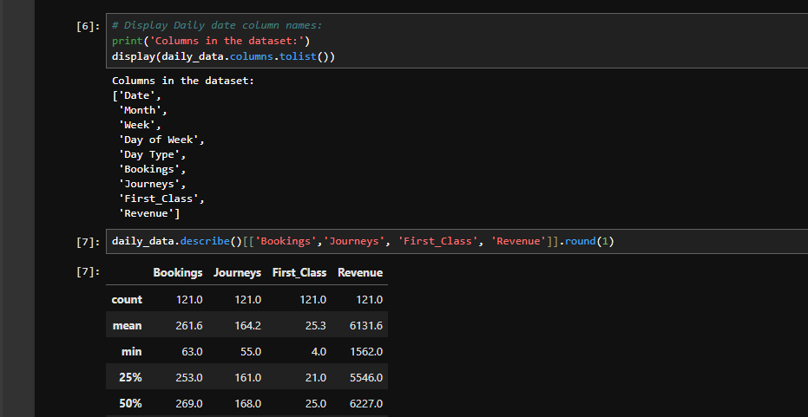
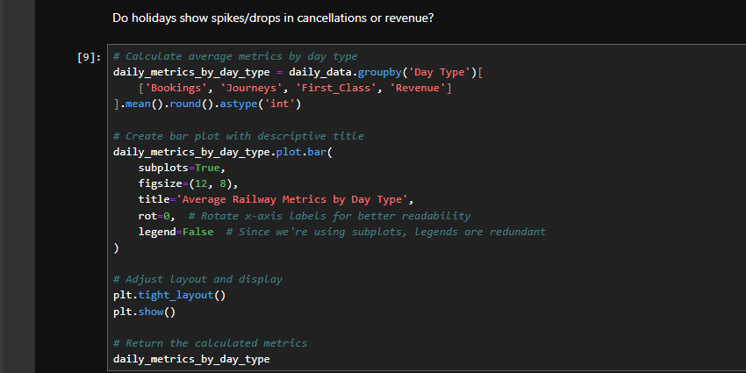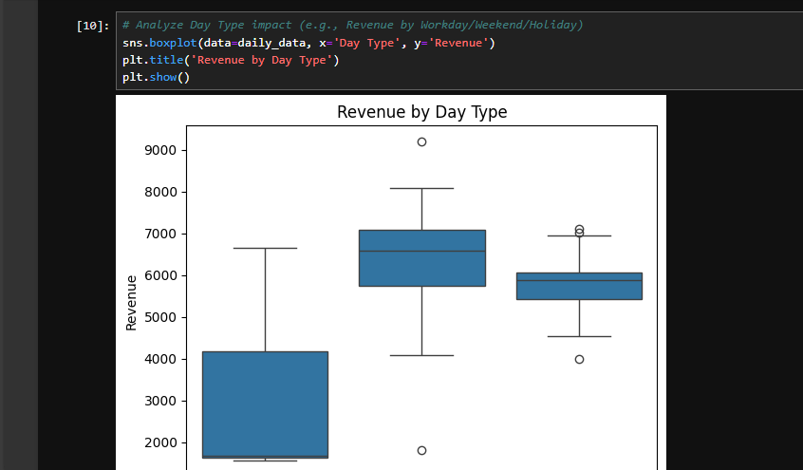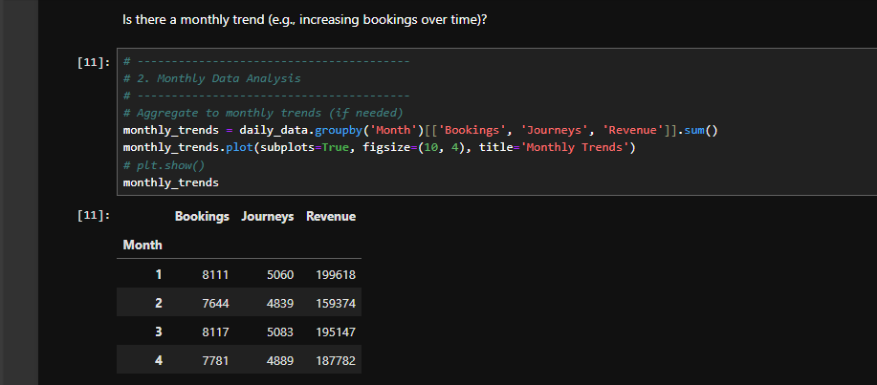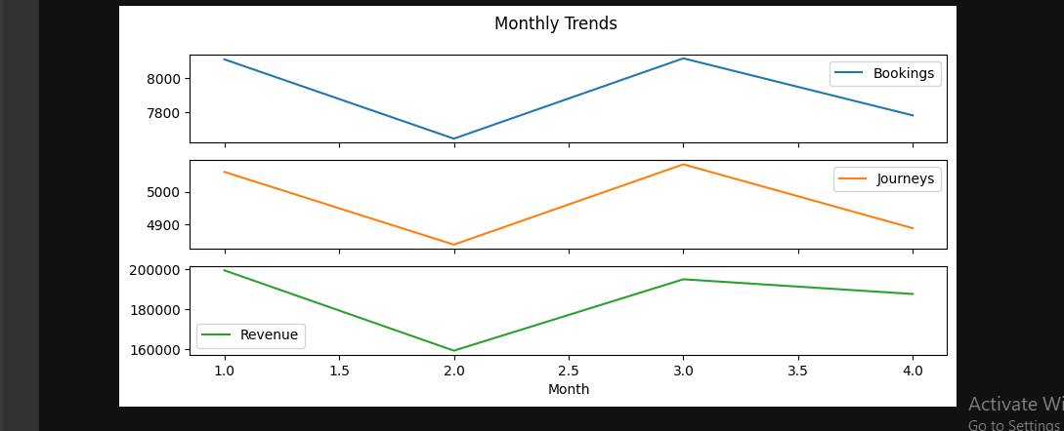
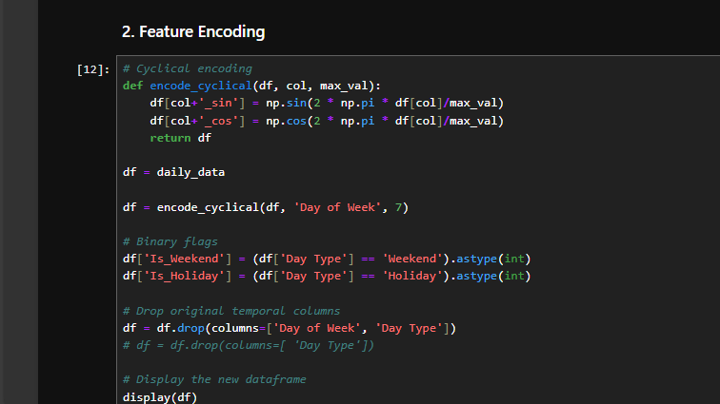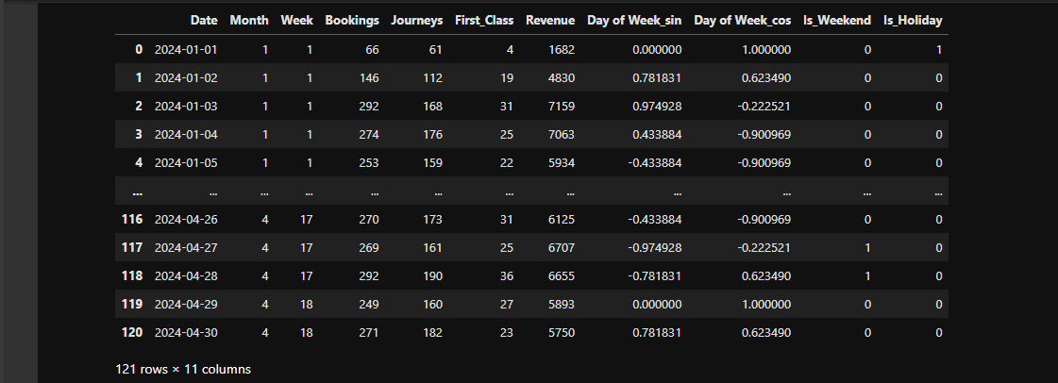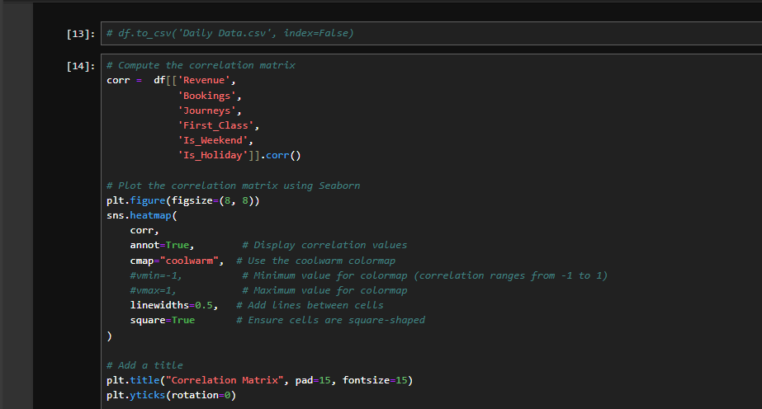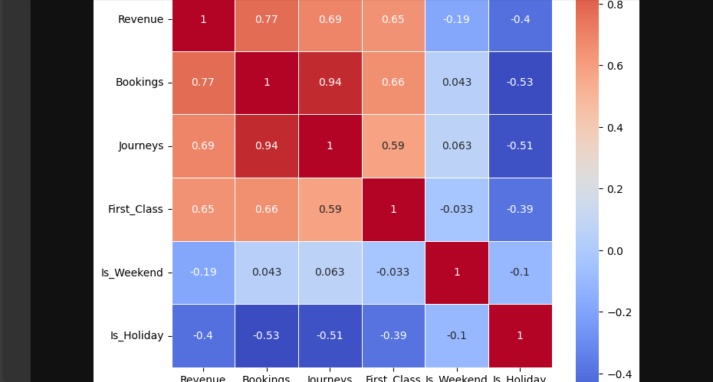

Forecasting the Revenue using Prophet
- Pros:
  - Excellent at capturing multiple seasonalities (daily, weekly, yearly).
  - Easily including additional regressors (like weekend and holiday indicators).
  - User-friendly with interpretable components (trend, seasonality, holidays).
- Cons:
  - Might be less flexible in very short-term dynamics compared to more tailored models.
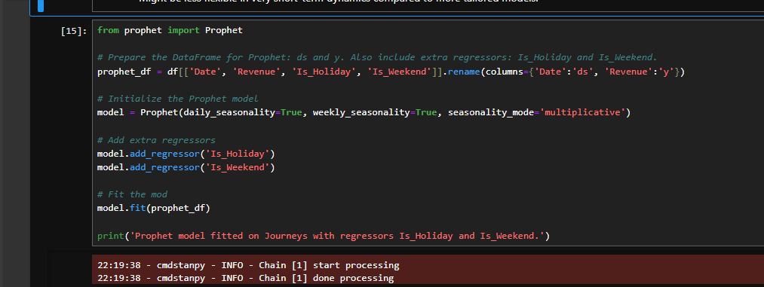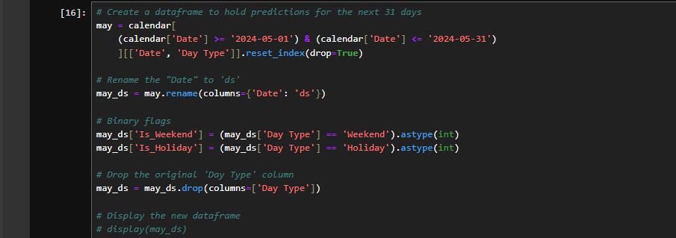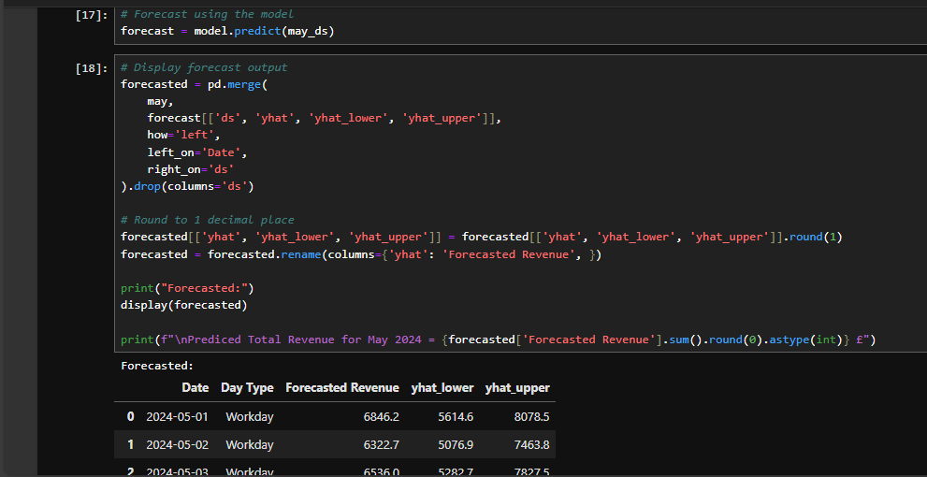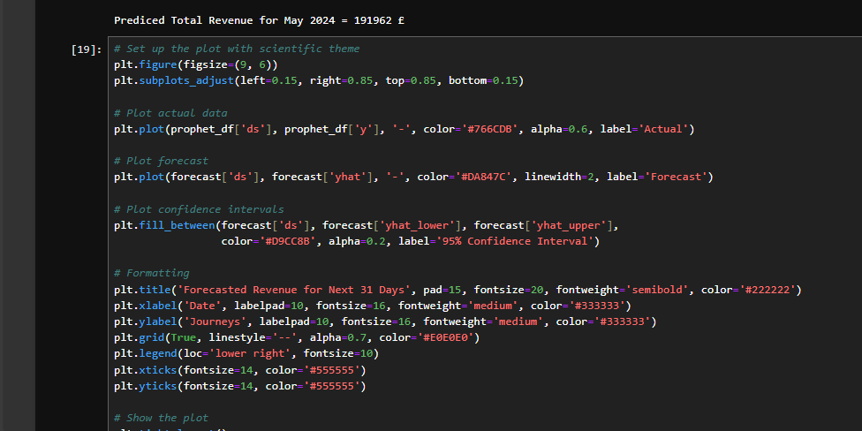
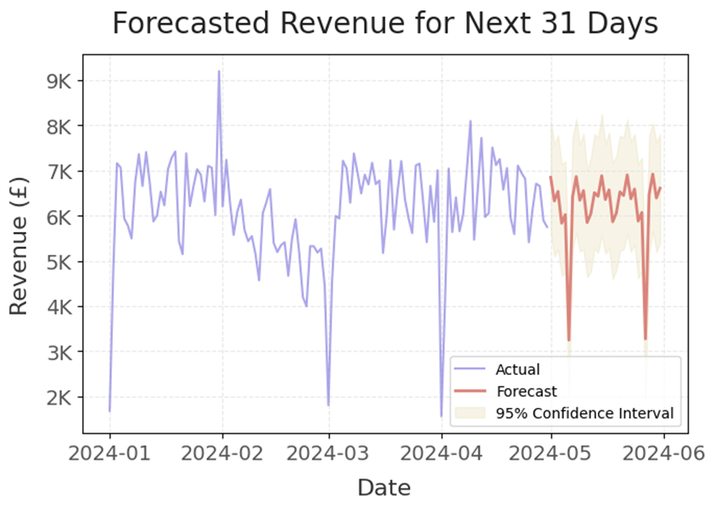
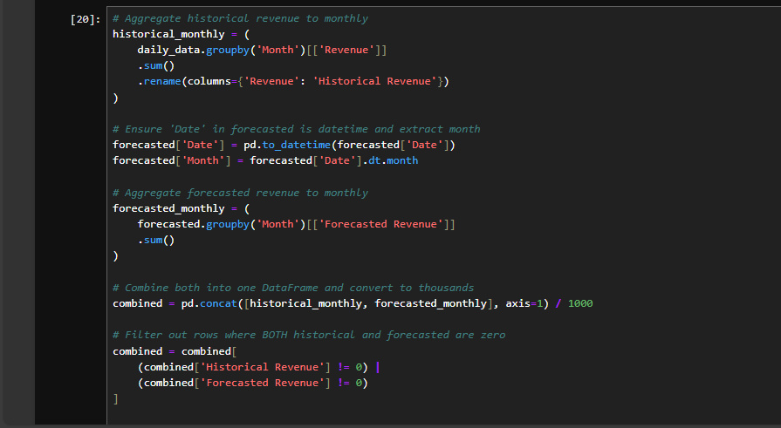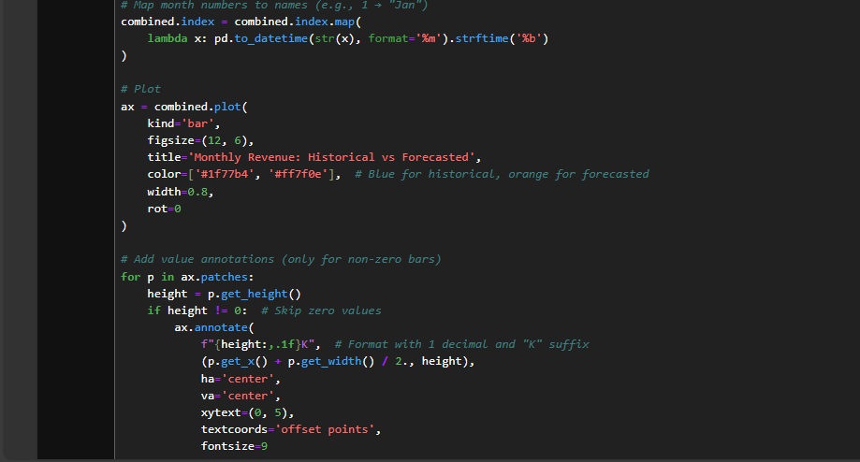
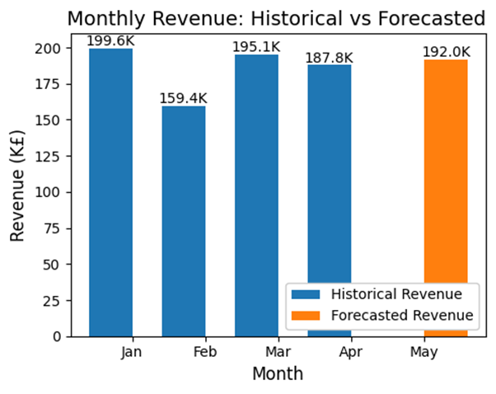
- Predicted Total Revenue for May 2024 $≈$ 192k £
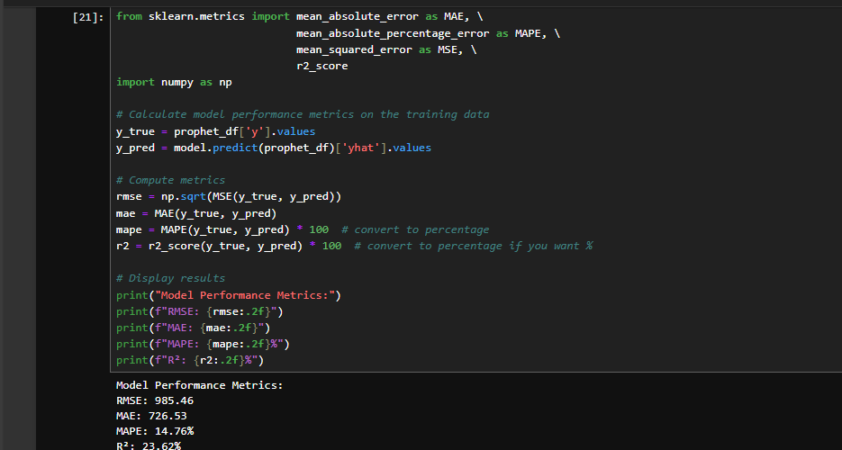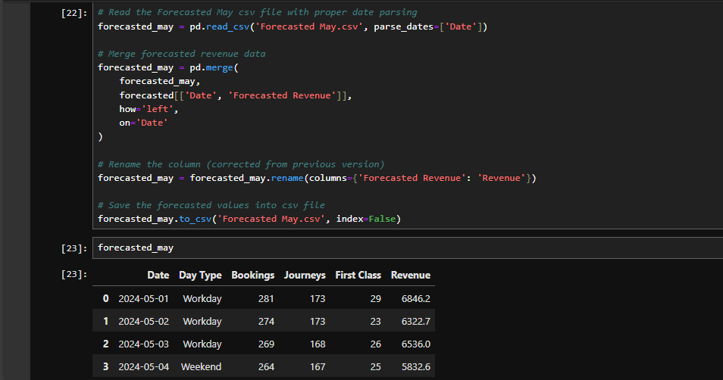

Forecasting the Revenue using Random Forest Regressor
Machine Learning Approaches (e.g., Random Forest, XGBoost):
- Pros:
  - Can capture non-linear relationships and interactions between features, potentially providing more accurate forecasts if engineered well.
  - Can incorporate multiple regressors (holiday flags, weekend flags) directly as features.
- Cons:
  - Often require more data and careful feature engineering to avoid overfitting.
  - They can be less interpretable compared to classical time series models
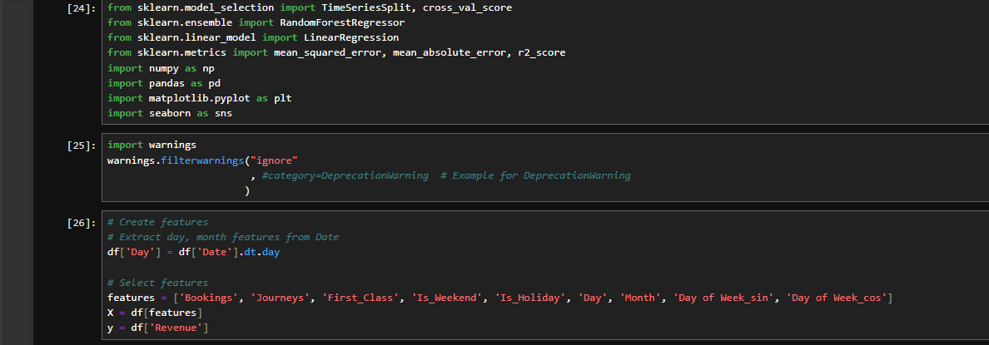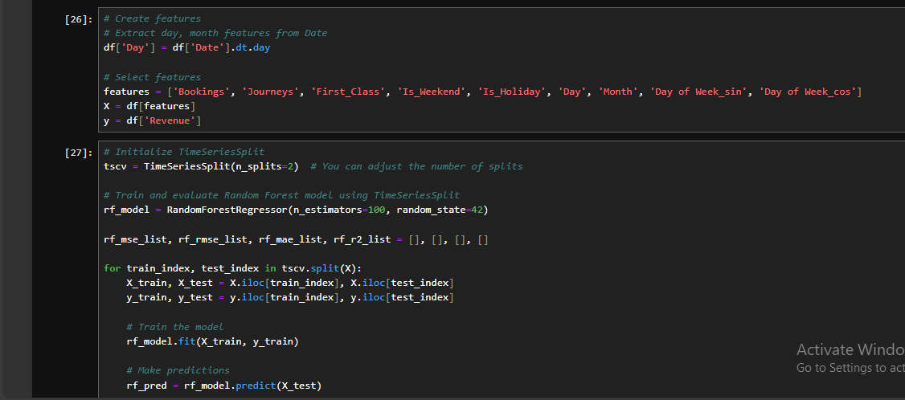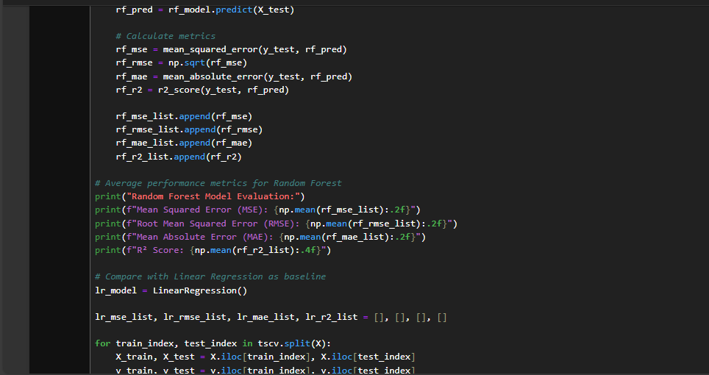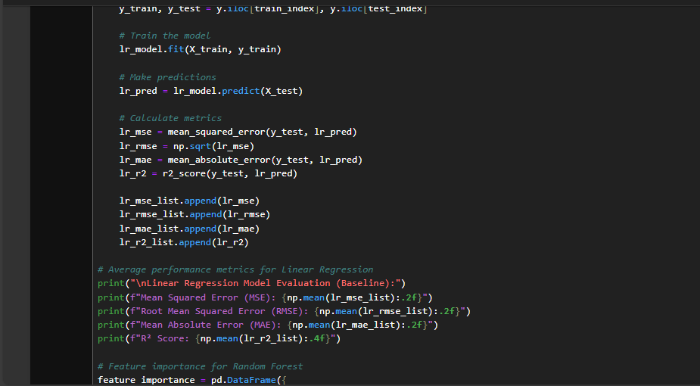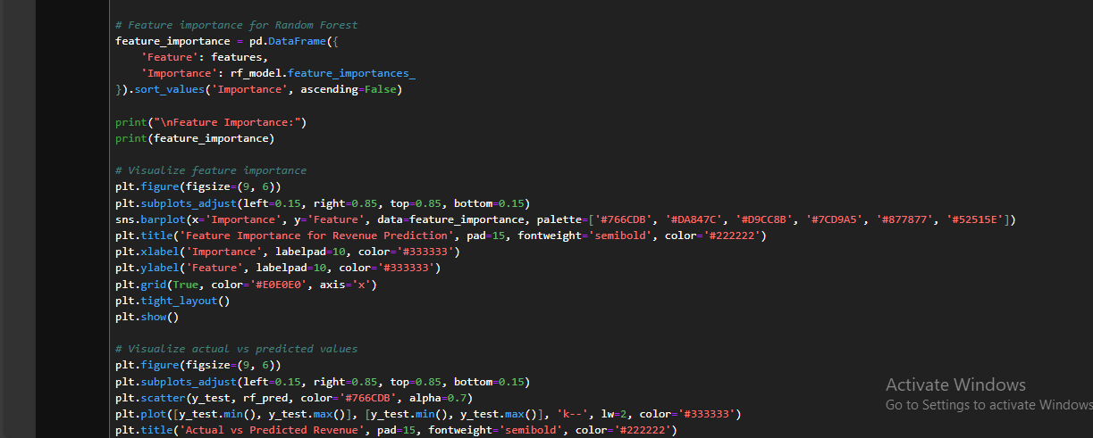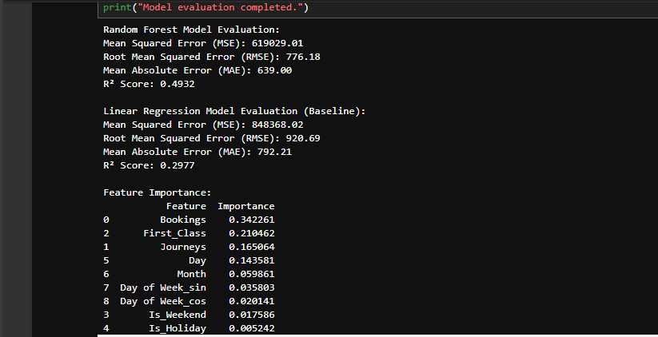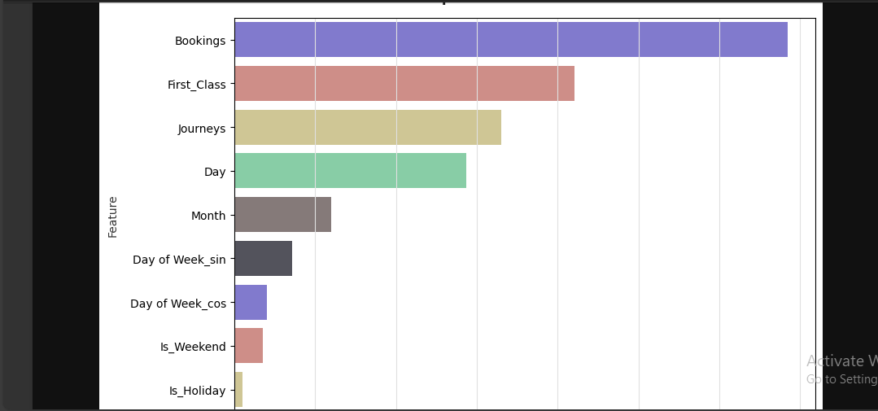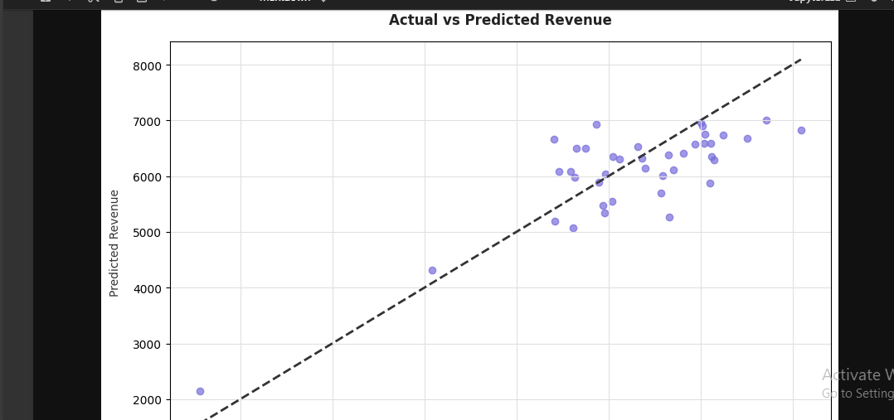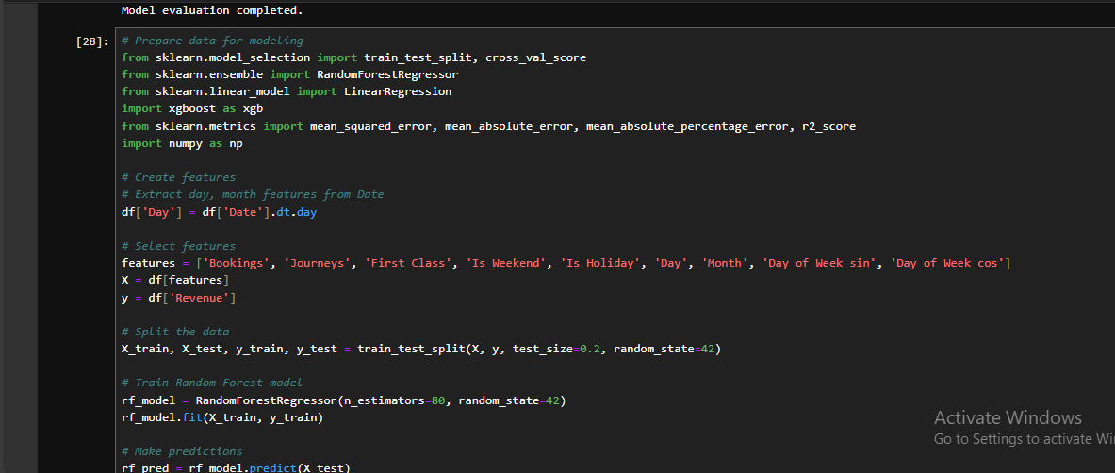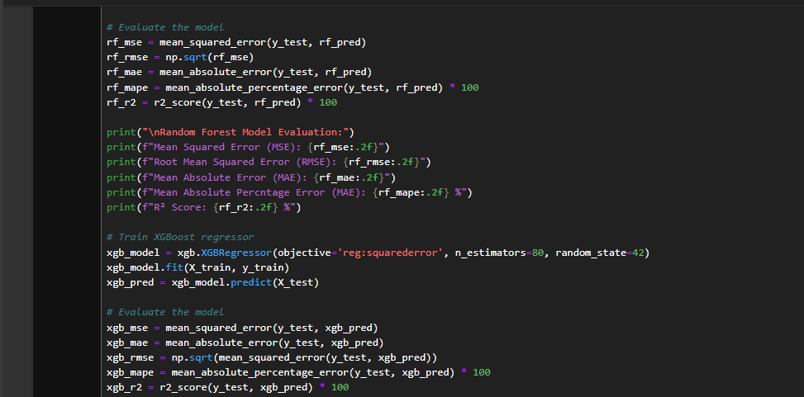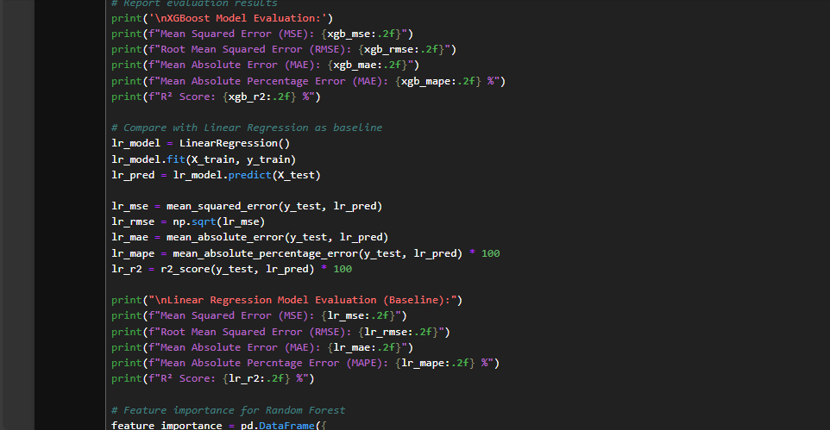

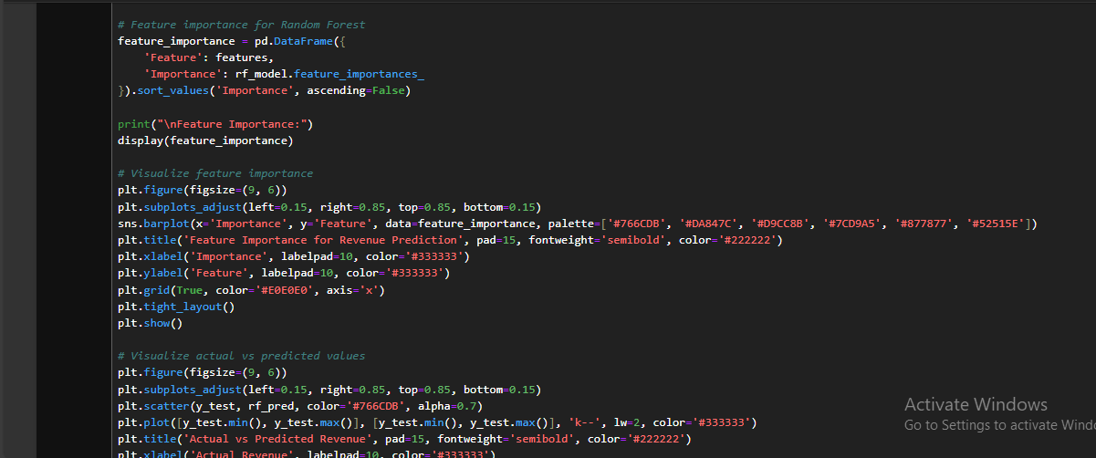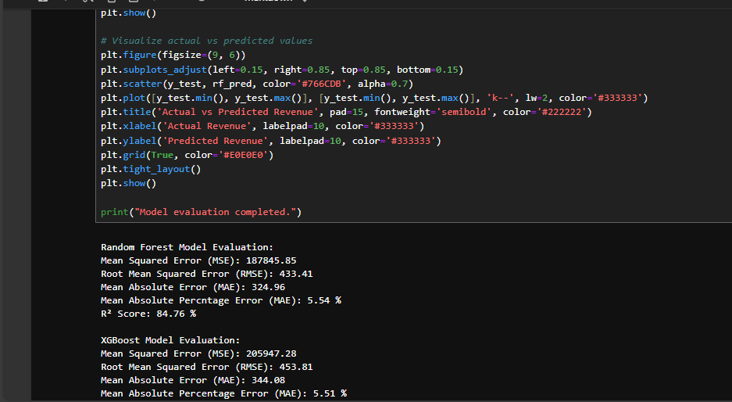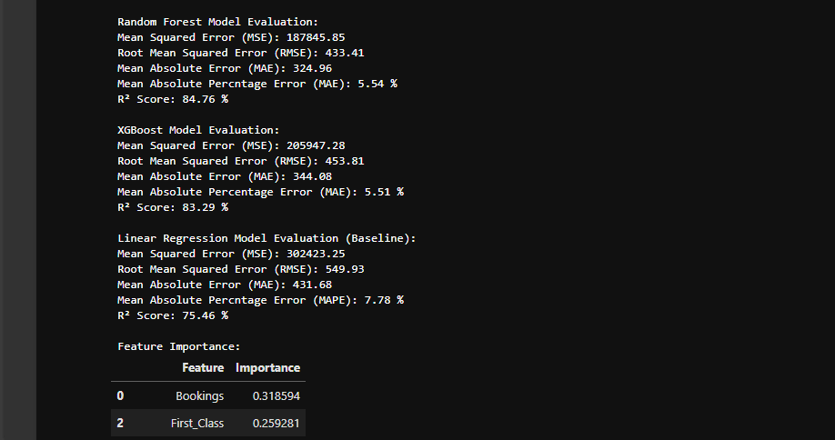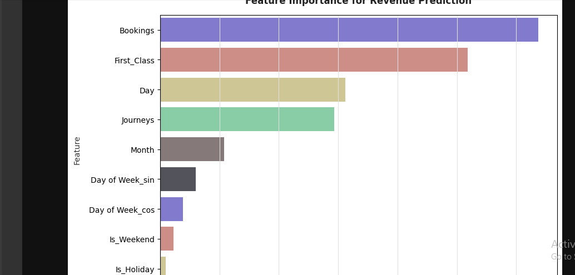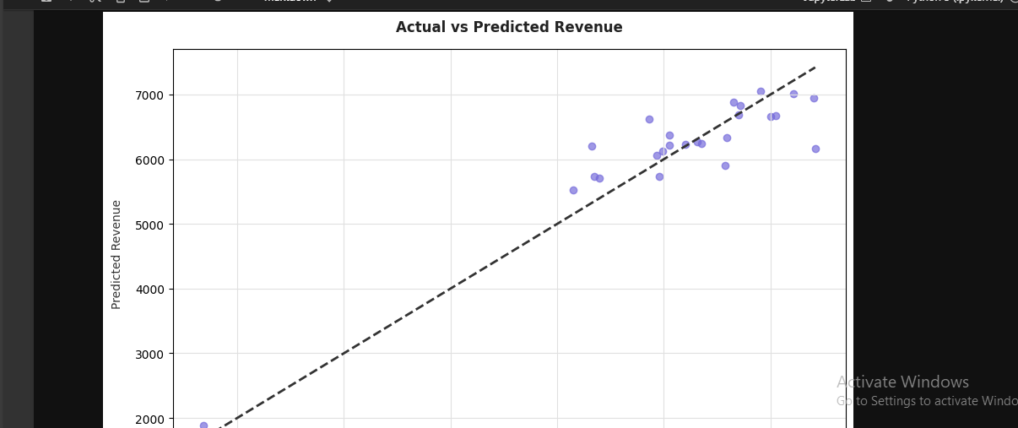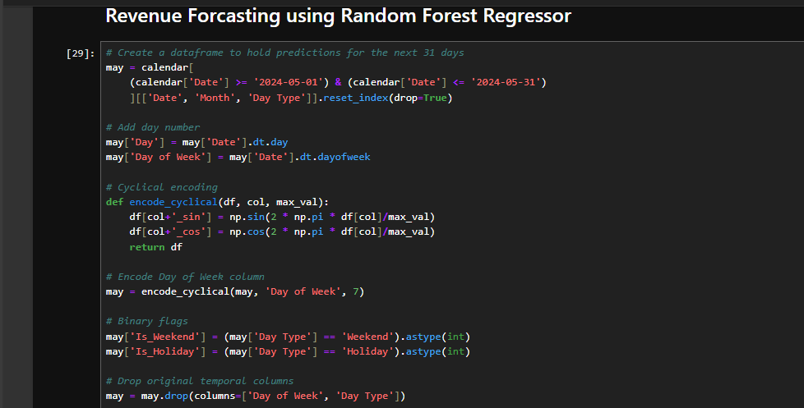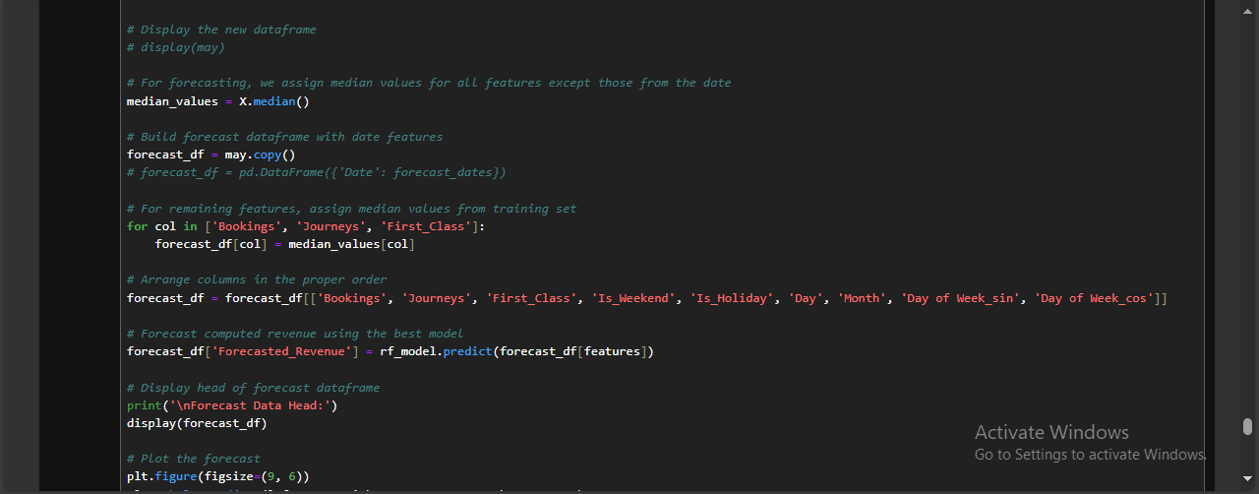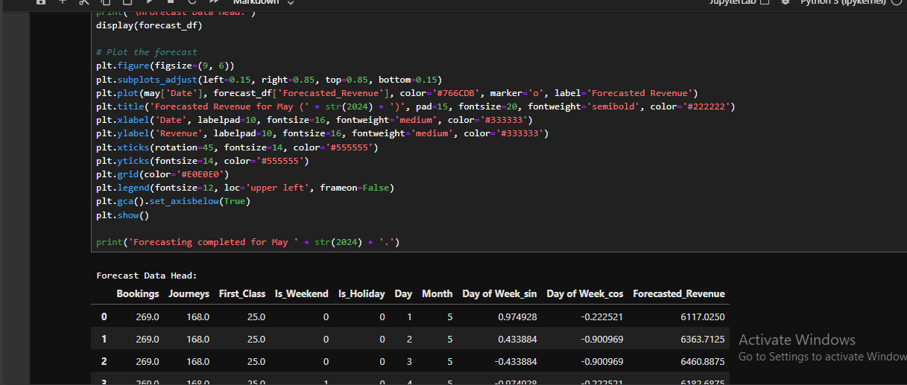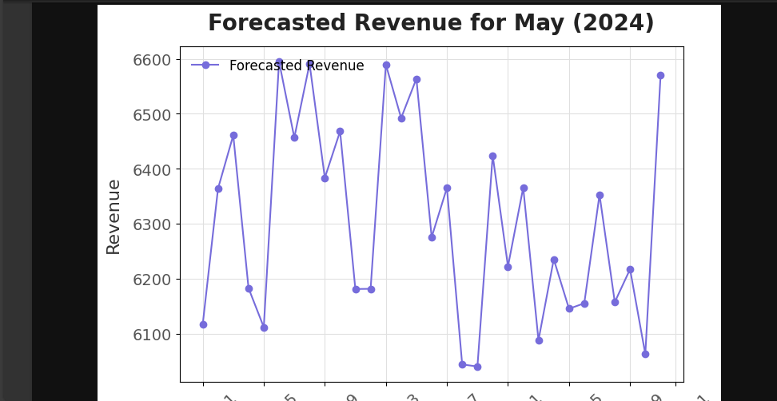

Predicted Total Revenue for May 2024 = 195457 £

9.0 Recommendations
- Peak hours
• Try to reduce the time between trains as much as possible to make trains come more often during busy hours.
• Add more staff at the main stations during peak hours to help manage the large number of passengers and keep everyone safe.
• Use real-time information systems like digital screens and mobile app alerts to keep passengers updated about train times and how crowded stations or trains are.
- Most delayed routes

- Inform passengers about service levels and real-time changes through various communication channels to reduce confusion and enhance the user experience
- conduct a comprehensive review of the operational performance on these routes in order to identify the root causes of the delays, whether they are due to infrastructure issues, signaling systems, or a shortage of human resources.

- Refunded
Due to the high number of refund requests for trips experiencing delays ranging from 15 minutes to over an hour, we propose the implementation of a clear and structured refund policy that balances passenger rights with the project’s operational capacity. The proposed policy is as follows:
- If the delay is less than 15 minutes: No refund will be issued.
- If the delay is between 15 and 30 minutes: 25% of the ticket value will be refunded.
- If the delay is between 30 and 60 minutes: 50% of the ticket value will be refunded.
- If the delay exceeds 60 minutes: 100% of the ticket value will be refunded
- Holidays Bookings
after analyzing the data and discovering that the number of bookings decreases on holidays, and considering that the number of trips is also lower on these days, we recommend that the sector continues with the current system to ensure a balance between the number of trips and the number of bookings, thereby maintaining operational efficiency and adequately meeting passenger needs during these periods

