Mapping Technological Similarity Between Companies
A Comparison of TF-IDF and Sentence-BERT on European Patent Abstracts

Data Capstone Project
BSc Informatics, 4th Semester
IMC University of Applied Sciences Krems
Authors
Enas Alaawaj, Saad Helal
Individual contribution: Enas Alaawaj 40%, Saad Helal 60%
Submission date: 23 June 2026
Source code: github.com/SaadHelal-IMC/Capstone-Project

Abstract
Understanding which companies operate in similar technological spaces is valuable for competitive intelligence, partner discovery, and innovation policy, yet such relationships are rarely stated explicitly. This project infers them from text. We collected 3,799 European patent applications filed in 2023-2024 by 34 large multinational companies across five technology areas (artificial intelligence, telecommunications, wireless networks, batteries, and electric mobility) using the European Patent Office Open Patent Services (EPO OPS) API. After cleaning applicant names and translating 321 non-English abstracts into English, 3,769 abstracts with usable text were carried into the analysis. Each patent abstract was turned into a numeric vector using two competing methods: a classical lexical baseline (TF-IDF) and a modern semantic encoder (Sentence-BERT, all-MiniLM-L6-v2). Patents were aggregated into a single vector per company, and pairwise cosine similarity produced a 34×34 company-similarity matrix for each method. We then clustered companies with K-Means and hierarchical (Ward) clustering, built a similarity network with NetworkX, and extracted latent technology themes with Latent Dirichlet Allocation. Sentence-BERT clearly outperformed the lexical baseline, raising the silhouette score from 0.063 to 0.131 and producing five interpretable groups: industrial/automotive, technology/telecom, electronics/materials, healthcare, and a pharmaceutical outlier (Novartis). The resulting network reproduced intuitive rivalries (Toyota and Honda, BMW and Volkswagen, Google and Microsoft) and identified IBM, Roche, and Philips as bridges between communities. The main finding is that semantic embeddings recover industry structure that keyword overlap misses, while translation removes language as a confounding signal.

1. Introduction

1.1 Problem statement
Companies that work on similar technologies are natural competitors, potential collaborators, and useful comparators for analysts and investors. However, there is no official registry that says these firms are technologically alike. Industry classifications such as NACE or stock-market sectors are coarse and often misleading: a single conglomerate may file patents in batteries, software, and medical imaging at once. Patents, by contrast, are a direct, public, and standardized record of what a company actually invents. The problem we address is therefore: given only the text of companies' recent patents, can we automatically measure how technologically similar two companies are, group them into coherent communities, and identify which firms bridge otherwise separate fields?

1.2 Objectives
The project was broken into the following concrete tasks:
- Collect a balanced, comparable corpus of recent patents for a fixed set of large companies via the EPO OPS API.
- Clean and standardize messy applicant names and translate non-English abstracts so language does not drive the results.
- Represent each patent abstract numerically using two methods, a TF-IDF baseline and Sentence-BERT, and aggregate to one vector per company.
- Compute a company-to-company similarity matrix and use it to cluster companies, build a similarity network, and model latent topics.
- Compare the two representations quantitatively (cluster quality) and qualitatively (interpretability) and report which is better and why.

1.3 Data
The dataset consists of 3,799 patent applications published in 2023 and 2024, retrieved from the EPO OPS bibliographic service. For each patent we kept the title, abstract, applicant name(s), International Patent Classification (IPC) codes, the document number, and the publication date. Searches were issued per company and per IPC area, so the corpus is intentionally balanced across 34 firms and five technology areas: G06N (AI/machine learning), H04L (digital telecommunications), H04W (wireless networks), H01M (batteries/fuel cells), and B60L (propulsion of electric vehicles). After filtering to abstracts of more than 50 characters, 3,769 patents entered the modelling stage.

1.4 Background
Two background challenges shape the work. First, patent applicant fields are noisy: the same firm appears as SIEMENS AG [DE], SIEMENS CORP [US], and in Chinese characters, so raw names must be mapped to a canonical company. Second, European patents are multilingual; roughly 8.5% of abstracts in our corpus are not in English (mostly German from Bosch, Siemens, Volkswagen and Infineon). If left untranslated, a similarity model can cluster companies by language rather than by technology, a confound we explicitly remove.

2. Literature Review
Measuring similarity from text is a long-studied problem. The classical approach represents documents as term-frequency-inverse-document-frequency (TF-IDF) vectors (Salton & Buckley, 1988), which weight words by how distinctive they are, and compares them with cosine similarity. TF-IDF is fast and interpretable but treats words as independent symbols: it cannot tell that automobile and vehicle mean the same thing. Modern sentence embeddings address this. Sentence-BERT (Reimers & Gurevych, 2019) fine-tunes transformer language models so that semantically similar sentences map to nearby vectors, and the compact all-MiniLM-L6-v2 model has become a standard, efficient encoder for semantic similarity tasks.
In the patent domain, patent landscaping and technology-mapping studies use IPC co-occurrence, citation networks, and increasingly text embeddings to position firms and fields. Company-similarity and competitor-identification networks built from patents or filings are an established analytic tool. Clustering quality is commonly judged with the silhouette coefficient (Rousseeuw, 1987), and latent themes in a corpus are often extracted with Latent Dirichlet Allocation (Blei, Ng & Jordan, 2003). Our contribution is not a new algorithm but a controlled head-to-head comparison of a lexical and a semantic representation on the same balanced, translated patent corpus.

2.1 Success criteria
Drawing on this literature we defined success before running the models: (1) the semantic method should achieve a higher silhouette score than the TF-IDF baseline; (2) the resulting clusters should align with widely understood industry groupings (e.g., car makers together, chip/electronics makers together); and (3) the most-similar company pairs surfaced by the model should match well-known real-world rivalries. These criteria are partly quantitative and partly qualitative, which suits an unsupervised problem with no ground-truth labels.

3. Methodology

3.1 Data collection, description and management
Data was collected with a Python client (01_data_collection.py) that authenticates against EPO OPS with OAuth, then issues CQL queries combining an applicant name, an IPC area, and the 2023-2024 publication window. The client handles pagination and rate limiting and writes one row per patent. A cleaning step (02_eda.py) maps raw applicant strings to 34 canonical company names using substring matching plus a small set of special rules (for example BAYERISCHE MOTOREN WERKE to BMW, TELEFONAKTIEBOLAGET to ERICSSON). A translation step (02b_translate.py) detects each abstract's language with langdetect and translates the 321 non-English abstracts to English with deep-translator, preserving the original text in a separate column.
Key observations from exploratory analysis: the corpus is well balanced across the five IPC areas (498-968 patents each) and reasonably balanced across firms, with a long-tailed exception: Novartis contributed only two qualifying patents, which later makes it a statistical outlier. Almost all patents have abstracts, and the median abstract length is several hundred characters, long enough to embed meaningfully.
Patents per IPC area | Count
G06N (AI / machine learning) | 968
H04L (digital telecommunications) | 929
H01M (batteries / fuel cells) | 707
H04W (wireless networks) | 697
B60L (electric-vehicle propulsion) | 498
Table 1. Distribution of collected patents across the five technology areas.
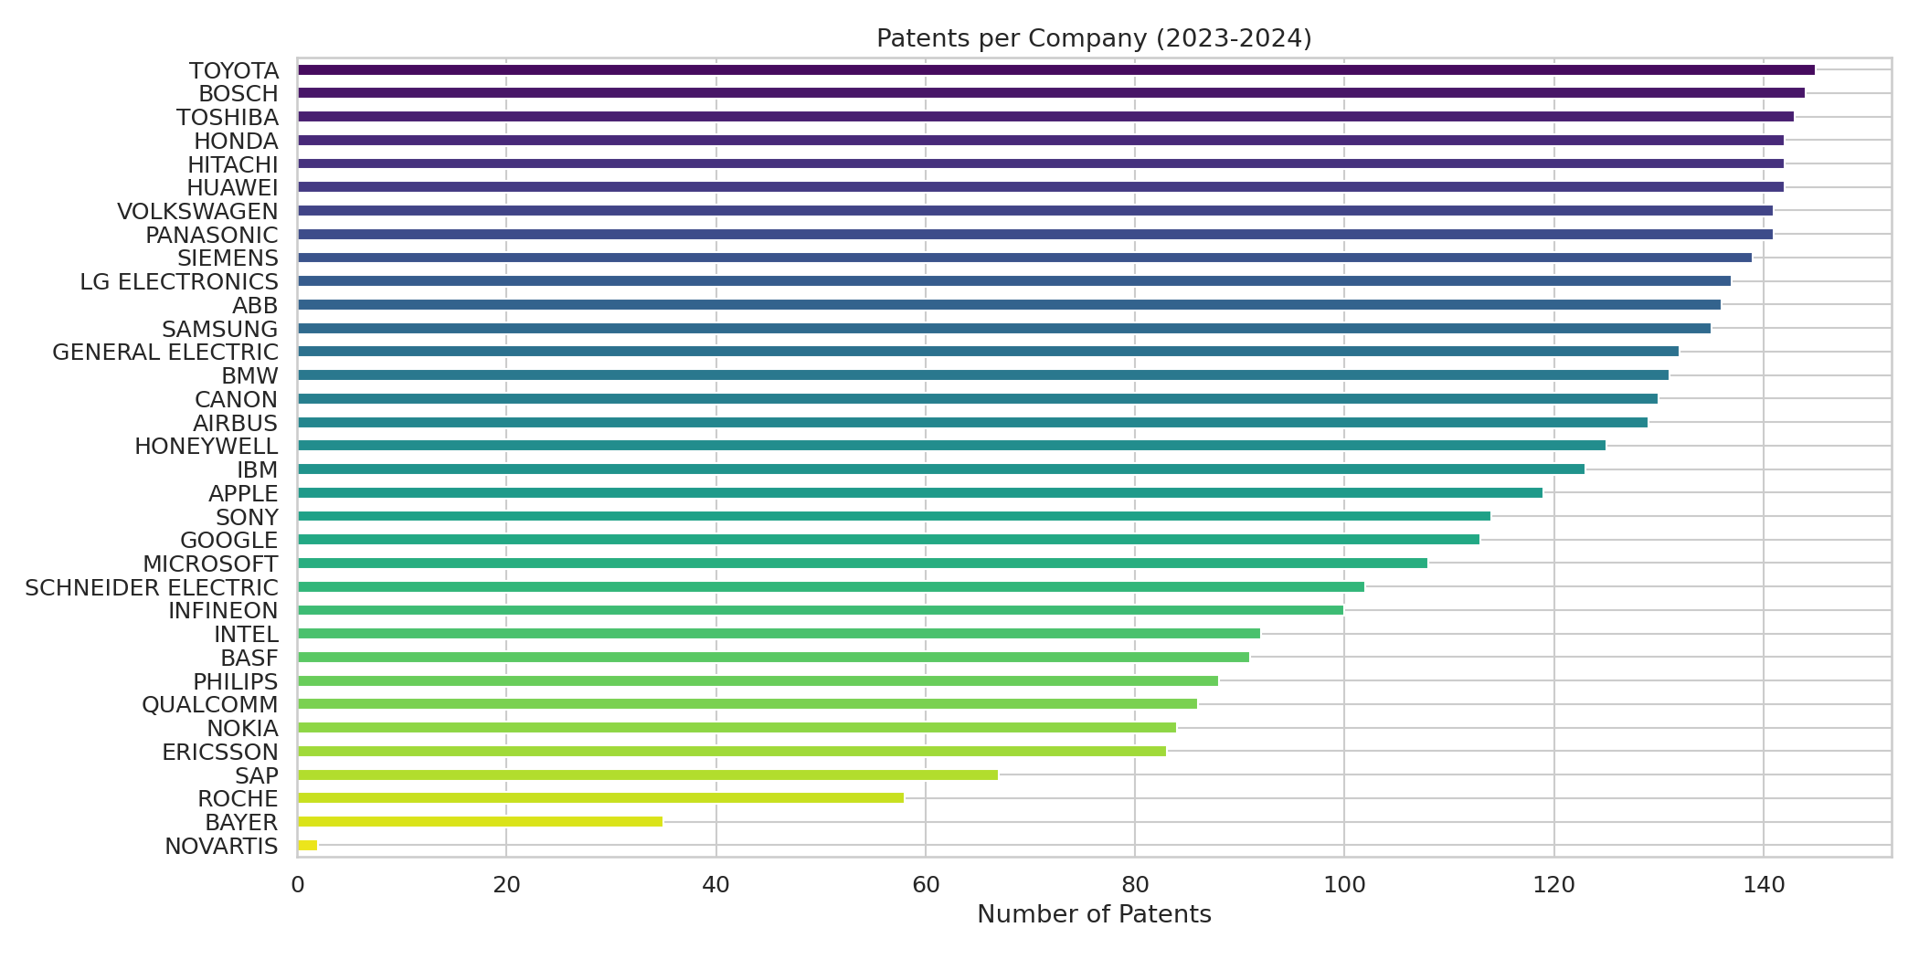
Figure 2. Number of qualifying patents per company (2023-2024).
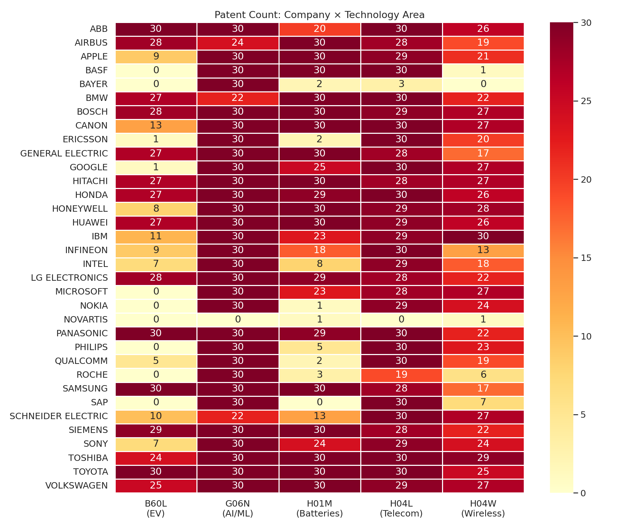
Figure 3. Company x technology-area heatmap, showing each firm's patenting focus.

3.2 Problem formulation
We formalize the task as follows. The corpus is a set of N = 3,769 patent abstracts, each a text document. An embedding function f maps every abstract to a vector x_i ∈ ℝ^d, with d = 5,000 for TF-IDF and d = 384 for Sentence-BERT. For a company c with its set of patents P_c, we form a single company vector by averaging and L2-normalizing its patent vectors:
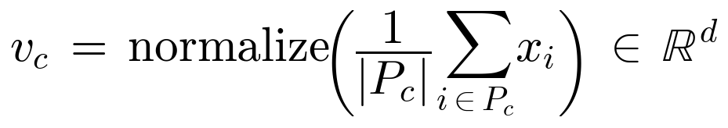
With 34 companies this yields a matrix V ∈ ℝ^(34×d). The central object of the analysis is the pairwise cosine-similarity matrix S ∈ ℝ^(34×34), defined as:
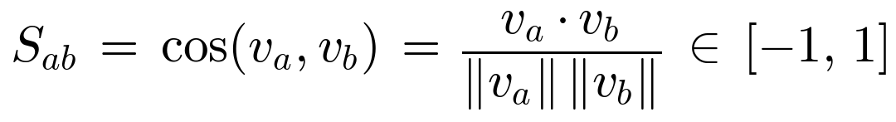
The outputs are: (i) a cluster label y_c ∈ {0, …, 4} for each company; (ii) an undirected similarity graph G = (V, E) where an edge connects two firms whose similarity exceeds a threshold τ; and (iii) a topic distribution over 8 latent topics per company from LDA.

3.3 Analysis techniques
Two embedding spaces are compared. The TF-IDF vectorizer uses up to 5,000 features, English stop-word removal, unigrams and bigrams, sublinear term-frequency scaling, and document-frequency cut-offs (min_df = 3, max_df = 0.85). Sentence-BERT uses the pre-trained all-MiniLM-L6-v2 model to encode each abstract into a 384-dimensional semantic vector. Both spaces feed the identical downstream pipeline so the comparison is fair: cosine similarity, K-Means (k = 5, matching the five technology areas, validated with elbow and silhouette analysis), hierarchical clustering with Ward linkage, t-SNE for 2-D visualization, a NetworkX similarity graph with degree and betweenness centrality, and an LDA topic model with 8 topics. The full flow is shown in Figure 1.
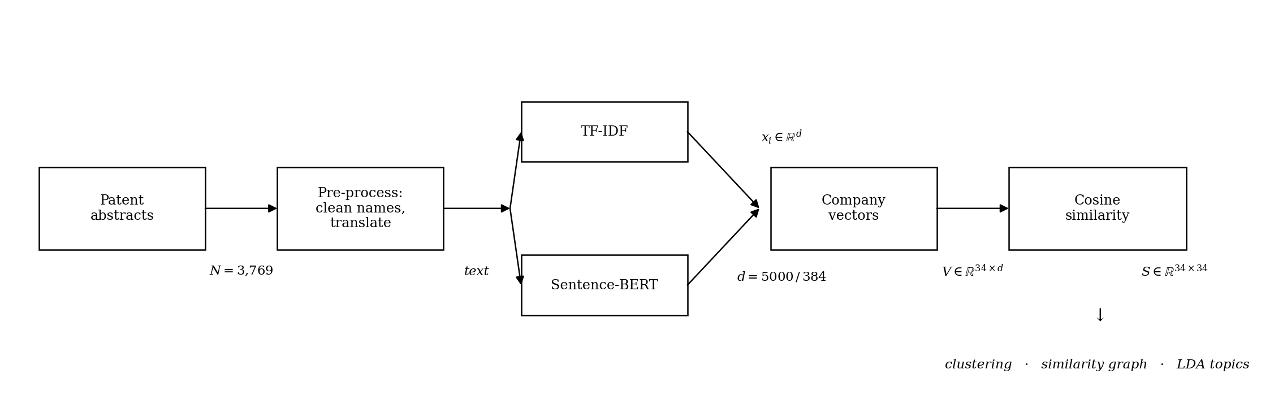
Figure 1. End-to-end model / processing pipeline.
A note on the graph threshold: because SBERT similarities are systematically higher than TF-IDF similarities, a single fixed threshold is not comparable across methods. We therefore use τ = 0.85 for the SBERT graph (and 0.3 for the TF-IDF baseline) so that each network is sparse enough to reveal structure rather than connecting every firm to every other.

3.4 Tools and software
The project is implemented entirely in Python 3.10. Data handling uses pandas and numpy; collection uses requests and python-dotenv; translation uses langdetect and deep-translator; modelling uses scikit-learn (TF-IDF, K-Means, hierarchical clustering, t-SNE, LDA) and sentence-transformers (SBERT); the network is built with networkx; and all figures are produced with matplotlib and seaborn. The code base is organized as four numbered scripts that run in sequence and is published with a requirements.txt and a README on GitHub.

4. Results

4.1 Experiments and evaluation protocol
The central experiment is the head-to-head comparison of TF-IDF and Sentence-BERT under an identical downstream pipeline. We evaluate each representation along three axes: cluster separation (silhouette score at k = 5), the distribution of pairwise similarities (mean, minimum, maximum), and the qualitative interpretability of the resulting clusters, top pairs, and network. Because the task is unsupervised, there is no held-out accuracy; instead, the evaluation protocol combines the internal silhouette metric with the pre-registered success criteria from Section 2.1. Cluster count was checked with an elbow/silhouette sweep over k = 2..10, which supported a small number of clusters consistent with the five technology areas. The silhouette coefficient measures, for each point, how much closer it is to its own cluster than to the nearest other cluster; it ranges from -1 to 1, and higher is better.
Metric | TF-IDF | Sentence-BERT
Embedding dimensions | 5,000 | 384
Silhouette score (k = 5) | 0.0627 | 0.1305
Mean pairwise similarity | 0.430 | 0.796
Companies / patents analysed | 34 / 3,769 | 34 / 3,769
Table 2. Quantitative comparison of the two representations.
Sentence-BERT more than doubles the silhouette score (0.131 vs 0.063), meaning its clusters are markedly better separated, even though it uses far fewer dimensions. Its higher mean similarity (0.796) reflects that semantic vectors place all technology documents in a denser region of space, which is why the network needs a higher edge threshold.

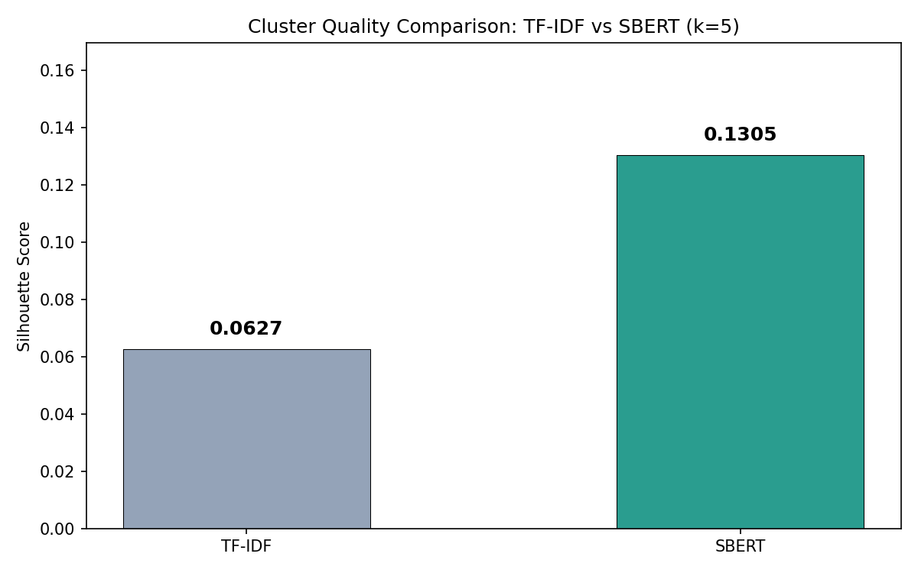
Figure 4. Cluster-quality comparison (silhouette score, k = 5).
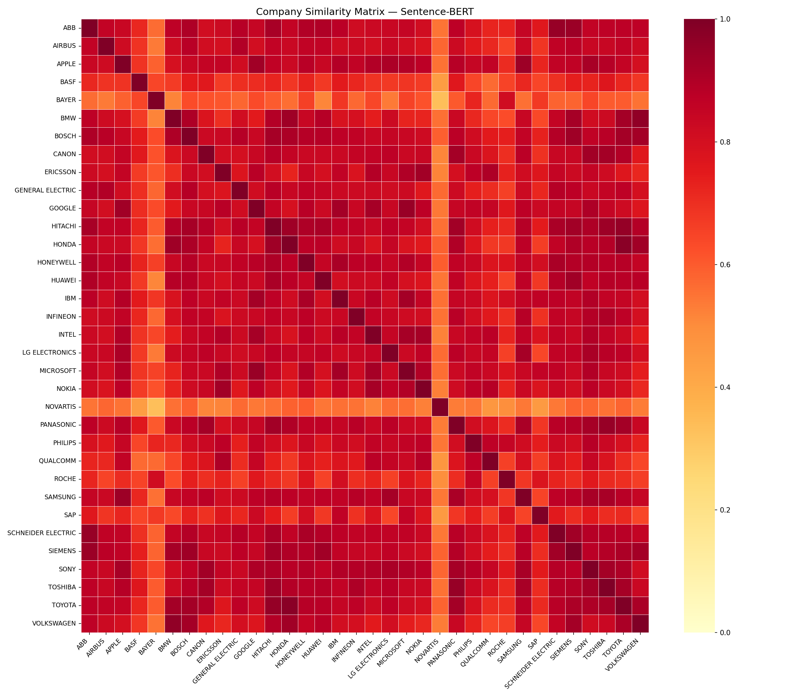
Figure 5. Sentence-BERT company similarity matrix. Warmer cells indicate higher similarity; block structure corresponds to industry groups.

4.2 Clusters
The five-way K-Means solution on the SBERT space is highly interpretable. The clusters correspond to recognizable industries, and Novartis separates out as a one-firm cluster, a direct consequence of its very small, pharmaceutical-only patent sample.
Cluster | Label | Members
0 | Industrial / Automotive | ABB, Airbus, BMW, Bosch, General Electric, Hitachi, Honda, Huawei, Schneider Electric, Siemens, Toyota, Volkswagen
1 | Technology / Telecom | Apple, Ericsson, Google, Honeywell, IBM, Intel, Microsoft, Nokia, Qualcomm, SAP
2 | Pharma outlier | Novartis
3 | Electronics / Materials | BASF, Canon, Infineon, LG Electronics, Panasonic, Samsung, Sony, Toshiba
4 | Healthcare | Bayer, Philips, Roche
Table 3. Sentence-BERT K-Means clusters (k = 5).
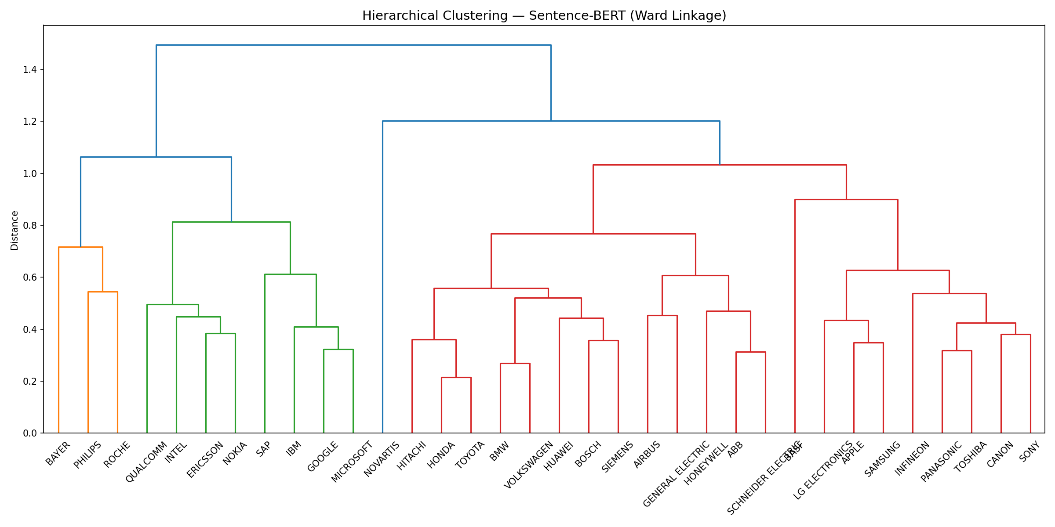
Figure 6. Hierarchical (Ward) clustering of companies in the SBERT space.
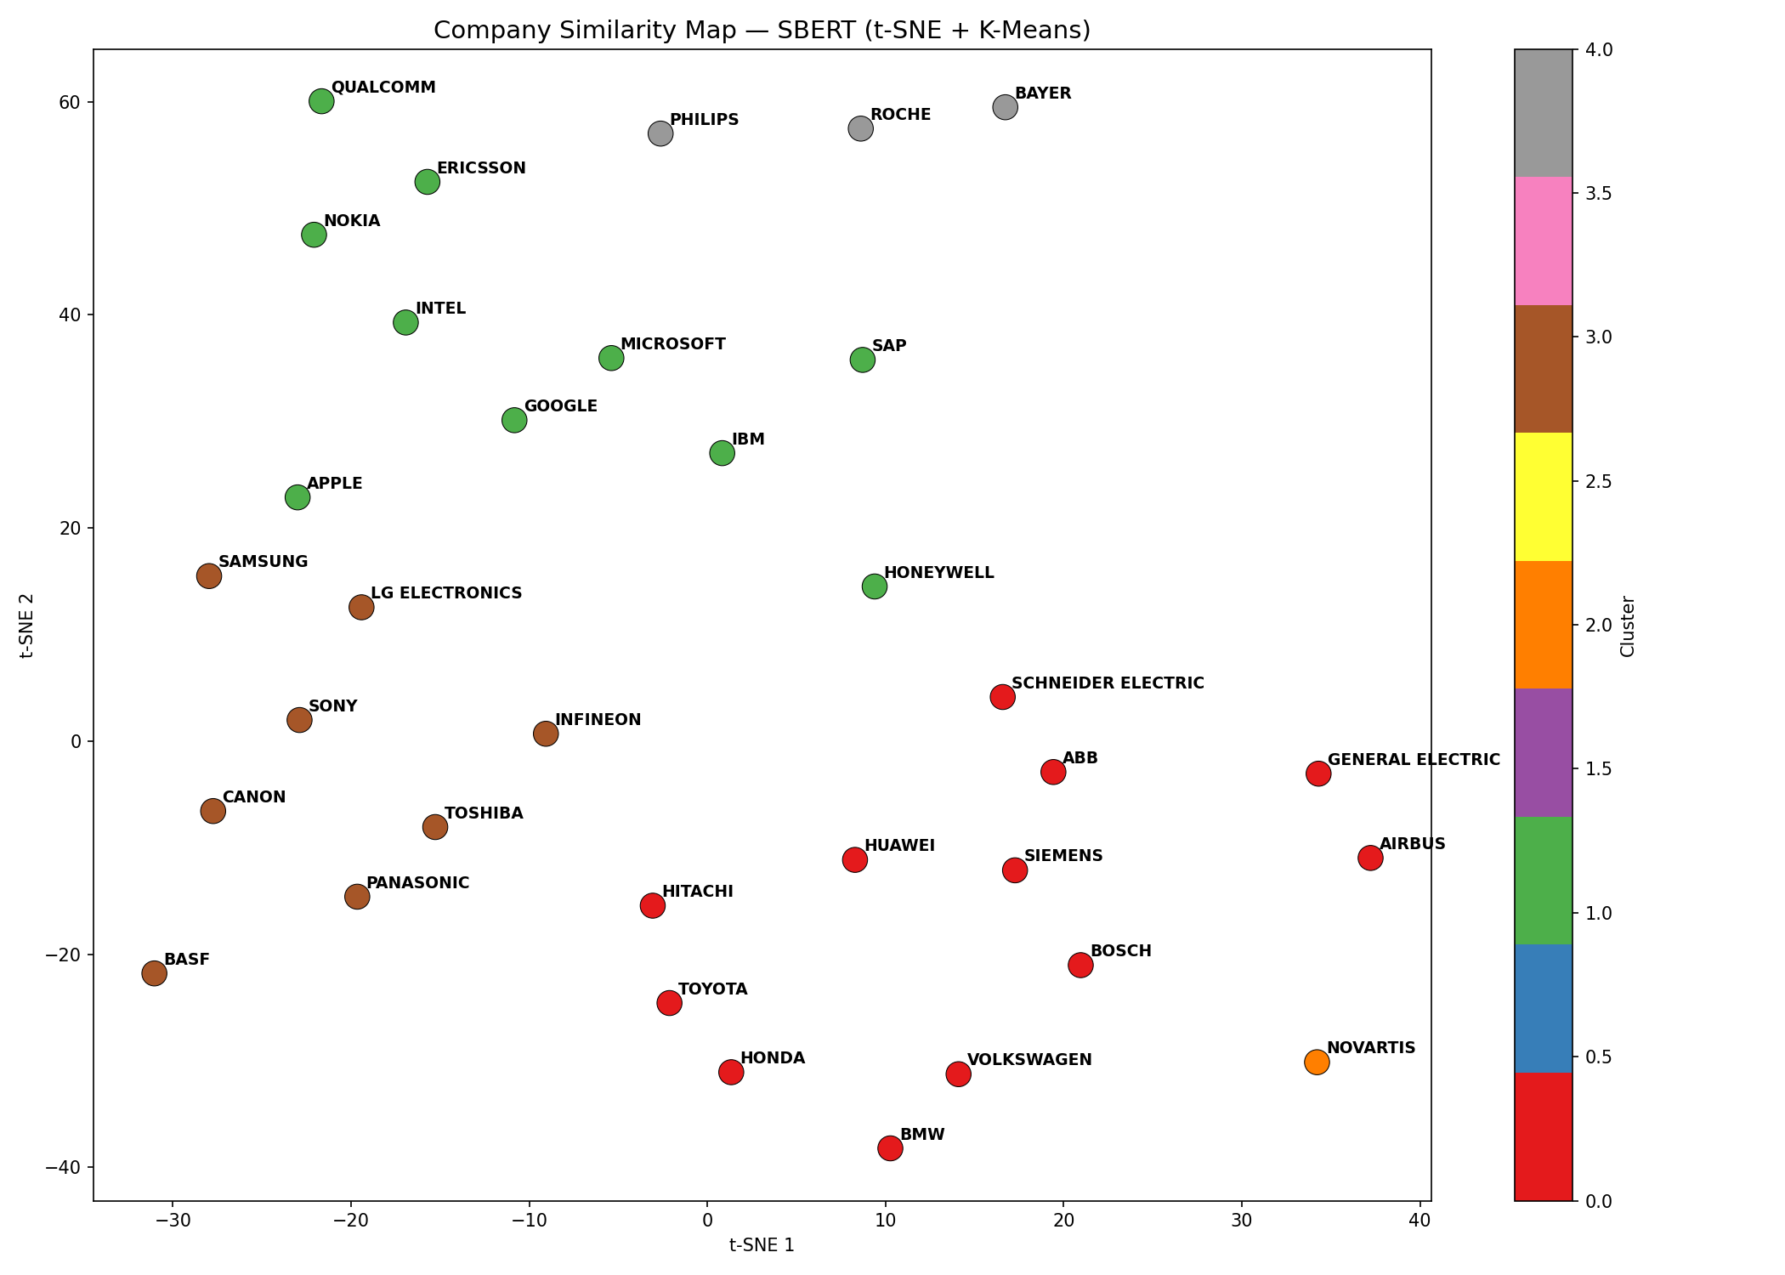
Figure 7. t-SNE projection of company vectors, coloured by K-Means cluster.

4.3 Most- and least-similar company pairs
The highest-similarity pairs map onto well-known direct competitors, which is strong face-validity for the method. The lowest-similarity pairs all involve Novartis, confirming its position as a technological outlier in this sample.
Most similar pairs | Similarity | Least similar pairs | Similarity
Honda / Toyota | 0.977 | Bayer / Novartis | 0.333
BMW / Volkswagen | 0.964 | BASF / Novartis | 0.446
Hitachi / Toyota | 0.954 | Novartis / SAP | 0.454
ABB / Schneider Electric | 0.951 | Novartis / Qualcomm | 0.468
Google / Microsoft | 0.948
Table 4. Extreme company pairs by Sentence-BERT cosine similarity.

4.4 Similarity network
At threshold τ = 0.85 the SBERT network has 34 nodes and 359 edges, a density of 0.640, and an average clustering coefficient of 0.814, indicating a tightly knit graph with clear communities. Ranking nodes by betweenness centrality highlights the firms that connect otherwise separate communities: IBM (0.081), Roche (0.057), and Philips (0.042) act as bridges, which fits their real-world breadth across software, healthcare, and electronics.
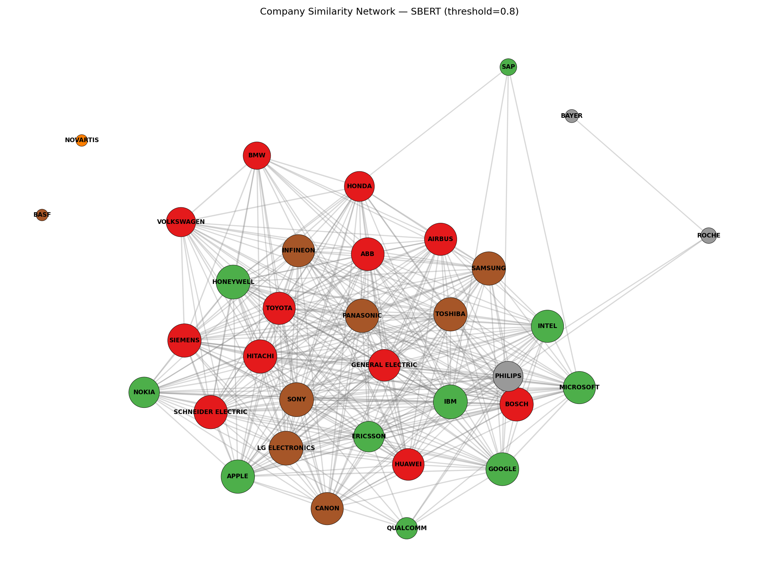
Figure 8. Company similarity network (Sentence-BERT, τ = 0.85), nodes coloured by cluster.

4.5 Topic modelling
The LDA model over 8 latent topics assigns each company a distribution over technology themes (Figure 9). The themes line up with the IPC areas. For instance, distinct battery/EV, wireless-communication, and machine-learning topics appear, and most firms concentrate on two or three themes, consistent with their cluster membership.
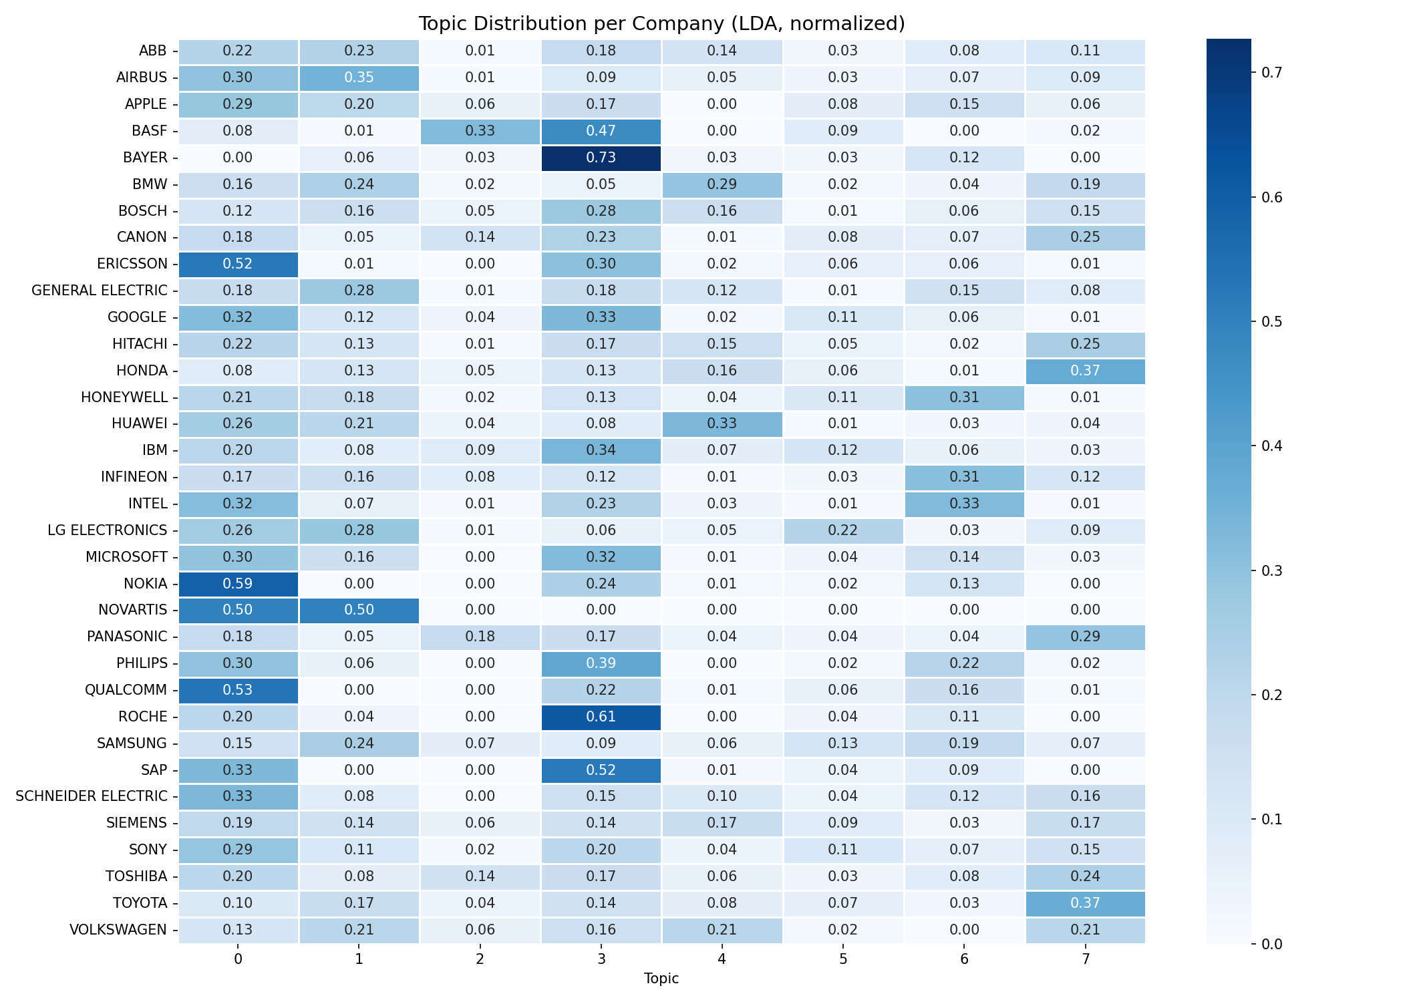
Figure 9. Normalised LDA topic distribution per company.

5. Discussion
The results support all three success criteria. Quantitatively, Sentence-BERT beat the TF-IDF baseline on cluster separation by roughly a factor of two (silhouette 0.131 vs 0.063), and it did so with one-thirteenth of the dimensions. Qualitatively, its clusters map cleanly onto industries and its top pairs reproduce textbook rivalries (Toyota-Honda, BMW-Volkswagen, Google-Microsoft). The interpretation is that keyword overlap, which is all TF-IDF can see, is a weak proxy for technological similarity: two car makers may describe the same invention with different vocabulary, and TF-IDF penalises that, whereas SBERT recognises the shared meaning. This is the core finding of the project.
The translation step mattered. Before translating, German-language abstracts from Bosch, Siemens, Volkswagen and Infineon tended to pull those firms together for the wrong reason, namely shared language rather than shared technology. Translating the 321 non-English abstracts removed this artefact, so the surviving structure reflects technology, not nationality. This is a concrete example of a preprocessing decision changing what the model learns.
Limitations. First, Novartis is represented by only two patents, so its outlier status is partly a sampling artefact rather than a deep statement about pharmaceutical innovation; any company with a thin sample would behave similarly. Second, averaging all of a company's patent vectors into one point discards internal diversity, since a conglomerate that genuinely works across several fields is collapsed to its centroid. Third, the corpus is restricted to five IPC areas and two years, so the similarity we measure is conditional on that slice of activity, not a company's entire portfolio. Fourth, the graph edge threshold is a free parameter; different thresholds change the network's density and which firms look like bridges, so the centrality numbers should be read as indicative rather than absolute.
What we would do differently. With more time we would (a) weight the company vector by patent recency or citation count rather than a plain average, (b) keep companies as distributions of patents and compare them with a set-based or earth-mover distance instead of a single centroid, and (c) validate clusters against an external industry taxonomy to get a semi-supervised score rather than relying on the silhouette metric alone. We would also balance the sample so that no company enters with only a handful of patents.

5.1 Future work
- Expand the corpus to more IPC areas, more years, and more firms to test whether the structure is stable over time.
- Try domain-adapted or patent-specific embedding models (e.g., PatentSBERTa) that may capture technical language better than a general-purpose encoder.
- Add patent citations to build a hybrid text-plus-citation similarity, and model each company as a sub-network rather than a single vector.
- Turn the static network into an interactive dashboard so analysts can explore neighbourhoods and thresholds directly.

6. Conclusion
This project set out to measure technological similarity between companies directly from the text of their patents, and to determine whether a modern semantic encoder beats a classical lexical baseline at that task. Working from 3,799 EPO patents (3,769 analysed) filed in 2023-2024 by 34 multinationals across five technology areas, we built a complete, reproducible pipeline: collection, name-cleaning, translation, embedding, similarity, clustering, network analysis, and topic modelling.
The objectives were met. Sentence-BERT produced substantially better-separated clusters than TF-IDF (silhouette 0.131 vs 0.063) and recovered five intuitive industry groups together with believable competitor pairs and sensible bridge firms (IBM, Roche, Philips). The experiments answer the original question affirmatively: meaningful, industry-aligned company similarity can be inferred from patent abstracts alone, and semantic embeddings are the better tool for it because they capture meaning rather than surface vocabulary. Equally important, the translation experiment showed that careful preprocessing, not just model choice, determines whether the signal reflects technology or an accident of language. The key recommendation for anyone reusing this approach is therefore to pair a semantic encoder with language normalisation and a balanced sample, and to treat single-vector company representations as a useful but lossy summary of a firm's real technological footprint.

Bibliography
Blei, D. M., Ng, A. Y., & Jordan, M. I. (2003). Latent Dirichlet Allocation. Journal of Machine Learning Research, 3, 993-1022.
Reimers, N., & Gurevych, I. (2019). Sentence-BERT: Sentence Embeddings using Siamese BERT-Networks. Proceedings of EMNLP-IJCNLP 2019.
Rousseeuw, P. J. (1987). Silhouettes: A graphical aid to the interpretation and validation of cluster analysis. Journal of Computational and Applied Mathematics, 20, 53-65.
Salton, G., & Buckley, C. (1988). Term-weighting approaches in automatic text retrieval. Information Processing & Management, 24(5), 513-523.
Pedregosa, F. et al. (2011). Scikit-learn: Machine Learning in Python. Journal of Machine Learning Research, 12, 2825-2830.
Hagberg, A., Schult, D., & Swart, P. (2008). Exploring network structure, dynamics, and function using NetworkX. Proceedings of the 7th Python in Science Conference (SciPy).
European Patent Office. Open Patent Services (OPS) Web Service. https://www.epo.org/searching-for-patents/data/web-services/ops.html

