Influence of Generative AI on Metacognitive Skills
(Planning and Self-Evaluation)
Technical and Business Writing (TBW) — Research Paper
Methods, Findings, Recommendations & Conclusion
Taha Akhtar (23K-0555) · Saad Hussain (23K-0705) · Syed Farhan Ali (23K-0862)
Tanzeel Adnan (23K-0849) · Saaim Zeeshan (23K-0573)
FAST NUCES, Karachi Campus

1. Methodology
1.1 Research Design
This study employed a cross-sectional quantitative survey design to examine the relationship between generative AI usage and two metacognitive skills — planning and self-evaluation — among undergraduate students. The quantitative approach was selected because it allows systematic measurement of self-reported behaviors across a reasonably large sample and supports statistical comparison and correlation analysis, both of which are necessary to address the study's central hypothesis.
1.2 Population and Sample
The target population was undergraduate students at FAST NUCES, Karachi Campus, enrolled in Computer Science (CS), Software Engineering (SE), Artificial Intelligence (AI), and Data Science (DS) programs. A convenience sample was recruited through online distribution of a structured Google Form questionnaire. A total of 72 responses were collected; 2 respondents indicated they had never used AI and were excluded, yielding a final analytical sample of n = 70. The sample was predominantly third-year (Junior) students (n = 53; 75.7%), with CS/SE/AI/DS respondents comprising 85.7% of the active sample.
1.3 Instrument
The survey instrument comprised 20 questions organized into four thematic blocks: (1) demographic and contextual items; (2) AI usage patterns (frequency, tools, stage of consultation); (3) planning scale items (Q9–Q12, five-point Likert); and (4) self-evaluation scale items (Q13–Q14, Q16–Q18). Reverse-scored items (Q11, Q14, Q16, Q18) were reflected (6 – score) before computing composite means, so higher composite scores consistently represent stronger autonomous metacognitive engagement.
1.4 Data Collection Procedure
The questionnaire was distributed electronically to students across multiple CS, SE, AI, and DS batch group chats during late April 2026. Participation was voluntary and anonymous. All data were exported from Google Forms as a CSV file for analysis.
1.5 Data Analysis
Analysis was conducted in Python 3.12 using the pandas and scipy libraries. Descriptive statistics (means, SDs, frequency distributions) were computed for all items and composite scores. Pearson product-moment correlations tested the association between AI usage frequency and each composite metacognitive score (α = .05). An independent-samples t-test compared high- vs. low-frequency users, noted as exploratory given sample imbalance (n = 68 vs. n = 2).

2. Findings
2.1 AI Usage Patterns
The overwhelming majority of participants reported very high generative AI usage: 52 respondents (74.3%) used AI multiple times per day, 16 (22.9%) a few times per week, and only 2 (2.9%) rarely or never. Taken together, 97.1% of the sample uses AI daily or weekly, indicating that generative AI has become routine in students' academic workflows (Figure 1). When asked at which stage they first consult AI, 64.3% reported using it "throughout the entire process" — treating it not as a finishing tool but as a continuous co-processor integrated into every phase of their work (Figure 2).
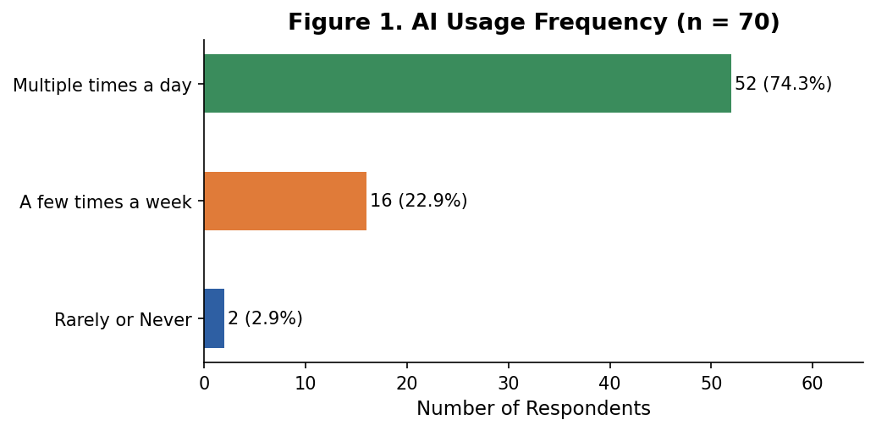
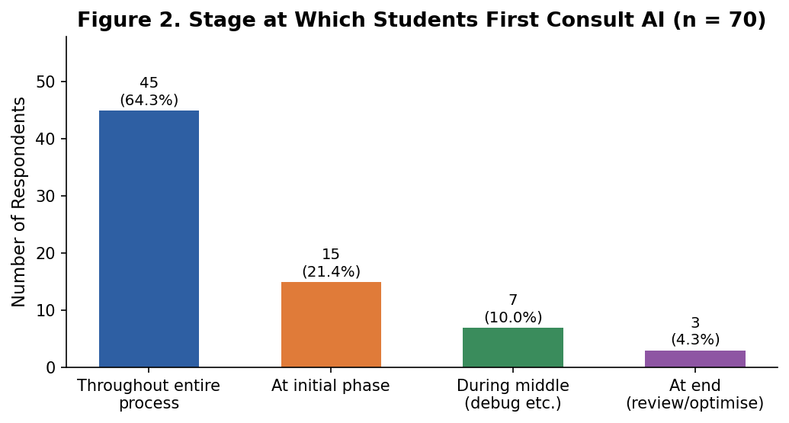
2.2 Trust and Dependency
Students exhibited moderate trust in AI-generated content (mean = 3.43, SD = 0.67; Figure 4a). The modal trust rating was 4 (n = 34; 48.6%). Despite this moderate trust, only 34.3% of students critically evaluate AI output before using it; 58.6% skim for obvious errors only, and 7.1% use output immediately (Figure 3). Perceived dependency (Q17) averaged 3.17 (SD = 0.98), with 32.9% indicating a moderate-to-severe impact if AI were removed tomorrow (Figure 4b).
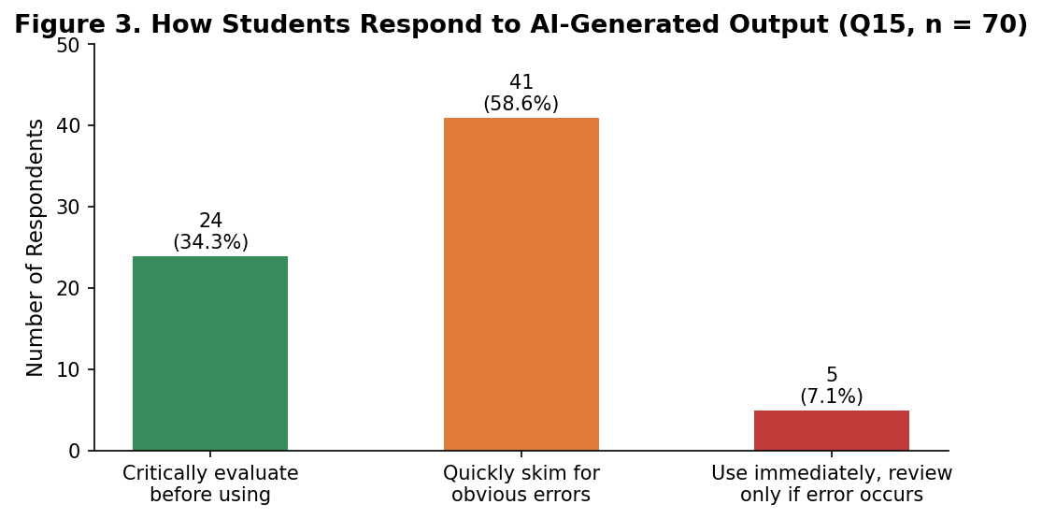
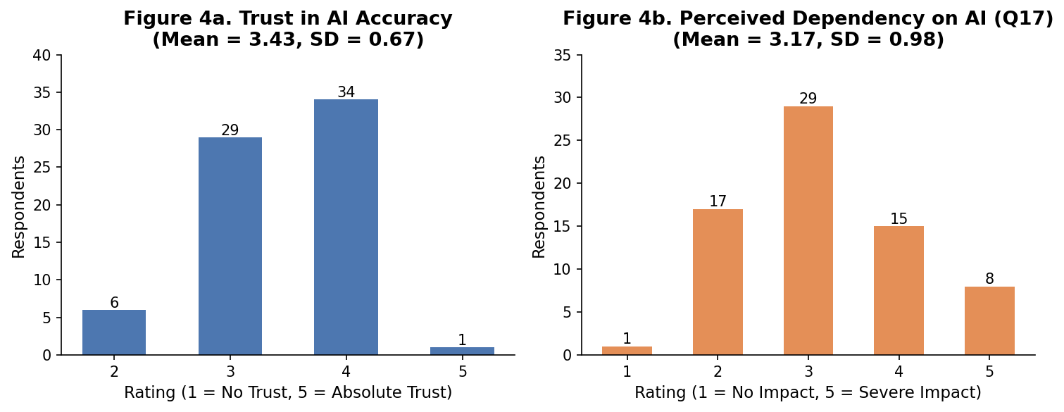
2.3 Planning Scale Results
The planning scale results reveal a nuanced picture of AI's role in student structuring behaviors. The strongest signal is Q10 (mean = 4.09), where students strongly agree that AI helps break down large tasks — indicating AI has become deeply embedded in planning, but as an external scaffold. Q12 (mean = 3.89) indicates goal-directed iterative prompting. Q9 (mean = 3.43, SD = 1.12) shows moderate autonomous pre-task planning, with high individual variation. Q11 (mean = 2.96) — the reverse-scored item — sits near neutral, suggesting a meaningful subset does allow AI to replace their own structuring. The composite autonomous planning score of 3.45 (SD = 0.70) sits slightly above the scale midpoint, indicating moderate but not robust independent planning (Figure 5).
Table 1. Planning Scale Item Means and Standard Deviations (n = 70)
Item | Mean | SD
Q9 — Creates plan before prompting AI | 3.43 | 1.12
Q10 — Uses AI to break down tasks | 4.09 | 1.02
Q11 — Relies on AI for structuring (reverse-scored) | 2.96 | 1.30
Q12 — Iterative prompt refinement | 3.89 | 1.07
Composite Autonomous Planning Score | 3.45 | 0.70

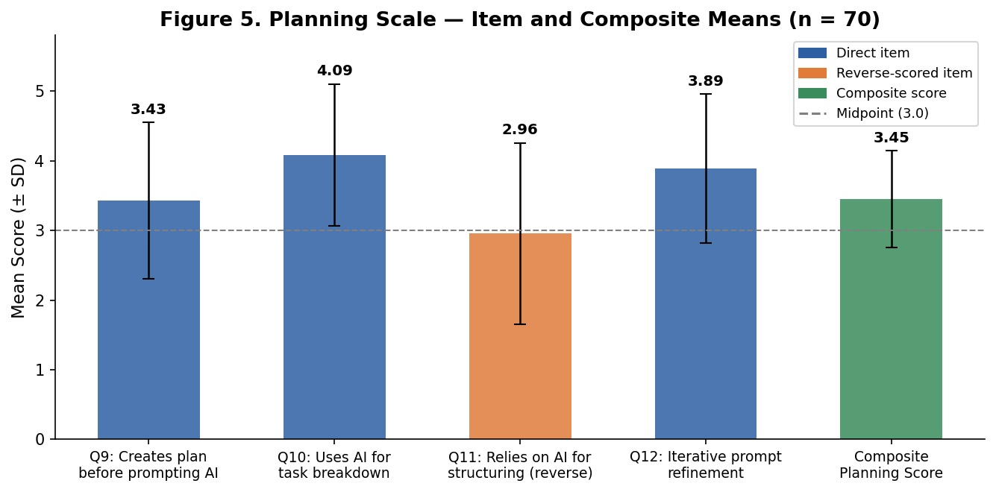
2.4 Self-Evaluation Scale Results
Self-evaluation results are more concerning. The composite self-evaluation score of 3.02 (SD = 0.60) sits essentially at the scale midpoint (Figure 7). Q13 (mean = 3.87) shows students do recognize knowledge gaps from AI feedback — a positive sign. However, Q16 (mean = 3.64, SD = 1.19) — whether work feels like their own — is the most alarming item: a majority agree their AI-assisted output feels inauthentic. Q14 (mean = 3.04) indicates post-task overestimation of independent ability, replicating Stadler et al.'s [9] experimental finding. Q18 (mean = 3.11) confirms that recall difficulty after heavy AI use is common. Together these items describe a pattern of eroded autonomous self-assessment consistent with Fan et al.'s [6] "metacognitive laziness" effect (Figure 6).
Table 2. Self-Evaluation Scale Item Means and Standard Deviations (n = 70)
Item | Mean | SD
Q13 — Recognises knowledge gaps via AI feedback | 3.87 | 1.02
Q14 — Overestimates independent ability (reverse-scored) | 3.04 | 1.13
Q16 — Work does not feel like own (reverse-scored) | 3.64 | 1.19
Q18 — Harder to recall when AI did majority (reverse-scored) | 3.11 | 1.32
Composite Self-Evaluation Score | 3.02 | 0.60

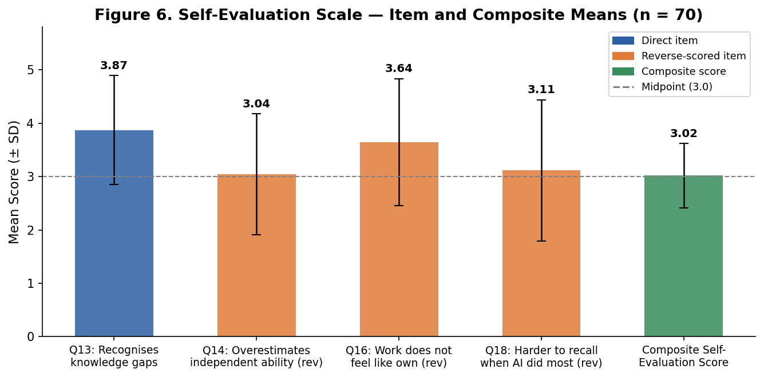
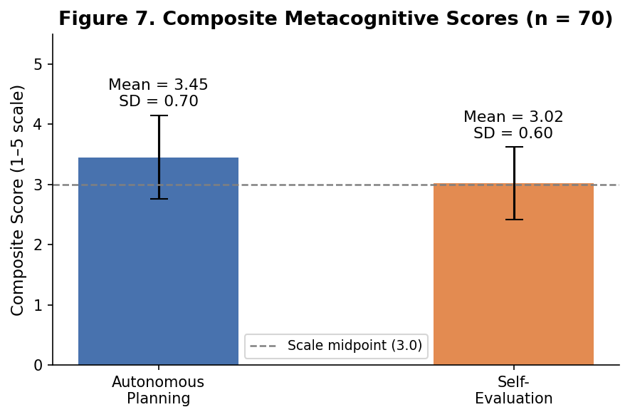
2.5 Likert Response Distribution
Figure 10 presents the full Likert distribution heatmap across all eight scale items, showing the percentage of respondents at each response level. The heatmap makes visible the concentration of responses in the Agree/Strongly Agree range for Q10, Q12, and Q13 (positive engagement indicators) and Q14, Q16, and Q18 (negative self-evaluation indicators), reinforcing the quantitative summary from Tables 1 and 2.
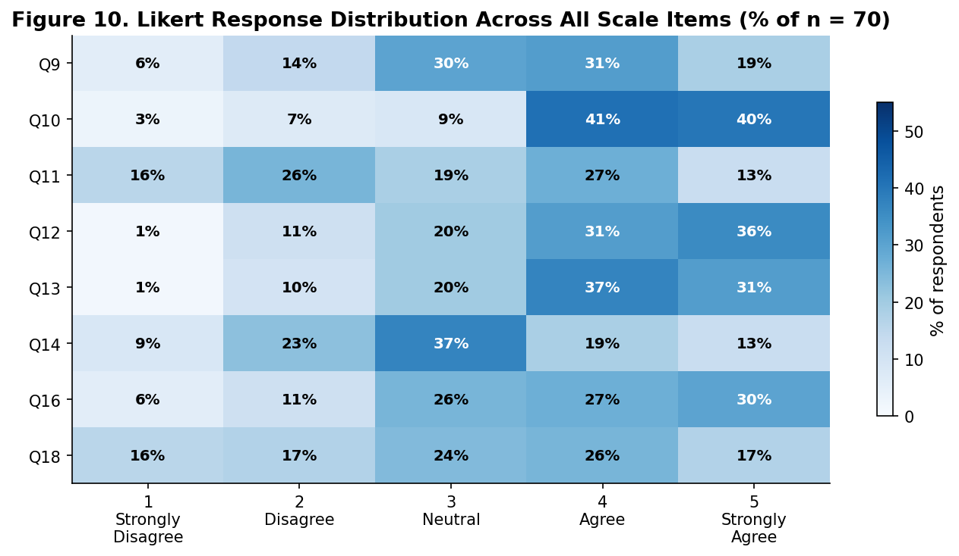
2.6 Metacognitive Laziness — Stage of Occurrence
Question 19 asked students whether they feel "lazy" when using AI and at which stage. 42.9% reported no laziness. Of those who did: 28.6% (n = 20) reported it during Development, 22.9% (n = 16) during Evaluation — precisely where self-evaluation is most critical — and 4.3% (n = 3) during Planning (Figure 8).
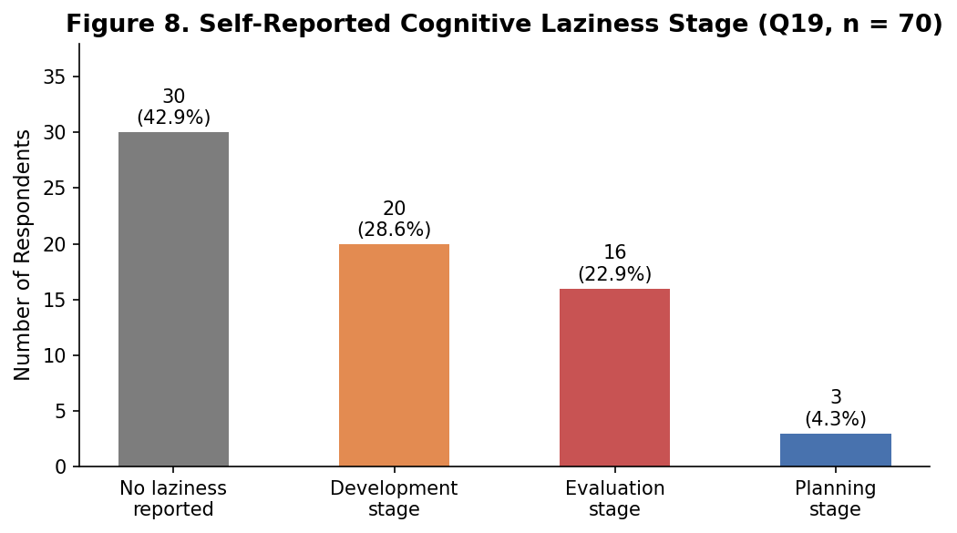
2.7 Correlation Analysis
Pearson correlations between AI usage frequency and composite scores were: r = −0.169 (p = .163) for planning and r = 0.053 (p = .662) for self-evaluation — neither statistically significant at α = .05. As Figure 9 shows, this is driven by near-total sample homogeneity in usage frequency (97.1% daily/weekly) rather than an absence of effect. The correlation scatter plots illustrate this restricted range clearly: virtually all data points cluster at frequency scores 4–5, providing insufficient contrast to detect a frequency-gradient effect within this population.
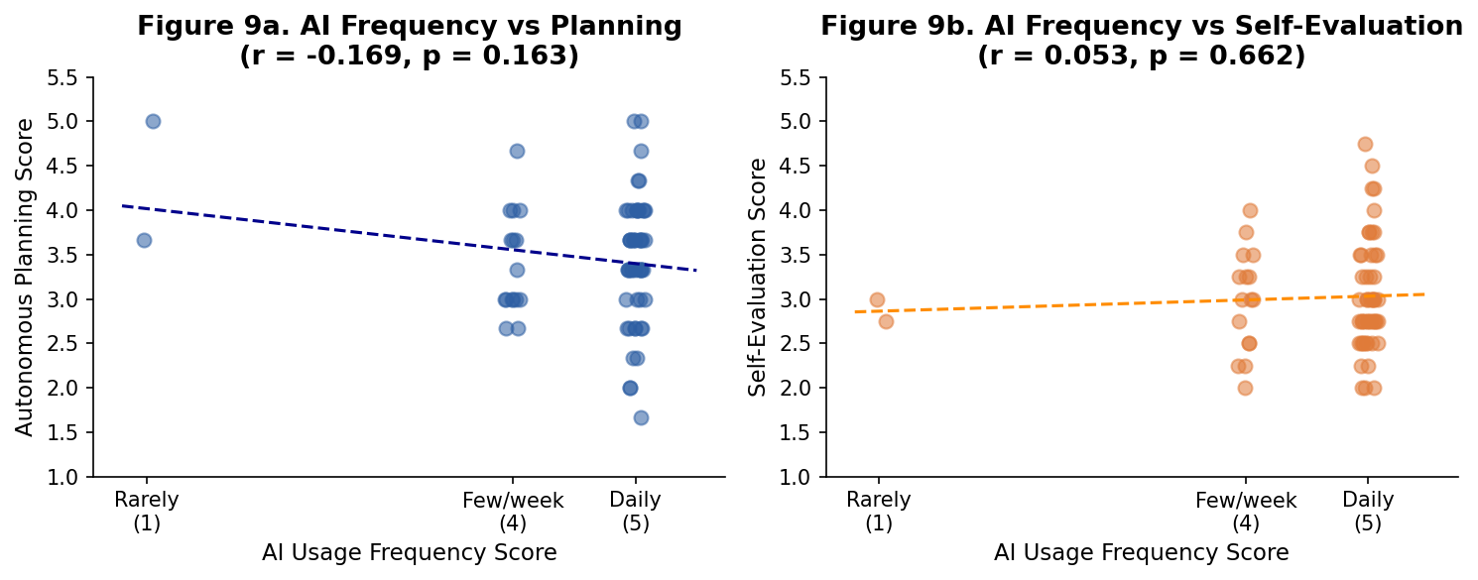

3. Recommendations
The findings point to three domains for targeted intervention: instructional design, institutional policy, and individual student practice.
3.1 Embed Mandatory Pre-Task Planning Checkpoints (For Educators)
Because 64.3% of students consult AI throughout the entire process and Q11 scores suggest a meaningful subset skip autonomous structuring, assignments should require a documented planning artifact — an outline, task-breakdown chart, or written goal statement — submitted before AI-assisted work begins and graded independently of the final output. This mirrors scaffolding shown to be effective by Xu et al. [8], where built-in metacognitive prompts significantly increased self-regulated learning behaviors.
3.2 Require Comparative Self-Evaluation Submissions (For Educators)
The self-evaluation composite score of 3.02 and Q16 mean of 3.64 (many students feeling the work is not their own) point to significant loss of critical ownership. Educators should require a short "self-evaluation memo" alongside AI-assisted work, in which students (a) identify two claims they verified or modified, (b) articulate one inaccuracy they found, and (c) rate their confidence in reproducing the work without AI. This directly targets the overestimation pattern in Q14 and the 22.9% evaluation-stage laziness.
3.3 Teach AI Literacy as Critical Evaluation, Not Just Usage (For Educators)
With 58.6% of students skimming AI output and trust averaging 3.43, institutions should incorporate AI literacy modules covering hallucination detection, source fidelity, and the limits of AI-generated reasoning — consistent with Baidoo-Anu and Owusu Ansah's [2] finding that fabricated citations and over-reliance are key risks of unstructured AI use.
3.4 Use AI as a Diagnostic Tool, Not a Shortcut (For Students)
Students should adopt an "interrogative use" model: instead of asking AI to produce deliverables, ask it to question a draft, identify weaknesses, or explain concepts already attempted. This shifts AI from a cognitive replacement to a cognitive challenger. Multiple Q20 responses explicitly acknowledged that using AI to complete lab work prevented understanding of underlying concepts, which hurt exam performance.
3.5 Institutional Policy: Transparent AI Use Declarations (For Institutions)
Given 97.1% daily/near-daily AI use, blanket prohibitions are counterproductive. Institutions should develop tiered AI use policies specifying — at the assignment level — whether AI is permitted for ideation only, for drafting with mandatory self-evaluation, or not at all. Transparency declarations (documenting which parts involved AI and how output was verified) create accountability without the burden of detection tools.

4. Conclusion
This study investigated whether pervasive generative AI use among 70 AI-using undergraduates at FAST NUCES Karachi affects their metacognitive skills — specifically planning and self-evaluation. The findings provide evidence that warrants both measured concern and targeted action.
On planning, the results are mixed. Students retain moderate autonomous planning behavior (composite mean = 3.45), but AI has taken on a heavy load of structuring work (Q10 mean = 4.09), and a meaningful proportion agree they invest less personal effort in structuring because AI will handle it. The planning skill is not absent, but it is increasingly mediated by AI rather than independently exercised — consistent with Ng et al.'s [5] warning about students skipping the forethought phase of self-regulated learning.
On self-evaluation, the findings are more concerning. The composite score of 3.02 sits at the midpoint. Three specific signals stand out: 65.7% of students skim or immediately accept AI output; 64.3% feel their AI-assisted work does not feel authentically theirs (Q16 mean = 3.64); and post-task overestimation of independent ability (Q14 mean = 3.04) replicates Stadler et al.'s [9] experimental finding that AI distorts self-assessment. These patterns are consistent with the "metacognitive laziness" construct of Fan et al. [6], with the Evaluation stage as the most acute point of metacognitive risk.
The absence of significant frequency-metacognition correlations reflects sample homogeneity rather than the absence of a relationship. The more meaningful observation is that a population using AI almost universally at high frequency shows metacognitive scores that cluster just above neutral rather than reflecting strong autonomous engagement. The baseline has been shifted.
This study fills a gap identified in the literature review: it provides the first context-specific, discipline-specific quantitative evidence on AI and metacognition from Pakistani computing undergraduates. The findings align with global trends [2], [5], [6], [8], [9] but give those trends local urgency. Limitations include a convenience sample dominated by third-year CS/SE students and the reliance on self-report measures. Future work should use validated instruments (e.g., MAI), experimental designs, and more balanced year-group sampling.
Generative AI is not going away. The challenge for educators, students, and institutions is not whether to use it but how to use it in ways that preserve, rather than outsource, the cognitive work that produces genuine learning. Without deliberate structural interventions — mandatory planning artifacts, comparative self-evaluation memos, AI literacy training, and tiered policies — the convenience of AI will continue to quietly erode the metacognitive habits students need when AI is not available.

5. References
[1] R. Michel-Villarreal et al., "Challenges and opportunities of generative AI for higher education as explained by ChatGPT," Education Sciences, vol. 13, no. 9, p. 856, 2023.
[2] D. Baidoo-Anu and L. Owusu Ansah, "Education in the era of generative AI: Understanding the potential benefits of ChatGPT," Journal of AI, vol. 7, no. 1, pp. 52–62, 2023.
[3] J. H. Flavell, "Metacognition and cognitive monitoring," American Psychologist, vol. 34, no. 10, pp. 906–911, 1979.
[4] B. J. Zimmerman, "Becoming a self-regulated learner: An overview," Theory into Practice, vol. 41, no. 2, pp. 64–70, 2002.
[5] D. T. K. Ng, C. W. Tan, and J. K. L. Leung, "Empowering student self-regulated learning through ChatGPT," British Journal of Educational Technology, vol. 55, no. 4, pp. 1328–1353, 2024.
[6] Y. Fan et al., "Beware of metacognitive laziness: Effects of generative AI on learning motivation, processes, and performance," British Journal of Educational Technology, vol. 56, no. 2, pp. 489–530, 2024.
[7] H. B. Essel et al., "ChatGPT effects on cognitive skills of undergraduate students," Computers and Education: Artificial Intelligence, vol. 6, p. 100198, 2024.
[8] W. Xu, Q. Liu, K. R. Koedinger, and L. Lin, "Enhancing self-regulated learning in generative AI environments," British Journal of Educational Technology, vol. 56, no. 4, pp. 1456–1478, 2025.
[9] M. Stadler, M. Bannert, and M. Sailer, "ChatGPT improves creative problem-solving in university students," Computers & Education, vol. 220, p. 105081, 2024.
[10] M. Gerlich, "AI tools in society: Impacts on cognitive offloading and critical thinking," Societies, vol. 15, no. 1, p. 6, 2025.
[11] J. Jose et al., "The cognitive paradox of AI in education: Between enhancement and erosion," Frontiers in Psychology, vol. 16, p. 1550621, 2025.

