OS Mid 1 Question 2(b) discussion:
here is the code which is provided in the solution:
#include <stdio.h>
#include <unistd.h>
#include <sys/types.h>
void print_val(int lv)
{
for (int j = lv; j < lv + 5; j++)
{
printf("%d ", arr[j]);
}
printf("\n");
}
int main()
{
//parent process P0
int arr[] = {1, 2, 3, 4, 5, 6, 7, 8, 9, 10, 11, 12, 13, 14, 15};
int start_index = 0;
pid_t pid = fork();
if (pid == 0)
{ // child process P1
printf("Process : ");
if (start_index != 0)
start_index += 5; // Move to the next 5 elements
print_val(start_index);
return 0; // exit P1
}
else if (pid > 0)
{ // parent process P0
printf("Process : ");
if (start_index != 0)
start_index += 5;
print_val(start_index);
pid_t pid1 = fork();
if (pid == 0)
{ // P2 - 2nd child of P0
printf("Process : ");
if (start_index != 0)
start_index += 5;
print_val(start_index);
return 0; // exit P2
}
else
// wait (NULL); // shifted below. No error checking.
}
else
return 1; // fprintf(stderr, "Fork failed!\n");
}
wait(NULL); // Wait for 1st child process to finish.
wait(NULL); // Wait for 2nd child process to finish.
return 0;
}

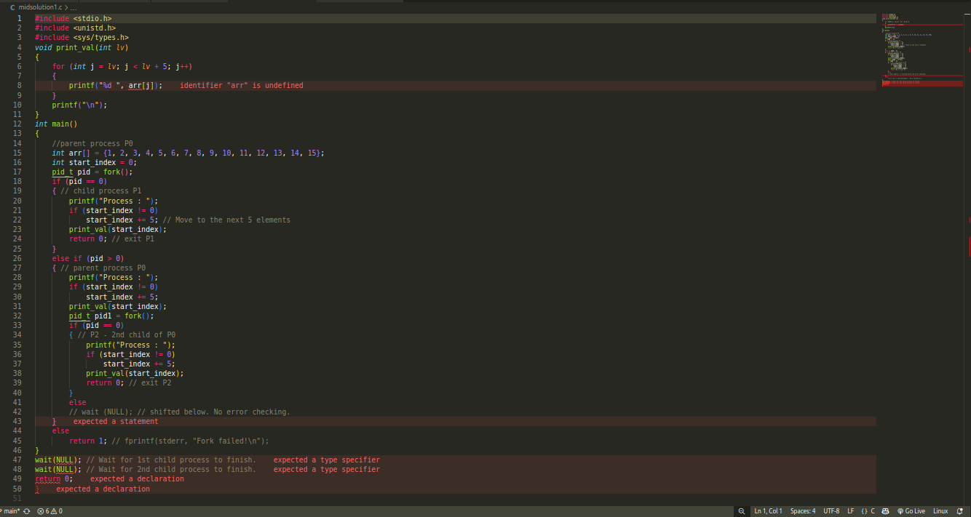
this solution code cannot be run as it contains syntax errors. The code contains following syntax errors:
- in function print_val, the array “arr” is used to access the data however it is not defined in the function’s scope as well as in global scope
- in line 41, there is an empty else block
- both the “wait(NULL)” statements and return 0 statement are written outside the main function

these errors can be resolved by:
- moving “arr” to the global scope
- comment out else statement
- move wait(NULL) and return 0 inside the main

after addressing these syntax errors the code becomes something like this:
#include <stdio.h>
#include <unistd.h>
#include <sys/types.h>

int arr[] = {1, 2, 3, 4, 5, 6, 7, 8, 9, 10, 11, 12, 13, 14, 15};

void print_val(int lv)
{
for (int j = lv; j < lv + 5; j++)
{
printf("%d ", arr[j]);
}
printf("\n");
}
int main()
{
//parent process P0
int start_index = 0;
pid_t pid = fork();
if (pid == 0)
{ // child process P1
printf("Process : ");
if (start_index != 0)
start_index += 5; // Move to the next 5 elements
print_val(start_index);
return 0; // exit P1
}
else if (pid > 0)
{ // parent process P0
printf("Process : ");
if (start_index != 0)
start_index += 5;
print_val(start_index);
pid_t pid1 = fork();
if (pid == 0)
{ // P2 - 2nd child of P0
printf("Process : ");
if (start_index != 0)
start_index += 5;
print_val(start_index);
return 0; // exit P2
}
// else
// wait (NULL); // shifted below. No error checking.
}
else
return 1; // fprintf(stderr, "Fork failed!\n");

wait(NULL); // Wait for 1st child process to finish.
wait(NULL); // Wait for 2nd child process to finish.
return 0;
}

when executing this code the output is something like this:
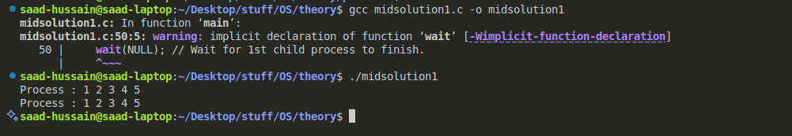
output discussion: this is not the output we were expecting, we were expecting a output of numbers from 1 to 15 with each process printing 5 numbers
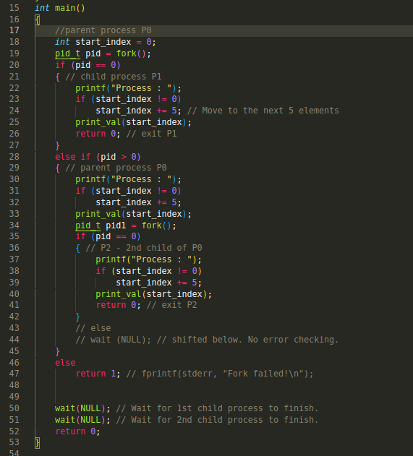
what is happening here ?
Take a look at line 28, we are moving inside the else if block ONLY IF the pid > 0, however inside this else if block, at line 35, we are comparing pid == 0 to print the 5 numbers, since these two statements are contradicting each other(pid can’t be 0 and greater than 0 at the same time), the lines inside the if statement (from line 36 to line 41) will never be executed and hence we are seeing output of only two processes printing the numbers:

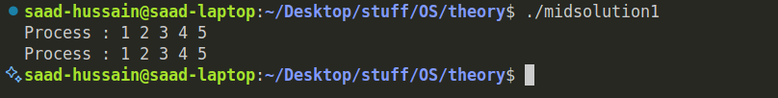
Solution for this problem?
At line 35 if we use pid1 instead of pid, as we want from newchild process(line 34) to print 5 numbers, then we will be able to solve this problem

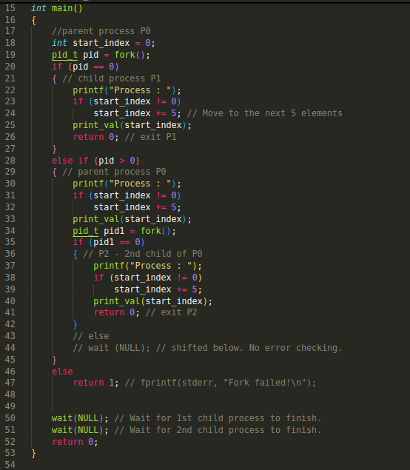

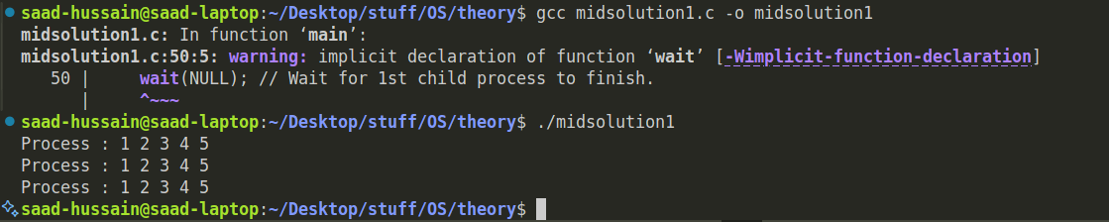
now we have three processes and each process is printing 5 numbers, but wait a minute, arent we trying to print all number from 1, 2, to all the way to 15, and not first 5 numbers printing three times

what is actually happening here:
take a look at the code

as we discussed in the class, unlike threads, when a child process is created using fork() it has its own memory map I.e it also contains its own copy of variable start_index that means each process will have a variable start_index initialized to 0 thats why they are printing only first five elements of the array and since each process have its own copy of variable, modifying the value of start_index will not effect others, unless it is a parent process in which if we modify a value it will affect childs values
here is the one of the correct code
#include <stdio.h>
#include <unistd.h>
#include <sys/types.h>

int arr[] = {1, 2, 3, 4, 5, 6, 7, 8, 9, 10, 11, 12, 13, 14, 15};

void print_val(int lv)
{
for (int j = lv; j < lv + 5; j++)
{
printf("%d ", arr[j]);
}
printf("\n");
}
int main()
{
//parent process P0
int start_index = 0;
pid_t pid = fork();
if (pid == 0)
{ // child process P1
printf("Process : ");
if (start_index != 0)
start_index += 5; // Move to the next 5 elements
print_val(start_index);
return 0; // exit P1
}
else if (pid > 0)
{ // parent process P0
wait(NULL); // Wait for 1st child process to finish.
start_index += 5; // Move to the next 5 elements
printf("Process : ");
print_val(start_index);
pid_t pid1 = fork();
if (pid1 == 0)
{ // P2 - 2nd child of P0
printf("Process : ");
if (start_index != 0)
start_index += 5;
print_val(start_index);
return 0; // exit P2
}
// else
// wait (NULL); // shifted below. No error checking.
}
else
return 1; // fprintf(stderr, "Fork failed!\n");

wait(NULL); // Wait for 1st child process to finish.
wait(NULL); // Wait for 2nd child process to finish.
return 0;
}

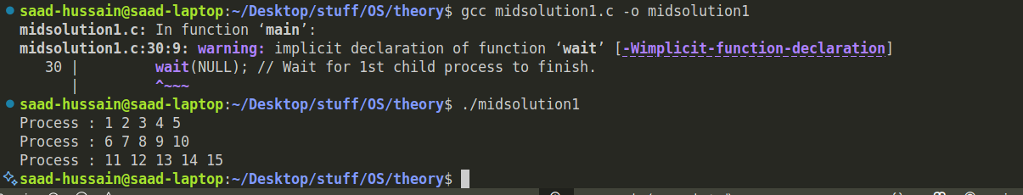
explanation

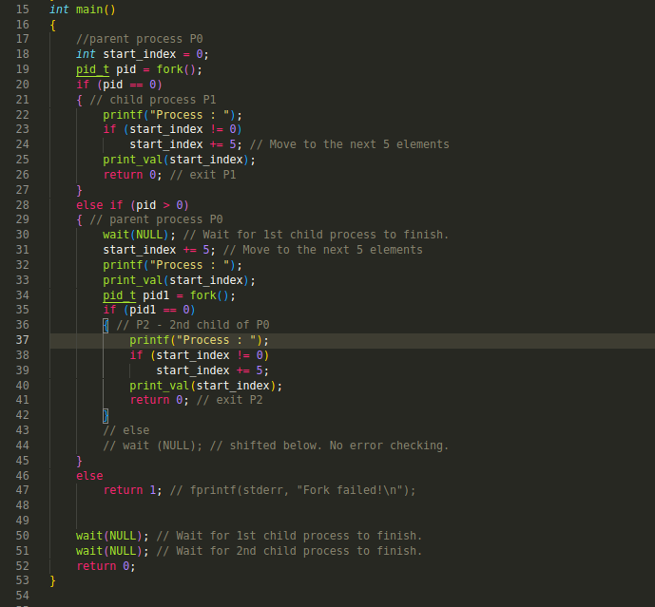

Explanation:
at line 30, wait(NULL) is used so that we get to know first 5 numbers have been printed, and now in parent process we modify the value of start_index(which will be affected in child processes) and print another 5 numbers and then execute fork and the next child will print another 5 numbers
key takeaways:
if you hardcode (one process will print from 0-4 index, one from 5-9 and one from 10-14 index) then you don’t need to use wait(NULL), but once you are using a common variable like start_index, you either have to wait(NULL) bcz only parent’s modification can be visible to childs and not child’s modification can be visible to another child or you have to implement shared memory to the solution (which was not part of mid 1)

