**Department of Electrical Engineering**

**Faculty Member: Dr. Wajahat Hussain** **Dated: 28-2-2107**

# Course/Section: BEE6-B Semester: 6th Semester

**EE-330 Digital Signal Processing**

**Lab3: Introduction to DSP Kit TMS 320C6713 DSK**

|  |  |  |  |  |
| --- | --- | --- | --- | --- |
| **Name** | **Reg. no.** | **Report**  **Marks**  **/ 10** | **Lab Quiz-**  **Viva Marks**  **/ 5** | **Total / 15** |
| **Saad Iqbal** | **111394** |  |  |  |
| **Usman Iqbal** | **111393** |  |  |  |
| **Abdullah Bin Asif** | **111596** |  |  |  |

**Objectives**

The objective of this lab is to introduce the DSP Starter Kit C6713

* Getting started with DSP Kit
* Getting Started with Code Composer Studio
* Basic Code Compilation on DSP Kit
* Working with basic sinusoids on DSP Kit

### **Introduction of the TMS 320 C 6713 Digital Signal Processor kit**

The TMS320C6713 DSP Starter Kit (DSK) developed jointly with Spectrum Digital is a low-cost development platform designed to speed the development of high precision applications based on TI´s TMS320C6000 floating point DSP generation.

The DSK also has four user-programmable DIP switches and four LEDs that can be used to control and monitor programs running on the DSP. The signal processor is further controlled by an IDE known as CCS. Which has a C/C++ compiler, assembler, linker, debugger, and program loader. The DSP is connected with the kit using a USB port.

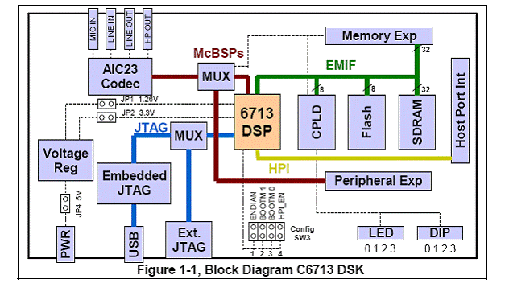

Figure Block diagram of TMS 320C6713 kit

The C6713 DSK allows you to download and step through code quickly and uses Real Time Data Exchange (RTDX™) for improved Host and Target communications. It also includes fast and real time libraries and utilities such as flash burn to program the memory. The DSK can also be used with an external emulator through the external JTAG connector.

Additional peripherals and the internal connection includes:

* A highly efficient 16-channel enhanced direct memory access (EDMA) controller connects

the peripherals to the internal and external memory.

* Highly configurable PLL and clocking control logic to enable a variety of ratios of system and CPU clocks
* 256K bytes of internal memory to provide a large internal program and data store
* Two multichannel buffered serial ports (McBSPs) provide general connection to multiple serial standards including SPI
* Two general-purpose timers to count system events or generate clock outputs
* 16 MB dynamic RAM, 512 KB non-volatile Flash memory.

**Introduction of the 6713 series Digital Signal Processor**

The TMS320C6713 is the Highest-Performance Floating-Point Digital Signal Processor (DSP).The C6713 device is based on the high-performance, advanced very-long-instruction-word (VLIW) architecture developed by Texas Instruments (TI), making this DSP an excellent choice for multichannel and multifunction applications.

Specifications:

TMS320C6713 processor can fetch up to 256 bits of information (8*32) in a single cycle. The processor is operating at 225MHz clock frequency.

It delivers up to 1350 million floating-point operations per second (MFLOPS), 1800 million instructions per second (MIPS), and with dual fixed-floating-point multipliers up to 450 million multiply-accumulate operations per second.

It has 264 KB of internal memory 4kB as L1Program Cache, 4kB as L1Data Cache and

256kB as L2 memory shared between program and data. There are two sets of 16 32-bit general purpose registers.

Internal buses include a 32-bit program address bus, a 256-bit program data bus to accommodate eight 32-bit instructions two 32-bit data address buses, two 64-bit data buses and two 64-bit store data buses.

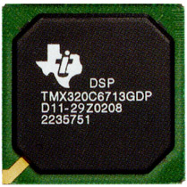

*Figure 3 The 320C6713 prcessor*

### **Introduction of the Code Composer Studio**

The code composer studio also known as (CSS) provides an environment which helps in real time digital signal processing using the C programming language. It is composed of a C compiler, assembler and a linker. The IDE comes with graphical support and real time debugging.

Now we will discuss about ***how a C program works*** in this environment. Firstly The C compiler compiles a C source program with extension .c to produce an assembly source file with extension .asm. The assembler assembles an .asm source file to produce a machine language object file with extension .obj. The linker combines object files and object libraries as input to produce an executable file with extension .out. This executable file represents a linked common object file format (COFF), popular in UNIX - based systems and adopted by several makers of digital signal processors. This executable file can be loaded and run directly on the digital signal processor.

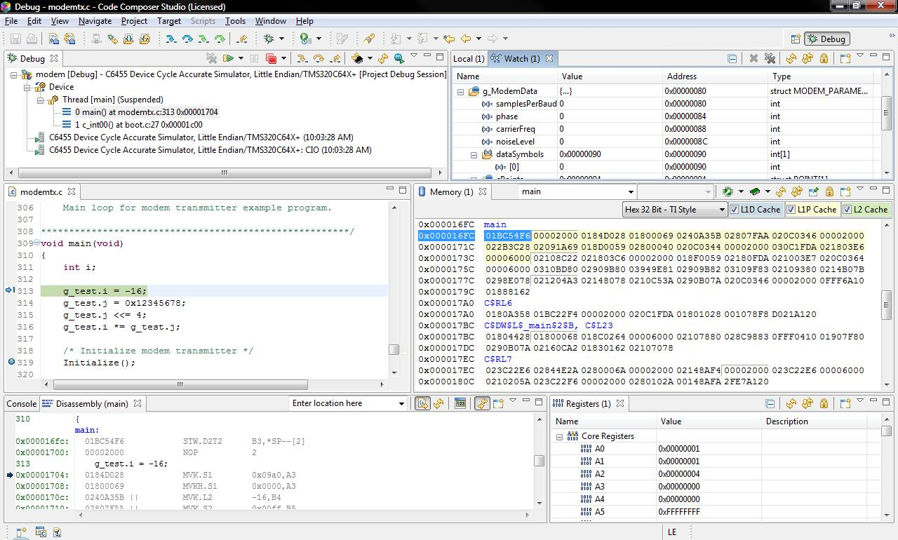

Figure Code composer studio interface

A number of features are available for the user that includes breakpoints, variable watch, memory watch, registers, graphical results and monitoring the real time execution.

Code Composer Studio is primarily designed as for embedded project design and low-level JTAG based debugging. However, the latest releases are based on unmodified versions of the Eclipse open source IDE, which can be easily extended to include support for OS level application debug (Linux, Android, and Windows Embedded) and open source compiler suites such as GCC.

**_________________________________________________**