**Department of Electrical Engineering**

|  |  |
| --- | --- |
| **Faculty Member: Dr. Wajahat Hussain** | **Dated: 7-3-2107** |
| **Course/Section: BEE6-B** | **Semester: 6th Semester** |

**EE-330 Digital Signal Processing**

**Lab4: Audio Processing using DSP Kit TMS 320C6713 DSK**

|  |  |  |  |  |
| --- | --- | --- | --- | --- |
| **Name** | **Reg. no.** | **Report Marks**  **/ 10** | **Lab Quiz-Viva Marks**  **/ 5** | **Total**  **/ 15** |
| **Abdullah Bin Asif** | **111596** |  |  |  |
| **Saad Iqbal** | **111394** |  |  |  |
| **Usman Iqbal** | **111393** |  |  |  |

**Objectives**

The objective of this lab is to explore some more features of Code Composer Studio (CCS) that is time domain and frequency domain plots of audio signal in addition to that we will also do real time processing of audio input.

* Time domain and frequency Domain Plots in CCS
* Real Time processing of Audio Signal
* Working with basic sinusoids on DSP Kit

1. **LAB TASK NO.1**

Modify program sine8_buf.c to generate a sine wave with a frequency of 3000 Hz. Verify your result using an oscilloscope connected to the LINE OUT socket on the DSK as well as using Code Composer to plot the 32 most recently output samples in both the time and frequency domains.

**CCS Waveform:**

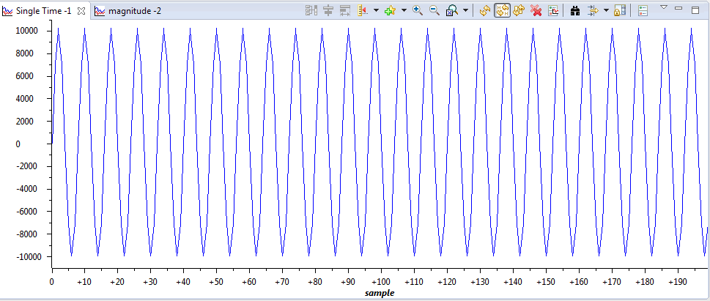

*Figure No. 1*

**CCS FFT Plot:**

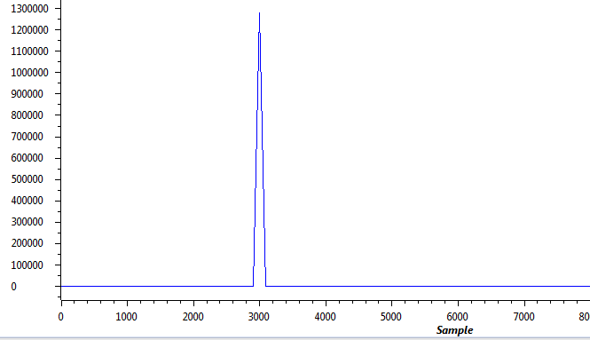

*Figure No. 2*

1. **LAB TASK NO.2**

Write polling - based program such that when DIP switch #3 is pressed down, LED #3 turns on and a 500 - Hz cosine wave is generated for 5 seconds.

**CCS Code:**

**//sine8_LED.c sine generation with DIP switch control**

**#include "dsk6713_aic23.h" //codec support**

**Uint32 fs = DSK6713_AIC23_FREQ_8KHZ; //set sampling rate**

**#define DSK6713_AIC23_INPUT_MIC 0x0015**

**#define DSK6713_AIC23_INPUT_LINE 0x0011**

**Uint16 inputsource=DSK6713_AIC23_INPUT_MIC;//select input**

**#define LOOPLENGTH 16**

**short loopindex = 0; //table index**

**short gain = 10; //gain factor**

**short sine_table[LOOPLENGTH]={1000,914,669,309,-104,-500,-809,-978,-978,-809,-500,-104,309,669,914,1000}; //sine values**

**int i;**

**void main()**

**{**

**comm_poll(); //init DSK,codec,McBSP**

**DSK6713_LED_init(); //init LED from BSL**

**DSK6713_DIP_init(); //init DIP from BSL**

**while(1) //infinite loop**

**{**

**if(DSK6713_DIP_get(3)==0) //=0 if DIP switch #0 pressed**

**{**

**DSK6713_LED_on(3); //turn LED #0 ON**

**for (i=1;i<40000;i++){**

**output_left_sample(sine_table[loopindex++]*gain); //output sample**

**if (loopindex >= LOOPLENGTH) loopindex = 0; //reset table index**

**}**

**}**

**else DSK6713_LED_off(3); //turn LED off if not pressed**

**} //end of while(1) infinite loop**

**} //end of main**

1. **LAB TASK NO.3**

Write an interrupt - driven program that maintains a buffer containing the 128 most recent input samples read at a sampling frequency of 16 kHz from the AIC23 codec, using the MIC IN socket on the DSK. Halt the program and plot the buffer contents using Code Composer.

**CCS Code:**

**//sine8_buf.c sine generation with output stored in buffer**

**#include "DSK6713_AIC23.h" //codec support**

**Uint32 fs=DSK6713_AIC23_FREQ_16KHZ; //set sampling rate**

**#define DSK6713_AIC23_INPUT_MIC 0x0015**

**#define DSK6713_AIC23_INPUT_LINE 0x0011**

**Uint16 inputsource=DSK6713_AIC23_INPUT_MIC; // select input**

**#define LOOPLENGTH 8**

**#define BUFFERLENGTH 128**

**int loopindex = 0; //table index**

**int bufindex = 0; //buffer index**

**int out_buffer[BUFFERLENGTH]; //output buffer**

**short gain = 10;**

**interrupt void c_int11() //interrupt service routine**

**{**

**short out_sample;**

**// possible sampling rates: 8, 16, 24, 32, 44, 48, 96 kHz**

**out_sample =input_sample();**

**output_sample(out_sample); //output sample value**

**out_buffer[bufindex++] = out_sample; //store in buffer**

**if (bufindex >= BUFFERLENGTH) bufindex = 0; //check for end of buffer**

**return; //return from interrupt**

**}**

**void main()**

**{**

**comm_intr(); //initialise DSK**

**while(1); //infinite loop**

**}**

**CCS Waveform:**

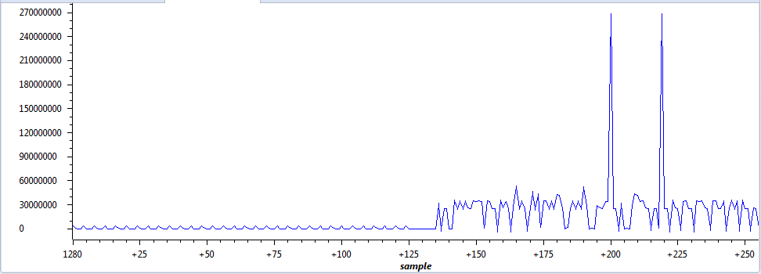

*Figure No. 3*

**Conclusion:**

In this lab we studied the fundamental concepts of signal processing using the DSK kit. We learned to generate a tone signal with a specific frequency, also we observed the FFT of a signal. Also the effects on the waveform were seen when the sampling rate was changed. In the last part we took an input from the user and displayed the waveform on the interface.

--------------------------------------------------------------------------------------------