**Department of Electrical Engineering**

|  |  |
| --- | --- |
| Faculty Member: Dr. Wajahat Hussain  Course/Section: BEE6-B | Dated: 11-4-2017  Semester: 6th Semester |

**EE-330 Digital Signal Processing**

**Lab #8 Frequency Response and Pole Zero Plots**

|  |  |  |  |  |
| --- | --- | --- | --- | --- |
| Name | Reg. no. | Report Marks  / 10 | Lab Quiz-  Viva Marks  / 5 | Total  / 15 |
| Saad Iqbal | 111394 |  |  |  |
| Usman Iqbal | 111393 |  |  |  |
| Abdullah Bin Asif | 111596 |  |  |  |

**Introduction:**

In this lab, we will use PeZ to create filters with complex conjugate poles and zeros. These are called second-order filters because the denominator polynomial is a quadratic with two roots. We will also be exposed to the response of the system when the poles and the zeros are shifted. We will ultimately design a filter of our own requirements.

**Task 1:**

**Look at the frequency response and determine what kind of filter you have?**

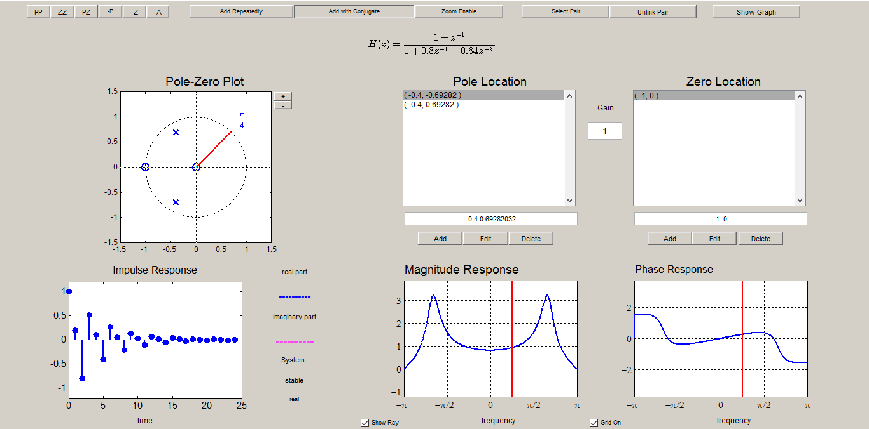

**Comment:**

The following is a Band Pass filter, it allows the frequencies near $\frac{π}{3}.$

* **Implement the following second-order system:**



**Solution:**

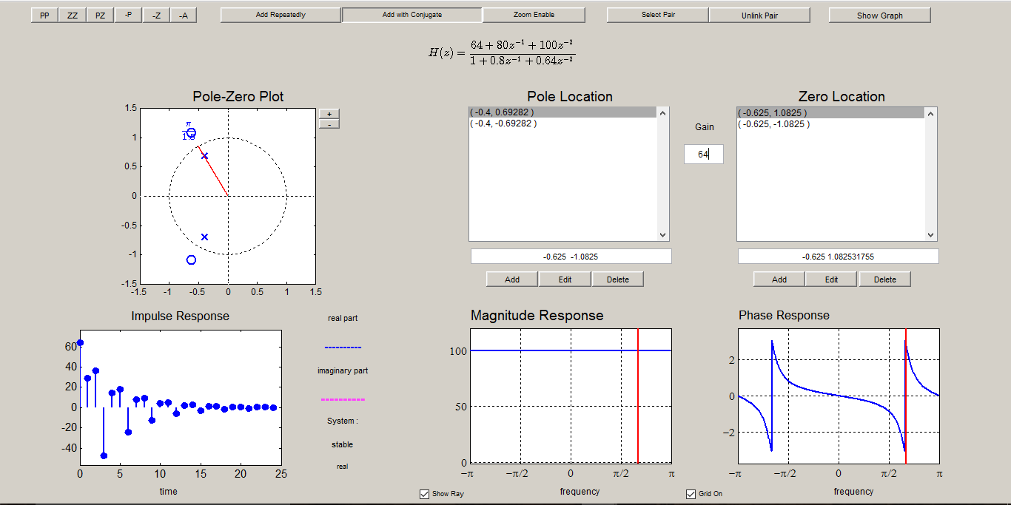

**Comment:**

It is an All Pass filter, it passes all the frequencies in the signal.

* **Now, use the mouse to “grab” the zero-pair and move the zeros to be exactly on the unit-circle at the same angle as the poles. Observe how the frequency response changes. In addition, determine the H(z) for this filter.**



**Solution:**

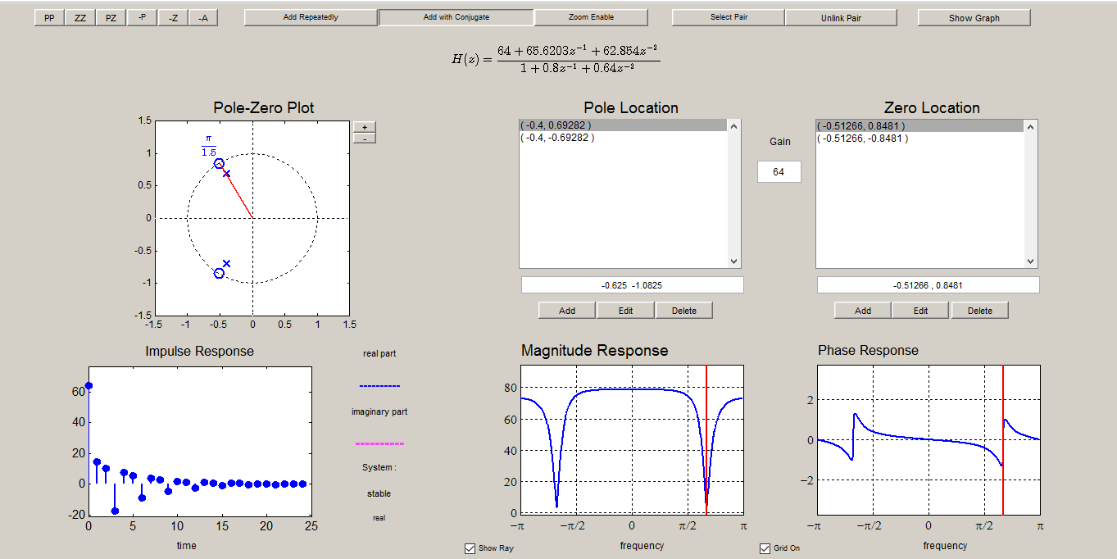

**Comments:**

The system has now become a notch filter tat nulls a specific frequency. H(z) for this filter is:

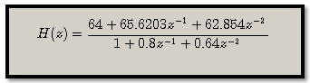

**Task 2:**

1. Place following single pole-pairs



Then determine the coefficients of the numerator and denominator of the resulting H (z).

**Solution:**

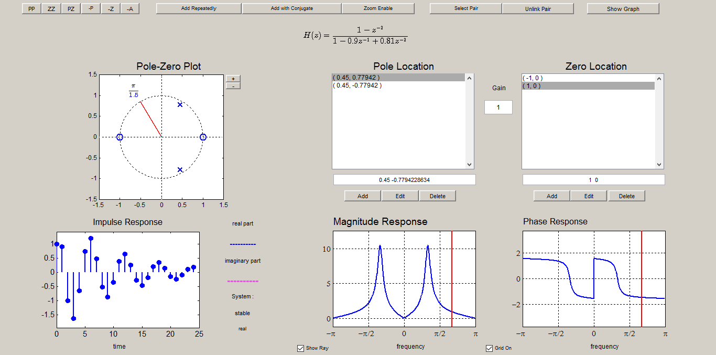

1. Make a plot of the frequency response (magnitude only) with freqz and measure the width of the peak versus frequency.

**Code:**

num=[1 0 -1]

den=[1 -0.9 0.81]

ww=-pi:pi/550:pi;

hh=freqz(num,den,ww

plot(ww,abs(hh))

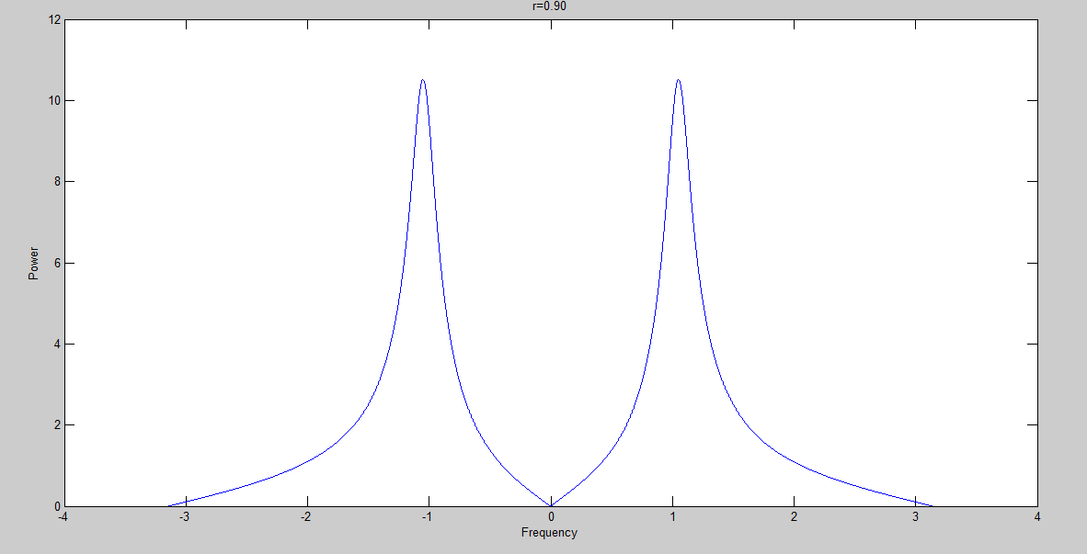

**Figure: Spectral plot**

**Width:** 0.2058 units.

1. Move the pole-pair so that the angles remain fixed at ±π/3, but the radius is r = 0.95 and r = 0.975. In each case, measure the 3-db width of the peak. Using these measured values, create a formula for the width that is proportional to (1 − r), e.g., the following works quite well Peak Width ≈ K (1 − r)/√r where K is a constant of proportionality.

**Comments:**

**R=0.95 & K ≅2**

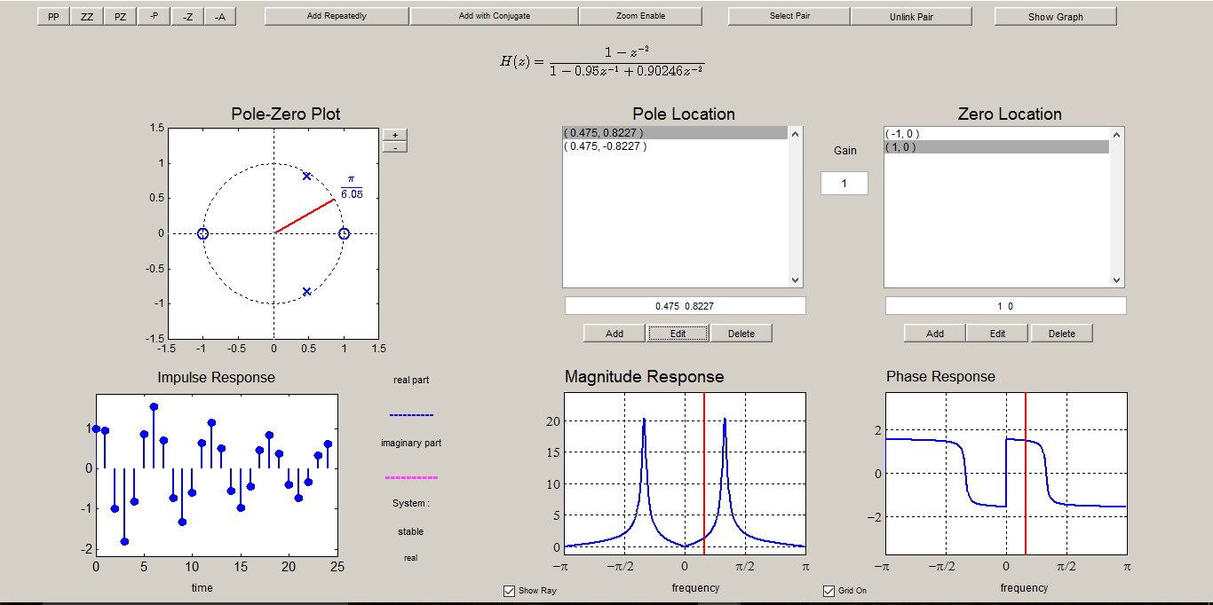

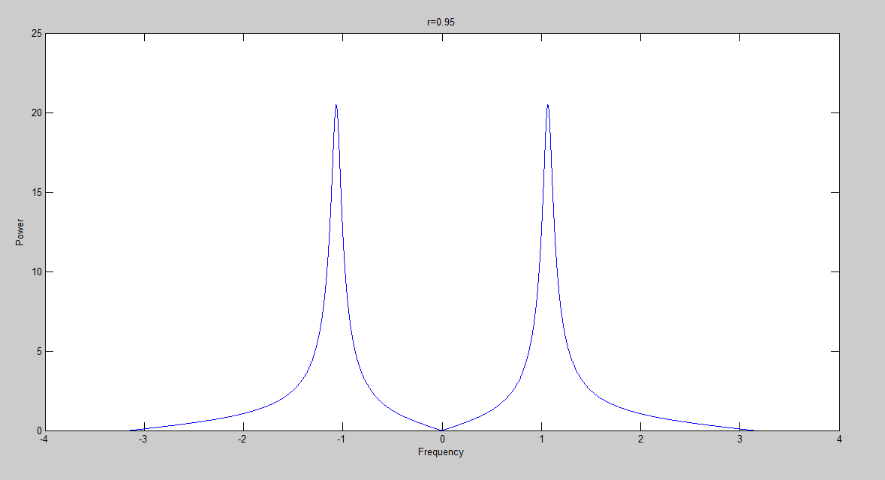

**Width:** 0.104 units.

**R=0.975 & K ≅2**

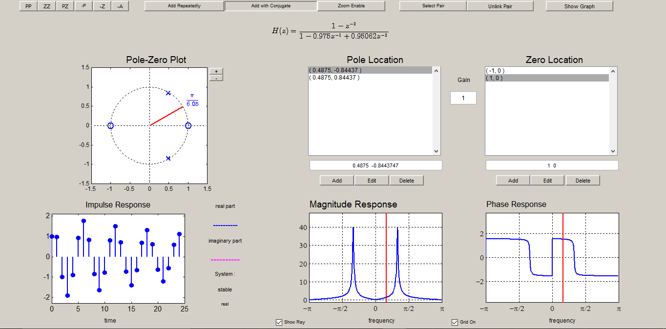

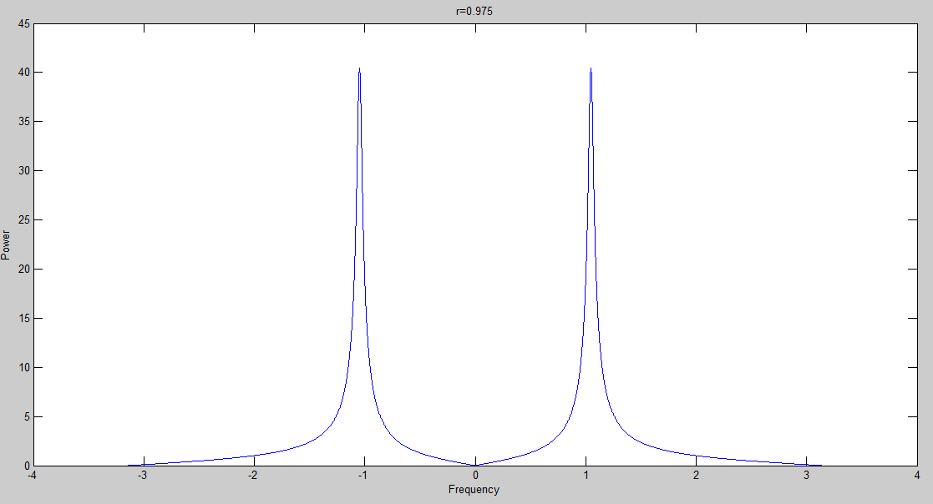

**Figure: Spectral plot**

**Width:** 0.051 units

**(d)** Move the pole-pair so that its radius remains fixed and the angles change from ±π/3 to ±π/4 and then to ±π/2. State a formula for the peak location as a function of the pole location.

**Solution:**

**At $\frac{ π}{ 4}$:**

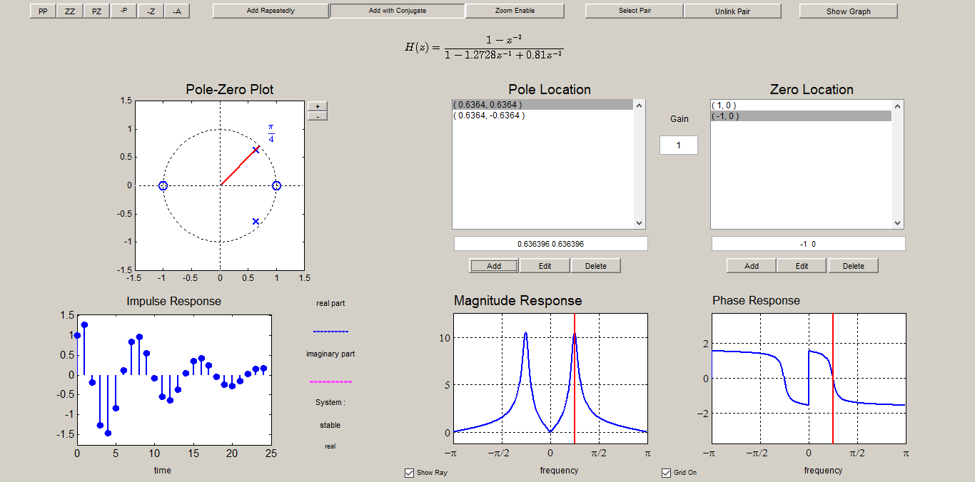

**Figure: Band pass filter at pi/4**

**At $\frac{ π}{ 2}$:**

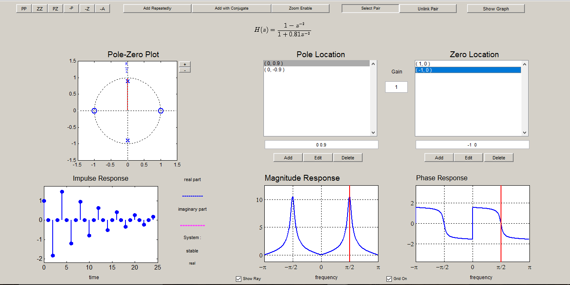

**Figure: Band pass filter at pi/2**

**Comments:**

These graphs show that wherever we place a pole that frequency is raised up, and we will see a peak there.

**Mathematical Formula:**

|  |
| --- |
| $$peak location=r(e^{j*pole location} )$$ |

**Passband and Stopband**

**Part a and b**

**Determine the stopband regions for three of the filters designed in the previous section. Use the cases where the pole angles are ±π/3 and the radii are r = 0.9, 0.95 and 0.975. In each case, measure the frequency regions of the two stopbands. There is one lower stopband for 0 ≤ ω ≤ ωs1 and one upper stopband for ωs2 ≤ ω ≤ π**

**For the same three filters, record the passband edges. The passband will be the peak width at the 3-dB level, so it will occupy a region such as ω1 ≤ ω ≤ ω 2 , where ω1 and ω2 are the band edges.**

* R=0.9

**Code:**

num=[1 0 -1]

den=[1 -0.9 0.81]

ww=-pi:pi/100000:pi;

hh=freqz(num,den,ww)

plot(ww,abs(hh))

xlabel('Frequency--->')

ylabel('Power')

title(' Band pass and Band stop regions')

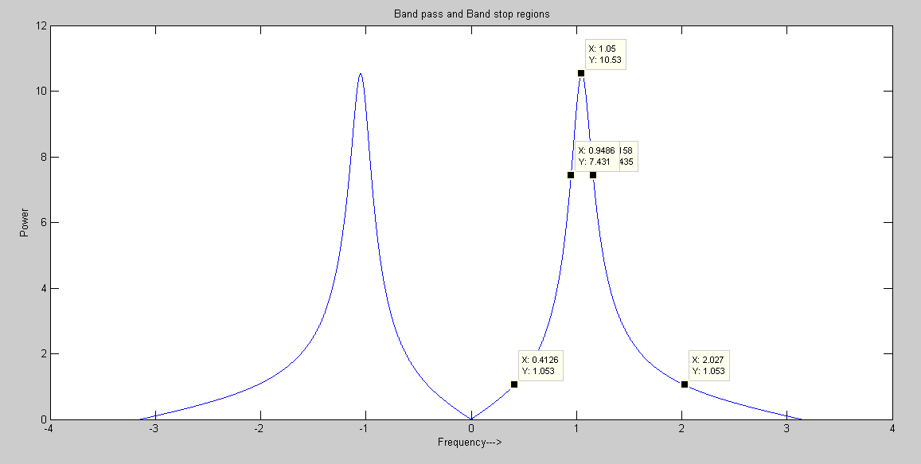

**Figure: For r=0.9**

**lower stop band:** 1.6144

**upper Pass band:** 0.209

* R=0.95

**Code:**

num=[1 0 -1]

den=[1 -0.95 0.9025]

ww=-pi:pi/100000:pi;

hh=freqz(num,den,ww)

plot(ww,abs(hh))

xlabel('Frequency--->')

ylabel('Power')

title(' Band pass and Band stop regions')

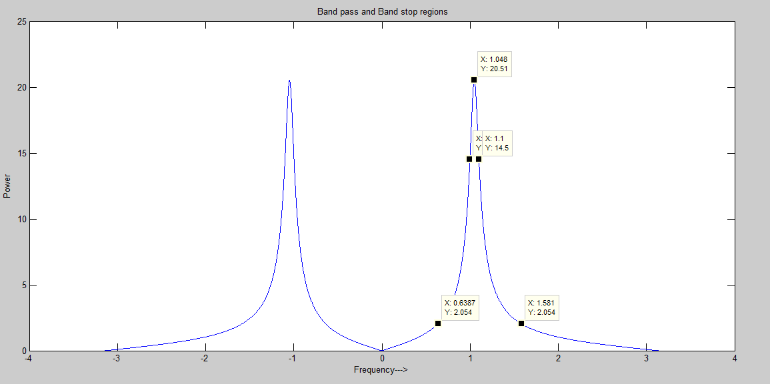

**Figure: For r=0.95**

**Lower stop band:** 0.9423

**Upper Pass band:** 0.1025

* R=0.975

**Code:**

num=[1 0 -1]

den=[1 -0.975 0.95062]

ww=-pi:pi/100000:pi;

hh=freqz(num,den,ww)

plot(ww,abs(hh))

xlabel('Frequency--->')

ylabel('Power')

title(' Band pass and Band stop regions')

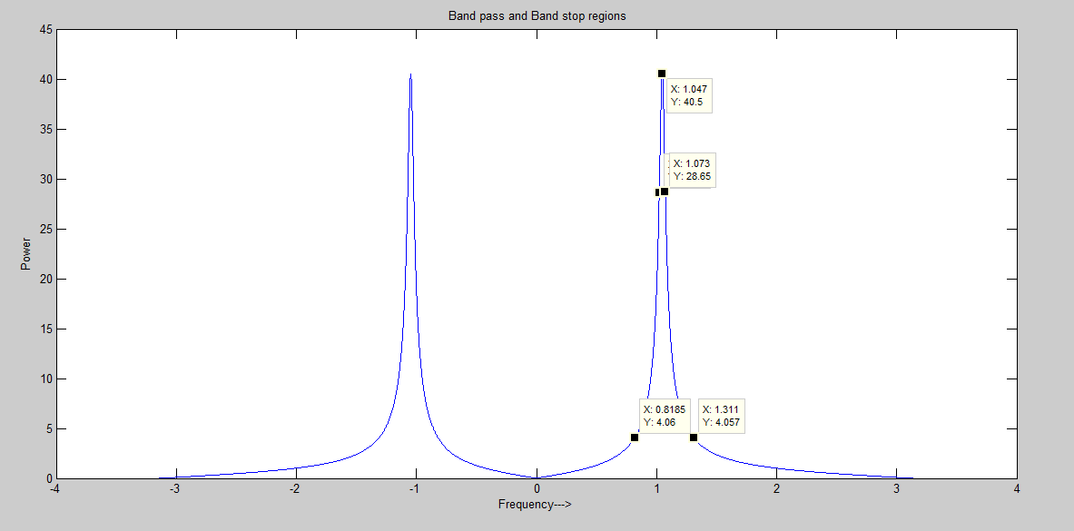

**Figure: For r=0.975**

**Lower stop band:** 0.4925

**Upper Pass band:** 0.051

**Part c:**

**Usually, filter design becomes difficult when we want the passband and stopband edges to be very close to one another. The difference between neighboring passband and stopband edges is called the Transition Width. Therefore, summarize the measurements of the previous two parts in a table that lists the two transition widths for each filter versus r. Can you state a simple formula for the transition width? Does it depend on r?**

Transition width=|stop band edge-pass band edge|

**For r=0.9**

Lower Transition width =0.536

Upper transition width=0.8694

**For r=0.95**

Lower Transition width =0.3588

Upper transition width=0.481

**For r=0.975**

Lower Transition width =0.2035

Upper transition width=0.238

**Formula**

$$\left(1-r\right)=\frac{(upper transition width-lower transition width)}{2}$$

As seen in above formula, it is obvious that it depends on r.

**________________________**

**Lab Task 3: Design a Filter Based on Analog Frequencies**

**One last question that relates to your understanding of sampling as well as digital filtering. Design a BPF whose passband is 2000 ≤ f ≤ 2200 Hz when the sampling rate is 8000 Hz using the IIR method above, i.e. Determine the value of r. As a reminder, you are designing a digital filter to be used as the system H (z) in Fig. 2. Once you have the filter, determine its stopbands and give the stopband edges in hertz.**

**Solution:**

Using formula:

w = 2 π (f1/fs)

w1 = 2 π (2000/8000) = 1.57

w2 =2 π (2200/8000) = 1.727

**Width** = 1.727 – 1.57 = 0.157

**Using K=2**,

0.157=2(1-r) r^0.5

r=0.975.

In order to find the angle we will take the mean value which comes out to be 1.6485 or 94.50

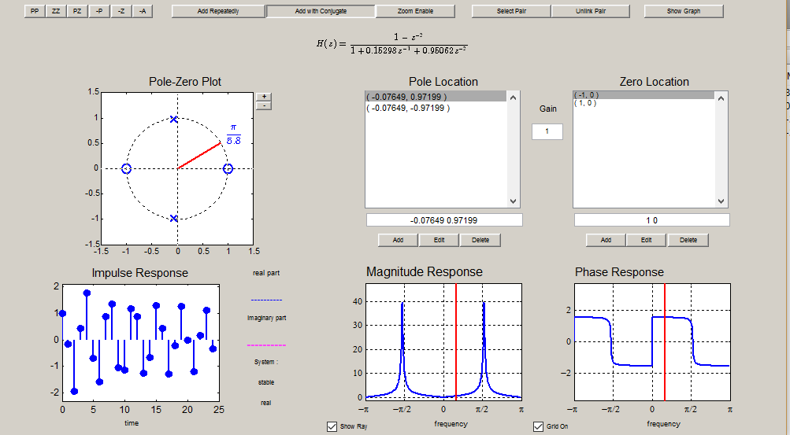

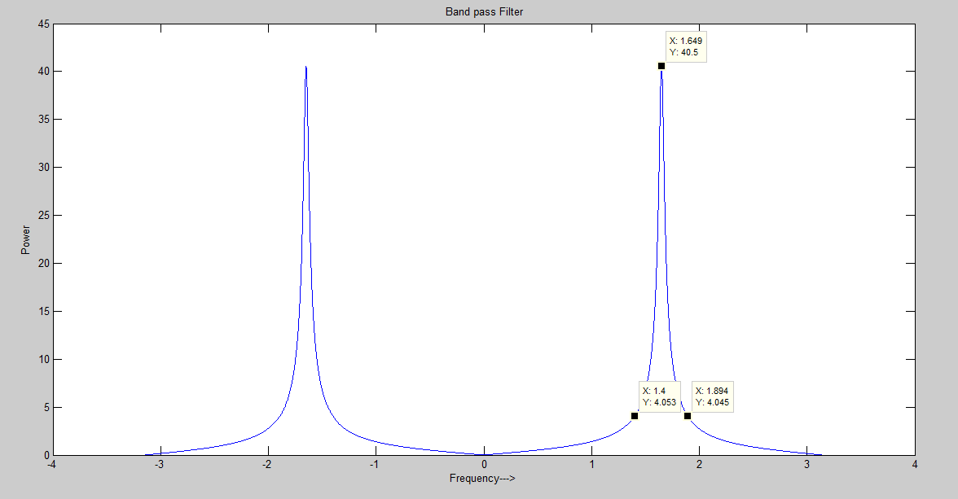

**Figure: spectral plot**

|  |  |  |
| --- | --- | --- |
| **Stop band** | **Frequency ( $ω$ radians)** | **Frequency (Hz) $\frac{ω}{2π}*fs$**  **= f** |
| **Lower stop band** | **1.4** | **1780** |
| **Upper stop band** | **1.894** | **2412** |

**Conclusion:**

* From this lab we got to know about the practical understanding of an filters.
* We analyzed the signal from its Spectrum plot.
* We learned to design different types of filter using *peZdemo*.
* Band Pass and Band stop filters were designed.
* The effect of changing the r and $ω$ were observed.

__________________________________