**Department of Electrical Engineering**

|  |  |
| --- | --- |
| Faculty Member: Dr. Wajahat Hussain  Course/Section: BEE6-B | Dated: 25-4-2017  Semester: 6th Semester |

**EE-330 Digital Signal Processing**

**Lab #10 FDA TOOL FOR FILTER DESIGN**

|  |  |  |  |  |
| --- | --- | --- | --- | --- |
| Name | Reg. no. | Report Marks  / 10 | Lab Quiz-  Viva Marks  / 5 | Total  / 15 |
| Saad Iqbal | 111394 |  |  |  |
| Usman Iqbal | 111393 |  |  |  |
| Abdullah Bin Asif | 111596 |  |  |  |

**OBJECTIVE:**

The purpose of this lab is to design a filter using FDA Tool in MATLAB.

**TASK 1:**

**Design a 6th order low-pass Butterworth filter with the specification similar to the one you have used in lab 7 for filtering audio signal.**

It is a 6th order Butterworth filter with a cut-off frequency of 4kHz which is the range of human voice and it is sampled at 16kHz.

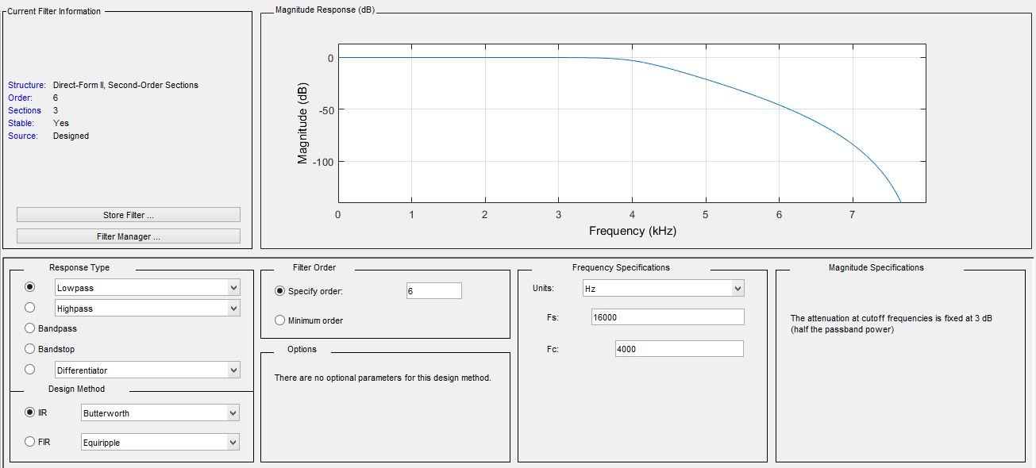

***Figure No.1 Butterworth Filter***

**TASK 2:**

**Use FDA Tool to design any one FIR filter.**

It is an 8th order Equiripple bandpass FIR filter which is sampled at 16kHz. Its passband is from 4.8kHz to 6.4kHz. 4kHz and 7.2 kHz are its stop frequencies.

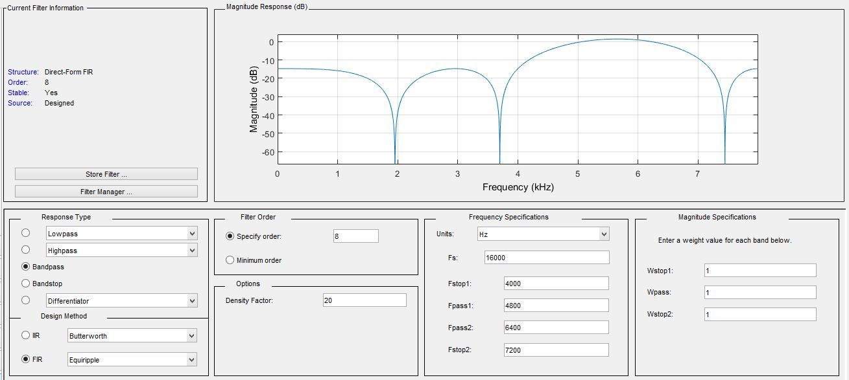

***Figure No.2 Equiripple Bandpass Filter***

**CONCLUSION:**

In this lab, we learnt how to use FDATool to design any filter in MATLAB using different factors given in that GUI.

______________________________________________