**Department of Electrical Engineering**

|  |  |
| --- | --- |
| **Faculty Member:____________________** | **Dated: ____________________** |
|  |  |
| **Course/Section:____________________** | **Semester: __________________** |
|  |  |

**EE-330 Digital Signal Processing**

**Lab #10 FDAtool for Filter design**

|  |  |  |  |  |
| --- | --- | --- | --- | --- |
| **Name** | **Reg. no.** | **Report Marks / 5** | **Viva Marks / 10** | **Total/15** |
|  |  |  |  |  |
|  |  |  |  |  |
|  |  |  |  |  |
|  |  |  |  |  |

**Lab8: FDAtool for filter design**

**Objectives**

The objective of this lab is to use Matlab FDAtool for filter design

**Lab Instructions**

* This lab activity comprises of three parts: Pre-lab, Lab Exercises, and Post-Lab Viva session.
* The lab report shall be uploaded on LMS three days before next scheduled lab. The Pre-lab tasks should be completed before coming to the lab and hard copy of Pre-lab session should be deposited with teacher/lab engineer at start of the lab for necessary evaluation. Alternatively, the reports can be submitted in PDF format on LMS.
* The students should perform and demonstrate each lab task separately for step-wise evaluation (please ensure that course instructor/lab engineer has signed each step after ascertaining its functional verification)
* Only those tasks that completed during the allocated lab time will be credited to the students. Students are however encouraged to practice on their own in spare time for enhancing their skills.

**Lab Report Instructions**

All questions should be answered precisely to get maximum credit. Lab report must ensure following items:

* Lab objectives
* MATLAB codes
* Results (graphs/tables) duly commented and discussed
* Conclusion

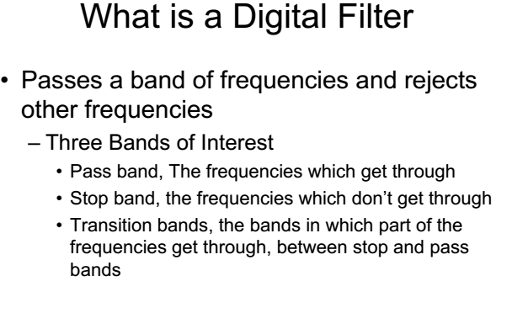

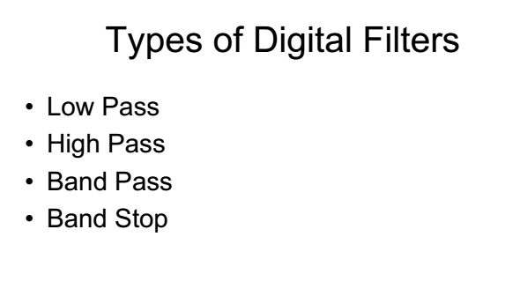

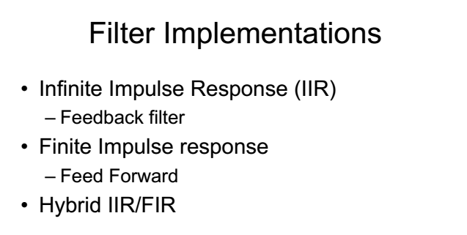

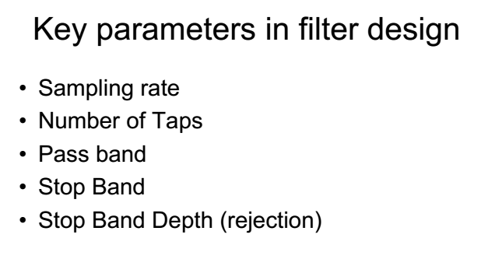

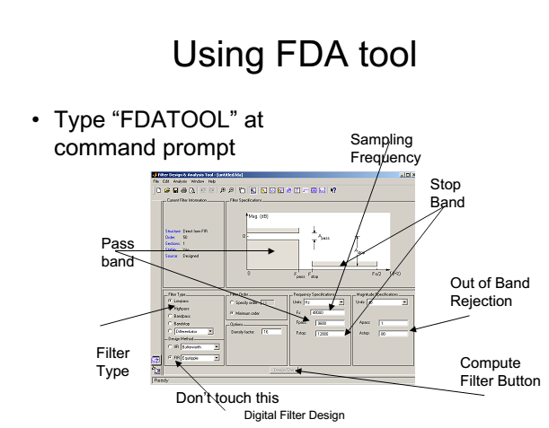

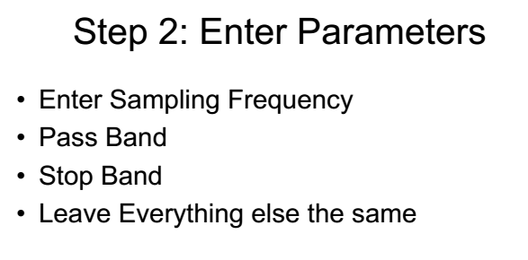

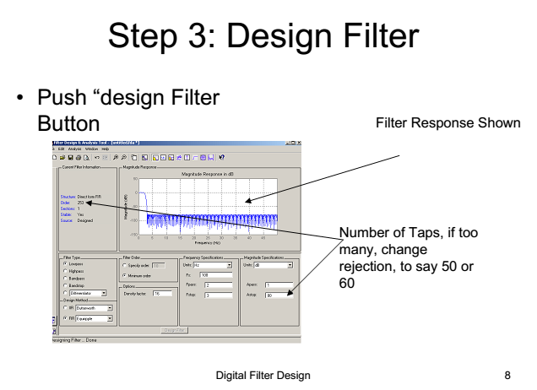

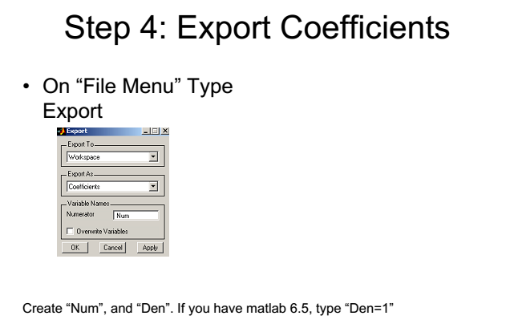

**Lab Task 1: Design a 6th order low-pass Butterworth filter with the specification similar to the one you have used in lab 7 for filtering audio signal.**

**Lab task 2: Use FDAtool to design any one FIR filter**