**Department of Electrical Engineering**

|  |  |
| --- | --- |
| Faculty Member: Dr. Wajahat Hussain  Course/Section: BEE6-B | Dated: 18-4-2017  Semester: 6th Semester |

**EE-330 Digital Signal Processing**

**Lab #9 Frequency Response and Nulling Filters**

|  |  |  |  |  |
| --- | --- | --- | --- | --- |
| Name | Reg. no. | Report Marks  / 10 | Lab Quiz-  Viva Marks  / 5 | Total  / 15 |
| Saad Iqbal | 111394 |  |  |  |
| Usman Iqbal | 111393 |  |  |  |
| Abdullah Bin Asif | 111596 |  |  |  |

**Lab 9: Frequency Response, Bandpass and Nulling Filters**

**Introduction:**

In this lab, we will study the response of FIR filters to inputs such as complex exponentials and sinusoids. We will also use firfilt(), or conv(), to implement filters and freqz() to obtain the filter’s frequency response. As a result, we will learn how to characterize a filter by knowing how it reacts to different frequency components in the input. Some key features of this lab are:

* Introduction to bandpass filters
* Introduction to Nulling filters
* Cascade systems and their frequency response
* How to extract information from sinusoidal signals

**Task 1: Frequency response of the four-point average:**

We examined filters that average input samples over a certain interval. These filters are called “running average” filters or “averages” and they have the following form for the L-point averager:

$y\left[n\right]=\frac{1}{L} \sum_{k=0}^{L-1}{x\left[n-k\right]}$---------------- (6)

1. Use Euler’s formula and complex number manipulations to show that the frequency response for the 4-point running average operator is given by:

$H\left(e^{jω}\right)=\frac{2\cos\left(0.5ω\right)+2cos⁡(1.5ω)}{4}e^{-j1.5ω}$---------------- (7)

**Solution:**

$$y\left[n\right]\overset{→}{F} Y\left(e^{jw}\right)$$

$$\frac{1}{L} \sum_{k=0}^{L-1}{x\left[n-k\right]} \overset{→}{F} Y\left(e^{jω}\right)$$

So, we can say that:

$$Y\left(e^{jω}\right)=\frac{1}{L} \sum_{k=0}^{L-1}{X\left(e^{jω}\right)e^{-jωk}}$$

Now, Frequency response is given as:

$H\left(e^{jω}\right)=\frac{1}{L} \sum_{k=0}^{L-1}{e^{-jωk}}$

For $L=4$:

$$H\left(e^{jω}\right)=\frac{1}{4}\left({1+e}^{-jω}+e^{-2jω}+e^{-3jω}\right)$$

$$H\left(e^{jω}\right)=\frac{e^{-1.5jω}}{4}\left(e^{1.5jω}+e^{0.5jω}+e^{-0.5jω}+e^{-1.5jω}\right)$$

$$H\left(e^{jω}\right)=\frac{e^{-1.5jω}}{4}\left(2\left(\frac{e^{0.5jω}+e^{-0.5jω}}{2}\right)+2\left(\frac{e^{1.5jω}+e^{-1.5jω}}{2}\right)\right)$$

Using Euler’s formula:

$$H\left(e^{jω}\right)=\frac{e^{-1.5jω}}{4}\left(2\left(cos⁡(0.5ω)\right)+2\left(cos⁡(1.5ω)\right)\right)$$

Hence, filter frequency response is equal to the equation (7).

1. Implement (7) directly in MATLAB. Use a vector that includes 400 samples between –π and π for $\hat{ω}$. Since the frequency response is a complex-valued quantity, use abs() and angle() to extract the magnitude and phase of the frequency response for plotting. Plotting the real and imaginary parts of $H(e^{j\hat{ω }})$ is not very informative.

**Matlab Code:**

clc;

clear all;

w= -pi:pi/200:pi;

K= 0.5.*exp(1i*1.5*w).*(cos(0.5*w)+cos(1.5*w));

subplot(2,1,1);

plot(w, abs(K))

subplot(2,1,2);

plot(w, angle(K))

xlabel('Normalized Radian Frequency')

**Matlab graph:**

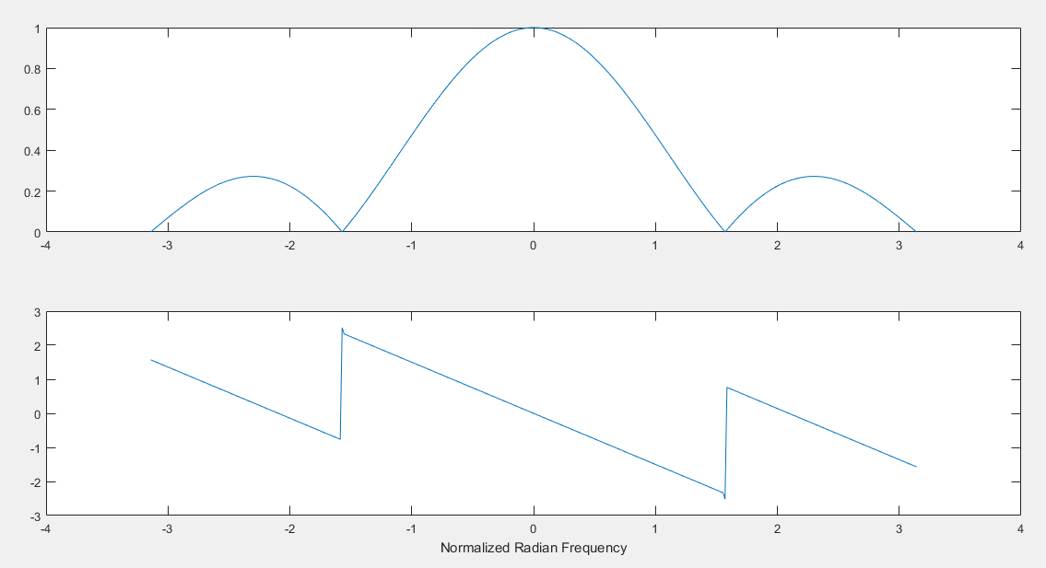

1. In this part, use freqz.m in MATLAB to compute $H\left(e^{j\hat{ω }}\right)$ numerically (from the filter coefficients and plot its magnitude and phase versus $\hat{ ω}$. Write the appropriate MATLAB code to plot both the magnitude and phase of $H(e^{j\hat{ω }})$. How do your results compare with part (b)?

**Matlab Code:**

clc;

clear all;

bb = [0.25, 0.25 0.25, 0.25]; %-- Filter Coefficients

ww = -pi:(pi/200):pi; %-- omega hat

HH = freqz(bb, 1, ww);

subplot(2,1,1);

plot(ww, abs(HH))

subplot(2,1,2);

plot(ww, angle(HH))

xlabel('Normalized Radian Frequency')

**Matlab graph:**

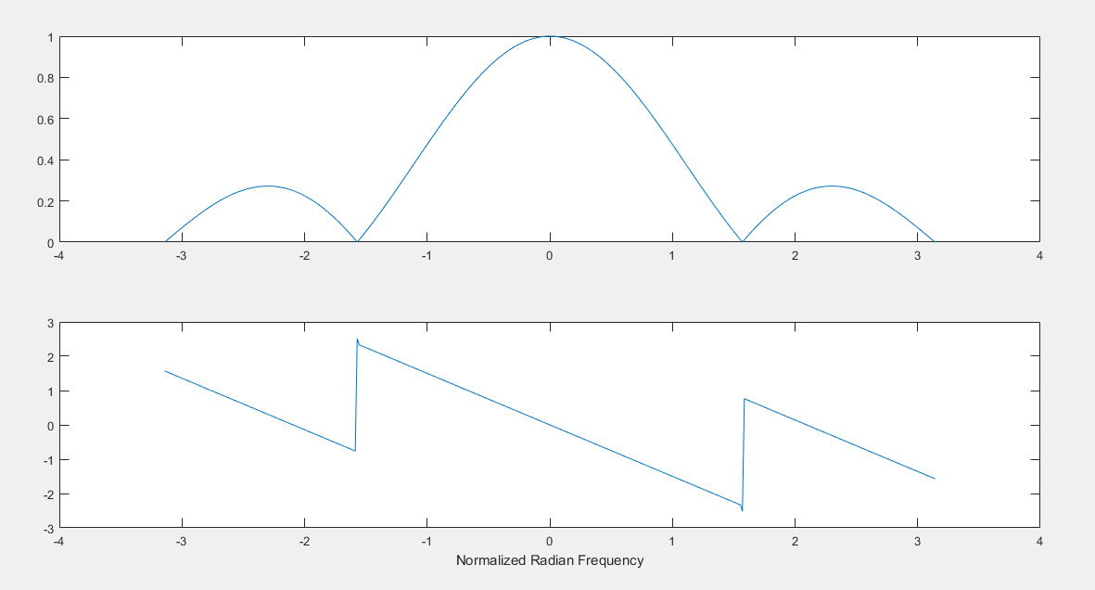

**Comments:**

Results are the same. But it is easy to calculate the frequency response of filter using method (c), than method b. As, it is efficient in computational cost.

**Task 2: Cascading two systems:**

More complicated systems are often made up from simple building blocks. In Fig. 2, two FIR filters are shown connected “in cascade.”



Assume that the system in Fig. 2 is described by the two equations:



1. Use freqz() in MATLAB to get the frequency responses for the case where α = 0.8 and M = 9. Plot the magnitude and phase of the frequency response for Filter #1, and also for Filter #2. Which one of these filters is a low pass filter?

**Matlab Code:**

clc;

clear all;

w= -pi:pi/200:pi;

a=0.8;

M=9;

bb1= a.^(0:M);

HH1= freqz(bb1,1,w);

subplot(2,2,1);

plot(w, abs(HH1))

subplot(2,2,3);

plot(w, angle(HH1))

xlabel('Normalized Radian Frequency of H1');

bb2= [1 -a];

HH2= freqz(bb2,1,w);

subplot(2,2,2);

plot(w, abs(HH2))

subplot(2,2,4);

plot(w, angle(HH2))

xlabel('Normalized Radian Frequency of H2');

**Matlab graph:**

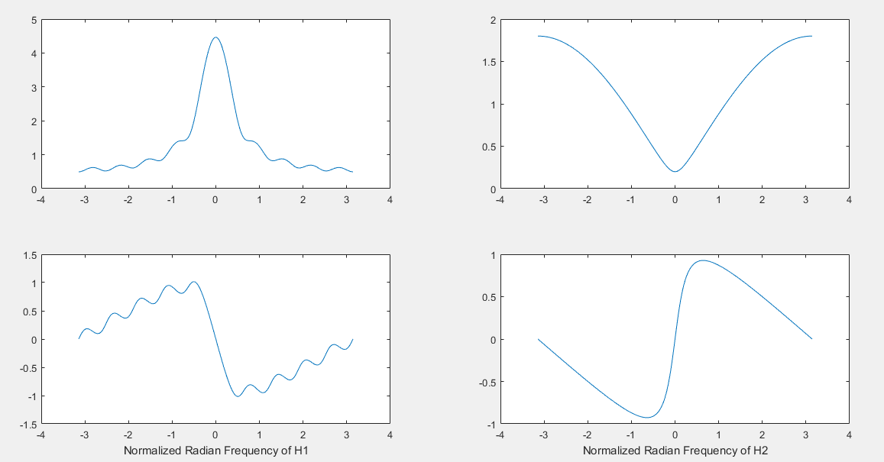

**Comment:**

Filter #1 is low pass filter. As, it allows low frequencies to pass and highly attenuates high frequencies.

Filter #2 is on the other hand acts as high pass filter.

1. Plot the magnitude and phase of the frequency response of the overall cascaded system.

**Matlab Code:**

.

.

.

.

.

HH=HH1.*HH2;

subplot(2,3,3);

plot(w, abs(HH))

subplot(2,3,6);

plot(w, angle(HH))

xlabel('Normalized Radian Frequency');

**Matlab graph:**

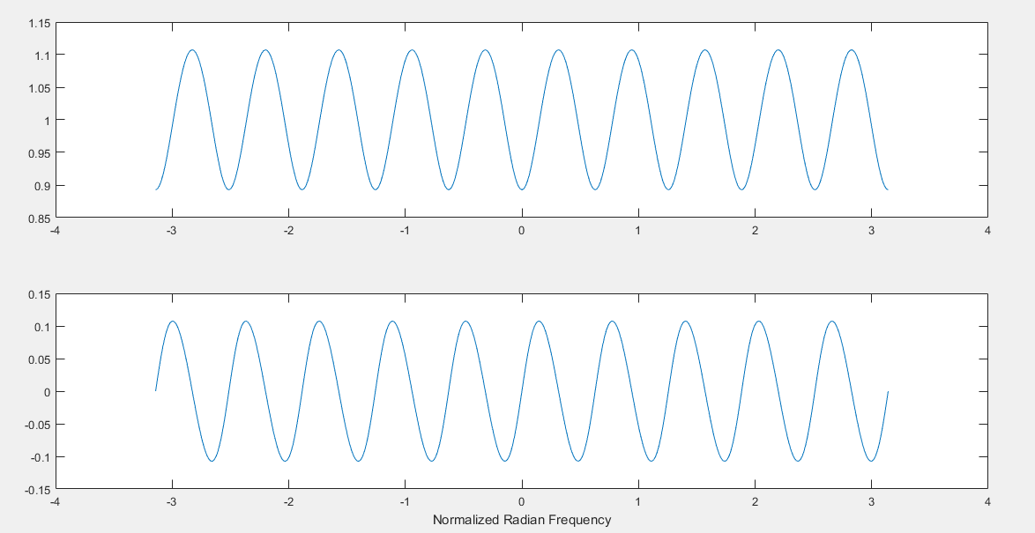

1. Explain how the individual frequency responses in part (a) are combined to get the overall frequency response in part (b). Comment on the magnitude combinations as well as the phase combinations.

**Comment:**

The filters are connected in cascade form. Therefore, total time response will be given as convolution in time domain. But, as we know convolution in time domain is equivalent to multiplication in frequency domain.

So, we calculate total response by product of frequency response of both filter. It comes out sinusoidal response with DC offset. Such filters can be approximate as pass band filter.

**Task 3:**

Nulling filters are filters that completely eliminate some frequency component. If the frequency is $\hat{ω}$ = 0 or $\hat{ω}$ = π, then a two-point FIR filter will do the nulling. The simplest possible general nulling filter can have as few as three coefficients. If $\hat{ω}$ is the desired nulling frequency, then the following length-3 FIR filter will have a zero in its frequency response at $\hat{ω}$ = $\hat{ω_{n}}$.

$y\left[n\right]=x\left[n\right]-2\cos\left(ω\right)x\left[n-1\right]+x\left[n-2\right]$---------------- (8)

For example, a filter designed to completely eliminate signals of the form $A_{k}e^{j0.5*pi*n}$ would have the following coefficients because we would pick the desired nulling frequency to be $\hat{ω}$ = 0.5π. b0 = 1, b1 = −2 cos(0.5π) = 0, b2 = 1.

1. Design a filtering system that consists of the *cascade of two FIR nulling filters* that will eliminate the following input frequencies: $\hat{ω}$ = 0.44π, and $\hat{ω}$ = 0.7π. For this part, derive the filter coefficients of both nulling filters.

**Solution:**

In order to eliminate 0.44 $π$:

Then:

$\hat{ω}$ = 0.44π. b0 = 1, b1 = −2 $cos(0.44π)$ = 0, b2 = 1

$$y\left[n\right]=x\left[n\right]-2\cos\left(0.44π\right)x\left[n-1\right]+x\left[n-2\right]$$

$$h\left[n\right]=[1-2\cos\left(0.44π\right) 1]$$

$$H_{1}\left(e^{jω}\right)=1-2\cos\left(0.44π\right)e^{-jω}+e^{-2jω}$$

In order to eliminate 0.7 $π$:

$\hat{ω}$ = 0.7π. b0 = 1, b1 = −2 $cos(0.7π)$ = 0, b2 = 1

$$y\left[n\right]=x\left[n\right]-2\cos\left(0.7π\right)x\left[n-1\right]+x\left[n-2\right]$$

$$h\left[n\right]=[1-2\cos\left(0.7π\right) 1]$$

$$H_{2}\left(e^{jω}\right)=1-2\cos\left(0.7π\right)e^{-jω}+e^{-2jω}$$

So,

Total response is:

$$H\left(e^{jω} \right)=H_{1}\left(e^{jω} \right)*H_{2}\left(e^{jω} \right)$$

Or,

$$H\left(e^{jω}\right)=1+\left(-2\cos\left(0.44π\right)-2\cos\left(0.7π\right)\right)e^{-jω}+\left(2+4cos\left(0.44π\right)\cos\left(0.7π\right)\right)e^{-2jω}+\left(-2\cos\left(0.44π\right)-2\cos\left(0.7π\right)\right)e^{-3jω}+e^{-4jω}$$

**Matlab code:**

clc;

clear all;

w= -pi:pi/200:pi;

bb1=[1 -2*cos(0.44*pi) 1];

bb2=[1 -2*cos(0.7*pi) 1];

HH1= freqz(bb1,1,w);

HH2= freqz(bb2,1,w);

HH = HH1.*HH2;

subplot(2,3,1);

plot(w, abs(HH1))

subplot(2,3,4);

plot(w, angle(HH1))

xlabel('Normalized Radian Frequency of H1');

subplot(2,3,2);

plot(w, abs(HH2))

subplot(2,3,5);

plot(w, angle(HH2))

xlabel('Normalized Radian Frequency of H2');

subplot(2,3,3);

plot(w, abs(HH))

subplot(2,3,6);

plot(w, angle(HH))

xlabel('Normalized Radian Frequency of H');

**Matlab graph:**

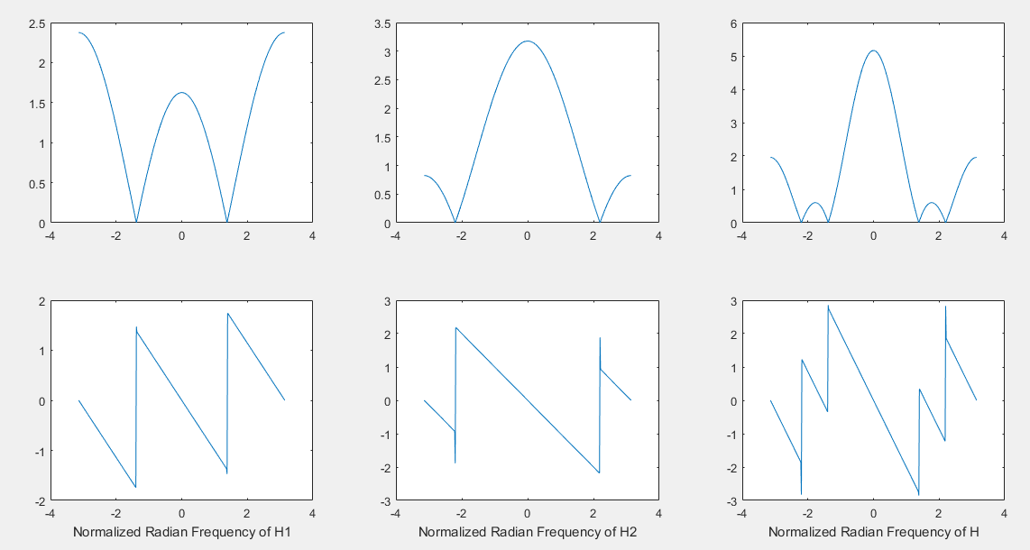

1. Generate an input signal x[n] that is the sum of three sinusoids:

$$x\left[n\right]=5\cos\left(0.3πn\right)+22\cos\left(0.44πn-\frac{pi}{3}\right)+22\cos\left(0.7πn-\frac{π}{4}\right)$$

Make the input signal 150 samples long over the range 0 < n < 149.

**Matlab code:**

clc;

clear all;

n=0:149;

xx= 5*cos(0.3*pi*n)+22*cos(0.44*pi*n-pi/3)+22*cos(0.7*pi*n-pi/4);

stem(n,xx)

**Matlab graph:**

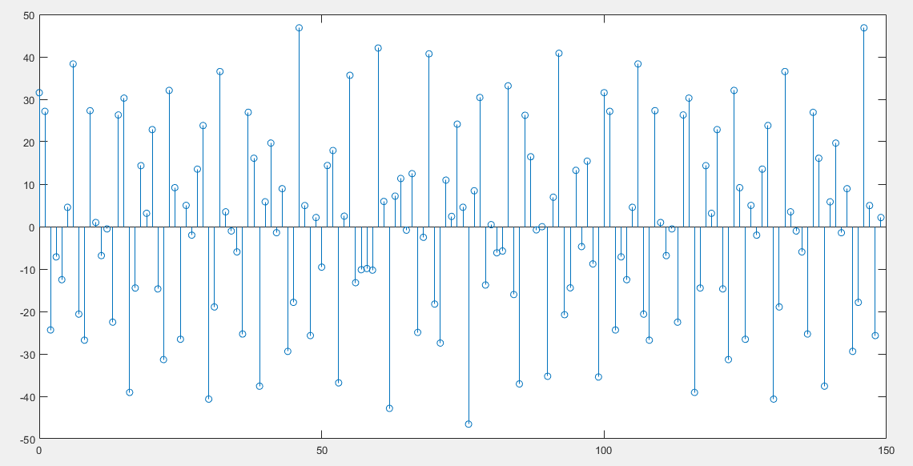

1. Use firfilt (or conv) to filter the sum of three sinusoids signal x[n] through the filters designed in part (a). Show the MATLAB code that you wrote to implement the cascade of two FIR filters.

**Matlab code:**

clc;

clear all;

h1=[1 -2*cos(0.44*pi) 1];

h2=[1 -2*cos(0.7*pi) 1];

h= firfilt(h1,h2);

n=0:149;

xx= 5*cos(0.3*pi*n)+22*cos(0.44*pi*n-pi/3)+22*cos(0.7*pi*n-pi/4);

KK= firfilt(h,xx);

stem(KK);

**Matlab graph:**

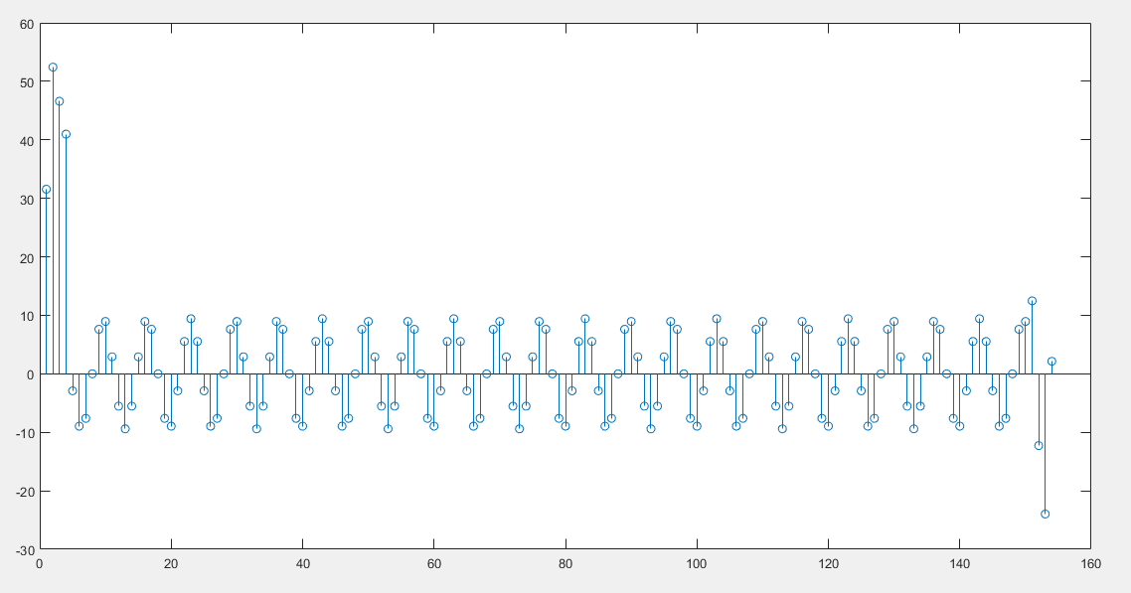

1. Make a plot of the output signal—show the first 40 points. Determine (by hand) the exact mathematical formula (magnitude, phase and frequency) for the output signal for n ≥ 5.

**Matlab code:**

.

.

stem(KK(1:40));

**Matlab graph:**

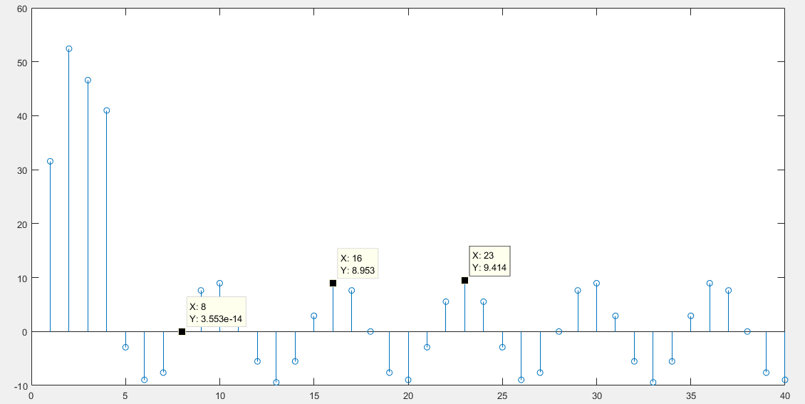

**Comments:**

By inspection, sequence is given as:

N= 7

Amplitude= 9.414

Phase= $\frac{4π}{7}$

$$y\left[n\right]=9.414cos⁡(\frac{2π}{7}n+\frac{2*360}{7})$$

$$y\left[n\right]=9.414cos⁡(0.286n+\frac{4π}{7})$$

1. Explain why the output signal is different for the first few points. How many “start-up” points are found, and how is this number related to the lengths of the filters designed in part (a)? Hint: consider the length of a single FIR filter that is equivalent to the cascade of two length-3 FIRs.

**Comments:**

4 start-up points are different from actual response. Because:

Length of cascaded filter is 5. The effective response of filter will appear after complete overlap of input signal and filter response. It happened at point 5.

General formula:

Start-up points = length of filter -1

**Conclusion:**

In this lab, we learnt to design FIR filter. This class of digital filters are largely used in digital image processing and also in other programs and systems. FIR filter are more stable and reliable than IIR filters. We also developed notch filter to suppress certain frequency from our output using MATLAB.

**----------------------------------------------**