**Department of Electrical Engineering**

|  |  |
| --- | --- |
| **Faculty Member:____________________** | **Dated: ____________________** |
|  |  |
| **Course/Section:____________________** | **Semester: __________________** |
|  |  |

**EE-232 Signals and Systems**

**Lab #5 Introduction to Properties of Systems**

|  |  |  |  |  |
| --- | --- | --- | --- | --- |
| **Name** | **Reg. no.** | **Report Marks / 10** | **Viva Marks / 5** | **Total/15** |
|  |  |  |  |  |
|  |  |  |  |  |
|  |  |  |  |  |
|  |  |  |  |  |

**Lab5: Introduction to Properties of Systems**

**Objectives**

The goal of this exericse is to gain familiarity with properties of systems. It is important to understand how to demonstrate when a system does or does not satisfy a given property. MATLAB can be used to create counter examples demonstrating that certain properties are not satisfied.

* How to determine if systems satisfy a particular property or not
* Properties of Linear Time Invariant Systems

**Lab Instructions**

* This lab activity comprises of three parts: Pre-lab, Lab Exercises, and Post-Lab Viva session.
* Only those tasks that completed during the allocated lab time will be credited to the students. Students are however encouraged to practice on their own in spare time for enhancing their skills.

**Lab Report Instructions**

All questions should be answered precisely to get maximum credit. Lab report must ensure following items:

* Lab objectives
* Matlab codes
* Results (graphs/tables) duly commented and discussed
* Conclusion

# Introduction to Systems

## Pre-Lab

### Introduction

Systems can be classified into different categories based upon certain properties. Generally, it is easier to identify a case or input for which a particular property does not hold. For the remainder of this exercise please keep this point in mind. The first section covers memory/memory-less systems, causal/non-causal systems, time varying/time-invariant systems and linear and non-linear systems.

### Memory / Memory-less Systems

A system is memory-less if output of each value of independent variable is dependnet only on the input at that same time.

y[n] = x[n] (Memory-less System)

y[n] = x[n] – x[n-1] (System with Memory)

### Causal / Non-causal Systems

A system is causal if it does not depend on future values of input to determine the output. If a system output y(t) depends only on the input at present or earlier times, we say that the system is causal. Another way to say this is that the output does not anticipate future values of the input. All memoryless systems are causal. A noncausal system anticipates the future values of the input signal in some way.

y[n] = x[n] - x[n-1] (Causal System)

y[n] = x[n] – x[n+1] (Non/Anti-Causal System)

### Time varying / Invariant Systems

If a shifted input produces an output that is identically shifted then the system is a time invariant system.

y[n-N] = x[n-N] (Time Invariant System)

y[n] = (0.5)n+1 x3[n-1] (Time Varying System)

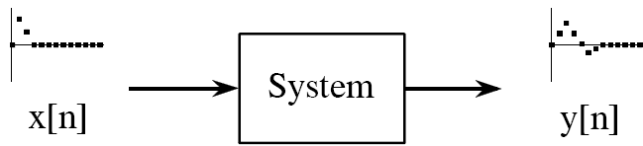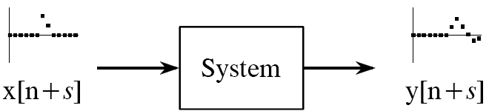

**if**

**then**

### Linear / Non-linear Systems

Linear systems adhere to the principle of superposition. Superposition, comprises of additivity and homogeneity.

Additivity if x1[n] y1[n] & x2[n] y2[n] then x1[n]+x2[n] y1[n]+y2[n]

Homogeneity if x[n] $→$ y[n] then ax[n] $→$ ay[n]

### Lab task 1:

1. Verify that the system y[n] = sin ((π/2)x[n]) is not linear. Use signal x1[n] = δ[n] and x2[n] = 2δ[n] to demonstrate if the system **violates** **linearity**.
2. Verify if the following system y[n] = x[n] + x[n+1] is **not** **causal**. Use the signal x[n]=u[n] to deomstrate this. Define vectors x and y to represent the input on the interval -5 ≤ n ≤ 9 and output on the interval -5 ≤ n ≤ 8.
3. Verify if the following system y[n] = x[2n] is **time** **variant** or **invariant**? Use a signal of your choice.

## Pre-Lab

Convolution is the process by which the output of a linear time invariant system can be determined to a specific input signal. We shall cover convolution in detail in the next lab. However, in this lab we shall only use the convolution function provided in MATLAB. Use the convolution function ‘conv or convn’ to verify the following properties of systems.

x[n] * y[n] = y[n] * x[n] (Commutative Property)

(x[n] *h1[n])* h2[n] = (h1[n]* h2[n])*x[n] (Associative Property)

### Lab task 2:

1. Given the signals x[n] = [1 2 3 4 5] and y[n] = [1 1 1 1 1], verify using ‘conv or convn’ function that commutative property holds.
2. Assume a 2-D signal (i.e., some image). Load image and assume it to be signal x. Next assume that instead of having a 2-D filter you have two one D filters h1[n] =[0.25 0.5 0.25] and h2[n]=[0.25;0.5;0.25]. Assume that the convolution (h1[n]* h2[n]) = h3[n] = [0.0625 0.125 0.0625; 0.125 0.25 0.125; 0.0625 0.125 0.0625]. Using this information and output at each stage verify that Associative property holds.