Table of Contents

Forwarding FortiFirewall Logs to Bindplane
Hands-on lab: send FortiFirewall syslog events to a Bindplane agent running on Windows, with both VMs in VirtualBox.
Author: Saad Qamar, SOC Analyst Repository: https://github.com/SaadJavedQamar/Forwarding-FortiFirewall-logs-to-Bindplane Date: 4 October 2026
Result: FortiFirewall syslog events (admin login, system events) reach the Bindplane agent and appear in Bindplane Live Preview.

Contents
- Overview and architecture
- Building the FortiFirewall VM in VirtualBox
- Connectivity test
- Syslog forwarding setup
- Result: logs in Bindplane
- Issues and fixes
- Next steps

1. Overview and architecture
The Bindplane agent was already installed on a Windows VM and Windows Event Logs were flowing. The goal was to send a firewall’s logs through the same agent. A Fortinet VM (FortiFirewall v8.0.1) running in VirtualBox was used as the lab firewall.
Component | Detail
Bindplane agent (collector) | Windows VM (VirtualBox, Bridged), IP 192.168.100.42, collector name DESKTOP-QHSR9HE
Firewall | FortiFirewall VM (VirtualBox, Bridged, built from the KVM image), IP 192.168.100.44
Log path | FortiFirewall -> Syslog UDP 514 -> Bindplane agent -> Bindplane configuration Windows_logs
Destination (currently) | Dev_Null (test only, logs are not stored)

2. Building the FortiFirewall VM in VirtualBox

2.1 Download the KVM image
VirtualBox has no official Fortinet image, so the KVM image is downloaded and converted.
You can download the KVM image from the Fortinet support site: sign in to FortiCare, then go to Downloads -> VM Images (support.fortinet.com/support/#/downloads/vm). Choose the product, set Select Platform to KVM, and pick “New deployment … KVM” (not “Upgrade from previous version”). This lab used FFW_VM64_KVM-v8.0.1.F-build0245-FORTINET.out.kvm.zip (137.84 MB). The same page also lists FortiGate KVM images.
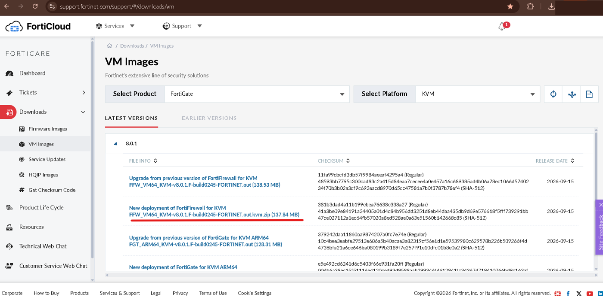
Fortinet VM Images page, KVM platform, New deployment download underlined
The zip contains fortios.qcow2. Copy it to a local folder such as C:\VMs\FFW_KVM (not OneDrive, to avoid sync problems).
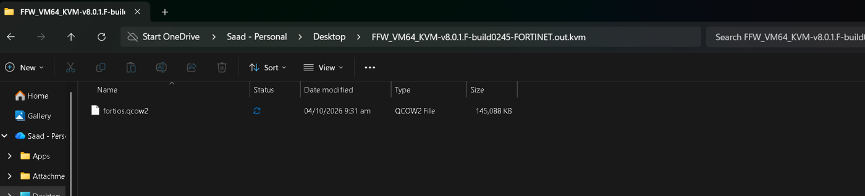
fortios.qcow2 inside the KVM zip

2.2 Convert the qcow2 image to VDI
cd "C:\Program Files\Oracle\VirtualBox"
VBoxManage clonemedium disk "C:\VMs\FFW_KVM\fortios.qcow2" "C:\VMs\FFW_KVM\fortios.vdi" --format VDI
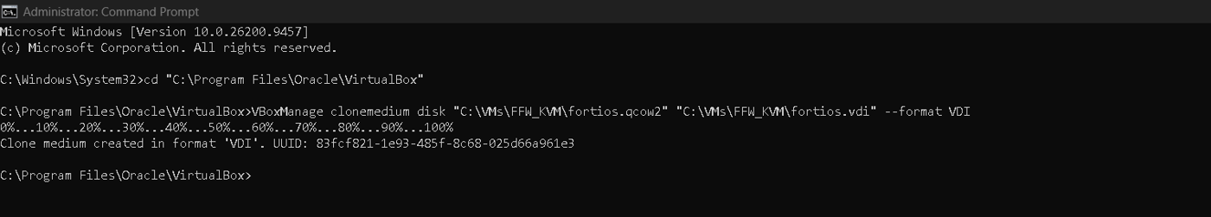
VBoxManage conversion succeeded

2.3 Create the VM
New VirtualBox VM: Type Linux, Version Other Linux (64-bit), RAM 2048 MB. On the Hard Disk step, select “Use an Existing Virtual Hard Disk File” and choose fortios.vdi. The default (create a new blank disk) will not boot.
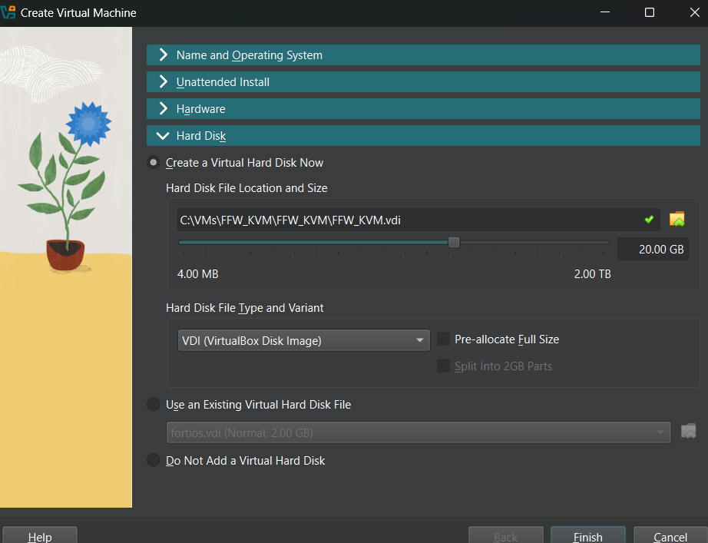
Create Virtual Machine wizard, Hard Disk section
Then open the VM settings:
- System: Chipset PIIX3, I/O APIC enabled, EFI off, Hard Disk first in boot order
- System -> Acceleration: Paravirtualization KVM
- Network: Bridged Adapter, adapter type Intel PRO/1000 MT Desktop (so the firewall is on the same LAN as the Windows VM)
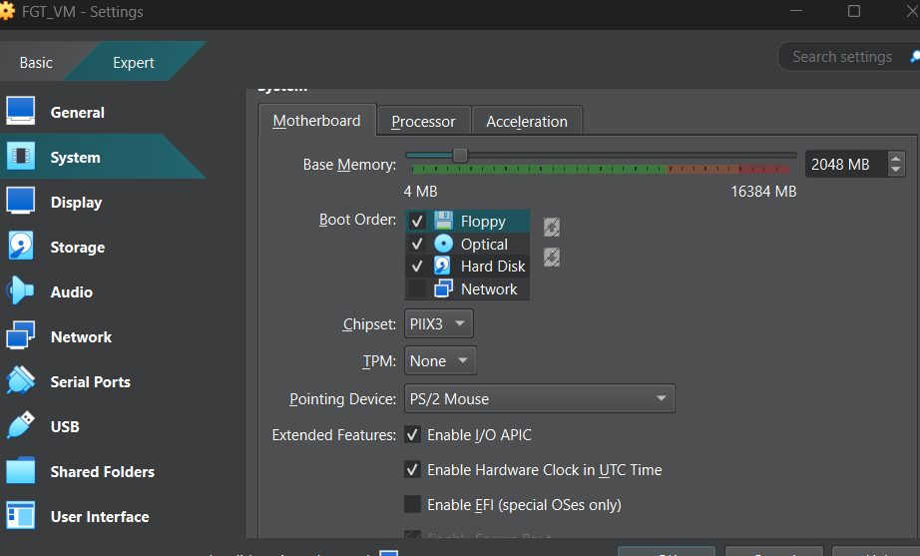
VirtualBox Motherboard settings

2.4 First boot
Log in on the console as admin with a blank password, then run get system interface physical. port1 received 192.168.100.44 from the router, which confirms Bridged mode works. The console also warned: “License invalid due to exceeding allowed 1 CPUs and 2048 MB RAM” (see Next steps).
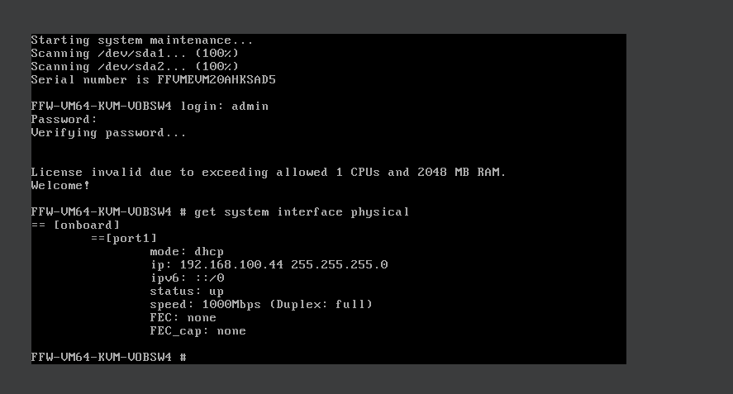
First boot, port1 = 192.168.100.44

3. Connectivity test
The Windows VM (Bindplane agent) is at 192.168.100.42 on the same subnet. It could ping the firewall with 0% loss. Pinging from the firewall to Windows failed because Windows Firewall blocks incoming ICMP. This does not affect syslog, which uses UDP 514.
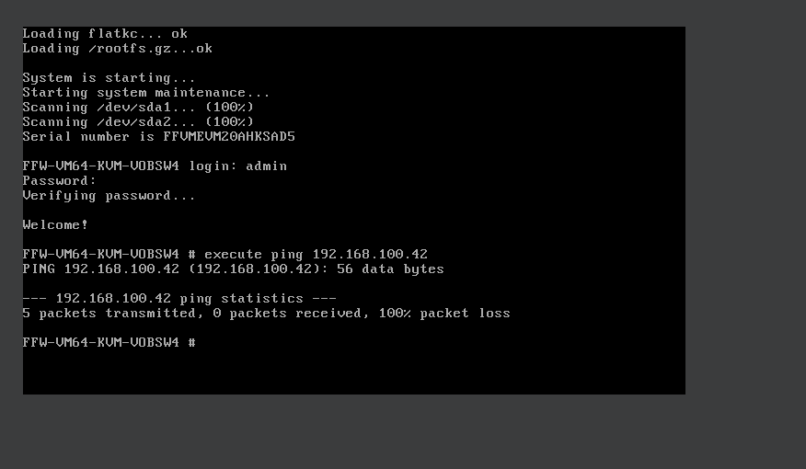
Firewall pinging Windows: 100% loss
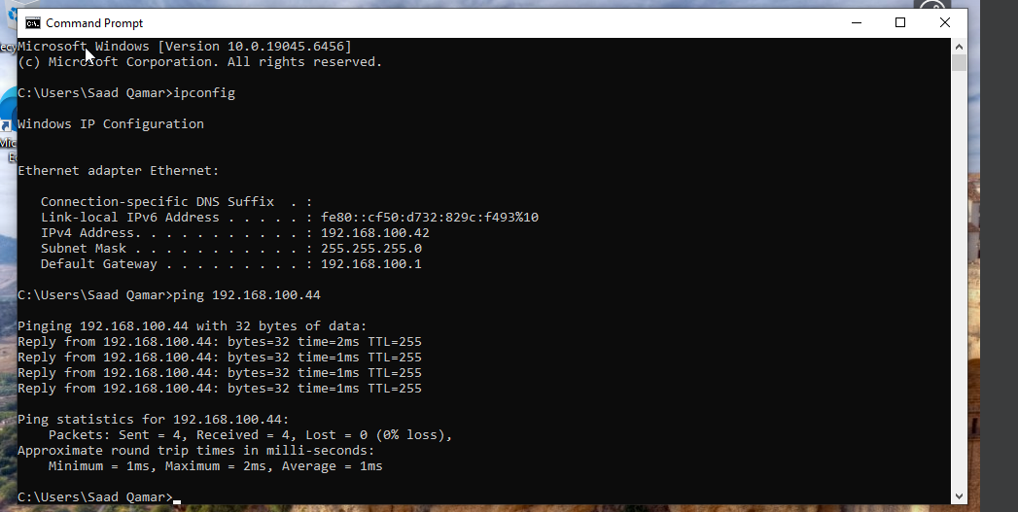
Windows ping to the firewall: 4/4 replies

4. Syslog forwarding setup

4.1 Syslog on the firewall
config log syslogd setting
set status enable
set server "192.168.100.42"
set mode udp
set port 514
end
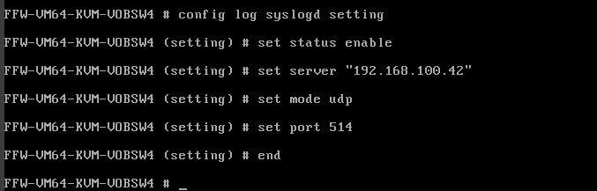
Syslog configuration in the FortiFirewall CLI

4.2 Inbound rule on the Windows VM
PowerShell as Administrator:
New-NetFirewallRule -DisplayName "Bindplane Syslog" -Direction Inbound -Protocol UDP -LocalPort 514 -Action Allow
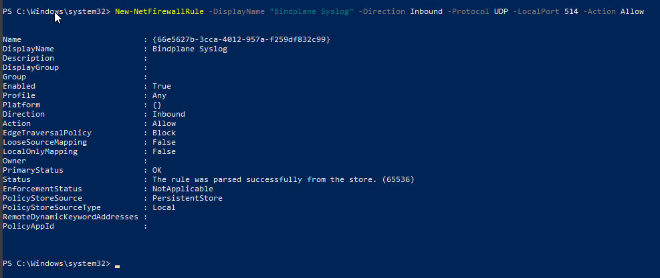
Windows Firewall rule created

4.3 Syslog source in Bindplane
In the Windows_logs configuration, add a Syslog source:
Setting | Value
Listening IP Address | 0.0.0.0
Listening Port | 514
Protocol | rfc3164
Transport Protocol | udp
Parse To | body
Binding to a port below 1024 requires the collector to run as Administrator on Windows.
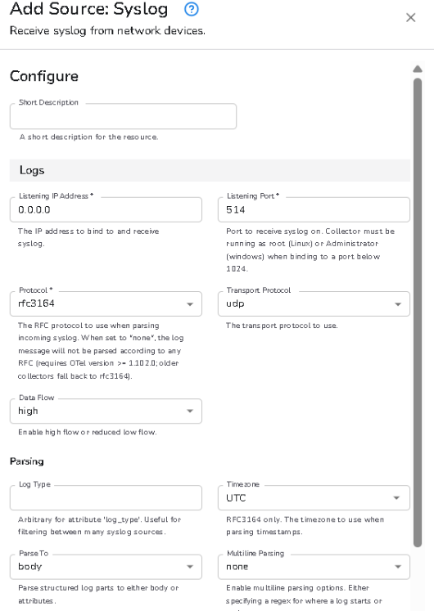
Bindplane Add Source: Syslog
In the draft pipeline, the Syslog line did not reach the destination and the status was “Rollout Pending”.
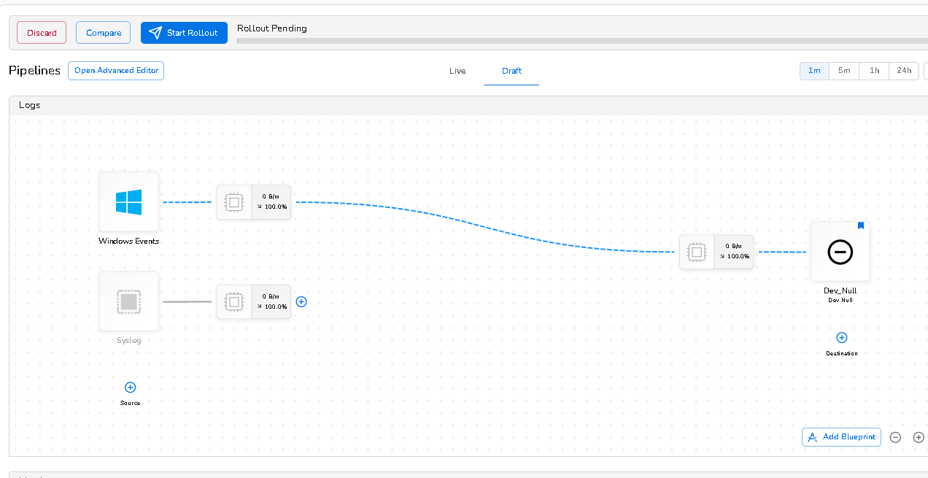
Draft pipeline: Syslog not connected, rollout pending
After connecting Syslog to the destination and pressing Start Rollout, both sources feed the destination (Windows Events 5.1 KB/m, Syslog 1.9 KB/m).
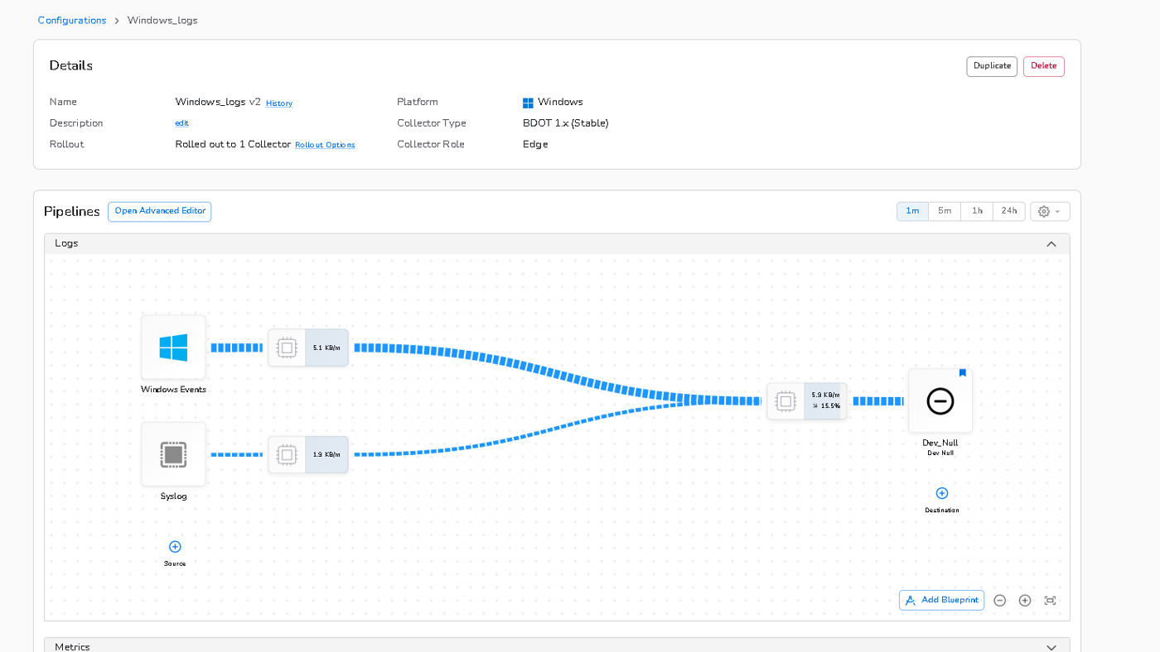
Live pipeline after rollout

4.4 Confirm the agent is listening
netstat -an | findstr 514
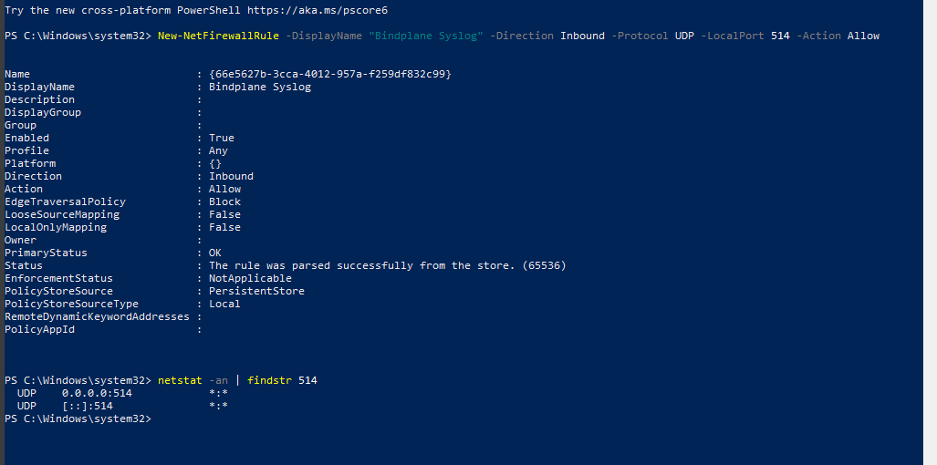
UDP 514 listening on 0.0.0.0 and [::]

5. Result: logs in Bindplane
Logging in to the firewall GUI (https://192.168.100.44) as admin generated an event log that appeared in Bindplane Live Preview. It includes logid="0100032001", logdesc="Admin login successful", srcip=192.168.100.13, dstip=192.168.100.44 and user="admin" in FortiOS key=value format.
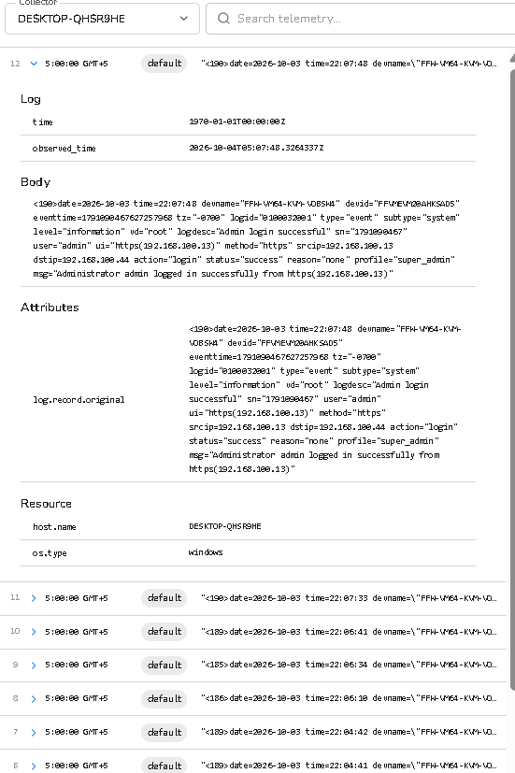
Live Preview: FortiOS admin login event
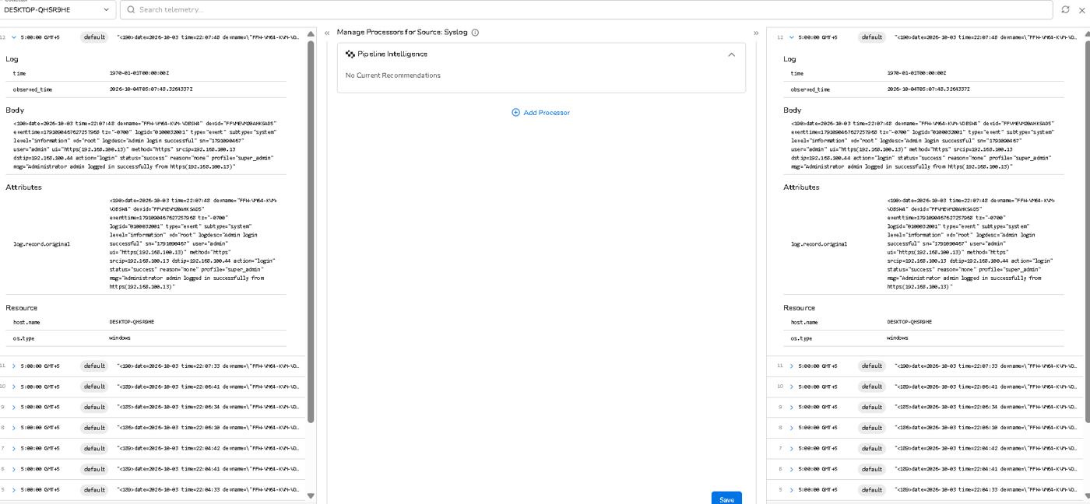
Manage Processors panel of the Syslog source (no processors yet)

6. Issues and fixes
Issue | Cause | Fix
VM would not boot from a fresh disk | Wizard default creates a blank disk | Choose “Use an Existing Virtual Hard Disk File” and select fortios.vdi
Firewall and agent on different networks | Host-only networking isolates the VM from the Windows VM | Put both VMs on Bridged Adapter, same LAN
Ping from firewall failed | Windows Firewall blocks ICMP | Ping is not needed for syslog; added an inbound UDP 514 rule
Syslog not linked to Dev_Null | Line incomplete in the draft | Connected the source to the destination and rolled out
License invalid warning | VM has more than 1 CPU / 2048 MB RAM | Reduce to 1 CPU and slightly less RAM, then recheck

GUI login and license
The GUI first showed “Authentication failure” (a password issue), and a later login worked. The GUI then showed only the License page because the VM license is invalid.
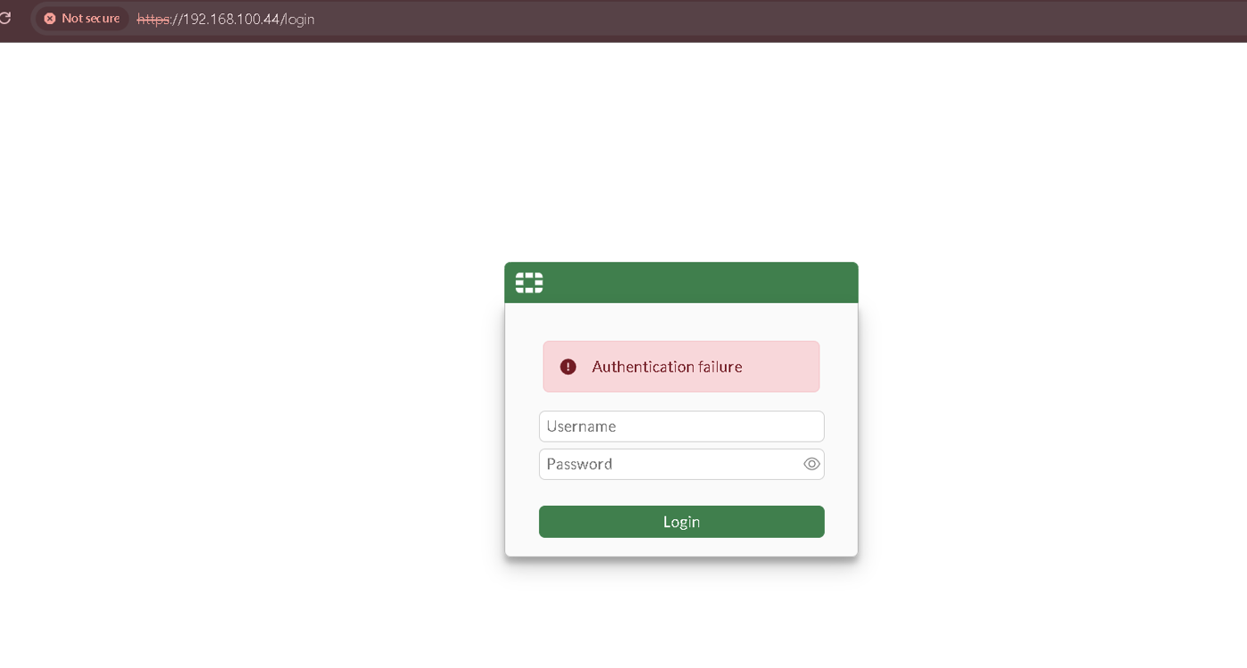
GUI: Authentication failure
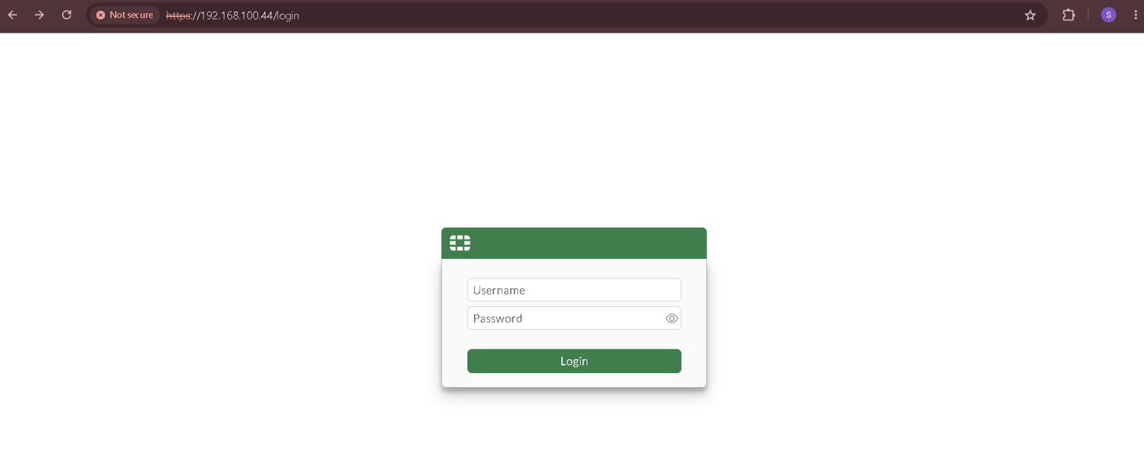
GUI login page
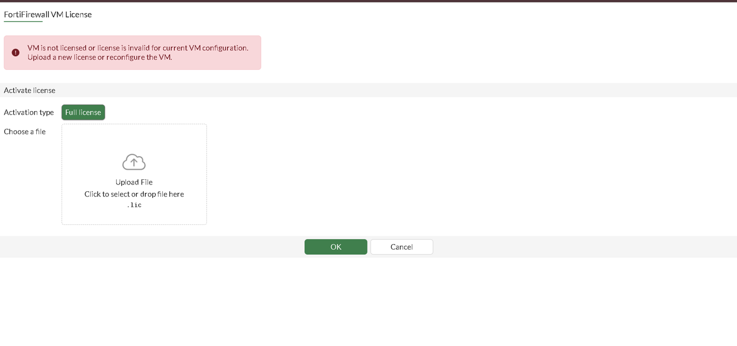
License page: VM is not licensed or license is invalid for current VM configuration
Note: syslog events arrived even with the license invalid, but other firewall features may stay limited until it is fixed.

7. Next steps
- Fix the license: power off the VM, set CPUs to 1, lower RAM slightly (for example 2000 MB), then check License Status with get system status. If it is still invalid, a valid .lic file or a FortiGate-VM evaluation will be needed.
- Add a real destination: Dev_Null discards logs. Add Google Cloud Logging, Splunk, Elastic, Loki or OTLP.
- Parse the logs: they are raw key=value text. Add a Bindplane processor (Parse Key Value) so srcip, dstip and action become separate fields.
- Generate more logs: enable Log Allowed Traffic -> All Sessions on a firewall policy and send traffic through it.
- Stable IP: use a DHCP reservation or static IP for firewall port1 so the syslog target does not change after a restart.

Author
Saad Qamar, SOC Analyst

