**Tableau Part-1**

**OBJECTIVES:**

* Installation of Tableau
* Create an account on Tableau
* Getting know of different sections & features in a Tableau
* Uploading the data sheet in a Tableau
* How to create different sheets in a Tableau
* Interpret different graphs in a Tableau
* How to create Dashboard in a Tableau
* How to create story in a Tableau
* How to save Tableau public Viz

**Task#01:**

* **Create a pie chart with the two labels**
* **Can you create the label Gender first, before you create the label on quantity?**
* **Can you change the position of the labels? Gender on top of quantity?**

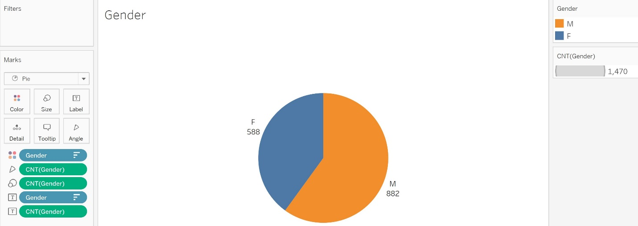

**Task#02:**

* **Create a bar chart based on Gender and Divorced**
* **Color the bar chart with the two genders (Male, Female)**
* **Sort in Descending Order**
* **Fill the whole screen**
* **Label the chart with quantity of both genders**
* **Rename Sheet 2 as “Hometown-Gender”**

**Task#03 (Different ways to Visualize):**

* **Create a Pie Chart for comparing Sales and Department**
* **Fill the whole screen**
* **Rename Sheet 3 as “Unit-Decision Skills”**

Comparing ‘Job Role’ and ‘Department’

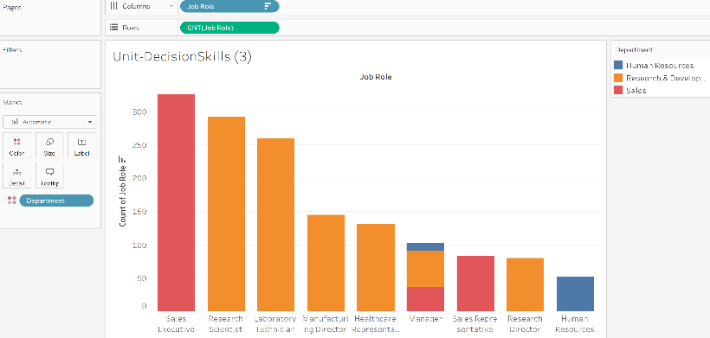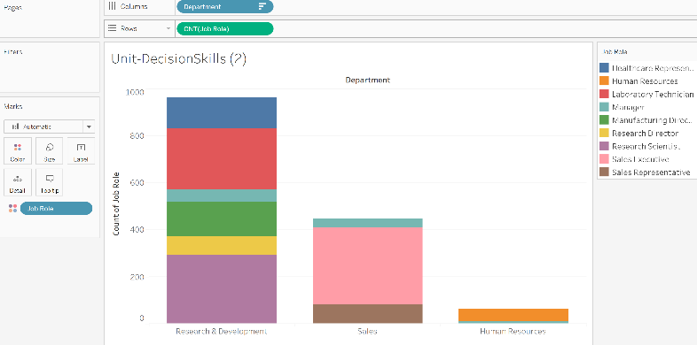

**Sorted in Descending order**

**Task#04**

* Create a bar chart, Education vs Hourly Rate
* Change the color segmentation
* Rename Sheet 5 as “Education-ServiceTime”
* Fill the whole screen
* Sort the Education level in descending order
* Is it better? Not too bad

**Task#05**

* Create a bar chart, Employee_ID vs Attrition_rate
* Fit Width
* Rename Sheet 7 as “EmployeeID-AttritionRate”
* Sort the Education level in descending order
* Color the segmentation

Dashboard for Department and Number of Employees in

**Task#06:**

* **Create a dashboard**
* **Click-and-drag:**
* **Sheet “Gender”**
* **Sheet “Unit-Decision Skills (2)”**
* **Sheet “EmployeeID-AttritionRate”**
* **Sheet “Hometown-Gender”**
* **Sheet“Education-ServiceTime”**

**Task#06a:**

Delete the legends for:

* Gender
* Count of Gender
* Attrition_rate
* Avg. Time of Service.

Float and move the legend for Decision_skill_possess

**Task#06b:**

* Remove the header Count of Gender from Hometown-Gender
* Extra, remove the following header:
* Count of unit, from Unit-DecisionSkills (2)
* Avg Time_of_service from Education-ServiceTime
* Graphical user interface, chart

  Description automatically generatedExtra, rename Dashboard 1 as “EmployeeAttrition_Dashboard”