**Tableau Case Study 2 (b)**

**OBJECTIVES:**

* **Working with maps**
* **Comparing different countries sales and profits**
* **Making cumulative graphs**

**Task#01:**

* Create map, use Country
* Put Sales into Size
* Duplicate map, put Profit into Color and remove Sales
* Change Color for Profit
* Rename Sheet 1 and Sheet 1 (2) to “Country Sales” and “Country Profit”

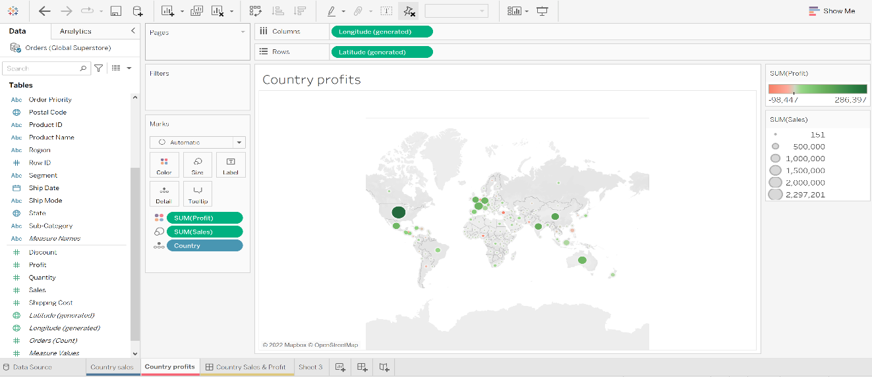

**Task#02:**

* Create Dashboard
* Put in Sheets “Country Sales” and “Country Profit”
* Rename Dashboard 1 to “Country Sales & Profit”
* Remove legends

**Task#03:**

* Create map, use State
* Fix the errors for State
* Put Sales into Size

**Task#04:**

* Duplicate map
* Put Profit into Color
* Remove Sales
* Change Color for Profit
* Rename the sheets, Sheet 3 and Sheet 3 (2) as“State Sales” and “State Profit”
* Filter Country to United States, for Sheet “State Sales”
* Repeat for Sheet “State Profit”

**Task#05:**

Create Dashboard

• Put in Sheets “State Sales” and “State Profit”

• Rename Dashboard 2 to “State Sales & Profit”

• Remove legends

**Task#06:**

Create two bar charts – for Sales, and Profit.

• Color the graph

• Sort the two graphs

• Rename Sheet 5 as “Sales vs Profit”

**Task#07:**

Put Sub-Category and Order Date into Columns

• Put Sales and Profit into Rows

• Change the graph into dual combination

• Change date format

• Fill entire view

• Change Sales to Bar, and Profit to Line.

• Change Sales to the left axis, and Profit to the right axis.

• Bring forward the line, if hidden.

• Extra: Change name for Sheet 6 to “Sales-Profit Trend”

**Task#08:**

• Create a new Dashboard, rename it to “Sales-Profit Dashboard”

• Change dashboard size to automatic

• Put Sheet “Sales vs Profit” on top, and “Sales-Profit Trend” at bottom.

• Remove the legend

**Task#09:**

• Create Calculated Field for UnitPrice

• Create bar chart, UnitPrice vs Sub-Category

• Take average of UnitPrice

• Sort descending

• Fill entire view

• Rename Sheet to “Average Price Per Unit”

**Task#10:**

• Duplicate the sheet “Average Price Per Unit”

• Create Calculated Field for UnitProfit

• Replace AVG(UnitPrice) with AVG(UnitProfit)

**Task#11:**

• Create New Dashboard

• Change dashboard size to automatic

• Put Sheet “Average Price Per Unit” above, and “Average Profit Per Unit” below.

• Rename Dashboard as “Average Price vs Profit Per Unit”

**Task#12:**

• Create new Worksheet, titled “Sales, Profit & Discount”

• Put three bars side-by-side (Sales, Profit, Discount); with respect to Sub-Category.

• Change Discount to AVG

• Color segment Profit

• Sort descending for Discount

**Task#13:**

• Create a new Worksheet, “Discount-Profit Trend All”

• Put Discount to Rows, Profit to Columns

• Untick Aggregate Measures

• Color segment Profit

• Show Trend Lines

**Task#14:**

• Duplicate Sheet “Discount-Profit Trend All”

• Rename the new Sheet “Discount-Profit Trend Table”

• Add filter for Table

**Task#15:**

• Create a new Dashboard, rename it to “Discount-Profit Dashboard”

• Change dashboard size to automatic

• Put Sheet “Sales, Profit & Discount” on top row, while the two scatter plots on the bottom row.

• Remove the legend

**Task#16:**

Create a new Story

• Create the first two pages, for “Country Sales & Profit”, and “State Sales & Profit”

• Create the next two pages, for “Sales-Profit Dashboard”, and“Discount-Profit Dashboard”

• Rename Story 1 as “Company KPI and Improvement Suggestion”

• Save your work into Tableau Public

