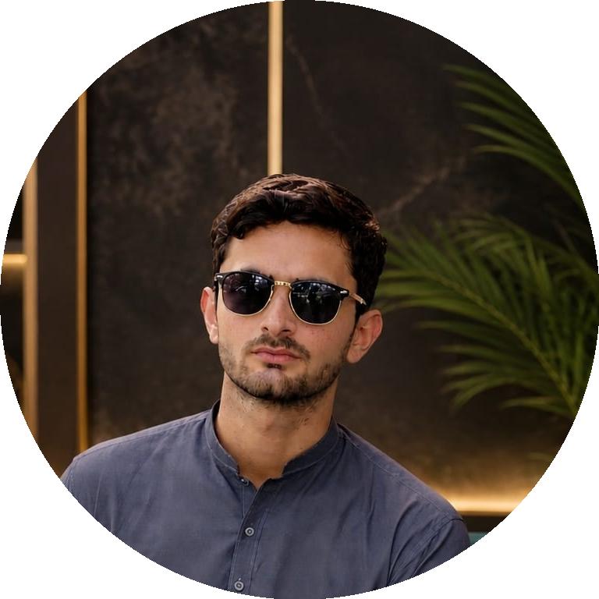  CONTACT  ✉ saadmuavia36203@gmail.com  📞 0303-6675660 (Call & WhatsApp)  📍 Lodhran, Punjab, Pakistan  SKILLS & TOOLS  ● HTML5 & CSS3  ● JavaScript (ES6+)  ● Bootstrap CSS  ● OOP(Java)  ● C++  ● IT Technician  CERTIFICATIONS  ● Full Stack Web Development — TICER (6 Months)  ● QA & Software Testing — Farmevo Internship  INTERESTS  ● Web Development  ● Quality Assurance  ● Agri-Tech  ● Open Source Projects | SAAD MUAVIA  FULL STACK DEVELOPER  SUMMARY  Motivated Full Stack Developer currently working as a QA Intern at Farmevo and pursuing IT studies at TICER, Lodhran. Completed a 6-month intensive Full Stack Web Development course, building 5 real-world web applications end-to-end. Skilled in front-end and back-end development along with hands-on software quality assurance and testing. Eager to build reliable, user-friendly web products in a professional development team.  EXPERIENCE  QA Intern 2025 – Present  Farmevo  • Collaborate with the development team to maintain product quality and reliability.  Full Stack Web Developer (Training Projects) 2024 – 2025  TICER — Full Stack Web Development Program  • Completed a 6-month, hands-on Full Stack Web Development course covering front-end and back-end technologies.  • Built and deployed 5 real-world web development projects, handling UI, server logic, and databases.  • Practiced Git-based version control and collaborative coding workflows.  EDUCATION  Intermediate / IT Studies Ongoing  TICER — Tareen Institute of Computer Education & Resources, Lodhran  Full Stack Web Development Course (6 Months) Completed  TICER, Lodhran  PROJECTS  • Delivered 5 real-world full stack web development projects — from UI design to backend & database integration.  • Projects covered responsive front-ends, REST APIs, authentication, and database-driven features.  AFFILIATIONS     Currently associated with TICER (Education) and Farmevo (QA Internship).  LANGUAGES  English (Working Proficiency) Urdu (Native)

